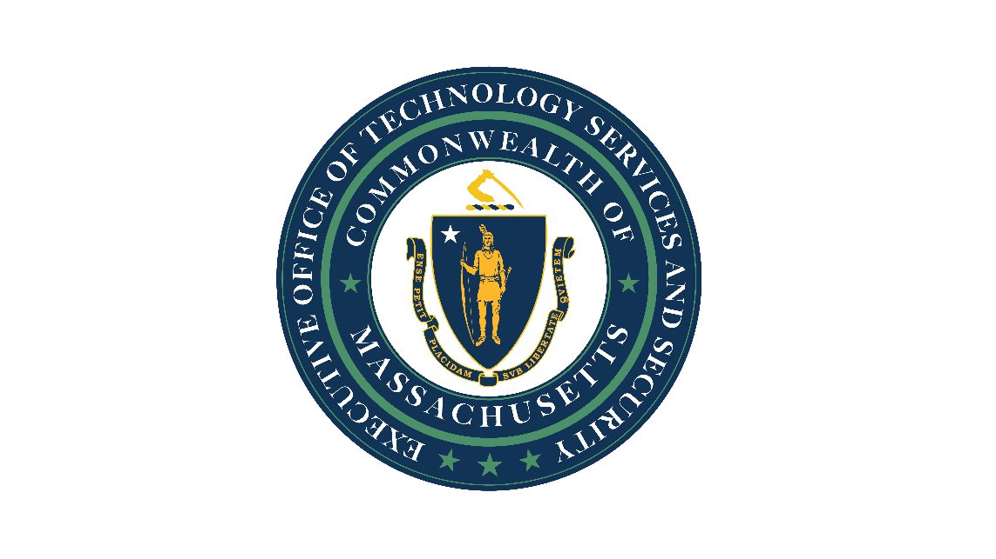

Commonwealth of Massachusetts IT Strategic Plan, 2026-2028

Secure. Modern. People First.

Executive Office of Technology Services and Security (EOTSS)
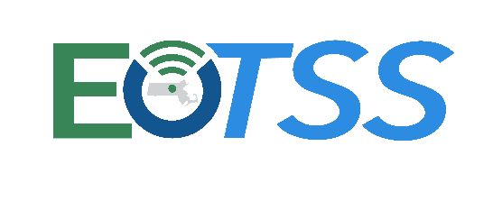

Published: April 15, 2026

Table of Contents

Commonwealth of Massachusetts IT Strategic Plan, 2026-2028 1
Letter from the Secretary 3
Executive Summary: Strategic Plan (2026-2028) 4
Constituent Experience 14
Cybersecurity 21
Data and Analytics 27
Innovation and Emerging Technology 35
IT Services 41
Strategy and Communications 50
Workforce 56
Appendix I. Why centralize IT functions? 61
Appendix II. Maturity model for growth opportunities 62
Appendix III. Top priorities in each pillar 63
Appendix IV. Data and Analytics 64
Appendix V. Glossary of terms 65

Letter from the Secretary
Dear Colleagues, Partners, and Constituents of the Commonwealth,
Over the past several years, the Commonwealth and EOTSS have meaningfully strengthened our technology foundation: modernizing infrastructure, expanding digital services, advancing accessibility, and improving our cybersecurity posture.

We have strengthened partnerships across the Executive Branch, consolidated key services and platforms, and supported agencies in delivering critical programs. At the same time, we have begun building the enterprise capabilities required to meet the evolving expectations of the people of Massachusetts. This strategic plan marks our next phase: Secure. Modern. People First.
Our direction is clear: Technology must be a core enabler of effective government.
We will continue investing in resilient infrastructure, trusted data, and a skilled workforce, while strengthening governance, accountability, and long-term sustainability. In parallel, we will advance innovation responsibly applying emerging technologies, including AI, in ways that improve operations and service delivery while managing risk and keeping our data and information secure.
This plan is grounded in enterprise alignment. We are clarifying priorities, strengthening planning and governance, and ensuring that our investments deliver measurable value across agencies and for the people we serve. Our approach allows us to scale what works, reduce duplication, and free up agencies to focus on achieving their missions.
Ultimately, our focus is on helping the Commonwealth deliver effective people-centered services. Whether someone is applying for housing support, renewing a driver’s license, or looking for affordable childcare, their experiences should be simple, accessible, secure, and responsive. By designing services around real-life events and journeys, we will improve outcomes and strengthen public trust.
Delivering this strategy will require collective effort.
- To our employees: your expertise and commitment are essential to this work.
- To our agency partners: your collaboration ensures mission alignment and impact.
- To our vendors and external partners: your partnership helps us deliver at scale.
- And to the people of Massachusetts: this work is ultimately in service of you.
We have both an opportunity and a responsibility to lead. By executing this strategy with discipline and focus, we will strengthen government, improve service delivery, and position Massachusetts as a national leader in secure, modern, and people-first technology.
Sincerely,

Jason Snyder
Secretary of Technology Services and Security and Chief Information Officer (CIO)

Executive Summary: Strategic Plan (2026-2028)

Purpose of the strategic plan
The strategic plan summarizes EOTSS’ enterprise-wide priorities to drive alignment across both the Commonwealth and our organization, while also empowering our staff to prioritize their work effectively. Within the plan, we detail how we organize our work to achieve our strategic objectives and define key results for measuring our progress.

Executive Office of Technology Services and Security (EOTSS)
EOTSS is the Commonwealth’s lead information technology (IT) organization, with broad governance authority over the IT assets and staff of the Executive Branch.
EOTSS is involved in shaping the information available online about the Commonwealth, the technology people interact with online and over the phone when dealing with Massachusetts’ government, as well as the things that go unseen, like the infrastructure that keeps it all up and running. In addition to technology, we provide governance, training, and technical standards that drive quality improvements at all levels – we work to make sure that information and systems are accessible to everyone, that everyone’s data remains private and secure, and that the Commonwealth can effectively protect itself from cyberattacks.
“Our mission is to provide technology leadership across the Commonwealth to enhance the quality of public service and foster positive community outcomes.”
Successfully delivering government services at scale requires technology. Technology enables executive branch agencies to fulfill their missions and serve the public—therefore, technology considerations must be integrated into goal setting, planning, and service delivery across policy areas and programs.
Better technology and better IT governance mean more effective government services for everyone who lives in and visits the Commonwealth.
EOTSS’ philosophy balances our dual role: as a leader that enables secretariats and agencies and as an IT service provider that delivers enterprise-wide technology. We aim to have clearly defined roles and responsibilities between EOTSS and other secretariats and agencies that allow us to partner effectively to deliver government services to our constituents.
Secretariats and agencies have policy and program expertise crucial for building the right technology to serve their constituents and meet their missions. Because EOTSS centralizes certain enterprise-wide “backstage” technology infrastructure, platforms, applications, functions, and expertise, secretariats and agencies can focus on “front stage” policy and service delivery in their respective domains.
However, this division of labor is not strict: technology permeates the entire spectrum, and agencies vary in their levels of technical maturity and capacity. In serving a dual role, EOTSS must balance:
- Providing technology and services to agency program and IT staff that effectively enables their “front stage” work
- Leading with guidance and processes that empower agencies to leverage agency-specific solutions while maintaining alignment to EOTSS standards and policies
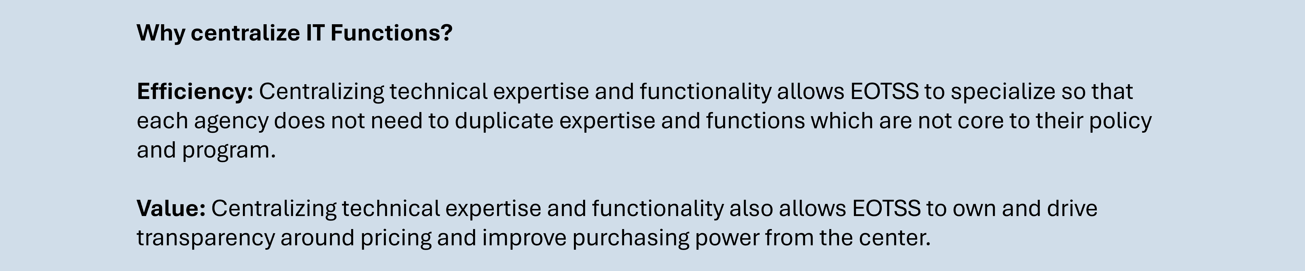
Please refer to Appendix I, why we centralize IT functions.

Vision for the Commonwealth’s future
The Commonwealth will deliver digitally-enabled government services that are secure, modern, and accessible, powered by resilient infrastructure, trusted data, responsible AI, and a skilled, engaged workforce. By putting constituents at the center and building capacity across state and local partners, we will provide seamless, personalized, and high-quality experiences that earn trust and improve outcomes for the people we serve. We will align enterprise technology strategy, governance, and investment to enable agencies to effectively deploy technology in support of service delivery and operations, while innovating with confidence, safeguarding privacy, and managing risk.

Commonwealth IT priorities
EOTSS sets the enterprise-wide priorities for the Commonwealth, which represent the shared IT goals of the Executive Branch and reflect the Commonwealth’s coordinated approach to technology modernization, cybersecurity, digital experience, and data-driven government. As the IT Secretariat, EOTSS works in partnership with all secretariats and agencies to define priorities through structured governance, cross-secretariat collaboration, and alignment with the Governor’s broader strategic objectives. These priorities are not limited to EOTSS initiatives; rather, they guide IT investment, policy, and execution across the enterprise. EOTSS plays a central role in setting direction, establishing standards, convening stakeholders, and driving accountability to ensure consistent progress statewide. By framing these priorities at the enterprise level, we reinforce our responsibility to both lead and operationalize technology strategy across the Executive Branch while avoiding duplication of agency-specific initiatives.
Enterprise-wide priorities: This list summarizes our enterprise-wide priorities for fiscal year 2027 (FY27).
- Constituent Experience: Personalize and streamline constituent experiences with the Commonwealth
- Cybersecurity: Strengthen security and resilience
- Data and Analytics: Leverage data to be more data-driven
- Innovation and Emerging Technology: Enhance productivity and service delivery through AI and other emerging technology

Summary of our seven strategic pillars
EOTSS identified seven pillars that are critical individually, and as an integrated set, to achieving our overall vision.
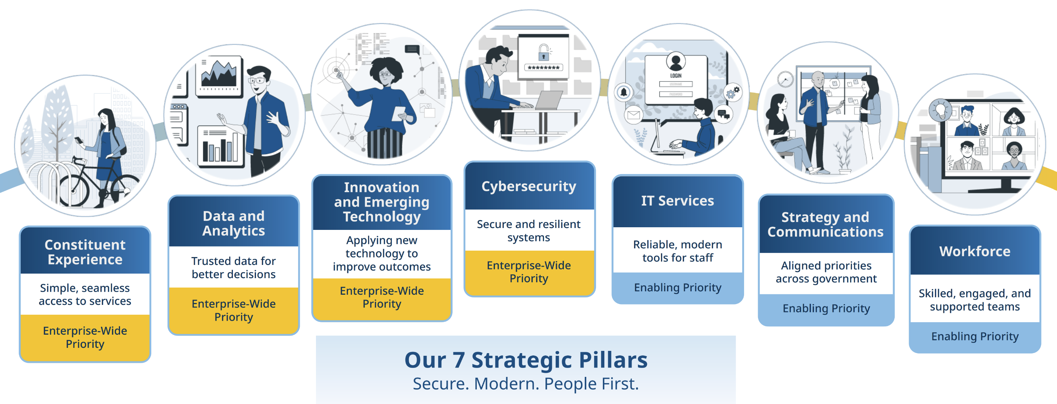
EOTSS is organizing our planned work in alignment with these pillars. Our seven strategic pillars are:
- Constituent Experience: The Commonwealth delivers consistently high-quality end-to-end experiences that enable all constituents to get the information and services they need, where and when they need them.
- Cybersecurity: Commonwealth systems and information are secure and resilient in an everchanging threat landscape, so that we continue to protect constituent privacy and prevent or mitigate harmful access to systems.
- Data and Analytics: Commonwealth data and data insights are easily and securely accessed by (1) state agencies for evidence-based policymaking, program design, and program delivery, and (2) by the public for research, innovation, and government accountability, while respecting the privacy rights of the people who may be subjects of the data.
- Innovation and Emerging Technology: EOTSS is a leader in innovation at the Commonwealth, with the means and expertise to apply emerging technology to government operations and services effectively and to enable secretariats and agencies to do the same.
- IT Services: All Commonwealth staff and affiliated personnel can securely access modern technology and tools to perform their duties, where (1) EOTSS centrally supports enterprise IT functions and (2) agencies and partners provide technology specific to their programs and services.
- Strategy and Communications: Commonwealth secretariats and agencies are aligned on shared IT initiatives and priorities that advance the needs of constituents.
- Workforce: The Commonwealth continually develops and empowers a stable, engaged, capable, and diverse workforce that can deliver against our IT mission over time.
Our pillars do not standalone. From our most external-facing public work down the stack to our technical foundations and more internal-facing enablement activities, our seven pillars integrate and build upon one another to drive impact.
Our foundations begin by aligning people, strategy, and finances through our pillars on Strategy and Communications and Workforce. On top of this layer, we build our technical foundations through our Cybersecurity and IT Services pillars, allowing us to provide modern and secure platforms and services that enable our secretariat and agency partners. Next, we can drive data usage and enable innovation through our Data and Analytics as well as our Innovation and Emerging Technology pillars. Finally, we have our constituent experience layer, which focuses on improving interactions. Together, these pillars help drive a future where constituents receive trusted, efficient, and high-quality public services from the Commonwealth.
Figure 1. Overview of how EOTSS’ strategic pillars integrate and stack to achieve outcomes
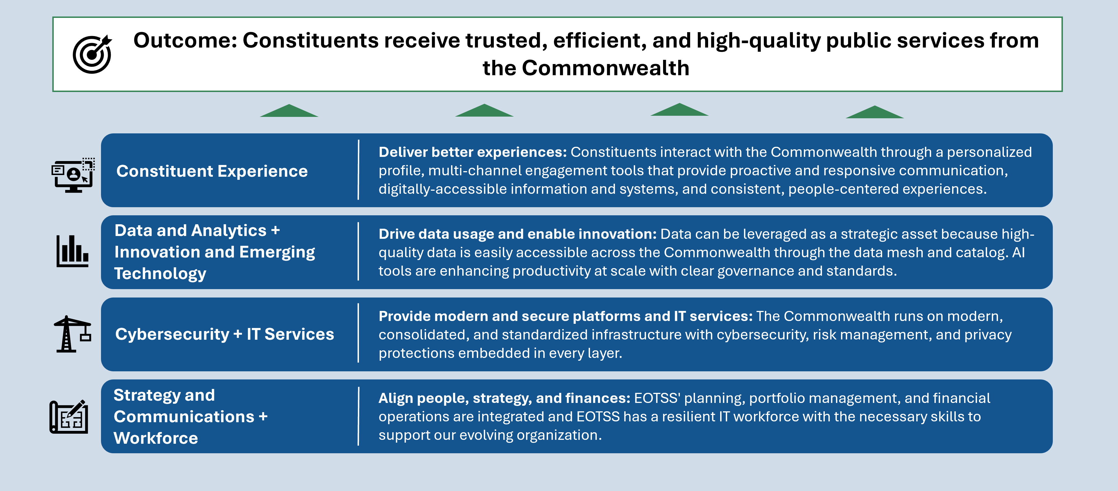
The scope of EOTSS’ strategic plan focuses on change initiatives that will drive us from our current state to our future vision across our seven strategic pillars. The strategic plan is not intended to be a comprehensive summary of everything EOTSS does; it is intended to focus on areas of growth and transformation. As a result, this plan does not capture the significant body of pre-existing operational work that will continue in alignment with our goals.

Cross-cutting themes

Common levers for achieving our objectives
Across our seven pillars, we consistently rely on three levers to drive our work:
- Leading Commonwealth IT: EOTSS leads IT through the creation of enterprise policy, governance groups, expert guidance, and preparing for the future. Our leadership work enables agencies to successfully leverage technology and tools, even as they evolve rapidly.
- Providing services to customers: EOTSS directly and centrally provides technology infrastructure, platforms, products, and applications for certain enterprise-wide functions.
- Maturing EOTSS: EOTSS continuously improves our services and operations by maturing our planning, resourcing, financial and service management processes.
The first two levers align well with our organizational philosophy: First, EOTSS is and will continue to be a service provider to our customers in the executive branch and beyond. Second, in addition to directly providing technology, EOTSS plays a critical IT leadership role that involves providing direction and enablement so that agencies can be successful on their own. This duality is reflected within the Cybersecurity, Data, Innovation, IT Services, and Constituent Experience plans— while Workforce and Strategy and Communications largely focus on lever three, planning and continuous improvement.

Opportunities for growth
The section below outlines common opportunities for growth and improvement that span multiple pillars:
- Moving from reactive to proactive to prepare for technology advancements: To effectively lead agencies in a rapidly evolving technology landscape, we need to dedicate specific capacity towards staying ahead of the curve. EOTSS teams need time and space to proactively learn about and plan for new technology, evolve our technology and service offerings, and maintain updated policies and guidance. As AI continues to mature, we need to prepare the groundwork to leverage it effectively. That means improving business processes to address underlying operational and service challenges, strengthening how we store data, and continuously improving legacy systems—whether within EOTSS or in partnership with agency customers.
- Maturing data readiness to be more data-driven: We also need to ensure data readiness even beyond its value to AI. This requires building the processes, policy, technology, new roles, and organizing functions to adequately support the expanding role of data across government services.
- Modernizing technology administration, organizations, and roles across the Commonwealth: In addition to modernizing technology, we see value in modernizing administrative structures—such as project funding models, service chargeback models, and contracts—to better support how we invest in, explore, and sustain new technologies and technology-related services. Additionally, technology needs have exploded, but technical staffing has not kept pace. We want to improve how Commonwealth technology organizations are staffed, to ensure they have the structure and expertise to operate according to best practices. As technology changes, we need to staff and upskill for specific roles and expertise. We also need to adjust how we organize and operate digital and IT teams, with stronger integration to service and program teams. Staying ahead of the curve while holding onto legacy systems that require continued support remains a challenge.
- Strengthening customer relationships: EOTSS wants to improve engagement with agency customers across domains, to ensure we understand IT and agency needs, effectively align our services to these needs, and ultimately deliver technical solutions that solve real problems.
- Ensuring alignment to standards and best practices: While EOTSS sets standards and policies across a variety of domains, we do not provide proactive enforcement across all of these areas—we are constantly maturing how to effectively communicate, educate, and enable agencies to meet standards while providing reasonable and feasible checkpoints along the way.
- Navigating our role as the IT secretariat while technology consolidation is still in flight: EOTSS has been in the process of consolidating IT functions since legislation allowing for this reorganization was passed in 2017. Until we have completed this consolidation effort, our model for supporting agencies lacks consistency and standardization.
We can evaluate each of our growth opportunities against a general maturity model, defined by the following five levels:
- Ad hoc: This level of maturity reflects a simple or immature understanding of a particular context. This level is characterized by a reactive nature, as well as limited and inconsistent coordination across and against overall strategic goals.
- Developing: This level of maturity reflects an intentional effort to actively develop knowledge and mature understanding. Similar to the ad hoc level, it is also characterized by a reactive nature but shows an increase in consistency and coordination.
- Maturing: This level of maturity reflects a more complex understanding and knowledge of a particular context, providing a strong foundation to refine and improve. This level is characterized by being more proactive, but often in an opportunistic rather than a reliable way.
- Scaling: This level of maturity reflects having a standard, repeatable approach across the organization that is operationalized, allowing for the organization to respond proactively to relevant situations.
- Optimizing: This level of maturity reflects a standard, repeatable approach that is aligned, coordinated, and subject to continuous improvement and adaptation to change.
These levels allow us to indicate where on the maturity model we are starting, and where we would like to arrive by the end of our current strategic plan. This path for improving each of our growth opportunities is summarized in the image below.
Figure 2. Overview of EOTSS’ maturity levels for identified growth opportunities, FY26-FY28
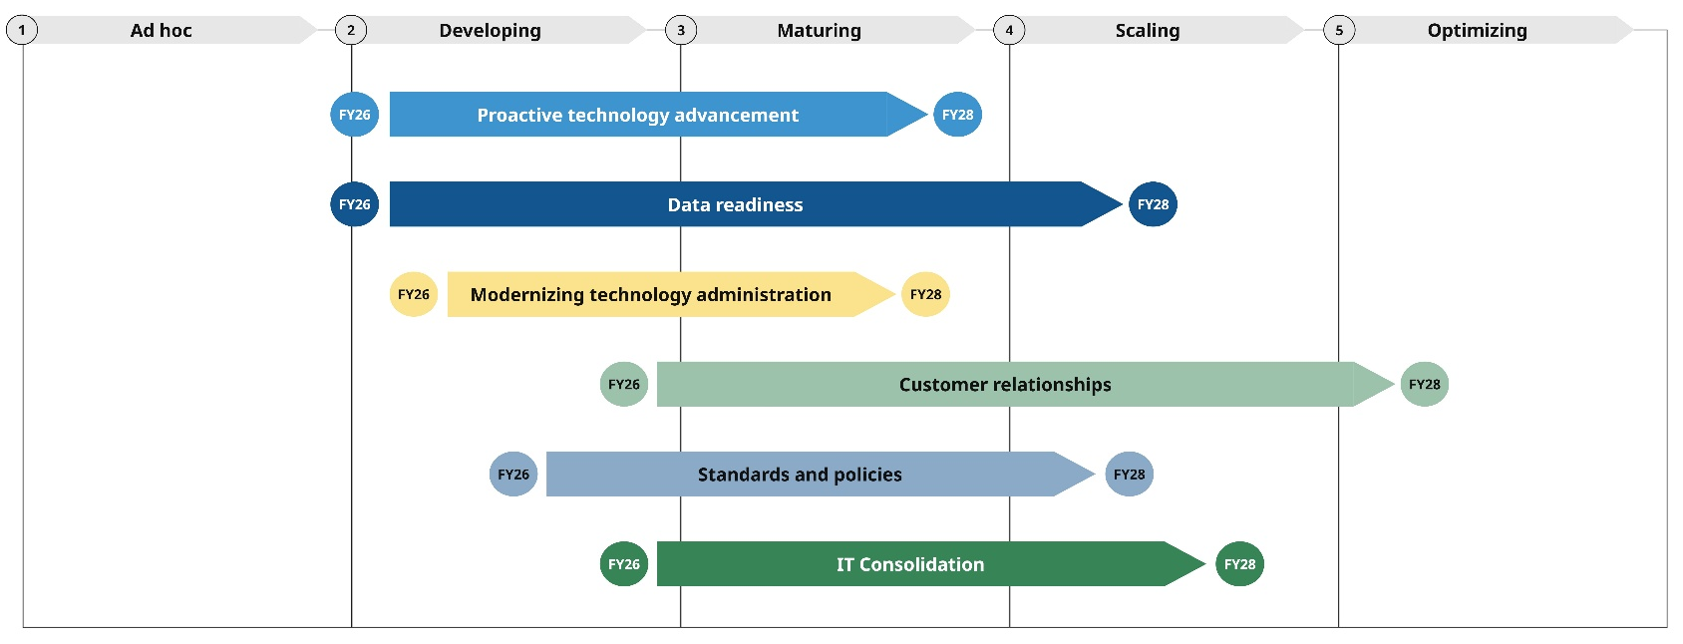
For more information on the maturity level of each growth opportunity, please refer to the maturity model appendix.
Within each of our pillars we call out specific questions for ongoing consideration that teams are currently grappling with—in some cases, similar questions impact multiple pillars. Often times, these questions are tied to active work and are opportunities to improve how we deliver against our mission and vision.

EOTSS’ FY27 Priorities
In addition to setting enterprise-wide priorities, EOTSS defines our own strategic priorities that outline our contributions directly as well as our role in enabling all Commonwealth agencies to advance these priorities. Our strategic plan outlines our objectives and initiatives through FY28, developed through a series of cross-functional workshops to ensure alignment across teams and domains, resulting in the following priorities:
- Define our data strategy: Develop a Commonwealth data strategy that ensures data readiness and enables innovation
- Strengthen security posture and response: Implement architectural standards (e.g., Zero Trust) and leverage automation for incident response and vulnerability management
- Roll out AI Assistant: Launch a Commonwealth AI Assistant for government staff and increase how many valuable AI tools are pushed into production, supported by enterprise standards
- Improve constituent experience: Provide adaptive, accessible, and streamlined constituent experiences directly and through capacity-building
- Mature centralized technology: Mature and standardize how we identify and provide centralized technology service and platform offerings
- Mature disaster recovery: Mature EOTSS’ disaster recovery and resiliency program
- Deliver enterprise data tools: Standardize and modernize data technology offerings for federated data sharing and integration services
- Rationalize data centers: Rationalize data centers to optimize our overall on-premises footprint
- Consolidate IT staffing and infrastructure: Consolidate IT staffing, Network, and Voice sites to streamline IT operations
- Provide AI trainings and guidance: Enable the use of emerging technology across the Commonwealth to improve government service delivery
We further support our prioritized work through cross-cutting enablement that is critical to our overall success:
- Building workforce resilience and future skills
- Maturing planning, governance, and service portfolio management
- Ensuring financial sustainability

Conclusion
As EOTSS matures as an organization, we remain committed to our mission to provide technology leadership across the Commonwealth to enhance the quality of public service and foster positive community outcomes.
The priorities we’ve identified are critical to fulfilling this mission and making progress toward our overall vision for IT in the Commonwealth, particularly in response to the following drivers:
- Mission-critical service reliability: IT as foundational infrastructure for all state services
- Cybersecurity: Ever-escalating threat landscape
- Digital equity: Ensuring that all people can access our services
- Operational resilience: Adapting to technology, policy, funding, and crisis-driven change
- Cost optimization: The need to do more with less
- Supporting whole-of-government services: Data silos introduce risk
- Responsible AI enablement: Opportunity to improve services with guardrails
- IT modernization: Aging systems cannot deliver for current needs

We are committed to delivering against our priorities, which are supported in greater detail by internal plans accompanying each pillar that outline not only committed work initiatives but also measurable key results that will help us maintain accountability and track our success.

To do this well requires collaboration across teams within EOTSS and working in partnership with all of our secretariats and agencies. This plan drives progress toward a future where the Commonwealth will deliver digitally-enabled government services that are secure, modern, and accessible, powered by resilient infrastructure, trusted data, responsible AI, and a skilled, engaged workforce.

For more detail on the objectives, initiatives, and key results supporting each pillar, please see the following individual planning documents:
- Constituent Experience
- Cybersecurity
- Data and Analytics
- Innovation and Emerging Technology
- IT Services
- Strategy and Communications
- Workforce

Constituent Experience

Our vision and strategy for the future of Constituent Experience in the Commonwealth
We envision a future where the Commonwealth delivers consistently high-quality end-to-end experiences that enable all constituents to get the information and services they need, where and when they need them.
“High-quality" means that experiences are accessible, simple, secure, and adaptable to a person’s needs, so that every time they engage with any part of their government, they're getting the most and best of the Commonwealth.
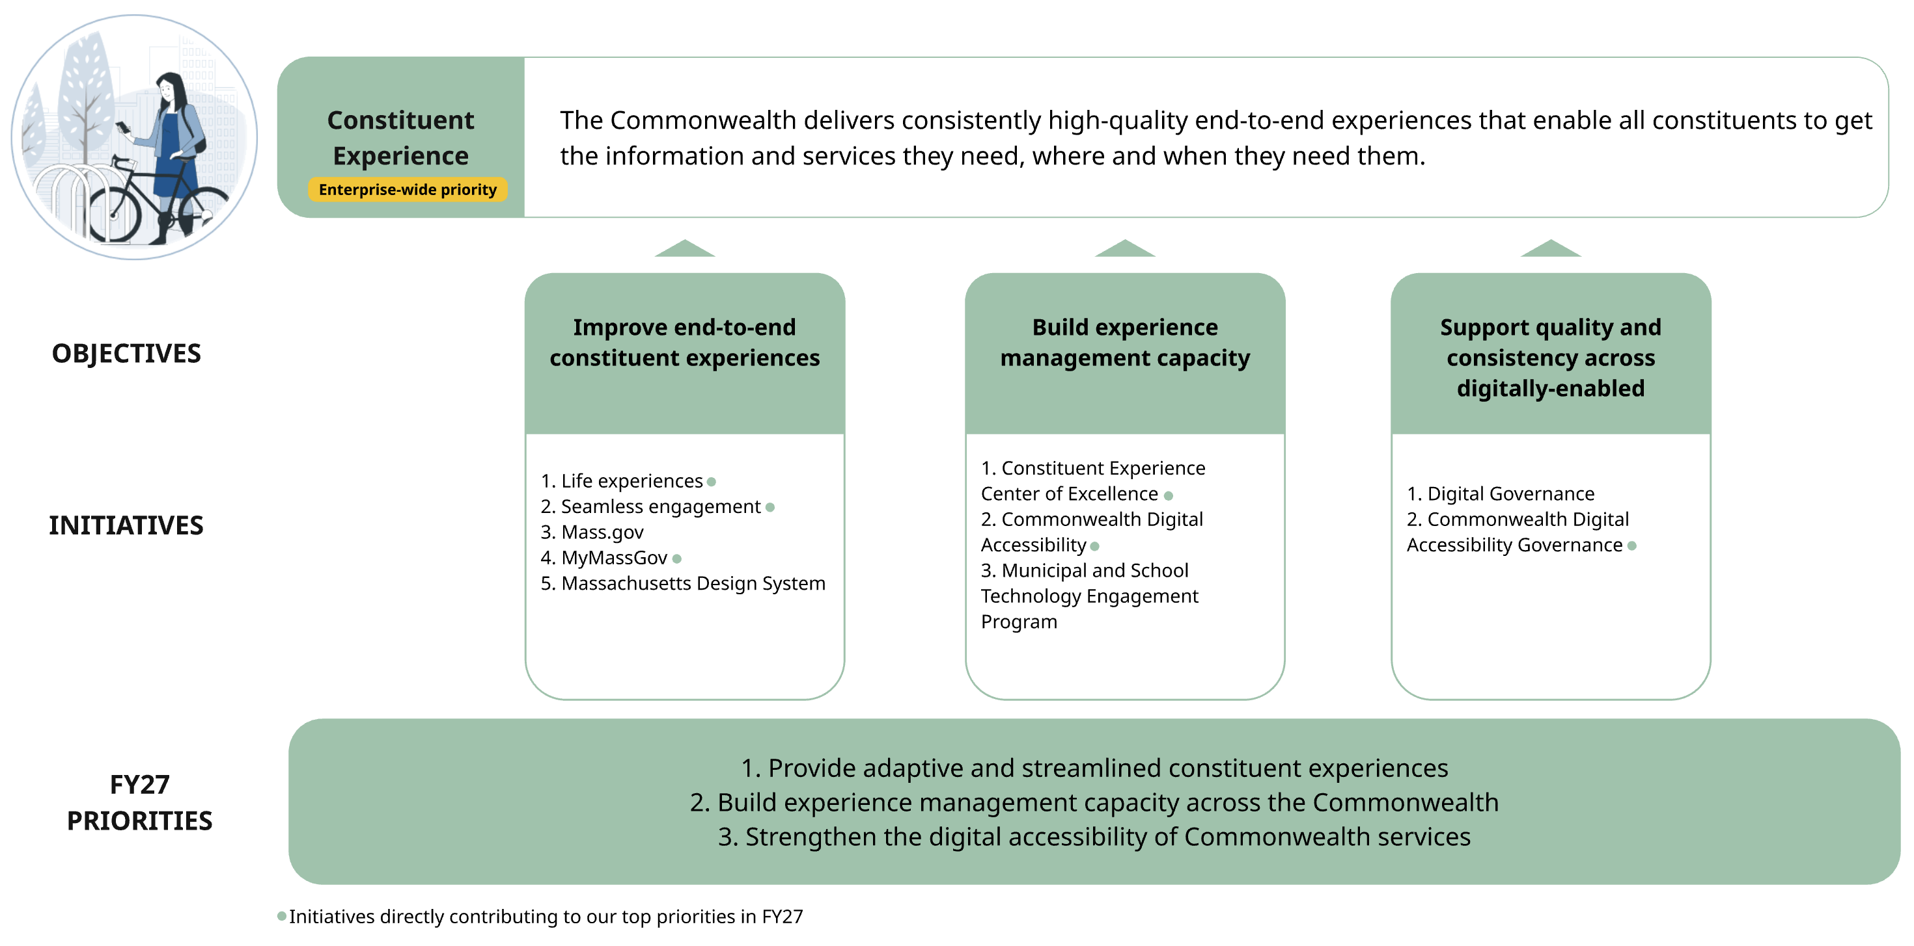
Find more details on Constituent Experience priorities and Constituent Experience objectives and initiatives.

EOTSS’ philosophy for Constituent Experience puts constituents at the center through service design and technology delivery, as well as agency capacity building
EOTSS leads the way in constituent-centered ways of working, smarter service design, and better technology. We leverage these practices when directly delivering solutions and we partner with secretariats and agencies to grow and augment their ability to work this way as well. Over time, EOTSS will explore opportunities to offer support in select areas to interested public-sector partners at the local level.
The initiatives and key results reflected in this plan align with our strategy to focus on common solutions to shared, cross-agency and cross-experience needs and approaches that are repeatable, scalable and sustainable. As such, we are not investing in doing one-off research, design or development efforts for a given agency.

Our values
To transform our state’s digital services, the Commonwealth needs to understand what constituents need and expect. Feedback from constituents and our agency partners has helped us identify seven core experience principles. They are:
- Keep it simple: Be clear and direct.
- Include me: Prioritize flexibility and accessibility-by-design.
- Recognize me: Design for personalization, continuity, and humanity.
- Don't waste my time: Strive for consolidation and speed.
- Keep me in the loop: Communicate proactively and seek feedback.
- Put it within my reach: Ensure awareness, transparency, and access.
- Earn my trust: Build confidence, establish security, set and meet expectations.
These principles help us invest in what matters most to the people we serve. Learn more about EOTSS’ Commonwealth Digital Roadmap Program online.

Top three priorities for Constituent Experience in FY27
The list below highlights our top three priorities for FY27. The following section summarizes all initiatives across all objectives.
- Provide adaptive and streamlined constituent experiences
EOTSS supports increasingly connected and personalized experiences across state services through our core offerings: MyMassGov, our solution for seamless login and personalized profile management; Seamless Engagement, which offers tools and solutions to improve customer communications and information exchange; and Mass.Gov, the Commonwealth’s website, as well as better integrating experiences across these offerings. Our priorities in FY27 focus on (1) MyMassGov, to build more robust and personalized profile functionality while expanding adoption across the Commonwealth’s most-used services, and (2) Seamless Engagement, to expand adoption of our Virtual Assistant tool while exploring opportunities to pilot and scale new solutions that help constituents successfully engage with the Commonwealth across channels.
- Build experience management capacity across the Commonwealth
As with accessibility, EOTSS wants to ensure that secretariats and agencies build teams that are capable of creating and continuously improving holistic, digitally-enabled, people-centered experiences. To ensure that these experiences are consistent and familiar across the Commonwealth, we are working from the center to grow the number of experience research and design teams. We are also developing common resources (e.g., the Massachusetts Design System) that our partners can use to improve constituent experiences.
- Strengthen the digital accessibility of Commonwealth services
EOTSS’ focus is on enabling existing and new constituent-facing services to meet our high expectations for accessibility, while building capable teams across EOTSS and other secretariats and agencies that can embed accessibility-by-design practices into all their experience design and technology work.

Questions for ongoing consideration
These are questions that we must continue to focus on as we manage our priorities and beyond.
- Secretariats and agencies have not adopted best practices at scale – for example, prioritizing people-centered continuous improvement into their daily operations, designing and delivering services with a modern approach that integrates technology and program decision-making, and sustaining this model throughout the product lifecycle. In addition to our ongoing capacity-building efforts, what levers are available to support our goal of expanding knowledge and use of these practices to secretariats and agencies?
- Massachusetts’ Executive Order 614 has served as a key driver in establishing and advancing the Commonwealth’s digital accessibility program, helping to align priorities and mobilize engagement across Secretariats. While compliance with established accessibility requirements provides an important baseline, the program is designed to go beyond minimum standards by building sustainable practices and long-term capacity. A core consideration for the program is how to balance near-term progress—such as addressing high-impact accessibility gaps—with longer-term efforts to strengthen governance, processes, and expertise needed to support accessibility at scale across the Commonwealth.
- EOTSS wants to support our colleagues at the local level in building the same secure, accessible, and people-centered experiences that we’re pursuing at the state level. Given our limited capacity, what are scalable ways to make these resources available?

EOTSS will drive toward our vision for Constituent Experience through three objectives
Our planned initiatives have been organized into three objectives. We anticipate that these objectives will be relatively stable over the next three years, but that specific initiatives and associated key results will vary year by year. The priorities outlined above may align to one or more initiatives.
- Improve end-to-end constituent experiences: EOTSS helps the Commonwealth improve end-to-end experiences that better meet constituents’ and cross-agency needs by providing digital solutions and the resources to use them effectively.
- Build experience management capacity: EOTSS enables and grows the Commonwealth's ability to design, deliver, and continuously improve accessible, people-centered experiences for constituents. We do this by providing state and municipal agencies with the knowledge, learning opportunities, tools, and support they need to be effective experience managers.
- Support quality and consistency across digitally-enabled experiences: EOTSS sets and enforces policies, standards, and guidelines for digital experiences that provide greater quality and consistency across state government. EOTSS leads the Commonwealth in excellent digital service delivery.
Many teams at EOTSS contribute to this work. Our efforts in this area are led primarily by Massachusetts Digital Service and the Accessibility Center for Consulting, Education, and Support Services (ACCESS) team, with important contributions from other teams such as the Office of Municipal and School Technology and MassGIS (the Bureau of Geographic Information).

Objective-by-objective summary of Constituent Experience initiatives and outcomes for FY26 to FY28

Objective 1: Improve end-to-end constituent experiences
EOTSS helps the Commonwealth improve end-to-end experiences that better meet constituents’ and cross-agency needs by providing digital solutions and the resources to use them effectively.
Under this objective, we have five initiatives:
- Life experiences (LX): Design end-to-end digitally-enabled experiences that help people navigate key moments in their lives—especially when those moments require interacting with multiple state services, programs, and touchpoints over time
In the FY26 to FY28 period, as EOTSS completes our first Life Experiences engagements with partner agencies, we are working to develop a templatized, repeatable methodology that we can apply to new use cases across the Commonwealth.
- Seamless engagement (SE): Constituents can seamlessly and successfully engage across channels and touchpoints to communicate, exchange information, answer questions, and get help navigating their journeys through state services
In the FY26 to FY28 period, EOTSS will expand the adoption of the Virtual Assistant by working with interested partners to support new constituent journeys and increase multi-channel engagement. We will also develop capabilities to provide a context-sensitive, multi-channel engagement experience and deliver more personalized support to help individuals seeking assistance.
- Mass.gov: Give constituents the fastest and easiest path to services and information offered by state government
In the FY26 to FY28 period, EOTSS' focus for the Mass.gov platform will primarily be on improving accessibility for constituents seeking information, enhancing the constituent experience in alignment with the seamless engagement initiative, and evaluating the content author experience in order to plan improvements.
- MyMassGov (MMG): Provide login and profile functionality that sets the foundation for connected and personalized experiences across state services, and allows constituents to manage access to state programs, keep their accounts secure, and store personal information
In the FY26 to FY28 period, our focus is on functionality for personalized profiles (e.g. customized management of personal information and more robust identity and credential management), ensuring the stability of the platform, and expanding adoption across the Commonwealth’s most-used services.
- Massachusetts Design System (MDS): Facilitate consistency, accessibility, and quality in all Massachusetts digital experiences for constituents
In the FY26 to FY28 period, EOTSS will grow the design system to include both reusable digital assets as well as methodological guidance for teams building digitally-enabled experiences. In addition, we will grow the number of agency users of the design system and provide a means for them to contribute digital assets back to the community.

Objective 2: Build experience management capacity
EOTSS enables and grows the Commonwealth's ability to design, deliver, and continuously improve accessible, people-centered experiences for constituents. We do this by providing state and municipal agencies with the knowledge, learning opportunities, tools, and support they need to be effective experience managers.
Under this objective, we have three initiatives:
- Constituent Experience Center of Excellence (CX COE): Enable and grow the Commonwealth's ability to design and deliver great people-centered service experiences for our constituents
In the FY26 to FY28 period, the CX COE’s priority is to help agencies adopt constituent-centered approaches, improve end-to-end journeys, and grow and strengthen experience research and design capabilities through skills-building for existing staff and strategic hiring. Through enablement engagements, communities of practice, and shared resources, the CX COE will work alongside agency teams to apply standards and methods to real-world challenges and drive meaningful improvements in constituent experience.
- Commonwealth Digital Accessibility: Assess and remediate digital assets and applications, prioritizing those that are public-facing, to create a culture of accessibility and inclusiveness where persons of all abilities and needs can effectively and equitably participate in and benefit from the digital services, programs, and activities offered by the Commonwealth of Massachusetts
In the FY26 to FY28 period, the Commonwealth Digital Accessibility Program will focus on (1) providing accessibility guidance and training for digital asset creators and managers and (2) guiding the Commonwealth’s work to make legacy public-facing information resources and digitally-enabled services accessible to all.
In addition, the Commonwealth Digital Accessibility Program will be pursuing many goals in collaboration with other teams and initiatives in this pillar. Notably, the ACCESS team will be collaborating with the CX COE to ensure that the Massachusetts Design System incorporates design methods, digital assets, and testing guidance that support accessibility-by-design. See our IT Services pillar for more information on how we are advancing accessibility within the Commonwealth.
- Municipal and School Technology Engagement Program: The Office of Municipal and School Technology (OMST) serves cities, towns, public school districts, public safety departments, municipal utility departments, counties, and planning commissions across the Commonwealth. OMST, in partnership with the ACCESS team, will provide accessibility guidance and trainings to build experience among local partners.
In the FY26 to FY28 period, OMST will collaborate with the ACCESS team to make select accessibility trainings and technical guidance available to public-sector partners at the local level.

Objective 3: Support quality and consistency across digitally-enabled experiences
EOTSS sets and enforces policies, standards, and guidelines for digital experiences that provide greater quality and consistency across state government. EOTSS leads the Commonwealth in excellent digital service delivery.
Under this objective, we have two initiatives:
- Digital Governance: Provide a framework of policies, standards, and processes to guide the Commonwealth’s digital service delivery—ensuring strong leadership, accountability, better resource utilization, and ultimately a better constituent experience
In the FY26 to FY28 period, the Digital Governance team will work to formally publish standards for select digital solutions (e.g., MyMassGov) to be adopted by other secretariats and agencies. More broadly, the team will work to (1) establish standards for all digitally-enabled services and (2) develop assessment and compliance mechanisms that agencies can use to ensure alignment and supports to make adoption easier.
- Commonwealth Digital Accessibility Governance: Create and maintain policies and procedures to monitor accessibility implementation across the Executive Branch.
In the FY26 to FY28 period, this initiative will focus on reviewing and updating enterprise accessibility policies and processes for managing digital accessibility oversight.

Cybersecurity

Our vision and strategy for the future of Cybersecurity in the Commonwealth
We envision a future where all Commonwealth systems and information are secure and resilient in an ever-changing threat landscape, so that we continue to protect constituent privacy and prevent or mitigate harmful access to systems.
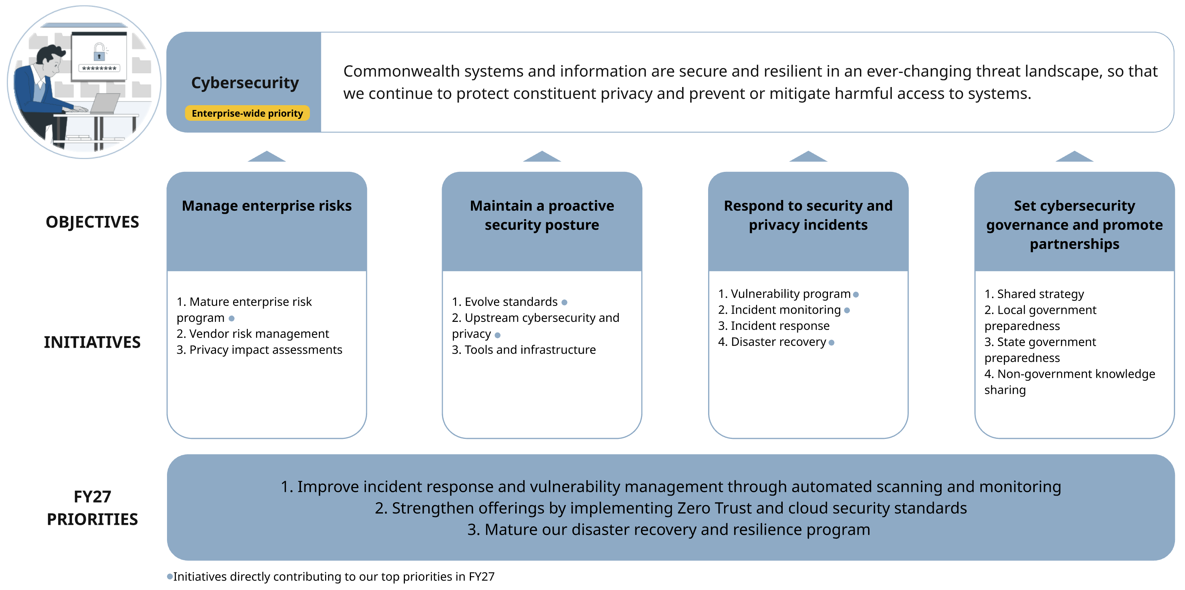
Find more details on Cybersecurity priorities and Cybersecurity objectives and initiatives.

EOTSS’ philosophy is to proactively support and address cybersecurity and privacy risks through infrastructure, services, and policies
EOTSS is the source of secure infrastructure for the Commonwealth. We monitor, respond to, and recover from incidents on EOTSS-managed platforms. We support response and recovery for agency-managed platforms. Where we do not directly own or monitor platforms used by agencies, we set enterprise policies and standards to ensure secure operations.
We envision an integrated security model where we identify and mitigate enterprise risks overall as well as cybersecurity and privacy risks at each phase of technology planning and implementation, across all layers of network, hardware, software, and data. To do so, we create resilient infrastructure, ensure agencies adhere to cybersecurity best practices through enterprise policies and standards, and proactively identify and minimize risks. When cyber or privacy incidents do occur, we address them quickly.
To keep our cybersecurity model responsive to new threats and best practices, we want to build capabilities internally, promote collaboration and knowledge sharing, and set shared goals and strategies for the Commonwealth.

Top three priorities for Cybersecurity in FY27
The list below highlights our top three priorities for FY27. The following section summarizes all initiatives across all objectives.
- Improve incident response and vulnerability management through automated scanning and monitoring
We want to automate alerts and monitoring processes to reduce manual overhead and incident response times as well as increase compliance for mitigating vulnerabilities.

- Strengthen offerings by implementing Zero Trust and cloud security standards
We want to support the development and implementation of Zero Trust Architecture and cloud security standards to maintain the efficacy of our infrastructure in an evolving cybersecurity environment.

- Mature disaster recovery and resiliency program
We want to enhance the resilience of our systems and data by implementing new data protection and backup solutions.

Questions for ongoing consideration
These are questions that we must continue to focus on as we manage our priorities and beyond. The cybersecurity threats facing the state are becoming more complex and the projected demand for our services is increasing. How do we effectively respond to these changes given existing capacity and funding constraints?

EOTSS will drive toward our vision for Cybersecurity through four objectives
Our planned initiatives have been organized into four objectives. We anticipate that these objectives will be relatively stable over the next three years, but that specific initiatives and associated key results will vary year by year. The priorities outlined above may align to one or more initiatives.
- Manage enterprise risks: EOTSS proactively identifies and remediates technical, operational, financial, reputational, legal, privacy, and political risks so that the Commonwealth can operate securely and effectively.
- Maintain a proactive security posture: EOTSS provides secure infrastructure, hardware, and platforms to Commonwealth agencies, while also setting and supporting adherence to enterprise policies and standards.
- Respond to security and privacy incidents: EOTSS (1) monitors environments and responds to security and privacy incidents on EOTSS-managed platforms and (2) helps partners with monitoring and recovery on their own applications.
- Set cybersecurity governance and promote partnerships: EOTSS (1) manages cybersecurity goals and services for the Commonwealth and (2) partners with state, local, and non-government partners to improve planning and operations.
In order to support our vision and these objectives, many teams across EOTSS are contributing work – these include our Operations, Legal and Privacy, Enterprise Risk Management (ERM), Technology, and OMST teams.

Objective-by-objective summary of Cybersecurity initiatives and outcomes for FY26 to FY28

Objective 1: Manage enterprise risks
EOTSS proactively identifies and remediates technical, operational, financial, reputational, legal, privacy, and political risks so that the Commonwealth can operate securely and effectively.
Under this objective we have three initiatives:
- Mature enterprise risk program: Develop a cross-functional and responsive risk program
In the FY26 to FY28 period, we will improve our understanding of the current risk landscape by completing an enterprise risk heat map and maturity assessment for EOTSS and cataloguing critical agency applications across the Executive Branch. We will support the development of enterprise risk heat maps across 50-75 percent of Secretariats, implement priority controls based on the gap analysis, and test the top 10 priority critical agency applications.
- Vendor risk management: Improve capabilities to efficiently identify and communicate vendor risk to partner agencies
In the FY26 to FY28 period, we will automate reporting to Secretariats to improve their visibility of risks and required compliance actions. We will also define a roadmap for increasing coverage of our vendor risk management program and improve the efficiency of our risk assessment process through increased automation and assess 50 percent of identified third-party vendors.
- Privacy impact assessments: Mature privacy impact assessment practice at EOTSS
In the FY26 to FY28 period, we will roll out a new privacy impact assessment (PIA) platform and define a roadmap for completing PIAs for all eligible EOTSS projects. We want to complete PIAs for all qualifying EOTSS-owned or sponsored projects to build a comprehensive picture of privacy risks at EOTSS.

Objective 2: Maintain a proactive security posture
EOTSS provides secure infrastructure, hardware, and platforms to Commonwealth agencies, while also setting and supporting adherence to enterprise policies and standards.
Under this objective we have three initiatives:
- Evolve standards: Update architecture standards to meet emerging security and privacy needs and ensure compliance
In the FY26 to FY28 period, we will enact new operational standards to meet emerging cybersecurity needs and best practices. Then we will begin implementing Zero Trust Architecture across our networks and high-value use cases for air gap backups. We want to mature our Zero Trust security alignment, expand air gap coverage of agency data, and continue developing best practice standards.
- Upstream cybersecurity and privacy: Integrate security and privacy controls early in technology planning and implementation
In the FY26 to FY28 period, we will deploy automated code scanning across priority and sensitive applications. We want to have automated code scanning coverage across all production code deployments.
- Tools and infrastructure: Provide Commonwealth agencies with refreshed tools and infrastructure that meet security and privacy standards
In the FY26 to FY28 period, we will formalize the auditing practice across the Executive Branch. We will also plan how to achieve high availability across our environments as well as prepare for and deploy Post-Quantum Cryptography.

Objective 3: Respond to security and privacy incidents
EOTSS (1) monitors environments and responds to security and privacy incidents on EOTSS-managed platforms and (2) helps partners with monitoring and recovery on their own applications.
Under this objective we have four initiatives:
- Vulnerability program: Increase scope, technical capabilities, and governance of vulnerability program
In the FY26 to FY28 period, we will deploy a new exposure management solution and then increase compliance for exposure mitigation.
- Incident monitoring: Mature EOTSS’ incident monitoring capabilities
In the FY26 to FY28 period, we will improve our incident monitoring capabilities by expanding coverage of Splunk across the Executive Branch. Then we want to improve the efficiency of our operations by automating common threat alerts.
- Incident response: Mature EOTSS’ incident response and investigation capabilities
In the FY26 to FY28 period, we will operationalize our privacy incident response process with a feedback mechanism to inform our privacy impact assessments (PIAs).
- Disaster recovery: Mature EOTSS’ disaster recovery capabilities
In the FY26 to FY28 period, we will deploy new solutions for data protection and data backups. We want to fully operationalize our data backups solution, a new application library, a new “clean room” solution, and have full coverage for the Executive Branch with the enterprise data protection solution.

Objective 4: Set cybersecurity governance and promote partnerships
EOTSS (1) manages cybersecurity goals and services for the Commonwealth and (2) partners with state, local, and non-government partners to improve planning and operations.
Under this objective, we have four initiatives:
- Shared strategy: Develop common goals and a shared security and privacy strategy across the Commonwealth
In the FY26 to FY28 period, we will define a plan to create a National Institute of Standards and Technology (NIST)-aligned cybersecurity strategy. We want to publish our cybersecurity strategy and create a process to continuously evolve our strategy to reflect EOTSS priorities and industry best practices.
- Local government preparedness: Support local government cyber preparedness
In the FY26 to FY28 period, we will enhance our Cybersecurity Health Check program, which identifies local government cybersecurity vulnerabilities. We want to distribute funding to address cybersecurity deficiencies identified through the Health Check program and increase our incident response planning and hiring support for municipalities.
- State government preparedness: Collaborate and plan within the Commonwealth for cyber preparedness and risk mitigation
In the FY26 to FY28 period, we will expand MA CIRT (Massachusetts Cyber Incident Response Team) to include key non-Executive Branch partners. We also want to review the efficacy and adoption of our Enterprise Data Privacy policies across the Executive Branch.
- Non-government knowledge sharing: Collaborate with non-government organizations for cyber preparedness and risk mitigation
In the FY26 to FY28 period, we will improve our cyber capabilities through information sharing partnerships with cybersecurity industry groups.

Data and Analytics

Our vision and strategy for the future of Data and Analytics in the Commonwealth
We envision a future where Commonwealth data and data insights are easily and securely accessed by (1) state agencies for evidence-based policymaking, program design, and program delivery, and (2) by the public for research, innovation, and government accountability, while respecting the privacy rights of the people who may be subjects of the data.
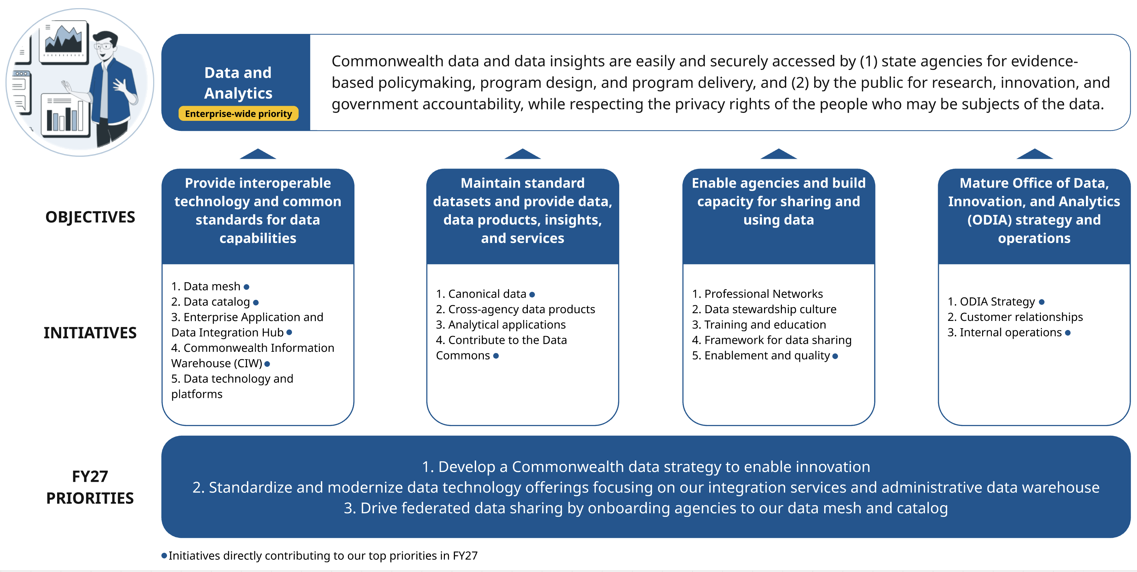
Find more details on Data and Analytics priorities and Data and Analytics objectives and initiatives.

EOTSS has a dual role: to provide centralized data services and to enable agency data autonomy
To support this vision, EOTSS wants to take advantage of our centralized role to provide technology, legal, and administrative supports that improve how Commonwealth agencies and partners use data to serve the public. Providing support from the center means focusing EOTSS’ efforts on (1) shared data functions and (2) cross-agency data opportunities.
- Shared data functions include common technology platforms or products, shared datasets, data sharing mechanisms, and data governance. Read more about why data sharing is a key opportunity in Appendix IV.
- Cross-agency data opportunities include situations where analytical efforts require data from multiple agencies—such as responses to complex crises like Covid or Emergency Shelter, in which no single agency has all the information necessary to be successful—or pilots that start with one agency and can be scaled across the enterprise. Learn more about cross-agency data success in Appendix IV.

In addition to directly providing and maintaining technology, EOTSS also aims to build capacity within and across agencies to enable their autonomy. EOTSS recognizes that our centralized role has limitations and that agencies need data expertise specific to their policy and domain to be successful. Part of this capacity-building work includes advancing a culture of data stewardship over data ownership, to encourage greater transparency and data sharing among agencies.
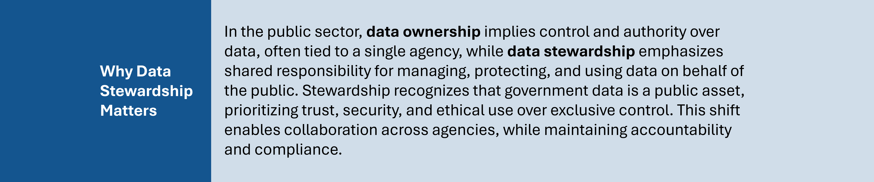
Read about why data stewardship matters in Appendix IV.
While EOTSS and our Office of Data, Innovation, and Analytics (ODIA) could support our overall vision through a variety of methods, our focus is to balance centralized support with agency autonomy. For this reason:
- We are not attempting to be an analytics-for-hire shop – we either want to identify cross-agency opportunities to support or enable agencies to do their own analytics well.
- We are not a compliance group that sets policies in order to enforce them – while we will set and communicate standards, our approach is to ensure agencies have the expertise to manage to these standards themselves rather than acting as an enforcement group directly.

Top three priorities for Data and Analytics in FY27
The list below highlights our top three priorities for FY27. The following section summarizes all initiatives across all objectives.
- Develop a Commonwealth data strategy that ensures data readiness and enables innovation
We want to build a Commonwealth-wide data strategy that supports agencies with governance, policy, and leadership through a rapidly evolving technology landscape. We want to contribute to a Data Commons that makes government data available to trusted partners in order to support innovation.

- Standardize and modernize data technology offerings, focusing on our integration services and administrative data warehouse
We want to modernize existing foundational data and data tools so that agencies can easily move, access, and use data. We also want to mature our process for determining which data solutions we offer and how we onboard agencies to new enterprise offerings.

- Drive federated data sharing by onboarding agencies to our data mesh and catalog
We want to roll out a data mesh to support federated data sharing across agencies, so agencies can more easily view relevant data that helps them develop their own products and/or make informed policy and program decisions. Over time, we will work to scale the quality and quantity of data available and increase agency utilization of data.

We want to roll out a data catalog that allows agencies to find datasets and use data products in our data catalog. Over time, we will work to expand the information and tools available in our data catalog as well as agency contributions to it.

Questions for ongoing consideration
These are questions that we must continue to focus on as we manage our priorities and beyond.
- How can EOTSS’ ODIA improve the way we communicate with both IT and service/program stakeholders across the Commonwealth, so that we can best understand and respond to customer-based data needs?
- How can our team create space to innovate and stay ahead of emerging technology? How can we carve out time to proactively evaluate data tools and technology that support important agency capabilities? How can we make sure we are preparing for an AI-future, with AI-ready data and tools that take advantage of AI functionality?

EOTSS will drive toward our vision for Data and Analytics through four objectives
Our planned initiatives have been organized into four objectives. We anticipate that these objectives will be relatively stable over the next three years, but that specific initiatives and associated key results will vary year by year. The priorities outlined above may align to one or more initiatives.
- Provide interoperable technology and common standards for data capabilities: EOTSS provides the technical tools and standards for Commonwealth entities to store, share, and analyze data while maintaining data security and privacy.
- Maintain standard datasets and provide data, data products, insights, and services: EOTSS builds and maintains standard datasets and provides data, data products, insights, and services to support agency operations and decisions as well as public research and innovation.
- Enable agencies and build capacity for sharing and using data: EOTSS makes it easy for agencies to share and use data by ensuring consistency and accuracy, as well as by building expertise across the Commonwealth.
- Mature Office of Data, Innovation, and Analytics (ODIA) strategy and operations: EOTSS has a well-defined data strategy and the ability to execute it.
In order to support our vision and these objectives, many teams across EOTSS in addition to ODIA are contributing work – these include our Technology Office, MassGIS, and our Legal Team.

Objective-by-objective summary of Data and Analytics initiatives and outcomes for FY26 to FY28

Objective 1: Provide interoperable technology and common standards for data capabilities
EOTSS provides the technical tools and standards for Commonwealth entities to store, share, and analyze data while maintaining data security and privacy.
Under this objective, we have five initiatives:
- Data mesh: Enable federated data collaboration across secretariats and agencies through its data mesh and related guidance
In the FY26 to FY28 period, our focus will be on rolling out the data mesh to our partners and increasing the value and usability of the data mesh by adding reusable tools and improving self-service options. Then we’ll mature our data mesh offerings by piloting production-stage data in data clean rooms and making synthetic data generation a self-service tool.
- Data catalog: Develop and maintain an enterprise data catalog of common and/or reusable data sets, data assets, and metadata so that Commonwealth staff can more easily find data
In the FY26 to FY28 period, our focus will be on rolling out the data catalog and then expanding access to and representation from agencies.
- Enterprise Application and Data Integration Hub: Develop and implement the Enterprise Application and Data Integration Hub so that Commonwealth secretariats and agencies can securely move data
In the FY26 to FY28 period, our focus will be on determining an integration strategy and solution set, migrating from legacy Secure File Transfer Protocol (SFTP) and application programming interface (API) Services tools and then modernizing according to our roadmap strategy.
- Commonwealth Information Warehouse (CIW): Develop a CIW roadmap and deliver against this roadmap to transform and modernize how administrative data is aggregated and used
In the FY26 to FY28 period, we will develop a transformation roadmap. Depending on what gets prioritized within this roadmap, we will aim to complete 1-2 priorities in FY27 (for example, completing governance pilots and reducing manual download by increasing access to secure data sharing). Then we’ll look to expose data from our information warehouse to our data mesh to deliver high-value administrative data products.
- Data technology and platforms: Determine what technology platforms or tools to standardize on to enable our data goals and respond to customer demand
In the FY26 to FY28 period, we want to finish developing an inventory of data capabilities and tools to guide future technology investments and recommendations. Based on this inventory, we’ll focus on recommending 1-3 prioritized tools to meet open data capability needs (for example, tools and guidelines for AI observability). We also want to develop a process for onboarding partners to enterprise tools. We may expand access to the Environmental Systems Research Institute (ESRI) Geospatial Information System (GIS) software ESRI for agencies who do not already have enterprise licenses.

Objective 2: Maintain standard datasets and provide data, data products, insights, and services
EOTSS builds and maintains standard datasets and provides data, data products, insights, and services to support agency operations and decisions as well as public research and innovation.
Under this objective, we have four initiatives:
- Canonical data: Build and maintain canonical datasets for shared Commonwealth use
In the FY26 to FY28 period, we will work toward making our MyMassGov (constituent single sign-on and user profile) information available in the data mesh to facilitate data linkage. We also want to expand our address data and improve our geospatial data supply chains and the longitudinal data available to agencies.
- Cross-agency data products: Deliver high-impact cross-agency data products to enable data-driven decision-making and improve service operations
In the FY26 to FY28 period, we want to test out rapid prototyping, advanced analytics, and AI capabilities through several pilots. In out years, we’ll expand upon rapid prototyping and advanced analytics depending on the outcomes of our pilot activities, while exploring how to incorporate AI capabilities into customer data products.
- Analytical applications: Deliver high-value analytical applications that can leverage existing data and data products to enable data-driven decision-making and improve service operations
In the FY26 to FY28 period, we plan to deliver at least one advanced analytical application for an agency partner so that they can leverage generative AI functionality.
- Contribute to the Data Commons: Enable innovation and research across Commonwealth partners by sharing our data securely
In the FY26 to FY28 period, we’ll transition ownership of the Data Commons to the Massachusetts Tech Collaborative (MTC), then we’ll define a model for how the Commonwealth securely and ethically shares data to the Data Commons and aim to share three datasets.
See our Innovation and Emerging Technology pillar for more information on other activities pushing innovation forward.

Objective 3: Enable agencies and build capacity for sharing and using data
EOTSS makes it easy for agencies to share and use data by ensuring consistency and accuracy as well as building expertise across the Commonwealth.
Under this objective, we have five initiatives:
- Professional networks: Establish and mature networks for building and supporting data expertise across agencies so they are empowered to be data-driven
In the FY26 to FY28 period, we will launch our Commonwealth Analytics Network before operationalizing it.
- Data stewardship culture: Coordinate and support a culture of data stewardship across the Commonwealth to enable and expand data sharing
In the FY26 to FY28 period, we will launch our Data Steward Network and increase engagement from designated data stewards.
- Training and education: Provide training and educational materials so that Commonwealth staff have the data skills necessary for success
In the FY26 to FY28 period, we want to pilot and scale persona-based training. We also want to mature how we identify software platform upskilling needs for our internal partners and incorporate these skills and trainings into ongoing work.
- Framework for data sharing: Mature and modernize the legal framework for data sharing as well as improve customer understanding of agency versus EOTSS roles and responsibilities within the data sharing process
In the FY26 to FY28 period, we want to streamline our data agreement process as well as identify an avenue for communicating data sharing compliance requirements across Executive Branch and partner agencies.
- Enablement and quality: Improve the efficiency and utility of shared data through data governance enablement and data quality
In the FY26 to FY28 period, we want to provide a definition for AI-ready data and then develop a communication strategy for addressing AI-readiness and metadata standards. We also want to set governance policy around data quality, discoverability, and stewardship.

Objective 4: Mature Office of Data, Innovation, and Analytics (ODIA) strategy and operations
EOTSS has a well-defined data strategy and the ability to execute against it.
Under this objective, we have three initiatives:
- ODIA Strategy: Establish a clear strategy for ODIA in alignment with secretariats and their data needs/utilization
In the FY26 to FY28 period, we will define a strategy for ODIA that supports our federated philosophy and balances centralized support with agency autonomy. Then we will define a strategy for the broader Commonwealth. Beyond that we will investigate data readiness for quantum computing.
- Customer relationships: Refine understanding of agency customers and improve relationship with them
In the FY26 to FY28 period, we will have a process for including agency users into ODIA’s discovery process, followed by piloting agency user input across the lifecycle of a product for two use cases.
- Internal operations: Evolve service delivery and internal operations to align with overall strategic direction
In the FY26 to FY28 period, we’ll update a shared operating model across our Data, Technology, and Operations teams to improve agility of our service delivery.

Innovation and Emerging Technology

Our vision and strategy for the future of Innovation and Emerging Technology in the Commonwealth
We envision a future where EOTSS is a leader in innovation at the Commonwealth, with the means and expertise to apply emerging technology to government operations and services effectively and to enable secretariats and agencies to do the same.
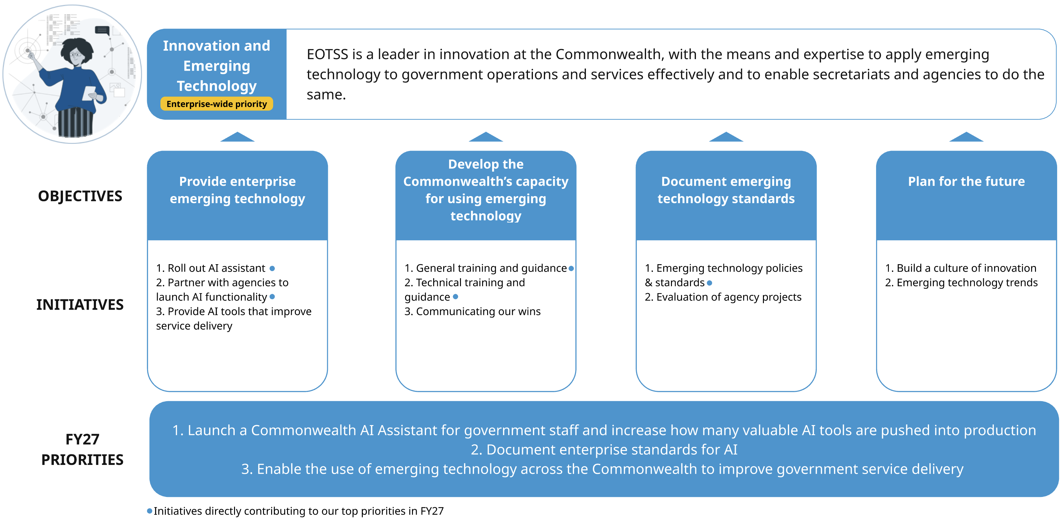
Find more details on Innovation and Emerging Technology priorities and Innovation and Emerging Technology objectives and initiatives.

EOTSS has a dual role: to provide emerging technology and to enable agency innovation
Emerging technologies can enhance the Commonwealth’s ability to improve service delivery. EOTSS’ primary role is to enable the effective and safe adoption of emerging technology as well as provide information, tools, and standards to encourage innovation and guide solutions. In tandem, EOTSS can play a direct role for enterprise-wide use cases, leveraging our staff expertise to build and deliver tools. For example, EOTSS is driving the rollout of a statewide AI assistant now, with the plan to hand over tool ownership to agencies. Whether directly or by enablement, EOTSS aims to increase the number of high-value AI tools in production within the Commonwealth in the next three years.

While we want to maintain awareness of AI work across the Commonwealth and leverage our expertise to guide safe choices, our end goal is to support agency autonomy to evaluate their own tools and use cases. We will not maintain final approval of each and every emerging technology initiative across the Commonwealth. Our focus is on setting and enabling standards, rather than enforcing compliance against these standards.

Top three priorities for Innovation and Emerging Technology in FY27
The list below highlights our top three priorities for FY27. The following section summarizes all initiatives across all objectives.
- Launch a Commonwealth AI Assistant for government staff and increase how many valuable AI tools are pushed into production
We want to put AI in the hands of public servants across all secretariats to drive productivity gains and innovation at the ground level, starting with the AI assistant in 2026.

- Document enterprise standards for AI
We want to provide thoughtful standards and processes to support teams to explore, build, buy, and use AI safely and in alignment with the Commonwealth’s needs and priorities.

- Enable the use of emerging technology across the Commonwealth to improve government service delivery
We want to provide accompanying training and guidance to empower staff to achieve success in using AI in their work.

We want to build a culture of innovation within EOTSS that empowers staff at all levels to rethink how work is executed, driving towards more efficient and effective processes.

Questions for ongoing consideration
These are questions that we must continue to focus on as we manage our priorities and beyond. How will EOTSS need to change to create the space, incentives, and support for staff and teams to innovate in their processes, services, and technical solutions?

EOTSS will drive toward our vision for Innovation and Emerging Technology through four objectives
Our planned initiatives have been organized into four objectives. We anticipate that these first three objectives will be relatively stable over the next three years, but ultimately subject to change, whereas the fourth objective is foundational to our work going forward. Specific initiatives and associated key results will vary year by year. The priorities outlined above may align to one or more initiatives.
- Provide enterprise emerging technology: EOTSS provides standard architecture, centralized infrastructure, and products, to enable adoption of emerging technology for both technical and non-technical staff.
- Develop the Commonwealth’s capacity for using emerging technology: EOTSS provides training and guidance to build capacity and expertise in emerging technology across the Commonwealth.
- Document emerging technology standards: EOTSS documents policy and technical standards governing emerging technology usage and development in the Commonwealth.
- [Foundational] Plan for the future: EOTSS defines a holistic strategy for emerging technology investment and develops its capacity and organizational structure to support consistent innovation.
In order to support our vision and these objectives, our Technology Office as well as our Administration, Engagement, and Legal teams are contributing to this work.

Objective-by-objective summary of Innovation and Emerging Technology initiatives and outcomes for FY26 to FY28

Objective 1: Provide enterprise emerging technology
EOTSS provides standard architecture, centralized infrastructure, and products, to enable adoption of emerging technology for both technical and non-technical staff.
Under this objective, we have three initiatives:
- Roll out AI Assistant: Improve employee productivity by providing access to a secure AI Assistant tool
In the FY26 to FY28 period, our focus is on rolling out an AI assistant to executive branch staff to support their work. We aim for staff at all secretariats to have access to this tool, allowing us to baseline utilization and set a target for increasing utilization in FY28.
- Partner with agencies to launch AI functionality: Enable agencies to successfully develop and leverage new and valuable AI tools, including in legacy systems
In the FY26 to FY28 period, we will be undertaking research, planning, and piloting work so that EOTSS can (1) provide AI tools to support Commonwealth developers (e.g., coding copilots and synthetic data generation) and (2) identify solutions to leverage AI in legacy systems and to handle protected data, with the ultimate aim of increasing the number of valuable AI tools in production.
- Provide AI tools that improve service delivery
In the FY26 to FY28 period, we will roll out more end-user AI tools to staff, including tools to support data activities (e.g., data quality evaluation, natural language querying of data, etc.) and tools to enhance the constituent experience (e.g., facilitating rapid prototyping of digital experiences, or analyzing constituent feedback).
See our Data and Analytics pillar for more information on our contributions to the Commonwealth Data Commons / AI Hub.

Objective 2: Develop the Commonwealth’s capacity for using emerging technology
EOTSS provides training and guidance to build capacity and expertise in emerging technology across the Commonwealth.
Under this objective, we have three initiatives:
- General training and guidance: Provide general training and guidance for Commonwealth staff to use AI tools for productivity, safely and effectively (including curating use case/guidance artifacts)
In the FY26 to FY28 period, we will roll out AI training to EOTSS staff and launch an AI working group for users. Then we will focus on providing guidance around high-value AI use cases to all secretariats.
- Technical training and guidance: Provide technical training and guidance for Commonwealth IT teams to plan, build, deliver, and manage AI solutions safely and effectively (including curating artifacts)
In the FY26 to FY28 period, we will support IT staff to deliver AI solutions by publishing a framework for evaluating AI tools, publishing enterprise reference architecture guidance for three basic use cases (e.g., chatbot), and delivering lunch and learn sessions for developers to learn how to build solutions with the new AI assistant. We will publish a Financial Operations (FinOps) model to enable staff to assess AI products and their implementation costs, incorporating potential automation savings. We will also dedicate time to examining potential harms from GenAI use in the Commonwealth and identifying mitigation strategies. We plan to define and publish an API approach to legacy data sources to allow AI solutioning for many of the critical products used across the state.
- Communicating our wins: Evangelize safe, effective use of emerging technology and innovation in government operations
In the FY26 to FY28 period, we will develop mechanisms to regularly share information about AI work at the Commonwealth, through newsletters and a new Mass.gov presence. Then we aim to evangelize the outcomes of the AI assistant rollout at conferences.

Objective 3: Document emerging technology standards
EOTSS documents policy and technical standards governing emerging technology usage and development in the Commonwealth.
Under this objective, we have two initiatives:
- Emerging technology policies and standards: Create and disseminate policies and standards governing the development and use of emerging technology at the Commonwealth
In the FY26 to FY28 period, we will update EOTSS’ enterprise policies and standards to integrate the Commonwealth’s latest AI policy, define and publish a robust AI enablement framework, and create a library of standards.

- Evaluation of agency projects: Provide parameters for buying or building emerging technology tools across the Commonwealth through evaluation processes and compliance frameworks
In the FY26 to FY28 period, we will establish an evaluation process for AI projects going through the EOTSS Architecture Review Board and ensure that all high-value or high-risk secretariat projects are evaluated such that any flagged projects are reviewed through the board. Then we want to develop a process to make sure EOTSS gets early-stage visibility into these high-value or high-risk secretariat projects, to provide guidance from the start.
See the IT Services pillar for additional work related to maturing our Architecture Review Board within the Technology office.

Objective 4: Plan for the future
EOTSS defines a holistic strategy for emerging technology investment and develops its capacity and organizational structure to support consistent innovation. Planning for the future is foundational work that we expect to support year over year to successfully leverage and respond to emerging technology and a rapidly evolving technical landscape.
Under this objective, we have two initiatives:
- Build a culture of innovation: Create opportunities for EOTSS’ teams and employees to innovate within their workstreams and build processes to surface and scale ideas across EOTSS
In the FY26 to FY28 period, we will pilot and evaluate new automated service delivery workflows at EOTSS. We also plan to evaluate our previous collaborations with higher education institutions and to define our ongoing partnership strategy. To support this work, we will evolve the resourcing and capacity of the AI program. We will also design a staff program that creates space for innovation, which we will launch in FY28.
- Emerging technology trends: Monitor emerging technology trends and plan for potential impacts
In the FY26 to FY28 period, we will establish and mature a process to monitor and report on emerging technology trends, evaluating potential impact on the Commonwealth and its IT functions

IT Services

Our vision and strategy for the future of IT Services in the Commonwealth
We envision a future where all Commonwealth staff and affiliated personnel can securely access modern technology and tools to perform their duties, where (1) EOTSS centrally supports enterprise IT functions and (2) agencies and partners provide technology specific to their programs and services.
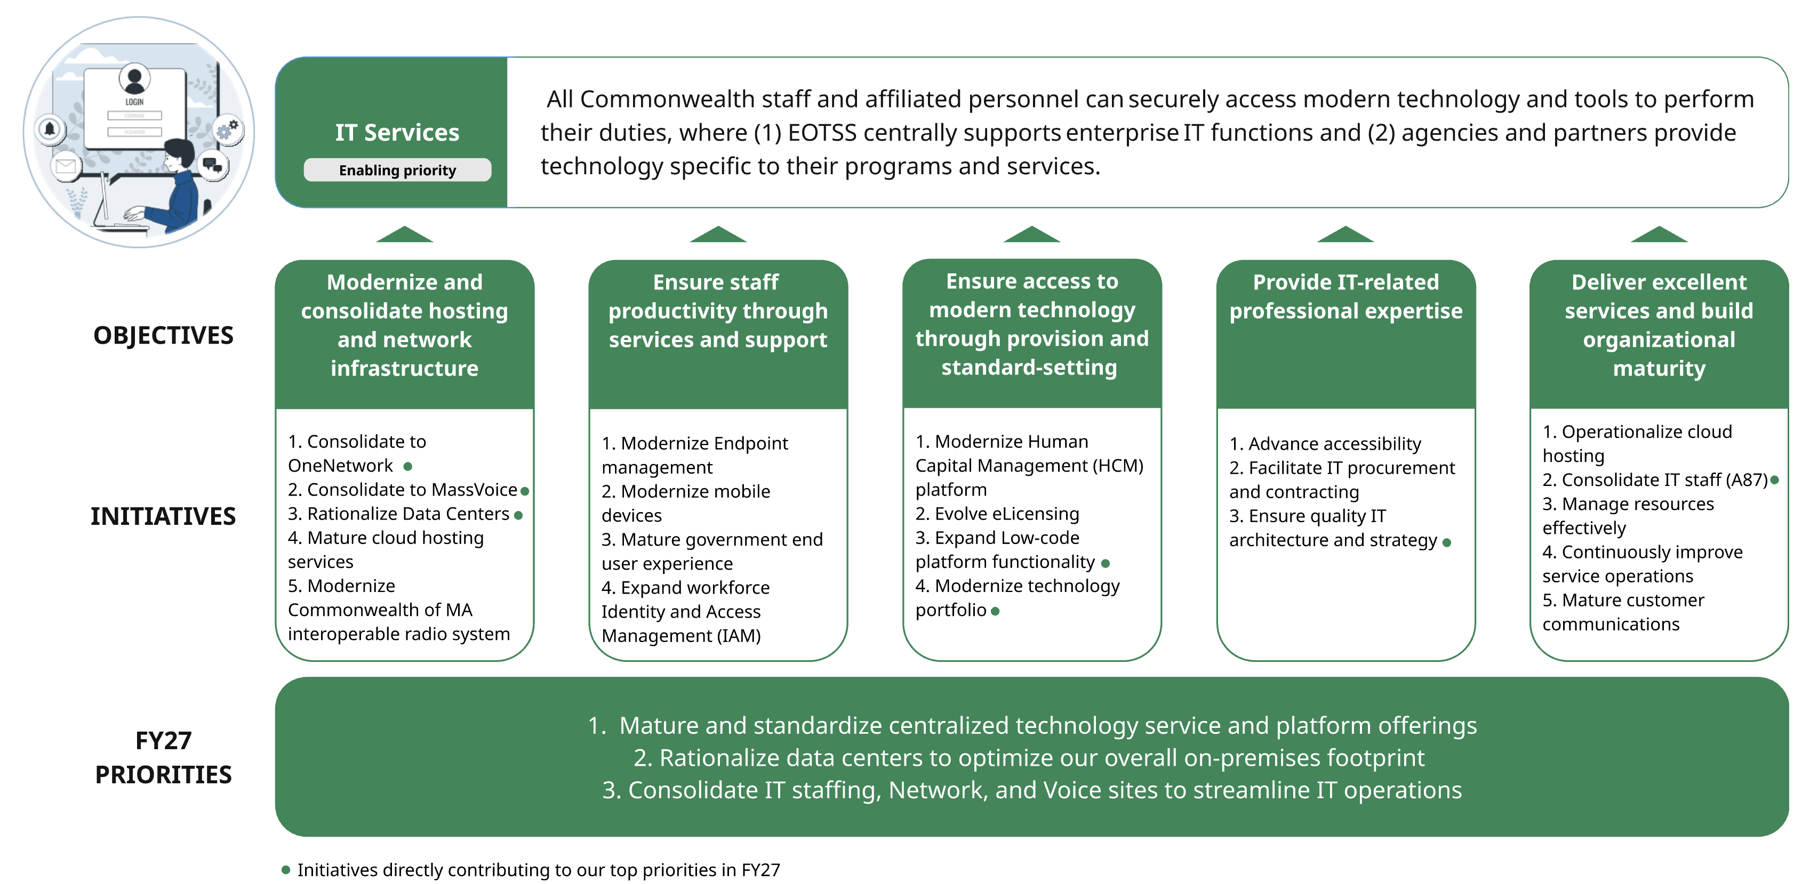
Find more details on IT Services priorities and IT Services objectives and initiatives.

EOTSS’ philosophy for delivering IT services within government balances centralization, standardization, and enablement
Today, all government agencies and programs rely on technology in order to deliver their services efficiently and at scale. As the IT secretariat for the Commonwealth, EOTSS is uniquely positioned to provide centralized technology and technical support to agencies where there is a shared need. This support may include providing specific infrastructure or technology products, supporting service and help requests for shared infrastructure or technology products, as well as providing subject matter expertise. The following principles describe EOTSS’ philosophy for IT service delivery that enables Commonwealth agencies and staff to do their jobs well:
- Excelling in our dual role as service provider and leader
EOTSS functions as both a service provider to our agency customers, as well as an IT leader that sets standards, makes recommendations, and provides guidance. We recognize that there is a need to continue playing both roles, and we want to make sure we can excel in each one. EOTSS provides and supports technology on a spectrum—from fully owned and maintained by EOTSS to agency-led with adherence to EOTSS standards. The greater ownership EOTSS has, the stronger our service delivery must be; the greater ownership agencies have, the more mature our ability to provide timely and valuable leadership must be.

- Maturing our model for providing a standard set of shared services
To better serve agency customers, we need to sharpen the definition of our shared services and mature our organization to best support these services. It’s important for EOTSS and our customers to be aligned on which services EOTSS offers to whom, as well as the model for offering those services. As EOTSS has evolved over time, we continue to support legacy technology and manage technical exceptions that don’t align with how we want to support customers in the future. As technology continually evolves, EOTSS must also work to update and adapt our service offerings accordingly. Responding to both of these realities means continuing to sharpen our definition of shared services and the standard set of use cases we support, so we can organize teams and service operations accordingly.
In line with our philosophy, we are not investing in our capabilities as a shop for hire, except for those instances where we are following an EOTSS-owned model for an enterprise-wide service (e.g., OneNetwork). For other services, our general stance is to provide guidance and technical enablement that allows agencies to successfully invest in their technical needs.

Top three priorities for IT Services in FY27
The list below highlights our top three priorities for FY27. The following section summarizes all initiatives across all objectives.
- Mature and standardize centralized technology service and platform offerings: EOTSS aims to mature the way we identify and support technology services by defining a product lifecycle, organizing our technology office according to this lifecycle, and standardizing how we onboard new technology to our portfolio before scaling tools and services to customers.

- Rationalize data centers to optimize our overall on-premises footprint: EOTSS aims to optimize where and how we host data.

- Consolidate IT staffing, Network, and Voice sites to streamline IT operations:
EOTSS will focus on completing IT staffing consolidation from remaining agencies while consolidating key network and voice sites in parallel, with the ultimate goal that all consolidated agencies are on OneNetwork and MassVoice.

Questions for ongoing consideration
These are questions that we must continue to focus on as we manage our priorities and beyond.
- How can we effectively mature our organization to stay ahead of agencies in order to provide them with the guidance they need, when they need it?
- How can we standardize service models in a way that is responsive to all customers? This requires balancing the needs of our core customers—the Executive branch agencies that must adhere to our policies and requirements, including any mandatory shared services—with requests for support from non-executive branch agencies (e.g., independents and constitutionals). This also requires balancing how we serve consolidated agencies and non-consolidated agencies, while the process of consolidation is still underway.
- How can we best communicate what we mean by shared IT services, so that secretariats and agencies understand the division of labor as well as how best to coordinate with EOTSS teams as needed?

EOTSS will drive toward our vision for IT Services through five objectives
Our planned initiatives have been organized into five objectives. We anticipate that these objectives will be relatively stable over the next three years, but that specific initiatives and associated key results will vary year by year. The priorities outlined above may align to one or more initiatives.
- Modernize and consolidate hosting and network infrastructure: EOTSS provides secure, scalable, and resilient cloud and on-premises infrastructure to meet agencies’ hosting, network, and communications needs efficiently.
- Ensure staff productivity through services and support: EOTSS ensures reliable access and support for IT tools and devices that enable productivity for state employees and affiliated personnel, on premises and remotely.
- Ensure access to modern technology through provision and standard-setting: EOTSS centrally identifies, manages, and supports certain standard technology platforms, applications, and products for common agency functions, in accordance with our data, security, risk, and privacy best practices—while setting standards for how Commonwealth agencies can maintain their own modern and up-to-date solutions.
- Provide IT-related professional expertise: EOTSS provides expertise and professional services in key domains that support agency customers' ongoing operations and project-based work, so that agencies can plan and deliver technology-enabled government services that meet standards and best practices.
- Deliver excellent services and build organizational maturity: EOTSS supports and continuously improves IT services for our Commonwealth customers to ensure services are standardized, high quality, and responsive to evolving end-user needs—while evaluating and adjusting our operating model (e.g., team roles, responsibilities, and capacity) to ensure efficient operations.
In order to support our vision and these objectives, many teams across EOTSS are contributing work – these include teams from Operations, Technology, Engagement, as well as Strategy and Planning.
In addition to the IT services represented in the objectives above, we also have separate strategic pillars for IT services related to Constituent Experience; Cybersecurity; and Data and Analytics.

Objective-by-objective summary of IT Services initiatives and outcomes for FY26 to FY28
While not explicitly referenced in each initiative, we expect all services to comply with our standards and practices for data, security, risk, and privacy.

Objective 1: Modernize and consolidate hosting and network infrastructure
EOTSS provides secure, scalable, and resilient cloud and on-premises infrastructure to meet agencies’ hosting, network, and communications needs efficiently.
Under this objective, we have five initiatives:
- Consolidate to OneNetwork: Transition supported agencies to OneNetwork to provide consistent and reliable network and communications infrastructure
We have estimated that more than 1,500 sites will eventually need to be consolidated onto OneNetwork, so our focus in the FY26 to FY28 period is to complete consolidation for 90 percent of the sites we identify for consolidation within each fiscal year.
- Consolidate to MassVoice: Transition supported agencies to MassVoice Cloud Enterprise software
In the FY26 to FY28 period, we will focus on consolidating or migrating prioritized locations onto MassVoice Cloud, with the goal of fully deprecating MassVoice Legacy in FY28.
- Rationalize data centers: Consolidate and rationalize data centers, including data migrations and retiring end-of-life, legacy, and on-premises servers and solutions
In the FY26 to FY28 period, we plan to migrate to our Springfield Data Center (SDC), deprecate our Public Safety and EOTSS data centers in Massachusetts Information Technology Center (MITC), and complete the consolidation of eight major data centers as well as our DOR centers at MITC.
- Mature cloud hosting services: Mature our cloud hosting services for customers by building a sustainable process to support ongoing operations, financial support, and resourcing
As we restructure our organization to mature our cloud hosting services, we will work to define these services in FY26 and then update our service model and operations in FY27.
- Modernize Commonwealth of Massachusetts Interoperable Radio System (CoMIRS): Modernize CoMIRS to support public safety agencies and organizations with modern voice radio infrastructure
In the FY26 to FY28 period, we will complete Phase 1A site construction before completing Phase 1B activities, migrating from an analog system to a new digital system.

Objective 2: Ensure staff productivity through services and support
EOTSS ensures reliable access to and support for IT tools and devices that enable productivity for state employees and affiliated personnel, on premises and remotely.
Under this objective, we have four initiatives:
- Modernize endpoint management: Modernize Endpoint Management to a cloud-based service
In the FY26 to FY28 period, we will update policies and device patching. We will also test and evaluate a password-less authentication approach, to be implemented in FY28.
- Modernize mobile devices: Modernize mobile device deployment with centralized Mobile Device Management
In the FY26 to FY28 period, we will draft and execute a mobile application management policy.
- Mature government end-user experience: Enhance end-user experience via self-service, support, and service features
In the FY26 to FY28 period, we will implement an AI-enabled chatbot for our help desk call center.
- Expand workforce Identity and Access Management (IAM): Expand workforce single sign-on by bringing applications into alignment with our identity and access management policy
In the FY26 to FY28 period, we will develop a dashboard to report on application compliance with our workforce single sign-on and define an enforcement policy to enforce MFA on all applications.
See our Constituent Experience pillar for more information on constituent single-sign on supported by MyMassGov.

Objective 3: Ensure access to modern technology through provision and standard setting
EOTSS centrally identifies, manages, and supports certain standard technology platforms, applications, and products for common agency functions, in accordance with our data, security, risk, and privacy best practices, while setting standards for how Commonwealth agencies can maintain modern and up-to-date solutions.
Under this objective, we have four initiatives:
- Modernize Human Capital Management (HCM) platform: Support Commonwealth agencies in transitioning to a modern HCM platform
In the FY26 to FY28 period, we will define our future support model for the new platform, finalize requirements, set up production-ready environments, and plan for our first major release of functionality.
- Evolve eLicensing: Develop an ePlace/Accela customer strategy following our Software as a Service (SaaS) migration
In the FY26 to FY28 period, we will complete our migration to SaaS for our eLicensing technology and integrate with our MyMassGov single sign-on. Then we will evaluate customer demand and define a go-forward service strategy.
- Expand low-code platform functionality: Drive expansion of low-code platform functionality available to agencies aligned to defined strategy and roadmap
In the FY26 to FY28 period, we will implement and expand access to the ServiceNow AI Assistant (NowAssist) (e.g., to service desk staff, agency developers, etc.) We will roll out functionality for our Configuration Management Database (CMDB) and expand access to it. We will continue delivering ServiceNow functionality as prioritized in our roadmap, for example piloting and scaling domain separation to allow expanded Commonwealth-wide functionality.
- Modernize technology portfolio: Evaluate existing services and platforms to determine what products and applications we should support and how
In the FY26 to FY28 period, we will develop a modernization strategy for key technology platforms, then define a roadmap for deprecating any identified platforms and pilot this deprecation process. We will also define a set of technology use cases and develop sustainable models for purchasing and operationalizing these use cases. Our stretch goal is to outline an approach for driving application modernization across the Commonwealth.
See our Data and Analytics pillar for more information on initiatives related to maturing cross-agency operational support for data technology.

Objective 4: Provide IT-related professional expertise
EOTSS provides expertise and professional services in key domains that support agency customers' ongoing operations and project-based work, so agencies successfully plan and deliver technology-enabled government services meeting standards and best practices.
Under this objective, we have three initiatives:
- Advance accessibility: Create a Commonwealth digital accessibility program for Executive Branch agencies to improve the accessibility of their services and information
In the FY26 to FY28 period, we’ll focus on hiring resources, developing trainings, adding language to procurement templates and beginning to track remediation and improvement metrics. Then we’ll report on progress across Secretariats related to application remediation, training completion, and digital asset inventories, eventually maturing how we centrally track our digital asset inventories.
See our Constituent Experience pillar for more information on how we are advancing accessibility in the Commonwealth.
- Facilitate IT Procurement and contracting: Provide materials, guidance and professional services to enable Commonwealth partners to successfully procure for, contract with, and manage against contracts for IT products and services
In the FY26 to FY28 period, we’ll define an approach to collecting vendor feedback from internal agency units and later implement a vendor management program. We’ll provide guidance related to agile procurement and contracting. Our Office of School and Municipal Technology (OMST) will also work with Operational Services Division (OSD) to increase access to procurement opportunities for municipalities and schools. Then we will implement a new tool to support our enterprise contract management.

- Ensure quality IT architecture and strategy: EOTSS evaluates strategy and architecture for high priority executive branch IT projects to ensure success
In the FY26 to FY28 period, we will develop a plan for our enterprise architecture team and begin documenting architectural standards. We will launch our enterprise architecture functionality, expand our architecture documentation, and mature our Architecture Review Board (ARB).

Objective 5: Deliver excellent services and build organizational maturity
EOTSS supports and continuously improves IT services for our Commonwealth customers to ensure services are standardized, high quality, and responsive to evolving end-user needs—while evaluating and adjusting our operating model (e.g., team roles, responsibilities, and capacity) to ensure efficient operations.
Under this objective, we have five initiatives:
- Operationalize cloud hosting: Define EOTSS Cloud Operations Strategy and set up team to support new model
In the FY26 to FY28 period, we will expand our training and coaching opportunities for our cloud support staff.
- Consolidate IT staff (A87): Complete A87 consolidation for the Executive Office of Health and Human Services (EOHHS), the Executive Office of Energy and Environmental Affairs (EEA), Department of Transportation (DOT), and Administration and Finance (ANF)
In the FY26 to FY28 period, we will complete consolidation for EHS Phase 1-3 and EEA Phase 1-3. We will also develop plans for ANF Department of Revenue (DOR) and DOT, aiming to complete the remaining phases for DOT and ANF DOR and rationalize all consolidated teams within EOTSS. When each consolidation phase is completed, we will enforce standard policy adoption.
- Manage resources effectively: Optimize how we assign resources to prioritized work through standard processes
In the FY26 to FY28 period, we will define standards and provide guidance for resource planning.
- Continuously improve service operations: EOTSS end-user incident response, service requests, fulfillment processes, and ongoing operations are predictable, repeatable, and reliable.
In the FY26 to FY28 period, we will update service level expectations (SLEs) for service offerings, refresh all our service catalog offerings, and update our incident SLAs. We will define an agency engagement capability for complex support use cases and establish an agency engagement team. We will also develop a staffing plan for end-user services.
- Mature customer communications: Improve communication to and from customers, including collecting and responding to feedback, to better meet needs
In the FY26 to FY28 period, we will focus on expanding feedback sessions with our IT Liaisons (ITL) and Designated Security Officers (DSO) while also rolling out a customer survey for demand planning.

Strategy and Communications

Our vision and strategy for the future of Strategy and Communications in the Commonwealth
We envision a future where Commonwealth secretariats and agencies are aligned on shared IT initiatives and priorities that advance the needs of constituents.
EOTSS makes decisions strategically, by understanding the needs of its customers (secretariats, agencies, and constituents), translating these needs into goals, and investing in the right work to advance these goals.
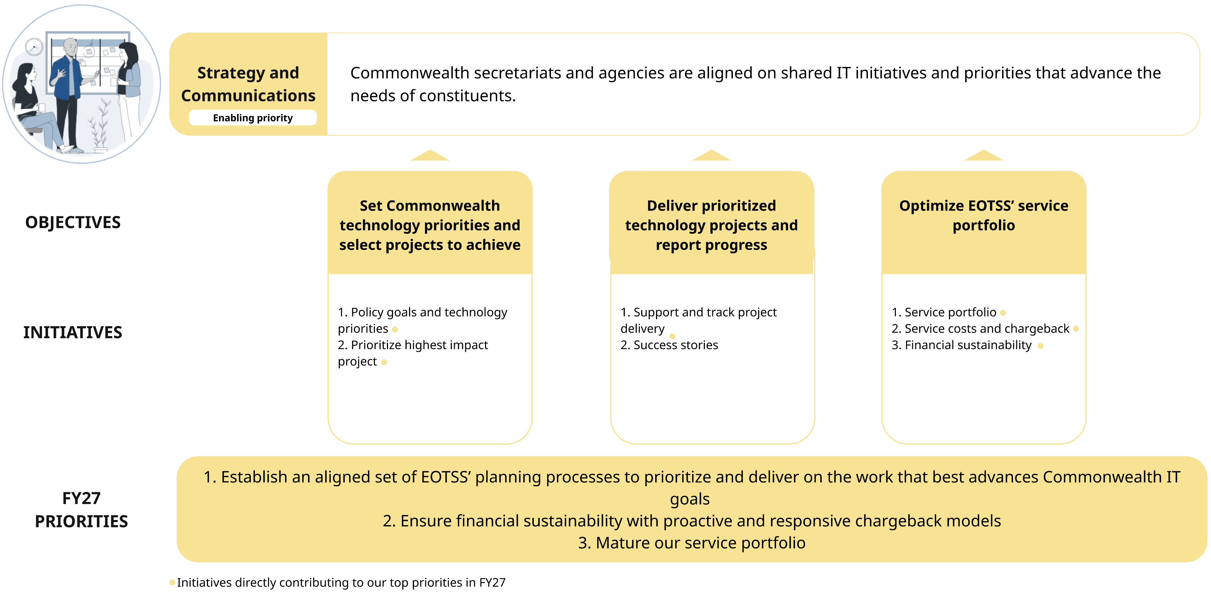
Find more details on Strategy and Communications priorities and Strategy and Communications objectives and initiatives.

EOTSS’ philosophy involves a two-pronged approach: maturing our planning infrastructure and service portfolio
- A mature planning infrastructure that supports both top-down and bottom-up communication that brings EOTSS and the Commonwealth into alignment on IT initiatives
- A dynamic service portfolio that provides customers with high-value support in a responsive, sustainable, and cost-effective way
While we want aligned IT planning across the Commonwealth, we are not centralizing all IT planning for secretariats. We want to provide information, tools, and artifacts to support effective IT planning by secretariat stakeholders, and we want to incorporate customer input into our planning to ensure EOTSS’ services meet the needs of secretariats.

Top three priorities for Strategy and Communications in FY27
The list below highlights our top three priorities for FY27. The following section summarizes all initiatives across all objectives.
- Establish an aligned set of EOTSS’ planning processes to prioritize and deliver on the work that best advances Commonwealth IT goals
We want to design and run planning processes that align customer demand planning, strategic planning, business planning, and capital planning. Customer demand planning will uncover the needs of our customers across the Commonwealth. Strategic planning will use this information to establish goals and identify how to achieve them in the coming years. Business and capital planning will direct capacity and resources on the ground to enable teams to deliver on their goals. A coordinated approach across these processes will provide leadership and teams with a clear, up-to-date understanding of the work that should be prioritized and the major IT initiatives that are happening across EOTSS and the Commonwealth.
- Ensure financial sustainability with proactive and responsive chargeback models
We want to ensure EOTSS is delivering high-value services to customers in a sustainable, transparent, and cost-effective way. We want to mature how we develop and update chargeback models with a focus on better incorporating customers into the process.

- Mature our service portfolio
We want to develop a responsive service portfolio with strong governance processes and transparency built on better information sharing. This involves maturing processes for managing how we add and deprecate services, training service owners on how they participate in new processes, and expanding the ways we incorporate customer needs into our service planning.

Questions for ongoing consideration
These are questions that we must continue to focus on as we manage our priorities and beyond.
- How can we support secretariats to integrate technology planning into their overall planning processes?
- How can we ensure that IT initiatives are adequately resourced so they can be deployed and sustained successfully? What supports should we provide secretariats and our own teams to (1) understand what resources are necessary for success, (2) how these resources fit into their organizational model now and over time and (3) plan and hire for resources on a time frame that enables success?

EOTSS will drive toward our vision for Strategy and Communications through three objectives
Our planned initiatives have been organized into three objectives. We anticipate that these objectives will be relatively stable over the next three years, but that specific initiatives and associated key results will vary year by year. The priorities outlined above may align to one or more initiatives.
- Set Commonwealth technology priorities and select projects to achieve them: The technology priorities EOTSS sets reflect this government's highest priority policy goals to meet the needs of constituents. EOTSS planning processes enable us to collaboratively select the right projects across the Commonwealth to achieve our shared goals.
- Deliver prioritized technology projects and report progress: EOTSS collaborates with our internal teams and our agency partners to deliver prioritized projects, track and communicate transparently about progress, and use reports to make informed prioritization, resource, and funding decisions.
- Optimize EOTSS’ service portfolio: EOTSS continuously improves our service portfolio to increase financial sustainability and value to customers while delivering our services with excellence.
In order to support our vision and these objectives, many teams across EOTSS are contributing work – these include our Administration team, Strategy and Planning Office, Engagement team, Office of the Secretary, and our Technology Office.

Objective-by-objective summary of Strategy and Communications initiatives and outcomes for FY26 to FY28

Objective 1: Set Commonwealth technology priorities and select projects to achieve them
The technology priorities EOTSS sets reflect this government's highest priority policy goals to meet the needs of constituents. EOTSS planning processes enable us to collaboratively select the right projects across the Commonwealth to achieve our shared goals.

Under this objective we have two initiatives:
- Policy goals and technology priorities: Align on secretariat policy and service delivery goals, set shared technology priorities, and communicate them clearly
In the FY26 to FY28 period, we will stand up a new three-year strategic planning process to define initiatives that improve how we advance the Commonwealth’s shared IT priorities. We will set capital investment targets and disseminate guidance to support thoughtful submissions. We will mature how we support secretariat-level IT planning, bringing enterprise architecture and emerging technology expertise to the table.
- Prioritize highest impact projects: Prioritize and fund projects that substantially advance our strategic priorities
In the FY26 to FY28 period, we will run an improved business planning cycle incorporating and aligning strategic and capital planning processes. We will also mature our intra- and cross-team prioritization capabilities by instituting regular cross-team project reviews.

Objective 2: Deliver prioritized technology projects and report progress
EOTSS collaborates with our internal teams and our agency partners to deliver prioritized projects, track and communicate transparently about progress, and use reports to make informed prioritization, resource, and funding decisions.
Under this objective we have two initiatives:
- Support and track project delivery: EOTSS’ project teams deliver, track, and report on progress and funding using modern best practices, in collaboration with agency partners
In the FY26 to FY28 period, we will roll out a strategic portfolio management tool to centralize tracking for (1) a prioritized subset of EOTSS’ internal projects and (2) all Commonwealth projects funded on EOTSS’ capital plan. We will also develop and disseminate project planning templates, resource planning guidance, and other artifacts.
- Success stories: Evangelize our success stories and theories of change through thoughtful internal and external communications
In the FY26 to FY28 period, we will build out a catalog of our successes to use for award submissions and other external engagements. We will also launch an external newsletter to evangelize our work to a broader audience.

Objective 3: Optimize EOTSS’ service portfolio
EOTSS continuously improves our service portfolio to increase financial sustainability and value to customers while delivering our services with excellence.
Under this objective we have three initiatives:
- Service portfolio: Strategically add, deprecate, right-size, and improve performance of services in our portfolio, in alignment with technology priorities and customer needs
In the FY26 to FY28 period, we will mature our service governance process, incorporating information from parallel customer demand planning and business planning processes to ensure alignment across EOTSS’ work. Then we will explore and roll out new strategies to offer coordinated support to customers who need to interact with multiple EOTSS teams.
To see more about how we are evolving existing and identified services, there is detailed information in our Constituent Experience; Cybersecurity; Data and Analytics; and IT Services plans.
- Service costs and chargeback: Develop and maintain efficient, transparent, fair, and sustainable cost management and recovery for prioritized services
In the FY26 to FY28 period, we will launch “Secretariat Business Reviews,” to better understand customer needs and experiences, and roll out reporting processes to share outcomes of these meetings (including forecasting, demand planning, risks, etc.). We will also roll out new financial operations (FinOps) governance processes to promote efficient cost management and recovery for our work with agencies and implement updated chargeback models for prioritized services.
- Financial sustainability: EOTSS’ budget and portfolio management teams collaboratively monitor and forecast budgets to ensure sustainable cost trends across our service and project portfolio
In the FY26 to FY28 period, we will implement Apptio to support our teams to collaboratively manage budgets. Then we will conduct a holistic review of financial tools and launch new products to support FinOps work at EOTSS.

Workforce

Our vision and strategy for the future of Workforce in the Commonwealth
We envision a future where the Commonwealth continually develops and empowers a stable, engaged, capable, and diverse workforce that can deliver against our IT mission over time.
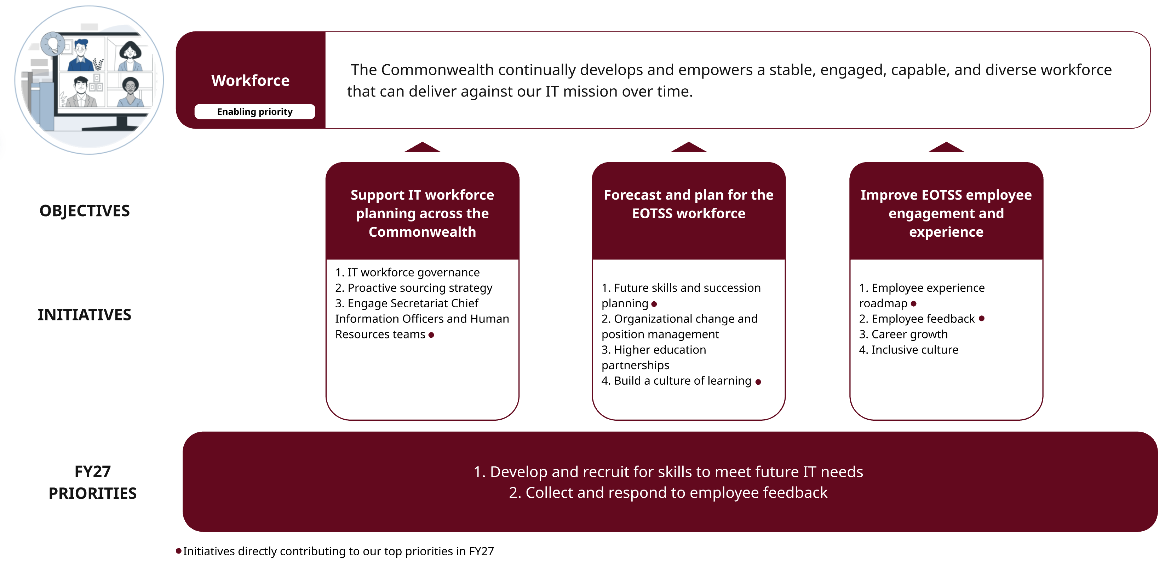
Find more details on Workforce priorities and Workforce objectives and initiatives.

EOTSS develops a resilient and engaged IT workforce, Commonwealth-wide
Given EOTSS role as the IT secretariat, we are positioned to support technical hiring across the Commonwealth. We want to build IT workforce models for EOTSS, as well as the Executive Branch, that are resilient to technology advancements and staffing changes, such as retirements and turnover. We want to prioritize the long-term efficacy of our current workforce, and also anticipate the skills and capabilities required for the IT workforce of the future based on emerging trends.
We conduct comprehensive workforce planning at EOTSS and provide guidance and tactical recruitment support across the Executive Branch to inform each secretariat’s strategy, but we do not do wholesale workforce planning for other secretariats.

Top priorities for Workforce in FY27
The list below highlights our top three priorities for FY27. The following section summarizes all initiatives across all objectives.
- Develop and recruit for skills to meet future IT needs
To ensure EOTSS is equipped to manage the technological challenges of the future, we need to (1) develop a process for identifying technical skills required for the future IT workforce, and (2) implement strategies to upskill and recruit for these capabilities.

- Collect and respond to employee feedback
We want to proactively and tangibly respond to employee feedback to promote organizational trust, improve the employee experience, and create targeted opportunities for employees to grow and develop at EOTSS.

Questions for ongoing consideration
These are questions that we must continue to focus on as we manage our priorities and beyond. How can we best support workforce planning when current resource constraints limit our ability at EOTSS and across the Executive Branch to hire more technical staff?

EOTSS will drive toward our vision for Workforce through three objectives
Our planned initiatives have been organized into three objectives. We anticipate that these objectives will be relatively stable over the next three years, but that specific initiatives and associated key results will vary year by year. The priorities outlined above may align to one or more initiatives.
- Support IT workforce planning across the Commonwealth: EOTSS provides guidance to improve IT workforce planning across the Commonwealth.
- Forecast and plan for the EOTSS workforce: EOTSS forecasts talent needs and develops strategies and processes to maintain a workforce at EOTSS responsive to technology needs today and in the future.
- Improve EOTSS employee engagement and experience: Improve the processes driving the employee experience from hiring to offboarding, while engaging employees so they feel valued and empowered by the organization.
The Administration team is the primary contributor to these objectives.

Objective-by-objective summary of Workforce initiatives and outcomes for FY26 to FY28

Objective 1: Support IT workforce planning across the Commonwealth
EOTSS provides guidance to improve IT workforce planning across the Commonwealth.
Under this objective we have three initiatives:
- IT workforce governance: Align service delivery associated workforce and financial recovery
In the FY26 to FY28 period, we will establish an IT Classification Governance Board with representation from across the Executive Branch. We also plan to identify future skills required for the IT workforce, so that we can update the IT classification system.
- Proactive sourcing strategy: Implement a proactive sourcing strategy for IT roles across the Executive Branch
In the FY26 to FY28 period, we will define all our sourcing pipelines (e.g., Apprenticeships, subject-matter areas, etc.) for the Executive Branch and begin tracking their efficacy over time. After identifying future IT skills, we will update all sourcing and pipeline activities to align to future skills needed.
- Engage Secretariat CIOs and Human Resources (HR) teams: Identify gaps faced by HR teams across the Executive Branch and develop or update offerings to meet those needs
In the FY26 to FY28 period, we will engage SCIOs to source feedback on challenges facing HR teams across the Executive Branch, such as emerging technology hiring. Then we want to identify and operationalize effective ways to resolve these challenges.

Objective 2: Forecast and plan for the EOTSS workforce
EOTSS forecasts talent needs and develops strategies and processes to maintain a workforce at EOTSS responsive to technology needs today and in the future.
Under this objective we have four initiatives:
- Future skills and succession planning: Assess organizational health at EOTSS and create a plan to account for future skill needs and retirement wave
In the FY26 to FY28 period, we will begin identifying areas requiring knowledge transfer at EOTSS as well as anticipate future skills required for the IT workforce. We will implement knowledge transfer and recruitment strategies to target these areas of risk and future skill needs. Then we want to reevaluate organizational health. In parallel, we will define the competencies and skills that constitute an agile workforce and then work to mature these skills across the organization.
- Organizational change and position management: Launch organizational change and position management governance
In the FY26 to FY28 period, we will define and launch a review process for organizational change management and position management with the EOTSS executive team.
- Higher education partnerships: Build higher education partnerships that are effective engagement and talent pipelines
In the FY26 to FY28 period, we will define success metrics for evaluating our higher education partnerships. See the Innovation and Emerging Technology pillar for additional work related to higher education partnerships, under objective four, initiative one.
- Build a culture of learning: Create and advertise comprehensive learning, development, and knowledge-sharing opportunities for EOTSS staff
In the FY26 to FY28 period, we will create new employee-centric learning and development opportunities and then increase participation rates for these opportunities.

Objective 3: Improve EOTSS employee engagement and experience
Improve the processes driving the employee experience from hiring to offboarding, while engaging employees so they feel valued and empowered by the organization.

Under this objective, we have four initiatives:

- Employee experience roadmap: Improve the processes driving the employee experience
In the FY26 to FY28 period, we will implement the employee experience roadmap, identify targeted areas for improvement, and later reevaluate the roadmap.
- Employee feedback: Employees feel they are valued by EOTSS and can affect the organization
In the FY26 to FY28 period, we will increase participation rate in pulse surveys by 10-20 percent so that we can implement at least 2 initiatives in response to employee concerns.
- Career growth: Employees feel empowered to perform well in their role and grow their career at EOTSS
In the FY26 to FY28 period, we will create a new employee recognition program.
- Inclusive culture: Employees feel included in the workplace
In the FY26 to FY28 period, we will launch an updated version of the Diversity Advisory Committee.

Appendix I. Why centralize IT functions?

Efficiency: Centralizing technical expertise and functionality allows EOTSS to specialize so that each agency does not need to duplicate expertise and functions which are not core to their policy and program.
Value: Centralizing technical expertise and functionality also allows EOTSS to own and drive transparency around pricing and improve purchasing power from the center.

Appendix II. Maturity model for growth opportunities
In our executive summary we outline six opportunities for growth and a maturity model that has five levels: (1) ad hoc, (2) developing, (3) scaling, (4) maturing, and (5) optimizing.
For each of these opportunity areas, we compare where we are in FY26 on the maturity model to where we want to be at the end of FY28. This information is summarized in the list below:
- Proactive technology advancement: Move from developing to maturing.
- Data readiness: Move from developing to scaling.
- Modernizing technology administration: Move from developing to maturing.
- Customer relationships: Move from maturing to optimizing.
- Standards and policies: Move from developing to scaling.
- IT consolidation: Move from developing to scaling.

Appendix III. Top priorities in each pillar
This list outlines the top three priorities within each pillar for FY27. Some of these priorities were consolidated as part of developing our top 10 priorities overall.

Constituent Experience priorities
- Personalize and streamline constituent journeys
- Build experience management capacity across the Commonwealth
- Strengthen the digital accessibility of Commonwealth services

Cybersecurity priorities
- Improve incident response and vulnerability management through automated scanning and monitoring
- Strengthen offerings by implementing Zero Trust and cloud security standards
- Mature our disaster recovery and resiliency program

Data and Analytics priorities
- Develop a Commonwealth data strategy that ensures data readiness and enables innovation
- Standardize and modernize data technology offerings, focusing on our integration services and administrative data warehouse
- Drive federated data sharing by onboarding agencies to our data mesh and catalog

Innovation and Emerging Technology priorities
- Launch a Commonwealth AI Assistant for government staff and increase how many valuable AI tools are pushed into production
- Document enterprise standards for AI
- Enable the use of emerging technology across the Commonwealth to improve government service delivery

IT Services priorities
- Mature and standardize centralized technology service and platform offerings
- Rationalize data centers to optimize our overall on-premises footprint
- Consolidate IT staffing, Network, and Voice sites to streamline IT operations

Strategy and Communications priorities
- Establish an aligned set of EOTSS’ planning processes to prioritize and deliver on the work that best advances Commonwealth IT goals
- Ensure financial sustainability with proactive and responsive chargeback models
- Mature our service portfolio

Workforce priorities
- Develop and recruit for skills to meet future IT needs
- Collect and respond to employee feedback

Appendix IV. Data and Analytics
Some details in the Data and Analytics section are provided by images. The text in those images is included in this appendix.

Data and Analytics opportunity
Moving the Commonwealth toward a shared enterprise data platform will enable agencies to easily find and view relevant data that they don’t own, by allowing for consistency and interoperability while reducing duplication and simplifying administrative overhead.​

Data and Analytics accomplishment
Example of a key accomplishment in cross agency data sharing: The Massachusetts’ Emergency Shelter System​
In 2023, the number of families eligible for and seeking housing under the state’s “right to shelter” law rapidly increased under a perfect storm of federal immigration policies, a shortage of affordable housing, and the end of COVID-era food and housing security programs. The Executive Office of Technology Services and Security (EOTSS) was tasked with developing an enterprise-wide solution for data sharing that could provide clarity in the moment and serve as a playbook for future emergencies. EOTSS closely collaborated with four Executive Offices to design and implement the Interagency Emergency Data Manager (IEDM) and Emergency Shelter Dashboard Suite. These tools worked in concert to transform a fragmented response into a shared, data-driven ecosystem that supported real-time operations, informed policy decisions, and respected the privacy and dignity of the families being served.

Why Data stewardship matters
In the public sector, data ownership implies control and authority over data, often tied to a single agency, while data stewardship emphasizes shared responsibility for managing, protecting, and using data on behalf of the public. Stewardship recognizes that government data is a public asset, prioritizing trust, security, and ethical use over exclusive control. This shift enables collaboration across agencies, while maintaining accountability and compliance.

Appendix V. Glossary of terms
This appendix provides a brief description of terms and terminology used throughout our strategic planning documentation.

Commonwealth of Massachusetts and EOTSS terms
EOTSS works with and across a variety of government entities and non-government partners. Throughout our strategic plan, the following terms may be used:
- Commonwealth or state: These terms are used interchangeably to refer to the Commonwealth of Massachusetts (ex. Commonwealth or state employees).
- Executive Branch: The branch of state government, led by the Governor, that is responsible for implementing laws, managing state agencies, and directing policy.
- Executive Office or Secretariat: These represent administrative areas led by a Governor-appointed secretary, who sits on the Governor’s cabinet. These offices/secretariats may oversee multiple, subordinate state agencies.
- Non-Executive organizations, Independents, and/or Constitutionals: These organizations may be run by separately elected officers or otherwise maintain greater autonomy than executive branch agencies reporting directly to the Governor.
- Agency or Agencies: This is a general term that may refer collectively to secretariats, executive offices, and their agencies.
- Customers or agency customers: This is a general term for any entity receiving services from EOTSS.
- Consolidated agencies: These are any state agencies where staff and services related to defined IT functions have been centralized within EOTSS, in line with the legislation that created EOTSS. Some state agencies still maintain their own IT departments and teams, including for functions that EOTSS centrally manages, because they have not completed the consolidation process yet.
- Constituents: These are people or groups who interact with the government to receive services.
- Agency users or government users: These are people within the Commonwealth, whether full time employees, contractors, or other affiliated personnel, who interact with EOTSS in order to deliver services to their constituencies.
- Organizations or partners: This is a general term used to describe entities that do not have a specific government affiliation, for example educational institutions, private industry partners, etc., or to describe a combination of government and non-government groups.

EOTSS also provides services to executive and non-executive agencies. Some of these services are mandatory while others follow an opt-in model. Throughout our strategic plan, the following terms may be used:
- Shared services, shared IT services, or service portfolio: This phrasing intends to be the most general and broad description of any type of service that EOTSS provides and/or supports. When “IT Services” is capitalized, we are specifically referring to our strategic plan for that pillar.
- Enterprise functions or enterprise services: This phrasing refers to functions or services that are required to meet the needs of large complex organizations (e.g., across EOTSS and/or across multiple secretariats or agencies).
- Common agency functions: This phrasing intends to informally refer to the types of functions that are not specific to a particular service area but are not necessarily managed at an enterprise level (e.g., project management).

Objectives and Key Results (OKR) framework and terms
The OKR framework is a management methodology that EOTSS is using to set goals and measure performance against these goals. The components of this framework include:
- Objectives: Statements that describe what we want to achieve—they must be concrete and action-oriented
- Key Results (KRs): Metrics to help us determine whether we are on track for achieving our objectives—they should be specific, time-bound, and measurable
- Initiatives: The projects, tasks, and activities for how we will achieve our objectives
Regarding Key Results, we have categorized them into one of three groups:
- Committed: By default, Key Results we have set that we believe are important to advancing our goals and objectives and are also achievable/feasible. These Key Results do have any particular labeling.
- Stretch: Key Results that represent an aspirational goal or something that we know we want to do but that we do not necessarily have the resources/capacity to tackle in this cycle. These Key Results are labeled as [Stretch].
- Learning: Key Results that represent opportunities to gather information to inform an approach but are not intended to measure our performance. Whether we achieve a “learning” Key Result or not (e.g., conducting a pilot) is less important than the outcome – gathering enough information to make a determination about how to proceed. These types of goals are intended to test hypotheses with almost any outcome (stop, continue, modify) being acceptable based on learnings. These Key Results are labeled as [Learning Goal].

