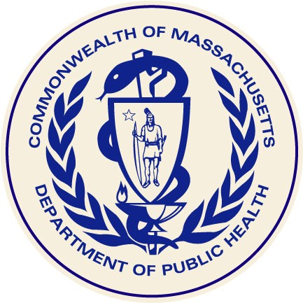



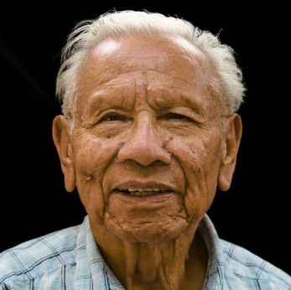
April Report
The Commonwealth’s High-Risk Senior Population

Results and Recommendations from a 2009 Statewide Oral Health Assessment

Massachusetts Department of Public Health
Office of Oral Health
July 2010
Acknowledgements

The Office of Oral Health acknowledges the Massachusetts Executive Office of Elder Affairs, the Massachusetts Senior Care Association and Harvard University Dental School for their support in implementing the 2009 Oral Health Assessment of Seniors.

The Office of Oral Health acknowledges and thanks the following individuals for their time and expertise in analyzing the data and developing this Report:

Kathy Phipps, DrPH
Nicole Laws, RDH, MS
Judith A. Jones, DDS, MPH, DScD
Donna E. Johnson, LICSW
Andy Epstein, RN, MPH
Kathy Atkinson
Jean Pontikas
Jill Mazzola, RN
Sherman Lohnes

The Office of Oral Health

The mission of the Office of Oral Health is to improve, promote and protect the oral health of Massachusetts residents.

The Office seeks to assure that:
- Evidence-based prevention programs such as community water fluoridation and school fluoride and sealant programs are utilized by Massachusetts communities and residents.
- All residents have access to dental services, especially underserved
populations.
- Publicly supported dental programs are efficiently managed and
coordinated.
- Oral health information is available to residents and decision-makers to promote oral health.

Additional and related information is also available from the
Massachusetts Department of Public Health website:
www.mass.gov/dph/oralhealth

The Commonwealth’s High-Risk Senior Population

Results and Recommendations from a 2009 Statewide Oral Health Assessment

Deval L. Patrick, Governor
Timothy P. Murray, Lieutenant Governor
JudyAnn Bigby, MD, Secretary
John Auerbach, Commissioner
Jewel Mullen, Director, Bureau of Community Health Access and Promotion
Donna E. Johnson, Director, Division of Primary Care and Health Access
Lynn A. Bethel, Director, Office of Oral Health

Office of Oral Health
Massachusetts Department of Public Health
250 Washington Street
Boston, MA 02108

July 2010

Table of Contents

List of Figures…………………………………………………... | 5-6
Executive Summary…………………………………………….. | 7-9
Introduction……………………………………………………... | 11
Methods………………………………………………………….. | 11-12
Respondents……………………………………………………... | 12
Demographics…………………………………………………… | 13-14
Results……………………………………………………………  Access to Dental Care and Insurance Status……………….  Edentulism……………………………………………………  Maxillary Arch……………………………………………….  Mandibular Arch…………………………………………….  Gingivitis……………………………………………………...  Untreated Decay……………………………………………...  Xerostomia……………………………………………………  Soft Tissue Lesions…………………………………………... | 15-29  15-17  18  19-20  21-22  23-24  24-25  26-27  28-29
Oral Health and Long Term Care……………………………... | 30
Nursing Director Survey……………………………………….. | 31-33
Prevention Strategies…………………………………………… | 34-35
Overview………………………………………………………… | 35
Recommendations………………………………………………. | 36
Glossary of Terms………………………………………………. | 39-41
Data Tables……………………………………………………… | 43-51

Figures

Figure 1. Age of Seniors Screened by Setting, MA 2009.

Figure 2. Race/Ethnicity of Seniors Screened by Setting, MA 2009.

Figure 3. Gender of Seniors Screened by Setting, MA 2009.

Figure 4. Percent of Meal Site Participants That Have a Dentist, MA 2009.

Figure 5. Time Since Last Dental Visit for Seniors at Meal Sites, MA 2009.

Figure 6. Seniors Screened at Meal Sites with Private Dental Insurance, MA 2009.

Figure 7. Seniors Screened at Meal Sites with MassHealth (Medicaid), MA 2009.

Figure 8. Prevalence of Total and Partial Edentulism by Setting, MA 2009.

Figure 9. Prevalence of Teeth Lost in the Maxillary Arch by Setting, MA 2009.

Figure 10. Absence of a Maxillary Denture for Partially and Fully Edentulous Seniors by Setting, MA 2009.

Figure 11. Maxillary Denture Function in Seniors Missing 3+ Maxillary Teeth by Setting, MA 2009.

Figure 12. Maxillary Denture Function in Seniors Missing All Maxillary Teeth by Setting, MA 2009.

Figure 13. Prevalence of Teeth Lost in the Mandibular Arch by Setting, MA 2009.

Figure 14. Absence of a Mandibular Denture for Partially and Fully Edentulous Seniors by Setting, MA 2009.

Figure 15. Mandibular Denture Function in Seniors Missing 3+ Mandibular Teeth by Setting, MA 2009.

Figure 16. Mandibular Denture Function in Seniors Missing All Mandibular Teeth by Setting, MA 2009.

Figure 17. Prevalence of Gingivitis Among Seniors with 1+ Teeth by Setting, MA 2009.

Figure 18. Prevalence of Untreated Decay Among Seniors at Meal Site and Treatment Urgency, MA 2009.

Figure 19. Prevalence of Untreated Decay Among Seniors at Long Term Care Facilities and Treatment Urgency, MA 2009.

Figure 20. Prevalence of Xerostomia Among Seniors with 1+ Teeth by Setting, MA 2009.

Figure 21. Prevalence of Untreated Decay Among All Seniors with 1+ Teeth and Xerostomia, MA 2009.

Figure 22. Prevalence of Soft Tissue Pain by Setting, MA 2009.

Figure 23. Soft Tissue Treatment Urgency by Setting, MA 2009.

Figure 24. Response Rate of Nursing Directors by County, MA 2009.

Figure 25. Nursing Director Opinion on Relationship Between Poor Oral Health and Systemic Disease(s), MA 2009.

Figure 26. Type of Health Provider Performing Dental Examination/Screening at
Admission, MA 2009

Figure 26. Type of Health Provider Performing Dental Examination/Screening at Admission, MA 2009.

Figure 27. Percent of Seniors Receiving Routine Dental Care in Long Term Care
Facilities, MA 2009

Figure 28. Primary and Secondary Barriers to Seniors Receiving Routine Dental Care in Long Term Care Facilities, MA 2009.

Figure 29. Payor Source for Seniors in Long Term Care Facilities, MA 2009.

Executive Summary

The purpose of this Report is to determine the oral health status of two high-risk groups of seniors in Massachusetts and to make recommendations to help meet their needs. From March to July 2009, the Massachusetts Department of Public Health Office of Oral Health with the assistance of the Executive Office of Elder Affairs and the Massachusetts Senior Care Association and in collaboration with the Harvard School of Dental Medicine conducted a statewide oral health assessment of 1,046 high-risk seniors (adults age 60 and older) at 21 long term care facilities and 20 state subsidized meal sites. The Office of Oral Health also conducted an electronic survey of nursing directors employed by long term care facilities statewide to determine their knowledge of oral health and the oral health practices within nursing home facilities.
Nearly 20% of seniors screened at meal sites had not had a dental visit in more than 5 years.

Adult residents over the age of 60 make up more than 13% of the state’s population and they are projected to grow to 20.9% by 2030. Of these, about 45,000 live in long term care facilities. With the majority of older Americans having at least one chronic disease and the scientific evidence demonstrating a relationship between chronic disease and oral health status, more attention needs to be paid to the barriers which may prohibit seniors from accessing regular dental care.

This report provides an overview of the oral health status of two high-risk senior population groups in Massachusetts; those who attend senior meal sites and residents of long term care facilities. The Senior Oral Health Assessment showed that:

- Nearly 20% of seniors at meal sites had not had a dental visit in more than 5 years.
- About 79% of seniors at meal sites did not have dental insurance and 70% were not eligible for MassHealth (Medicaid) insurance.
65% of seniors screened in long term care facilities had some natural teeth.
- 32% of the seniors screened at both sites were completely edentulous and of these, 17% had no dentures.
- 65% of seniors in long term care facilities had some natural teeth, and of these 13% had most of their natural teeth.
- 74% of seniors in long term care facilities had gingivitis, and 65% of all seniors screened had gingivitis.
- 35% of seniors at meal sites had untreated decay with 17% having major to urgent dental needs.
- 59% of seniors in long term care facilities had untreated decay with 34% having major to urgent dental needs.
- 62% of the seniors screened in both population groups with untreated decay, also had xerostomia.
- While 3% of seniors in long term care facilities reported having soft tissue pain, 6% needed follow-up care due to soft tissue lesions.

The Nursing Directors Survey showed that:

- Less than 50% of nursing directors knew there was a relationship between oral health and diabetes.
- 78% of long term care facilities have registered nurses perform the required oral health assessment upon admission.
- The shortage of dental professionals, cost of dental care and insurance status are the primary barriers impeding residents of long term care facilities from accessing routine dental care.

No longer are adults losing most or all of their teeth as they age. Many enjoy the benefits of community water fluoridation, topical fluorides and regular access to dental care. Unfortunately, as adults age their risk for developing oral and dental diseases increases, as do the barriers impeding their ability to get regular dental care. Stakeholders, advocates, health professionals, public health officials and policy makers can utilize lessons learned over the last decade in promoting and improving the oral health of children, and work together to implement solutions for expanding access to and improving the oral health of this adult population.

There are significant unmet oral health needs among seniors in Massachusetts. Based on the findings of the statewide oral health assessment and nursing directors’ survey, this report recommends the following:

1. Establishment of a special working group under the direction of the Department of Public Health Office of Oral Health, consisting of state agencies and institutions and organizations of dental, medical and senior services providers with a targeted interest in seniors. The purpose of the working group is to develop recommendations, guidelines, and policies to improve the oral health of seniors.

The recommendations, guidelines and polices at a minimum would address the following:

- How to promote dental and oral screenings being performed by a licensed dental professional within a reasonable time period of a patient’s admission to a long term care or nursing facility to assess the need for dental care and promote healthy aging.
- How to promote the active participation of a dental professional on the multi-disciplinary team which develops the residents’ care plan in long term care facilities.
- Inclusion and implementation of a dental care plan in the long term care facility residents’ individualized care plan to assist in the establishment of daily oral hygiene regimens and practices that cue or assist the residents with their daily oral hygiene practices.
- Develop and promote the availability of routine oral health in-service education for all nursing staff in long term care and nursing facilities to increase understanding of the association between oral health and systemic health, and the knowledge of the etiology of oral and dental diseases, and oral health prevention strategies to promote healthy aging.

2. Promote the utilization of the public health dental hygiene workforce in long term care and nursing facilities, senior housing, and other settings serving seniors to reduce disparities, and improve direct access to preventive care to those at highest-risk for dental disease.

3. Promote the training of physicians and nurses to perform oral health assessments, oral cancer screenings and applying fluoride varnish as part of an annual well-visit to foster the early identification of oral health concerns, soft tissue lesions, and to prevent tooth decay.

4. Examine and recommend models for coverage of preventive dental care in private and public medical (health) insurance plans for adults 65 years of age and older to promote optimal oral health.

5. Promote the incorporation of the oral health needs of seniors in dental and dental hygiene education, as well as continuing education courses; and the use of portable dental equipment in long term care facilities and other settings serving seniors to increase access.

Introduction

The Massachusetts Department of Public Health with assistance from the Massachusetts Executive Office of Elder Affairs and the Massachusetts Senior Care Association, and in collaboration with the Harvard School of Dental Medicine conducted an oral health assessment to describe the oral health status of Massachusetts residents age 60 and older residing in licensed long-term care facilities, and community residents who attend state-subsidized meal programs. Opportunities to improve their oral health and access to oral health services were also identified. At the time of the survey there were 443 licensed long term care facilities in Massachusetts and
27 state-funded nutrition programs at 400 congregate meal sites.

Methods

The Basic Screening Survey (BSS) methodology developed by the Association of State and Territorial Dental Directors (ASTDD) was used to assess the oral health of two high-risk population groups – residents of long-term care facilities and congregate meal site participants. The BSS is a nationally recognized oral health surveillance tool that provides a framework for obtaining oral health data that is inexpensive and easy to implement; yet always consistent. To assure consistency in the target population of older adults, ASTDD recommends that jurisdictions screen residents of long-term care facilities and/or congregate meal site participants. The information gathered through a screening survey is at a level consistent with monitoring the national health objectives found in the United States Public Health Service’s Healthy People document. A Basic Screening Survey is cross sectional (looking at a population at a point in time) and descriptive (intended for determining estimates of oral health status for the defined target population). The primary limitation of the older adult BSS is that the results are only generalizable to the target population, not the entire population of older adults.

About 45,000 Massachusetts residents live in long term care facilities, and about 25,000 ambulatory seniors participate in the state’s funded meal programs annually.
An electronic list of all long-term care facilities in Massachusetts was obtained from the Executive Office of Elder Affairs. Using data from the University of Massachusetts’ Center for Rural Massachusetts, each long-term care facility was coded as being either rural or non-rural. Because high-risk and medically compromised patients in rural communities are less likely to have access to dental care, the list of long-term care facilities was stratified by rural/non-rural status then a probability sample of 21 facilities was selected. For every long-term care facility selected, a meal site in the same or closest neighboring town was also selected. Selecting a meal site in the same community as the long-term care facility reduced survey costs while assuring that participants at both rural and non-rural meal sites were screened. Although the meal sites selected were not from a probability sample of meal sites, the results are
considered to be fairly representative of all meal site participants in Massachusetts. All adults at each site were eligible to participate in the survey if they provided verbal consent.

The oral health screenings were conducted by dental hygienists from the Massachusetts Department of Public Health who were trained to use the diagnostic criteria outlined in the Basic Screening Survey methodology. In addition to dental measures, demographic information, as well as dental insurance status and access to dental care were also obtained.

In November 2009, the Department developed and distributed a 21-item electronic survey to the nursing directors of all 443 state licensed nursing homes to better understand oral health practices within the long term care facilities and the nursing directors’ knowledge, attitudes and beliefs in regard to oral health.

Respondents

Of the 21 licensed long term care facilities selected, 21 (100%) participated while 20 of the 21 meal sites selected (95%) participated. A total of 834 seniors were screened at the long-term care facilities and 212 were screened at the meal sites.

A total of 220 nursing directors participated in the online survey, almost 50% of the sample (n=443).

Demographics

In Massachusetts 13.3% of the state’s population are considered seniors, defined as being 65 years of age or older. There are more than 143,000 residents age 85 and older and that number is expected to grow 52% by 2030.2 As the over age 65 population increases in age there are fewer minorities and a greater proportion of women. Only 8.8% of the state’s over 65 population are minorities (3.8% Black; 2.6% Hispanic: 8.8% Asian/Pacific Islander), and almost twice as many are women than men.2

About 45,000 Massachusetts residents live in long term care facilities annually.

About 45,000 Massachusetts residents live in long term care facilities, and about 25,000 ambulatory seniors participate in the state’s funded meal programs annually.

The oral health assessment showed:
- Of those screened at meal sites, 46% were 60 to 75 years of age, and 18% were over age 85, (Figure 1).
- Of those screened at long term care facilities, 14% were 60 to 75 years of age, and 54% were over the age of 85, (Figure 1).
- More than two thirds (68%) of all the seniors screened were 80 years of age and older, (Figure 1).
- Among all the seniors screened, 93% were white and nearly 75% were female, (Figure 3).

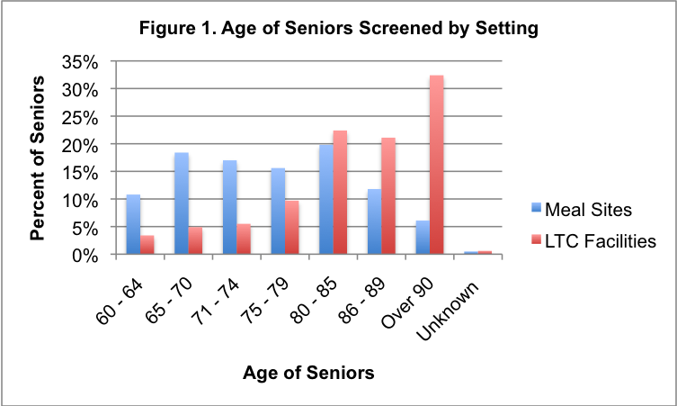

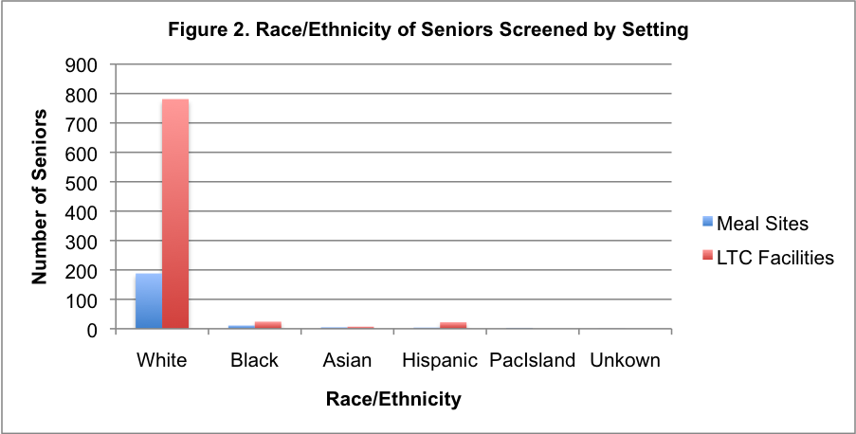

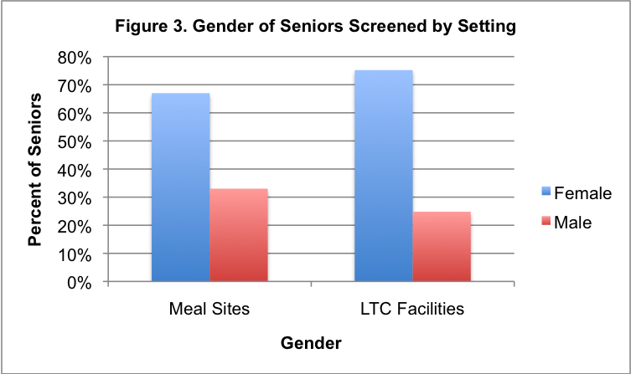

Access to Dental Care and Insurance Status

Recent research suggests that there is a relationship between oral health and cardiovascular disease, diabetes, and pneumonia.

The majority of seniors are covered by Medicare, which does not cover basic dental services.

About 853,000 Massachusetts seniors are Medicare beneficiaries.

Just 12% of residents 65 years of age or older are covered by MassHealth (Medicaid).

- In Massachusetts, over 30% of adults living with diabetes have six or more missing teeth, compared to 12% of those residents without diabetes.

About 80% of older Americans have at least one chronic condition and 50% have at least two, demonstrating the importance of initiatives which promote regular access to dental care, both preventive and restorative, to maintain optimal oral health, as well as general health. Access to oral health care is still a problem in Massachusetts, particularly in certain geographic areas and for particular population groups. Seniors experience particular barriers to accessing care, including a lack of transportation, mobility problems, insurance status, perceived need and the cost of dental care.

The majority of seniors are covered by Medicare which does not cover basic dental services; therefore, most seniors pay for these services on their own. In Massachusetts, about 853,000 senior residents are Medicare beneficiaries with 29% of them living below 150% of federal poverty level. Additionally, MassHealth (Medicaid) regulations make it difficult for seniors to qualify for dental benefits if they have countable assets valued of more than $2,000 or $3,000 as a couple. Of the more than 1.2 million Massachusetts residents who are covered by MassHealth,12% are 65 years of age or older. The limitations on access are apparent in the seniors studied.

- Over 79% of seniors screened at meal sites did not have dental insurance, (Figure 6).
- About 70% of seniors screened at the meal sites were not eligible for MassHealth (Medicaid) insurance, (Figure 7).
- Nearly 34% of the seniors screened at meal sites did not have a dentist of record, (Figure 4).
- Nearly 50% of seniors screened at meal sites hadn’t had a dental visit in the last year, (Figure 5).
- Nearly 20% of seniors screened at meal sites had not had a dental visit in more than 5 years, (Figure 5).

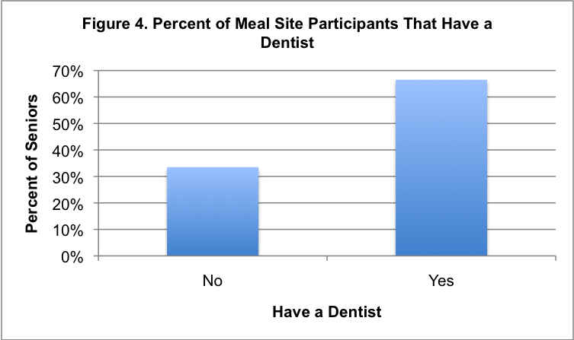

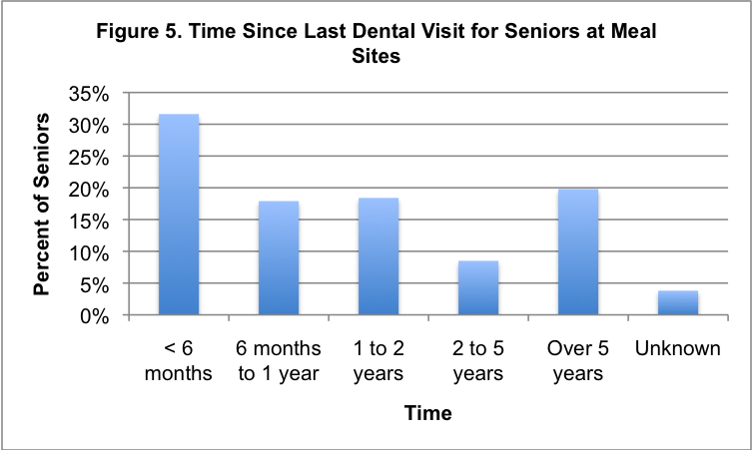

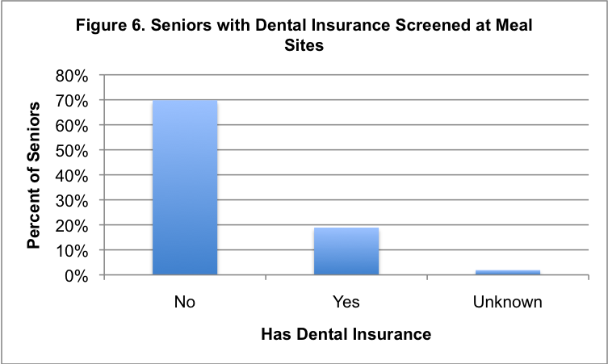

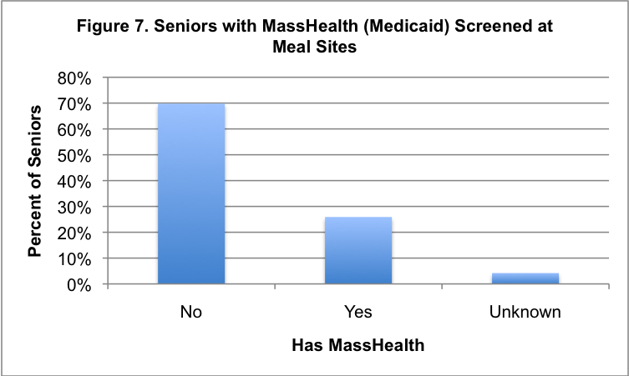

Edentulism

Edentulism is the loss of teeth and may be described as partial edentulism (the loss of one or more teeth not including the loss of third molars) or full edentulism (the loss of all teeth). The presence of teeth is important not only for chewing food and proper nutrition, but to assist in speaking, social interaction, employability, and to support the cheeks and lips for an esthetic appearance.
Tooth loss is used as a national indicator to determine the dental health status of adults.

35% of seniors at long term care facilities were completely edentulous and more than 50% of the edentulous seniors had no denture.

Tooth loss is used as a national indicator to determine the dental health status of adults. In 2004, 20.5% of adults age 65 and older in the U.S. were completely edentulous compared to 16.5% in Massachusetts. Participants in this study fared worse than the general Massachusetts population.

- 19% of seniors at meal sites were completely edentulous and of these 50% had no dentures, (Figure 8).
- 35% of seniors at long term care facilities were completely edentulous, and of these seniors about 50% had no dentures, (Figure 8).
- 26% of seniors at meal sites had most of their natural teeth, compared with 13% of seniors at long term care facilities, (Figure 8).

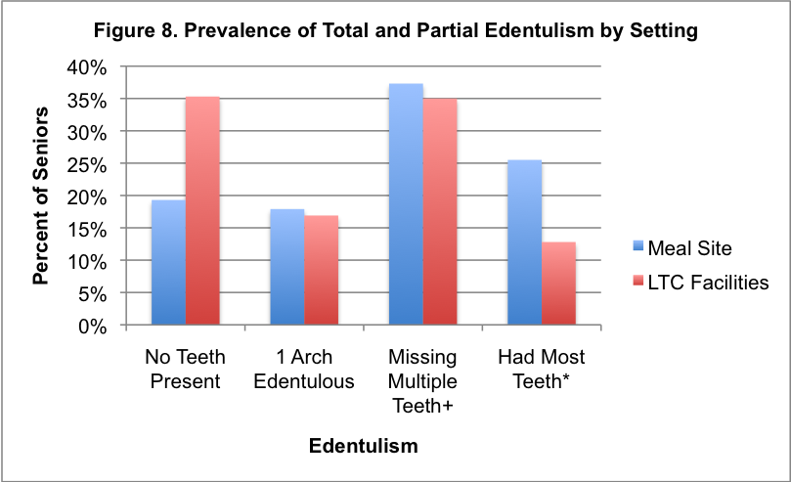
+ Missing 3+ teeth in each arch (excluding 3rd molars) but had at least one tooth in each arch
* Missing fewer than 3 teeth in each arch (excluding 3rd molars)

Maxillary Arch

The oral health assessment showed that:

- 36% of seniors screened at meal sites were missing all maxillary (upper) teeth, (Figure 9).
- 51% of seniors screened in long term care facilities were missing all maxillary teeth and 19% had no maxillary denture, (Figure 9 and Figure 10).
- 31% of seniors screened at meal sites were missing fewer than 3 teeth, compared with 17% of seniors at long term care facilities, (Figure 9).
- 17% of seniors screened at meal sites and 25% of seniors at long term care facilities missing all maxillary teeth experienced little to no function with their denture, (Figure 12).

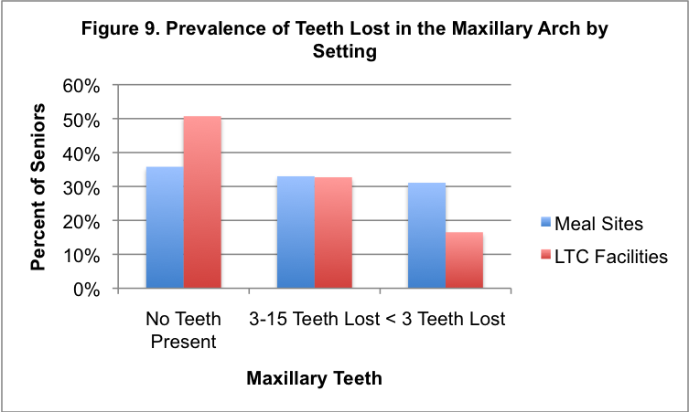

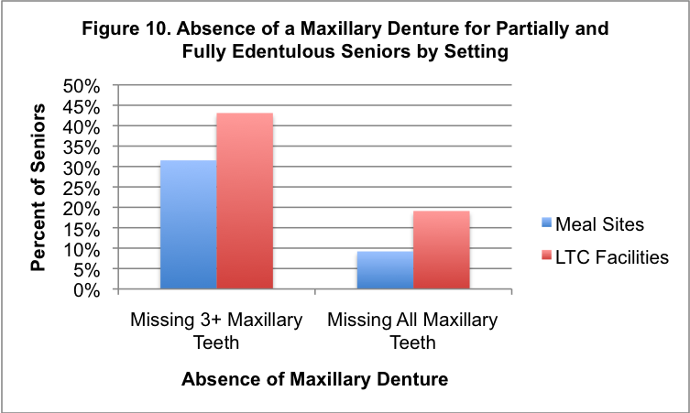
+ Missing 3+ teeth in the maxillary arch (excluding 3rd molars)

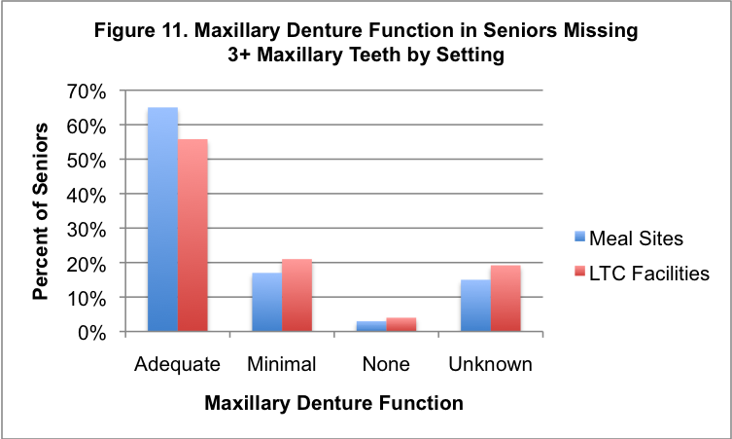

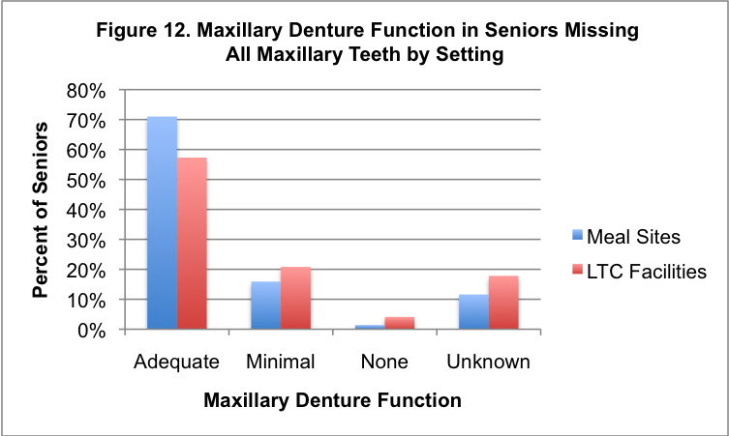

Mandibular Arch

The oral health assessment showed that:

- 21% of seniors screened at meal sites were missing all mandibular (lower) teeth and of these seniors, 21% had no denture, (Figure 13).
- 37% of seniors screened in long term care facilities were missing all mandibular teeth and of these seniors, 45% had no denture, (Figure 13).
- 34% of seniors screened at meal sites were missing less than 3 teeth, compared to 18% of seniors at long term care facilities, (Figure 13)
- 75% of seniors screened at meal sites experienced minimal to no function with either a full or partial mandibular denture, (Figure 16).

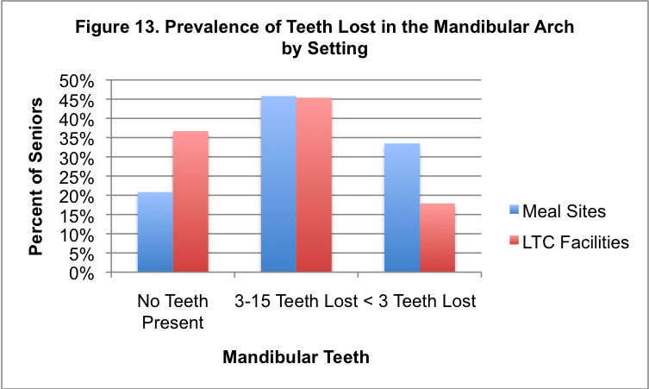
+ Missing 3+ teeth in the mandibular arch (excluding 3rd molars)

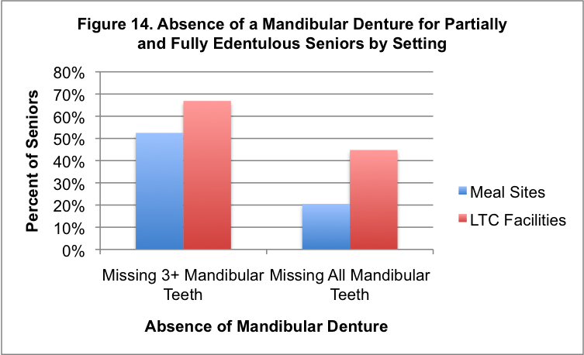

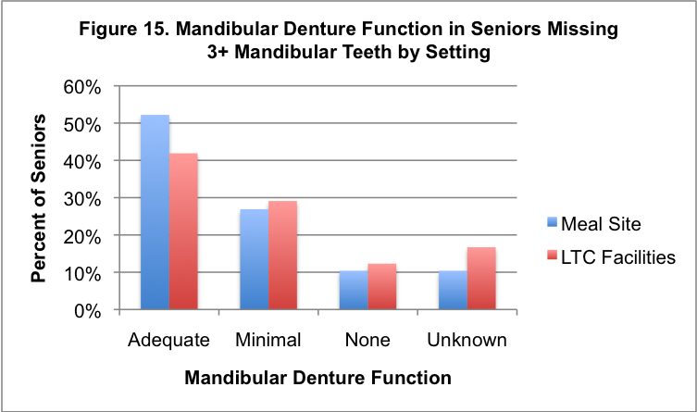

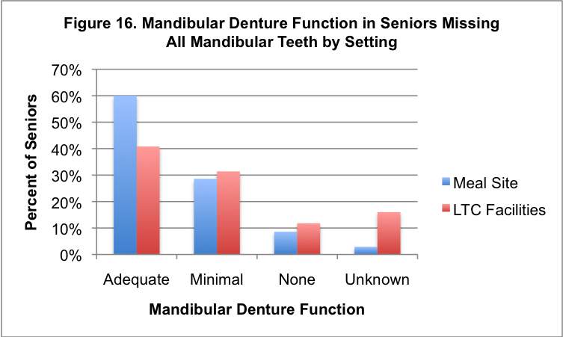
Gingivitis

Gingivitis is an infection of the gum tissue surrounding the teeth and is caused by bacteria and debris in the mouth that is not properly and regularly removed by tooth brushing. Gingivitis is a periodontal disease that causes the gum tissue to get red, inflamed (puffy) and bleed; it can also be sore to the touch. Uncontrolled periodontal diseases have been demonstrated to negatively impact other systemic diseases such as diabetes, cardiovascular disease, and bacterial pneumonia.
Uncontrolled periodontal diseases have been demonstrated to negatively impact other systemic diseases such as diabetes, cardiovascular disease, and even bacterial pneumonia.

35% of seniors screened at meal sites with at least one mandibular anterior tooth had gingivitis.

While regular access to professional dental care is essential for maintaining oral health for seniors with natural teeth, as well as those with complete tooth loss, optimal home care is just as essential. Thorough daily cleaning of both natural teeth and partial dentures to remove food debris and the bacteria that cause tooth decay and periodontal diseases, including gingivitis is essential. Unfortunately, many seniors experience disabilities that impair or prohibit their ability to carry out what may seem like the most basic daily activity -- tooth brushing.

- In Massachusetts 36% of adults age 65 and older have a documented disability, and of these 28% have a physical disability; 15% have a mobility disability; 10% have a cognitive disability; and 9% have a self-care disability.4

This limited ability to effectively and consistently clean the teeth and its surrounding structures places a senior at higher-risk for dental disease and may further affect their general health.

- 35% (n=60) of seniors screened at meal sites with at least one mandibular anterior (lower front) tooth had gingivitis, (Figure 17).
- 74% (n= 400) of seniors screened in long term care facilities with at least one mandibular anterior tooth had gingivitis, (Figure 17).

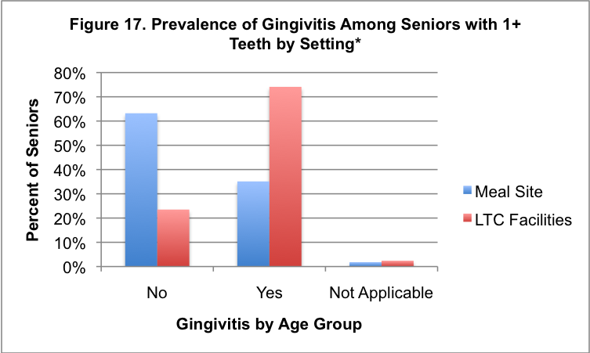
*1+ teeth located in the mandibular anterior sextant only

Untreated Decay

Dental caries is a progressive, destructive chronic disease caused by bacteria that damage the tooth. The damage caused by caries is called tooth decay or “a cavity”. It requires technically demanding, expensive and time consuming professional treatment to fix. Tooth decay is universally prevalent, anyone who is dentate (having a natural tooth) is susceptible; and, if left untreated, it only gets worse.
Tooth decay is universally prevalent, anyone who has natural teeth is susceptible; and if left untreated it only gets worse.
The oral health assessment showed that:

- 35% of seniors screened at meal sites had untreated decay, with 17% having major to urgent dental needs, (Figure 18).
- 59% of the seniors screened living in long term care facilities had untreated decay, with 34% having major to urgent dental needs, (Figure 19).

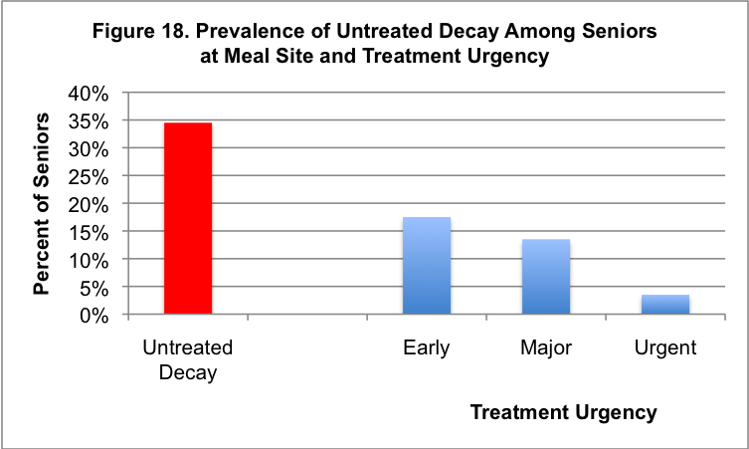

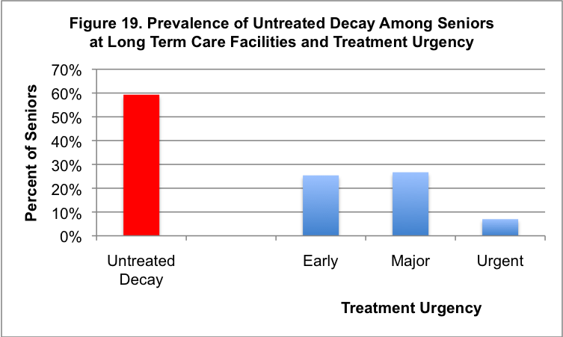

Xerostomia (Dry Mouth)

Compounding the impact of poor oral hygiene and the barriers to accessing dental care for seniors is their increased risk of dependency on prescription drugs and the impact of drug use on the oral cavity. More than 500 prescription drugs, many of which are used to treat chronic systemic conditions, have the side effect of xerostomia or dry mouth, a decrease in the production of saliva.

Saliva is important not only to aid in the digestive process, but also for lubrication of the mouth. Without this lubrication, the oral tissues become red and irritated, and are more susceptible to infections. Saliva also contains enzymes which neutralize the bacteria that produce acids in the mouth causing tooth decay. With a decrease in saliva, teeth are at a higher risk for developing cavities. Finally, saliva assists in the natural cleansing of the teeth and oral structures, and it provides an added topical benefit of fluoride for those individuals regularly consuming fluoridated water, assisting in the prevention of tooth decay.
More than 500 prescription drugs, many of which are used to treat chronic systemic conditions, have the side effect of xerostomia or dry mouth.

With a decrease in saliva, teeth are at a higher risk for developing cavities.

As one ages, gingival (gum) recession often occurs, exposing the teeth’s root surfaces. Because the root surface is softer, it is more susceptible to “root caries” or tooth decay on the root of the tooth. Root caries are common among seniors due to their limited production of saliva, (at least in part due to medication use), and physical and sensory limitations that may impact their effective regular removal of cavity causing bacteria.

- 32% of seniors screened with teeth screened in long term care facilities experienced xerostomia, compared to 27% of all the seniors screened in both population groups with teeth, (Figure 20).
- 62% of the seniors screened in both population groups who had untreated decay also had xerostomia, (Figure 21).**

**Among all seniors screened who had teeth there was a significant relationship between xerostomia and untreated decay.

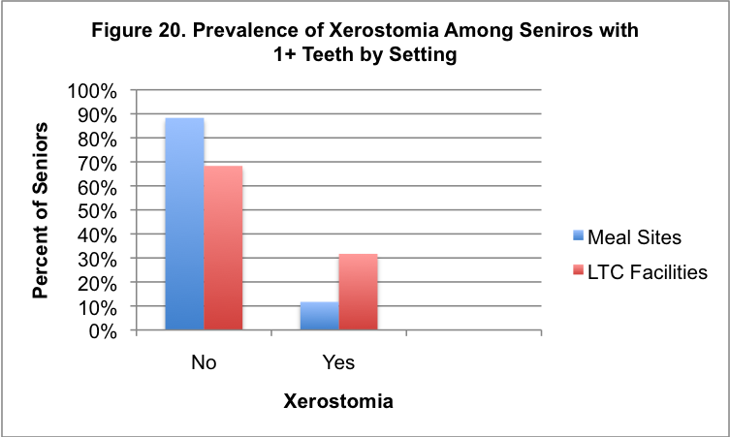

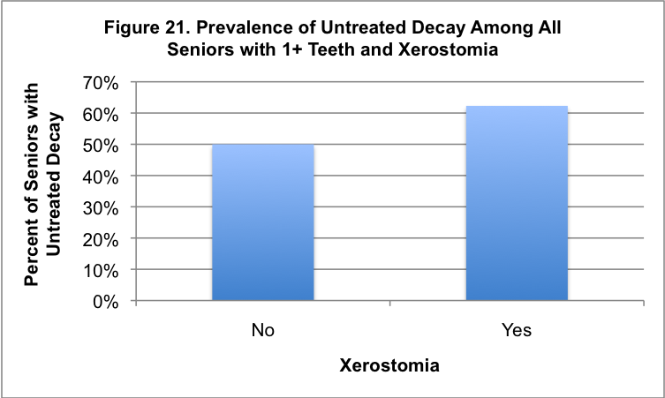

Soft Tissue Lesions

A lesion is any area of abnormal-looking skin found on the soft-tissues or mucous-lining of the mouth. Soft tissue lesions can vary in color, texture, and size, and may be present at birth. These lesions may also arise from an infection or injury, tobacco and/or excessive alcohol use, or irritation from an ill-fitting denture. These lesions are usually benign and temporary; in some cases they may be oral cancer.
Each year about 30,000 new cases of oral cancer are diagnosed in the US.

On average, seniors see their physician about 5.5 times a year, offering an opportunity for annual oral cancer screenings.

Each year about 30,000 new cases of oral cancer are diagnosed in the US. When found early, the survival rate for oral/pharyngeal cancer is 80%-90%; whereas a
late-stage diagnosis drops the five-year survival rate to only about 45%. Unfortunately, most oral cancers are detected in the late stage.

On average, seniors see their physician about 5.5 times a year, offering an opportunity for annual oral cancer screenings. Annual oral cancer screenings performed by either a medical or dental professional for those with and without natural teeth is an effective means for identifying soft tissue lesion early.

- 19% of seniors screened at meal sites had soft tissue pain, compared to 3% of seniors screened at long term care facilities, (Figure 22).

- About 6% of seniors screened at meal sites and long term care facilities needed follow-up for soft tissue lesions, (Figure 23).

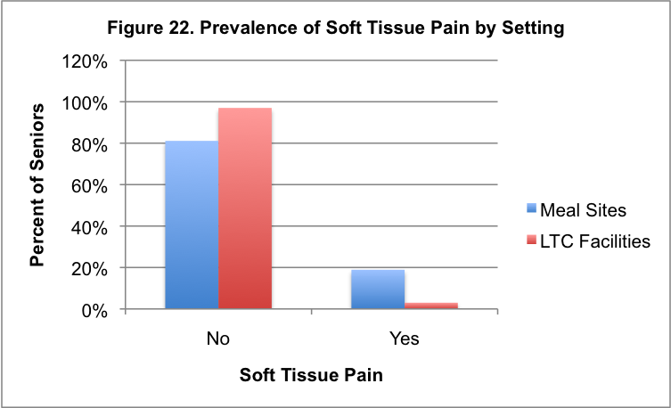

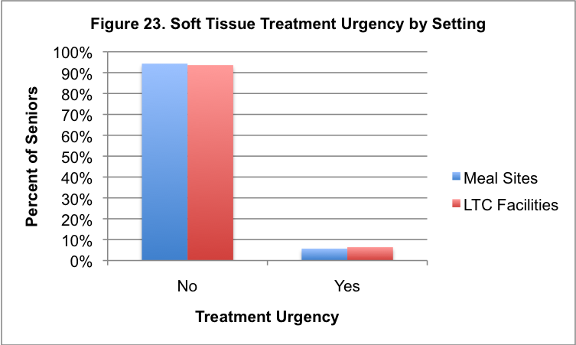

Oral Health and Long Term Care

For more than 1.4 million Americans and 45,000 Massachusetts residents age 65 and older “home” is a long term care facility.2

Federal Requirements- The Centers for Medicare and Medicaid Services (CMS) requires that all long term care/nursing facilities gather a Minimum Data Set (MDS) on each new admission within the first 14 days. The MDS includes a variety of assessments of the individual, including their oral health status (ability to chew, swallow and the presence of pain) and their ability to perform Activities of Daily Living (ADL), independently or with assistance, in order to produce a “comprehensive, accurate, standardized, reproducible assessment of each resident’s functional capacity.” The ADL includes oral hygiene practices, such as tooth brushing. CMS requires that the MDS be conducted or coordinated with the appropriate participation of health professionals11, but does not specifically require a licensed dental professional to conduct the oral health assessment. In the majority of circumstances the oral health assessment is conducted by nursing staff with limited to no oral health education or training (Figure 26), increasing the likelihood that some dental and oral diseases are not identified.
Residing in a long term care facility is a barrier to accessing regular professional, comprehensive dental care due to the senior’s inability to easily get to a dental facility.

Within seven days of completing the MDS, the facility must develop an individualized “care plan” which addresses the identified needs of the resident.11 The care plans are developed by an interdisciplinary team of health professionals from the facility, and typically include physicians, nurses, physical therapists, and dieticians. With oral health being a low priority in these facilities (Figure 28), licensed dental professionals do not typically determine the need of a referral and follow-up care, the frequency of routine dental services and/or the resident’s ability to independently and effectively perform daily oral hygiene practices which is required by Federal Law.11

Residing in a long term care facility can be a barrier to accessing regular professional, comprehensive dental care due to the senior’s inability to easily get to a dental facility. Lack of wheelchair access and limited and expensive transportation options also serve as barriers. In addition, a limited number of dental professionals offer dental care within nursing facilities. While each of these magnifies the challenges of receiving routine, as well as emergency dental care as someone ages, this also highlights the importance of educating physicians and nursing staff about the importance of oral health to systemic health (Figure 25), and the etiology of oral disease and techniques to effectively cleanse the mouth and teeth at least daily for a resident who can not effectively conduct this ADL on their own.
Long term care facilities should also be encouraged to seek out local dentists and public health dental hygienists who could become members of the residents’ care team, to provide dental services within the facility, as well as assist in navigating residents to dentists for dental treatment.

Nursing Directors Survey

In addition to the senior oral health screening, the Massachusetts Department of Public Health conducted a survey of nursing directors. The goal of this survey was to gain a better understanding of the oral health practices within long term care facilities, as well as the nursing directors’ knowledge, attitudes and beliefs with regard to oral health.

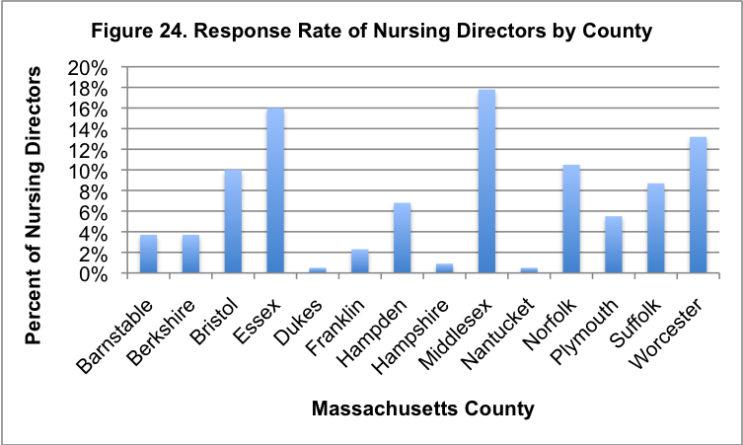

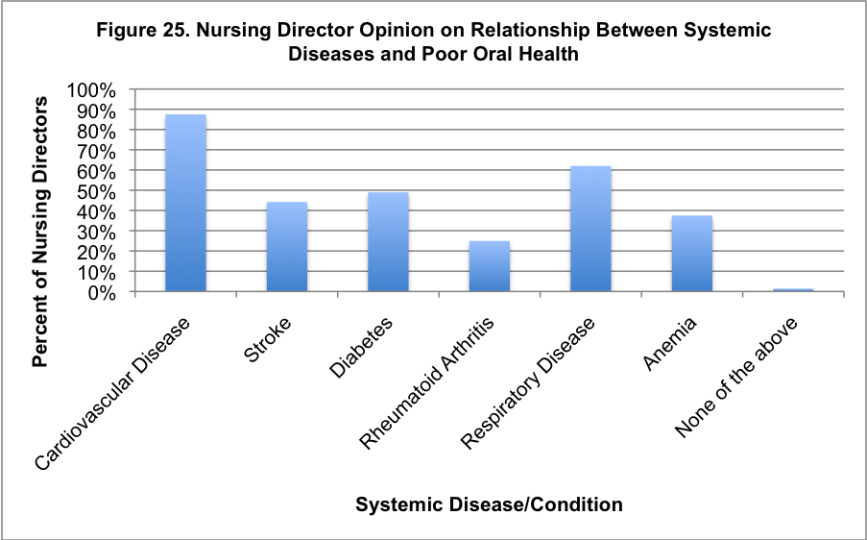

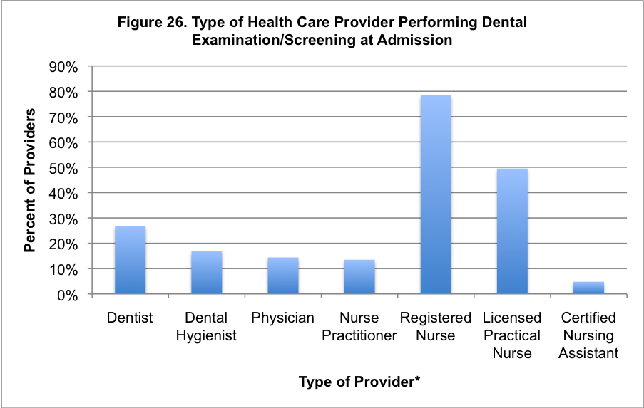
*Providers could choose more than one response.

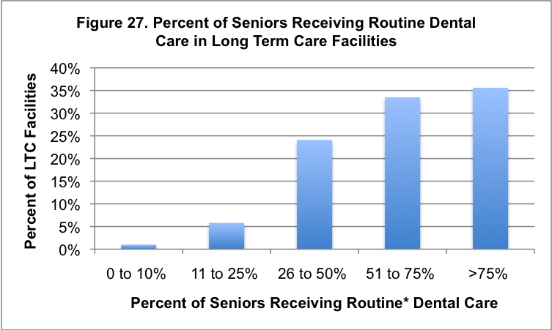
*Routine Dental Care includes cleanings, exams, fillings, and fabrication/repair of dentures.

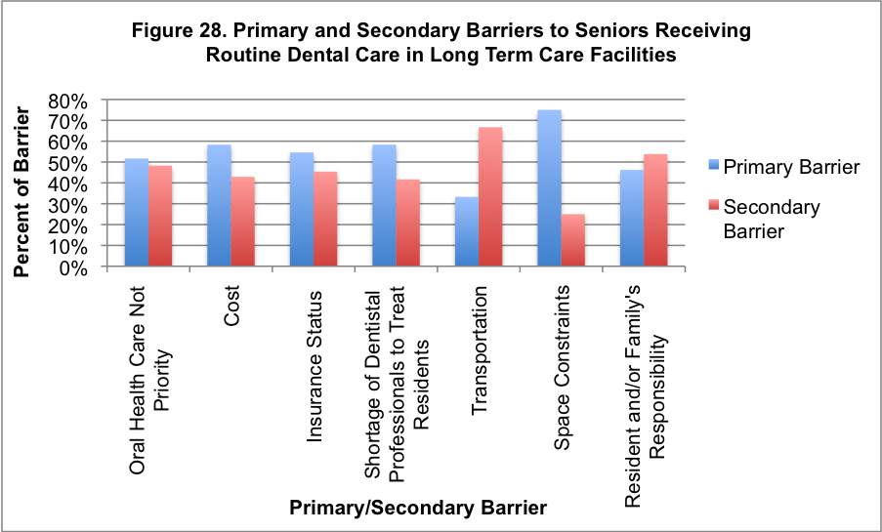

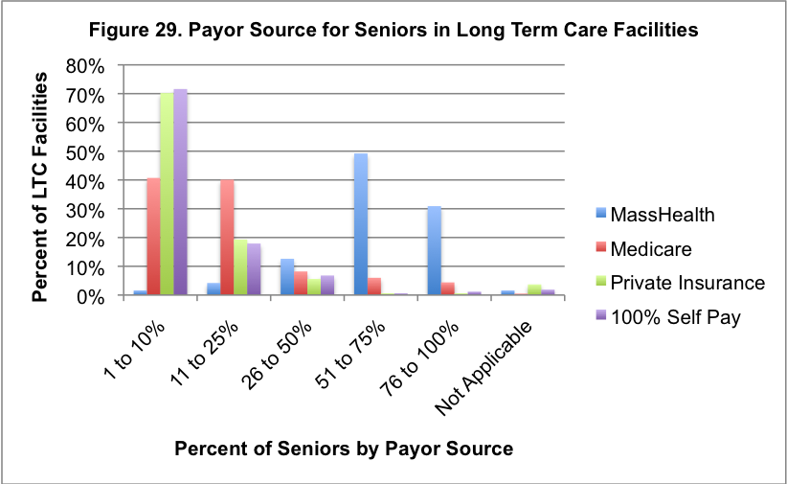

Prevention Strategies

As an individual ages, oral and dental diseases are commonly experienced; however, with advances in oral disease prevention and treatment, is it no longer the norm to “age into dentures”. While everyone who has teeth is susceptible to dental disease, the promotion and expanding availability of prevention strategies has made a significant impact on the retention of teeth. In fact, 14% of Massachusetts residents 65 to 74 years of age self-reported having no natural teeth compared to 22% nationally.25
Water fluoridation is the most cost-effective and efficient means for preventing tooth decay for all age groups, including seniors.

Community Water Fluoridation
For more than 65 years community water fluoridation has been preventing tooth decay by as much 65% in deciduous (baby) teeth and 35% in permanent (adult) teeth. Water fluoridation has both a systemic and topical effect. Water fluoridation is the most cost-effective and efficient means for preventing tooth decay for all age groups, including seniors. In 1951, Massachusetts began fluoridating its own community water supplies; currently, there are more than 3.9 million residents living in 141 communities receiving this health and economic benefit in Massachusetts.

Topical Fluorides
Topical fluoride is applied directly to the outer tooth surface to prevent tooth decay. Though topical fluorides prevent tooth decay by as much as 30% when applied regularly, rarely is this prevention strategy covered by dental or medical insurers for adults, even those at highest-risk for developing tooth decay. The most common form of topical fluoride is found in toothpaste. Topical fluorides applied by dental professionals come in the form of a gel, foam or varnish. Fluoride varnish, though as effective as other topical fluorides, may be considered more efficient because of the extended time it is in contact with a tooth’s surfaces. It is a useful, simple, quick and non-invasive method for the control and management of existing root caries lesions. It is not uncommon for professionals other than dentists and dental hygienists to apply fluoride varnish. Currently, pediatric medical providers in certain circumstances may apply fluoride varnish as part of well-visits and be reimbursed by some insurers.

The advent of fluoride in toothpaste began in 1956, with the national release of the first fluoride toothpaste with the slogan, “Look, Mom, no cavities!” In addition, there were professional advertisements for dentists encouraging their recommendation of fluoride toothpaste “for every member of the family”. Not only did the addition of fluoride to toothpaste serve as a complement to community water fluoridation for the prevention of tooth decay, it served to promote the value of accessing professional dental care. Since World War II there has been a marked and steady increase in the percentage of the population who utilize dental services which has made a positive impact on the number of seniors who, in the first decade of this century, have at least some natural teeth and optimal oral health.

Overview

Over the past decade the majority of attention, both in this state and across the nation, improving and promoting children’s oral health. The lessons learned over the past ten years should now be used to expand the focus to seniors.
Even seniors with no natural teeth require attention to oral health.
Historically, the attention paid to this growing adult population, the “Greatest Generation”, “Silent Generation” or “Baby Boomer” generation has been the result of the impact that their aging will have on the economy and healthcare financing; with little attention being paid to their oral health status.

A healthy mouth is linked to overall health and well being including chewing, eating and proper nutrition, the absence of dental pain, enhanced personal relationships, communication, employability and feeling good about one’s personal appearance. Even seniors with no natural teeth require attention to oral health.

Seniors have experienced many advances in health care over the years, including access to life-saving treatments and an ever-expanding range of prescription drugs. They have also experienced advances in dentistry including an emphasis on oral health education and promotion, advanced restorative procedures, expanded access to private
Seniors in Massachusetts are experiencing unmet oral health needs.
employer-paid dental insurance, and, most importantly, access to community water fluoridation and topical fluoride in toothpaste.

Yet, in spite of these advances, seniors in Massachusetts experience unmet oral health needs. This oral health assessment of two high-risk senior population groups showed that:

- Nearly 20% of seniors served by meal sites that were surveyed have not had a dental visit in more than 5 years and 79% of these seniors don’t have dental insurance.
- 10% of seniors at meal sites that were surveyed with no natural teeth also had no dentures.
- 74% of seniors at long term care facilities that were surveyed had gingivitis, and 59% had untreated decay.
- 62% of all seniors screened (both population groups) with untreated decay also experienced xerostomia.

Recommendations

Based on the findings of this statewide oral health assessment and survey of nursing directors, the Department of Public Health recommends the following:

1. Establishment of a special working group under the direction of the Department of Public Health Office of Oral Health, consisting of state agencies and institutions and organizations of dental, medical and senior services providers with a targeted interest in seniors. The purpose of the working group is to develop recommendations, guidelines, and policies to improve the oral health of seniors.
Establishment of a special working group to develop recom-
mendations, guidelines, and policies to improve the oral health of seniors.

The recommendations, guidelines and polices at a minimum would address the following:

- How to promote dental and oral screenings being performed by a licensed dental professional within a reasonable time period of a patient’s admission to a long term care or nursing facility to assess the need for dental care and promote healthy aging.
- How to promote the active participation of a dental professional on the multi-disciplinary team which develops the residents’ care plan in long term care facilities.
- Inclusion and implementation of a dental care plan in the long term care facility residents’ individualized care plan to assist in the establishment of daily oral hygiene regimens and that cue or assist residents with their daily oral hygiene practices.
- Develop and promote the availability of routine oral health in-service education for all nursing staff in long term care and nursing facilities to increase understanding of the association between oral health and systemic health, and the knowledge of the etiology of oral and dental diseases, and oral health prevention strategies to promote healthy aging.
Examine and recommend models for coverage of preventive dental care in private and public medical (health) insurance plans for adults 65 years of age and older.
2. Promote the utilization of the public health dental hygiene workforce in long term care and nursing facilities, senior housing, and other settings serving seniors to reduce disparities, and improve direct access to preventive care to those at highest-risk for dental disease.

3. Promote the training of physicians and nurses to perform oral health assessments, oral cancer screenings and applying fluoride varnish as part of an annual well-visit to foster the early identification of oral health concerns, soft tissue lesions, and to prevent tooth decay.

4. Examine and recommend models for coverage of preventive dental care in private and public medical (health) insurance plans for adults 65 years of age and older to promote optimal oral health..

5. Promote the incorporation of the oral health needs of seniors in dental and dental hygiene education, as well as continuing education courses; and the use of portable dental equipment in long term care facilities and other settings serving seniors to increase access.

Glossary of Terms

Activities Daily Living (ADL): The things a person normally does on routine basis, including any daily activity performed for self-care, which includes feeding, bathing, dressing, dressing, and grooming (tooth brushing).

Basic Screening Survey (BSS): Developed by the Association of State and Territorial Dental Directors, the BSS is a means of measuring dental caries prevalence within a population.

Cardiovascular Disease: A term that refers to various diseases of the heart and blood vessels.

Caries (Cavities or Dental Decay): A progressive, destructive chronic disease caused by bacteria that damage the hard tooth structures, enamel, dentin and cementum. The damage caused by caries is called a cavity also known as tooth decay.

Chronic Condition: A prolonged condition or illness that requires ongoing medical treatment.

Community Water Fluoridation: Community water fluoridation is the upward adjustment of the concentration of fluoride of a community water supply for optimal oral health. Optimal fluoride levels in Massachusetts are 0.9-1.2 ppm.

Dental (Oral) Screening: A brief exam of the oral cavity to detect any signs and symptoms of dental diseases.

Dentures: A removable dental appliance that replaces missing teeth; either partial or full.

Diabetes: A chronic disease in which the body does not produce or properly use insulin. Insulin is a hormone that is needed to convert sugar, starches and other food into energy needed for daily life.

Dietician: A health professional who provides counseling in nutrition and diet planning for people with or without medical conditions.

Disability: American’s with Disability Act defines disability as a physical or mental impairment that substantially limits one or more of the major life activities of an individual, a record of an impairment or being regarded as having an impairment.

Edentulism: A partial or complete loss of teeth.

Enzymes: Specialized proteins that assist with naturally occurring biological functions of the body.

Etiology: Various causes of a disease or disorder.

Fluoride: A form of fluorine, a naturally occurring mineral found in all water sources, including the ocean. The fluoride ion comes from the element fluorine. Fluorine is the 17th most abundant element in the earth's crust.

Fluoride Varnish: A highly concentrated (~22,000 ppm) topical application of fluoride which may prevent tooth decay by as much as 30%. Fluoride varnish has been used in Europe for the last 30 years. The use of fluoride varnish to prevent tooth decay is an off-label use. The Food and Drug Administration (FDA) recognizes fluoride varnish as a desensitizing agent and cavity liner.

Gingival (gum) Recession: Receding or movement of the gum tissue, resulting in exposure on the roots of the teeth.

Gingivitis: A reversible gum disease which may cause bleeding and/or swelling of the gums; may lead to a more serious gum disease.

Incidence: Total number of newly diagnosed cases of a disease, condition or illness in a population at a given time period.

Infection: A disease that can be transmitted from one person to another.

Mandibular: A term pertaining to the lower jaw.

Maxillary: A term pertaining to the upper jaw.

Medicaid: A federal-state program established in 1965 that provides health insurance coverage for low income individuals and families, as well as those with disabilities. Payment of the coverage is split 50:50 by the state and federal government. In Massachusetts the Medicaid program is referred to as MassHealth.

Medicare: A federal program established in 1965 that provides health insurance coverage for individuals 65 years of age and older and those that are disabled. Medicare is not based on income-eligibility and includes very limited, highly specialized dental coverage.

Pathology: Various characteristics of a disease or disorder.

Periodontal Disease: An irreversible and serious gum disease which permanently destroys periodontal tissue, such as periodontal ligaments and bone that support the teeth.

Pharynx: Part of the neck and throat which sits directly behind the mouth. It is comprised of:

Nasopharynx: The nasopharynx lies behind the nasal and oral cavities.

Oropharynx: The oropharynx lies behind the oral cavity.

Hypopharynx: The hypopharynx lies below the epiglottis and extends to the larynx where the respiratory and digestive pathways diverge.

Tonsils: The tonsils are areas of lymphoid tissue on either side of the throat.

Pneumonia: A serious respiratory disease caused by inflammation of the lungs.

Bacterial Pneumonia: A type of pneumonia caused by a bacterial infection.

Prevalence: Total number of existing cases of a disease, condition or illness in a population at a given time period.

Public Health Dental Hygienist: A "public health dental hygienist" (PHDH) is a new category of dental hygienist that provides preventive care for vulnerable population groups. A PHDH works in a public health setting without the supervision of a dentist.

Xerostomia: A medical condition known as “dry mouth” caused by a lack of saliva. The condition may be caused from medication-use, diabetes or another underlying medical condition.

Data Tables

Table 1: Number of individuals screened by setting
Setting | Frequency | Percent
Meal Site | 212 | 20.3%
Long Term Care Facility | 834 | 79.7%
Total | 1,046 | 100.0%

Table 2: Age of individuals screened by setting
 | Meal Site |  | Long Term Care Facility
Age Group | Frequency | Percent | Frequency | Percent
60 - 64 | 23 | 10.8% | 28 | 3.4%
65 - 70 | 39 | 18.4% | 41 | 4.9%
71 - 74 | 36 | 17.0% | 46 | 5.5%
75 - 79 | 33 | 15.6% | 81 | 9.7%
80 - 85 | 42 | 19.8% | 187 | 22.4%
86 - 89 | 25 | 11.8% | 176 | 21.1%
Over 90 | 13 | 6.1% | 270 | 32.4%
Unknown | 1 | 0.5% | 5 | 0.6%
Total | 212 | 100.0% | 834 | 100.0%

Table 3: Race/ethnicity of individuals screened by setting
 | Meal Site |  | Long Term Care Facility
Race | Frequency | Percent | Frequency | Percent
White | 188 | 88.7% | 781 | 93.6%
Black | 11 | 5.2% | 24 | 2.9%
Asian | 5 | 2.4% | 7 | 0.8%
Hispanic | 4 | 1.9% | 22 | 2.6%
PacIsland | 3 | 1.4% | 0 | 0.0%
Unknown | 1 | 0.5% | 0 | 0.0%
Total | 212 | 100.0% | 834 | 100.0%

Table 4: Gender of individuals screened by setting
 | Meal Site |  | Long Term Care Facility
Gender | Frequency | Percent | Frequency | Percent
Female | 142 | 67.0% | 627 | 75.2%
Male | 70 | 33.0% | 207 | 24.8%
Total | 212 | 100.0% | 834 | 100.0%

Table 5: Number & percent of meal site participants with a dentist
Has a Dentist | Frequency | Percent
No | 71 | 33.5%
Yes | 141 | 66.5%
Total | 212 | 100.0%

Table 6: Time since last dental visit for meal site participants
Last Dental Visit | Frequency | Percent
< 6 months | 67 | 31.6%
6 months to 1 year | 38 | 17.9%
1 to 2 years | 39 | 18.4%
2 to 5 years | 18 | 8.5%
Over 5 years | 42 | 19.8%
Unknown | 8 | 3.8%
Total | 212 | 100.0%

Table 7: Number & percent of meal site participants with dental insurance
Has Dental Insurance | Frequency | Percent
No | 168 | 79.2%
Yes | 40 | 18.9%
Unknown | 4 | 1.9%
Total | 212 | 100.0%

Table 8: Number & percent of meal site participants with MassHealth
Has MassHealth | Frequency | Percent
No | 148 | 69.8%
Yes | 55 | 25.9%
Unknown | 9 | 4.2%
Total | 212 | 100.0%

Table 9: Prevalence of total and partial edentulism by setting
 | Meal Site |  | Long Term Care Facility
Edentulism | Frequency | Percent | Frequency | Percent
No teeth present | 41 | 19.3% | 294 | 35.3%
1 arch edentulous | 38 | 17.9% | 141 | 16.9%
Missing multiple teeth+ | 79 | 37.3% | 292 | 35.0%
Had most teeth* | 54 | 25.5% | 107 | 12.8%
+ Missing 3+ teeth in each arch (excluding 3rd molars) but had at least one tooth in each arch
* Missing fewer than 3 teeth in each arch (excluding 3rd molars)

Table 10: Presence of dentures among the fully edentulous elders by setting
 | Meal Site  (n=41) |  | Long Term Care Facility  (n=294)
Dentures Present | Frequency | Percent | Frequency | Percent
Dentures in both arches | 33 | 80.5% | 162 | 55.1%
Denture in 1 arch only | 4 | 9.8% | 78 | 26.5%
No dentures | 4 | 9.8% | 54 | 18.4%

Table 11: Prevalence of teeth lost in the maxillary arch by setting
 | Meal Site |  | Long Term Care Facility
Maxillary Teeth | Frequency | Percent | Frequency | Percent
No teeth present | 76 | 35.8% | 423 | 50.7%
3-15 teeth lost | 70 | 33.0% | 273 | 32.7%
< 3 teeth lost | 66 | 31.1% | 138 | 16.5%
Total | 212 | 100.0% | 834 | 100.0%

Table 12: Absence of a maxillary denture in those partially dentate (missing 3+ maxillary
teeth) by setting
 | Meal Site |  | Long Term Care Facility
Have Maxillary Denture | Frequency | Percent | Frequency | Percent
No | 46 | 31.5% | 300 | 43.1%
Yes | 100 | 68.5% | 396 | 56.9%
Total | 146 | 100.0% | 696 | 100.0%

Table 13: Absence of a maxillary denture in those missing all maxillary teeth by setting
 | Meal Site |  | Long Term Care Facility
Have Maxillary Denture | Frequency | Percent | Frequency | Percent
No | 7 | 9.2% | 81 | 19.1%
Yes | 69 | 90.8% | 342 | 80.9%
Total | 76 | 100.0% | 423 | 100.0%

Table 14: Maxillary denture function in those missing 3+ maxillary teeth by setting
 | Meal Site |  | Long Term Care Facility
Denture Function | Frequency | Percent | Frequency | Percent
Adequate-No discomfort or movement when talking or chewing. | 65 | 65.0% | 221 | 55.8%
Minimal-Comfort varies, fits loosely, has movement when talking or chewing, may need adhesive. | 17 | 17.0% | 83 | 21.0%
None-Uncomfortable, gross movement when talking or chewing, must use adhesive. | 3 | 3.0% | 16 | 4.0%
Unknown-Senior was unable to report/screener was unable to identify. | 15 | 15.0% | 76 | 19.2%
Total | 100 | 100.0% | 396 | 100.0%

Table 15: Maxillary denture function in those missing all maxillary teeth by setting
 | Meal Site |  | Long Term Care Facility
Denture Function | Frequency | Percent | Frequency | Percent
Adequate | 49 | 71.0% | 196 | 57.3%
Minimal | 11 | 15.9% | 71 | 20.8%
None | 1 | 1.4% | 14 | 4.1%
Unknown | 8 | 11.6% | 61 | 17.8%
Total | 69 | 100.0% | 342 | 100.0%

Table 16: Prevalence of teeth lost in the mandibular arch by setting
 | Meal Site |  | Long Term Care Facility
Mandibular Teeth | Frequency | Percent | Frequency | Percent
No teeth present | 44 | 20.8% | 306 | 36.7%
3-15 teeth lost | 97 | 45.8% | 379 | 45.4%
< 3 teeth lost | 71 | 33.5% | 149 | 17.9%
Total | 212 | 100.0% | 834 | 100.0%

Table 17: Absence of a mandibular denture in those partially dentate (missing 3+
mandibular teeth) by setting
 | Meal Site |  | Long Term Care Facility
Have Mandibular Denture | Frequency | Percent | Frequency | Percent
No | 74 | 52.5% | 458 | 66.9%
Yes | 67 | 47.5% | 227 | 33.1%
Total | 141 | 100.0% | 685 | 100.0%

Table 18: Absence of a mandibular denture in those missing all mandibular teeth by
setting
 | Meal Site |  | Long Term Care Facility
Have Mandibular Denture | Frequency | Percent | Frequency | Percent
No | 9 | 20.5% | 137 | 44.8%
Yes | 35 | 79.5% | 169 | 55.2%
Total | 44 | 100.0% | 306 | 100.0%

Table 19: Mandibular denture function in those missing 3+ mandibular teeth by setting
 | Meal Site |  | Long Term Care Facility
Denture Function | Frequency | Percent | Frequency | Percent
Adequate-No discomfort or movement when talking or chewing. | 35 | 52.2% | 95 | 41.9%
Minimal-Comfort varies, fits loosely, has movement when talking or chewing, may need adhesive. | 18 | 26.9% | 66 | 29.1%
None-Uncomfortable, gross movement when talking or chewing, must use adhesive. | 7 | 10.4% | 28 | 12.3%
Unknown-Senior was unable to report/screener was unable to identify. | 7 | 10.4% | 38 | 16.7%
Total | 67 | 100.0% | 227 | 100.0%

Table 20: Mandibular denture function in those missing all mandibular teeth by setting
 | Meal Site |  | Long Term Care Facility
Denture Function | Frequency | Percent | Frequency | Percent
Adequate | 21 | 60.0% | 69 | 40.8%
Minimal | 10 | 28.6% | 53 | 31.4%
None | 3 | 8.6% | 20 | 11.8%
Unknown | 1 | 2.9% | 27 | 16.0%
Total | 35 | 100.0% | 169 | 100.0%

Table 21: Prevalence of gingivitis among those with 1+ teeth by setting
 | Meal Site |  | Long Term Care Facility
Gingivitis | Frequency | Percent | Frequency | Percent
No | 108 | 63.20% | 127 | 23.5%
Yes | 60 | 35.10% | 400 | 74.1%
Not Applicable | 3 | 1.80% | 13 | 2.4%
Total | 171 | 100.00% | 540 | 100.0%

Table 22: Prevalence of untreated decay among those with 1+ teeth by setting
 | Meal Site |  | Long Term Care Facility
Untreated Decay | Frequency | Percent | Frequency | Percent
No | 112 | 65.50% | 220 | 40.7%
Yes | 59 | 34.50% | 320 | 59.3%
Total | 171 | 100.00% | 540 | 100.0%

Table 23: Treatment urgency (hard tissue) among those with 1+ teeth by setting
 | Meal Site |  | Long Term Care Facility
Hard Tissue Urgency | Frequency | Percent | Frequency | Percent
1: None-No obvious decay or problems were noted (x-rays were not taken). | 112 | 65.5% | 221 | 40.9%
2: Early-Areas of possible decay exist. | 30 | 17.5% | 137 | 25.4%
3: Major-Large areas of decay are suspected. | 23 | 13.5% | 144 | 26.7%
4: Urgent- There is an immediate need for follow-up and/or dental treatment due to pain and/or infection. | 6 | 3.5% | 38 | 7.0%
Total | 171 | 100.0% | 540 | 100.0%

Table 24: Prevalence of xerostomia among those with 1+ teeth by setting
 | Meal Site |  | Long Term Care Facility
Xerostomia | Frequency | Percent | Frequency | Percent
No | 151 | 88.3% | 369 | 68.3%
Yes | 20 | 11.7% | 171 | 31.7%
Total | 171 | 100.0% | 540 | 100.0%

Table 25: Untreated decay among elders with 1+ teeth and xerostomia status
Xerostomia | # of Adults Screened | % with Untreated Decay
No | 520 | 50.0%
Yes | 191 | 62.3%
Total | 711 | 53.3%
p-value = 0.003

Table 26: Untreated decay and xerostomia among elders with 1+ teeth
Untreated Decay | # of Adults Screened | % with Xerostomia
No | 332 | 21.7%
Yes | 379 | 31.4%
Total | 711 | 26.9%
p-value = 0.003

Table 27: Number & percent of individuals with soft tissue pain by setting
 | Meal Site |  | Long Term Care Facility
Pain-Tissue | Frequency | Percent | Frequency | Percent
No | 172 | 81.1% | 809 | 97.0%
Yes | 40 | 18.9% | 25 | 3.0%
Total | 212 | 100.0% | 834 | 100.0%

Table 28: Soft tissue treatment urgency among all elders by setting
 | Meal Site |  | Long Term Care Facility
Soft Tissue Urgency | Frequency | Percent | Frequency | Percent
No-No obvious pathology was noted. | 200 | 94.3% | 781 | 93.6%
Yes-There is an immediate need for follow-up and/or treatment due to possible soft tissue pathology. | 12 | 5.7% | 53 | 6.4%
Total | 212 | 100.0% | 834 | 100.0%

Table 29: Confidence intervals for all long term care facility residents
Variable | Number with Data | Percent with Condition | 95% Confidence Interval
Soft Tissue Pain | 834 | 3.0% | 2.0 - 4.5
Edentulous (no natural teeth) | 834 | 35.3% | 32.0 - 38.6
Need Soft Tissue Dental Care | 834 | 6.4% | 4.8 - 8.3
Xerostomia (dry mouth) | 834 | 31.5% | 28.4 - 34.8

Table 30: Confidence intervals for long term care facility residents with
1+ teeth (dentate residents)
Variable | Number with Data | Percent with Condition | 95% Confidence Interval
Soft Tissue Pain | 540 | 2.2% | 1.2 – 4.0
Hard Tissue Pain | 540 | 4.4% | 2.9 – 6.6
Untreated Decay | 540 | 59.3% | 55.0 – 63.4
Gingivitis | 527 | 75.9% | 72.0 – 79.4
Need Restorative Care  -early, major or urgent- | 540 | 59.1% | 54.8 – 63.2
Need Urgent Restorative Dental Care | 540 | 7.0% | 5.1 – 9.6
Xerostomia (dry mouth) | 540 | 31.7% | 27.8 – 35.8

Table 31: Confidence intervals for long term care facility residents with no natural teeth (edentulous residents)
Variable | Number with Data | Percent with Condition | 95% Confidence Interval
Both Dentures Missing | 294 | 18.4% | 14.1 – 23.3
One or Both Dentures Missing | 294 | 44.9% | 39.1 -50.8
Has Both Dentures | 294 | 55.1% | 49.2 – 60.9

Table 32: Percent of respondents by Massachusetts County
County | Frequency | Percent
Barnstable | 8 | 3.7%
Berkshire | 8 | 3.7%
Bristol | 22 | 10.0%
Essex | 35 | 16.0%
Dukes | 1 | 0.5%
Franklin | 5 | 2.3%
Hampden | 15 | 6.8%
Hampshire | 2 | 0.9%
Middlesex | 39 | 17.8%
Nantucket | 1 | 0.5%
Norfolk | 23 | 10.5%
County | Frequency | Percent
Plymouth | 12 | 5.5%
Suffolk | 19 | 8.7%
Worcester | 29 | 13.2%
Total | 219 | 100%

Table 33: Poor oral health has a relationship with what systemic disease(s)?
(Respondents were allowed to choose more than one response)
Systemic Disease | Percent
Cardiovascular Disease | 87.5%
Stroke | 44.2%
Diabetes | 49.0%
Rheumatoid Arthritis | 25.0%
Respiratory Disease | 62.0%
Anemia | 37.5%
None | 1.4%

Table 34: Health provider performing dental examination/screening at admission
(Respondents were allowed to choose more than one response)
Type of Provider | Percent
Dentist | 26.9%
Dental Hygienist | 16.8%
Physician | 14.4%
Nurse Practitioner | 13.5%
Registered Nurse | 78.4%
Licensed Practical Nurse | 49.5%
Certified Nursing Assistant | 4.8%

Table 35: Percent of seniors receiving routine dental care in long term care

facilities
Seniors Receiving Routine Dental Care | Frequency | Percent
0 to 10% Seniors | 2 | 1.0%
11 to 25% Seniors | 11 | 5.8%
26 to 50% Seniors | 46 | 24.1%
51 to 75% Seniors | 64 | 33.5%
76+ % Seniors | 68 | 35.6%
Total | 191 | 100%

Table 36: Primary and secondary barriers to seniors receiving routine dental

care in long term care facilities
Barrier | Frequency  (Primary/Secondary) | Percent  (Primary/Secondary) | Total  Frequency
Oral Health Care is  Not a Priority | 15/14 | 51.7% / 48.3% | 29
Cost | 49/36 | 58.3% / 42.9% | 84
Insurance Status | 53/44 | 54.6% / 45.4% | 97
Shortage of Dental Professionals | 35/25 | 58.3% / 41.7% | 60
Transportation | 2/4 | 33.2% / 66.7% | 6
Space Constraints | 3/1 | 75.0% / 25.0% | 4
Residents or Family’s Responsibility to Access Dental Care | 6/7 | 46.2% / 53.8% | 13

Table 37: Payor source for seniors in long term care facilities
Seniors | Percent of Payor Source in LTC Facilities
Seniors | Mass Health | Medicare | Private Insurance | 100% Self Pay
1 to 10% | 1.6% | 40.7% | 70.2% | 71.6%
11 to 25% | 4.2% | 40.1% | 19.3% | 17.9%
26 to 50% | 12.6% | 8.2% | 5.6% | 6.8%
51 to 75% | 49.2% | 6.0% | 0.6% | 0.6%
76 to 100% | 30.9% | 4.4% | 0.6% | 1.2%
Not Applicable | 1.6% | 0.5% | 3.7% | 1.9%

The senior oral health assessment and the printing of this Report were partially supported with funding from HRSA’s Grants to State’s to Support Oral Health Workforce Activities; T12HP07701.



Office of Oral Health
Massachusetts Department of Public Health
250 Washington Street
Boston, MA 02108
617-624-6074

Basic Screening Survey: An Approach to Monitoring Community Oral Health. Association of State and Territorial Dental Directors, December 2008
Gibson, Mary Jo, Fox-Grage, Wendy, Houser, Ari. Across the States 2009: Profiles of Long-Term Care and Independent Living- Massachusetts. Eighth Edition. AARP Public Policy Institute. Washington, DC.
Massachusetts Executive Office of Elder Affairs. email communication. March 15, 2010.
Gibson, Mary Jo, Fox-Grage, Wendy, Houser, Ari. Across the States 2009: Profiles of Long-Term Care and Independent Living- Massachusetts. Eighth Edition. AARP Public Policy Institute. Washington, DC.
Massachusetts Executive Office of Elder Affairs. email communication. March 15, 2010.
US Department of Health and Human Services. Oral Health in America: A Report of the Surgeon General. Rockville, MD: US Department of Health and Human Services, National Institute of Dental and Craniofacial Research, National Institutes of Health, 2000.
Massachusetts Department of Public Health Office of Oral Health. The Status of Oral Disease in Massachusetts: The Great Unmet Need 2009. Massachusetts Department of Public Health. 2009.
Centers for Disease Control and Prevention. Healthy Aging: Improving and Extending Quality of Life of Older Americans: At a Glance 2010. Accessed on March 14, 2010 at www.cdc.gov/chronicdisease/resources/publications/AAG/aging.htm
Why Health Reform is Important in Massachusetts. American Association of Retired Persons (AARP). Accessed on February 27, 2010 at assets.aarp.org/rgcenter/health/state_hcb_09_ma.pdf
Division of Medical Assistance; 130 CMR 519.005l; MassHealth coverage types.
The Kaiser Family Foundation, statehealthfacts.org. State Medicaid Fact Sheets, 2006-2007: Massachusetts. Accessed on March 14, 2010 http://www.statehealthfacts.org/mfs.jsp?rgn=23&rgn=1&x=14&y=16
Barnett, ML. The oral-systemic disease connection: An update for the practicing dentist. JADA 2006;137(Suppl):5S-6S.
4 US Department of Health and Human Services. Oral Health in America: A Report of the Surgeon General. Rockville, MD: US Department of Health and Human Services, National Institute of Dental and Craniofacial Research, National Institutes of Health, 2000.
Sreebny LM, Schwartz SS. A reference guide to drugs and dry mouth-2nd ed. Gerodontology. 1997;14:33-47.
Porter SR, Scully C, Hegarty AM. An update of the etiology and management of xerostomia. Oral Surg Oral Med Oral Pathol Oral Radiol Endod. 2004;97:28-46.
US Department of Health and Human Services, Centers for Disease Control and Prevention. http://www.cdc.gov/OralHealth/topics/cancer.htm. Accessed March 14, 2010.
Oral Cancer Foundation. http://oralcancerfoundation.org. Accessed March 14, 2010.
Trude, Sally, Ginsburg, Paul B. An Update on Medicare Beneficiary Access to Physician Services. Issue Brief No. 93, February 2005. http://www.hschange.com/CONTENT/731/. Accessed on March 20, 2010.
Federal Nursing Home Law, 42 CFR 483.20, Accessed March 20, 2010.
Federal Nursing Home Law, 42 CFR 483.25, Accessed March 20, 2010.
Centers for Disease Control and Prevention. Recommendations for using fluoride to prevent and control dental caries in the United States. Morbidity and Mortality Weekly Report 50(2001): 1-42.
Beltran-Aguilar, ED, Goldstein, JW, Lockwood, SA. Fluoride varnishes: A review of their clinical use, cariostatic mechanism, efficacy and safety. J of the American Dental Association. 2000, 131(5): 589-596.
Brailsford, SR, Fiske, J, Gilbert, S, et al. The effects of the combination of chlorhexidine/thymol and fluoride containing varnishes on the severity of root caries lesions in frail institutionalized elderly people. J of Dentistry. 2002, 30(7-8): 319-324.
Petry, Ashley. The invention of Crest: A lucky mistake. J Indiana Dental Association. 2008, (150th Anniversary Issue), 31-37.
Brown, L Jackson. Chapter 20 Dental Services Among Elderly Americans: Utilization, Expenditures, and Their Determinants Improving Oral Health for the Elderly, Springer New York, 2008.
U.S. Department of Health and Human Services. Oral Health in America: A Report of the Surgeon General. Rockville, MD: U.S. Department of Health and Human Services, National Institutes of Health, National Institute of Dental and Craniofacial Research, 2000.

