Massachusetts HIV Epidemiologic Profile
Statewide Report – Data as of 7/1/2025, Accessible MS Word Version, optimized for screen reader use
Please note that while the content of this report is the same as the pdf version, the format and pagination have been modified significantly to optimize use with screen readers to ensure access for audiences who are blind or visually impaired.
Suggested citation:
Massachusetts Department of Public Health, Bureau of Infectious Disease and Laboratory Sciences. Massachusetts HIV Epidemiologic Profile, Statewide Report – Data as of 7/1/2025 https://www.mass.gov/lists/hivaids-epidemiologic-profiles Published December 2025. Accessed [date].
Bureau of Infectious Disease and Laboratory Sciences
Massachusetts Department of Public Health
Dr. Alfred DeMaria, Jr. Campus
305 South Street
Jamaica Plain, MA 02130
Questions about this report
Tel: (617) 983-6560
To reach the Reporting and Partner Services Line
Tel: (617) 983-6999
To speak to the on-call epidemiologist
Tel: (617) 983-6800
Questions about infectious disease reporting
Tel: (617) 983-6801
Requests for additional data
https://www.mass.gov/lists/infectious-disease-data-reports-and-requests
HIV Data Dashboard
https://www.mass.gov/info-details/hiv-data-dashboard
Slide sets for HIV Epidemiologic Profile Reports
https://www.mass.gov/lists/hivaids-epidemiologic-profiles

Contents
LIST OF COMMONLY USED ACRONYMS 3
EXECUTIVE SUMMARY 4
EPIDEMIC AT A GLANCE 9
TRENDS IN HIV INFECTION DIAGNOSES OVER TIME 11
RECENT HIV INFECTION DIAGNOSES 16
PERSONS LIVING WITH HIV INFECTION 22
MORTALITY AMONG INDIVIDUALS WITH HIV 27
GEOGRAPHIC DISTRIBUTION OF HIV INFECTION 34
HIV CARE CONTINUUM 39
SOCIAL VULNERABILITY INDEX 44
TECHNICAL NOTES 45

LIST OF COMMONLY USED ACRONYMS

AFAB | Assigned Female at Birth
AI/AN | American Indian/Alaska Native
AIDS | Acquired Immunodeficiency Syndrome
AMAB | Assigned Male at Birth
API | Asian/Pacific Islander
BIDLS | Bureau of Infectious Disease and Laboratory Sciences
DPH | (Massachusetts) Department of Public Health
HIV | Human Immunodeficiency Virus
HSR | Health Service Region
HTSX | Heterosexual Sex
IDU | Injection Drug Use
MSM | Male-to-Male Sex, Men Who Have Sex with Men
N | Number
N/A | Not Applicable
NH | Non-Hispanic
NIR | No Identified Risk
PLWH | Persons (or Individuals) Living with HIV Infection
Pres. HTSX | Presumed Heterosexual Sex
PR/USD | Puerto Rico/United States Dependency
PWID | Persons Who Inject Drugs

EXECUTIVE SUMMARY
Epidemic at a Glance
- The number of persons living with HIV infection (PLWH) in Massachusetts increased by 13% from 22,078 in 2015 to 24,838 in 2024.
- After ranging from 609 to 654 from 2015 to 2018, the number of new HIV infection diagnoses declined to 529 in 2019. In 2020, the number of new HIV infection diagnoses further declined to 435 and then remained at this lower level in 2021 and 2022, when there were 451 and 448 diagnoses, respectively. However, caution should be used in the interpretation of this decline and subsequent stabilization due to the impact of COVID-19 on access to HIV testing and care services, and case surveillance activities. The number of new HIV infection diagnoses returned to pre-pandemic levels in 2023 (N=546), increasing by 22% compared to the prior year, and then by an additional 10% in 2024 (N=602). The largest increases in HIV diagnoses from 2022 to 2024 were among people born outside the US (by 50% from 211 to 316), Black non-Hispanic individuals (by 61% from 153 to 246), individuals with presumed heterosexual (by 54% from 59 to 91) and male-to-male sex (MSM) exposure modes (by 49% from 169 to 251), individuals under 30 years of age (by 48% from 124 to 184), and individuals diagnosed in the Central (by 64% from 33 to 54) and Northeast HSRs (by 62% from 85 to 138).
- The number of deaths due to any cause among individuals reported with HIV infection increased by 14% from 325 in 2015 to a peak of 369 in 2022 and then decreased by 11% to 330 in 2024.
- Although there have been some reductions in cases over the past ten years, vulnerable and historically marginalized populations remain disproportionately impacted:
  - Men who have sex with men (MSM) continued to represent the largest proportion of new HIV infection diagnoses (41% overall and 56% among individuals assigned male at birth [AMAB] in 2022–2024).
  - Individuals with IDU exposure mode accounted for 33% of deaths among individuals with HIV in 2024 but only 8% of new HIV infection diagnoses in 2022–2024 and 13% of all PLWH on 12/31/2024.
Trends in HIV Infection Diagnoses Over Time
- Disparities persist in number of individuals diagnosed with HIV infection in Massachusetts by sex at birth, place of birth, race/ethnicity, exposure mode, and age.
- Male-to-male sex (MSM) remained the predominant exposure mode from 2015 to 2024.
- The number of reported cases with injection drug use (IDU) as the primary exposure mode increased from 50 in 2015 to a peak of 115 in 2017 and then decreased to 60 in 2019. The increase in 2017 was primarily due to an outbreak among persons who inject drugs (PWID) in the northeast part of the state between 2016 and 2018. Following a focused public health response, the number of HIV infection diagnoses attributed to IDU in the northeast has decreased. However, in early 2019, a new cluster of HIV infection was identified in Boston among PWID who were experiencing or had experienced recent homelessness, and the total statewide number of reported cases with IDU as the primary exposure mode increased to 82 in 2021. Following another focused public health response, the number of HIV infection diagnoses attributed to IDU has decreased by 48% to 43 cases in 2024.
- As of July 1, 2025, a total of 239 cases diagnosed since November 2018 have been investigated and identified as part of the Boston HIV cluster. As it is an active cluster of concern, additional cases will continue to be investigated and added. Continuing trends among those newly diagnosed in the Boston cluster (N=16 cases diagnosed in 2024) include an increase in polysubstance and methamphetamine use.
- The distributions of individuals diagnosed with HIV infection by sex assigned at birth remained relatively stable, while distributions by race/ethnicity, age at diagnosis, and place of birth shifted from 2015 to 2024:
  - The proportion of HIV infection diagnoses among White (non-Hispanic) individuals decreased from 38% to 26%, while it increased from 29% to 41% among Black (non-Hispanic) individuals.
  - The proportion of HIV infection diagnoses among 30–39 year-olds increased from 24% to 34%, while it decreased from 18% to 11% among 50–59 year-olds.
  - The proportion of HIV infection diagnoses among individuals born in the US decreased from 56% to 46%, while it increased from 37% to 52% among individuals born outside the US.
Recent HIV Infection Diagnoses
- Those with no identified risk (NIR) comprised the second largest exposure mode group reported to the Massachusetts Department of Public Health (DPH), accounting for 29% of recent HIV infection diagnoses and consisting predominantly of individuals AMAB (75%), individuals born outside the US (63%), and Black (non-Hispanic) individuals (52%). Beginning in 2019, all new diagnoses of HIV infection were assigned to field epidemiologists for partner services, education, and linkage to HIV care. Please note that although field epidemiologists offer additional support in the collection of risk information as part of this process, some of the information doesn’t meet the CDC-defined exposure mode categories. For example, risks occurring outside the US, such as transfusion/transplant risk (blood product), are not assigned as a primary exposure mode because it is not possible to verify the information internationally, so these cases would be assigned no identified risk. DPH will collect and maintain expanded risk information for local analyses and future use in case the CDC-defined exposure mode categories are updated.
- One in ten (10%) individuals AFAB and diagnosed with HIV infection from 2022 to 2024 reported IDU as their primary exposure mode, compared to one in 14 (7%) individuals AMAB.
- Black (non-Hispanic) and Hispanic/Latinx individuals were diagnosed with HIV infection during 2022–2024 at rates 13 and six times that of White (non-Hispanic) individuals, respectively.
- During 2022 to 2024, 49% (N=785) of all individuals diagnosed with HIV infection were born outside the US. This proportion varied by race/ethnicity: 70% of Black (non-Hispanic) individuals diagnosed with HIV infection were born outside the US, compared to 67% of Asian/Pacific Islander, 59% of Hispanic/Latinx, and 9% of White (non-Hispanic) individuals. An additional 7% of Hispanic/Latinx individuals diagnosed with HIV infection during this time period were born in Puerto Rico/US Dependencies.
Persons Living with HIV Infection (PLWH)
- Challenges to reducing the disparate impacts of HIV in specific populations remain:
  - Racial/ethnic disparities persist among PLWH, and marked differences exist by exposure mode, current gender, place of birth, and geographic region of residence in the state.
  - MSM was the most frequently reported exposure mode, accounting for 40% of PLWH overall and 57% of individuals AMAB living with HIV infection.
  - While 12% of all Massachusetts residents live in the Boston HSR, it is the current residence of 28% of PLWH.
Mortality Among Individuals Reported with HIV
- Disparities in mortality among individuals reported with HIV paralleled those in diagnosis rates by sex assigned at birth and race/ethnicity but not exposure mode. Individuals with IDU exposure mode were over-represented among HIV-positive individuals who died. The leading causes of death among individuals reported with HIV infection with IDU and IDU/MSM exposure mode who died in 2023 (with a known cause) were external causes of injuries and poisonings (which includes opioid overdoses) which accounted for 37% (N=45/122) of deaths, cancer which accounted for 17% (N=21/122) of deaths, and HIV which accounted for 13% (N=16/122) of deaths.
- The average age at death among individuals reported with HIV increased by 4.5 years, from 56.5 years in 2015 to 61.0 years in 2024. For comparison, the average age at death of the general Massachusetts population remained between 75.1 and 76.8 from 2014 to 2023.
- Survival of individuals diagnosed with AIDS has increased over time. In the earliest cohort of AIDS diagnoses (1990–1994), estimated survival at five years after AIDS diagnosis was 32%, compared to 89% in the most recent cohort (2020–2024).
- The proportion of deaths among individuals reported with HIV infection attributed to HIV-related causes decreased from 31% (N=89/284) in 2015 to 17% (N=51/307) in 2023. The leading non HIV-related causes of death among individuals reported with HIV infection who died in 2023 (with a known cause) were external causes of injuries and poisonings (which includes opioid overdoses) and cancer which both accounted for 22% (N=67/307) of deaths, and heart disease which accounted for 9% (N=26/307) of deaths.
Geographic Distribution of HIV Infection
- The cities and towns with the highest average annual rate of HIV infection diagnosis during 2022 to 2024 included Brockton (30.3 per 100,000), Everett (21.1), Chelsea (19.6), Randolph (18.1), and Boston (17.4). Boston had the highest number of new HIV infection diagnoses from 2022–2024 (N=352), followed by Brockton (N=96).
- Suffolk County was selected as one of 48 counties nationally that was prioritized for funding in the U.S. Health and Human Services initiative “Ending the HIV Epidemic (EHE): A Plan for America.” Suffolk County had the highest average age-adjusted rate of HIV infection diagnosis during 2022 to 2024 among all Massachusetts counties at 14.7 per 100,000.
The Massachusetts HIV Care Continuum
- Among 513 individuals newly diagnosed with HIV infection in 2023 (and alive in Massachusetts through 2024), 85% overall achieved viral suppression, increasing to 90% among those linked to care, and to 93% among those retained in care. Viral suppression was lowest among individuals with IDU exposure mode (56% compared to 81% to 90% among other exposure modes).
- Among 23,515 persons living with HIV infection (PLWH) in Massachusetts at the end of 2024 (and diagnosed through 2023), 64% were virally suppressed, 4% were not virally suppressed, and 33% did not have a viral load test done in 2024. Viral suppression increased to 90% among those engaged in care and to 94% among those retained in care. Please note that the rate of viral suppression may be underestimated as the total number of PLWH used to calculate these rates includes all individuals who have ever been diagnosed with HIV infection in Massachusetts, with no evidence of death or having moved out of the state or country. See the section, Massachusetts HIV Care Continuum – PLWH for more information.

EPIDEMIC AT A GLANCE
The number of persons living with HIV infection (PLWH) in Massachusetts increased by 13% from 22,078 in 2015 to 24,838 in 2024. After ranging from 609 to 654 from 2015 to 2018, the number of new HIV infection diagnoses declined to 529 in 2019. In 2020, the number of new HIV infection diagnoses further declined to 435 and then remained at this lower level in 2021 and 2022, when there were 451 and 448 diagnoses, respectively. However, caution should be used in the interpretation of this decline and subsequent stabilization due to the impact of COVID-19 on access to HIV testing and care services, and case surveillance activities. The number of new HIV infection diagnoses returned to pre-pandemic levels in 2023 (N=546), increasing by 22% compared to the prior year, and then increased by an additional 10% in 2024 to 602. The number of deaths due to any cause among individuals reported with HIV infection increased by 14% from 325 in 2015 to a peak of 369 in 2022 and then decreased by 11% to 330 in 2024.
FIGURE 1: History of the HIV epidemic, Massachusetts 2015–2024
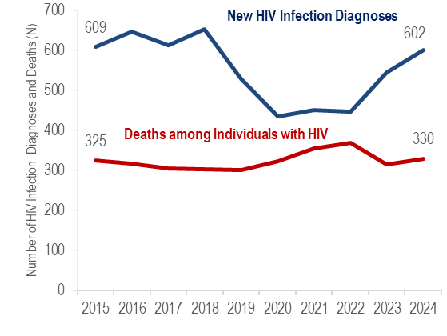
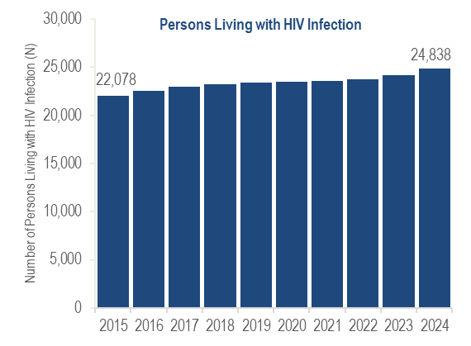

N = 602 New HIV diagnoses in MA in 2024
N = 24,838 Persons living with HIV infection in MA as of 12/31/2024
N = 330 Deaths among individuals reported with HIV in MA in 2024
Men who have sex with men (MSM) continued to represent the largest proportion of new HIV infection diagnoses: 41% of all new HIV infection diagnoses in 2022–2024, and 56% among individuals assigned male at birth (AMAB).
During 2022–2024, the HIV infection diagnosis rates among Black (non-Hispanic) and Hispanic/Latinx individuals were 13 and six times that of White (non-Hispanic) individuals, respectively.
Individuals with injection drug use (IDU) exposure mode accounted for 33% of deaths among individuals reported with HIV in 2024 but only 13% of all PLWH.

TRENDS IN HIV INFECTION DIAGNOSES OVER TIME
FIGURE 2: Trends in HIV infection diagnoses, Massachusetts 2015 – 2024
HIV Infection Diagnoses | 2015 N | 2015 % | 2024 N | 2024 %
Total | 609 | 100% | 602 | 100%
Sex Assigned at Birth
Assigned Male Sex | 447 | 73% | 432 | 72%
Assigned Female Sex | 162 | 27% | 170 | 28%
Race/Ethnicity
White NH | 231 | 38% | 154 | 26%
Black NH | 179 | 29% | 246 | 41%
Hispanic/Latinx | 168 | 28% | 183 | 30%
API | 22 | 4% | 14 | 2%
Other/Unknown | 9 | 1% | 5 | 1%
Age Group (Years)
0-12 | 4 | 1% | 1 | <1%
13-19 | 23 | 4% | 12 | 2%
20-29 | 170 | 28% | 171 | 28%
30-39 | 149 | 24% | 206 | 34%
40-49 | 124 | 20% | 103 | 17%
50-59 | 107 | 18% | 68 | 11%
60-69 | 26 | 4% | 31 | 5%
70+ | 6 | 1% | 10 | 2%
Exposure Mode
MSM | 266 | 44% | 251 | 42%
IDU | 50 | 8% | 43 | 7%
MSM/IDU | 21 | 3% | 11 | 2%
HTSX | 38 | 6% | 26 | 4%
Other | 5 | 1% | 1 | <1%
Pres. HTSX | 65 | 11% | 91 | 15%
NIR | 164 | 27% | 179 | 30%
Place of Birth
US | 344 | 56% | 275 | 46%
PR/USD | 37 | 6% | 11 | 2%
Non-US | 228 | 37% | 316 | 52%
Health Service Region
Boston | 152 | 25% | 137 | 23%
Central | 49 | 8% | 54 | 9%
Metro West | 113 | 19% | 88 | 15%
Northeast | 130 | 21% | 138 | 23%
Southeast | 99 | 16% | 123 | 20%
Western | 55 | 9% | 55 | 9%
Prisoner | 10 | 2% | 7 | 1%
Other/Unknown | 1 | <1% | 0 | 0%

Key Points
From 2015 to 2024, the proportion of HIV diagnoses increased among Black (non-Hispanic) individuals from 29% to 41%, and among people born outside the US from 37% to 52%, indicating an intersection of these two populations. Among individuals recently diagnosed with HIV infection (2022 - 2024), 70% of Black (non-Hispanic) individuals were born outside the US, compared to 67% of Asian/Pacific Islander, 59% of Hispanic/Latinx, and 9% of White (non-Hispanic) individuals.

Overall
The number of new HIV infection diagnoses decreased by 26% from 2015 to 2022 and then increased by 34% in 2024. Distributions by sex assigned at birth remained relatively stable, while distributions by race/ethnicity, age at diagnosis, exposure mode, and place of birth shifted.
By Sex Assigned at Birth
HIV infection diagnoses decreased slightly among individuals AMAB (by 3%, from 447 to 432) and increased slightly among individuals AFAB (by 5%, from 162 to 170).
By Race/Ethnicity
HIV infection diagnoses decreased among Asian/Pacific Islander individuals (by 36%, from 22 to 14) and White (non-Hispanic) individuals (by 33%, from 231 to 154) but increased among Black (non-Hispanic) individuals (by 37% from 179 to 246) and Hispanic/Latinx individuals (by 9% from 168 to 183). The proportion of HIV infection diagnoses among White (non-Hispanic) individuals decreased from 38% to 26%, while it increased from 29% to 41% among Black (non-Hispanic) individuals.
By Age at HIV Infection Diagnosis
HIV infection diagnoses decreased among 0–12 year-olds (from four to one), 13–19 year-olds (by 48%, from 23 to 12), 40–49 year-olds (by 17%, from 124 to 103), and 50–59 year-olds (by 36%, from 107 to 68), but remained stable among 20–29 year-olds (from 170 to 171), and increased among 30–39 year-olds (by 38%, from 149 to 206), 60–69 year-olds (by 19%, from 26 to 31), and 70+ year-olds (from six to 10). The proportion of HIV infection diagnoses among 30–39 year-olds increased from 24% to 34%, while it decreased from 18% to 11% among 50–59 year-olds.
By Exposure Mode
HIV infection diagnoses decreased among individuals with MSM/IDU (by 48%, from 21 to 11), heterosexual sex (by 32%, from 38 to 26), MSM (by 29%, from 320 to 227), and “other” exposure modes (from five to one). All diagnoses in the other category were related to pediatric exposures, with no confirmed clotting factor, transfusion, or transplant-related exposures in the ten-year time period. HIV infection diagnoses increased among individuals with presumed heterosexual sex (by 40%, from 65 to 91) and no identified risk (by 9%, from 164 to 179) exposure modes. The number of reported cases with injection drug use (IDU) as the primary exposure mode increased by 37% from 60 in 2019 to 82 in 2021. This was primarily due to a cluster of HIV infection identified in early 2019 in Boston among PWID who were experiencing or had experienced recent homelessness. Following a focused public health response, the number of HIV infection diagnoses attributed to IDU decreased by 48% from 82 in 2021 to 43 in 2024.
By Place of Birth
HIV infection diagnoses decreased among individuals born in PR/USD (by 70%, from 37 to 11) and individuals born in the US (by 20%, from 344 to 275) and increased among individuals born outside the US (by 39% from 228 to 316). The proportion of HIV infection diagnoses among individuals born in the US decreased from 56% to 46%, while it increased from 37% to 52% among individuals born outside the US.
FIGURE 3: Trends in HIV infection diagnoses by sex assigned at birth, Massachusetts 2015 – 2024

Assigned Male at Birth: | 2015 N | 2015 % | 2024 N | 2024 %
Total | 447 | 100% | 432 | 100%
Race/Ethnicity
White NH | 190 | 43% | 122 | 28%
Black NH | 95 | 21% | 139 | 32%
Hispanic/Latinx | 135 | 30% | 155 | 36%
API | 18 | 4% | 12 | 3%
Other/Unknown | 9 | 2% | 4 | 1%
Age Group (Years)
0-12 | 3 | 1% | 0 | 0%
13-19 | 14 | 3% | 10 | 2%
20-29 | 132 | 30% | 148 | 34%
30-39 | 108 | 24% | 142 | 33%
40-49 | 93 | 21% | 66 | 15%
50-59 | 80 | 18% | 45 | 10%
60-69 | 15 | 3% | 17 | 4%
70+ | 2 | <1% | 4 | 1%
Exposure Mode
MSM | 266 | 60% | 251 | 58%
IDU | 33 | 7% | 24 | 6%
MSM/IDU | 21 | 5% | 11 | 3%
HTSX | 12 | 3% | 13 | 3%
Other | 3 | 1% | 0 | 0%
NIR | 112 | 25% | 133 | 31%
Place of Birth
US | 276 | 62% | 227 | 53%
PR/USD | 28 | 6% | 9 | 2%
Non-US | 143 | 32% | 196 | 45%

Assigned Female at Birth: | 2015 N | 2015 % | 2024 N | 2024 %
Total | 162 | 100% | 170 | 100%
Race/Ethnicity
White NH | 41 | 25% | 32 | 19%
Black NH | 84 | 52% | 107 | 63%
Hispanic/Latinx | 33 | 20% | 28 | 16%
API | 4 | 2% | 2 | 1%
Other/Unknown | 0 | 0% | 1 | 1%
Age Group (Years)
0-12 | 1 | 1% | 1 | 1%
13-19 | 9 | 6% | 2 | 1%
20-29 | 38 | 23% | 23 | 14%
30-39 | 41 | 25% | 64 | 38%
40-49 | 31 | 19% | 37 | 22%
50-59 | 27 | 17% | 23 | 14%
60-69 | 11 | 7% | 14 | 8%
70+ | 4 | 2% | 6 | 4%
Exposure Mode
IDU | 17 | 10% | 19 | 11%
HTSX | 26 | 16% | 13 | 8%
Other | 2 | 1% | 1 | 1%
Pres. HTSX | 65 | 40% | 91 | 54%
NIR | 52 | 32% | 46 | 27%
Place of Birth
US | 68 | 42% | ≥5 | N/A
PR/USD | 9 | 6% | <5 | N/A
Non-US | 85 | 52% | 120 | 71%

Race/Ethnicity by Sex Assigned at Birth
From 2015 to 2024, the number of HIV infection diagnoses decreased 36% among White (non-Hispanic) individuals assigned male at birth (AMAB) and 33% among Asian/Pacific Islander individuals AMAB, while it increased 46% among Black (non-Hispanic) individuals AMAB and 15% among Hispanic/Latinx individuals AMAB. Among individuals assigned female at birth (AFAB), the number of diagnoses increased 27% among Black (non-Hispanic) individuals AFAB, while it decreased 22% among White (non-Hispanic) individuals AFAB and 15% among Hispanic/Latinx individuals AFAB.
Exposure Mode by Sex Assigned at Birth
The number of HIV infection diagnoses decreased among individuals AMAB with MSM, MSM/IDU, and IDU exposure modes, remained relatively stable among those with HTSX exposure mode and increased among those with NIR exposure mode. The number of diagnoses decreased among individuals AFAB with HTSX and NIR exposure modes, remained relatively stable among those with IDU exposure mode, and increased among those with presumed heterosexual exposure mode.
Place of Birth by Sex Assigned at Birth
From 2015 to 2024, the number of HIV infection diagnoses among individuals born in the US and Puerto Rico/US Dependencies decreased for individuals AMAB and AFAB, while the number born outside the US increased among individuals AMAB and AFAB.

RECENT HIV INFECTION DIAGNOSES
Who is most at risk for HIV infection? Recent HIV infection diagnoses are the best available indicator for who is most at risk for HIV infection. Monitoring new diagnoses helps us to determine who is affected and inform effective prevention activities.
FIGURE 4. Percentage of individuals diagnosed with HIV infection by current gender, age, race/ethnicity, and exposure mode, Massachusetts 2022 – 2024 (N=1,596)
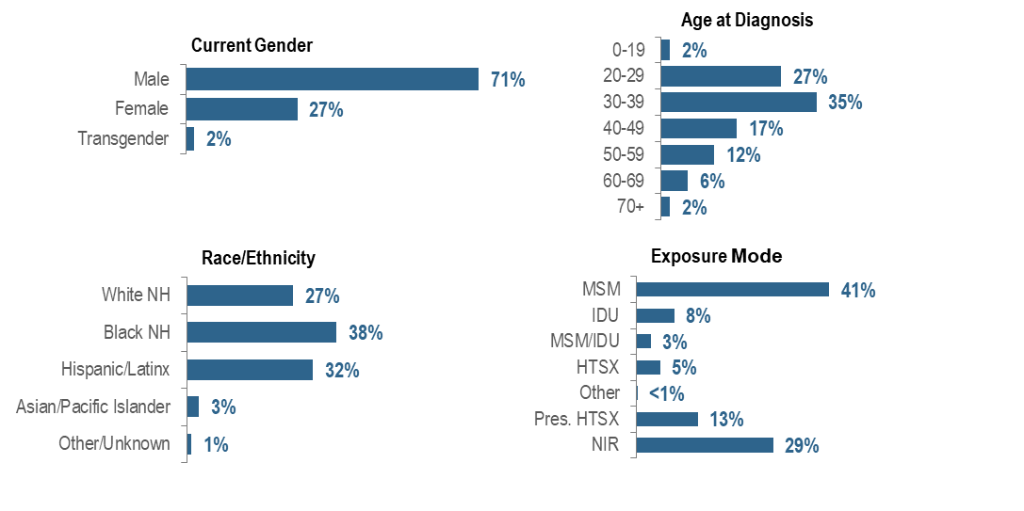
Disparities in the number of individuals diagnosed with HIV infection persist by current gender, exposure mode, and race/ethnicity in Massachusetts. Individuals newly diagnosed with HIV infection in Massachusetts during 2022–2024 were predominantly male (71%), young (27% 20–29 year-olds and 35% 30–39 year-olds), Black (non-Hispanic) (38%), with an exposure mode of MSM (41%). While MSM was the leading exposure mode, a large percentage of new HIV infection diagnoses had no identified risk (29%).

FIGURE 5. Percentage of individuals diagnosed with HIV infection by race/ethnicity and place of birth, Massachusetts 2022 – 2024
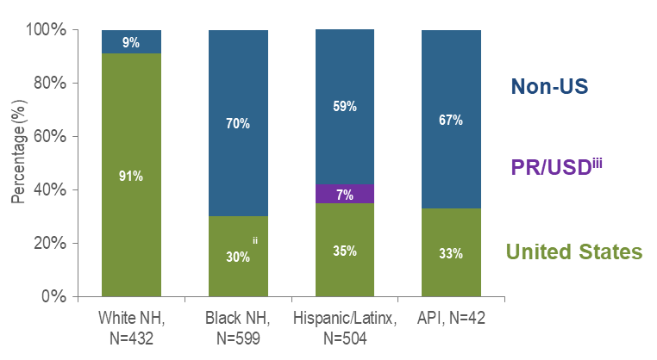

Figure 5 Notes: ^{ii} US born and Puerto Rico/USD categories are combined for Black (non-Hispanic) individuals due to small numbers to adhere to cell suppression rules
^{iii} 97% of individuals diagnosed with HIV infection from 2022–2024 who were born in a US dependency (USD) were born in Puerto Rico (PR)

Seventy percent of Black (non-Hispanic) individuals diagnosed with HIV infection during 2022–2024 were born outside the US, compared to 67% of Asian/Pacific Islander, 59% of Hispanic/Latinx, and 9% of White (non-Hispanic) individuals.

FIGURE 6. Percentage of individuals diagnosed with HIV infection by race/ethnicity, age, exposure mode, and place of birth by sex assigned at birth, Massachusetts 2022 – 2024
(AMAB, N=1,162; AFAB, N=396)
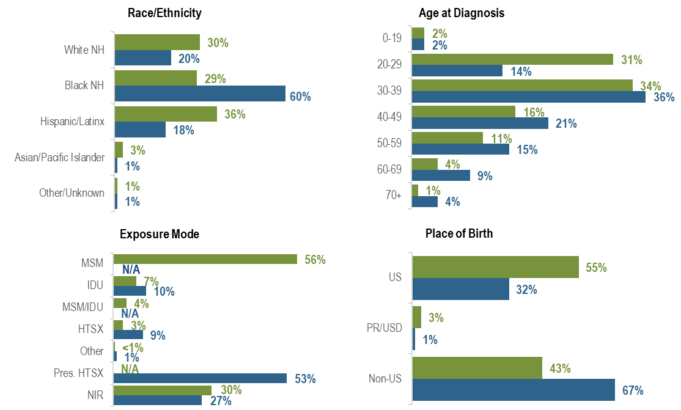
The distributions of new HIV infection diagnoses by race/ethnicity, age, exposure mode, and place of birth varied by sex assigned at birth: the largest proportion of individuals assigned male at birth (AMAB) was Hispanic/Latinx (36%), while the largest proportion of individuals assigned female at birth (AFAB) was Black (non-Hispanic) (60%). A larger proportion of individuals AMAB (31%) than AFAB (14%) was diagnosed between the ages of 20 and 29 years. MSM was the predominant exposure mode among individuals AMAB (56%), while presumed heterosexual sex was the predominant exposure mode among individuals AFAB (53%). A larger proportion of individuals AFAB (67%) than AMAB (43%) was born outside the US.

FIGURE 7. Percentage of individuals diagnosed with HIV infection by exposure mode and race/ethnicity, Massachusetts 2022 – 2024
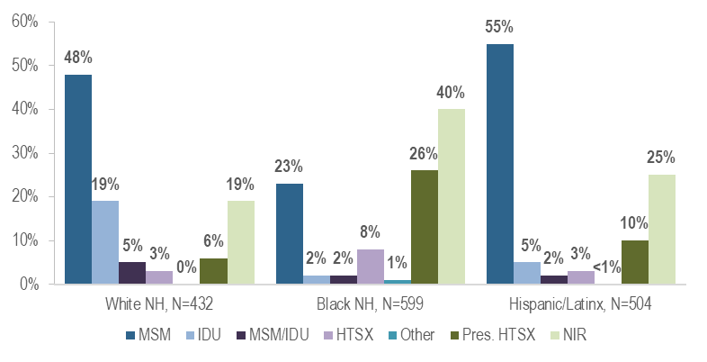
While the predominant exposure mode among White (non-Hispanic) and Hispanic/Latinx individuals recently diagnosed with HIV infection was MSM (48% and 55%, respectively), the largest proportion of Black (non-Hispanic) individuals was assigned no identified risk for exposure mode (40%). Of the Black (non-Hispanic) individuals assigned NIR, 79% (N=190/239) were non-US born. Please note that although field epidemiologists offer additional support in the collection of risk information, some of the information doesn’t meet the CDC-defined exposure mode categories. For example, risks occurring outside the US, such as transfusion/transplant risk (blood product), are not assigned as a primary exposure mode because it is not possible to verify the information internationally, so these cases would be assigned no identified risk.

HIV does not affect all Massachusetts residents equally. One way to understand which populations are experiencing differential impacts is to compare rates of HIV diagnosis per 100,000 population.
FIGURE 8. Average annual age-adjusted HIV diagnosis rates per 100,000 population by sex assigned at birth and race/ethnicity, Massachusetts 2022 – 2024 (N=1,596)
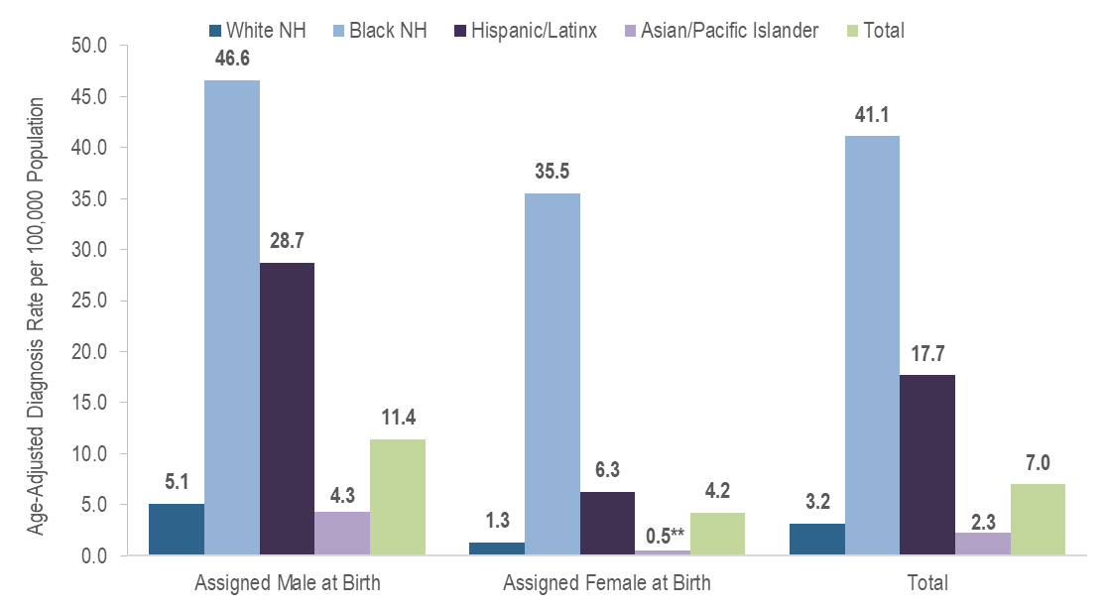
Figure 8 Note: **Rates based on numerators <12 are marked with an asterisk (**) and should be interpreted with caution.
In 2022 – 2024, the average annual age-adjusted HIV diagnosis rate per 100,000 population of individuals assigned male at birth (AMAB) was nearly three times that of individuals assigned female at birth (AFAB). There were large disparities in average annual age-adjusted HIV diagnosis rates for 2022 to 2024 by race/ethnicity. Compared to the rate among White (non-Hispanic) individuals, the rate among:
- Black (non-Hispanic) individuals was 13 times greater, and
- Hispanic/Latinx individuals was six times greater.
With respect to differences based on race/ethnicity and sex assigned at birth, the average annual age-adjusted HIV diagnosis rate for 2022 to 2024 among:
- Black (non-Hispanic) individuals assigned male at birth (AMAB) was nine times that of White (non-Hispanic) individuals AMAB,
- Hispanic/Latinx individuals AMAB was six times that of White (non-Hispanic) individuals AMAB,
- Black (non-Hispanic) individuals assigned female at birth (AFAB) was 28 times that of White (non-Hispanic) individuals AFAB, and
- Hispanic/Latinx individuals AFAB was five times that of White (non-Hispanic) individuals AFAB.

PERSONS LIVING WITH HIV INFECTION
Who is currently living with HIV infection? The number of persons living with HIV infection (PLWH) reflects the impact of HIV in Massachusetts.
FIGURE 9. Percentage of PLWH by current gender, age, race/ethnicity, and exposure mode, Massachusetts 2024 (N=24,838)
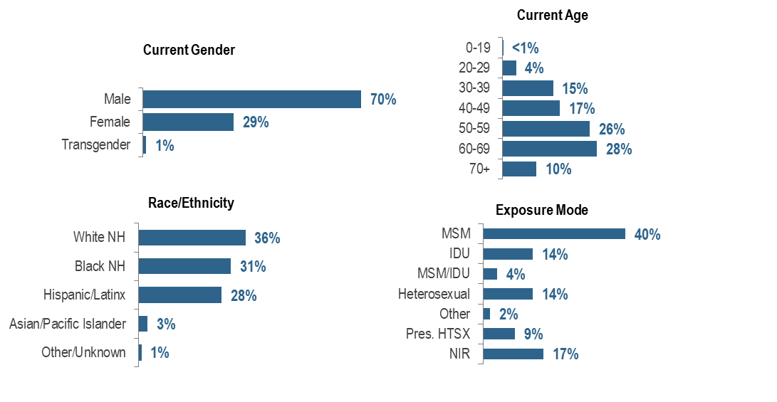
Racial/ethnic disparities persist among PLWH, and marked differences exist by current gender, age, and exposure mode. PLWH in Massachusetts are predominantly male (70%), older (38% aged 60+ years), and White non-Hispanic (36%). Male-to-male sex was the most frequently reported exposure mode, at 40%.

FIGURE 10. Percentage of PLWH by race/ethnicity and place of birth, Massachusetts 2024
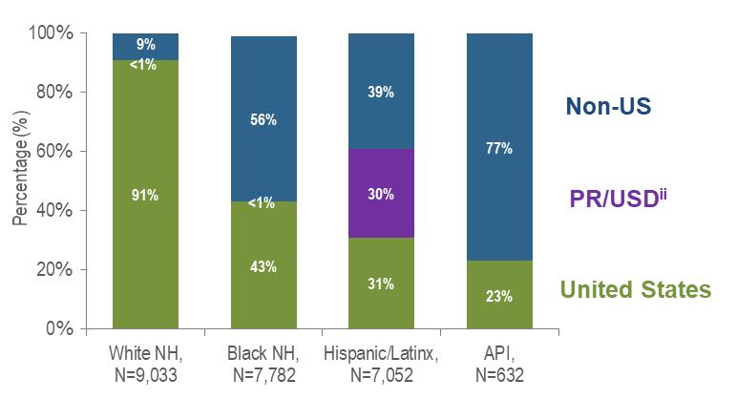

Figure 10 Note: ^{ii} 98% of PLWH on 12/31/2024 who were born in a US dependency were born in Puerto Rico

A total of 77% of Asian/Pacific Islander PLWH in Massachusetts in 2024 were born outside the US, compared to 56% of Black (non-Hispanic), 39% of Hispanic/Latinx, and 9% of White (non-Hispanic) PLWH. An additional 30% of Hispanic/Latinx PLWH were born in Puerto Rico/US Dependencies.

FIGURE 11. Percentage of persons living with HIV infection (PLWH) by race/ethnicity, age, exposure mode, and place of birth by sex assigned at birth, Massachusetts 2024
(Assigned Male at Birth, N= 17,591; Assigned Female at Birth, N= 7,247)

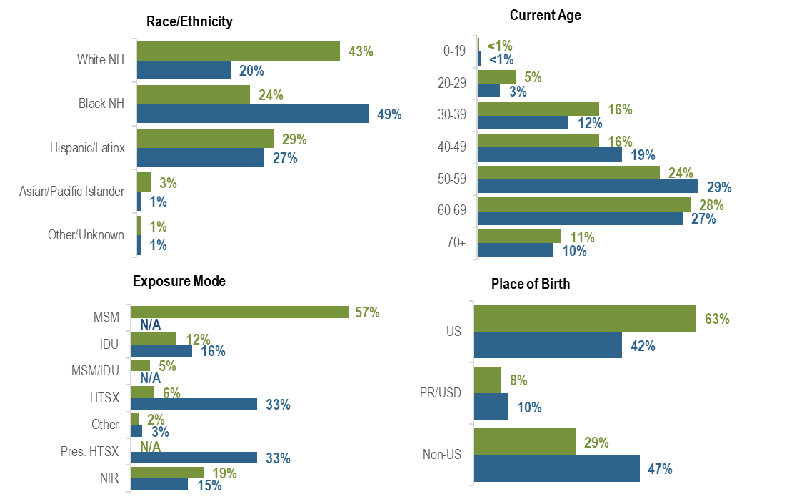
The distributions of PLWH by race/ethnicity, exposure mode, and place of birth varied by sex assigned at birth: the largest proportion of individuals assigned male at birth (AMAB) living with HIV infection was White (non-Hispanic) (43%), while the largest proportion of individuals assigned female at birth (AFAB) was Black (non-Hispanic) (49%). MSM (57%) was the predominant exposure mode among individuals AMAB compared to heterosexual sex and presumed heterosexual sex (both 33%) among individuals AFAB. A larger proportion of individuals AFAB (47%) than AMAB (29%) was born outside the US.

FIGURE 12. Percentage of PLWH by exposure mode and race/ethnicity, Massachusetts 2024
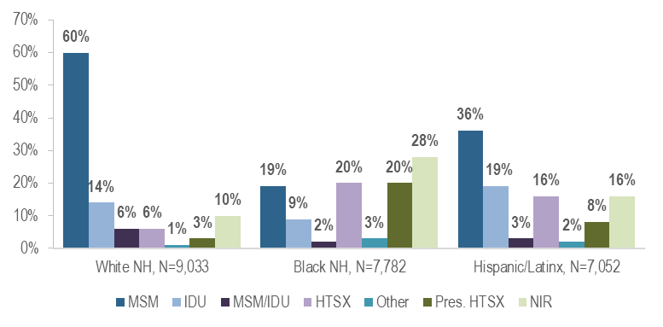
The predominant exposure mode among White (non-Hispanic) PLWH was MSM (60%). Among Black (non-Hispanic) PLWH, the largest proportion was reported with no identified risk (28%), followed by heterosexual sex (20%), presumed heterosexual sex (20%), and MSM (19%). Among Hispanic/Latinx PLWH, the largest proportion was MSM (36%), followed by IDU (19%).
FIGURE 13. Age-adjusted HIV prevalence rates per 100,000 population by sex assigned at birth and race/ethnicity, Massachusetts 2024 (N=24,838)
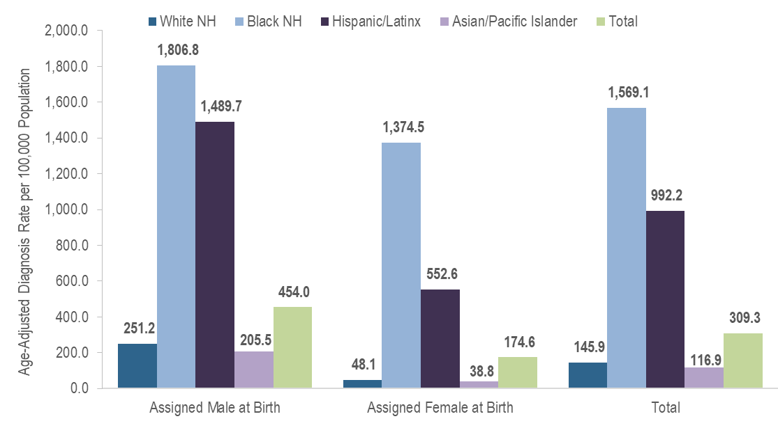

In 2024, the age-adjusted HIV prevalence rate per 100,000 population of individuals assigned male at birth (AMAB) was nearly three times that of individuals assigned female at birth (AFAB). There were large disparities in age-adjusted prevalence rates by race/ethnicity. Compared to the rate among White (non-Hispanic) individuals, the rate among:
- Black (non-Hispanic) individuals was 11 times greater, and
- Hispanic/Latinx individuals was seven times greater.
With respect to differences based on race/ethnicity and sex assigned at birth, the age-adjusted HIV prevalence rate among:
- Black (non-Hispanic) individuals AMAB was seven times that of White (non-Hispanic) individuals AMAB,
- Hispanic/Latinx individuals AMAB was six times that of White (non-Hispanic) individuals AMAB,
- Black (non-Hispanic) individuals AFAB was 29 times that of White (non-Hispanic) individuals AFAB, and
- Hispanic/Latinx individuals AFAB was 11 times that of White (non-Hispanic) individuals AFAB.

MORTALITY AMONG INDIVIDUALS WITH HIV
Who is dying with HIV and how has this changed over time?
In 2023, 53 deaths among Massachusetts residents were attributed to HIV-related causes (generally, opportunistic illnesses, for a full list of stage-3 defining opportunistic illnesses, see: https://www.cdc.gov/mmwr/preview/mmwrhtml/rr6303a1.htm#Appendix). Forty-three percent (N=23/53) of HIV-related deaths were among White (non-Hispanic) individuals, 26% (N=14/53) were among both Hispanic/Latinx and Black (non-Hispanic) individuals. Hispanic/Latinx and Black (non-Hispanic) Massachusetts residents died from HIV-related causes at younger ages (average ages of death were 56.2 and 56.7, respectively) compared to White non-Hispanic residents (average age of death was 63.5 years).
FIGURE 14. Average annual age-adjusted death rates among individuals reported with HIV per 100,000 population by sex assigned at birth and race/ethnicity, Massachusetts 2022–2024 (Total number of deaths among individuals reported with HIV from 2022–2024=1,015)
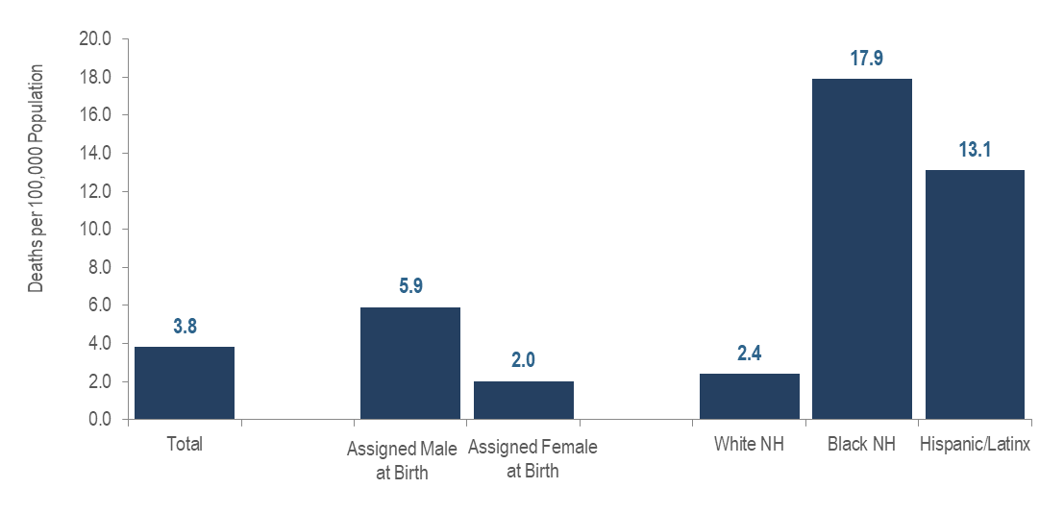
Age-Adjusted Rates
In 2022 – 2024, the average annual age-adjusted death rate per 100,000 population for individuals assigned male at birth reported with HIV was three times that for individuals assigned female at birth. There were also large disparities in death rates by race/ethnicity: the rates among Black (non-Hispanic) individuals and Hispanic/Latinx individuals were seven and five times that of White (non-Hispanic) individuals, respectively.
Age at Death
The average age at death among individuals reported with HIV increased by 4.5 years, from 56.5 years in 2015 to 61.0 years in 2024. For comparison, the average age at death of the general Massachusetts population remained between 75.1 and 76.8 from 2014 to 2023.
FIGURE 15. Deaths among individuals reported with HIV by exposure mode, Massachusetts 2024 (N=330)
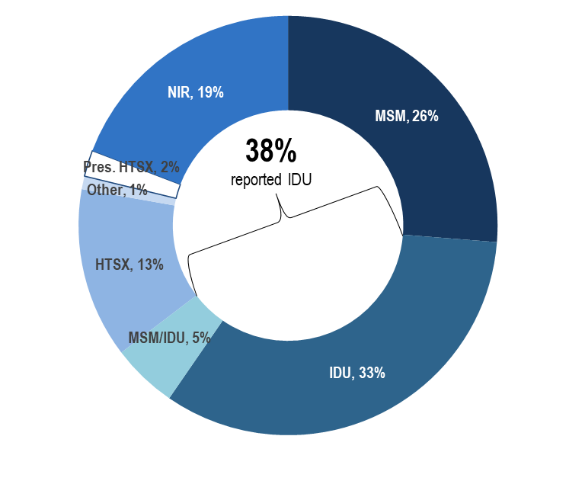
Exposure Mode
Individuals with IDU exposure mode accounted for the largest proportion of deaths among individuals reported with HIV. In 2024, 33% of deaths among individuals with HIV were reported with an exposure mode of IDU and an additional 5% were reported with an exposure mode of MSM/IDU, compared to 7% and 2%, respectively, of 2024 HIV infection diagnoses. The leading causes of death among individuals reported with HIV infection with IDU and IDU/MSM exposure mode who died in 2023 (with a known cause) were external causes of injuries and poisonings (which includes opioid overdoses) which accounted for 37% (N=45/122) of deaths, cancer which accounted for 17% (N=21/122) of deaths, and HIV which accounted for 13% (N=16/122) of deaths.
Survival among individuals diagnosed with AIDS
FIGURE 16. Five-year survival among individuals with AIDS by year of diagnosis, Massachusetts 1990–2024 (Total number of AIDS diagnoses from 1990–2024, N=23,237)
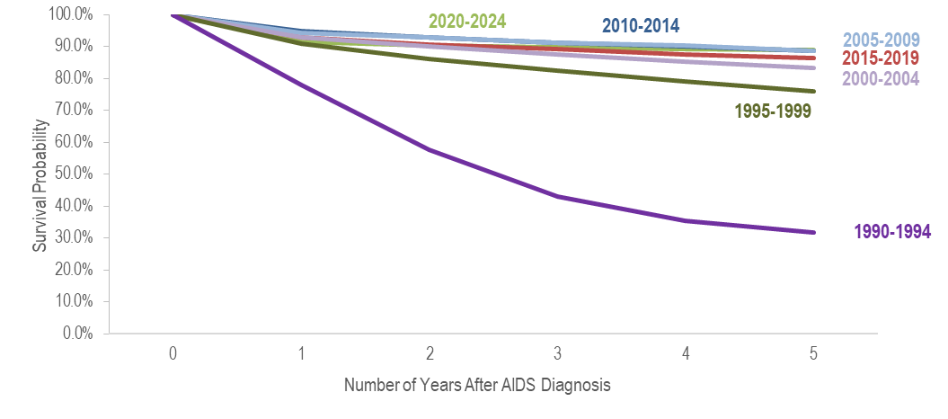
Survival of individuals diagnosed with AIDS has increased over time. In the earliest cohort of AIDS diagnoses (1990–1994), estimated survival at five years after AIDS diagnosis was 32%, compared to 89% in the most recent cohort (2020–2024).
Trends in Age-Adjusted Rates of Death
FIGURE 17. Age-adjusted rate of death per 100,000 population among individuals reported with HIV by sex assigned at birth, Massachusetts 2015–2024 (Total number of deaths among individuals reported with HIV from 2015–2024=3,244)
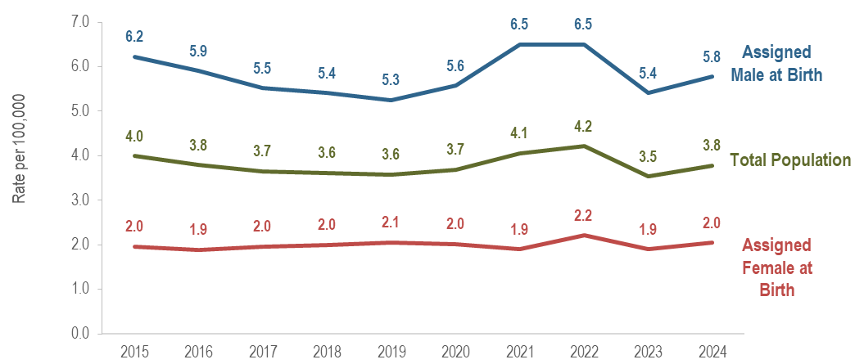
Over the last 10 years of available data, the age-adjusted rate of death per 100,000 population of individuals assigned male at birth (AMAB) reported with HIV has remained 2.6 to 3.4 times that of individuals assigned female at birth (AFAB). In 2024, the age-adjusted rate of individuals AMAB (5.8 per 100,000) was 2.8 times the rate of individuals AFAB (2.0 per 100,000).
TRENDS IN DEATHS AMONG INDIVIDUALS WITH HIV
The leading non-HIV related causes of death among individuals reported with HIV infection who died in 2023 (with a known cause) were external causes of injuriesand poisonings (which includes opioid overdoses) and cancer which both accounted for 22% (N=67/307) of deaths and heart disease which accounted for 9% (N=26/307) of deaths.

FIGURE 18. Trends in all-cause deaths among individuals reported with HIV, Massachusetts 2015–2024
All-Cause Deaths | 2015 N | 2015 % | 2024 | 2024 %
Total | 325 | 100% | 330 | 100%
Sex Assigned at Birth
Assigned Male Sex | 243 | 75% | 241 | 73%
Assigned Female Sex | 82 | 25% | 89 | 27%
Race/Ethnicity
White NH | 151 | 46% | 170 | 52%
Black NH | 96 | 30% | 78 | 24%
Hispanic/Latinx | 73 | 22% | 76 | 23%
API | 1 | <1% | 4 | 1%
Other/Unknown | 4 | 1% | 2 | 1%
Age Group (Years)
0-12 | 0 | 0% | 0 | 0%
13-19 | 0 | 0% | 0 | 0%
20-29 | 7 | 2% | 0 | 0%
30-39 | 16 | 5% | 29 | 9%
40-49 | 48 | 15% | 31 | 9%
50-59 | 131 | 40% | 68 | 21%
60-69 | 90 | 28% | 118 | 36%
70+ | 33 | 10% | 84 | 25%
Exposure Mode
MSM | 86 | 26% | 86 | 26%
IDU | 138 | 42% | 110 | 33%
MSM/IDU | 14 | 4% | 17 | 5%
HTSX | 23 | 7% | 42 | 13%
Other | 4 | 1% | 4 | 1%
Pres. HTSX | 22 | 7% | 7 | 2%
NIR | 38 | 12% | 64 | 19%
Place of Birth
US | 257 | 79% | 249 | 75%
PR/USD | 38 | 12% | 38 | 12%
Non-US | 30 | 9% | 43 | 13%

Overall
The number of deaths due to any cause among individuals reported with HIV infection increased by 14% from 325 in 2014 to a peak of 369 in 2022 and then decreased by 11% to 330 in 2024.
By Sex Assigned at Birth
The annual number of deaths remained relatively stable among individuals AMAB (from 243 to 241) and increased slightly among individuals AFAB (by 9% from 82 to 89).
By Race/Ethnicity
The annual number of deaths increased among White (non-Hispanic) individuals (by 13% from 151 to 170), decreased among Black (non-Hispanic) individuals (by 19% from 96 to 78), and remained relatively stable among Hispanic/Latinx individuals (from 73 to 76).
By Age at Death
There was only one death among the youngest age groups (0–12 and 13–19) over the ten-year period and less than ten per year among the 20–29 year age group (except for 2019 when there were 12). Deaths decreased among the 40–49 year age group (by 35% from 48 to 31) and the 50–59 year age group (by 48% from 131 to 68). Deaths increased among the 30–39 year age group (by 81% from 16 to 29), the 60–69 year age group (by 31% from 90 to 118), and the 70+ year age group (more than doubled from 33 to 84).
By Exposure Mode
Deaths increased among individuals with heterosexual (by 83%, from 23 to 42), no identified risk (by 68%, from 38 to 64), and MSM/IDU (by 21%, from 14 to 17) exposure modes. Deaths remained stable among individuals with MSM and other exposure modes. Deaths decreased among individuals with IDU (by 20% from 138 to 110) and presumed heterosexual (by 68%, from 22 to 7) exposure modes.
By Place of Birth
Deaths increased among individuals born outside the US (by 43%, from 30 to 43), decreased slightly among individuals born in the US (by 3% from 257 to 249) and remained stable among individuals born in Puerto Rico/US dependencies (at 38).

FIGURE 19. Trends in causes of death among individuals reported with HIV infection, Massachusetts 2015–2023 (N=2,680)
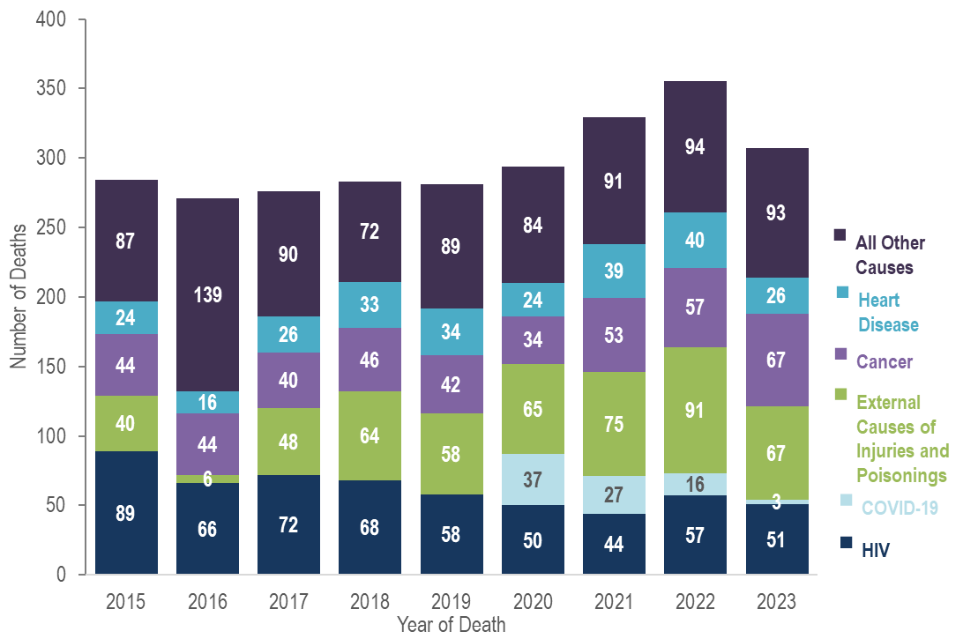
Trends in Causes of Death
The proportion of deaths among individuals reported with HIV infection attributed to HIV-related causes decreased from 31% (N=89/284) in 2015 to 17% (N=51/307) in 2023.
In 2023, 22% (N=67/307) of deaths were attributable to both external causes of injuries and poisonings (which includes opioid overdoses) and cancer, followed by HIV which accounted for 17% (N=51/307), and heart disease which accounted for 9% (N=26/307). While COVID-19 was the third leading cause of death among persons reported with HIV infection in 2020, it was the eleventh leading cause of death in 2023, accounting for only 1% (N=3/307) of deaths in that year. By comparison, the leading causes of death in 2023 among the general population of Massachusetts residents were cancer, which accounted for 21% (N=12,631/61,219) of deaths, heart disease, which accounted for 20% (N=11,970/61,219), unintentional injuries, which accounted for 7% (N=4,465/61,219), and chronic lower respiratory disease, which accounted for 4% (N=2,484/61,219).

GEOGRAPHIC DISTRIBUTION OF HIV INFECTION
What is the geographic distribution of the HIV epidemic in Massachusetts?
FIGURE 20. Percentage distributions of 2022–2024 HIV infection diagnoses (N=1,596) and 2024 persons living with HIV infection (PLWH, N=24,838) by Health Service Region (HSR), Massachusetts
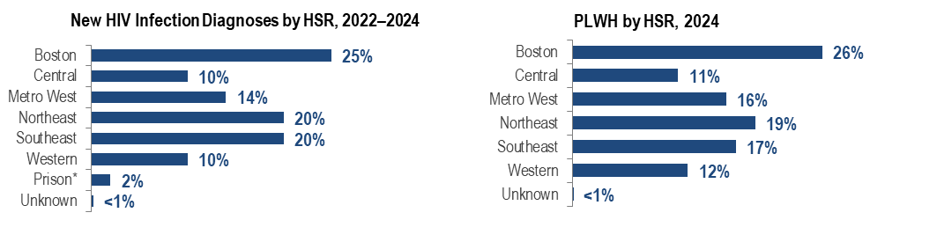
Figure 20 Note: *HSRs are regions defined geographically to facilitate focused health service planning. While prisons are not an HSR, the prison population is presented separately in this analysis because of its unique service planning needs. The prisons category represents persons who were diagnosed with HIV infection while in a correctional facility. As these data do not reflect current incarceration status, the category is not included for persons living with HIV infection.

The greatest proportion of new HIV infection diagnoses in 2022 – 2024 was among residents of the Boston HSR (25%), followed by the Northeast HSR (20%), the Southeast HSR (20%), and the Metro West HSR (14%). Similar geographic distributions were observed for persons living with HIV infection (PLWH). The Boston HSR had the highest proportion of PLWH in 2024 (26%), followed by the Northeast HSR (19%), the Southeast HSR (17%), and the Metro West HSR (16%).
FIGURE 21. Percentage distribution of HIV infection diagnoses by Health Service Region (HSR) and exposure mode, Massachusetts 2022–2024 (N=1,596)
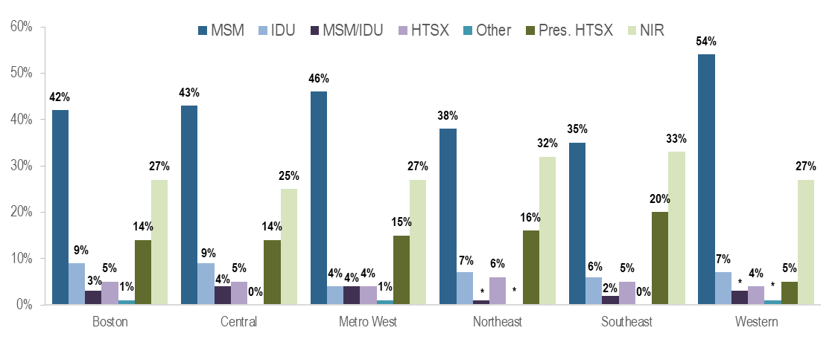
MSM was the most frequently reported exposure mode in all regions of Massachusetts for individuals diagnosed with HIV infection during 2022 to 2024, accounting for 54% of diagnoses in the Western HSR, 46% in the Metro West HSR, 43% in the Central HSR, 42% in the Boston HSR, 38% in the Northeast HSR, and 35% in the Southeast HSR. The Boston and Central HSRs had the highest proportion of individuals with IDU exposure mode, both at 9%. IDU accounted for 4% to 7% of HIV infection diagnoses in the remaining regions.
FIGURE 22. Percentage distribution of HIV infection diagnoses by Health Service Region (HSR) and race/ethnicity, Massachusetts 2022–2024 (N=1,596)
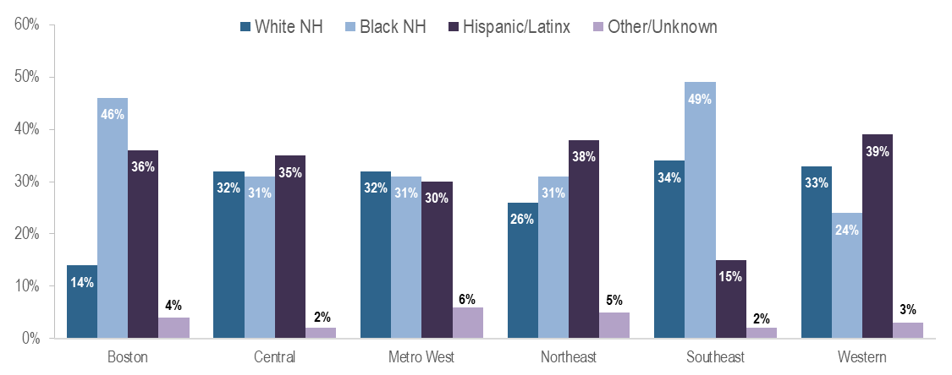
The Southeast and Western HSRs had the highest proportions of recent HIV infection diagnoses (2022–2024^{i}) among White (non-Hispanic) individuals at 34% and 33%, respectively, while the Southeast HSR had the highest proportion among Black non-Hispanic individuals at 49%, and the Western and Northeast HSRs had the highest proportion among Hispanic/Latinx individuals at 39% and 38%, respectively.
FIGURE 23. Average annual age-adjusted rate of HIV infection diagnosis per 100,000 population by county, Massachusetts 2022–2024
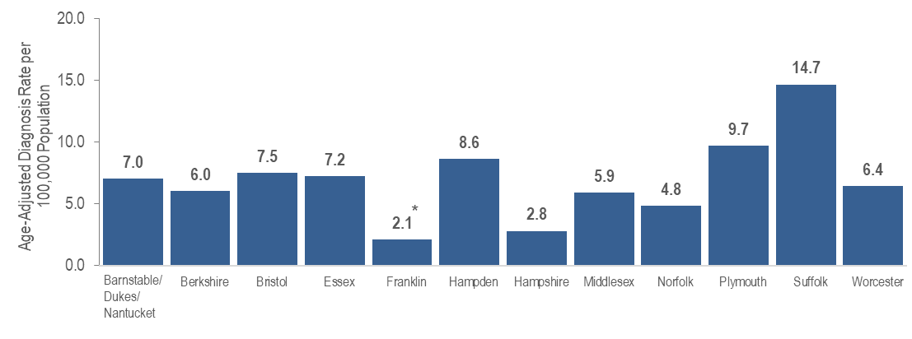
Figure 23 Note: *Rates based on numerators <12 are marked with an asterisk (*) and should be interpreted with caution. Barnstable, Dukes, and Nantucket Counties are combined because of small numbers.
Suffolk County, in which Boston is the biggest city, was selected as one of 48 counties nationally that was prioritized for funding in the U.S. Department of Health and Human Services’ initiative “Ending the HIV Epidemic (EHE): A Plan for America”. This is a ten-year initiative beginning in 2020 to achieve a 75% reduction in new HIV infections in five years and at least a 90% reduction in ten years. For more information about EHE, see https://www.hrsa.gov/ending-hiv-epidemic and the Suffolk County EHE Plan. Suffolk County had the highest average age-adjusted rate of HIV infection diagnosis during 2022 to 2024 among all Massachusetts counties at 14.7 per 100,000, as well as the highest prevalence rate of persons living with HIV infection in 2024 at 798.1 per 100,000.

FIGURE 24. Average annual rate of HIV infection diagnosis per 100,000 population by city/town, Massachusetts 2022–2024
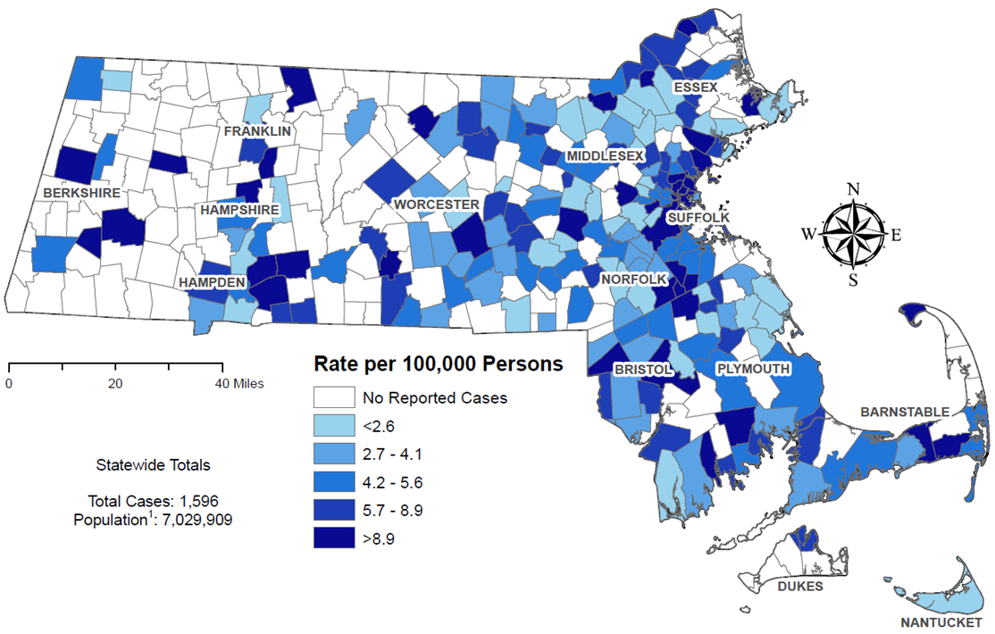
Figure 24 note: Regional HIV diagnosis data exclude individuals diagnosed in a correctional facility.
The cities and towns with the highest average annual rate of HIV infection diagnosis during 2022 to 2024 included Brockton (30.3 per 100,000), Everett (21.1), Chelsea (19.6), Randolph (18.1), and Boston (17.4). Boston had the highest number of new HIV infection diagnoses from 2022–2024 (N=352), followed by Brockton (N=96).
In early 2019, a new cluster of HIV infection was identified in Boston among PWID who were experiencing or had experienced recent homelessness. As of July 1, 2025, a total of 239 cases diagnosed since November 2018 have been investigated and identified as part of the Boston cluster. Continuing trends among those newly diagnosed in the Boston cluster (N=16 cases diagnosed in 2024) include an increase in polysubstance and methamphetamine use.
FIGURE 25. Prevalence rate of persons living with HIV infection (PLWH) per 100,000 population by city/town, Massachusetts 2024
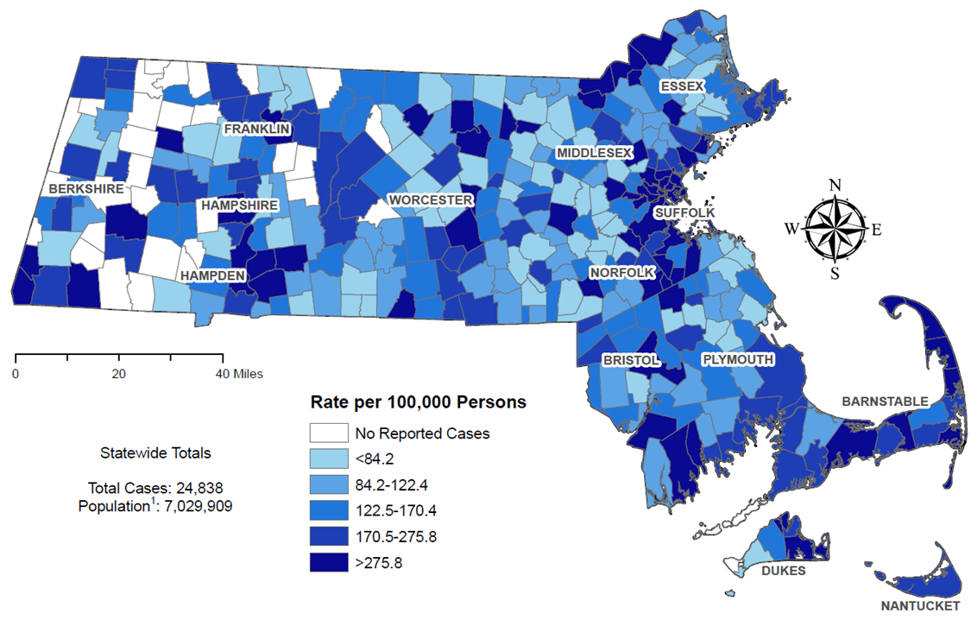
Figure 25 note: Regional HIV data may include PLWH who may have been incarcerated in 2024.
The cities and towns in Massachusetts with the highest prevalence rate of PLWH in 2024 included Provincetown (12,313.6 per 100,000), Ayer (861.0), Boston (853.0), Springfield (846.5), and Chelsea (789.5). Boston and Springfield had the highest numbers of PLWH in 2024, at 5,763 and 1,320, respectively.

HIV CARE CONTINUUM – NEWLY DIAGNOSED
FIGURE 26. Stages of HIV care among individuals newly diagnosed with HIV infection in Massachusetts, 2023 (N=513)
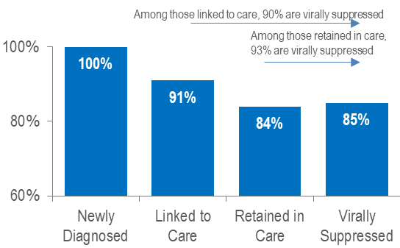
FIGURE 27. Viral load status among individuals newly diagnosed with HIV infection in Massachusetts, 2023 (N=513)
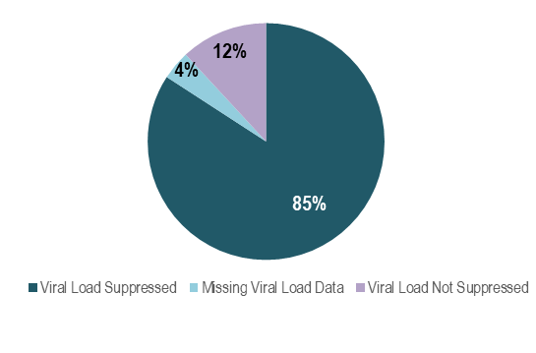
Figure 27 Note: Missing Viral Load Data includes individuals who had not had a lab reported in the 12-month period after diagnosis.
Among 513 individuals newly diagnosed with HIV infection in 2023 (and alive in Massachusetts through 2024), 85% were virally suppressed, 12% were not virally suppressed, and 4% did not have a viral load test in the year after diagnosis. Among those newly diagnosed individuals who were linked to care (N=468) and retained in care (N=433), rates of viral suppression were higher at 90% and 93%, respectively. Among individuals diagnosed with HIV infection in 2023, timely linkage to care differed by exposure mode and age at diagnosis. Viral suppression was lowest among individuals with IDU exposure mode (56% compared to 81% to 90% among other exposure modes).
FIGURE 28. Linkage to care among individuals newly diagnosed with HIV infection by sex assigned at birth, race/ethnicity, age, and exposure mode, Massachusetts 2023 (N=513)
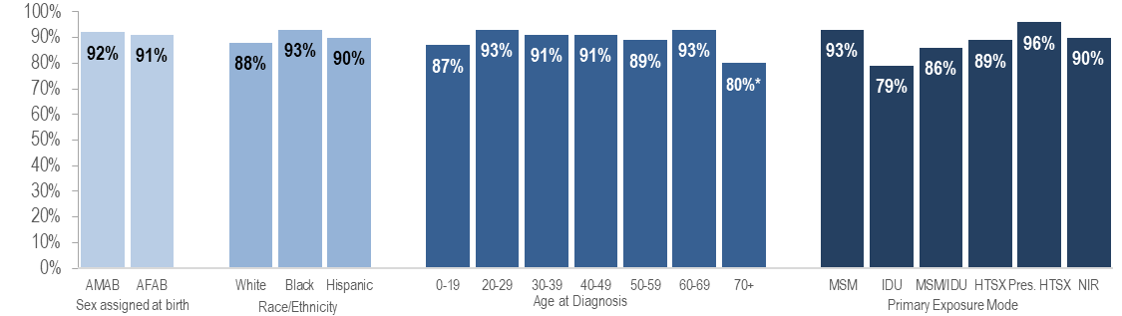
FIGURE 29. Viral suppression among individuals newly diagnosed with HIV infection by sex, race/ethnicity, age, and exposure mode, Massachusetts 2023 (N=513)
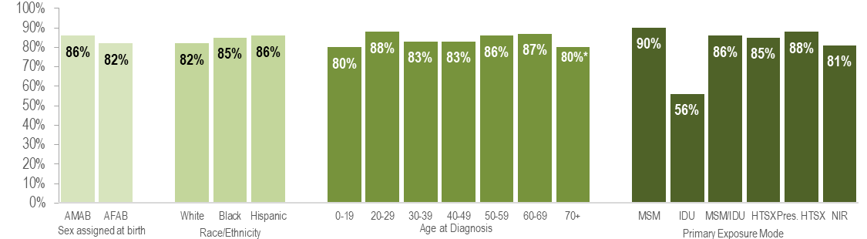Figure 28 and 29 Note: *Percentages based on numerators <5 are marked with an asterisk (*) and should be interpreted with caution

HIV CARE CONTINUUM – PLWH
FIGURE 30. Stages of HIV care among persons living with HIV infection in Massachusetts, 2024 (N=23,515)
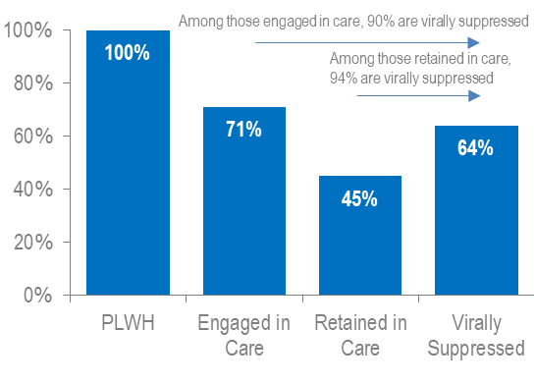
FIGURE 31. Viral load status among persons living with HIV infection in Massachusetts, 2024 (N=23,515)
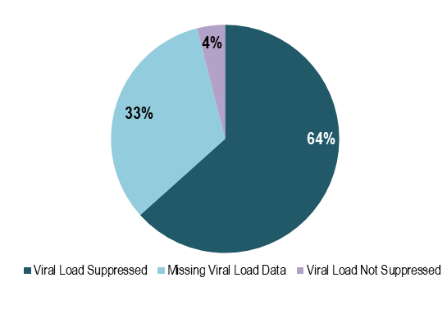
Figure 31 Note: Missing Viral Load Data includes individuals who had not had a lab reported in the past year
Among 23,515 persons living with HIV infection (PLWH) in Massachusetts at the end of 2024 (and diagnosed through 2023), 64% were reported as virally suppressed, 4% were reported as not virally suppressed, and 33% did not have a viral load test in 2024. Among those PLWH who were engaged in care (N=16,663) and retained in care (N=10,469), rates of viral suppression were higher at 90% and 94%, respectively. Please note that the total number of PLWH used to calculate these rates includes all individuals who have ever been diagnosed with HIV infection in Massachusetts with no evidence of death or having moved out of the state or country. Quality assurance efforts are currently being conducted to update the number of PLWH used for this analysis. In 2024, engagement in care among PLWH differed slightly by age. Viral suppression was lowest among individuals with IDU exposure mode (58% compared to 62% to 68% among other exposure modes).
FIGURE 32. Engagement in care among persons living with HIV infection by sex assigned at birth, race/ethnicity, age, and exposure mode, Massachusetts 2024 (N=23,515)
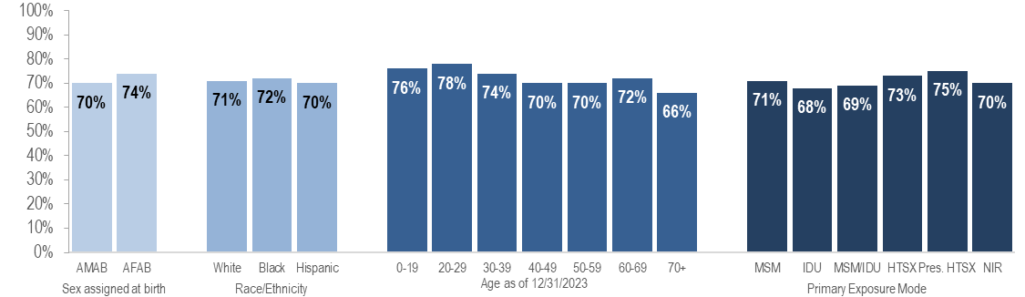
FIGURE 33. Viral suppression among persons living with HIV infection by sex assigned at birth, race/ethnicity, age, and exposure mode, Massachusetts 2024 (N=23,515)
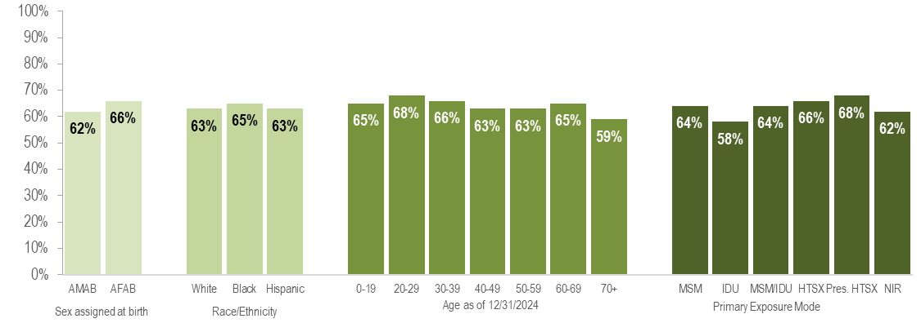

FIGURE 34. Viral suppression among persons living with HIV infection engaged in care by sex assigned at birth, race/ethnicity, age, and exposure mode, Massachusetts 2024 (N=16,663)
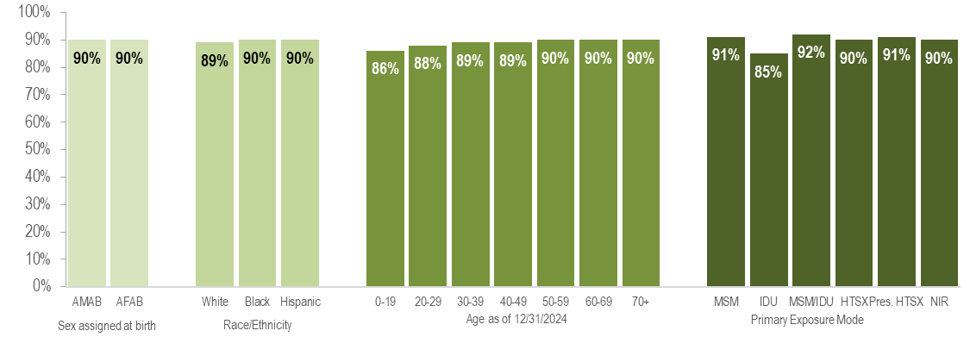
Among 16,663 persons living with HIV infection (PLWH) and engaged in care in Massachusetts at the end of 2024, viral suppression did not differ substantially by sex assigned at birth, race/ethnicity or age. Viral suppression was lowest among individuals with IDU exposure mode (85% compared to 90% to 92% among other exposure modes).

SOCIAL VULNERABILITY INDEX
The social vulnerability index (SVI) is a tool to identify socially vulnerable communities that was created by CDC and the Agency for Toxic Substances and Disease Registry (ATSDR). The CDC/ATSDR SVI uses U.S. Census data to determine the social vulnerability of every census tract. The SVI ranks each tract on 16 social factors, including poverty, lack of vehicle access, and crowded housing, and groups them into four related themes: socioeconomic status, household characteristics, racial and ethnic minority status, and housing type/transportation. Each census tract receives a separate ranking for each of the four themes, as well as an overall ranking. Originally developed to incorporate social determinants of health into emergency response and recovery efforts for environmental and natural disasters, more recently, higher SVI has been linked to higher HIV diagnosis rates, COVID-19 mortality, and lower COVID-19 vaccination coverage.
FIGURE 35. HIV infection diagnoses by Social Vulnerability Index*, Massachusetts 2022–2024
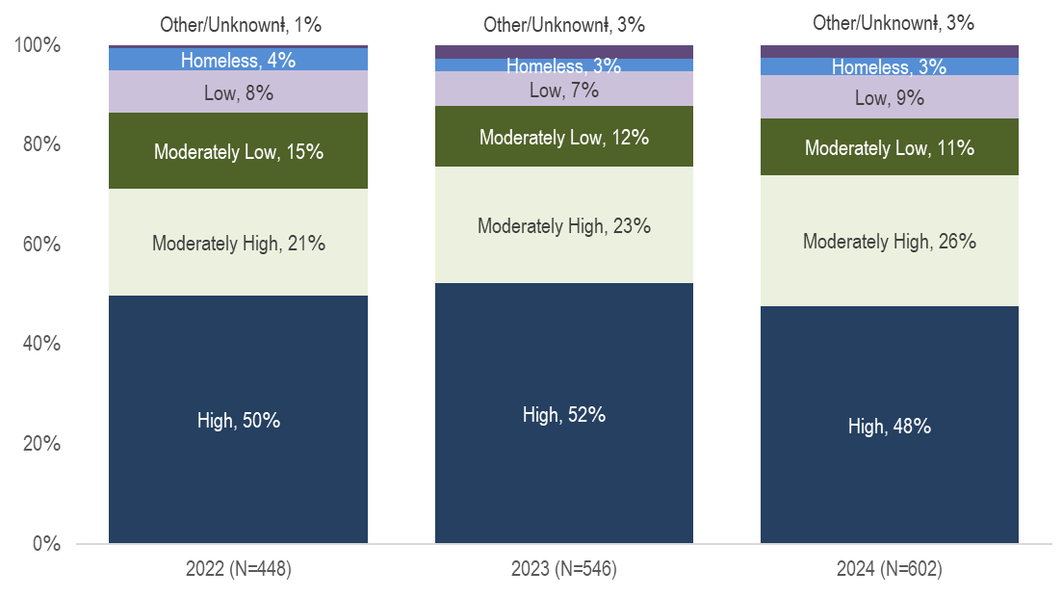
Figure 35 Notes: * Census tract level overall SVI values for 2020 were obtained from CDC/Agency for Toxic Substance and Disease Registry (CDC/ATSDR) and assigned to all cases based on their street address at diagnosis. Values range from 0 to 1, with higher values implying greater social vulnerability. SVI rankings were grouped into quartiles (low, <0.25; mid low, 0.25 - <0.49; mid high, 0.5 - <0.74; high >=0.75).
ⱡ Other/Unknown includes correctional facility addresses, P.O. Box addresses, hospital addresses, and addresses that could not be geocoded
Social Vulnerability Index
The majority of individuals recently diagnosed with HIV infection in Massachusetts were diagnosed in areas with high (48% in 2024) or moderately high (26% in 2024) social vulnerability.

TECHNICAL NOTES

Data source for all HIV case data:

Massachusetts Department of Public Health (DPH) Bureau of Infectious Disease and Laboratory Sciences (BIDLS) HIV Surveillance Program. Data are current as of 7/1/2025 and may be subject to change.

Impact of COVID-19:

The coronavirus disease 2019 (COVID-19) pandemic had a large impact on the screening, treatment, and surveillance of other infectious diseases from 2020 to 2024. Nationally, the Centers for Disease Control and Prevention (CDC) observed significant declines in HIV testing (and diagnoses) during the COVID-19 pandemic that are likely attributed to interruptions in the availability of clinical services, patient hesitancy in accessing face-to-face clinical services, and shortages in HIV testing reagents/materials. At time of publication, the full effect of the COVID-19 pandemic on case detection and reporting and efforts to control the spread of infectious disease in the Commonwealth has yet to be determined. As such, please interpret 2020 to 2023 HIV surveillance data presented in this report with caution.

Individuals diagnosed with HIV infection:

New HIV diagnoses include only individuals who were first diagnosed in Massachusetts. HIV diagnoses data reflect the year of HIV infection diagnosis among all individuals reported with HIV infection, with or without an AIDS diagnosis, for the most recently available three-year (2022–2024) or ten-year (2015–2024) period.

Individuals living with HIV infection by current residence:

As of January 1, 2018, the Massachusetts Department of Public Health (MDPH) Bureau of Infectious Disease and Laboratory Sciences (BIDLS) HIV fact sheets, epidemiologic reports, and other HIV data presentations include all individuals living with HIV infection who are currently residing in Massachusetts. These prevalent cases include those who may have been first diagnosed in another state. Reports of incidence or new diagnoses will continue to include only individuals who are first diagnosed in Massachusetts. Please note that HIV fact sheets, data reports, and presentations published from 2011 to 2017 include only cases that were first diagnosed in Massachusetts. BIDLS service planning continues to ensure responsive services to the entire population living with HIV infection in Massachusetts, regardless of place of diagnosis.

Individuals diagnosed with AIDS:
AIDS diagnoses include only individuals who were first diagnosed in Massachusetts for the most recently available three-year (2022–2024) or ten-year (2015–2024) period.

Individuals born in Puerto Rico or other US Dependencies (American Samoa, Guam, the Northern Mariana Islands, the Republic of Palau, and the U.S. Virgin Islands)

97% of individuals diagnosed with HIV infection (HIV DX) from 2022–2024, 99% of individuals diagnosed with HIV infection from 2015–2024, 98% of persons living with HIV infection on 12/31/2024, 99% of individuals diagnosed with AIDS from 2015–2024, 100% of individuals who died from 2022–2024, and 99% of individuals who died from 2015–2024 who were born in a US dependency were born in Puerto Rico.

Individuals born outside the US (non-US born)
Individuals born outside the US (non-US born) excludes individuals born in the United States, Puerto Rico, American Samoa, Guam, the Northern Mariana Islands, the Republic of Palau, and the U.S. Virgin Islands.

Gender

Current gender data present number and percentage distributions of HIV surveillance data for cisgender (persons whose current gender identity corresponds with their sex assigned at birth) and transgender individuals. Please note that reported numbers among transgender individuals are likely to be underestimates due to underreporting of current gender.

Configuration of Health Service Regions (HSR)

For HIV and AIDS diagnoses, residence is at diagnosis. For individuals living with HIV infection and deaths, residence is based on the most recent record available. Definitions of Health Service Regions can be found at: Health Services Regions.
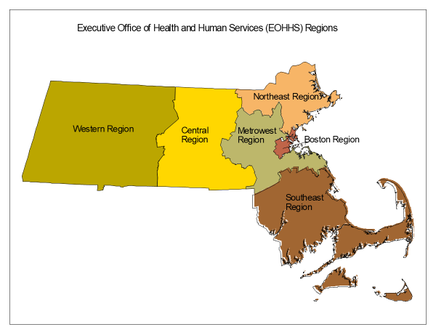

Prisons

HSRs are regions defined geographically to facilitate targeted health service planning. While prisons are not an HSR, the prison population is presented separately because of its unique service planning needs. The prisons category represents persons who were diagnosed with HIV infection while in a correctional facility. As these data do not reflect current incarceration status, the category is not included for individuals living with HIV infection or deaths among individuals with HIV.

Configuration of Massachusetts cities/towns and counties

For HIV and AIDS diagnoses, residence is at diagnosis. For individuals living with HIV infection and deaths, residence is based on the most recent record available.
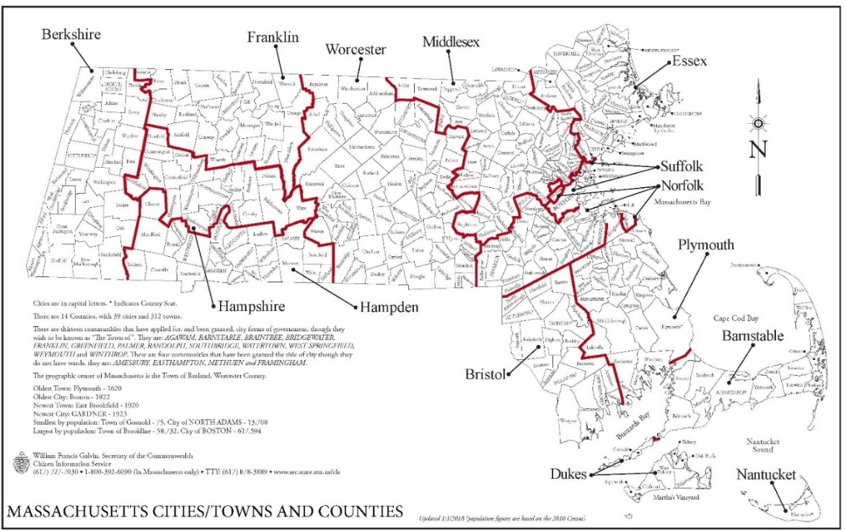

Age

Age in years is at HIV diagnosis for individuals diagnosed with HIV infection, age on 12/31/2024 for individuals living with HIV infection, and age at death for individuals reported with HIV who died. Please note, pediatric HIV infections diagnosed under age 13 are reported by year of diagnosis; therefore, the annual number of pediatric diagnoses differs from the annual number of perinatal infections (among infants) that are reported by year of birth.

Background on HIV reporting system

Massachusetts Department of Public Health (MDPH) regulations started requiring healthcare providers to submit case report forms, with demographic and risk information, on individuals diagnosed with AIDS in 1983, and with HIV infection in 1999. Existing cases of HIV infection diagnosed through 1998 were also to be reported by the end of 1999. When comparing HIV infection diagnosed before 1999 to HIV infection diagnosed after 1999, users should consider the differences in HIV reporting requirements for these two time periods. Since HIV was not reported at diagnosis prior to 1999 and clinical providers were given a relatively short time frame within which to report all prevalent HIV cases, the pre-1999 data may be less complete than data reported after 1999. Additionally, pre-1999 HIV infection diagnoses do not include individuals who were diagnosed with HIV infection and who died before 1999 without being reported with AIDS, nor do they include individuals who were no longer receiving HIV-related health care in Massachusetts at the point when HIV (non-AIDS) reporting became mandatory.

Beginning in 2019, all new diagnoses of HIV infection were assigned to field epidemiologists for partner services, to ensure disease education/comprehension, and assist with linkage to HIV care. As a part of this process, field epidemiologists helped to collect pertinent epidemiological, demographic, and risk information of the individual.

Data limitations

While trends in new HIV diagnoses are the best indicator of those who are most at risk of HIV infection, HIV surveillance reflects only incident diagnoses among individuals who are in care and not the actual incidence of new infections. Individuals may be living with HIV infection for many years prior to being tested and seeking care, at which point the case is considered a “diagnosis” and reported to the MDPH Bureau of Infectious Disease and Laboratory Sciences. In the most recent years of data presented, delays may occur in the reporting of a case to MDPH after it is diagnosed. Although Massachusetts regulations require providers to submit HIV case reports in a timely fashion, some 2024 HIV infection diagnoses will be reported to the surveillance program after the release of this report. Thus, the 2024 data presented in this report may change slightly. Previous analyses of Massachusetts HIV case data have suggested that the distribution of HIV infection diagnoses by race/ethnicity, sex assigned at birth and exposure mode for cases reported more than 6 months after diagnosis was not substantially different than the distribution of HIV cases reported within 6 months. Caution should be exercised when considering changes in HIV diagnosis trends for 2024.

Deaths among people reported with HIV

All-cause death data include only individuals who were first diagnosed with HIV in Massachusetts for the most recently available three-year (2022–2024) or ten-year (2015–2024) period.

The death data presented in this report include all deaths among people diagnosed and reported with HIV in Massachusetts to present a full description of trends in mortality among this population. This includes deaths from non-HIV related causes such as drug overdoses, suicides, motor vehicle accidents and other causes. Therefore, the total number of annual deaths reported here will vary from the number of HIV-related deaths reported in Massachusetts Deaths by the Massachusetts Department of Public Health, Office of Population Health (available at https://www.mass.gov/lists/death-data). The death data reported here are considered complete through 2023. Data on deaths occurring in Massachusetts are from matches with the Massachusetts Registry of Vital Records and Statistics and from provider reports. Data on deaths occurring outside of Massachusetts are from matches with the Social Security Death Master File.

HIV primary exposure mode definitions
The HIV primary exposure mode indicates the most probable risk behavior associated with HIV infection. Assignment of primary exposure mode is done in accordance with Centers for Disease Control and Prevention (CDC) guidelines when multiple exposure modes are reported. Although the reported primary exposure mode is the most likely mode of transmission, there is always the possibility that it is not the actual mode of transmission. Following is a description of the exposure mode categories:
- MSM (Male-to-Male Sex): Includes all individuals assigned male at birth who report any sexual contact with other individuals that identify as male. Please note that in accordance with CDC guidelines, this category is defined by an individual’s assigned sex at birth and not an individual’s current gender identity.
  - Sex with Men: This exposure mode category is used by the Bureau of Infectious Disease and Laboratory Sciences (BIDLS) to categorize sexual risk in transgender women reporting sex with men only. For the purposes of official reporting in the MA HIV Surveillance System and to CDC, exposure mode for transgender women is based on sex assigned at birth, and therefore would be reported as male-to-male sex.
- IDU (Injection Drug Use): Cases among persons who report injection drug use.
- MSM/IDU: Includes all individuals assigned male at birth who report both sexual contact with other individuals that identify as male and injection drug use.
  - Sex with Men/IDU: This exposure mode category is used by BIDLS to categorize sexual risk in transgender women reporting both sex with men and injection drug use. For the purposes of official reporting in the MA HIV Surveillance System and to CDC, exposure mode for transgender women is based on sex assigned at birth, and therefore would be reported as MSM/IDU.
- Heterosexual Sex: Cases among persons who report heterosexual sex with a person with, or at increased risk for, HIV infection (e.g., a person who injects drugs (PWID)). The sub-categories for this mode of transmission are listed below.
          - Heterosexual Sex w/ a person who injects drugs
          - Heterosexual Sex w/ a person w/ HIV infection or AIDS
          - Heterosexual Sex w/ bisexual male
          - Other Heterosexual Sex: includes all other sub-categories of heterosexual risk, such as heterosexual contact with a person infected through a blood transfusion.
        - Other: Cases among persons with other known exposure modes, including receipt of clotting factor, receipt of transfusion or transplant, and mother-to-child transmission through pregnancy, childbirth, or breastfeeding (perinatal transmission).
        - Presumed Heterosexual: The presumed heterosexual risk category is used by BIDLS exclusively for individuals assigned female at birth to identify HIV exposure mode when sex with individuals that identify as male was the only reported risk factor, there was no evidence of current or past IDU, and behavioral risk and HIV status information about sexual partners that identify as male was unknown. The rationale for the application of the presumed heterosexual risk category to individuals assigned female at birth only has been addressed in the MDPH Office of HIV report “Intersecting Risks: HIV Infection among Heterosexual Women and Men in Massachusetts” (2010).
- NIR (No Identified Risk): Cases among persons with no reported history of exposure to HIV through any of the listed exposure categories. Follow-up is conducted to determine risk for those cases that are initially reported without a risk identified. Includes cases among individuals assigned male at birth who were previously categorized in Massachusetts as Presumed Heterosexual.

Cell suppression methodology:

Values one through four are suppressed for denominator populations less than 50,000 or for unknown population sizes. Additional values of zero and greater than or equal to five may be suppressed to prevent back calculation. Values less than five are not suppressed for unknown health service region or for compound categories (categories containing two or more subcategories, such as ‘other/undetermined’ race/ethnicity or ‘other’ exposure modes, which includes pediatric, blood, and blood product exposure modes), because the exact count of each subcategory cannot be determined.

Population estimates used for rate calculations

As of 1/1/2020, BIDLS calculates rates per 100,000 population using denominators estimated by the University of Massachusetts Donahue Institute using a modified Hamilton-Perry model. 2020 population estimates were used for single-year rates; for pooled year rates (i.e., 2019-2021), the 2020 population estimates were multiplied by three. For more information, see: Strate S, et al. Small Area Population Estimates for 2011 through 2020, report published Oct 2016, and http://www.donahue.umassp.edu/business-groups/economic-public-policy-research/massachusetts-population-estimates-program. Note that rates and trends calculated using previous methods cannot be compared to these.

Rates based on numerators <12
Rates based on numerators <12 are marked with an asterisk (*) and should be interpreted with caution.

Explanation of age-adjusted rates

A rate of a disease per 100,000 population is a useful way to compare groups with substantially different population sizes rather than relying on the raw number of cases. For example, the number of individuals living with HIV infection (PLWH) on December 31, 2024 who are Hispanic/Latinx is 7,052, whereas the number of individuals living with HIV infection who are white (non-Hispanic) is 9,033. Although the number of individuals living with HIV infection who are Hispanic/Latinx in Massachusetts is smaller than the number of individuals living with HIV infection who are white (non-Hispanic), we also need to consider that there are far fewer individuals of Hispanic/Latinx heritage living in Massachusetts than white (non-Hispanic) individuals. Hispanic/Latinx individuals represent 12% of the Massachusetts population compared to white (non-Hispanic) individuals who represent 71% of the population. If HIV had the same impact on the Hispanic/Latinx population of the state as on the white (non-Hispanic) population, then there should be six times as many cases in white (non-Hispanic) individuals, but there are less than twice as many. By calculating a rate which takes into consideration the differences in the population size, it is evident that the number of individuals living with HIV infection for every 100,000 Hispanic/Latinx individuals in Massachusetts is much higher than the rate for every 100,000 white (non-Hispanic) individuals. This is called a "crude rate" and is calculated by dividing the number of individuals living with HIV infection by the population of interest (the total number of Hispanic/Latinx individuals in Massachusetts, for example) and multiplying by 100,000. (See example below.)

Example: Calculation of crude HIV prevalence rate for white (non-Hispanic) individuals, Massachusetts (186.9 per 100,000)

Crude HIV prevalence rate for white (non-Hispanic) individuals | = [number of white (non-Hispanic) individuals living with HIV infection ÷ population size of white (non-Hispanic) individuals] ×100,000
 | = (9,033/4,832,394.52) ×100,000
 | = (0.001869260) ×100,000
 | = 186.9

However, sometimes, in addition to the population size being different, the age composition of the populations is different. In Massachusetts, the black (non-Hispanic) and Hispanic/Latinx populations are on average younger than white (non-Hispanic) population (medians: 29.7 years and 24.5 years vs. 38.8 years, respectively). Therefore, it is necessary to age-adjust the HIV prevalence rate to get a true comparison of the impact of the disease across racial/ethnic groups without an effect from the differences in age composition. Age-adjustment of rates minimizes the distortion created by differences in age composition. Age-adjusted rates are calculated by weighting the age-specific rates for a given population by the age distribution of a standard population. The weighted age-specific rates are then summed to produce the adjusted rate for all ages combined.

HIV Care Continuum Indicator Definitions:

- HIV care continuum among individuals newly diagnosed with HIV infection in Massachusetts: “Newly Diagnosed” includes individuals diagnosed in 2023, alive through 12/31/2024, and living in Massachusetts based on last known address. “Linked to Care” is defined as having ≥1 viral load (VL) or CD4 test result within 3 months of diagnosis. “Retained in Care” is defined as having ≥2 VL or CD4 test results at least 3 months apart during the 12-month period after diagnosis. “Virally Suppressed” is defined as having a VL <200 copies/mL for the most recent VL test drawn during the 12-month period after diagnosis.
- HIV care continuum among persons living with HIV infection (PLWH) in Massachusetts: “PLWH” refers to individuals diagnosed through 2023, alive through 12/31/2024, and living in Massachusetts based on last known address. “Engaged in Care” is defined as having ≥1 VL or CD4 test result in 2024. “Retained in Care” is defined as having ≥2 VL or CD4 test results at least 3 months apart in 2024. “Virally Suppressed” is defined as having a VL <200 copies/mL for the most recent VL test drawn in 2024.

AIDS Progression

Progression to AIDS refers to individuals diagnosed with HIV while living in Massachusetts who were later diagnosed with AIDS while living in Massachusetts. Individuals diagnosed with HIV or AIDS outside of Massachusetts are excluded. Individuals diagnosed with HIV and AIDS concurrently (AIDS diagnosis within 2 months of HIV diagnosis) are also excluded. Year refers to year of AIDS diagnosis.

Providers may use this number to report individuals newly diagnosed with a notifiable sexually transmitted infection, including HIV, or request partner services. Partner services is a free and confidential service for individuals recently diagnosed with a priority infection. The client-centered program offers counseling, linkage to other health and social services, anonymous notification of partners who were exposed and assistance with getting testing and treatment. For more information, see: https://www.mass.gov/service-details/partner-services-program-information-for-healthcare-providers)
Please consider the impact of the COVID-19 pandemic on infectious disease screening, treatment, and surveillance in the interpretation of 2020–2022 data.
For more information, see: Charles Alpren et al. “Opioid Use Fueling HIV Transmission in an Urban Setting: An Outbreak of HIV Infection Among People Who Inject Drugs—Massachusetts, 2015–2018”, American Journal of Public Health 110, no. 1 (January 1, 2020): pp. 37-44. https://doi.org/10.2105/AJPH.2019.305366
Please consider the impact of the COVID-19 pandemic on infectious disease screening, treatment, and surveillance in the interpretation of 2020–2022 data.
For more information, see: Joint MDPH and BPHC Clinical Advisory: Increase in newly diagnosed HIV infections among persons who inject drugs in Boston, March 15, 2021, available at: https://www.mass.gov/doc/joint-mdph-and-bphc-clinical-advisory-hiv-transmission-through-injection-drug-use-in-boston-march-15-2021/download
Please consider the impact of the COVID-19 pandemic on infectious disease screening, treatment, and surveillance in the interpretation of 2020–2022 data.
External causes of injuries include intentional injuries (e.g., homicide and suicide), unintentional injuries (e.g., motor vehicle and non-transport related accidents), and injuries of undetermined intent.
Final cause of death is not yet available for all 2024 deaths among individuals with HIV as of 7/1/2025.
Please consider the impact of the COVID-19 pandemic on infectious disease screening, treatment, and surveillance in the interpretation of 2020–2022 data.
Data Source for Massachusetts death data: Office of Population Health, Massachusetts Department of Public Health. Note: 2023 death data are preliminary and 2024 death data are not yet available.
Final cause of death is not yet available for all 2024 deaths among individuals with HIV as of 7/1/2025.
Among cities that reported at least 12 HIV infections during 2022–2024.
Virally Suppressed” is defined as having a VL <200 copies/mL for the most recent VL test drawn during the 12-month period after diagnosis.
“Linked to Care” is defined as having ≥1 viral load (VL) or CD4 test result within 3 months of diagnosis.
“Retained in Care” is defined as having ≥2 VL or CD4 test results at least 3 months apart during the 12-month period after diagnosis.
Please consider the impact of the COVID-19 pandemic on infectious disease screening, treatment, and surveillance in the interpretation of 2020–2022 data.
“Virally Suppressed” is defined as having a VL <200 copies/mL for the most recent VL test drawn in 2024.
“Engaged in Care” is defined as having ≥1 VL or CD4 test result in 2024.
“Retained in Care” is defined as having ≥2 VL or CD4 test results at least 3 months apart in 2024.
Please consider the impact of the COVID-19 pandemic on infectious disease screening, treatment, and surveillance in the interpretation of 2020–2022 data.
Please consider the impact of the COVID-19 pandemic on infectious disease screening, treatment, and surveillance in the interpretation of 2020–2022 data.
Please consider the impact of the COVID-19 pandemic on infectious disease screening, treatment, and surveillance in the interpretation of 2020–2022 data.
All individuals diagnosed with HIV infection from 2015-2024 with other exposure mode were pediatric exposures
99% of individuals diagnosed with HIV infection from 2015–2024 who were born in a US dependency were born in Puerto Rico
Please consider the impact of the COVID-19 pandemic on infectious disease screening, treatment, and surveillance in the interpretation of 2020–2022 data.
While the majority of pediatric exposures are confirmed perinatal exposures, this category also includes a small number of pediatric cases with insufficient documentation of maternal HIV status to confirm perinatal exposure.
For more information, see: Charles Alpren et al. “Opioid Use Fueling HIV Transmission in an Urban Setting: An Outbreak of HIV Infection Among People Who Inject Drugs—Massachusetts, 2015–2018”, American Journal of Public Health 110, no. 1 (January 1, 2020): pp. 37-44. https://doi.org/10.2105/AJPH.2019.305366 and Joint MDPH and BPHC Clinical Advisory: Increase in newly diagnosed HIV infections among persons who inject drugs in Boston, March 15, 2021, available at: https://www.mass.gov/doc/joint-mdph-and-bphc-clinical-advisory-hiv-transmission-through-injection-drug-use-in-boston-march-15-2021/download
Please consider the impact of the COVID-19 pandemic on infectious disease screening, treatment, and surveillance in the interpretation of 2020–2022 data.
All individuals diagnosed with HIV infection from 2015–2024 with other exposure mode were pediatric exposures
99% of individuals diagnosed with HIV infection from 2015–2024 who were born in a US dependency (USD) were born in Puerto Rico (PR)
Please consider the impact of the COVID-19 pandemic on infectious disease screening, treatment, and surveillance in the interpretation of 2020–2022 data.
Please consider the impact of the COVID-19 pandemic on infectious disease screening, treatment, and surveillance in the interpretation of 2020–2022 data.
Please consider the impact of the COVID-19 pandemic on infectious disease screening, treatment, and surveillance in the interpretation of 2020–2022 data.
Please consider the impact of the COVID-19 pandemic on infectious disease screening, treatment, and surveillance in the interpretation of 2020–2022 data.
Please consider the impact of the COVID-19 pandemic on infectious disease screening, treatment, and surveillance in the interpretation of 2020–2022 data.
As of 1/1/2020, BIDLS calculates rates per 100,000 population using denominators estimated by the University of Massachusetts Donahue Institute using a modified Hamilton-Perry model (Strate S, et al. Small Area Population Estimates for 2011 through 2020, report published Oct 2016). Note that rates and trends calculated using previous methods cannot be compared to these. All rates are age-adjusted using the 2000 US standard population.
Please consider the impact of the COVID-19 pandemic on infectious disease screening, treatment, and surveillance in the interpretation of 2020–2022 data.
Please consider the impact of the COVID-19 pandemic on infectious disease screening, treatment, and surveillance in the interpretation of 2020–2022 data.
Please consider the impact of the COVID-19 pandemic on infectious disease screening, treatment, and surveillance in the interpretation of 2020–2022 data.
Please consider the impact of the COVID-19 pandemic on infectious disease screening, treatment, and surveillance in the interpretation of 2020–2022 data.
As of 1/1/2020, BIDLS calculates rates per 100,000 population using denominators estimated by the University of Massachusetts Donahue Institute using a modified Hamilton-Perry model (Strate S, et al. Small Area Population Estimates for 2011 through 2020, report published Oct 2016). Note that rates and trends calculated using previous methods cannot be compared to these. All rates are age-adjusted using the 2000 US standard population.
Please consider the impact of the COVID-19 pandemic on infectious disease screening, treatment, and surveillance in the interpretation of 2020–2022 data.
Please consider the impact of the COVID-19 pandemic on infectious disease screening, treatment, and surveillance in the interpretation of 2020–2022 data.
Data Source for Massachusetts death data: Office of Population Health, Massachusetts Department of Public Health. Note: 2023 death data are preliminary and 2024 death data are not yet available.
As of 1/1/2020, BIDLS calculates rates per 100,000 population using denominators estimated by the University of Massachusetts Donahue Institute using a modified Hamilton-Perry model (Strate S, et al. Small Area Population Estimates for 2011 through 2020, report published Oct 2016). Note that rates and trends calculated using previous methods cannot be compared to these. All rates are age-adjusted using the 2000 US standard population.
Please consider the impact of the COVID-19 pandemic on infectious disease screening, treatment, and surveillance in the interpretation of 2020–2022 data.
Data Source for Massachusetts death data: Office of Population Health, Massachusetts Department of Public Health. Note: 2023 death data are preliminary and 2024 death data are not yet available.
External causes of injuries include intentional injuries (e.g., homicide and suicide), unintentional injuries (e.g., motor vehicle and non-transport related accidents), and injuries of undetermined intent.
Final cause of death is not yet available for all 2024 deaths among individuals with HIV as of 7/1/2025.
Please consider the impact of the COVID-19 pandemic on infectious disease screening, treatment, and surveillance in the interpretation of 2020–2022 data.
As of 1/1/2020, BIDLS calculates rates per 100,000 population using denominators estimated by the University of Massachusetts Donahue Institute using a modified Hamilton-Perry model (Strate S, et al. Small Area Population Estimates for 2011 through 2020, report published Oct 2016). Note that rates and trends calculated using previous methods cannot be compared to these. All rates are age-adjusted using the 2000 US standard population.
Please consider the impact of the COVID-19 pandemic on infectious disease screening, treatment, and surveillance in the interpretation of 2020–2022 data.
External causes of injuries include intentional injuries (e.g., homicide and suicide), unintentional injuries (e.g., motor vehicle and non-transport related accidents), and injuries of undetermined intent.
Final cause of death is not yet available for all 2024 deaths among individuals with HIV as of 7/1/2025.
Other includes pediatric and clotting factor/transfusion/transplant-related exposures
Ninety-nine percent of individuals reported with HIV/AIDS who died from 2014–2023 who were born in a US dependency (USD) were born in Puerto Rico (PR)
Please consider the impact of the COVID-19 pandemic on infectious disease screening, treatment, and surveillance in the interpretation of 2020–2022 data.
Deaths among individuals reported with HIV infection with a missing cause of death are excluded from this analysis (2015–2023 N=234). Data are presented for the most recent nine-year period for which cause of death data was available.
Please consider the impact of the COVID-19 pandemic on infectious disease screening, treatment, and surveillance in the interpretation of 2020–2022 data.
External causes of injuries include intentional injuries (e.g., homicide and suicide), unintentional injuries (e.g., motor vehicle and non-transport related accidents), and injuries of undetermined intent.
Unintentional injuries include injuries such as motor vehicle-related and other transportation related deaths, falls, fires, and drownings that were not intended to occur.
Chronic Lower Respiratory Disease (ICD-10 title) corresponds to Chronic Obstructive Pulmonary Disease (COPD) (ICD-9 title). ICD10 codes for this cause of death are J40-J47.
Source: Massachusetts Department of Public Health, Office of Population Health. Note: 2023 death data are preliminary, and 2024 death data are not yet available.
Please consider the impact of the COVID-19 pandemic on infectious disease screening, treatment, and surveillance in the interpretation of 2020–2022 data.
Please consider the impact of the COVID-19 pandemic on infectious disease screening, treatment, and surveillance in the interpretation of 2020–2022 data.
As of 1/1/2020, BIDLS calculates rates per 100,000 population using denominators estimated by the University of Massachusetts Donahue Institute using a modified Hamilton-Perry model.
Please consider the impact of the COVID-19 pandemic on infectious disease screening, treatment, and surveillance in the interpretation of 2020–2022 data.
Among cities that reported at least 12 HIV infections during 2022–2024.
For more information, see: Joint MDPH and BPHC Clinical Advisory: Increase in newly diagnosed HIV infections among persons who inject drugs in Boston, March 15, 2021, available at: https://www.mass.gov/doc/joint-mdph-and-bphc-clinical-advisory-hiv-transmission-through-injection-drug-use-in-boston-march-15-2021/download
Please consider the impact of the COVID-19 pandemic on infectious disease screening, treatment, and surveillance in the interpretation of 2020–2022 data.
Among cities that reported at least 50 PLWH as of 12/31/2024. Note: The rates of HIV prevalence for Provincetown, and Ayer are high because of small population sizes (3,663 and 8,479, respectively), as opposed to the number of cases (451 and 73, respectively). The rate of HIV prevalence in Ayer is also high due to the inclusion of incarcerated individuals housed at Federal Medical Center (FMC) Devens.
Please consider the impact of the COVID-19 pandemic on infectious disease screening, treatment, and surveillance in the interpretation of 2020–2022 data.
Please consider the impact of the COVID-19 pandemic on infectious disease screening, treatment, and surveillance in the interpretation of 2020–2022 data.
Please consider the impact of the COVID-19 pandemic on infectious disease screening, treatment, and surveillance in the interpretation of 2020–2022 data.
For definitions of the care continuum stages, see Technical Note XX
Please consider the impact of the COVID-19 pandemic on infectious disease screening, treatment, and surveillance in the interpretation of 2020–2022 data.
Please consider the impact of the COVID-19 pandemic on infectious disease screening, treatment, and surveillance in the interpretation of 2020–2022 data.
For more information, see: https://www.atsdr.cdc.gov/placeandhealth/svi/index.html
Gant, Z., Dailey, A., Hu, X. et al. A Census Tract–Level Examination of Diagnosed HIV Infection and Social Vulnerability among Black/African American, Hispanic/Latinx, and White Adults, 2018: United States. J. Racial and Ethnic Health Disparities (2022). https://doi.org/10.1007/s40615-022-01456-7
Dasgupta S, Bowen VB, Leidner A, et al. Association Between Social Vulnerability and a County’s Risk for Becoming a COVID-19 Hotspot — United States, June 1–July 25, 2020. MMWR Morb Mortal Wkly Rep 2020;69:1535–1541. DOI: http://dx.doi.org/10.15585/mmwr.mm6942a3
Please consider the impact of the COVID-19 pandemic on infectious disease screening, treatment, and surveillance in the interpretation of 2020–2022 data.
Source: Centers for Disease Control and Prevention and Health Resources and Services Administration. Integrated Guidance for Developing Epidemiologic Profiles: HIV Prevention and Ryan White HIV/AIDS Program Planning. Atlanta, Georgia: Centers for Disease Control and Prevention; 2022.

