________________________
February 20, 2013
In the Matter of Docket No. WET-2011-040 & 041
Stilkat, LLC Andover
________________________

FINAL DECISION

The parties in these consolidated appeals have filed a Joint Stipulation of Dismissal. The parties’ Stipulation of Dismissal constitutes a waiver by the Petitioner to any further administrative review before the Department as well as appeal to court of the Denial of the Requests for Superseding Order of Conditions. Accordingly, the Department issues this final decision incorporating the parties’ Stipulation of Dismissal and dismisses this appeal.

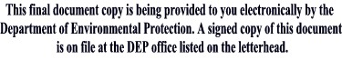
__________________________
Kenneth Kimmell
Commissioner

