Stormwater Pollution Education: Fertilizing the Lawn
When you fertilize the lawn, remember . . .
you're not just fertilizing the lawn.
It's hard to imagine that a green, flourishing lawn could pose a threat to the environment, but the fertilizers you apply to your lawn are potential pollutants! If applied improperly or in excess, fertilizer can be washed off your property and end up in lakes and streams. This causes algae to grow, which uses up oxygen that fish need to survive. So if you fertilize, please follow directions and use sparingly.
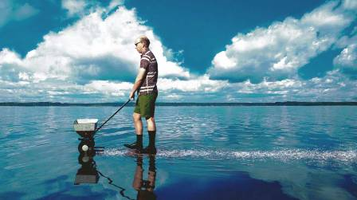
Clean water is important to all of us.
It's up to all of us to make it happen. In recent years, sources of water pollution like industrial wastes from factories have been greatly reduced. Now, more than 60 percent of water pollution comes from stormwater runoff, which picks up pollutants like leaking oil from cars, fertilizers from farms and gardens, and failing septic tanks. All these sources add up to a big pollution problem.
But each of us can do small things to help clean up our water - and that adds up to a pollution solution!
Why do we need clean water?
Having clean water is of primary importance for our health and economy. Clean water provides recreation, commercial opportunities, fish habitat, drinking water, and adds beauty to our landscape. All of us benefit from clean water-and all of us have a role in getting and keeping our lakes, rivers, streams, marine, and ground waters clean.
What's the problem with fertilizers?
Fertilizer is a "growing" problem for lakes, rivers, and streams, especially if it's not used carefully. If you use too much fertilizer or apply it at the wrong time, it can easily wash off your lawn or garden into storm drains and then flow into lakes or streams. Just like in your garden, fertilizer in lakes and streams makes plants grow. In water bodies, extra fertilizer can mean extra algae and aquatic plant growth. Too much algae causes water quality problems and makes boating, fishing, and swimming unpleasant. As algae decay, it uses up oxygen in the water that fish and other wildlife need.
Clean Water Tips: How can you fertilize and help keep our waters clean?
- Use fertilizer sparingly. Many plants don't need as much fertilizer or need it as often as you might think.
- Don't fertilize before a rain storm.
- Consider using organic fertilizers. They release nutrients more slowly.
Have your soil tested before applying fertilizers to your lawn and gardens.
A standard soil test costs $15. You may not need to add any fertilizer.
To order a soil test or for more information contact the
UMass Extension Soil Testing Lab at 413-545-2311
http://soiltest.umass.edu/ordering-information

http://www.umass.edu/soiltest/.)


Brought to you by the Town of ________

