Storyboard Guide for PIPs

Directions: A storyboard is a tool that can be used to simply and clearly communicate the story of a performance improvement project (PIP). The aim of a storyboard is to allow audiences to quickly grasp the main points of the story by providing only the most essential information and including one or more easy-to- understand charts that demonstrate the impact of the effort.

Storyboards may be presented in various formats, such as a one-two page handout, a large display poster, or even as presentation slides. The same key content should be presented in each. This guide is intended to be used by the person leading QAPI efforts in your facility, administrative leaders, or any other staff needing to communicate to an audience the results of a specific performance improvement project. An example of a storyboard is included in this guide.

Key Content to Include in your Storyboard:

- Problem. One sentence on the issue or opportunity being addressed by this PIP.
- Aim. One sentence on what this PIP aims to achieve.
- Intervention(s). Briefly describe what change was introduced to address the problem or opportunity.
If there was more than one change, use bullet points to list the multiple interventions.
- Measures/Indicators. List what measure(s) or indicator(s) are being used to monitor whether the change is effective.
- Results. One to two sentences on the results. Consider including a graph with notes that gives a picture of the impact of the changes over time, or stories that describe the success.
- Lessons Learned. Document 1-2 key lessons that were learned through the PIP.
- Next Steps. Performance improvement is a continuous process. In one to two sentences, describe the next steps (e.g., to further refine the intervention; to introduce the change in other parts of the nursing home; to take steps to standardize the change).

Depending on space limitations and the nature of your audience, you may choose to include additional information such as pictures or images that help bring the story to life; the names of the PIP team members; a description or visual of any quality improvement tools utilized; specific references from the literature that support the change approach.

Example of a storyboard starts on the next page:

Disclaimer: Use of this tool is not mandated by CMS, nor does its completion ensure regulatory compliance.

Sunnyside Nursing Home Busy City, Massachusetts November 21, 2018

Problem: Beginning in April 2017, Sunnyside began to see an increase in pressure ulcers among its high-risk residents; in June 2017, more than 10% of high-risk residents had been diagnosed with a pressure ulcer.

Aim: To reduce the occurrence of pressure ulcers in high-risk residents to less than 5% by November 2017.

Interventions:
- Redesign admissions packet to include the comprehensive pressure ulcer risk assessment form, to be completed within a resident’s first 24 hours of admission;
- Require a half day in-service training for all nursing assistants and licensed nursing staff on assessment for pressure ulcer risk and prevention;
- Utilize pressure redistribution mattresses for all residents at high-risk for pressure ulcers.
- Utilize pressure redistribution wheel chair cushions as applicable for all residents at high-risk for pressure ulcers.

Measures:
- Process measure: Number of new residents with completed pressure ulcer risk assessment with 24 hours of admission (Measure Goal: 100% of new residents by March 2018).
- Process measure: Number of residents at high risk for pressure ulcers with pressure redistribution mattresses. (Measure Goal: 100% of residents at high risk for pressure ulcers will have pressure redistribution mattresses by May 2018)
- Process measure: Number of residents at high risk for pressure ulcers and that use a wheel chair, with pressure redistribution wheel chair cushions. (Measure Goal: 100% of high risk residents using wheel chairs will have pressure redistribution cushions for their wheelchairs by May 2018)
- Outcome measure: Percent of high-risk residents with new, nursing home-acquired pressure ulcers (Measure Goal: Less than 5% by November 2018).

Results: As of April 2018, all new residents at Sunnyside received a comprehensive pressure ulcer risk assessment with 24 hours of admission. 100% of high risk residents have pressure redistribution mattresses. 100% of high risk residents that use a wheel chair have a pressure redistributing wheelchair cushion. The facility experienced a reduction in new pressure ulcers among high-risk residents over the 18-month period, from a high of 12% in August 2017 to a low of 5% in November 2018.

Disclaimer: Use of this tool is not mandated by CMS, nor does its completion ensure regulatory compliance.

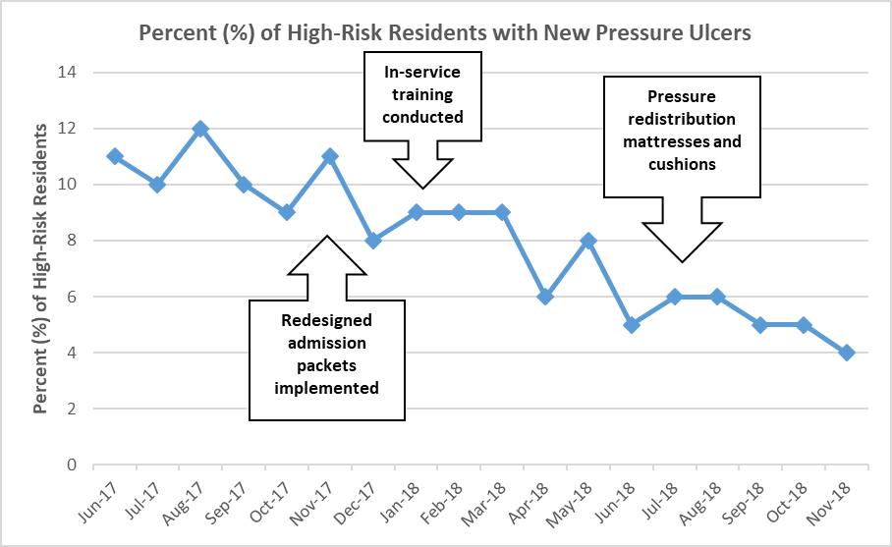

Lessons Learned:
- Although Sunnyside had a policy in place that each new resident should receive a pressure ulcer risk assessment, the admission packets were not set-up to help prompt staff to do so consistently with each admission.
- Nursing staff need more frequent training on pressure ulcer risk assessment and prevention.

Next Steps:
- Continue monitoring to make sure current pressure ulcer rates are maintained or improve.
- Integrate the pressure ulcer assessment tool into the facility’s electronic resident records system.
- Develop a more frequent training program on pressure ulcers for nursing staff.

Contact Information:
If you have any questions about this information, please contact xxx at xxx.

Source: Adapted with permission from the Institute for Healthcare Improvement (http://www.IHI.org).

Disclaimer: Use of this tool is not mandated by CMS, nor does its completion ensure regulatory compliance.

