Background

INDOOR AIR QUALITY
WATER DAMAGE ASSESSMENT

Stoughton Historical Society
6 Park Street
Stoughton, MA

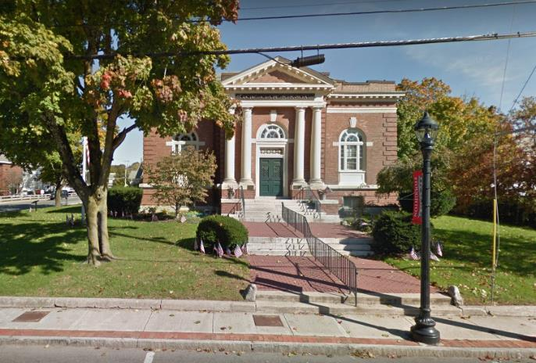

Prepared by:
Massachusetts Department of Public Health
Bureau of Environmental Health
Indoor Air Quality Program
March 2019

Building: | Stoughton Historical Society
Address: | 6 Park Street, Stoughton, MA
Assessment Requested by: | Paul Giffune, Director of Facilities, Town of Stoughton
Date of Assessment: | March 22, 2019
Bureau of Environmental Health/Indoor Air Quality (BEH/IAQ) Program Staff Conducting Assessment: | Cory Holmes, Environmental Analyst
Reason for Request: | Water infiltration and damage to building materials

Methods
BEH/IAQ staff performed moisture measurements of porous building materials and a visual inspection for water damage and/or microbial growth.

Results/Discussion

Microbial/Moisture Concerns
The visit occurred the morning after a night of heavy rain/wind conditions. Obvious water damage was apparent in the form of stained ceiling plaster, water stains on wood/crown molding and peeling paint/efflorescence on walls (Pictures 1 through 9). Efflorescence is a characteristic sign of water damage to building materials such as brick, mortar, or plaster, but it is not mold growth. As moisture penetrates and works its way through mortar around brick, water-soluble compounds dissolve, creating a solution. As the solution moves to the surface of the brick or mortar, water evaporates, leaving behind white, powdery mineral deposits. This condition indicates that water from the exterior has penetrated into the building. Plaster and brick do not typically support mold growth because these materials are not carbon-based; however paint, items, or debris near the walls/windows that are moistened may become a mold-colonized. When present, efflorescence can be readily cleaned.
Moisture measurements of water-damaged materials indicated that they were dry in the main foyer but wet in the Pierce Room/office; no visible mold growth on building materials was observed during the assessment. The most likely source of water penetration is through ornate cornice work along the roof and missing/damaged mortar around exterior brickwork (Pictures 10 through 15).

Conclusions/Recommendations
In view of the findings at the time of the visit, the following recommendations are made:
- Long-Term measures should be taken to address chronic water penetration issues including consultation with building envelope specialists/building engineers to conduct a thorough investigation and make recommendations to reduce water penetration.
- Until leaks are fixed, the following should be ongoing:
- Systematically perform building walk-throughs following any severe weather to check for leaks and promptly commence drying operations;
- Take measures to protect materials from further damage. Move porous items (e.g., books, paper, cardboard) away from areas with known water leaks; and
- Scrape away loose paint and debris from walls and clean/vacuum with a high efficiency particulate arrestance (HEPA) filter equipped vacuum cleaner.
- For more information on mold refer to the US EPA’s “Mold Remediation in Schools and Commercial Buildings” (US EPA, 2008). Available at: http://www.epa.gov/mold/mold-remediation-schools-and-commercial-buildings-guide.
- Refer to resource manuals and other related indoor air quality documents for further building-wide evaluations and advice on maintaining public buildings. Copies of these materials are located on the MDPH’s website: http://mass.gov/dph/iaq.

References
US EPA. 2008. Mold Remediation in Schools and Commercial Buildings. US Environmental Protection Agency, Office of Air and Radiation, Indoor Environments Division, Washington, D.C. EPA 402-K-01-001. http://www.epa.gov/mold/mold-remediation-schools-and-commercial-buildings-guide.
Picture 1
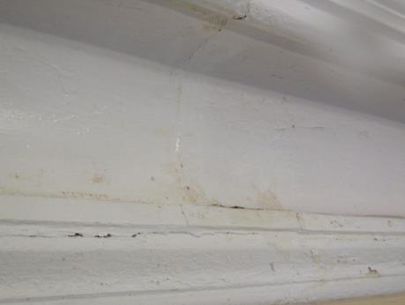
Water-damaged plaster and crown molding in main foyer
Picture 2
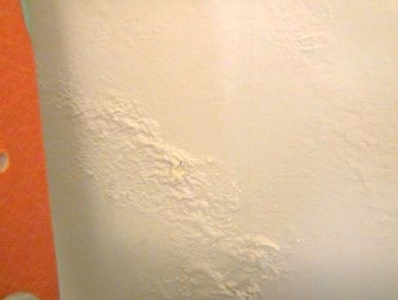
Peeling paint/efflorescence on wall plaster
Picture 3
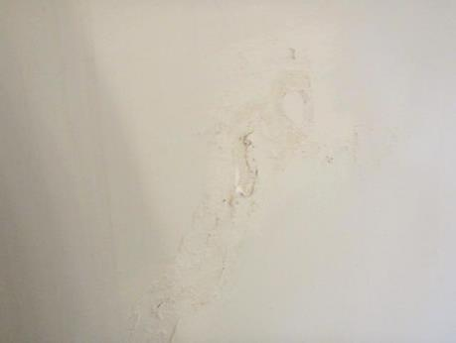
Peeling paint/efflorescence on wall plaster
Picture 4
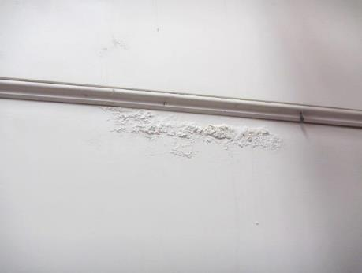
Efflorescence on wall plaster
Picture 5
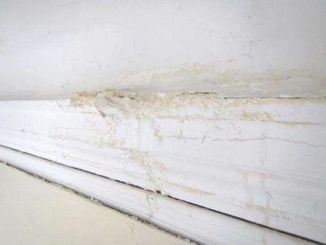
Water-damaged crown molding and ceiling plaster
Picture 6
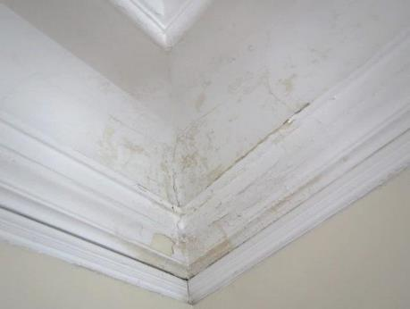
Water-damaged crown molding and wall/ceiling plaster
Picture 7
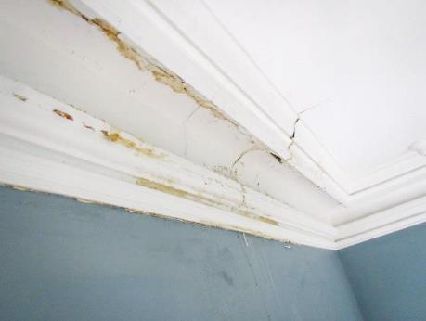
Water-damaged crown molding and wall/ceiling plaster
Picture 8
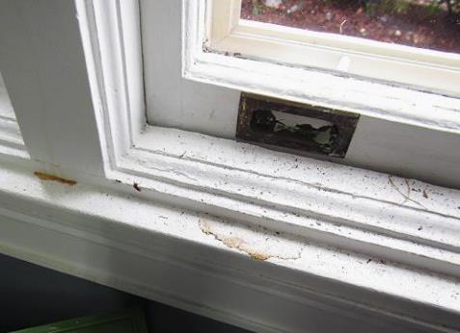
Water stains from dripping on windowsills
Picture 9
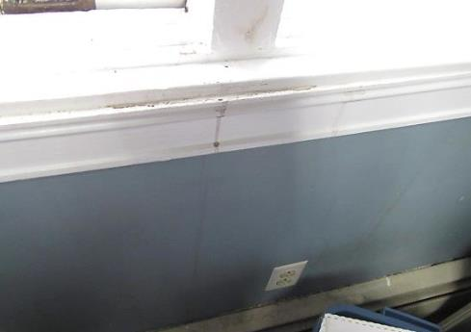
Water stains from dripping on windowsills/wall
Picture 10
Cornice work around roof
Picture 11
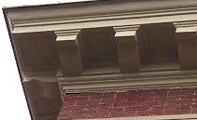
Breach (arrow) along cornice work near roof
Picture 12
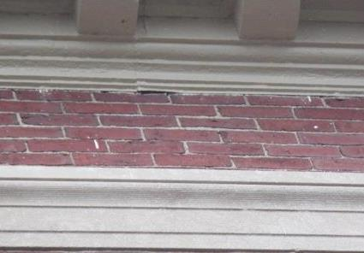
Breach (arrow) along cornice work near roof
Picture 13
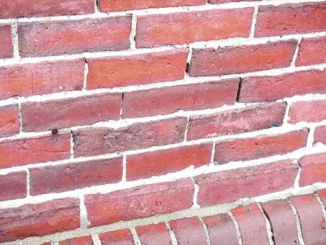
Missing/damaged mortar around brick
Picture 14
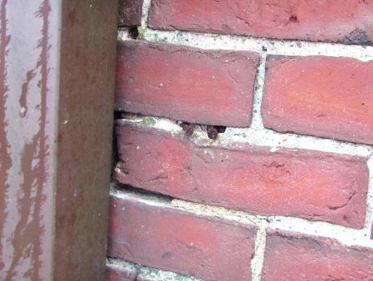
Missing/damaged mortar around brick
Picture 15
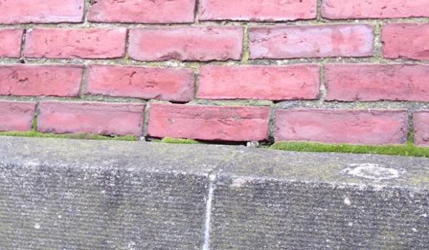
Missing/damaged mortar around brick

