# BACKGROUND

**INDOOR AIR QUALITY**

**ASSESSMENT**

**Stoughton Police Department**

**26 Rose Street**

**Stoughton, MA**

Exterior view of 
Stoughton Police Department
26 Rose Street
Stoughton, MA


Prepared by:

Massachusetts Department of Public Health

Bureau of Climate Change and Environmental Health

Indoor Air Quality Program

August 2023

|  |  |
| --- | --- |
| Building: | Stoughton Police Department (SPD) |
| Address: | 26 Rose Street, Stoughton, MA |
| Assessment Requested by: | Paul Giffune, Facilities Director, Town of Stoughton |
| Reason for Request: | General indoor air quality (IAQ) assessment |
| Date of Assessment: | July 19, 2023 |
| Massachusetts Department of Public Health/Bureau of Climate and Environmental Health (MDPH/BCEH) Staff Conducting Assessment: | Cory Holmes, Assistant Director, IAQ Program |
| Building Description: | The SPD is a one-story, brick-faced building with basement constructed in 1998. The flat portions of the roof consist of PVC membrane and the sloped portions are metal, which were being repaired and repainted at the time of assessment. Please note, the SPD was previously assessed by the MDPH IAQ Program in January 2016. Since then, some mechanical ventilation/air conditioning upgrades were made by installing ceiling units throughout the building to supplement the general heating, ventilation, and air conditioning (HVAC) system, however the main air handling units (AHUs) are original equipment. |
| Windows: | Not openable |

# METHODS

Please refer to the IAQ Manual for methods, sampling procedures, and interpretation of results (MDPH, 2015).

# RESULTS AND DISCUSSION

The following is a summary of indoor air testing results (Table 1).

* ***Carbon dioxide*** levels were above the MDPH guideline of 800 parts per million (ppm), in 7 of 17 areas, indicating a lack of air exchange in some areas at the time of assessment. This is most likely due to a combination of the HVAC system operating in air conditioning mode, which limits outside air intake (due to heat and elevated relative humidity) and the equipment being past its service life, which will be discussed further in the *Ventilation* section of this report.
* ***Temperature*** was within or close to the MDPH recommended range of 70°F to 78°F in areas tested.
* ***Relative humidity*** was above the MDPH recommended range of 40 to 60% in 7 of 17 areas, indicating the HVAC units may not be operating at proper capacity to reduce moisture in indoor air. This is discussed further in both the *Ventilation* and *Moisture Concerns* section of this report.
* ***Carbon monoxide*** levels were non-detectable (ND) in all areas tested.
* ***Fine particulate matter (PM2.5)*** concentrations measured indoors were below the National Ambient Air Quality Standard (NAAQS) limit of 35 μg/m3 in all areas tested, with the exception of the garage (44 μg/m3). These levels are most likely due to outdoor air infiltration through spaces around the exterior door. Please note, air quality in the Northeast United States was greatly affected by Canadian wildfires over the summer of 2023 (NY Times, 2023).

## Ventilation

A heating, ventilating, and air conditioning (HVAC) system has several functions. First it provides heating and, if equipped, cooling. Second, it is a source of fresh air. Finally, an HVAC system will dilute and remove normally occurring indoor environmental pollutants by not only introducing fresh air, but by filtering the airstream and ejecting stale air to the outdoors via exhaust ventilation. Even if an HVAC system is operating as designed, point sources of respiratory irritation may exist and cause symptoms in sensitive individuals.

The main HVAC system for the SPD consists of seven or eight residential-style air AHUs located in a mechanical room (Picture 1), which draw in outside air and heat/cool it. Conditioned air is ducted to multi-directional, ceiling-mounted supply diffusers (Picture 2) and returned via ceiling vents (Picture 3) back to AHUs.

Please note, this equipment is at the end of its service life which are now over 26 years old. According to the American Society of Heating, Refrigeration, and Air-Conditioning Engineers (ASHRAE), the service life[1] of this type of unit is 15-20 years, assuming routine maintenance of the equipment (ASHRAE, 1991). These units have been shown to be insufficient to provide proper air exchange, temperature and humidity control as evidenced by the presence of portable AC units that were deployed throughout the facility in 2016 (Picture 4), which emptied condensation into buckets. This is illustrated further with the recent installation of cassette units (Picture 5). Although the cassette units provide some relief, the relative humidity measurements indicate that they are not fully able to remove excess humidity (Table 1).

Also noted in the attic mechanical room was conditioned air escaping via an access panel in ductwork that was not secure (Picture 6). Finally, it was observed that all the interior doors surrounding the dispatch area were pegged open to the main hallways (Picture 7). HVAC systems are designed and balanced for closed areas. These conditions can reduce the efficiency of the system and contribute to temperature/comfort or condensation issues.

AHUs have filters, which should be changed 2-4 times a year or per the manufacturer’s recommendations. Filters should be at least a Minimum Efficiency Rating Value (MERV) of 8 *or higher*, if they fit and the equipment can handle the pressure reductions caused by more restrictive filters. Filters at SPD were confirmed to be MERV 13 and Stoughton Facilities staff reported that they are changed at least twice a year under a preventative maintenance program. Filters were clean and recently changed at the time of assessment (Picture 8).

In order to have proper ventilation with a mechanical ventilation system, the systems must be balanced after installation to provide an adequate amount of fresh air to the interior of a room while removing stale air from the room. It is recommended that HVAC systems be re-balanced every five years to ensure adequate air systems function (SMACNA, 2013).

The garage and sally ports contain carbon monoxide monitors (Picture 9), presumably they turn on a local exhaust system and alert occupants once a setpoint is met. It is important to note that any monitoring equipment with sensor technology should be calibrated or replaced as per the manufacturer’s instructions.

## Moisture Concerns

As mentioned previously, the HVAC system does not appear to be able to sufficiently remove excess moisture as shown by relative humidity measurements above the MDPH guideline of 40-60% (Table 1), which can lead to comfort complaints. Please note, that even in the absence of liquid water, high humidity above 70% for an extended period of time can lead to water damage and mold growth in susceptible materials (ASHRAE, 2019).

A few water-damaged ceiling tiles were observed (Table 1, Picture 10), which are evidence of building envelope and/or plumbing leaks. When a water leak is discovered and repaired, water-damaged tiles should be changed.

## Other Concerns

A number of areas are covered with carpeting, some areas have had carpet squares installed in the last year. In general, it is not recommended for fire departments and other emergency response agencies to have carpeted floors due to the possible cross-contamination that may occur from footwear contact with automotive products, chemicals, or biological contamination. In addition, the Institute of Inspection, Cleaning and Restoration Certification (IICRC) discusses floor covering in its guideline, “Standard for Professional Cleaning of Textile Floor Coverings” (IICRC, 2015). Based on this standard, the IICRC recommends twice-daily vacuuming and/or pile-lifting cleaning for commercial carpeting in heavy traffic areas. This frequency of cleaning of the building as well as the use of vacuum cleaners equipped with high-efficiency particulate arrestance (HEPA) filters would remove respirable dust from the indoor air. Office areas were also mostly carpeted. Carpets in these areas should be cleaned annually (or semi-annually in soiled/high traffic areas) in accordance with Institute of Inspection, Cleaning and Restoration Certification (IICRC) recommendations, (IICRC, 2012).

Finally, some supply, exhaust, and return vents had accumulations of dust and debris (Picture 11, Table 1). This dust/debris can be reaerosolized under certain conditions, or grow mold if it gets moistened, and should be cleaned periodically (e.g., during regular filter changes).

# CONCLUSIONS AND RECOMMENDATIONS

In view of the findings at the time of assessment, the following recommendations are made:

### **Ventilation recommendations**

1. Continue with preventative maintenance plans for general HVAC systems.
2. Make necessary adjustments to HVAC controls/air intakes to allow an increase in fresh air (weather-permitting/relative humidity < 60%) to rooms with elevated carbon dioxide levels (Table 1).
3. Continue to change filters for HVAC equipment 2-4 times a year using MERV 8 or the highest MERV rating the ventilation system can accommodate to improve air filtration as much as possible without significantly reducing airflow.
4. Clean the interior of AHUs during regular filter changes using a HEPA-filtered vacuum cleaner with brush attachment or compressed air.
5. Periodically check exhaust vents in restrooms for draw and make adjustments/repairs as needed.
6. Inspect and seal any breaches/holes in the HVAC system/ductwork allowing conditioned air to escape (Picture 6).
7. Operate all supply and exhaust ventilation equipment continuously during occupied hours.
8. Keep all doors closed in each AC zone to maintain air temperature and prevent condensation in adjoining uncooled areas.
9. Have the HVAC system balanced every 5 years in accordance with SMACNA recommendations (SMACNA, 2013).
10. Due to the age/lack of efficiency, consult with an HVAC engineering firm to conduct a full evaluation of HVAC components, for developing a plan for replacement or overhaul of systems and controls.

### **Water damage recommendations**

1. Work with HVAC vendor/engineer to monitor and adjust temperature set points to better manage/reduce indoor relative humidity and improve comfort.
2. Replace water-damaged ceiling tiles once leaks from plumbing, HVAC or building envelope have been resolved.
3. Seal spaces around/beneath exterior doors (where space/light can be seen) with weather-stripping.

## Other recommendations

1. Clean supply, return, and exhaust vents regularly to remove accumulated dust/debris.
2. If ceiling tiles around dusty vents cannot be cleaned, replace.
3. Consideration should be given to replacing carpeting with a different type of floor covering that can be readily cleaned. Until that time, clean carpeting in accordance with IICRC recommendations (IICRC, 2012); annually (or semi-annually in soiled/high traffic areas). Worn carpeting past its lifespan (>11 years) should be replaced.
4. Contact the manufacturer of the local exhaust/sensor system for the garage/sally port regarding proper operation and maintenance. Determine if system has manual override, if not consider contacting an electrician/HVAC technician to install a method to provide continuous ventilation in this area.
5. For buildings in New England, periods of low relative humidity during the winter are often unavoidable. Therefore, scrupulous cleaning practices should be adopted to minimize common indoor air contaminants whose irritant effects can be enhanced when the relative humidity is low. To control for dusts, a high efficiency particulate arrestance (HEPA) filter equipped vacuum cleaner in conjunction with wet wiping of all surfaces is recommended. Avoid the use of feather dusters. Drinking water during the day can help ease some symptoms associated with a dry environment (throat and sinus irritations).
6. Refer to resource manual and other related IAQ documents located on the MDPH’s website for further building-wide evaluations and advice on maintaining public buildings. These documents are available at: <http://mass.gov/dph/iaq>.

# REFERENCES

ASHRAE. 1991. ASHRAE Applications Handbook, Chapter 33 “Owning and Operating Costs”. American Society of Heating, Refrigeration and Air Conditioning Engineers, Atlanta, GA.

ASHRAE. 2019. American Society of Heating, Refrigeration and Air Conditioning Engineers (ASHRAE) Ventilation for Acceptable Indoor Air Quality. ANSI/ASHRAE Standard 62.1-2019. Atlanta, GA.

IICRC. 2012. Institute of Inspection, Cleaning and Restoration Certification. Carpet Cleaning: FAQ.

IICRC. 2015. Institute of Inspection, Cleaning and Restoration Certification. Commercial Carpet Cleaning: FAQ.

MDPH. 2015. Massachusetts Department of Public Health. “Indoor Air Quality Manual: Chapters I-III”. Available at: [Indoor air quality - manual and appendices | Mass.gov](https://www.mass.gov/lists/indoor-air-quality-manual-and-appendices)

NY Times. 2023. **Maps: Tracking Air Quality and Smoke From Wildfires.** <https://www.nytimes.com/interactive/2023/us/smoke-maps-canada-fires.html>

SMACNA. 2013. HVAC Systems Commissioning Manual. 2nd ed. Sheet Metal and Air Conditioning Contractors’ National Association, Inc., Chantilly, VA

**Picture 1**

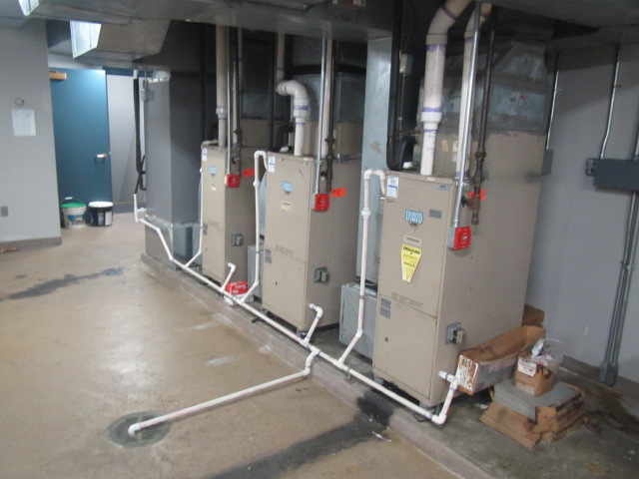

**Residential-style air-handling units in attic mechanical room**

**Picture 2**

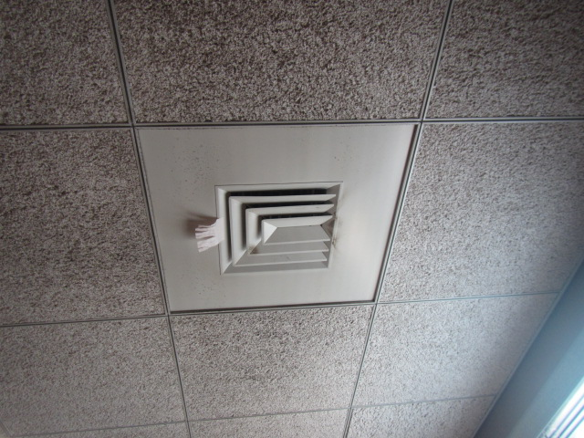

**Ceiling-mounted supply diffuser, note dust/debris accumulation on vent and surrounding ceiling tiles**

**Picture 3**

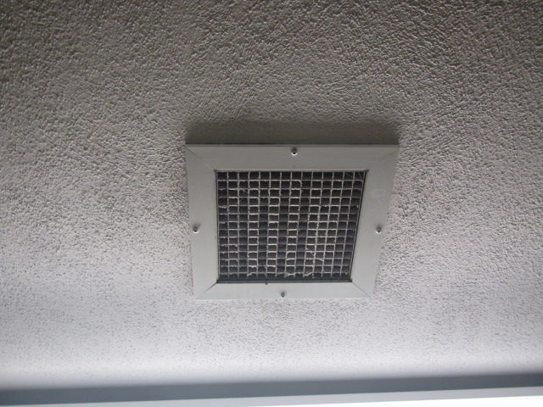

**Ceiling-mounted return vent**

**Picture 4**

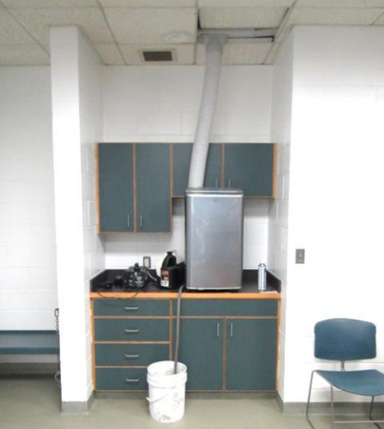

**Portable AC Unit in booking room, note condensation draining in bucket (photo taken by MDPH IAQ staff in 2016)**

**Picture 5**

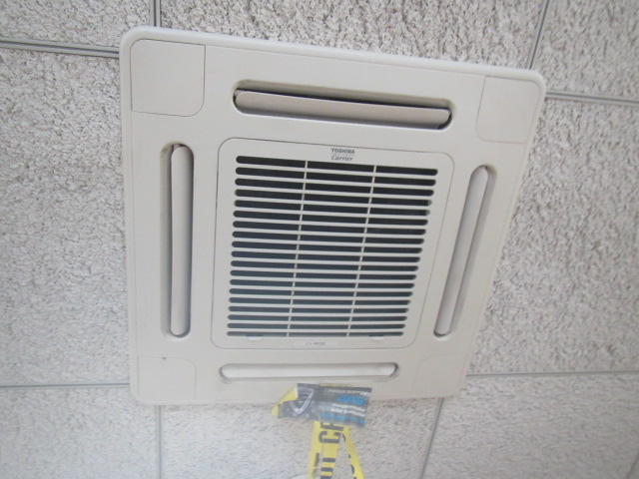

**Typical “Cassette” unit installed throughout the facility. Please note, these units do not introduce fresh/outside air but *recirculate* only**

**Picture 6**

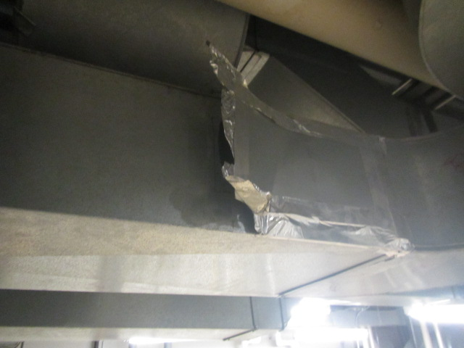

**Breach in ductwork allowing conditioned air to escape**

**Picture 7**

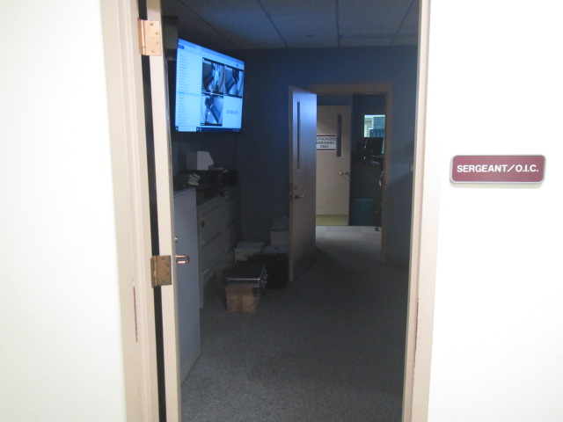

**Interior doors open to main hallways**

**Picture 8**

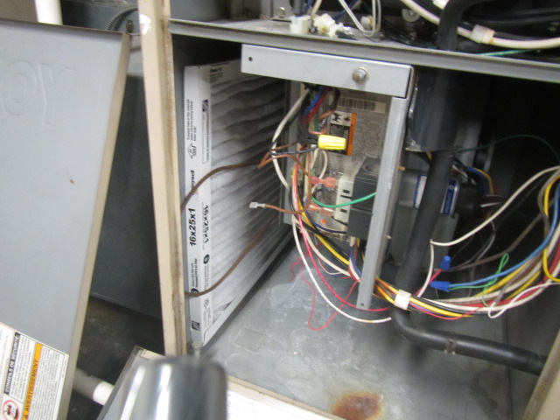

**MERV 13 Filter installed in AHU**

**Picture 9**

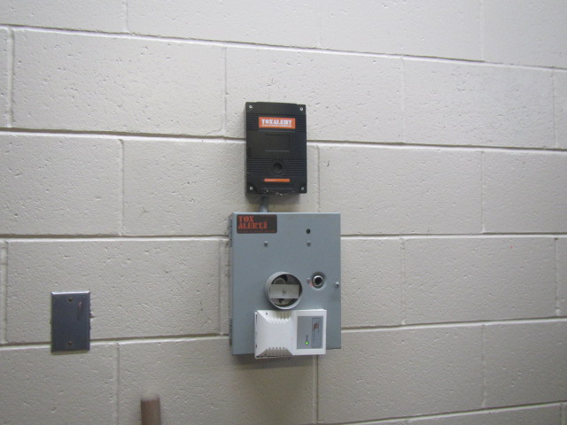

**Carbon monoxide monitor in Sally Port/Garage**

**Picture 10**

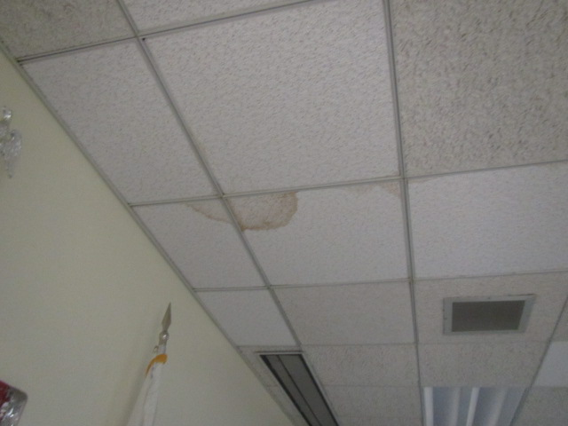

**Water-damaged ceiling tiles**

**Picture 11**

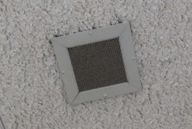

**Ceiling-mounted exhaust vent, note clogged with dust/debris**

| Location | **Carbon**  **Dioxide**  **(ppm)** | **Carbon Monoxide**  **(ppm)** | **Temp**  **(°F)** | **Relative**  **Humidity**  **(%)** | **PM2.5**  **(µg/m3)** | **Occupants**  **in Room** | **Windows**  **Openable** | **Ventilation** | | **Remarks** |
| --- | --- | --- | --- | --- | --- | --- | --- | --- | --- | --- |
| **Supply** | **Exhaust** |
| Background | 427 | ND | 84 | 74 | 73 |  |  |  |  | Warm and humid, slight breeze, partly cloudy, elevated outdoor particulates |
| Main Detectives Office | 786 | ND | 74 | 59 | 5 | 2 | N | Y | Y | Space beneath exterior door, dust/debris on vents |
| Detectives’ Office | 784 | ND | 74 | 57 | 6 | 2 | N | Y | Y | Carpeting |
| Squad Room | 798 | ND | 70 | 70 | 18 | 1 | N | Y | Y | 5 WD CTs, dust/debris on vents and surrounding CTs, carpeting |
| Male Locker Room | 567 | ND | 68 | 70 | 27 | 0 | N | Y | Y | Restroom exhaust off, stained CTs, space around exterior door |
| Female Locker Room | 551 | ND | 68 | 73 | 14 | 0 | N | Y | Y | Restroom exhaust off |
| Garage |  | ND |  |  | 44 |  | N |  | Y | Carbon monoxide monitor |
| Booking | 607 | ND | 70 | 67 | 17 | 0 | N | Y | Y | Dust/debris on vents |
| Sally Port |  | ND |  |  | 27 |  |  |  | Y | Carbon monoxide monitor, spaces around exterior door |
| Matron Area | 580 | ND | 71 | 65 | 16 | 0 | N | Y | Y | Dust/debris on vents |
| Lieutenant A Office | 848 | ND | 70 | 59 | 12 |  | N | Y | Y | Carpet |
| Deputy Chief Office | 918 | ND | 70 | 59 | 10 | 2 | N | Y | Y | Carpeting (old) |
| Lieutenant B Office | 861 | ND | 70 | 58 | 11 | 0 | N | Y | Y | Carpeting (old) |
| Records | 906 | ND | 70 | 56 | 11 | 1 | N | Y | Y | Mini-spilt, carpet, PF |
| Chief Office | 656 | ND | 69 | 63 | 11 | 0 | N | Y | Y | Carpet, dust/debris on vents |
| Chief Admin Office | 662 | ND | 70 | 61 | 11 | 0 | N | Y | Y | Carpet, dust/debris on vents, photocopier |
| Chief Restroom |  |  |  |  |  |  | N | Y | Y | Exhaust off, dust/debris on vents |
| Community Room | 763 | ND | 70 | 59 | 16 | 1 | N | Y | Y | Dust/debris on vents |
| Juvenile Office | 870 | ND | 70 | 59 | 11 | 0 | N | Y | Y | Carpet, dust/debris on vents |
| Dispatch | 1072 | ND | 69 | 56 | 9 | 3 | N | Y | Y | DO (2), carpet, dust/debris on vents |
| Seargent Area | 936 | ND | 70 | 58 | 14 | 1 | N | Y | Y | Carpet, dust/debris on vents, DO |
| Employee Restrooms |  |  |  |  |  |  | N | N | Y | Exhaust off |

1. The service life is the median time during which a particular system or component of … [an HVAC]… system remains in its original service application and then is replaced. Replacement may occur for any reason, including, but not limited to, failure, general obsolescence, reduced reliability, excessive maintenance cost, and changed system requirements due to such influences as building characteristics or energy prices (ASHRAE, 1991).