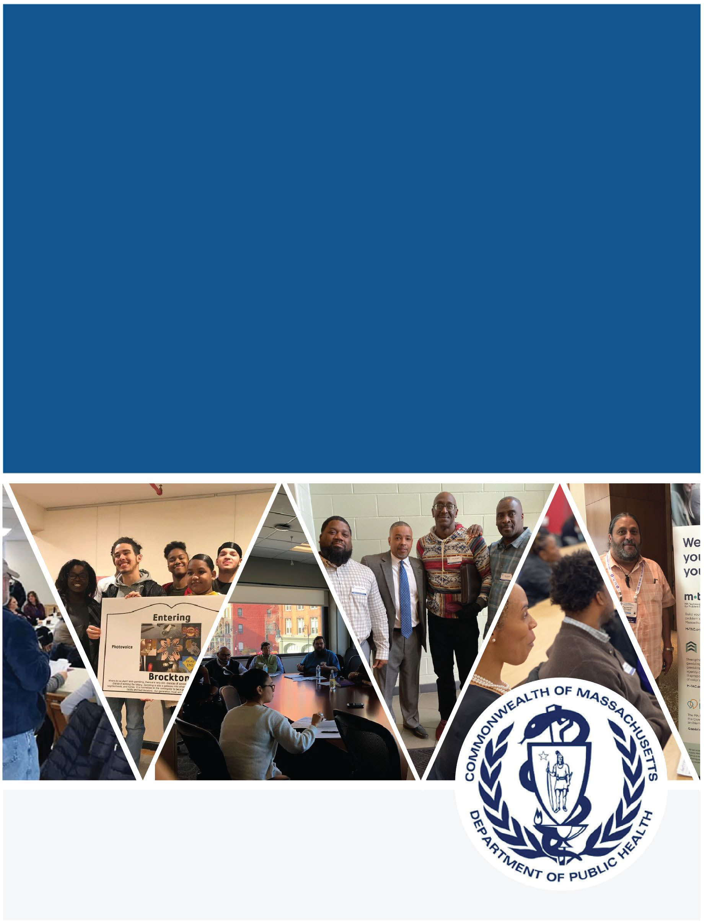

Strategic Plan 2022-2026
Working Together to Mitigate Harms Associated with Problem Gambling

January 2023

Massachusetts Department of Public Health Office of Problem Gambling Services

TABLE OF CONTENTS
OVERVIEW AND BACKGROUND 2
Purpose 2
Acknowledgments 2
Background 3
STRATEGIC PLAN 2022-2026 4
Who We Are 4
Purpose, Mission and Vision 4
Guiding Principles 4
Strategic Vision for Public Health Overall 4
Accomplishments to Date 6
Accomplishments and Milestones 7
Stakeholder Engagement to Inform Strategic Plan Development 11
Overview 11
Key Themes 12
Major Impact Areas, Goals, Strategies, and Measures 12
Expand Reach 14
Enhance Effectiveness 16
Conclusion 17

OVERVIEW AND BACKGROUND

PURPOSE
This strategic plan was created to guide the work of the Massachusetts Department of Public Health (DPH)’s Office of Problem Gambling Services (henceforth referred to as “OPGS” or “the Office”) during the time period 2022-2026. It details the origins of the Office, accomplishments to date by the Office and its partners, and the Office’s core focus, principles, and strategic priorities going forward.
From 2016 to 2021, the Commonwealth of Massachusetts’ response to mitigating harms from problem gambling was guided by a strategic plan spearheaded by the Public Health Trust Fund. Over this five-year period, OPGS and its partners executed strategies across 11 priority areas identified in the 2016-2021 plan, thereby establishing a foundation for expanded impact going forward.
The prior strategic plan has matured, and OPGS has been charged with leading an expanded public health driven and equity-centered response to mitigating harms associated with continued expansion of gambling opportunities across the Commonwealth. OPGS operates in concert with colleagues across DPH, in alliance with an array of local, state, and national partners, and in service and response to historically underserved and marginalized communities. By empowering community voice and acknowledging those who are experiencing health inequities, OPGS will promote equity and mitigate harms associated with problem gambling. OPGS will work over the time period governed by this plan to continue maximizing positive impact by ensuring reach and effectiveness of problem gambling prevention, treatment, and recovery services.

ACKNOWLEDGMENTS
DPH/OPGS would like to thank the over 300 community members throughout the Commonwealth who participated in this process and lent their voices to the development of this plan. We also thank the following organizations for their partnerships and contributions:

- Boston Chinatown Neighborhood Center
- Cambridge Health Alliance
- City of Revere, MA
- City of Springfield, MA
- City of Worcester, MA
- Division on Addiction at Cambridge Health Alliance
- Doura-Schawohl Consulting
- Education Development Center
- Executive Office of Public Safety and Security
- Gandara Mental Health Center
- The Greater Malden Asian American Community Coalition, Inc. (GMAACC)
- Health Resources in Action
- International Center for Responsible Gambling
- John Snow, Inc
- Kindbridge Institute
- Maryland Council on Problem Gambling
- Massachusetts Council on Gaming and Health
- Massachusetts Gaming Commission
- Massachusetts Public Health Association
- Massachusetts State Lottery Commission
- Massachusetts Center of Excellence for Problem Gambling Prevention
- National Association of Administrators for Disordered Gambling Services
- National Council on Problem Gambling
- Old Colony YMCA
- Public Health Institute of Western Massachusetts
- Social Science Research and Evaluation Inc.
- Stairway to Recovery
- ThinkArgus
- UMass Boston
- University of Nevada, Las Vegas

BACKGROUND
Mitigating harm from problem gambling has been a priority and focus of Massachusetts government since the Expanded Gaming Act of 2011. The government’s response, led by DPH in partnership with other public and private health and human services organizations, has expanded with a particular focus on communities affected directly by the legalization of casino-based gambling.
OPGS’ response to mitigating harm from problem gambling is grounded deeply in public health principles. Problem gambling exacerbates health inequities in myriad ways. An array of research has shown it frequently co-occurs with mental health and substance misuse disorders, inhibiting recovery and entrapping individuals, families, and communities in negative reinforcement cycles.1 Problem gambling mitigation is, therefore, inextricably interwoven with broader DPH and societal work to eradicate health inequities in the Commonwealth.
In recognition of these dynamics, OPGS was created to ensure a comprehensive and integrated public health response to problem gambling using data to inform initiatives, engage communities, and ensure cultural intelligence and humility. The Office takes a community-driven approach rooted in the Social Determinants of Health, with a racial equity lens. The Office’s work focuses on elevating the voice of historically underserved communities and strengthening the government’s response to the needs of those who are disproportionately impacted by problem gambling.

1 A few examples of research among many include Goodyear-Smith F, Arroll B, Kerse N, Sullivan S, Coupe N, Tse S, Shepherd R, Rossen F, Perese L. Primary care patients reporting concerns about their gambling frequently have other co- occurring lifestyle and mental health issues. BMC Family Practice, 10 April 2006, 7-25; Kee-Lee Chou, Tracie O. Afifi.
Disordered (Pathologic or Problem) Gambling and Axis I Psychiatric Disorders: Results From the National Epidemiologic Survey on Alcohol and Related Conditions. American Journal of Epidemiology, Volume 173, Issue 11, 1 June 2011, 1289– 1297. Afifi, T.O., Cox, B.J., Martens, P.J. et al. The Relationship between Problem Gambling and Mental and Physical Health Correlates among a Nationally Representative Sample of Canadian Women. Canadian Journal of Public Health Volume 101, 2010, 171–175; Caler KR, Vargas Garcia JR, Nower L. Problem gambling among ethnic minorities: results from an epidemiological study. Asian Journal of Gambling Issues and Public Health, Volume 7, Article 7, 7 September 2017, 1-13. Raybould, J.N., Larkin, M. & Tunney, R.J. Is there a health inequality in gambling related harms? A systematic review. BMC Public Health Volume 305, Article 21, 6 February 2021, 1-17.

STRATEGIC PLAN 2022-2026

WHO WE ARE
OPGS is an Office within the Massachusetts Department of Public Health, a Department under the Commonwealth’s Executive Office of Health and Human Services (EOHHS), the largest secretariat in Massachusetts state government.

Purpose, Mission and Vision
The OPGS purpose, mission, and vision are outlined below, and are aligned with those for DPH.
Our Purpose: Work to prevent and address problem gambling and related issues in Massachusetts.
Our Mission: The Office works every day to mitigate the harmful effects of problem gambling and related health concerns through a variety of community-level strategies that ensure a strong public health response to problem gambling.
Our Vision: To ensure a comprehensive and integrated public health response that will include utilization of data to inform initiatives, engagement of communities, and that which ensures cultural intelligence and humility.

Guiding Principles
The OPGS’ guiding principles are as follows:
Community Engagement – OPGS serves the community, is inspired by the community, is guided by the needs and insights of the community, and empowers the community, including individuals and groups passionate about addressing problem gambling and associated health concerns, at risk for problem gambling, or struggling with problem gambling and its ill effects.

Public Trust – As part of a publicly funded state agency, OPGS has a responsibility to the people of Massachusetts to ensure that all of its operations and programs are administered with integrity and strong internal controls.

Racial Equity – OPGS adheres to the definition of racial equity put forth by the Center for Social Inclusion as “both an outcome and a process. As an outcome, we achieve racial equity
when race no longer determines one’s socioeconomic outcomes; when everyone has what
they need to thrive, no matter where they live.”

Partnership – OPGS actively seeks to connect with others who share the Office’s vision and principles while bringing complementary knowledge, skills, and resources. The Office works with an array of public and private partners on a joint, comprehensive, and integrated public health response to problem gambling and associated health concerns.

Strategic Vision for Public Health
The mission of DPH is to prevent illness, injury, and premature death, to assure access to high quality public health and health care services, and to promote wellness and health equity for all people in the Commonwealth. DPH envisions a Commonwealth in which all people enjoy optimal

health. Massachusetts ranks among the healthiest of states according to comparative analyses, but also faces numerous challenges, including chronic and infectious disease, substance misuse, violence, preventable hospitalizations, and health disparities.
DPH recognizes the deep and insidious intersectionality between barriers to optimal health and structural disparities faced by historically marginalized communities. DPH staff — including the OPGS team — work in concert with each other and networks of external partners to provide communities facing health inequities with holistic supports to overcome systemic barriers to optimal health.
The following graphic summarizes the DPH vision, mission, and guiding principles:
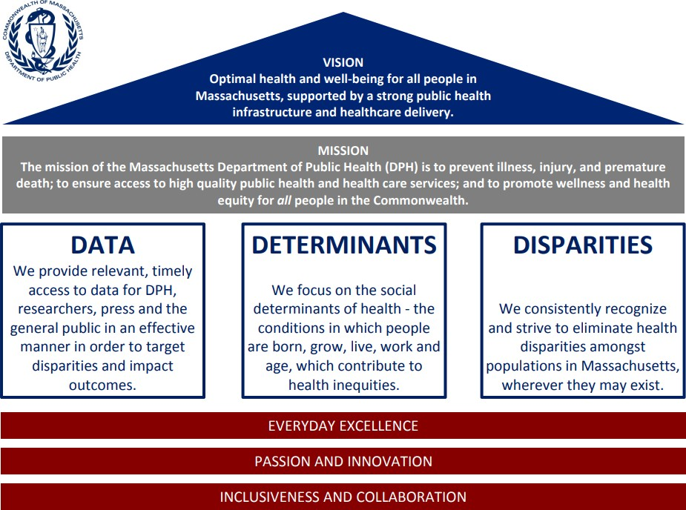

ACCOMPLISHMENTS TO DATE
Since 2016, OPGS’ approach to mitigating harm from problem gambling behaviors has received national recognition within the field of problem gambling for leadership in the promotion of equity. The 2016-2021 strategic plan articulated the following priority areas which guided the efforts of OPGS and its partners:

1 | Prevention for Youth
2 | Prevention for High-Risk Populations
3 | Focus on Community-Level Interventions
4 | Coordination of Problem Gambling Services
5 | Integration of Addiction Services, Mental Health Services, and Primary Care
6 | Decrease in Stigma and Unsupportive Social Norms
7 | Increase in Availability of Support Services
8 | Increase in Availability of Culturally Appropriate Services
9 | Contribution to the Evidence Base for Problem Gambling Services
10 | Establishment of an Evaluation Infrastructure
11 | Expansion of Institutional Capacity to Address Problem Gambling and Related Issues
In response, the OPGS team has engaged over 2,000 community stakeholders and in concert with 40 community-based partners spearheaded over twenty-three (23) initiatives. On the next two pages are year-over-year examples of milestones and accomplishments achieved in the course of that work.

Accomplishments and Milestones

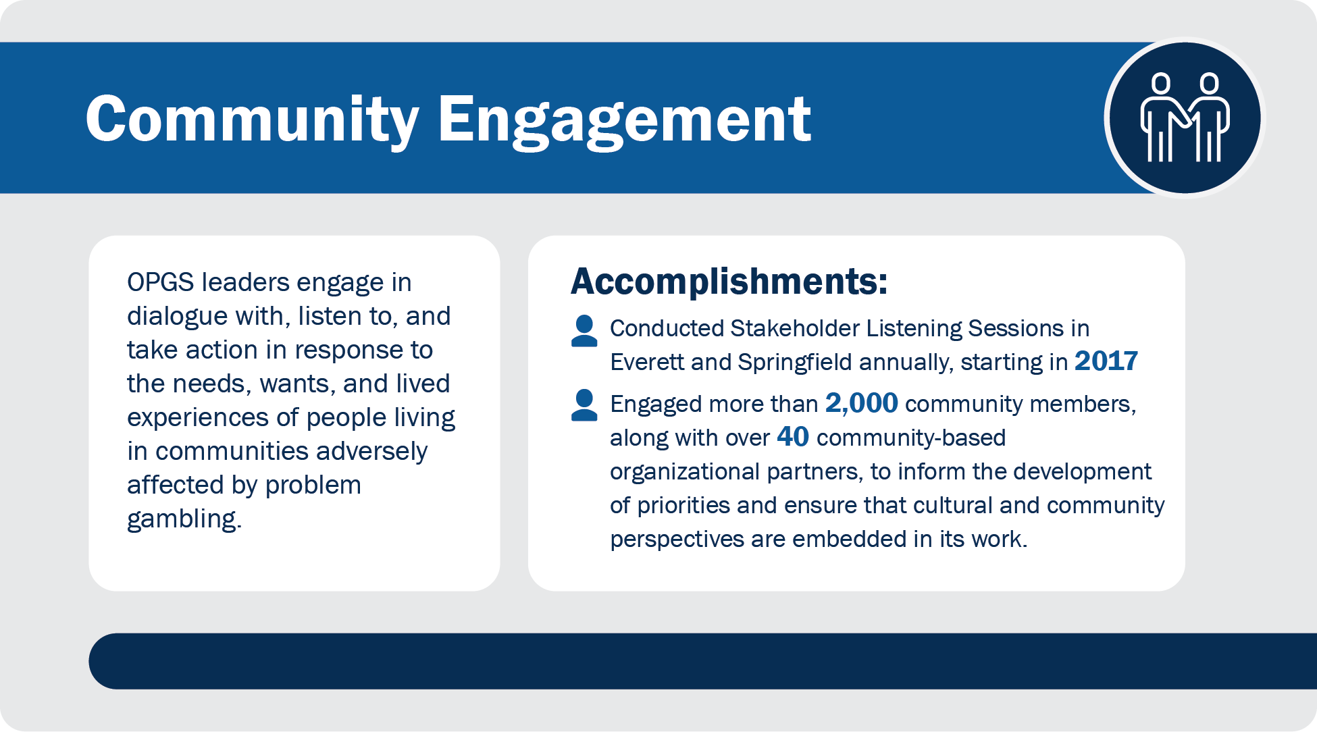
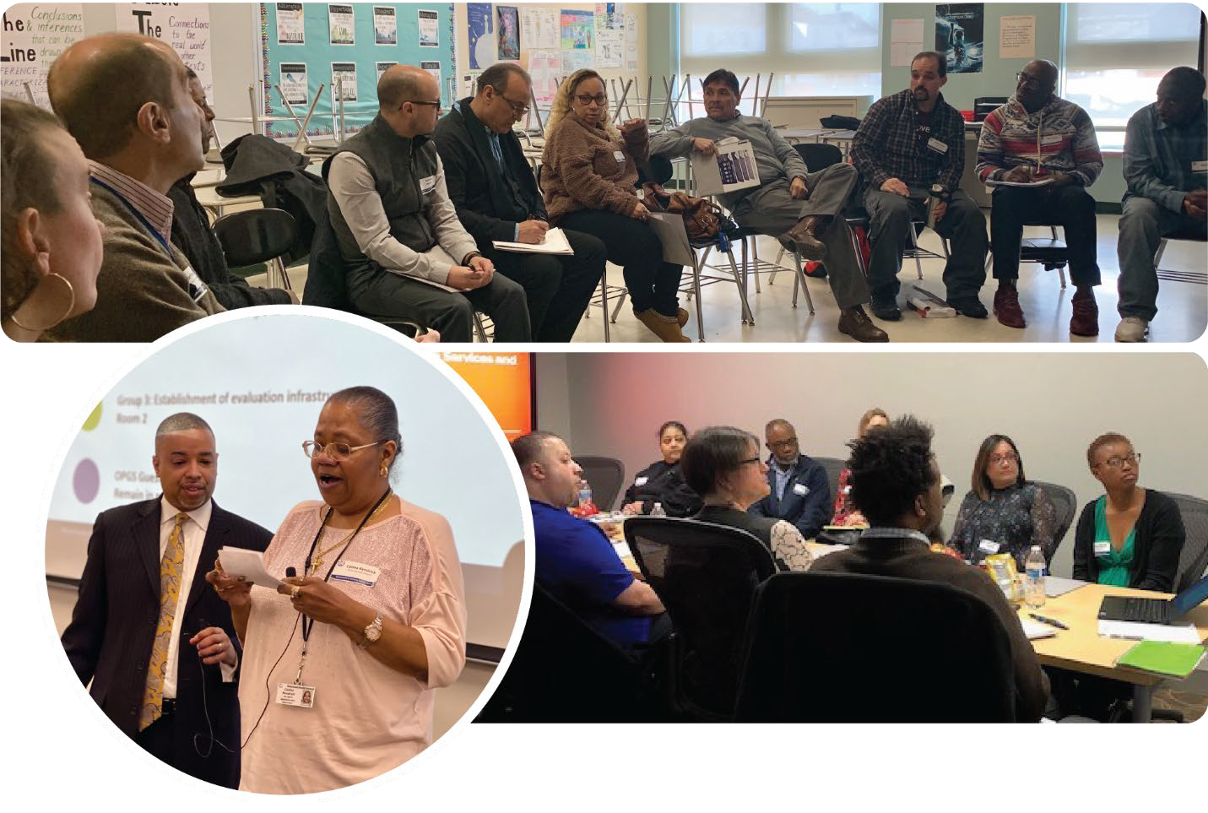

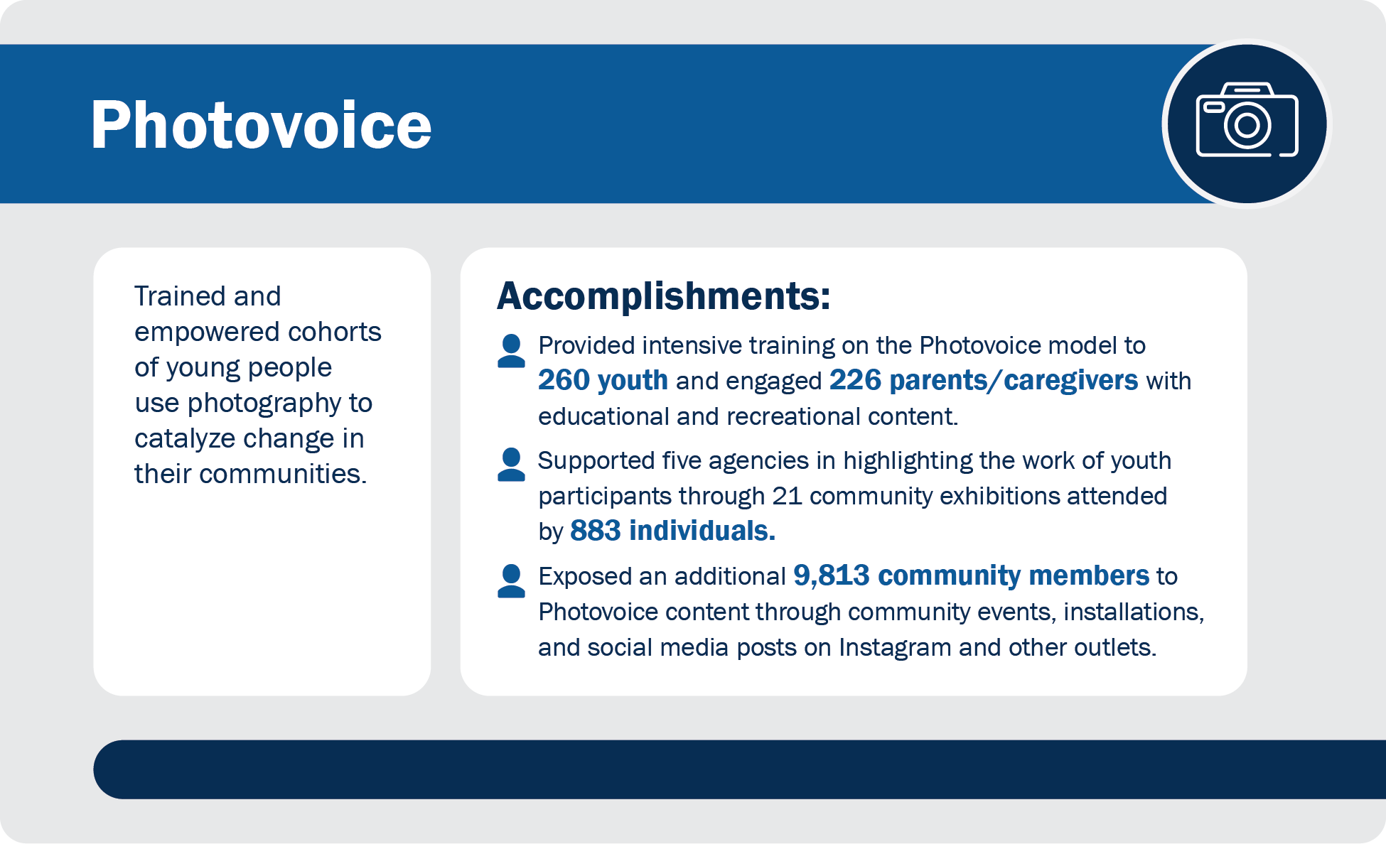

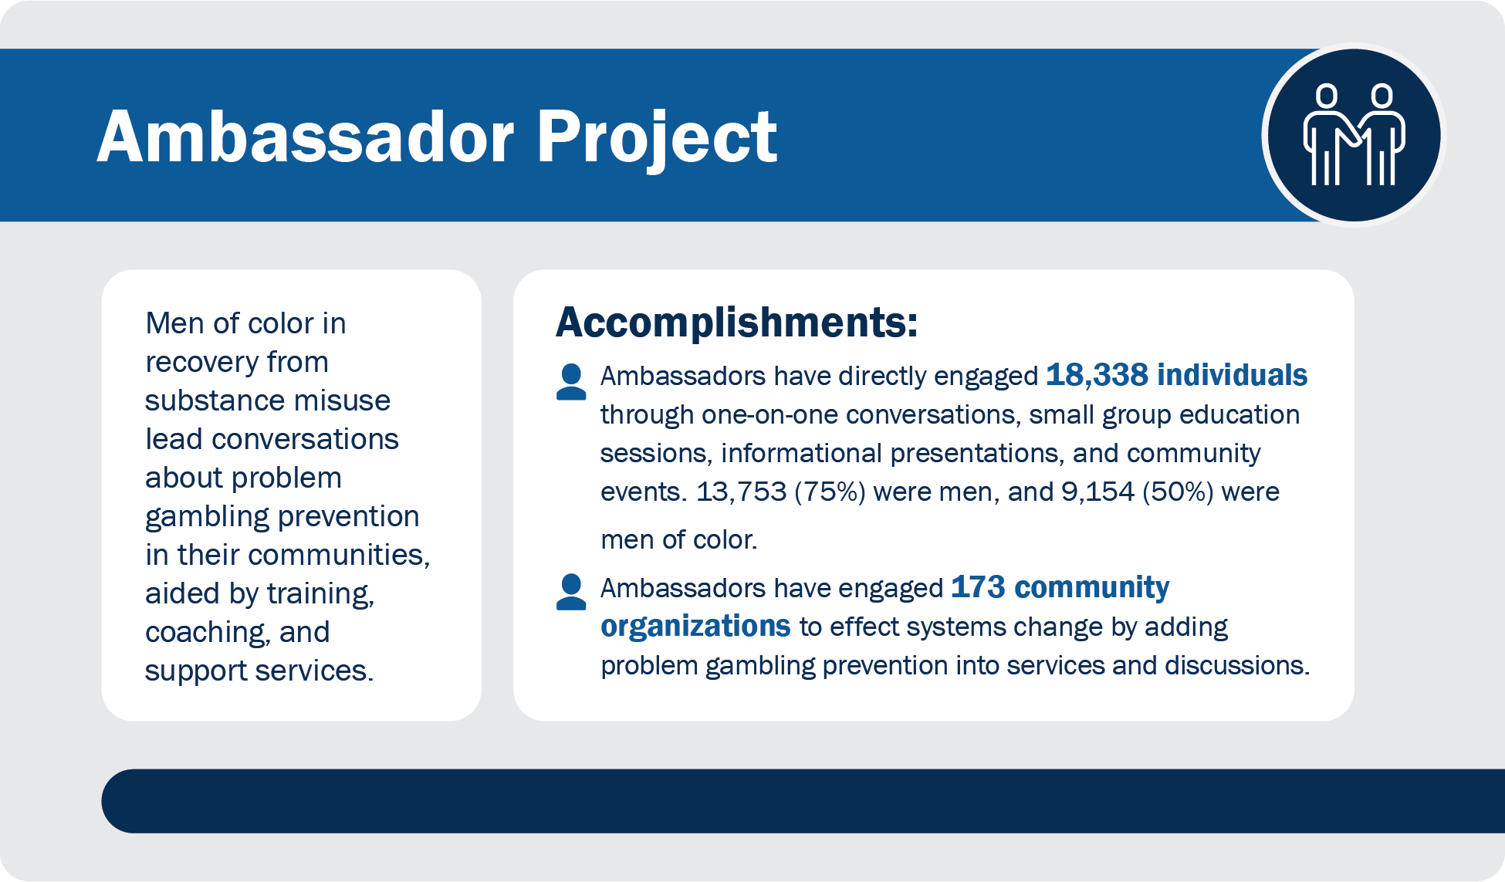
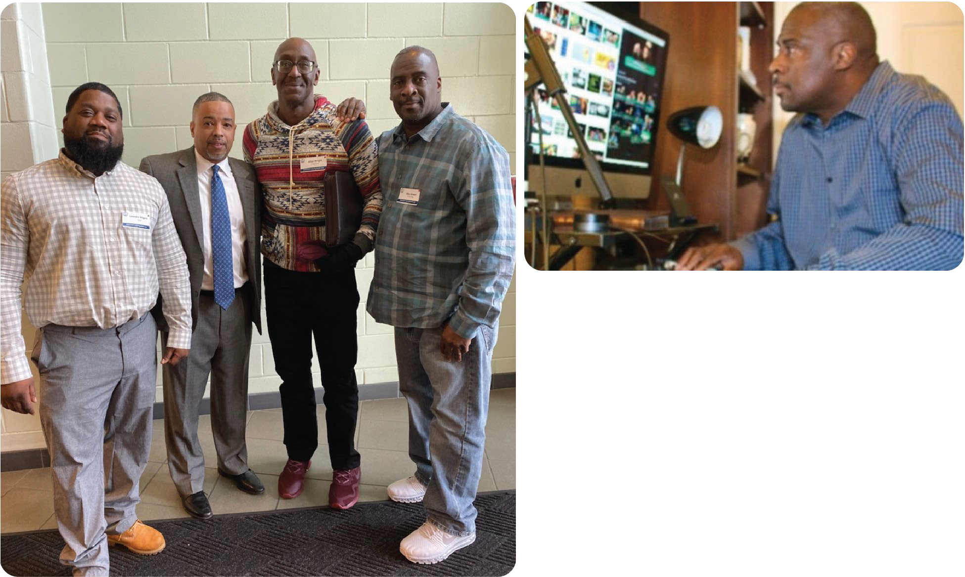

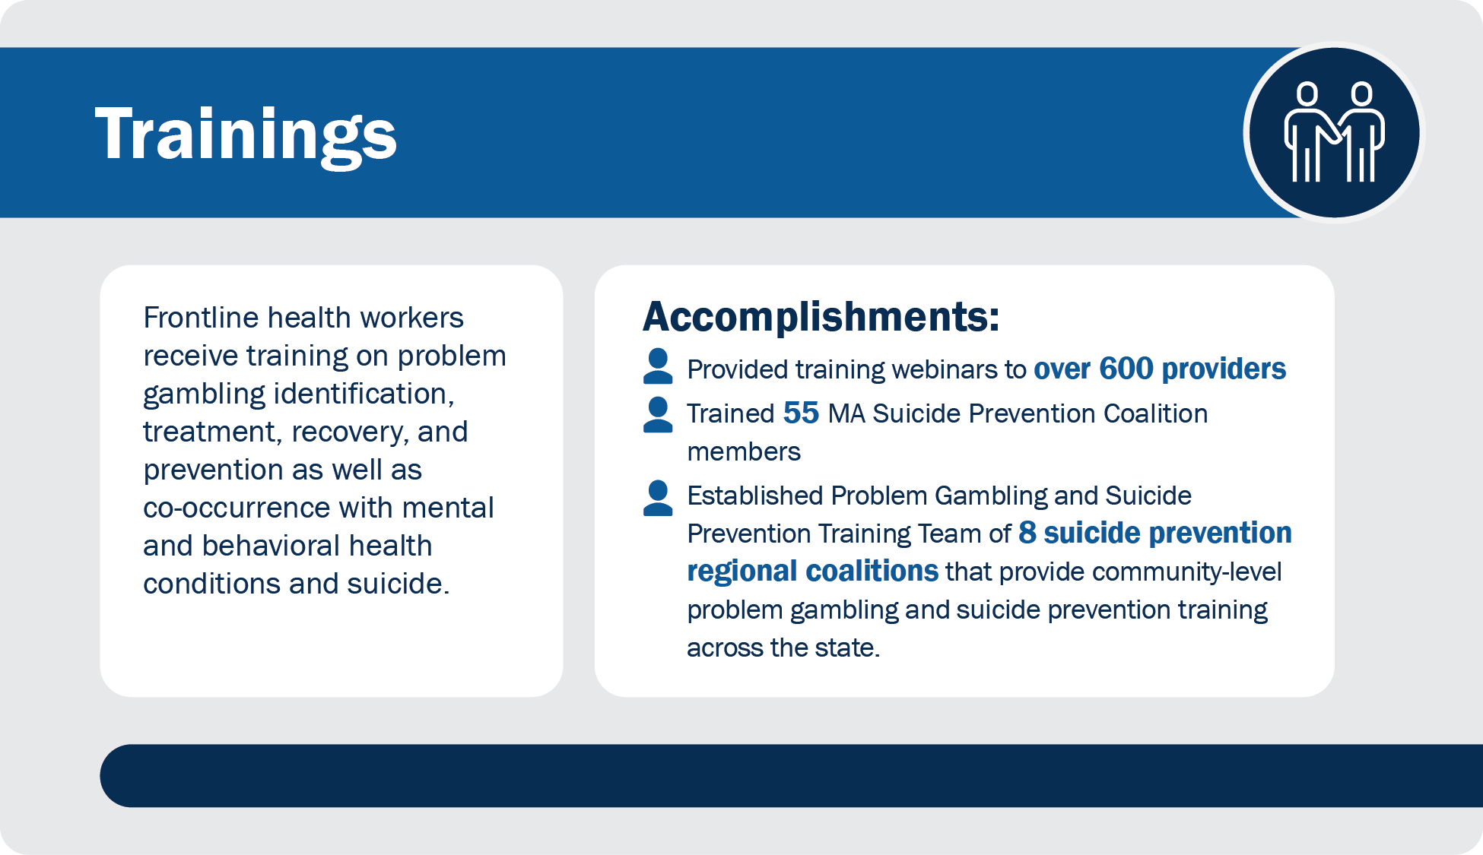
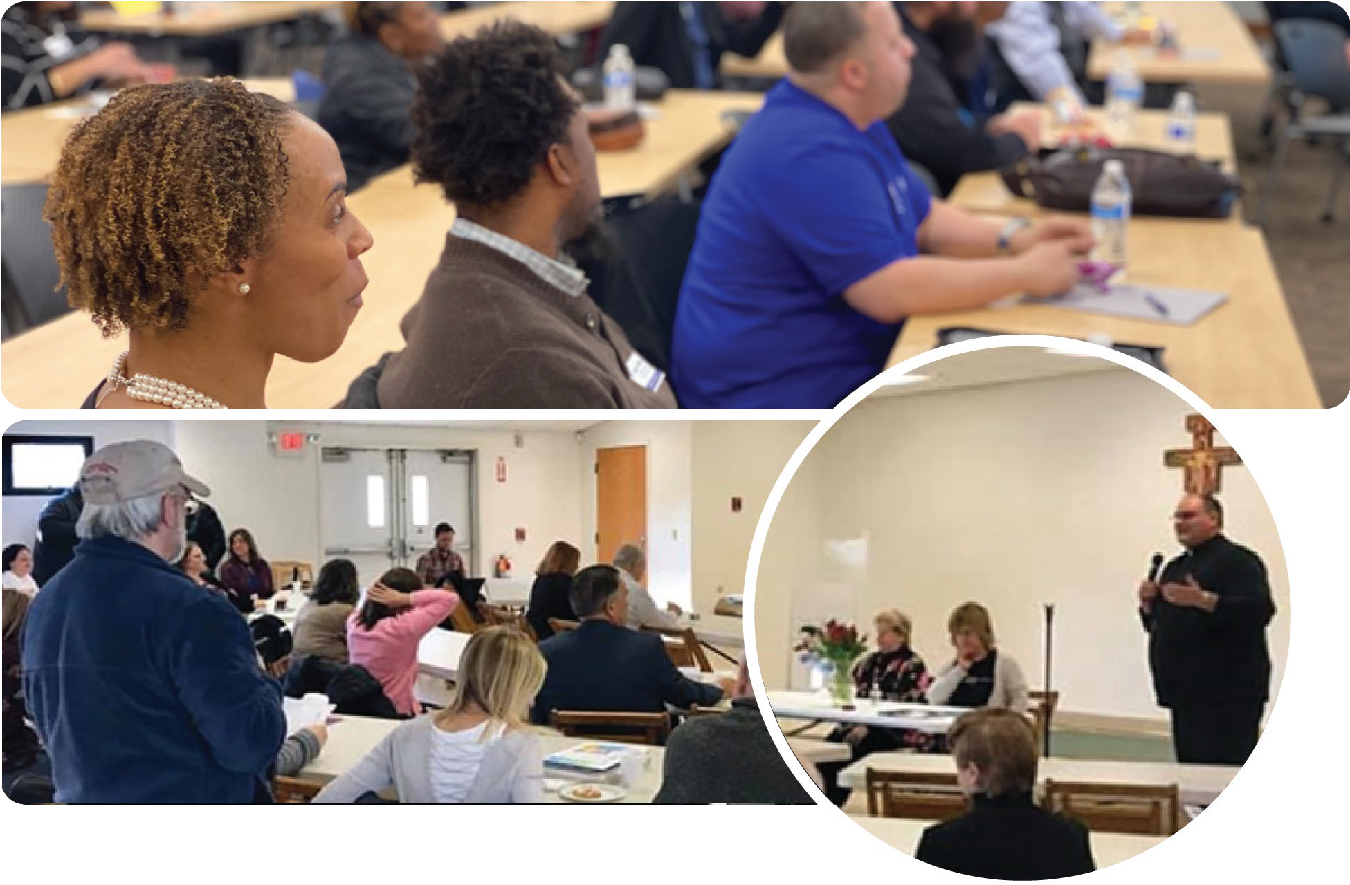

In addition to these accomplishments, OPGS has empowered and equipped people to help the individuals and communities they love prevent and mitigate harms from problem gambling and strengthen community-level and culturally appropriate prevention, treatment, and recovery services, including:
- Developing and implementing the MassMen and Gambling Project, a self-assessment and screening and resource tool for men on MassMen.org.
- Convening the Community-Level Health Project, a community-driven initiative to identify and address specific gambling-related health concerns and outline improvement initiatives to be carried out at the community level in Springfield and Everett.
- Implementing Project Build Up, a grant program aimed at strengthening the capacity of the workforce in outpatient substance use and gambling treatment agencies to provide or promote gambling treatment services.
- Publishing practice guidelines for Treating Gambling Related Harms, a web-based platform and an evidence-based treatment resource for behavioral and mental health providers.
- Coordinating an Intimate Partner Violence and Gambling Assessment to provide tools and information to intimate partner violence education programs and their staff members.
- Leading a Regional Planning Process to engage community stakeholders and continuously improve reach and efficacy of prevention programs.
- Revising “Your First Step to Change” 3rd Edition, an evidence-based self-assessment and intervention tool.
- Publishing online resources with information about community services and supports for friends and family who are concerned about a person’s gambling.
- Launching the Treatment Gap Analysis, a comprehensive analysis of gambling treatment in the Commonwealth.
- Launching the Massachusetts Problem Gambling Helpline, a comprehensive helpline that provides support and access to treatment centers and resources for those concerned about problem gambling and other related issues.
- Launching public awareness campaigns through the Let’s Get Real About Gambling platform, which promotes frank conversations about gambling as an issue of health equity.
Going forward, OPGS will build on this foundation of accomplishment to further expand reach and strengthen effectiveness of efforts to remedy community health inequities exacerbated by harm from problem gambling, continue to lift up community voice and drive a concerted public health response.

STAKEHOLDER ENGAGEMENT TO INFORM STRATEGIC PLAN DEVELOPMENT

Overview
To inform the new strategic plan and promote equity, OPGS conducted listening sessions, focus groups, and individual interviews to understand the impact of expanded gambling on community members disproportionately affected by problem gambling. Sessions were facilitated in English and Spanish by third-party vendors to create a safe space for participants to communicate their thoughts openly and honestly.. These efforts were central to the Office’s efforts to promote equity and lift up the community voice in the development of this strategic plan. In total, we engaged 496 people through these sessions, with a significant number of people being from historically underserved and marginalized communities.

The following table summarizes the participants who provided input to OPGS strategic planning:

Session Type | Number of Participants
Community Listening Sessions | 375
Stakeholder Listening Sessions | 87
Vendors/Partners | 14
MA Government Stakeholders | 12
National Stakeholders | 6
 | TOTAL: 496

Key Themes
Several major themes emerged from these sessions:
- Acute gaps in access to behavioral and mental health prevention, treatment, and recovery services – particularly in historically underserved and marginalized communities – persistently reinforce inequities in health. Members of these communities view problem gambling as a seamless part of the broader behavioral and mental health landscape, and look to DPH and its government and community partners for help.
- The Problem Gambling field faces an urgent need to ensure that equity is central to its prevention, treatment, and recovery work as well as its research base. Community members and DPH vendors and partners in particular spotlight prevention activities responsive to the needs of historically underserved and marginalized communities as critical to addressing root causes of problem gambling and urge a focus on upstream prevention in conjunction with strengthening access to treatment and recovery services.
- In all areas of public health and human services, the collective community need is greater than any single government agency can meet. DPH, like all organizations, needs to prioritize how it focuses its finite resources, guided by the voice of the community, data, mission and principles. The majority of community members and OPGS vendors and partners interviewed look to DPH to prioritize historically underserved and marginalized communities.
- The expansion of gambling/gaming modalities, including legalized betting on sports and rapid growth of online gambling and gaming, brings with it a mix of challenges and opportunities. Challenges include stretching of OPGS and vendor/partner capacity as well as deepened societal normalizing of gambling behaviors. Opportunities include the potential for new alliances (e.g., with sports organizations and individual athletes) and expanded access to prevention, treatment, and recovery services (e.g., through online platforms).

MAJOR IMPACT AREAS
In identifying priorities for 2022-2026, OPGS took the following into account:
- Input and feedback from stakeholders, with a particular focus on the voice of the community
- Strategic priorities of DPH and EOHHS
- Lessons learned from implementing the 2016-2021 strategic plan

Two major aspects that are central to impact emerged from this work, including goals, strategies, and performance measures. These areas are as follows:
- Expand Reach
- Enhance Effectiveness
Our goals are outlined below. The tables on the following pages break down each goal explicitly, including relevant strategies and performance measures.
Impact Area: Expand Reach
- Goal #1: Expand and increase awareness of the risks associated with problem gambling and available treatment services, with a focus on intersectionality with other aspects of mental and behavioral health as well as structural inequities and social determinants of health.
- Goal #2: Lift up community voice across the Commonwealth, building on foundations established through equity-focused engagement with casino-host communities of Everett and Springfield.
- Goal #3: Inject equity-centered mitigation of negative effects from problem gambling into the existing behavioral and mental health prevention and treatment infrastructure.
- Goal #4: Strengthen priority populations’ access to existing treatment resources.

Impact Area: Enhance Effectiveness
- Goal #5: Strengthen the number and capacity of providers, vendors, and partners with knowledge of and connection to priority populations.
- Goal #6: Strengthen and enhance OPGS’ capacity to conduct data collection, surveillance, and evaluation to analyze, and inform policy, programs, and impact of services.
- Goal #7: Continuously improve the array of services funded by OPGS, centered on equity and based on data, surveillance, and engagement of the community.
The following narrative details the strategies OPGS plans to pursue to expand reach and enhance effectiveness to ensure health and wellness for ALL people in Massachusetts negatively affected by problem gambling. Included are performance measures OPGS and its partners plan to use to track implementation and impact of their work, adjusting specific activities and priorities as needed.

Expand Reach
In efforts to expand the reach of its work, OPGS will enhance data collection, surveillance, and community engagement to promote equity, lift up community voice, and meet community needs, with a particular focus on historically underserved and marginalized communities.

Goal #1
Expand and increase awareness of the risks associated with problem gambling and available treatment services, with a focus on intersectionality with other aspects of mental and behavioral health as well as structural inequities and social determinants of health.
Strategies:
- Integrate and share communication campaigns and resources across prevention, treatment, and recovery support services to maximize reach and promote equity.
- Conduct targeted outreach to people and organizations positioned to strengthen priority population members’ awareness of treatment resources that are right for them. Examples may include but not be limited to community-based organizations, faith-based organizations, primary health care providers, and urgent health care providers.
- Leverage existing vendors and partner networks to support, share, and display public awareness campaigns and treatment resources at the community level.
- Leverage the community voice to target the focus, language, and outreach strategies of public awareness campaigns.
- Promote community-based trainings to increase awareness of risks associated with problem gambling.
- Integrate problem gambling awareness raising into broader public health prevention efforts (e.g., substance abuse, suicide, violence prevention, mental health).
Measures:
- Community member awareness, ascertained through:
  - Responses to surveys and notes from listening sessions
  - Data and feedback from vendors and partners
  - Data, metrics, and media testing and impressions from public awareness campaigns

Goal #2
Lift up community voice across the Commonwealth, building on foundations established through equity-focused engagement with casino-host communities of Everett and Springfield.
Strategies:
- Conduct annual Stakeholder Listening Sessions, building on lessons learned from previous engagements.
- Work in partnership with colleagues across DPH to conduct and analyze equity-focused engagement with communities of color to align and optimize reach.

Measures:
- Numbers of sessions conducted
- Communities engaged through listening sessions
- Numbers of community members engaged
Goal #3
Integrate equity-centered mitigation of negative effects from problem gambling into the existing behavioral and mental health prevention and treatment infrastructure.
Strategies:
- Add and build capacity of service providers for problem gambling by integrating evidence- based screening tools routinely used at points of behavioral and mental health intake.
- Provide problem gambling-related trainings to behavioral and mental health workers, with a particular focus on those serving priority populations.
Measures:
- Numbers of people trained
- Pre/Post evaluation from people trained
- Numbers and community reach of behavioral and mental health tools and venues positively impacted
- Data and evaluation from vendors and partners

Goal #4
Strengthen priority populations’ access to existing treatment resources.
Strategies:
- Build capacity of problem gambling and non-problem gambling support helplines by aligning resources and integrating problem gambling within other areas of service within Massachusetts.
- Integrate problem gambling screenings across various public, mental, and behavioral health sectors (e.g., drug courts, community mental health centers.)
- Increase the distribution of problem gambling tools including Practice Guidelines for Treating Gambling-Related Problems to strengthen priority populations’ access to evidence-based problem gambling treatment resources.
- Provide grants to build capacity of problem gambling treatment service providers.
- Promote training and workforce opportunities to increase mental and behavioral health providers’ knowledge of and capacity to treat problem gambling-related problems.
Measures:
- Partner data tracking usage by members of OPGS priority populations

Enhance Effectiveness
To enhance the effectiveness of its work, OPGS will place equity central to data collection, surveillance, evaluation, and targeting of services and supports to optimize effectiveness and overall impact.

Goal #5
Strengthen the number and capacity of providers, vendors, and partners with knowledge of and connection to priority populations.
Strategies:
- Build capacity of community and faith-based organizations anchored at the community level.
- Increase access to OPGS vendor procurement processes to community and faith-based organizations anchored at the community level.
Measures:
- Number of people and organizations trained
- Number of organizational partnerships established by OPGS

Goal #6
Strengthen and enhance OPGS’ capacity to conduct data collection, surveillance, and evaluation to analyze, and inform policy, programs, and impact of services.
Strategies:
- Strengthen OPGS capacity to coordinate data, surveillance, and evaluation.
- Establish the Data to Action Framework to inform policy and practice.
- Establish routinized mechanisms to evaluate implementation and impact of key OPGS- supported services.
- Leverage data and surveillance to identify trends:
  - Priority populations
  - Implementation and impact of service array
  - Continuous process and capacity improvement priorities
Measures:
- Year-over-year service trends, including numbers of people from priority populations and geographies served and types of services provided

Goal #7
Continuously improve the array of services funded by OPGS, centered on equity and based on data, surveillance, and engagement of the community.
Strategies:
- Produce and publish an annual report that summarizes OPGS access and impact.
- Conduct annual Stakeholder Listening Sessions that include reports out to the community, listening to the community voice, and publishing summaries of the community’s input and feedback.
- Conduct evaluations of programs and publish evaluation reports.
- Conduct needs assessments and pilot programs.
Measures:
- Year-over-year adjustments to the array of services funded by OPGS, including numbers and demographics of people served and services provided

CONCLUSION
Over the period 2022-2026, OPGS will build on the lessons learned, and on feedback from community voices that are central to the strong foundation established in implementing the prior strategic plan by expanding reach and enhancing effectiveness to ensure health and wellness for ALL people in Massachusetts affected by problem gambling. OPGS will continue to take its primary inspiration and direction from the voice of the community, supported and further informed by data to promote equity at the community level. OPGS will work closely with partners to combat health inequities, preventing harm from problem gambling where possible, and maximizing equitable access to treatment and recovery services.

