Strawberry Banana Overnight Oats

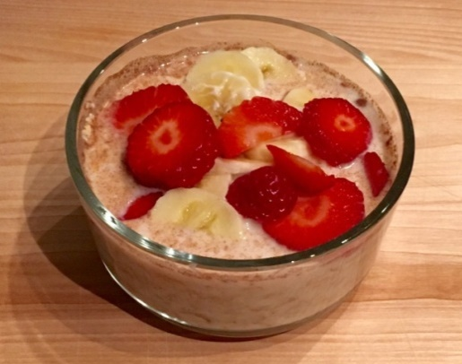
Ingredients
- ½ cup rolled oats
- ½ cup plain yogurt
- ½ cup low-fat milk
- ½ teaspoon cinnamon
- ¼ cup of fresh or frozen berries
- ½ cup of sliced bananas
Directions
- In a plastic container, add the oats.
- Pour in the yogurt, milk, and cinnamon and stir gently to combine.
- Add the fruit and cover the container with a lid.
- Refrigerate overnight or for at least 4 hours.

Serves: 1 ● Serving Size: 1 container ● Prep Time: 10 minutes● Cook Time: 4 hours
Supplies
- Measuring cups
- Measuring spoons
- Plastic container with lid
- Small knife
- Cutting board
Overnight Oat Variations
- PB&J Oats: ½ cup oats, ½ cup low-fat milk, ½ cup frozen or fresh strawberries, and ½ cup peanut butter
- Coconut Oats: ½ cup oats, 1 ½ teaspoons lemon juice, ½ cup low-fat milk, ½ cup vanilla yogurt, 1/3 cup shredded coconut, and ½ cup fresh or frozen fruit of choice
- Peach Oats: ½ cup oats, ½ cup low-fat milk, ½ cup vanilla yogurt, 1 teaspoon cinnamon, and 2/3 cup frozen or fresh peaches
- Apple Pie Oats: ½ cup oats, ½ cup low-fat milk, ¼ cup plain yogurt, 1 teaspoon cinnamon, ½ cup chopped apple, and 1 teaspoon honey

Nutrition Facts Per Serving: 295 calories, 4 g Fat, 56 g Carbohydrate, 11 g Protein, 58 mg Sodium

