**Stroke Community Awareness in Massachusetts:**

**A project that empowers communities to take the lead**

In 2023 the Massachusetts Department of Health (DPH) unveiled the Stroke Community Awareness Collaboration Project (the Project) — an initiative to fund and empower communities across the state to develop stroke awareness activities.

**Goal: Spread stroke awareness.**

When someone has a stroke, the best way to prevent death or long-term disability is to get treatment immediately. This means people need to know how to identify the signs and symptoms of stroke and to call 911, so treatment may start in the ambulance on the way to the hospital.

**Strategy: Meet people where they are.**

To participate, local leaders in health care, public health, and social services formed Collaborations and developed plans to reach those most at risk of stroke in ways that would resonate with and fit in with the lived experiences of people in their communities. Whether the Collaboration participants connected with people at a frequented supermarket, a farmers market, or at a popular family outing location, the Project’s strategy was to give communities the resources to enact a principle we frequently discuss in public health: meeting people   
where they are.

**Action: Fund, support, and advise local Collaborations.**

DPH worked with a contracted vendor to fund 21 groups that were comprised of organizations that deliver services at all stages of stroke treatment and recovery. These included 26 hospitals, 12 emergency medical services agencies, 11 post-acute organizations, nine community resource organizations, two community health centers, two home care agencies, and one primary care provider. The funded Collaborations were chosen based on the feasibility of their plans to disseminate stroke messaging within an appropriate budget that would reach both a large and, when possible, targeted audience of those at greatest risk of stroke, which include Black non-Hispanic, Asian non-Hispanic, and Hispanic populations. The Collaborations received an average award of $7,646, along with subject matter expertise and technical assistance from DPH and the contracted vendor throughout the Project.

**Future**: **Encourage ongoing efforts using new and strengthened relationships.**

As the teams implemented their activities, a recurring theme emerged. The Project was serving as a launchpad for the participating providers and organizations to build and strengthen relationships — not just among themselves, but with other regional resources that helped provide outreach in localized ways. Examples included television and radio stations, regional sports teams, and supermarkets. While the Collaborations’ various activities served the original purpose of educating the public on stroke, it’s these relationships that may leave the greatest legacy by facilitating ongoing opportunities to continue outreach.

**Examples: Read on…**

The next pages illustrate some of the innovative and successful partnerships formed and awareness activities   
carried out through this Project.

**Worcester Metro Area**

**Partnering with local sports teams to spread stroke awareness**

**Lead Organization:**

UMass Memorial Health - Neurology Department

**Collaborators:**

Fairlawn Rehabilitation Hospital, St. Vincent Hospital, UMass Memorial Health – Emergency Department, UMass Memorial Emergency Medical Services, and VNA Care

**How did the team connect with their community?**

**Stroke awareness messaging using local sports mascots**

* **Public Service Announcement (PSA)**  
  The Collaboration made a [stroke education PSA](https://www.youtube.com/watch?v=3YLMpriq4kw&feature=youtu.be) using local kids and area sports mascots to help deliver “BE-FAST” messaging, an acronym that helps people recognize the signs of stroke.
* **Education materials**To go with the PSA, the group created their own “BE-FAST” collateral (flyers, magnets) with the same local mascot branding.

Quote text box:

“The mascots are a big part of the community, and we were able to get all the teams to allow their mascots to participate free of charge, which was absolutely amazing!” - Kayla Overly, Team Lead, Stroke Neurology Physician Assistant at UMass Memorial Medical Center

Image 1: Woman on baseball field pointing to the team's BE FAST message on the jumbotron. The image is the same as the magnet.

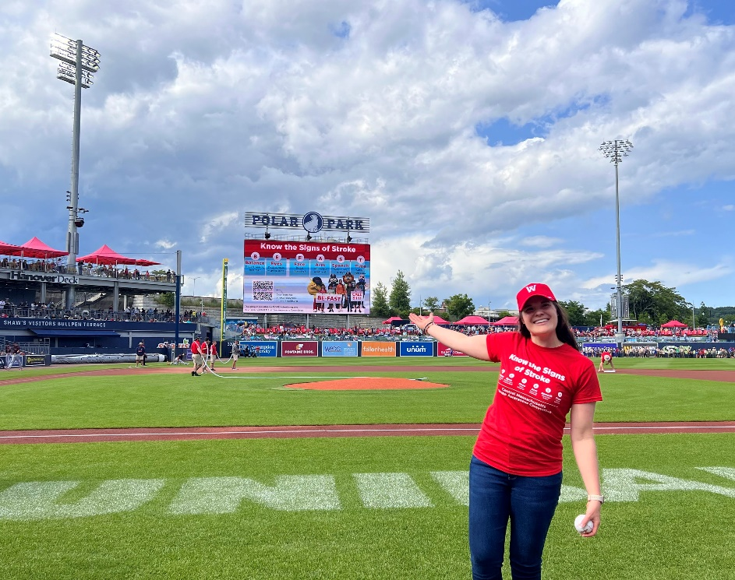

Image 2: A picture of the filming of the public service announcement. Kids and local sports mascots hold a sign that says BE FAST and another that says Call 911.

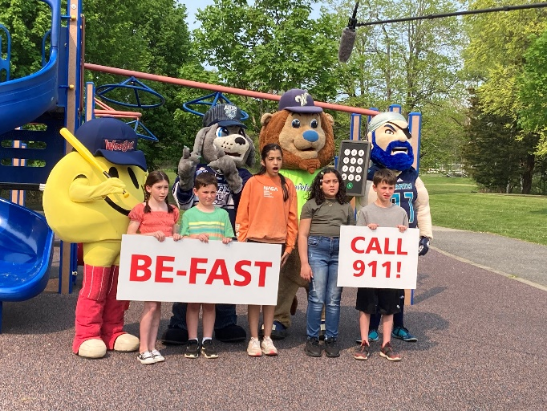

Image 3: Image of the team's magnet. Know the Signs of stroke with the BE FAST acronym. B stands for balance, E for eyes, F for face, A for arm, S for speech, T for time. Kids and local sports mascots hold a sign that says BE FAST and another that says Call 911.

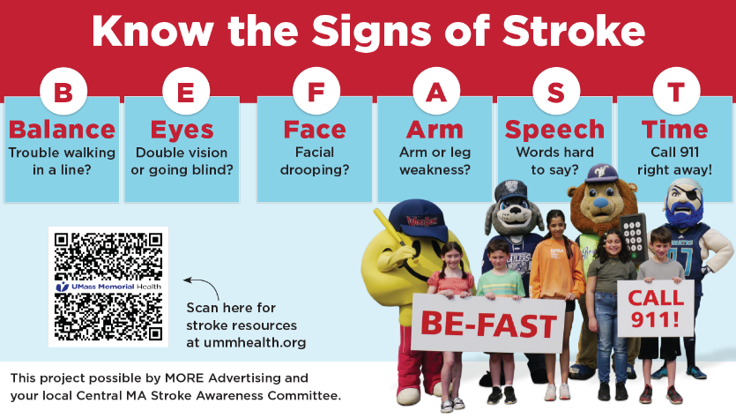

**Baseball game event**

* **“Stroke Awareness Day” at Polar Park**The group partnered with the Worcester Red Sox to honor four local stroke survivors as “Hometown Heroes” on the field at the start of the game while their BE FAST message ran on the jumbotron. Going to a Woo Sox game is a popular and affordable family outing in the area and averages more than 7,000 attendees per game.
* **TV interview**Rachel Henry, one of the “Hometown Heroes,” was interviewed about her story during live TV coverage of the game on New England Sports Network (NESN). She talked about stroke prevention, treatment, and recognizing the signs of stroke.
* **In-person education at the game**Local health care professionals and stroke survivors staffed two tables at the ballpark to provide education, talk about their stories, and share stroke education materials.

**What will be the long-term impact of this Project?**

* **New relationships with community influencers**This Project facilitated the formation of relationships with local sports leagues, opening the door for future opportunities to spread stroke information in creative, engaging, and localized ways.
* **Strengthened relationships among local health care leaders**The Project strengthened relationships among the health care organizations in the collaboration.
* **Uniquely branded PSA and education materials**The PSA and materials, which were created to resonate with their community, can be used for years.

Quote in text box:

“Working on this project made the relationships we had with our health care partners stronger and allowed for new relationships to form. Now I would have no fear in reaching out to any of them about any projects or opportunities that may come up again. This project was really awesome in allowing that to happen.” - Kayla Overly, Team Lead

Image 4: A group of people posing for a picture on a baseball field.  
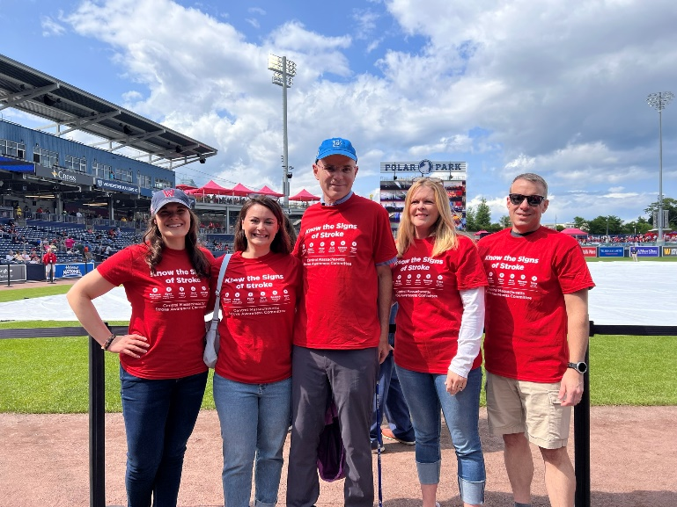

Image 5: Photo of a woman and two men with headsets on talking about stroke survivorship on a local television program.

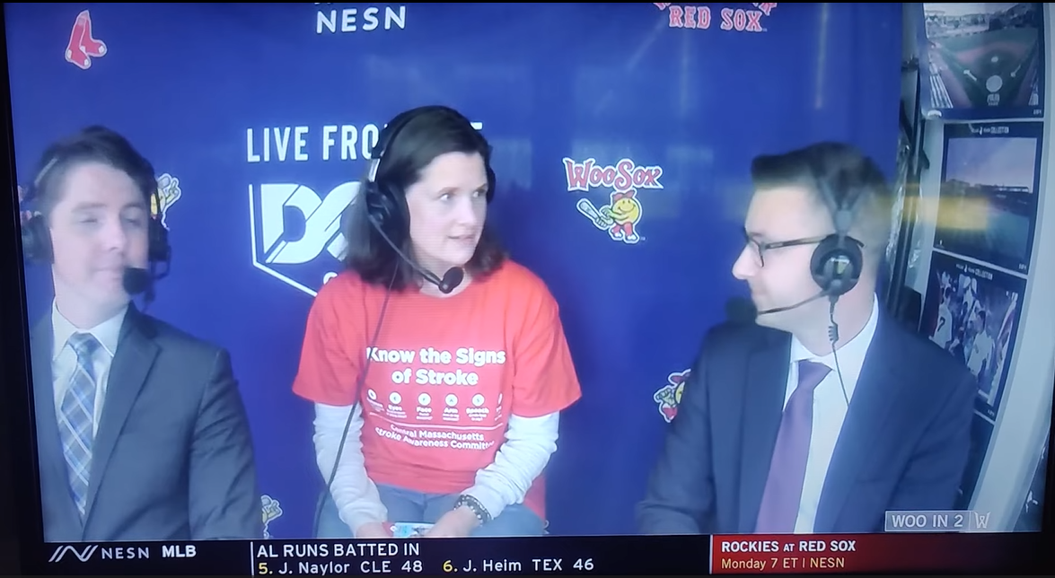

**Greater Brockton**

**Meeting people where they are: Local produce, local providers**

**Lead Organization:**

Good Samaritan Medical Center

**Collaborators:**

Brewster Ambulance, Brockton Cable Access, Brockton Neighborhood Health Center, Encompass Health Rehabilitation Hospital of Braintree, and Signature Healthcare Brockton Hospital

**How did the team connect with their community?**

**Weekly stroke education at a farmers market**

Local health care professionals staffed a table at a farmers market in Brockton every Friday for five months. Among many services, they provided:

* **Stroke education** in English, Spanish, Cape Verde Creole, and Haitian Creole.
* **On-site blood pressure checks and free blood pressure cuffs** to those in need.
* **Help setting up health care visits** for people identified to be at risk for stroke.

Quote in text box:

“We’re trying to reach people who are vulnerable and may even be undocumented. They may not want to go to clinics and often wait until there’s an emergency and have to be brought to the hospital. We asked ourselves, ‘How can we reach these people?’ So, we joined forces with Brockton Neighborhood Health Center to provide services at the farmers market.” - Mary Peterson, RN, Team Lead, Stroke Program Coordinator at Good Samaritan Medical Center

Image 6: A group of people standing around a table at the Brockton Farmers Market

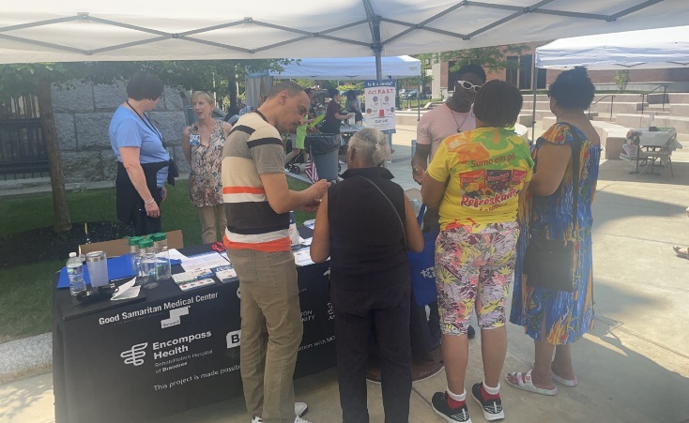

Image 7: A person sitting at a table. His arm is connected to a blood pressure machine.

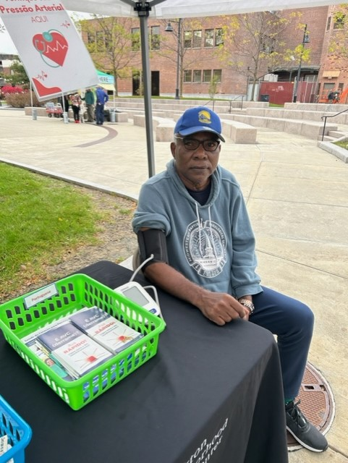

**Stroke education video featuring local providers**

* The Collaboration made a [video about stroke prevention, identification, treatment, and recovery](https://www.youtube.com/watch?v=KRqhZrpKtew) in English, Spanish, Portuguese, and Haitian Creole.
* The video features local health care professionals from each of the collaborating organizations.
* Video is or will be available to view on a local cable channel, hospital lobby TVs, online, and at community events.

Image 8: A screenshot of the video. Image shows a local doctor talking on the screen with text in the background that says "Post-Stroke Treatment: Meet primary care physician, further testing, manage additional stokes."

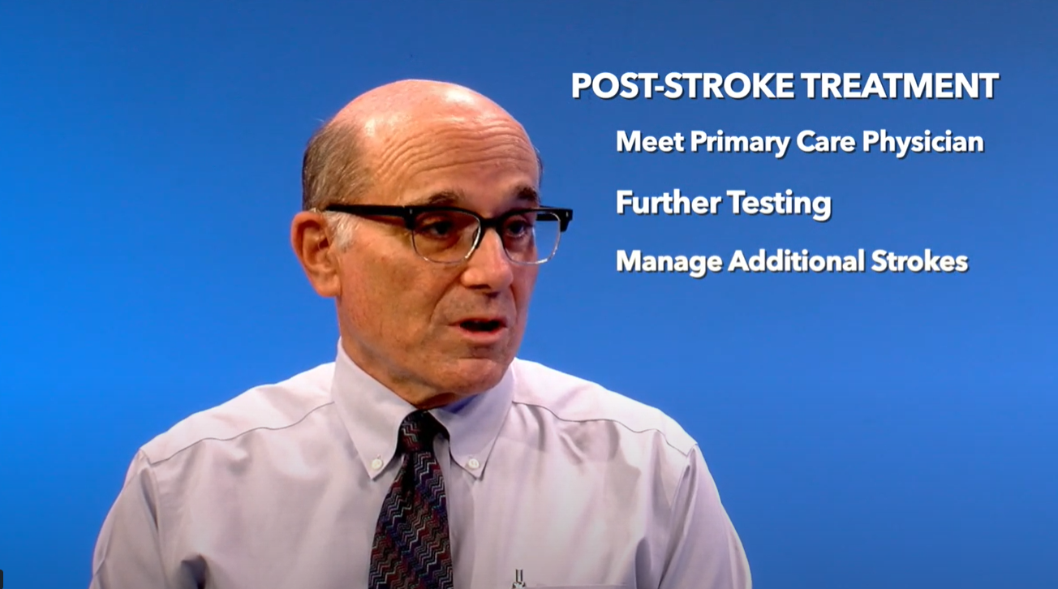

Quote in text box:

“I see the video as a huge sign of respect for our community. Having our own physicians and people from the community…we’re saying we have the expertise in Brockton; Brockton’s important; and we are translating this video into your community’s languages because you’re important.” - Mary Peterson, Team Lead

**What will be the long-term impact of this Project?**

* **Strengthened relationships among local health   
  care leaders**: The Project strengthened relationships among the health care organizations in the Collaboration.
* **Trust built with community members**: Often the biggest drivers of action, like making a health appointment, is an encounter with someone you trust. The farmers markets offered a safe space for people to connect with health care professionals outside of a clinic.
* **New opportunities for community events:** 
  + **Farmers market**: To continue next year
  + **Video screenings and discussion**: The video provides new outreach opportunities at community-based education events. (e.g. a Haitian church event)

Quote in text box:

“We're all very proud and very excited…we networked out and pulled together a community of different entities to work together for stroke awareness. This grant was a slam dunk and was exactly what we needed!” - Mary Peterson, Team Lead

**New Bedford/Fall River Area**

**Bringing stroke education to local hot spots – with success at a popular grocery chain**

**Lead Organization:**

Southcoast Health

**Collaborators:**

City of Fall River Emergency Medical Services, and New Bedford Emergency Medical Services

**How did the team connect with their community?**

**Stroke education at community hot spots**

Team members and health care professionals staffed stroke education tables at a local library, food pantry, and two Market Basket locations — a New England grocery chain known for affordable prices. Staff provided:

* **Stroke education** in English, Spanish, and Portuguese.
* **On-site blood pressure checks and free blood pressure cuffs and cookbooks** for those with high BP.
* **Recommendations for care** at local community health centers that provide a range of services.

The team found overwhelming success reaching a large volume of residents at both Market Basket locations.

Quote in text box:

“One of our EMS partners suggested Market Basket… they had done some events there. The store services our target demographic of primarily Portuguese- and Spanish-speaking residents, and the foot traffic at those Market Baskets is off the charts, so we thought it made a ton of sense.” - Ethan Kehoe, Team Member, Senior Advancement Officer at Southcoast Health

Image 9: Photo of the exterior of a Market Basket supermarket

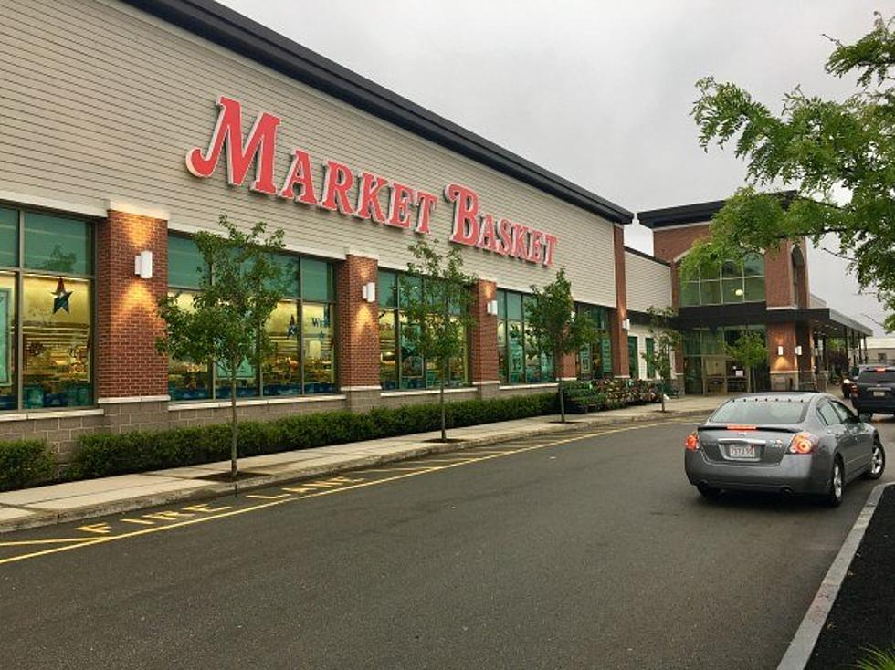

Image 10: A group of people under a blue tent in a Market Basket parking lot.

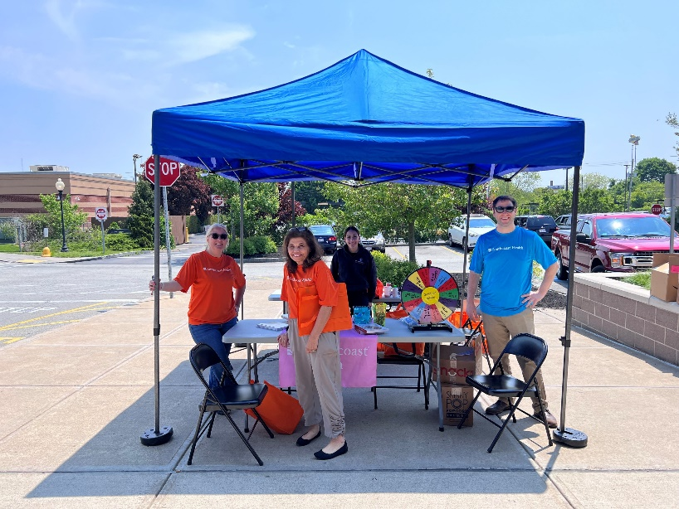

**Local radio spots in Spanish and Portuguese**Given the team’s interest in reaching Spanish- and Portuguese-speaking communities, they worked with local radio stations WJFD (Portuguese) and WKKB (Spanish) to spread messaging on:

* **Stroke awareness**The team put out two 30-second radio PSAs – one on recognizing the signs of stroke and one on stroke prevention. They were played throughout the month of May in Spanish and Portuguese.
* **Event promotion**The radio stations promoted the library, food pantry, and Market Basket events twice a day for a week leading up to each event.

Image 11: The logo for WKKB radio station. Text: "LATINA 100.3 FM"

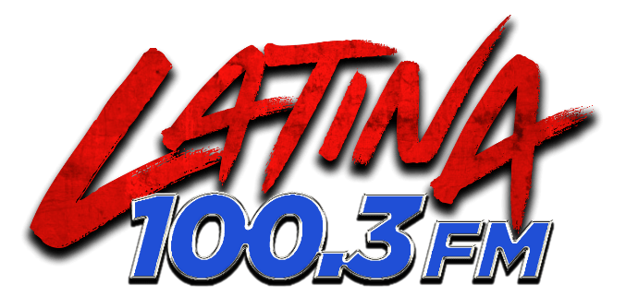

Image 12: The logo for WJFD radio station. Text: "WJFD 97.3 FM, Biggest Portuguese Radio Station in the USA"

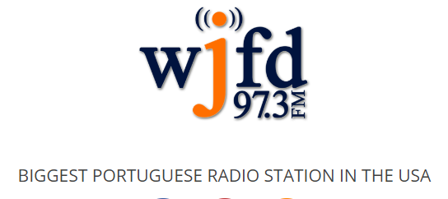

**What will be the long-term impact of this Project?**

* **The partnership with Market Basket**: While one of the EMS partners already had a relationship with Market Basket, Southcoast Health did not. The Project launched this new connection, paving the way for more stroke awareness events at these highly trafficked grocery stores.
* **Strengthened relationships among Collaboration members**: The Project strengthened relationships among the health care organizations in the Collaboration.
* **Continuation of community events**: The team plans to keep the momentum going and continue their blood pressure screening events – particularly in May, which is National Stroke Awareness Month.

Image 12: Graphic that says, "National Stroke Awareness Month May." Blue background, white text, and an orange head with a white brain.

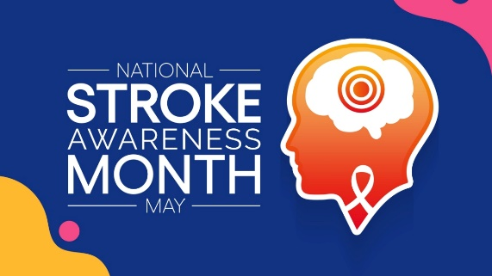

Quote in text box:

“Without question, the greatest and most sustainable success of the project is the Collaboration itself, including the health system and local EMS departments, which then expanded to include broader government involvement in each city with Market Basket as a partner. - The team in their final report

Quote in text box:

“Stroke Month in May is the optimum time to focus on outreach. We're going to continue to expand this work with the community partners that were involved. - Ethan Kehoe, Team Member