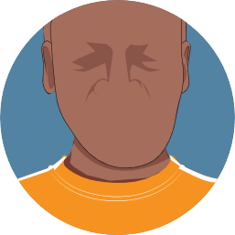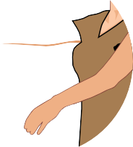

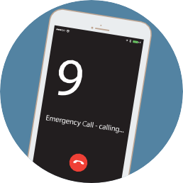
FACE or
droops
ARM or
weakness
SPEECH
difficulty
TIME
is critical.

Is it a stroke?
Act F. A. S.T.

Learn more at mass.gov/stroke

What is a stroke?
Know the signs of stroke
Remember to act F.A.S.T.
A person could be having a stroke if they show any of these signs:
- Face droops on one side.
- Arm weakness. When the person lifts both arms, one arm drifts down.
- Speech difficulty. The person has trouble speaking, or is not making sense when speaking.
- Time is critical. Call 911 immediately.

You may be having a stroke if you experience any of the following:
- Sudden weakness on one side of the body.
- Sudden confusion, trouble speaking, or understanding words.
- Sudden problems seeing or blurry vision.
- Sudden trouble walking or loss of balance.
- Sudden severe headache with no known cause.
A stroke occurs when a blood vessel that carries oxygen to the brain is blocked by a clot or bursts.
When that happens, part of the brain cannot get the oxygen it needs, causing brain cells to die.
Fast treatment may reduce the long term effects of stroke.

Emergency medical technicians (EMTs) save precious time by continuing care in the ambulance and alerting the hospital to prepare for arrival.
If you see any sign of stroke, don’t hesitate—call 911!
Care starts when the ambulance arrives.
at any sign of stroke!
Call 911

Change your daily habits to lower your risk for stroke
Changes in a few daily habits can lower your risk for stroke. Combining a healthy diet, healthy blood pressure, regular physical activity, and quitting tobacco can make a bigger difference than you think. Get started with helpful tips and resources at mass.gov/stroke.
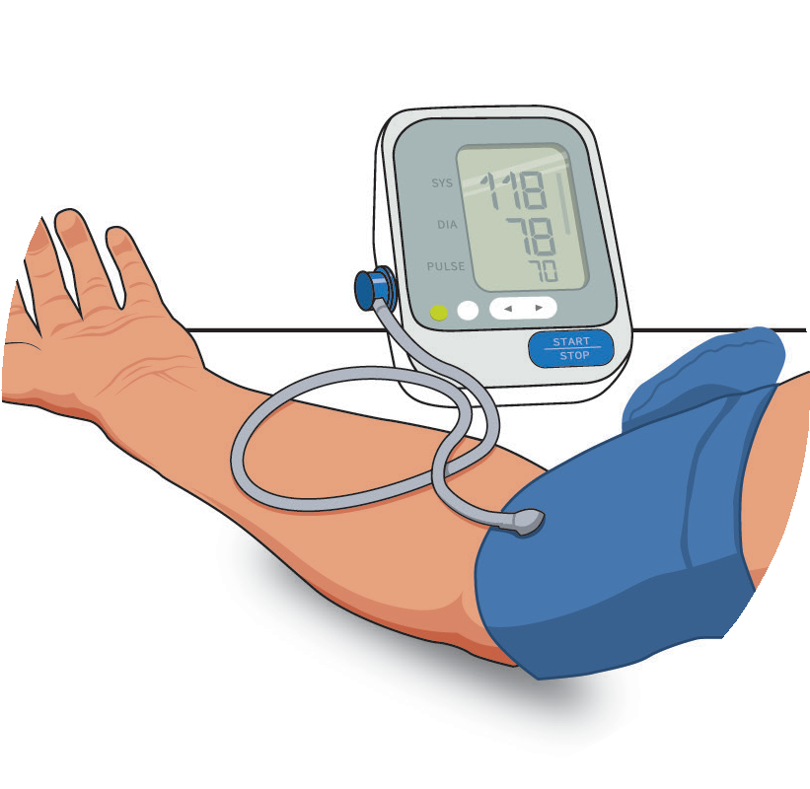

Check your blood pressure regularly and take all medications as prescribed.
Add more healthy foods, such as fruits, vegetables and lean proteins to your diet. Talk with your doctor about what’s right for you.

For help quitting, call
1-800- QUIT-NOW

Get active whenever you can! Try for 30 minutes a day, five days a week.
Quitting smoking and vaping lowers your risk! Tobacco and nicotine increase your risk for stroke by raising your blood pressure.

Start lowering your risk today.

Who’s at risk for a stroke?
You may be at a higher risk of a stroke if you:
- Are over 65 years of age.
- Are African American, Hispanic, or Asian.
- Have a family history of stroke.
- Had a previous stroke or “mini stroke” which is also called a TIA.
Find helpful tips and resources at mass.gov.stroke
MASSACHUSETTS DEPARTMENT
OF PUBLIC HEALTH
HD5914

