|  |  |
| --- | --- |
|  | ***Commonwealth of Massachusetts***  ***Executive Office of Health and Human Services*** Office of Medicaid *www.mass.gov/masshealth* |

MassHealth

Transmittal Letter SUD-20

September 2018

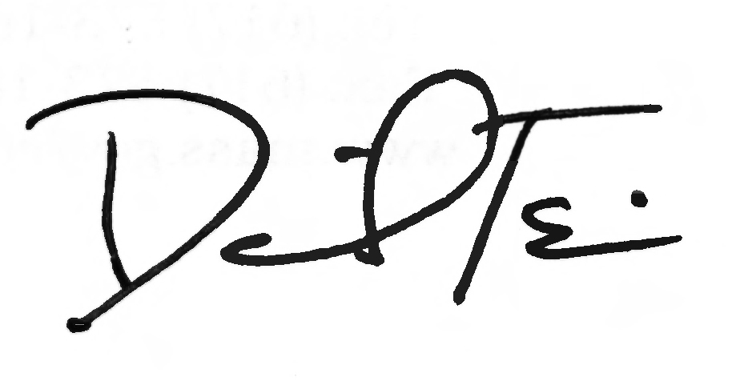

**TO:** Substance Use Disorder Treatment Centers Participating in MassHealth

**FROM:** Daniel Tsai, Assistant Secretary for MassHealth

**RE:** *Substance Use Disorder Treatment Manual* (Changes to service codes and descriptions)

This letter transmits revisions to the service codes and descriptions listed in Subchapter 6 of the *Substance Use Disorder Treatment Manual*. These codes and descriptions are effective for dates of service on or after December 29, 2017.

**MassHealth Website**

This transmittal letter and attached pages are available on the MassHealth website at [www.mass.gov/lists/masshealth-transmittal-letters-by-provider-type-s-v](http://www.mass.gov/lists/masshealth-transmittal-letters-by-provider-type-s-v).

To sign up to receive email alerts when MassHealth issues new transmittal letters and provider bulletins, send a blank email to [join-masshealth-provider-pubs@listserv.state.ma.us](mailto:join-masshealth-provider-pubs@listserv.state.ma.us). No text in the body or subject line is needed.

**Questions**

If you have any questions about the information in this transmittal letter, please contact the MassHealth Customer Service Center at (800) 841-2900, email your inquiry to [providersupport@mahealth.net](mailto:providersupport@mahealth.net), or fax your inquiry to (617) 988-8974.

NEW MATERIAL

(The pages listed here contain new or revised language.)

Substance Use Disorder Treatment Manual

Pages vi and 6-1 through 6-6

OBSOLETE MATERIAL

(The pages listed here are no longer in effect.)

Substance Use Disorder Treatment Manual

Pages vi and 6-1 through 6-3 — transmitted by Transmittal Letter SUD-18

|  |  |  |
| --- | --- | --- |
| **Commonwealth of Massachusetts**  **MassHealth**  **Provider Manual Series** | **Subchapter Number and Title**  Table of Contents | **Page**  vi |
| Substance Use Disorder Treatment Manual | **Transmittal Letter**  SUD-20 | **Date**  12/29/17 |

6. Service Codes and Descriptions 6-1

Service Codes and Descriptions 6-1

Modifiers 6-4

National Drug Code (NDC) Requirements 6-4

Billing Multiple Units of Buprenorphine and Buprenorphine/Naloxone 6-5

Appendix A. Directory A-1

Appendix C. Third-Party-Liability Codes C‑1

Appendix T. CMSP-covered Codes T-1

Appendix U. DPH-Designated Serious Reportable Events That Are Not Provider

Preventable Conditions U-1

Appendix V. MassHealth Billing Instructions for Provider Preventable Conditions……………... V-1

Appendix W. EPSDT Services Medical and Dental Protocols and Periodicity Schedules………… W-1

Appendix X. Family Assistance Copayments and Deductibles X-1

Appendix Y. EVS Codes/Messages Y-1

Appendix Z. EPSDT/PPHSD Screening Services Z-1

601 Service Codes and Descriptions

###### Service

CodeModifier Service Description

### **Inpatient Services**

H0010 Alcohol and/or drug services sub-acute detoxification (residential addiction program inpatient) (clinically managed detoxification services)

H0011 Alcohol and/or drug services; acute detoxification (medically monitored inpatient detoxification services) (facility with 37 or fewer licensed beds)

H0011 Alcohol and/or drug services; acute detoxification (medically monitored inpatient detoxification services) (facility with more than 37 licensed beds)

### **24-Hour Community-Based Services**

H0018 Behavioral health; short-term residential (nonhospital residential treatment program), without room and board, per diem (transitional support services)

H0019 Behavioral health; long-term residential (nonmedical, nonacute care in a residential treatment program where stay is typically longer than 30 days; without room and board, per diem (residential rehabilitation services for transitional age youth and young adults: youth residential substance use disorder treatment)

H0019 HA Behavioral health; long-term residential (nonmedical, nonacute care in a residential treatment program where stay is typically longer than 30 days), without room and board, per diem (residential rehabilitation treatment services for youth: clinically intensive youth residential substance use disorder treatment)

H0019 HD Behavioral health; long-term residential (nonmedical, nonacute care in a residential treatment program where stay is typically longer than 30 days), without room and board, per diem (residential rehabilitation services pregnant enhancement)

H0019 HF Behavioral health; long-term residential (nonmedical, nonacute care in a residential treatment program where stay is typically longer than 30 days), without room and board, per diem (family residential treatment for 11 families)

H0019 HF Behavioral health; long-term residential (nonmedical, nonacute care in a residential treatment program where stay is typically longer than 30 days), without room and board, per diem (family residential treatment for 12 families)

H0019 HF Behavioral health; long-term residential (nonmedical, nonacute care in a residential treatment program where stay is typically longer than 30 days), without room and board, per diem (family residential treatment for 13 families)

H0019 HF Behavioral health; long-term residential (nonmedical, nonacute care in a residential treatment program where stay is typically longer than 30 days), without room and board, per diem (family residential treatment for 14 families)

H0019 HF Behavioral health; long-term residential (nonmedical, nonacute care in a residential treatment program where stay is typically longer than 30 days), without room and board, per diem (family residential treatment for 15 families)

H0019 HF Behavioral health; long-term residential (nonmedical, nonacute care in a residential treatment program where stay is typically longer than 30 days), without room and board, per diem (family residential treatment for 16 or more families)

601 Service Codes and Descriptions (cont.)

###### Service

CodeModifier Service Description

H0019 HV Behavioral health; long-term residential (nonmedical, nonacute care in a residential treatment program where stay is typically longer than 30 days), without room and board, per diem (residential rehabilitation services child enhancement)

H0019 TH Behavioral health; long-term residential (nonmedical, nonacute care in a residential treatment program where stay is typically longer than 30 days), without room and board, per diem (residential rehabilitation services postpartum enhancement)

H2034 Alcohol and/or drug abuse halfway houses services, per diem (residential rehabilitation services)

### **Opioid Treatment Services**

H0020 Alcohol and/or drug services methadone administration and/or service (provision of the drug by a licensed program) (dose only visit)

H0004 TF Behavioral health counseling and therapy (methadone/opioid counseling) per 15-minute unit (individual counseling, intermediate level of care, four units maximum per day)

T1006 HR Alcohol and/or substance abuse services (methadone/opioid counseling) per 30-minute unit (family/couple counseling, two units maximum per day)

H0005 HQ Alcohol and/or drug service group counseling by a clinician (methadone/opioid counseling) per 45-minute unit (two units maximum per day)

H0001 U1 Alcohol and/or drug assessment (buprenorphine and naltrexone medication evaluation, at initiation of treatment)

H0033 Oral medication administration, direct observation (buprenorphine, first dosage only)

H0033 U2 Oral medication administration, direct observation (buprenorphine, dosing only visit)

H0033 U3 Oral medication administration, direct observation (oral naltrexone dosing)

96372 Therapeutic prophylactic or diagnostic injection (specify substance or drug); subcutaneous or intramuscular (Naltrexone)

J0571* Buprenorphine, oral, 1 mg (maximum 32 mg per day) (prior authorization required) (*NDC required)

J0572* Buprenorphine/naloxone, oral, less than or equal to 3 mg (maximum of one unit (film or pill) per day; may be combined with J0573, J0574, and J0575, as medically necessary) (*NDC required)

J0573* Buprenorphine/naloxone, oral, greater than 3 mg, but less than or equal 3.1 to 6 mg (maximum of one unit (film or pill) per day; may be combined with J0572, J0574, and J0575, as medically necessary) (*NDC required)

J0574* Buprenophine/naloxone, oral, greater than 6 mg, but less than or equal to 10 mg. (maximum of 4 units (film or pill) per day; may be combined with J0572, J0573, and J0575, as medically necessary) (*NDC required)

J0575* Buprenorphine/naloxone, oral, greater than 10 mg (maximum of 2 units (film or pill) per day; may be combined with J0572, J0573, and J0574, as medically necessary) (*NDC required)

J2315* Injection, naltrexone, depot form, 1 mg (maximum of 380 mg. per month) (*NDC required)

J3490* Unclassified drugs (Naltrexone, oral)

601 Service Codes and Descriptions (cont.)

###### Service

CodeModifier Service Description

80305 Drug tests(s), presumptive, any number of drug classes, any number of devices or procedures (eg, immunoassay); capable of being read by direct optical observation only (eg, dipsticks, cups, cards, cartridges) includes sample validation when performed, per date of service

80306 Drug test(s), presumptive, any number of drug classes, any number of devices or procedures, (eg, immunoassay) read by instrument assisted direct optical observation (eg, dipsticks, cups, cards, cartridges), includes sample validation when performed, per date of service

80307 Drug test(s), presumptive, any number of drug classes, any number of devices or procedures, by instrument chemistry analyzers (eg, utilizing immunoassay [eg, EIA, ELISA, EMIT, FPIA, IA, KIMS, RIA]), chromatography (eg, GC, HPLC), and mass spectrometry either with or without chromatography, (eg, DART, DESI, GC-MS, GC-MS/MS, LC-MS, LCMS/MS, LDTD, MALDI, TOF) includes sample validation when performed, per date of service

### **Outpatient Services**

90882 HF Environmental intervention for medical management purposes on a psychiatric patient’s behalf with agencies, employers, or institutions (substance abuse program) (case consultation) (per 30-minute unit two units maximum per day)

97810 HF Acupuncture, one or more needles; without electrical stimulation, initial 15 minutes of personal one-on-one contact with the patient (substance abuse program) (I.C) (one unit maximum per day)

97811 HF each additional 15 minutes of personal one-on-one contact with the patient, with re-insertion of needle(s) (substance abuse program) (I.C.) (three units maximum per day) (to be used in conjunction with 97810)

H0004 Behavioral health counseling and therapy, per 15 minutes (individual counseling) (four units maximum per day)

H0005 Alcohol and/or drug services group counseling by a clinician (per 45-minute unit) (two units maximum per day)

T1006 Alcohol and/or substance abuse services family/couple counseling (per 30-minute unit, two units maximum per day)

### **Enhanced Inpatient Detoxification Services for Pregnant Members**

H0011 HD Alcohol and/or drug services; acute detoxification (medically monitored inpatient detoxification services), pregnant/parenting woman’s program (facility with 37 or fewer licensed beds)

H0011 HD Alcohol and/or drug services; acute detoxification (medically monitored inpatient detoxification services), pregnant/parenting woman’s program (facility with more than 37 licensed beds)

601 Service Codes and Descriptions (cont.)

###### Service

CodeModifier Service Description

### **Intensive Outpatient Detoxification Services for Pregnant Members**

H0004 HD Behavioral health counseling and therapy, per 15 minutes (pregnant/parenting women’s program) (individual counseling) (four units maximum per day)

T1006 HD Alcohol and/or drug services family/couple counseling (pregnant/parenting women’s program) (per 30-minute unit) (two units maximum per day)

H0005 HD Alcohol and/or drug services; group counseling by a clinician (pregnant/parenting women’s program) (per 45-minute unit) (two units maximum per day)

H0006 HD Alcohol and/or drug services case management (pregnant/parenting women’s program) (per 15-minute unit) (four units maximum per day)

### **Day Treatment Program for Pregnant Members**

H1005 Prenatal care, at-risk enhanced service package (includes H1001-H1004) (prenatal care, at-risk enhanced service antepartum management/care coordination/education/follow-up home visit) (individual counseling) (per one hour unit, one unit maximum per day)

H1005 HQ Prenatal care, at-risk enhanced service package (includes H1001-H1004) (group setting) (prenatal care, at-risk enhanced service antepartum management/care coordination/education/follow-up home visit) (per four hour unit) (one unit maximum per day)

602 Modifiers

Opioid treatment service centers that purchase drugs through the 340B drug pricing program must include the Modifier “UD” to the HCPCS code (J-code) to identify drugs purchased through that program.

Modifier Modifier Description

UD Drug purchased through the 340B drug pricing program (for use if appropriate with service codes J0571, J0572, J0573, J0574, J0575, and J2315)

603 National Drug Code (NDC) Requirement

Opioid treatment service centers are required to submit claims on all outpatient claims for drugs administered during the course of a member’s visit with the exact National Drug Code (NDC) that appears on the product administered (applicable to service codes J0571, J0572, J0573, J0574, J0575, J2315, and J3490; designated with “*” in Section 601). The NDC must be submitted in the 5-4-2 digit format (i.e., xxxxx-xxxx-xx). Opioid treatment service centers must therefore include both the HCPCS code (J-code) and the NDC when billing MassHealth for these drugs.

604 Billing Multiple Units of Buprenorphine and Buprenorphine/Naloxone

Pursuant to the limits set forth in Section 601, opioid treatment service centers may bill multiple units of buprenorphine or buprenorphine/naloxone (service codes J0571, J0572, J0573, J0574, J0575) as needed to reach the medically necessary dosage.

This page is reserved.