BACKGROUND

INDOOR AIR QUALITY
ASSESSMENT

Ephraim Curtis Middle School
22 Pratts Mill Road
Sudbury, Massachusetts

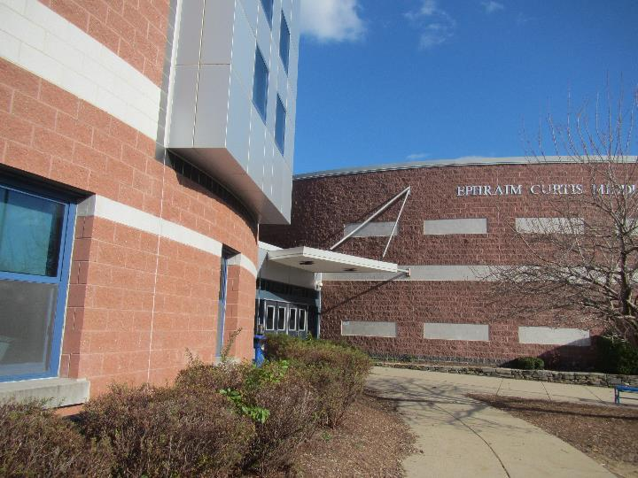

Prepared by:
Massachusetts Department of Public Health
Bureau of Environmental Health
Indoor Air Quality Program
January 2023
Building: | Ephraim Curtis Middle School (CMS)
Address: | 22 Pratts Mill Road, Sudbury, MA
Assessment Requested by: | Bill Murphy, Health Director, Town of Sudbury
Reason for Assessment: | General Indoor Air Quality (IAQ) concerns
Date of Assessment: | November 18, 2022
Massachusetts Department of Public Health/Bureau of Environmental Health (MDPH/BEH) Staff Conducting Assessment: | Michael Feeney, Director, IAQ Program, Ruth Alfasso, Environmental Engineer/Inspector, and Jennifer Lajoie, Environmental Analyst/Inspector, IAQ Program
Building Description: | The CMS was built in 2000 as a middle school. It is a multi-story brick building with a complex shape and multiple sections of flat roof. The building contains general classrooms, science classrooms, an auditorium, gymnasium, cafeteria, kitchen, library, computer room, art room, music room and office spaces.
Windows: | Openable in most areas

METHODS
Please refer to the IAQ Manual for methods, sampling procedures, and interpretation of results (MDPH, 2015).

RESULTS AND DISCUSSION
The following is a summary of testing results (Table 1):
- Carbon dioxide was below the MDPH guideline of 800 parts per million (ppm) in most areas visited indicating adequate fresh air in most classrooms and other spaces. Levels above 800 ppm were found in some smaller classrooms with high occupancy. This is discussed further below.
- Temperature was within the recommended comfort range of 70°F to 78°F.
- Relative humidity was below the recommended range of 40% to 60% in all areas assessed, which is common during the heating season.
- Carbon monoxide levels were non-detectable (ND) in all areas assessed.
- Fine particulate matter (PM2.5) concentrations were below the National Ambient Air Quality Standard (NAAQS) level of 35 μg/m³.
- Total volatile organic compounds (TVOCs) were ND in all areas tested. Note: about half of the areas visited were tested for VOCs.

Ventilation
A heating, ventilating, and air conditioning (HVAC) system has several functions. First it provides heating and, if equipped, cooling. Second, it is a source of fresh air. Finally, an HVAC system will dilute and remove normally occurring indoor environmental pollutants by not only introducing fresh air, but by filtering the airstream and ejecting stale air to the outdoors via exhaust ventilation. Even if an HVAC system is operating as designed, point sources of respiratory irritation may exist and cause symptoms in sensitive individuals.
Fresh air in classrooms is supplied by ceiling-mounted fresh air diffusers (Picture 1) connected to air handling units (AHUs) located on the roof. Return or exhaust vents are present in classrooms (Picture 2). These may return air to the AHU or exhaust it directly from the building. As shown in Picture 2, many of the exhaust vents were located near the classroom doors. With this configuration, the HVAC system works most effectively to remove stale air from classrooms when the classroom doors are closed. With classroom doors open, air can be drawn from the hallway, reducing the effectiveness of the exhaust.
In one wing of the school, there are also vents that appear to supply fresh air along the side of the building (Picture 3). These may be connected to HVAC equipment located above the ceiling plenum in this wing.
As noted above, some classrooms (about 15%) had levels of carbon dioxide above 800 ppm. Most of these were smaller classrooms without windows, and/or had higher levels of occupancy (Table 1). Space planning for classes should consider the capacity for each room and try not to exceed it. In classrooms with windows, opening the windows during temperate weather can help introduce additional fresh air. Ensure all windows are tightly closed at the end of the day for security reasons and to avoid freezing pipes. Windows should also be kept closed while air conditioning is in use to prevent condensation and water damage.
To maximize air exchange, the MDPH recommends that both supply and exhaust ventilation operate continuously during periods of occupancy. To have proper ventilation with a mechanical supply and exhaust system, the systems must be balanced to provide an adequate amount of fresh air to the interior of a room while removing stale air from the room. It is recommended that HVAC systems be re-balanced every five years to ensure adequate air systems function (SMACNA, 1994).
At the CMS, the HVAC system supplies cooling as well as heating. Some areas have supplemental cooling by ductless air conditioners mounted on walls (Picture 4) or window units. Ductless air conditioners provide only cooling, and no fresh air.
Concerns about airflow and noise were expressed in the library, which is a large open space with a high, round, ceiling/skylight (Picture 5). Fresh air vents are arranged around the circular wall (Picture 6). The staff member working in this room expressed concerns that the ventilation system is too loud when it operates, making teaching in the attached open classroom difficult. The air is also directed in a manner as to cause significant drafts and blowing when operating.

Microbial/Moisture Concerns
All classrooms were assessed for the presence of visible water damage. Water-damaged ceiling tiles were noted in a few areas (Picture 7; Table 1). These may be from leaks from the air conditioning system or plumbing. Leaks should be repaired, and the water-damaged materials removed and replaced as soon as practical. During replacement of tiles, the area above the removed tiles should be checked for additional water damage and repairs made as needed.
An ongoing water leak was noted in the Chorus Room (Pictures 8 and 9). This appears to be where two sections of the building meet. Areas where different types of building materials, or different levels of roof, are attached to each other can be subject to leaks as the building ages and settles. The roof, including flashing between different sections, and the rest of the building envelope should be examined and repaired. The area has likely been leaking chronically, as there is peeling paint, rusted metal, and spots that may be water stains or mold growth on surfaces in the ceiling. Since the materials used on this portion of the building are not porous, any mold growth is likely on a surface layer of dust and debris that can be cleaned. Once the leaks are repaired, water-damaged materials should be repaired, and any removed ceiling tiles replaced.

Building Materials That May Be Prone to Condensation
It is important to note that Massachusetts experienced extended periods of relative humidity during the last several summers. July of 2021 was the wettest ever recorded in Massachusetts, and the three-month period from June through August 2021 (meteorological summer), was the fourth wettest on record, according to the National Oceanic and Atmospheric Administration’s Centers for Environmental Information. The three-month period also was the third warmest ever in the state and was tied for the warmest on record across the United States. (HG, 2021, NOAA, 2021). These conditions are challenging for buildings, particularly those without air conditioning.

The CMS was assessed to determine if floors on the lowest level, which are cement on soil, were subject to developing condensation during extended (> 24 hours) hot, humid weather. The key to managing condensation in hot, humid weather indoors is understanding dew point. When warm, moist air passes over a cooler surface, condensation can form. Condensation is the collection of moisture on a surface at or below the dew point. The dew point is the temperature that air must reach for saturation to occur. If a building material/component has a temperature below the dew point, condensation will accumulate on that material. Over time, condensation can collect and form water droplets. Floor tiles show signs of chronic condensation exposure (Picture 10).

A method to locate areas in a building prone to condensation is to measure air and building material temperatures using a laser thermometer (Table 2). If a wide temperature range exists between measurements (>5°F), the building materials at the colder end of the range may be prone to becoming moistened with condensation if exposed to hot, humid weather for extended periods of time. According to the test results in Table 2, floors on the lowest level of the building would appear to be prone to condensation under high-humidity conditions.

Water Vapor Sources

Classrooms on the first floor had bowed ceiling tiles (Picture 11). As ceiling tiles become moistened by high relative humidity, the wetting can cause ceiling tiles to distend (bow) while sitting in the suspended ceiling rails. One source of water vapor that can increase indoor relative is extended periods of hot, humid weather with heavy rains, as what occurred during the summer of 2021.

Another source of water vapor is plumbing with dry drain traps. The purpose of a drain trap is to prevent the backflow of sewer gas and odors from the drainage system. Without wetted traps, water vapor from the drain system can enter the building interior to increase relative humidity, which in turn can cause bowing ceiling tiles. As drain systems become filled with heavy rain, gases and water vapor can be forced backwards via the drain system to enter the building interior if traps are not maintained to have an airtight seal. The areas that are prone to this condition are ones with a significant number of sinks or drains, such as science classrooms, art rooms, food preparation areas, and locker rooms.

Of note, are the science classrooms, which had unused sinks (Picture 12). In addition, each chemical hood has a faucet with drain (Picture 13), which do not appear to be used. Eye wash stations all have drains that may be connected to the main school drain system (Picture 14). Sink traps should be maintained by having water poured down them periodically. If sinks are no longer needed, drains should be sealed, and the water source shut off.

Building Envelope Issues
IAQ staff examined the building envelope to identify possible sources of water outside, breaches in the building envelope, and/or other conditions that could provide a source of moisture that can adversely affect indoor air quality. The following outdoor conditions related to moisture were identified:
- Plants were observed in direct contact with and near the foundation and building exterior (Picture 15). Plants near the building can cause water damage to brickwork and mortar. In addition, plants shading exterior walls can slow drying. Water can eventually penetrate the brick, subsequently freezing and thawing during the winter. This freezing/thawing action can weaken and damage bricks and mortar.
- Weep holes for the exterior walls were buried under soil in many areas. Weep holes are designed to drain water that enters from the exterior through the brick (Figures 1 and 2). If weep holes are buried, water inside the wall cavity is less able to drain, leading to increased water penetration and humidity inside.
- Mulch was used near the building (Picture 15), which not only holds moisture against the building, but can also be a fire hazard. Current Massachusetts code (527 CMR 1.00, section 10.13.10.4.) prohibits the use of mulch within 18” of a flammable building exterior (MBFP, 2020). While brick exteriors are not subject to this regulation, mulch should be kept away from buildings. Mulch and plants can also be a source of food and harborage for pests.

These conditions can undermine the integrity of the building envelope and provide a means for water entry into the building through exterior walls, foundation concrete, and masonry (Lstiburek & Brennan, 2001). In addition, these breaches in exterior areas can provide a means for drafts and pest entry into the building.

Windows in a number of locations have loose gaskets (Picture 16). Window gaskets in this condition indicates that the window system has lost the ability to prevent air leaks and water penetration, which in turn decreases the ability to control temperature.

One room has a wall-mounted exhaust fan of undetermined purpose (Picture 17). This fan installation can allow for cold air in winter or hot, humid air in summer weather to enter the room when this fan is not activated. If this fan in not used, consideration should be given to sealing the opening to prevent unconditioned air and water vapor intrusion.

Other water-related issues
Other moisture-related issues were observed at the CMS. Many classrooms were equipped with sinks, some of which were in poor condition or broken (Picture 18). Broken plumbing can be a source of leaks.
Ductless air conditioners collect condensation that drains by means of a hose. These drains should have a proper outlet either by gravity or a pump. The drain hoses and pumps, where used, should be checked periodically as clogs or malfunction can lead to leaks.

Other issues

Location/Background
IAQ staff examined whether any hazardous waste sites exist on or near school property. At the time of this review, no current/active Massachusetts Contingency Plan projects for this building or property were found in the Massachusetts Department of Environmental Protection database (MDEP, 2022). A review of other environmental data indicates that no specific source of emissions from chemicals spills, industry or possible hazardous waste sites exist in proximity to the school (MDEP, 2022). In addition, given the wind patterns in Massachusetts are primarily westerly, no emission source that could impact the school could be identified upwind from the school.

Volatile Organic Compounds
Testing for Total Volatile Organic Compounds (TVOCs) was conducted in many classrooms. While all TVOC measurements were non-detect (ND) during the assessment, a variety of products were found in classrooms that may be a source of VOCs. Dry erase markers, cleaners, hand sanitizers, and other products were noted. VOCs can cause irritation of the respiratory system and eyes. Only cleaners purchased by the school should be used in classrooms to prevent product interactions. Scented products, such as candles, air fresheners, and reed diffusers should not be used.
Several kinds of equipment that may produce VOCs and other pollutants were also found, including a laminator, 3-D printers, and photocopiers (Table 1). All of these should be used in areas with good exhaust ventilation, and away from occupants to the greatest extent possible.
The National Institute of Occupational Safety and Health (NIOSH), provides the following research information concerning the use of 3D printers:
[I]nvestigators found that a desktop 3D printer emitted smaller particles than those from laser printers that use plastic toner and far greater amounts of certain chemicals linked to asthma. In what they believe is the first discovery of its kind, the investigators also found that 3D printers emit chemicals that combine to form new compounds, including a chemical linked to asthma [and] suggest the need to take precautions to reduce emissions from desktop 3D printers in the home and office… [It is important to use] controls to reduce emissions from desktop 3D printers in non-industrial settings. To reduce emissions, the investigators recommend five specific steps:
- Always use the manufacturer’s supplied controls (full enclosure appears more effective at controlling emissions than a cover).
- Use the printer in a well-ventilated place, and directly ventilate the printer.
- Maintain a distance from the printer to minimize breathing in emitted particles and choose a low-emitting printer and filament when possible.
- Turn off the printer if the printer nozzle jams and allow it to ventilate before removing the cover.
- Use engineering measures first, such as manufacturer-supplied equipment and proper ventilation, then use materials with lower emissions. Finally, wear protective equipment, such as respirators. (NIOSH, 2016).
Implementation of these control measures would reduce odors and any associated irritation due to this equipment.
In a few classrooms, tennis balls were found sliced open and placed on chair legs to reduce noise (Picture 19; Table 1). Tennis balls are made of materials that may be a source of respiratory irritants. Constant wearing of tennis balls can produce fibers and off-gas VOCs. Tennis balls are made with a natural rubber latex bladder, which becomes abraded when used as a chair leg pad. Use of tennis balls in this manner may introduce latex dust into the school environment. Some individuals are highly allergic to latex (e.g., spina bifida patients) (SBAA, 2001). It is recommended that the use of materials containing latex be limited to reduce the potential for symptoms in sensitive individuals (NIOSH, 1997). Latex-free glides should be used for this purpose.

Other Issues
The science wing has several chemical fume hoods, some of which appear to be in use while others do not. It is recommended that chemical hoods be certified annually thereafter, or whenever a significant change has been made in its use or location. Chemical fume hood certification is determined by several factors, including the average face velocity, the overall condition of the hood, the types and quantities of chemicals used in the hood. Certification of chemical fume hoods is denoted by a sticker adhered to each device, usually on the window. IAQ staff could not located any certification stickers or other signs when the hoods were last inspected.
The following conditions were noted in the chemical preparation rooms:
- One room had an acid storage cabinet, with its door ajar. In this condition, evaporating acid vapors can enter the room as demonstrated by the chemical staining on its doors (Picture 20).
- The acid cabinet is not vented to remove acid vapor from occupied areas.
- The acid storage cabinet is located beneath a four-way fresh air diffuser (Picture 21), which directs air over the acid cabinet. In this configuration, acid vapors can be directed into the room.
- Chemical preparation rooms do not appear to have exhaust vents; so it can be assumed that the chemical fume hoods were intended to be exhaust ventilation for these areas. With these systems deactivated, the preparation rooms do not have exhaust ventilation, which should operate continuously in areas where flammable and acid materials are stored.
- A number of chemical storage containers have missing or damaged labels (Picture 22). Proper labeling allows for quick identification of materials in case of a spill or fire.
- A counter surface was found covered with an unidentified powdered material (Picture 23). Science materials should be promptly and properly cleaned to prevent exposure and unintended interactions of incompatible chemicals.

There were several classrooms containing workshop equipment such as table saws and drills (Picture 24). The majority of this equipment appeared to be connected to a centralized wood dust collection system, which removes dust from the source and contains it for later disposal (Picture 25). Dust collection systems need to be operated every time cutting/drilling occurs, and the collection vessel needs to be emptied regularly. Wood dust can be irritating to the skin, eyes, and respiratory tract, and collected wood dust or shavings can become mold colonized if moistened, or pest food/harborage if left unattended for long periods of time.
Loose spills of pencil shavings were also found in several classrooms (Picture 26; Table 1). These can also become airborne and be a source of irritating dusts.
An art room was equipped with a kiln. The kiln had a dedicated exhaust vent that should be used every time the kiln is used, and for a period of time afterwards, to remove heat and pollutants.
Food and food preparation equipment were found in many classrooms and offices. Some of the equipment had spills or crumbs (Picture 27) which can lead to smoke or odors, and be attractive to pests.
Items were found hanging from the ceiling in some areas. Hanging items can collect dust. In addition, the process of hanging items from the ceiling can expose occupants to dust and debris from above the ceiling tile system. A few ceiling tiles were also found ajar. The ceiling tile plenum should be continuous.
Some offices and other areas were carpeted. Area rugs were also found in some classrooms (Table 1). Carpets should be vacuumed regularly using a high-efficiency particulate arrestance (HEPA)-equipped vacuum cleaner to prevent aerosolization of dusts. Area rugs should also be cleaned regularly and should be stored off the floor during the summer months to prevent water damage. Used area rugs should not be brought into the school from outside, as these may be contaminated with allergens such as pet dander.
The Environmental Protection Agency (EPA) conducted a National School Radon Survey in which it discovered nearly one in five schools had “…at least one frequently occupied ground contact room with short-term radon levels above 4 [picocuries per liter] pCi/L” (US EPA, 1993). The BEH/IAQ Program therefore recommends that every school be tested for radon, and that this testing be conducted during the heating season while school is in session in a manner consistent with USEPA radon testing guidelines. Radon measurement specialists and other information can be found at www.nrsb.org and http://aarst-nrpp.com/wp, with additional information at: http://www.mass.gov/eohhs/gov/departments/dph/programs/environmental-health/exposure-topics/iaq/radon.

CONCLUSIONS AND RECOMMENDATIONS
The following documents can provide guidance that can be used to reduce the impact of hot, humid weather in buildings.
- Mold Growth Prevention during Hot, Humid Weather https://www.mass.gov/service-details/preventing-mold-growth-in-massachusetts-schools-during-hot-humid-weather
- Remediation and Prevention of Mold Growth and Water Damage in Public Schools https://www.mass.gov/service-details/remediation-and-prevention-of-mold-growth-and-water-damage-in-public-schools-and

The following recommendations are made to improve and maintain good IAQ:

Ventilation Recommendations
- Run supply and exhaust systems continuously when the school is occupied.
- Consider size and ventilation of classrooms when scheduling large groups of students.
- Continue with regular filter changes for HVAC equipment using the best quality/highest minimum efficiency rating value (MERV) that can be used. During filter changes, vacuum debris from AHU cabinets.
- Maintain portable air conditioners, window air conditioners and air purifiers in accordance with manufacturer's instructions including cleaning and filter changes.
- Use openable windows for additional fresh air during temperate weather. Tightly close windows at the end of the day and avoid opening windows when air conditioning is in use.
- Consider having the HVAC system balanced if it has been more than 5 years since the last balancing.
- For best functioning of the exhaust system, keep classrooms doors closed.
- Consider adjusting the flow rate of air into the library, and/or reconfiguring the supply vents to reduce noise and drafts.
- Ensure lab hoods are maintained and calibrated in accordance with regulations and manufacturer’s instructions.

Water damage recommendations
- Replace water-damaged ceiling tiles once leaks from plumbing, HVAC or building envelope have been resolved.
- Have the roof and building joints above the Chorus room inspected and repaired to fix leaking. Once leaks have been resolved, repair water-damaged materials including removing rust, and scraping and repainting damaged surfaces. Until leaks can be addressed, ensure water collection vessels (trash cans, buckets) are emptied frequently when needed and kept clean to avoid odors.
- Use the guidance in the documents above to monitor and address potential condensation issues on the lowest level. In areas with likely condensation issues, avoid storing anything on floors, particularly porous items such as papers, cardboard, or carpeting.
- Trim plants at least 5 feet away from the building.
- Avoid the use of mulch next to the building.
- Where possible, unbury weep holes to improve building envelope drainage.
- Repair plumbing promptly. Keep the traps of any seldom-used fixtures wet by periodically pouring water down them. Any plumbing that is no longer needed should be properly cut and capped.
- Ensure condensation hoses and pumps from ductless air conditioners are in good condition. Monitor periodically for clogs and malfunctions to prevent leaks and odors from stagnant water.
- Consider repair or replacement of windows with failing gaskets.
- Determine the use of the fan in Picture 17. If used to eject smoke during chemistry experiments, consideration should be given to temporarily sealing the opening during hot, humid weather. This fan may be used during hot, humid weather to help eject water vapor from the building.

Chemistry Classrooms/Storerooms
- Have fume hoods that are used for chemical preparation certified annually in accordance with requirements.
- Operate the adjacent chemical fume hood continuously to provide exhaust ventilation for flammable and acidic chemical storage cabinets.
- The acid cabinet should have a dedicated vent pipe that allows for acid vapors to vent outdoors. Relocating the acid cabinet closer to the exhaust ventilation so that acid vapors are captured and directed outdoors should be considered.
- All debris and other contamination should be cleaned from counter surfaces promptly to prevent possible chemical interactions.
- All hazardous materials should be labelled clearly with chemical names.
- All chemical fume hood sinks should have traps wet at least twice per week.
- If connected to school drain system, have all eyewash stations drain traps wet twice/week.

Other recommendations
- Avoid bringing in scented products (e.g., air fresheners, candles). Use only school-provided cleaning materials to avoid potential product interactions.
- Consider moving heavily used photocopiers away from occupants and to areas with exhaust ventilation.
- Use laminators away from occupants and use with good ventilation and/or an open window.
- Use local/direct exhaust ventilation and dust collection systems for workshop equipment and ensure the dust collection system is regularly emptied.
- Use the exhaust vent for the kiln whenever the equipment is in use and for a cooldown period afterwards.
- Keep 3D printers away from occupants when in use and use exhaust ventilation wherever possible to prevent exposure to VOCs and particulates.
- Avoid using latex-containing tennis balls as chair or table glides. Replace with latex-free glides or other materials.
- Keep food in tightly closed pest-proof containers and keep food preparation equipment clean and free of spills and crumbs.
- Ensure the ceiling tile plenum remains intact to prevent infiltration of dust and debris.
- Clean pencil shavings daily.
- Clean area rugs and carpets in accordance with IIRC recommendations. Store area rugs rolled up and off the floor in a dry area during summer break.
- The school should be tested for radon by a certified radon measurement specialist during the heating season when school is in session. Radon measurement specialists and other information can be found at: www.nrsb.org, and http://aarst-nrpp.com/wp.
- To learn more about radon, review the MDPH’s Radon in Schools and Child Care Programs factsheet, with additional information at: http://www.mass.gov/eohhs/gov/departments/dph/programs/environmental-health/exposure-topics/iaq/radon.
- Consider adopting the US EPA document, “Tools for Schools” as a method for maintaining a good indoor air quality environment. This document can be downloaded from the Internet at http://www.epa.gov/iaq/schools/index.html
- Refer to the resource manual and other related indoor air quality documents located on the MDPH’s website for further building-wide evaluations and advice on maintaining public buildings. These documents are available at http://mass.gov/dph/iaq.

REFERENCES
ACGIH. 1989. Guidelines for the Assessment of Bioaerosols in the Indoor Environment. American Conference of Governmental Industrial Hygienists, Cincinnati, OH.
HG. 2021. Mold keeps South Hadley High School shuttered. Hampshire Gazette. https://www.gazettenet.com/South-Hadley-High-School-still-closed-amid-mold-remediation-42413519.
IICRC. 2012. Institute of Inspection, Cleaning and Restoration Certification. Carpet Cleaning: FAQ.

Lstiburek, J. & Brennan, T. 2001. Read This Before You Design, Build or Renovate. Building Science Corporation, Westford, MA. U.S. Department of Housing and Urban Development, Region I, Boston, MA.
MBFP. 2020. Massachusetts Comprehensive Fire Safety Code. 527 CMR 1.00: Board Of Fire Prevention Regulations. October 2, 2020.
MDEP. 2022. Energy and Environmental Affairs Data Portal. https://eeaonline.eea.state.ma.us/portal#!/home

MDPH. 2015. Massachusetts Department of Public Health. “Indoor Air Quality Manual: Chapters I-III”. Available at: https://www.mass.gov/lists/indoor-air-quality-manual-and-appendices.
NOAA. 2021. Summer 2021 neck and neck with Dust Bowl summer for hottest on record. National Oceanic and Atmospheric Administration, 1401 Constitution Avenue NW, Room 5128, Washington, DC 20230 https://www.noaa.gov/news/summer-2021-neck-and-neck-with-dust-bowl-summer-for-hottest-on-record
NIOSH. 1997. NIOSH Alert Preventing Allergic Reactions to Natural Rubber latex in the Workplace. National Institute for Occupational Safety and Health, Atlanta, GA.
NIOSH. 2016. Control Measures Critical for 3D Printers. NIOSH Research Rounds. National Institute for Occupational Safety and Health, Cincinnati, OH. Volume 1, Number 12 (June 2016). https://www.cdc.gov/niosh/research-rounds/resroundsv1n12.html
SBAA. 2001. Latex In the Home And Community Updated Spring 2001. Spina Bifida Association of America, Washington, DC.
SMACNA. 1994. HVAC Systems Commissioning Manual. 1st ed. Sheet Metal and Air Conditioning Contractors’ National Association, Inc., Chantilly, VA.
US EPA. 1993. Radon Measurement in Schools, Revised Edition. Office of Air and Radiation, Office of Radiation and Indoor Air, Indoor Environments Division (6609J). EPA 402-R-92-014
US EPA. 2000. Tools for Schools. Office of Air and Radiation, Office of Radiation and Indoor Air, Indoor Environments Division (6609J). EPA 402-K-95-001, Second Edition. http://www.epa.gov/iaq/schools/index.html.
US EPA. 2008. “Mold Remediation in Schools and Commercial Buildings”. Office of Air and Radiation, Indoor Environments Division, Washington, DC. EPA 402-K-01-001. September 2008. Available at: http://www.epa.gov/mold/mold-remediation-schools-and-commercial-buildings-guide

Figure 1

Drainage Plane Function: Weep Holes Drain Water from the Wall System to

Prevent Moisture Penetration into the Interior

Drainage Plane

Driving Rain

Water
Movement

Exterior Curtain Wall

Weep Hole

Figure 2

Blocked Weep Hole and Water Accumulation in the Drainage Plane

Drainage Plane

Exterior Curtain Wall

Accumulate Water

Moisture Weep Hole Blocked with Wick

Picture 1
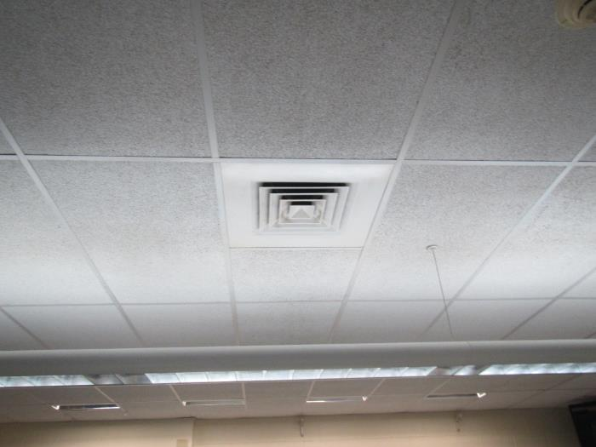
Typical supply vent
Picture 2
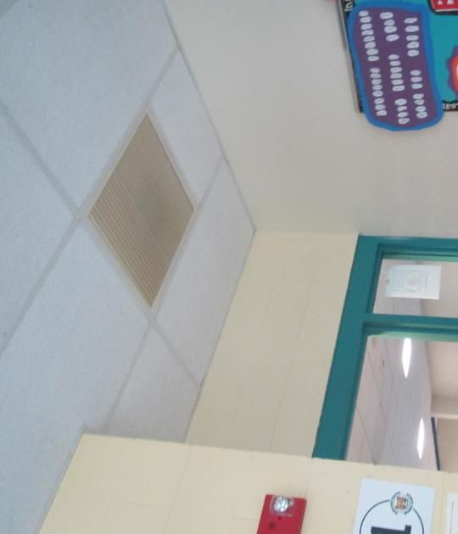
Typical return/exhaust vent in classroom, note proximity to door
Picture 3
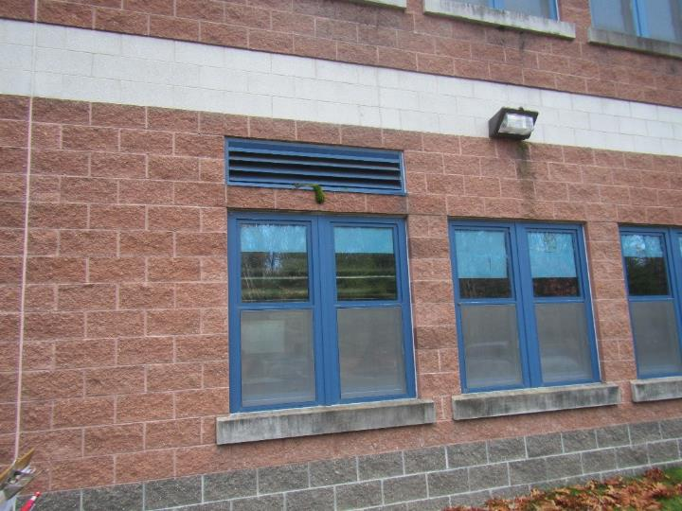
Air intake vents along one wing of the school
Picture 4
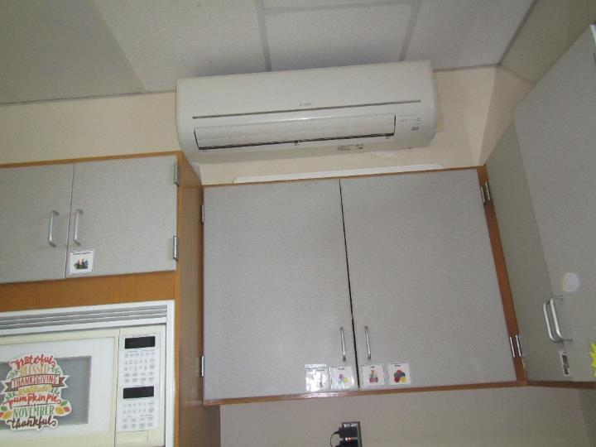
Ductless air conditioner on classroom wall
Picture 5
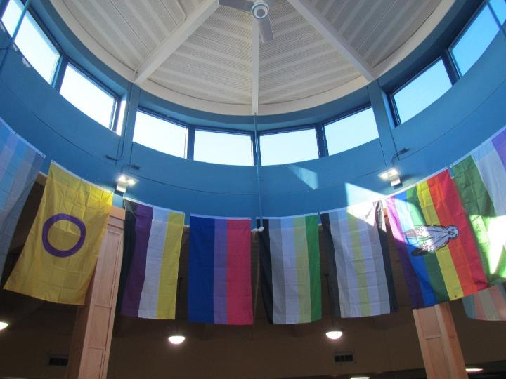
High, round ceiling with windows in the library
Picture 6
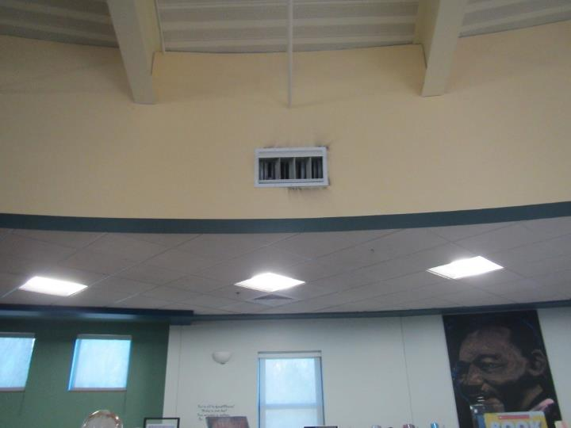
Supply vent in the library
Picture 7
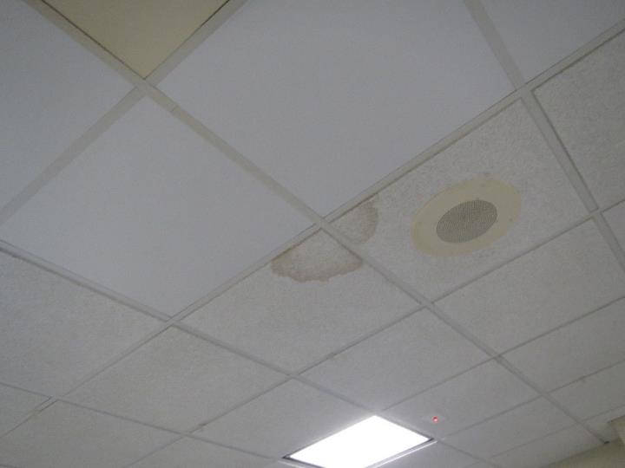
Water-damaged ceiling tiles
Picture 8
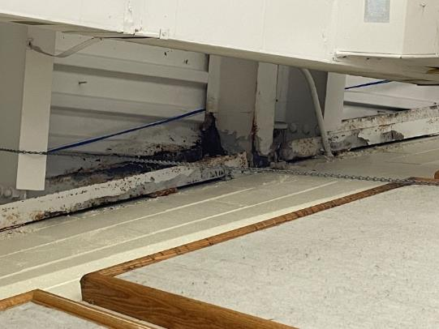
Area of leak in Chorus Room
Picture 9
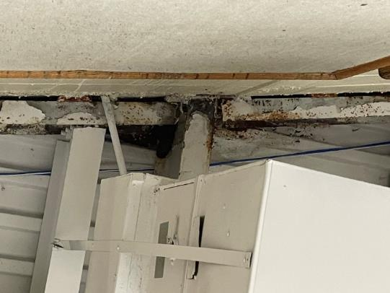
Area of leak in Chorus Room
Picture 10
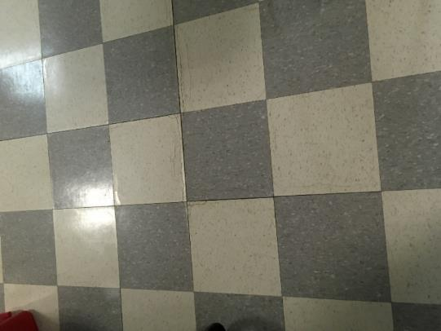
Tile edges lifting showing signs of chronic water exposure
Picture 11
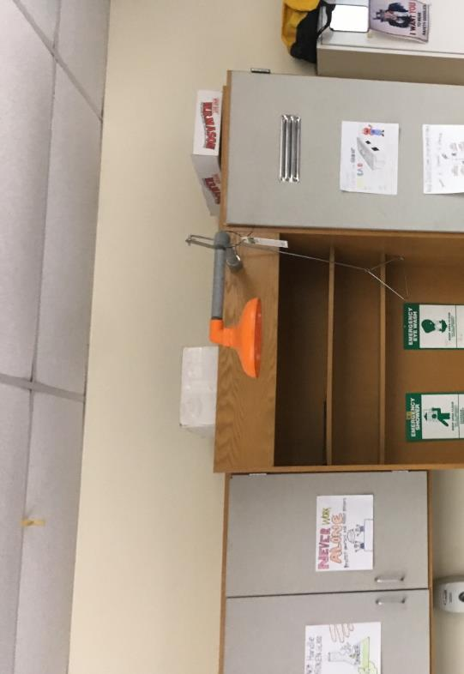
Bowing ceiling tiles
Picture 12
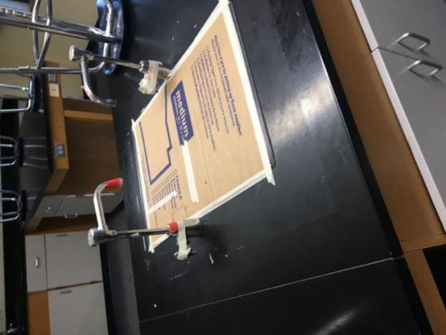
Abandoned sink
Picture 13
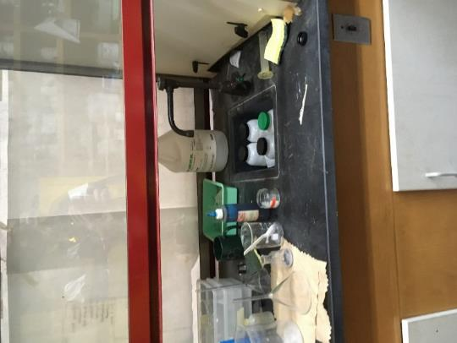
Chemical fume hood faucet and sink
Picture 14
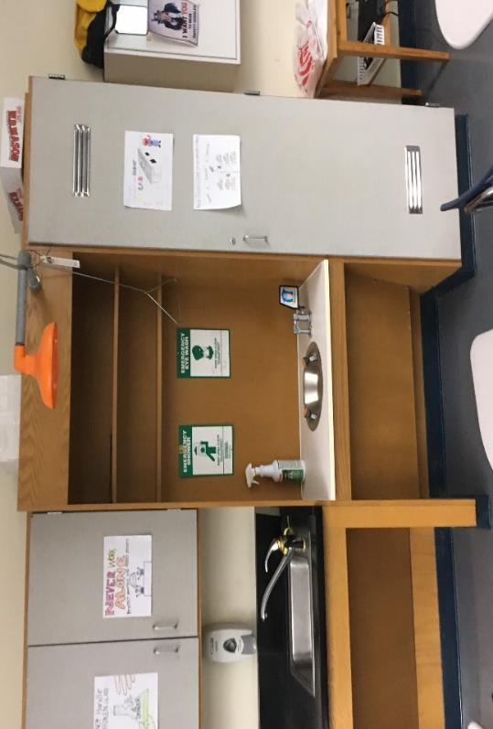
Eye wash station with sink/drain; unknown what drain is connected to
Picture 15
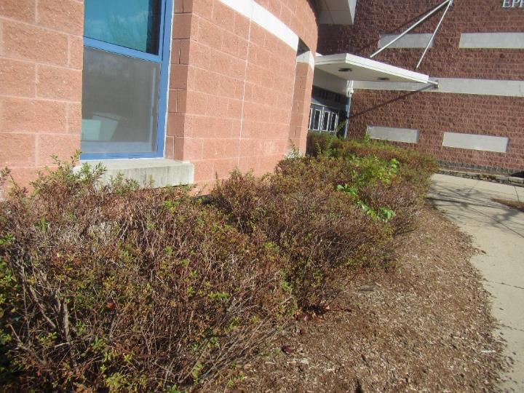
Plants and mulch next to the building
Picture 16
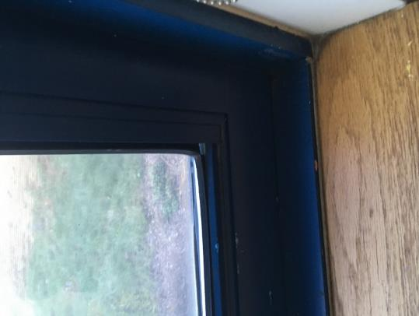
Window with loose gasket
Picture 17
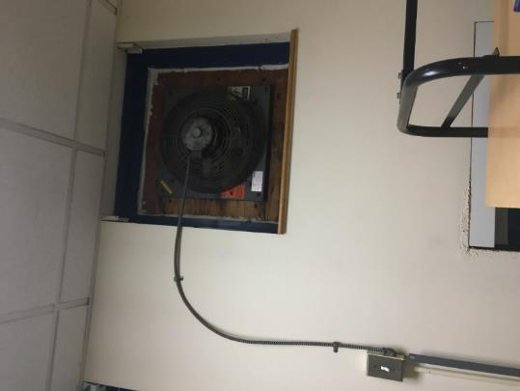
Wall-mounted exhaust fan of unknown purpose
Picture 18
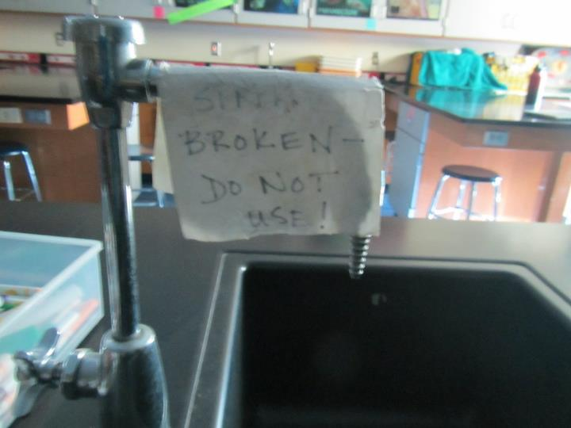
Broken sink
Picture 19
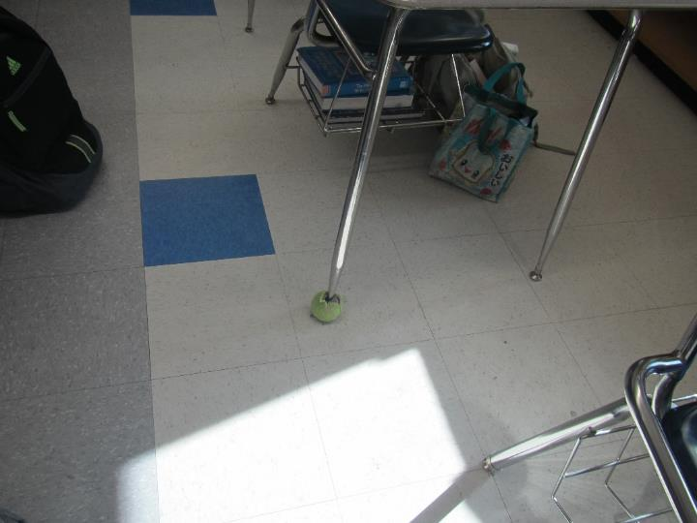
Tennis ball as table glide
Picture 20
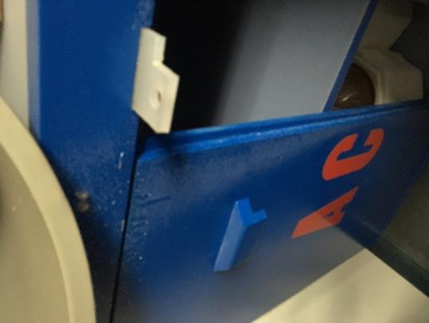
Stains on acid cabinets doors, indicating vapor movement out of cabinet
Picture 21
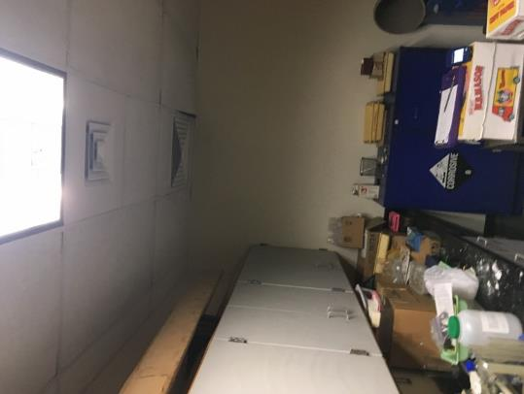
Acid storage cabinet located beneath a four-way fresh air diffuser
Picture 22
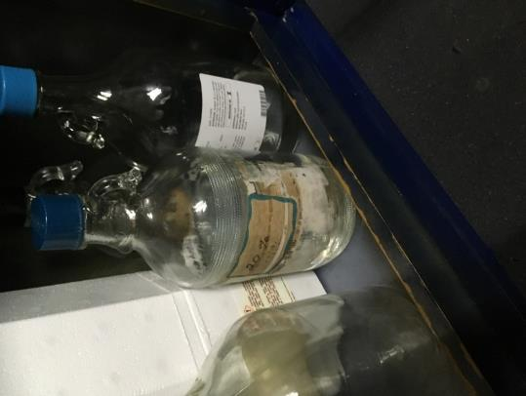
Missing and damaged labels on stored chemicals
Picture 23
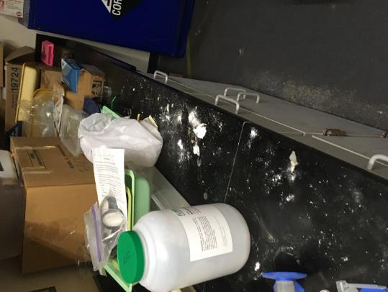
Counter surface with an unidentified powdered material
Picture 24
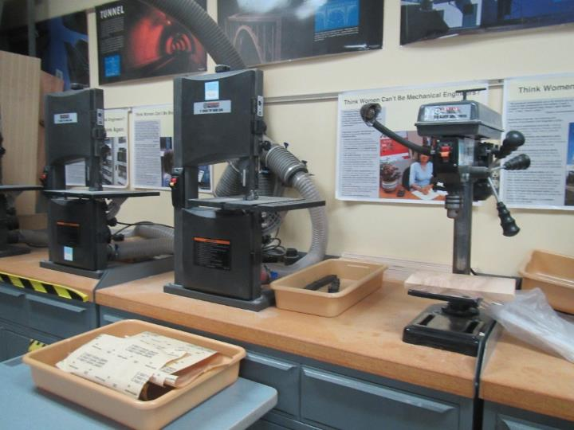
Workshop equipment with attached dust collection
Picture 25
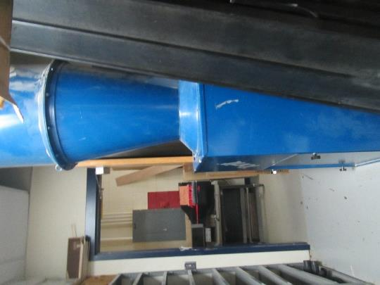
Wood dust collection system
Picture 26
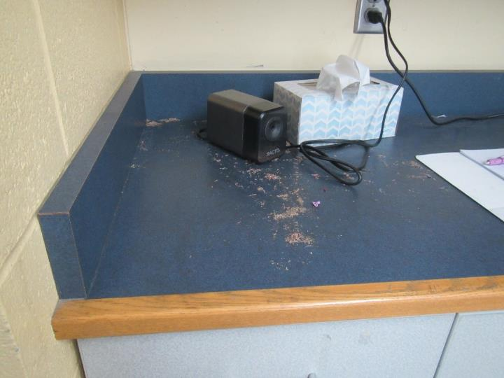
Pencil shavings on counter
Picture 27
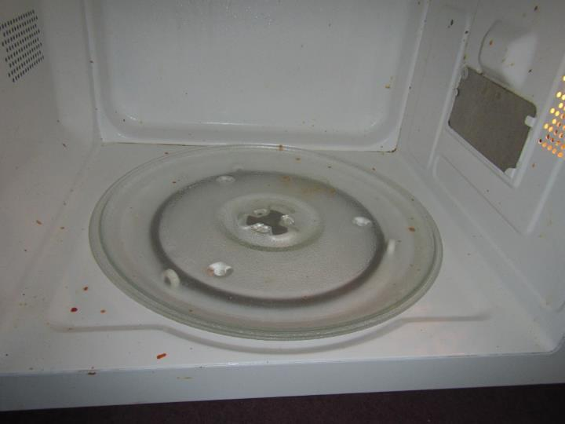
Food debris in a microwave
Location/ Room | Carbon  Dioxide  (ppm) | Carbon Monoxide  (ppm) | Temp  (°F) | Relative  Humidity  (%) | PM2.5  (µg/m³) | VOCs  (ppm) | Occupants  in Room | Windows  Openable | Ventilation |  | Remarks
 |  |  |  |  |  |  |  |  | Supply | Exhaust
Background (outside) | 353 | ND | 52 | 36 | 3 | ND |  |  |  |  | Clear
Third Floor
Stairwell 2 |  |  |  |  |  |  |  |  |  |  | Desks in stairwell landing
301 | 494 | ND | 71 | 24 | ND | ND | 0 | N | Y | Y | Area rug, DEM, HS
303 | 548 | ND | 71 | 24 | ND | ND | 0 | Y | Y | Y | Sink
306 | 508 | ND | 71 | 23 | 2 | ND | 0 | Y | Y | Y | Sink, DEM
309 | 530 | ND | 71 | 24 | 2 | ND | 0 | Y | Y | Y | DEM, PF, microwave, sink
312 | 565 | ND | 71 | 24 | ND | ND | 4 | Y | Y | Y | DEM, plant
315 | 593 | ND | 71 | 25 | 1 | ND | 1 | Y | Y | Y | Aquariums (most or all dry), DEM, items, boxes
318 | 461 | ND | 71 | 25 | 1 | ND | 1
319 | 636 | ND | 72 | 26 | ND | ND | 0 | N | Y | Y | Computers, area rug, DEM, 1 WD CT
321 | 567 | ND | 71 | 24 | 1 | ND | 1 | Y | Y | Y | DEM, sink
324 | 618 | ND | 71 | 26 | 1 | 3 | 3 | N | Y | Y | DEM, plush items
325 | 497 | ND | 71 | 24 | 1 | ND | 0 | Y | Y | Y | DEM, sink
326 | 1285 | ND | 73 | 36 | 1 | ND | 12 | N | Y | Y | Area rug
328 | 578 | ND | 72 | 25 | 1 | ND | 1 | N | Y | Y | DEM
330 | 540 | ND | 72 | 23 | 1 | ND | 2 | Y | Y | Y | DEM, sink
332 | 502 | ND | 71 | 24 | 1 | ND | 0 | Y | Y | Y | Plant, sink, DEM, rubber balls
336 | 524 | ND | 72 | 27 | ND | -- | 1 | Y | Y | Y | Sink, cleaners
339 | 783 | ND | 72 | 29 | ND | -- | 21 | Y | Y | Y | Sink
342 | 944 | ND | 72 | 31 | ND | -- | 19 | Y | Y | Y | Sink
345 | 737 | ND | 71 | 31 | ND | -- | 1 | Y | Y | Y | Sink
346 | 990 | ND | 72 | 32 | ND | -- | 8 | N/A | Y | Y
346A | 1209 | ND | 72 | 35 | ND | -- | 1 | N/A | Y | N
348 | 656 | ND | 71 | 28 | ND | -- | 6 | Y | Y | Y | Sink, dislodged CT
349 | 930 | ND | 72 | 31 | ND | -- | 9 | N/A | Y | Y | Sink
351 | 760 | ND | 71 | 29 | ND | -- | 13 | Y | Y | Y | Sink
353 | 619 | ND | 71 | 30 | ND | -- | 0 | Y | Y | Y | Photocopier, fridge, microwave, Keurig coffeemaker, WD CTs
Second floor
Library | 408 | ND | 73 | 21 | ND | ND | 1 | Y | Y dusty | Y | Carpet, couches, area rug
IT/library office | 415 | ND | 73 | 23 | ND | ND | 23 | Y | Y | Y
Student Services (SS) Main office | 629 | ND | 72 | 29 | ND | -- | 1 | N/A | Y | Y | Air purifier
SS1 | 641 | ND | 72 | 29 | ND | -- | 0 | N/A | Y | Y | WD CT around smoke alarm
SS2 | 647 | ND | 72 | 29 | ND | -- | 1 | Y | Y | Y | Mini fridge on carpet, aquarium, carpet
SS3 | 694 | ND | 72 | 29 | ND | -- | 2 | Y | Y | Y | Carpet, fridge, air purifier
SS4 | 664 | ND | 71 | 32 | ND | -- | 2 | Y | Y | Y
SS6 | 643 | ND | 74 | 27 | ND | -- | 1 | N/A | Y | Y | Fridge, carpet
SS7 | 664 | ND | 74 | 32 | ND | -- | 0 | N/A | Y | Y | Hand sanitizer
201 | 649 | ND | 73 | 28 | ND | -- | 0 | N | Y | Y | Air purifier, photocopier
203 | 554 | ND | 73 | 23 | ND | ND | 2 | Y | Y | Y | DEM, TBs
206 | 703 | ND | 73 | 23 | ND | ND | 8 | Y | Y | Y | Area rug, TBs, vacuum cleaner (not HEPA), plants
209 | 601 | ND | 73 | 23 | 10 | ND | 5 | Y | Y | Y | Plants, area rugs, DEM
212 | 642 | ND | 73 | 24 | 7 | ND | 0 | Y | Y | Y | TBs, DEM, PF
215 | 527 | ND | 73 | 23 | ND | ND | 0 | Y | Y | Y | DEM, PS
218 | 624 | ND | 73 | 25 | ND | ND | 1 | Y | Y | Y | DEM, PS
219 | 787 | ND | 73 | 30 | ND | -- | 5 | N | Y | Y | Bowed CT
220 | 819 | ND | 73 | 30 | ND | -- | 6 | N | Y | Y
221 | 580 | ND | 73 | 26 | ND | -- | 3 | Y | Y | Y | Sink with food, toaster, coffeemaker, gaps around sprinkler system in ceiling
221A | 579 | ND | 72 | 27 | ND | -- | 1 | N | Y | Y
224A- Science Prep | 602 | ND | 71 | 29 | ND | -- | 0 | N | Y | Y | Microwave, sink, coffeemakers, fridge
224 | 515 | ND | 72 | 26 | ND | -- | 7 | Y | Y | Y | Sinks
227 | 594 | ND | 71 | 28 | ND | -- | 1 | Y | Y | Y | Sinks, labs
229 | 829 | ND | 74 | 29 | ND | -- | 4 | N | Y | Y
230 | 807 | ND | 74 | 29 | ND | -- | 1 | Y | Y | Y
233 | 904 | ND | 74 | 30 | ND | -- | 3 | Y | Y | Y
236 | 934 | ND | 74 | 30 | ND |  | 20 | Y | Y | Y
242 | 778 | ND | 74 | 24 | 1 | ND | 0 | Y 1 Open | Y | Y | DEM, PF, wall scuffs
245 | 800 | ND | 74 | 26 | ND | ND | 13 | N | Y | Y | TBs
246 | 791 | ND | 74 | 28 | ND | ND | 1 | N | Y | Y | Area rug
247 | 603 | ND | 74 | 25 | ND | ND | 0 | N | Y | Y | DEM, CP, candle
248 sci | 494 | ND | 73 | 22 | ND | ND | 2 | N | Y | Y | Sinks, emergency sink/shower, DEM, sci prep room
251 sci | 523 | ND | 72 | 25 | ND | ND | 0 | Y | Y | Y | WAC, DEM, sinks
253 teachers planning | 604 | ND | 73 | 24 | ND | ND | 0 | N | Y | Y | Food, fridge, microwave, PC
254 | 612 | ND | 73 | 23 | ND | ND | 10 | Y | Y | Y | Sink, oven, wall-mounted minisplit, WD CT, plant
254 inner |  |  |  |  |  |  |  |  |  |  | Washer and dryer, rug
254 restroom |  |  |  |  |  |  |  |  |  | Y
257 | 257 | ND | 72 | 28 | ND | ND | 15 | Y | Y | Y | Microwave, DEM
260 | 618 | ND | 71 | 25 | ND | ND | 15 | Y | Y | Y | Shop tools
263 | 526 | ND | 73 | 24 | ND | ND | 16 | N | Y | Y | Shop tools, 3D printer, shop vac
266 | 530 | ND | 72 | 25 | ND | ND | 10 | Y | Y | Y | DEM, plant
269 computer lab | 566 | ND | 73 | 25 | ND | ND | 20 | N | Y | Y | Computers
329 | 782 | ND | 73 | 26 | 1 | ND | 0 | Y | Y | Y | PS, PF, wall scuffs, DEM, HS
First floor
Gym | 545 | ND | 68 | 25 | ND | ND | 0 | Y | Y | Y
178 orchestra | 424 | ND | 67 | 24 | ND | ND | 0 | Y | Y | Y | Instruments and cases
CAF | 439 | ND | 70 | 24 | ND | ND | 0 |  | Y | Y
154 | 608 | ND | 71 | 26 | ND | ND | 16 | Y | Y | Y | Sink, area rug, DEM
152 | 721 | ND | 71 | 29 | ND | ND | 0 | N | Y | Y | DEM, plant, items
101 | 483 | ND | 72 | 24 | Nd | ND | 0 | N | Y | Y | DEM, hanging items
103 | 628 | ND | 71 | 23 | 1 | ND | 1 | Y | Y | Y | Area rug, couch
Principal | 465 | ND | 72 | 21 | ND | ND | 0 | Y | Y | Y | Plant, carpet
Copy area of main office | 394 | ND | 72 | 22 | ND | ND | 1 | Y | Y | Y | Carpet, laminator, 3 PC, plants
Nurse | 417 | ND | 71 | 22 | ND | ND | 1 | Y | Y | Y | Coffee
145 | 723 | ND | 73 | 27 | ND | ND | Class entering | Y | Y | Y | PS
175 | 733 | ND | 69 | 32 | ND | -- | 22 | Y | Y | Y
190 | 495 | ND | 68 | 27 | ND | -- | 1 | Y | Y | Y | Rust on ceiling pipes, bucket amongst seats for ceiling leak
Staff Dining | 513 | ND | 70 | 28 | ND | -- | 0 | Y | Y | Y | Sink, fridge, toaster oven microwave, food
169 | 777 | ND | 71 | 29 | ND | -- | 14 | Y | Y | Y | Sink
153 | 581 | ND | 72 | 27 | ND | -- | 0 | N | Y | Y | Fridge, sink, microwaves, photocopier, shredder, food
Main office conference room | 463 | ND | 70 | 26 | ND | -- | 0 | Y | Y | Y
Main office staff room | 566 | ND | 73 | 28 | ND | -- | 5 | N | Y | Y | Fridge, food, sink, microwave
Nurse Treatment Room | 453 | ND | 72 | 24 | ND | -- | 0 | N | Y | Y | Air purifier, sink, copier, medications
142 | 741 | ND | 75 | 27 | ND | -- | 0 | Y | Y | Y | Microwave
109 | 735 | ND | 71 | 34 | ND | ND | 18 | Y | Y | Y
172 art | 932 | ND | 71 | 31 | ND | ND | 31 | Y | Y | Y | 1 WD CT
172 Kiln room | 467 | ND | 68 | 30 | ND | ND | 0 | N | N | Y
154 | 802 | ND | 70 | 34 | ND | ND | 17 | Y | Y | Y
101 | 584 | ND | 71 | 33 | ND | ND | 6 | Y | Y | Y
103 | 552 | ND | 71 | 32 | ND | ND | 5 | Y | Y | Y
106 | 590 | ND | 72 | 33 | ND | ND | 1 | Y | Y | Y | 1 WD CT
106 office | 557 | ND | 73 | 31 | ND | ND | 1 | Y | Y | Y | Window open
109 | 1048 | ND | 73 | 37 | ND | ND | 20 | Y | Y | Y
112 | 883 | ND | 72 | 35 | 3 | ND | 20 | Y | Y | Y
118 | 1082 | ND | 71 | 37 | ND | ND | 17 | N | Y | Y
119 | 834 | ND | 73 | 36 | ND | ND | 2 | Y | Y | Y
121 | 615 | ND | 71 | 33 | ND | ND | 18 | Y | Y | Y | 3 WD CT
127 | 692 | ND | 70 | 33 | ND | ND | 15 | Y | Y | Y
148 | 677 | ND | 71 | 31 | ND | ND | 0 | N | Y | Y
147 | 662 | ND | 71 | 35 | ND | ND | 0 | Y | Y | Y
129 | 690 | ND | 72 | 34 | ND | ND | 0 | Y | Y | Y
130 | 631 | ND | 72 | 32 | ND | ND | 0 | Y | Y | Y

Location | Air Temperature  (ºF) | Relative Humidity  (%) | Temperature at Floor/Wall Junction  (ºF) | Difference in Temperature of Air v. Floor/Wall Junction  (ºF)
Main office | 67 | 26 | 57 | 10
103 | 71 | 32 | 59 | 12
106 office | 73 | 31 | 66 | 7
109 | 71 | 34 | 64 | 7
112 | 72 | 35 | 52 | 20
118 | 71 | 37 | 52 | 19
127 | 71 | 33 | 49 | 23
130 | 72 | 32 | 47 | 25
148 | 71 | 33 | 49 | 23
154 | 70 | 34 | 63 | 7
172 | 71 | 31 | 64 | 7

