MAURA T. HEALEY
Governor
KIMBERLEY DRISCOLL
Lieutenant Governor
The Commonwealth of Massachusetts
Executive Office of Health and Human Services Department of Public Health
250 Washington Street, Boston, MA 02108-4619

KATHLEEN E. WALSH
Secretary
ROBERT GOLDSTEIN, MD, PhD
Commissioner
Tel: 617-624-6000
www.mass.gov/dph

December 21, 2023

Steven T. James House Clerk
State House Room 145 Boston, MA 02133

Michael D. Hurley Senate Clerk
State House Room 335 Boston, MA 02133

Dear Mr. Clerk,

Pursuant to Section 232 of Chapter 111 of the Massachusetts General Laws, please find enclosed a report
from the Department of Public Health entitled “Suicides in Massachusetts: 2019-2020.”

Sincerely,

Robert Goldstein, MD, PhD Commissioner
Department of Public Health

(this page has intentionally been left blank)

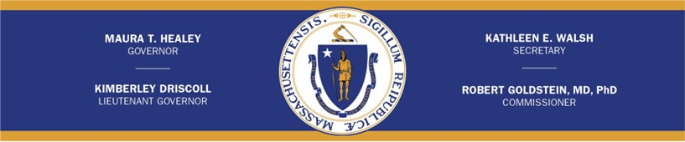

Suicides in Massachusetts 2019-2020

December 2023

(this page has intentionally been left blank)

Legislative Mandate
The following report is hereby issued pursuant to Section 232 of Chapter 111 of the Massachusetts General Laws as follows:

The department, in consultation with the executive office of public safety and security shall, subject to appropriation, collect, record and analyze data on all suicides in the Commonwealth. Data collected for each incident shall include, to the extent possible and with respect to all applicable privacy protection laws, the following: (i) the means of the suicide; (ii) the source of the means of the suicide; (iii) the length of time between purchase of the means and the death of the decedent; (iv) the relationship of the owner of the means to the decedent; (v) whether the means was legally obtained and owned pursuant to the laws of the commonwealth;
(vi) a record of past suicide attempts by the decedent; and (vii) a record of past mental health treatment of the decedent.

The department shall annually submit a report, which shall include aggregate data collected for the preceding calendar year and the department’s analysis, with the clerks of the House of Representatives and the Senate and the Executive Office of Public Safety and Security not later than December 31. Names, addresses or other identifying factors shall not be included.

The commissioner shall work in conjunction with the offices and agencies in custody of the data listed in this section to facilitate collection of the data and to ensure that data sharing mechanisms are in compliance with all applicable laws relating to privacy protection. Data collected and held by the department to complete the report pursuant to this section shall not be subject to section 10 of chapter 66 and clause Twenty-sixth of section 7 of chapter.

Executive Summary
Section 232 of Chapter 111 of the Massachusetts General Laws tasks the Massachusetts Department of Public Health (DPH) with collecting, recording, and analyzing data on all suicides in the Commonwealth and submitting an annual report.

DPH analyzed data collected on suicides for 2019 and 2020 and found the following:

- In 2019, 642 suicides occurred in Massachusetts, and in 2020, 615 suicides occurred. The combined total (n=1,257) was greater than the number of deaths due to motor vehicles (n=677) and homicides (n=325) combined for both years.
- In 2019, the age-adjusted rate of suicide in Massachusetts was 8.5/100,000 persons, and in 2020, it was 8.2/100,000 persons. The age-adjusted rate of suicide was increasing at an average rate of 1.2% per year between 2010 and 2018. However, rates have been falling since 2018 and are close to levels seen in the previous decade. There were approximately 2% more suicides in 2020 than in 2010.
- Between 2019 and 2020, the majority of suicide decedents were male (n=959, 76.3%). However, since 2010, the rate of suicides for males decreased 8.3% mainly due to decreases in suicides seen in 2019 and 2020. During this same time period, the rate of suicides increased 8.5% for females.
- Suicides in 2019 and 2020 most commonly occurred among individuals 55-64 years of age (n=259, 20.6%) followed by individuals 45-54 years of age (n=243, 19.3%).
- In 2019 and 2020, the most prevalent means of suicide for males were hanging/suffocation (47.9%) and firearms (26.2%), which combined accounted for 74.0% of all male suicides.
- In 2019 and 2020, the most prevalent means of suicide for females were hanging/suffocation (41.9%) and poisonings/overdoses (38.9%), which combined accounted for 80.9% of all female suicides.
- In 2019 and 2020, firearms accounted for 21.6% of all suicides (n=272). Males accounted for 92.3% of all firearm suicides (n=251). Handguns were the most common type of firearm used in suicides (n=224, 82.4%).
- In 2019 and 2020, poisonings/overdoses accounted for 17.9% of all suicides (n=225). Females accounted for 51.6% of all poisoning/overdose suicides (n=116). Opiates (n=117, 52.0%) and antidepressants (n=83, 36.9%) were the most common classes of drugs used. Note more than one substance may be associated with a single suicide. Because these substances are not mutually exclusive, the total count will add up to more than the 225 decedents who died from poisoning or overdose.
- In 2019 and 2020, 34.6% of female suicide decedents (n=103), and 15.6% of male suicide decedents (n=150) were known to have a prior suicide attempt.
- In 2019 and 2020, 73.8% of female suicide decedents (n=220), and 53.5% of male suicide decedents (n=513) were known to have a history of treatment for a mental health or substance use problem.
- As of May 2021, ED visits for suicidal ideation among female youth age 0-24 are 19% higher than what they were in January 2020, and ED visits for suicide attempts among female youth are 29% higher than what they were in January 2020.

Introduction

In 2014, the Legislature passed Chapter 284 of the Acts of 2014: An Act to reduce gun violence. This law included a requirement for the Massachusetts Department of Public Health (DPH) to collect, record, and analyze data on all suicides in the Commonwealth.

The Massachusetts Violent Death Reporting System (MAVDRS) began collecting data on all homicides, suicides, deaths of undetermined intent, unintentional firearm deaths, and legal intervention deaths that occurred in the Commonwealth starting in 2003. MAVDRS is a part of the National Violent Death Reporting System (NVDRS) and is funded by the Centers for Disease Control and Prevention (CDC). The software, variables, and coding guidance are standardized by CDC across all funded states. The data contained in this report are from 2019 and 2020, the latest years available. Due to the extensive information collected, CDC allows sixteen months after the end of the data year for data completion.

Since the passage of Chapter 284 of the Acts of 2014, MAVDRS has worked towards obtaining better data on all the information specified in the legislation. MAVDRS has been working with current data partners, which include the Registry of Vital Records and Statistics (RVRS), the Office of the Chief Medical Examiner (OCME), the Massachusetts State Police (MSP), and the Boston Police Department (BPD), as well as new partners within the Executive Office of Public Safety and Security (EOPSS), like the Department of Criminal Justice Information Services (DCJIS), to work on obtaining additional data elements and improving the quality of data currently collected. MAVDRS received data for 2019 and 2020 firearm suicides from DCJIS that has been used to improve the reporting on information related to firearm suicides.

Suicide Data 2019-2020
In 2019, there were 642 suicides (9.2/100,000 persons), and in 2020, there were 615 suicides (8.7/100,000 persons) that occurred in the Commonwealth of Massachusetts. In 2019, 488 of the decedents were male (14.4/100,000 persons, 76.0%), and 154 of the decedents were female (4.3/100,000 persons, 24.0%). In 2020, 471 of the decedents were male (13.8/100,000 persons, 76.6%), and 144 of the decedents were female (4.0/100,000 persons, 23.4%).

Figure 1. Suicides, Homicides, and Motor Vehicle Deaths, MA 2010-2020
800
725
688
601
624
588
585
608
631
638
642
615
347
374
383
387
351
354
344
347
355
336
343
212
202
135
148
147
146
144
174
151
149
176

700

600
Number of Deaths

500

400

300

200

100

0
2010 2011 2012 2013 2014 2015 2016 2017 2018 2019 2020
Incident Year

Suicides Motor Vehicle Deaths Homicides

Sources: Massachusetts Violent Death Reporting System (MAVDRS), Massachusetts Department of Public Health; Fatality Analysis and Reporting System (FARS, data accessed 07/11/2022), National Highway Traffic Safety Administration

- In 2019 and 2020, the number of suicide deaths (n=1,257) was 1.9 times higher than the number of motor vehicle traffic-related deaths (n=679) and 3.9 times higher than the number of homicides (n=325).
- In 2019, Massachusetts had a lower age-adjusted rate of suicide (8.5/100,000 persons) compared to the rest of the United States (13.9/100,000 persons). This trend continued in 2020, when Massachusetts had an age-adjusted rate of suicide of 8.2/100,000 persons compared to the national age-adjusted rate of 13.5/100,000 persons.¹
- Between 2010 and 2018, age-adjusted suicide rates in Massachusetts increased an average of 1.2% per year. This increase is lower than the increase in the U.S. age-adjusted suicide rate, which increased an average of 2.1% per year during this time. Between 2018 and 2020, age-adjusted suicide rates decreased in both Massachusetts and the U.S. In Massachusetts, age-adjusted suicide rates decreased an average of 8.3% per year, while the U.S. age-adjusted suicide rate decreased an average of 2.7% per year.

¹ Source: Centers for Disease Control and Prevention (CDC), WISQARS – Fatal Injuries Report, 1999-2020, for National, Region, and States (Restricted)

Suicide Rate Demographics

Figure 2a. Male Suicide Rate, MA 2010-2020
18.0
16.3
15.1
15.9
13.8
14.5
14.2
14.1
14.7
14.4
13.1
13.8
Suicide Rate
16.0
Rate Per 100,000 Persons
14.0
12.0
10.0
8.0
6.0
4.0
2.0
0.0
2010 2011 2012 2013 2014 2015 2016 2017 2018 2019 2020
Incident Year

Source: Massachusetts Violent Death Reporting System, Massachusetts Department of Public Health

Figure 2b. Female Suicide Rate, MA 2010-2020
6.0
4.9
4.3
4.5
4.5
4.7
4.4
4.3
4.0
4.2
4.0
3.7
Suicide Rate

5.0
Rate Per 100,000 Persons

4.0

3.0

2.0

1.0

0.0
2010 2011 2012 2013 2014 2015 2016 2017 2018 2019 2020
Incident Year

Source: Massachusetts Violent Death Reporting System, Massachusetts Department of Public Health

- While the majority of deaths by suicide occurred in males, there has been an overall decrease in the suicide rate among males in the past decade, while females have seen a net increase.
- When comparing suicide rates from 2010 and 2020, the suicide rate among males decreased 8.3% (from 15.1 to 13.8 per 100,000 persons). During this same time period, the suicide rate among females increased 8.4% (from 3.7 to 4.0 per 100,000 persons).
- Despite the fluctuations we see in suicide rates from year to year, modeled annual percent changes (APC) in suicide rates for both males and females between 2010 and 2020 were fairly low (0.5% per year for males and 0.6% per year for females).

Figure 3. Average Annual Suicide Rates by Sex and Age Group, MA 2019-2020 (n=1,257)²

25.0
Male
Female Total
n=179
n=198
n=26

20.0
Suicide Rate (per 100,000 Persons)
n=159
n=139
n=109
n=44

15.0
n=100
n=200
n=190
n=243
n=259
n=144

10.0
n=134
n=51
n=64
n=61
n=52
n=28

5.0
n<6
n<6 n=7
n=34
n=41
n=35
n=8
n<6

0.0
0-14 15-24 25-34 35-44 45-54 55-64 65-74 75-84 85+
Age Group
Source: Massachusetts Violent Death Reporting System, Massachusetts Department of Public Health

- 39.9% of suicides that occurred from 2019-2020 were among individuals 45-64 years (n=502). Between 2010 and 2020, the rate of suicides in this age group increased an average of 0.8% per year, although the number of suicides in this age group decreased in 2019 and 2020.
- The age groups with the highest rates of suicide for males were individuals aged 85+ years (23.7/100,000 persons, n=26) and individuals aged 55-64 years (21.5/100,000 persons, n=198).
- The age groups with the highest rates of suicide for females were individuals aged 45-54 (6.8/100,000 persons, n=64) and individuals aged 55-64 (6.1/100,000 persons, n=61).

Figure 4. Average Annual Suicide Rates by Sex and Race/Ethnicity, MA 2016-2020 (n=3,309)³
18.0
n=2,155
Male
Female
n=2,813
Total
n=118
n=174
n=658
n=145
n=219
n=73
n=116
n=43
n=27
n=45
16.0
Age-Adjusted Suicide Rate
(per 100,000 Persons)
14.0
12.0
10.0
8.0
6.0
4.0
2.0
0.0
White, nH Black, nH Hispanic Asian, nH
Race/Ethnicity
Source: Massachusetts Violent Death Reporting System, Massachusetts Department of Public Health

- From 2016-2020, the average annual age-adjusted suicide rate was highest among White, non-Hispanic males (16.5/100,000 persons, n=2,155).
- Similarly, White, non-Hispanic females had a higher average annual age-adjusted rate of suicide (4.8/100,000 persons, n=658) compared to other race/ethnicity groups.

² Rates are not calculated for counts less than six and are considered unstable for counts less than 20.
³ Rates are not calculated for other race/ethnicity groups due to low counts.

Figure 5. Average Annual Suicide Rates by Age Group and Race/Ethnicity, MA 2016-2020 (n=3,309)⁴

30.0
White, nH Black, nH Hispanic Asian, nH Total
n=7

25.0
Suicide Rate (per 100,000 Persons)

20.0
n=436
n=580
n=615

15.0
n=412
n=42
n=545
n=503
n=654
n=661
n=295
n=13
n=325

10.0
n=265 n=27 n=47
n=36 n=382
n=59 n=27
n=21 n=36
n=22 n=31 n=19
n=15
n=22
n=8
n=11
n=127
n=138
n=71
n=79

5.0
n=12
n<6 n=6 n<6 n=22
n=9
n=6
n<6 n<6 n<6
n<6 n<6

0.0
0-14 15-24 25-34 35-44 45-54 55-64 65-74 75-84 85+
Age Group
Source: Massachusetts Violent Death Reporting System, Massachusetts Department of Public Health

- From 2016-2020, the age groups with the highest suicide rates were among individuals aged 45-54 years (14.1/100,000 persons, n=654) and among individuals aged 55-64 years (14.1/100,000 persons, n=661).
- Among White, non-Hispanics, the age group with the highest suicide rate was also among individuals aged 45-54 years (16.7/100,000 persons, n=580). However, among other race/ethnicity groups, suicide rates peak at a much younger age.
- Among Black, non-Hispanics, suicide rates peaked among individuals aged 25-34 years (10.2/100,000 persons, n=42).
- Among Hispanics, suicide rates also peaked among individuals aged 25-34 years (7.9/100,000 persons, n=59). Although rates were higher among individuals aged 65-74 years, the rate is considered unstable due to counts being under twenty (n=13).
- Among Asian, non-Hispanics, suicide rates peaked at the earliest age, among individuals aged 15-24 (9.3/100,000 persons, n=36). Although rates were higher among individuals aged 85+ years, the rate is considered unstable due to counts being under twenty (n=7).
- Among all stable rates (i.e. where counts for a given race/ethnicity are 20 or greater), suicide rates were highest among White, non-Hispanics in all but one age group. Among individuals aged 15-24 years, suicide rates were highest among Asian, non-Hispanics.

⁴ Rates are not calculated for counts less than six and are considered unstable for counts less than 20. Rates are not calculated for other race/ethnicity groups due to low counts.

Figure 6. Suicide Counts and Average Annual Suicide Rates by County, MA 2019-2020
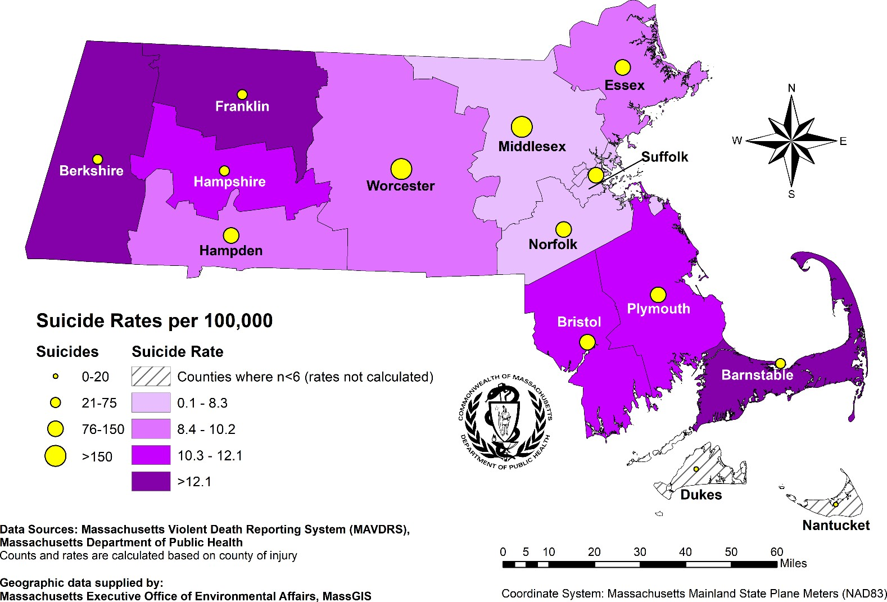

- In 2019-2020, suicide rates in Massachusetts were highest in the more rural counties. The counties with the highest rates of suicide were:
  - Franklin County (18.3/100,000 persons, n=26),
  - Berkshire County (17.2/100,000 persons, n=44), and
  - Barnstable County (12.1/100,000 persons, n=54)
- Middlesex County had the highest number of suicides (n=246) but also had one of the lowest suicide rates due to it being the most populous county in the state (7.5/100,000 persons).
- The county with the lowest measurable suicide rate from 2019-2020 was Suffolk County (6.6/100,000 persons, n=106). In general, the urban counties in and around Boston had the lowest suicide rates in Massachusetts.

The Means of Suicide and Source of the Means of Suicide

Chapter 111 M.G.L., Section 232, (i) and (ii) specify that this report contains both the means of the suicide (e.g. firearm suicides) and the source of the means (e.g. type of firearm). The means used in suicides varies greatly, as does its source. Studying patterns in the use of these means can help better inform prevention efforts, specifically those related to means restriction. The following information represents the data currently available on the type and source of means used in suicides in Massachusetts in 2019 and 2020.

Figure 7. Suicides by Sex and Means, MA 2019-2020 (n=1,257)⁵
Males (n=959)

Females (n=298)

Other
15%
Poisoning/
Overdose
11%
Hanging/
Suffocation
48%
Firearm
26%
Other
12%
Poisoning/
Overdose 39%
Hanging/
Suffocation 42%
Firearm
7%

Source: Massachusetts Violent Death Reporting System, Massachusetts Department of Public Health

Table 1. Means of Suicide: Number, Percent, and Rate, MA 2019-2020
 | Male |  |  | Female |  |  | Total
Means of Suicide | N | Percent | Rate per  100,000 | N | Percent | Rate per  100,000 | N | Percent | Rate per  100,000
Hanging/Suffocation | 459 | 47.9 | 6.8 | 125 | 41.9 | 1.7 | 584 | 46.5 | 4.2
Firearm | 251 | 26.2 | 3.7 | 21 | 7.0 | 0.3 | 272 | 21.6 | 1.9
Poisoning/Overdose | 109 | 11.4 | 1.6 | 116 | 38.9 | 1.6 | 225 | 17.9 | 1.6
Sharp Instrument | 48 | 5.0 | 0.7 | 11 | 3.7 | 0.2 | 59 | 4.7 | 0.4
Fall | 40 | 4.2 | 0.6 | 11 | 3.7 | 0.2 | 51 | 4.1 | 0.4
Other Means | 52 | 5.4 | 0.8 | 14 | 4.7 | 0.2 | 66 | 5.3 | 0.5
Total | 959 | 100.0 | 14.1 | 298 | 100.0 | 4.1 | 1,257 | 100.0 | 9.0
Source: Massachusetts Violent Death Reporting System, Massachusetts Department of Public Health

- The most prevalent means of suicide from 2019-2020 were hanging/suffocation (n=584, 46.5%), firearm (n=272, 21.6%), and poisoning/overdose (n=225, 17.9%).
- For males, the most common means were hanging/suffocation (n=459, 47.9%) and firearm (n=251, 26.2%).
- For females, the most common means were hanging/suffocation (n=125, 41.9%) and poisoning/overdose (n=116, 38.9%).

⁵ Percentages may not add up to 100% due to rounding.

Table 2. Source of Means of Firearm Suicides:
Number, MA 2019-2020⁶
Means | N | %
Firearm | 272 | 100.0
Handgun | 224 | 82.4
Semi-Automatic Pistol | 94
Revolver | 68
Bolt Action | <6
Unknown Type | ≥6
Shotgun | 28 | 10.3
Pump Action | 10
Semi-Automatic | <6
Single Shot | <6
Double Barrel | <6
Unknown Type | 10
Rifle | 14 | 5.1
Bolt Action | <6
Automatic | <6
Semi-Automatic | <6
Lever Action | <6
Unknown Type | 6
Other/Unknown Type | 6 | 2.2
Source: Massachusetts Violent Death Reporting System, Massachusetts Department of Public Health

- Massachusetts has a lower rate of firearm suicides compared to the rest of the country. From 2019- 2020, the firearm suicide rate for the U.S. was 7.3/100,000 persons compared to 1.9/100,000 persons for Massachusetts.⁷
- There were three known types of firearms used in firearm-related suicides from 2019-2020: handguns, shotguns, and rifles.
- The most common type of firearm used was a handgun (n=224, 82.4%).
- The majority of decedents who died from firearm-related suicides were male (n=251, 92.3%).

⁶ Data suppressed for counts less than six for select variables. Some values greater than six have also been suppressed to prevent back-calculation.
⁷ Source: Centers for Disease Control and Prevention (CDC), WISQARS – Fatal Injuries Report, 1999-2020, for National, Region, and States (Restricted)

Table 3. Source of Means of Hanging/Suffocation Suicides:
Number, MA 2019-2020⁸
Means | Male | Female | Total
Hanging/Suffocation | 459 | 125 | 584
Rope/Clothing Line | 183 | 36 | 219
Belt/Strap | 106 | 18 | 124
Cord/Cable/Wire | 58 | 20 | 78
Clothing/Shoelace | 24 | 20 | 44
Plastic Bag/Plastic Bag + Gas | 22 | 10 | 32
Sheet/Curtain | 25 | 6 | 31
Dog Leash | ≥6 | <6 | 18
Other Specified Means | ≥6 | <6 | 22
Unknown | 9 | 7 | 16
Source: Massachusetts Violent Death Reporting System, Massachusetts Department of Public Health

- For suicides by hanging/suffocation, the most common known ligatures used were:
  - Rope/clothing line (n=219, 37.5%),
  - Belt/strap (n=124, 21.2%), and
  - Cord/cable/wire (n=78, 13.4%).
- For males, the most common ligatures used were:
  - Rope/clothing line (n=183, 39.9%),
  - Belt/strap (n=106, 23.1%), and
  - Cord/cable/wire (n=58, 12.6%).
- For females, the most common ligatures used were:
  - Rope/clothing line (n=36, 28.8%),
  - Cord/cable/wire (n=20, 16.0%), and
  - Clothing/shoelace (n=20, 16.0%).
- Thirty-two decedents used plastic bags as a means of suffocation, either alone or in conjunction with a gas such as helium or propane.
- “Other specified means” includes chains, garden hoses, laundry hoses, and zip ties.

⁸ Data suppressed for counts less than 6 for select variables. Some values greater than 6 have also been suppressed to prevent back- calculation.

Table 4. Source of Means of Poisoning/Overdose
Suicides: Number, MA 2019-2020^{9,10}
Means | Male | Female | Total
Poisoning Suicides | 109 | 116 | 225
Alcohol | 11 | 12 | 23
Amphetamine | <6 | <6 | ≥6
Analgesics | <6 | ≥6 | 18
Anticonvulsant | 8 | 10 | 18
Antidepressant | 31 | 52 | 83
Antihistamines | 10 | 16 | 26
Antipsychotic | 14 | 9 | 23
Barbiturates | 0 | <6 | <6
Benzodiazepines | 19 | 55 | 74
Carbon Monoxide | 28 | 9 | 37
Cardiovascular Agent | 16 | 21 | 37
Cocaine | ≥6 | <6 | 12
Muscle Relaxant | <6 | ≥6 | 12
Opiate | 51 | 66 | 117
Other Substance Class | 30 | 23 | 53
Total Substances Used | 234 | 307 | 541
Source: Massachusetts Violent Death Reporting System, Massachusetts Department of Public Health

- There were 560 different substances included as the cause of death in 225 poisoning suicides from 2019- 2020. On average, two different substances were used in a poisoning suicide.
- The most common classes of substances used in poisoning suicides were:
o Opiates (n=117, 21.6%),
  - Antidepressants (n=83, 15.3%), and
  - Benzodiazepines (n=74, 13.7%).
- Among males, the most common classes of substances used in poisoning suicides were:
  - Opiates (n=51, 21.8%),
  - Antidepressants (n=31, 13.2%), and
  - Carbon monoxide (n=28, 12.0%).
- Among females, the most common classes of substances used in poisoning suicides were:
  - Opiates (n=66, 21.5%),
  - Benzodiazepines (n=55, 17.9%), and
  - Antidepressants (n=52, 16.9%).
- The most common substance in “Other substance class” were anxiolytics/sedatives, which accounted for 1.5% out of the 541 substances used (n=8).

⁹ The substances listed have been identified as the cause of death of decedents (n=225); however, please note that more than one substance may be associated with a single suicide. Because these substances are not mutually exclusive, the total count will add up to more than the 225 decedents who died from poisoning.

Table 5. Source of Means of Sharp Instrument
Suicides: Number, MA 2019-2020
Means | N | %
Sharp Instrument | 59 | 100.0
Knife | 32 | 54.2
Razor Blade/Box Cutter | 14 | 23.7
Multiple/Other/Not Specified | 13 | 22.0
Source: Massachusetts Violent Death Reporting System, Massachusetts Department of Public Health

- For suicides by sharp instruments between 2019 and 2020, the most common instrument used was a knife (n=32, 54.2%).

Table 6. Source of Means of Fall Suicides:
Number, MA 2019-2020¹¹
Means | N | %
Fall | 51 | 100.0
Residential Building | 19 | 37.3
Bridge | 10 | 19.6
Parking Garage | ≥6 | --
Health Care Facility | <6 | --
Other/Unknown | 14 | 27.5
Source: Massachusetts Violent Death Reporting System, Massachusetts Department of Public Health

- From 2019-2020, residential buildings/dorms (n=19, 37.3%) were most often utilized in suicides resulting from falling or jumping from a height.

Table 7. Source of Means of Other Suicides:
Number, MA 2019-2020¹¹
Means | N | %
Other Means | 66 | 100.0
Train | 23 | 34.8
Drowning | 19 | 28.8
Fire/Burn | 13 | 19.7
Motor Vehicle | ≥6 | --
Other/Unknown | <6 | --
Source: Massachusetts Violent Death Reporting System, Massachusetts Department of Public Health

- From 2019-2020, the most prevalent other means of suicide were those involving being struck by trains (n=23, 34.8%) and drownings (n=19, 28.8%).

The Relationship Between the Owner of the Means and the Decedent

Table 8. Relationship of Suicide Decedent to Gun Owner,
MA 2019-2020
Firearm Suicides | 272 | 100.0%
Relationship | N | %
Self | 120 | 44.1%
Other Known Person* | 30 | 11.0%
Unknown | 122 | 44.9%
*Includes family, friend, or other known person
Source: Massachusetts Violent Death Reporting System, Massachusetts Department of Public Health

MAVDRS collects information on the relationship of the owner of a firearm to the decedent from police reports and medical examiner files. However, information on the relationship between the owner and decedent is not always clearly documented in these records. Additional information was obtained for this report from DCJIS to improve this information.

From 2019-2020, of the 272 firearm suicides, 150 had documented information on the relationship of the firearm owner to the decedent. In 44.1% of suicides by firearm, it was known that the decedent was the owner of the firearm. In 11.0% of cases, it was known that the owner of the firearm was a family member, friend, or other known person.

For prescription drugs used in poisoning suicides, MAVDRS collects information on the relationship between the decedent and the person for whom the prescription medication was prescribed. From 2019-2020, 47.7% of pharmaceutical drugs used in poisoning suicides were known to be prescribed to the decedent. Among females, the percentage was 51.3%, while among males, the percentage was 40.9%.

MAVDRS does not collect information on the relationship between the owner of the means and the decedent for the following means because these are commonly available and/or non-regulated objects: hanging/suffocation, sharp instruments, non-prescription drugs, or falls.

The Length of Time Between Purchase of the Means and the Death of the Decedent

Table 9. Length of Time Between Firearm Purchase
and Death of Decedents who Owned Firearm, MA 2019-2020
Length of Time from Firearm Purchase to Death | N | %
Decedent was Gun Owner | 120 | 100.0%
Less than 1 year | 13 | 10.8%
Between 1 and 5 years | 48 | 40.0%
Over 5 years | 50 | 41.7%
Unknown | 9 | 7.5%
Source: Massachusetts Violent Death Reporting System, Massachusetts Department of Public Health

MAVDRS was able to obtain information on the length of time between the purchase of the means and the death of the decedent for firearm suicides where the decedent was the owner of the firearm. Information on the length of time from purchase to death was known for 92.5% of firearm suicides where the decedent owned the firearm. Overall, 10.8% of decedents had owned the firearm for less than one year, 40.0% of decedents had owned the firearm between one and five years, and 41.7% of decedents had owned the firearm for over five years.

Whether the Means was Legally Obtained and Owned Pursuant to the Laws of the Commonwealth

Of the variety of means used in suicides, only those by firearm and poisoning may or may not be obtained and owned legally. For firearms, MAVDRS currently collects information on whether a firearm was known to be stolen, but this information is often incomplete. Of the 272 firearm suicides from 2019-2020, less than six were known to be stolen.

From 2019-2020, there were 12 known cases where illicit substances were part of the cause of death in poisoning suicides. MAVDRS does not currently have a variable for capturing whether prescription drugs used in poisoning suicides were obtained legally or not.

Circumstances

Figure 8. Circumstances Associated with Suicide, MA 2019-2020 (n=1,257)¹²

Current Mental Health Problem
68.9%
58.3%
52.5%
33.7%

31.7%
20.7%

20.1%

16.1%

14.6%

History of Treatment for Mental Health Problem

Current Treatment for Mental Health Problem

Left Suicide Note

Alcohol and/or Other Substance Use Problem

Intimate Partner Problem

History of Suicide Attempts

Physical Health Problem

Job/Financial Problem

0% 10% 20% 30% 40% 50% 60% 70% 80%
Source: Massachusetts Violent Death Reporting System, Massachusetts Department of Public Health

A circumstance is a condition, fact, or event that affects a situation. Circumstances surrounding the decedent’s life prior to death can highlight opportunities for future prevention efforts. MAVDRS systematically collects information on suicides and allows for more than one circumstance to be listed for a suicide decedent. From 2019-2020, 97.9% of suicide decedents had at least one circumstance identified during case review (n=1,231), and 89.9% had multiple circumstances known (n=1,130). It is important to remember that some circumstances are more likely to be known and documented than others, and if a circumstance is not identified, that does not mean it was not present in the decedent’s life. The above figure represents percentages of circumstances noted out of all suicides (n=1,257). Among all suicide decedents from 2019-2020:

- 68.9% had a documented current mental health problem, such as depression, anxiety disorder, bipolar disorder, schizophrenia, or post-traumatic stress disorder.
- 52.5% were currently receiving treatment for a mental health or substance use problem, and 58.3% had a history of treatment for a mental health or substance use problem. Among those who had a documented current mental health problem:
  - 75.2% were currently receiving treatment, and
  - 81.1% had a history of treatment.
- 33.7% left a suicide note.
- 31.7% had a known alcohol or other substance use issue.
- 20.7% experienced an intimate partner problem prior to their death, such as divorce, break-up, jealousy, or conflict. From 2019-2020, there were nine intimate partner-related homicide/suicide cases.
- 20.1% had a known history of suicide attempts.
- 16.1% had a physical health problem.
- 14.6% experienced job and/or financial problems.

¹² Circumstances are not mutually exclusive and will not add up to 100%. Additionally, 2.1% of decedents did not have any circumstances identified during case review.

Past Suicide Attempts

Information on past suicide attempts is obtained from the medical examiner’s files and police reports, which rely on information from psychiatric/hospital records and/or the decedent’s family and friends. There are limitations to these sources of information, as friends and family of the decedent may not know of the decedent’s past suicide attempts or may choose not to report that information to the authorities. Additionally, hospital records are not available on all suicides, and even if they are present, not all suicide attempts would cause an injury that would make this information present in records.

Table 10. Means of Suicide Decedents who had a Previous Suicide Attempt, MA 2019-2020¹³
 | Male |  |  | Female |  |  | Total
 | Prior  Attempts | Total | Percent | Prior  Attempts | Total | Percent | Prior  Attempts | Total | Percent
Total | 150 | 959 | 15.6 | 103 | 298 | 34.6 | 253 | 1,257 | 20.1
Hanging/Suffocation | 87 | 459 | 19.0 | 46 | 125 | 36.8 | 133 | 584 | 22.8
Firearm | ≥6 | 251 | -- | <6 | 21 | -- | 13 | 272 | 4.8
Poisoning/Overdose | 28 | 109 | 25.7 | 42 | 116 | 36.2 | 70 | 225 | 31.1
All Other Means | ≥6 | 140 | -- | ≥6 | 36 | -- | 37 | 176 | 21.0
Source: Massachusetts Violent Death Reporting System, Massachusetts Department of Public Health

- Of the 1,257 suicide decedents from 2019-2020, 253 (20.1%) had a previous suicide attempt. Females had a significantly higher percentage (34.6%) of prior suicide attempts than males (15.6%).
- Among hanging/suffocation decedents, females were significantly more likely to have a prior suicide attempt (n=46, 36.8%) compared to males (n=87, 19.0%).
- Among poisoning/overdose decedents, females were more likely to have a prior suicide attempt (n=42, 36.2%) compared to males (n=28, 25.7%), although this difference is not statistically significant.

¹³ Data suppressed for counts less than 6 for select variables. Some values greater than 6 have also been suppressed to prevent back-calculation.

Past Mental Health Treatment of the Decedent

One important protective factor against suicide is having effective mental health treatment. While 68.9% of suicide decedents from 2019-2020 had evidence of a current mental health problem, only 58.3% of decedents had evidence of ever receiving mental health treatment. Additionally, among suicide decedents who had evidence of a current mental health problem, 81.1% of decedents had evidence of ever receiving mental health treatment, suggesting that a portion of people who could benefit from mental health treatment are not receiving it. Finding ways to address gaps in treatment could help prevent future suicides.

Table 11. Means of Suicide Decedents with History of Treatment (Tx) for Mental Health or Substance Abuse
Problem, MA 2019-2020
 | Male |  |  | Female |  |  | Total
 | History of Tx | Total | Percent | History of Tx | Total | Percent | History of Tx | Total | Percent
Total | 513 | 959 | 53.5 | 220 | 298 | 73.8 | 733 | 1,257 | 58.3
Hanging/Suffocation | 260 | 459 | 56.6 | 94 | 125 | 75.2 | 354 | 584 | 60.6
Firearm | 98 | 251 | 39.0 | 12 | 21 | 57.1 | 110 | 272 | 40.4
Poisoning/Overdose | 72 | 109 | 66.1 | 95 | 116 | 81.9 | 167 | 225 | 74.2
All Other Means | 83 | 140 | 59.3 | 19 | 36 | 52.8 | 102 | 176 | 58.0
Source: Massachusetts Violent Death Reporting System, Massachusetts Department of Public Health

- Of the 1,257 suicide decedents from 2019-2020, 733 (58.3%) were noted to have a history of treatment for a mental health or substance use problem. Females were significantly more likely to have a history of treatment (n=220, 73.8%) than males (n=513, 53.5%).
- Among hanging/suffocation decedents, females were significantly more likely to have a history of treatment for a mental health or substance use problem (n=94, 75.2%) than males (n=260, 56.6%).
- Among firearm decedents, females were more likely to have a history of treatment for a mental health or substance use problem (n=12, 57.1%) than males (n=98, 39.0%), although the difference was not statistically significant.
- Among poisoning/overdose decedents, females were significantly more likely to have a history of treatment for a mental health or substance use problem (n=95, 81.9%) than males (n=72, 66.1%).
- Among all other decedents, males were more likely to have a history of treatment for a mental health or substance use problem (n=83, 59.3%) than females (n=19, 52.8%), although the difference was not statistically significant.
- Among all decedents, those who died by poisoning/overdose were significantly more likely to have a history of treatment for a mental health or substance use problem compared to those who died by any other means.
- Conversely, among all decedents, those who died by firearm were significantly less likely to have a history of treatment for a mental health or substance use problem compared to those who died by any other means.

Syndromic Surveillance Program
Since January 2019, the Massachusetts Syndromic Surveillance Program has been collecting data from 100% of emergency department (ED) visits within the state. Real-time data is transmitted from ED facilities, including data on the reason for the visit and basic patient demographic information. Data are collected at the visit level, so an individual patient may have multiple visits. The Syndromic Surveillance Program relies on definitions created by the CDC to capture ED visits for certain syndromes, such as suicidal ideation and suicide attempts. Figure 9 below shows the number of ED visits per month in Massachusetts for all reasons, suicidal ideation, and suicide attempts between January 2019 and May 2021.
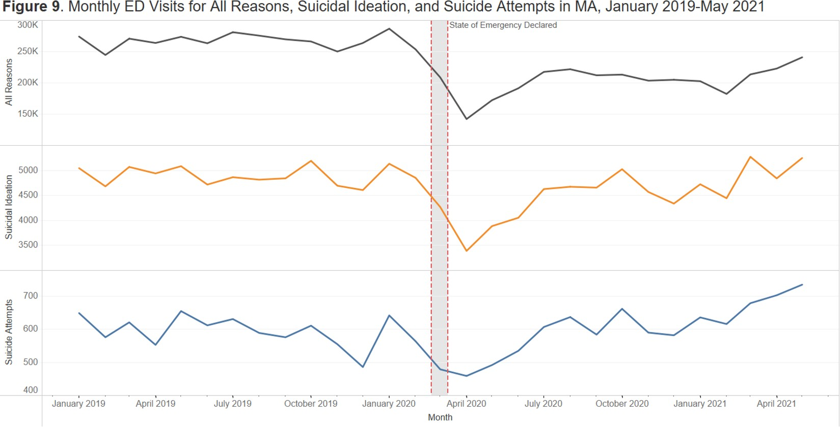
Source: Massachusetts Syndromic Surveillance Program

ED Visit Trends
- Throughout 2019 and early 2020, ED visits across all three syndromes remained relatively constant. Between January 2019 and February 2020, there was an average of 266,290 total monthly ED visits, 4,882 monthly ED visits related to suicidal ideation, and 591 monthly ED visits related to suicide attempts.
- As the COVID-19 pandemic began to unfold, and a state of emergency was declared in early March of 2020, ED visits sharply declined. Between January and April of 2020, total monthly ED visits declined 50%, ED visits for suicidal ideation declined 34%, and ED visits for suicide attempts declined 28%.
- Since April 2020, ED visits across all three syndromes have risen. However, as of May 2021, total monthly ED visits are still down 16% from their peak in January 2020. Conversely, ED visits for both suicidal ideation and suicide attempts in May 2021 are at their highest levels since full reporting began in 2019.
- While recent trends in suicide-related ED visits are rising, the range of data currently available is still limited. Syndromic surveillance started collecting complete data from all facilities in Massachusetts in January 2019, so there are currently only two and a half years of complete data to analyze. Nevertheless, the recent increase in suicide-related ED visits continues to be of concern.

Suicidal Ideation and Suicide Attempts
While recent trends in ED visits show an overall increase in the number of visits related to suicidal ideation and suicide attempts, differences exist by sex and age. Specifically, we noticed that compared to other sex and age groups, females under age 25 saw the largest relative increase in ED visits related to suicide since the start of the pandemic. Figure 10 below shows the number of ED visits per month in Massachusetts for all reasons, suicidal ideation, and suicide attempts between January 2019 and May 2021 by sex for youth between age 0 and 24.
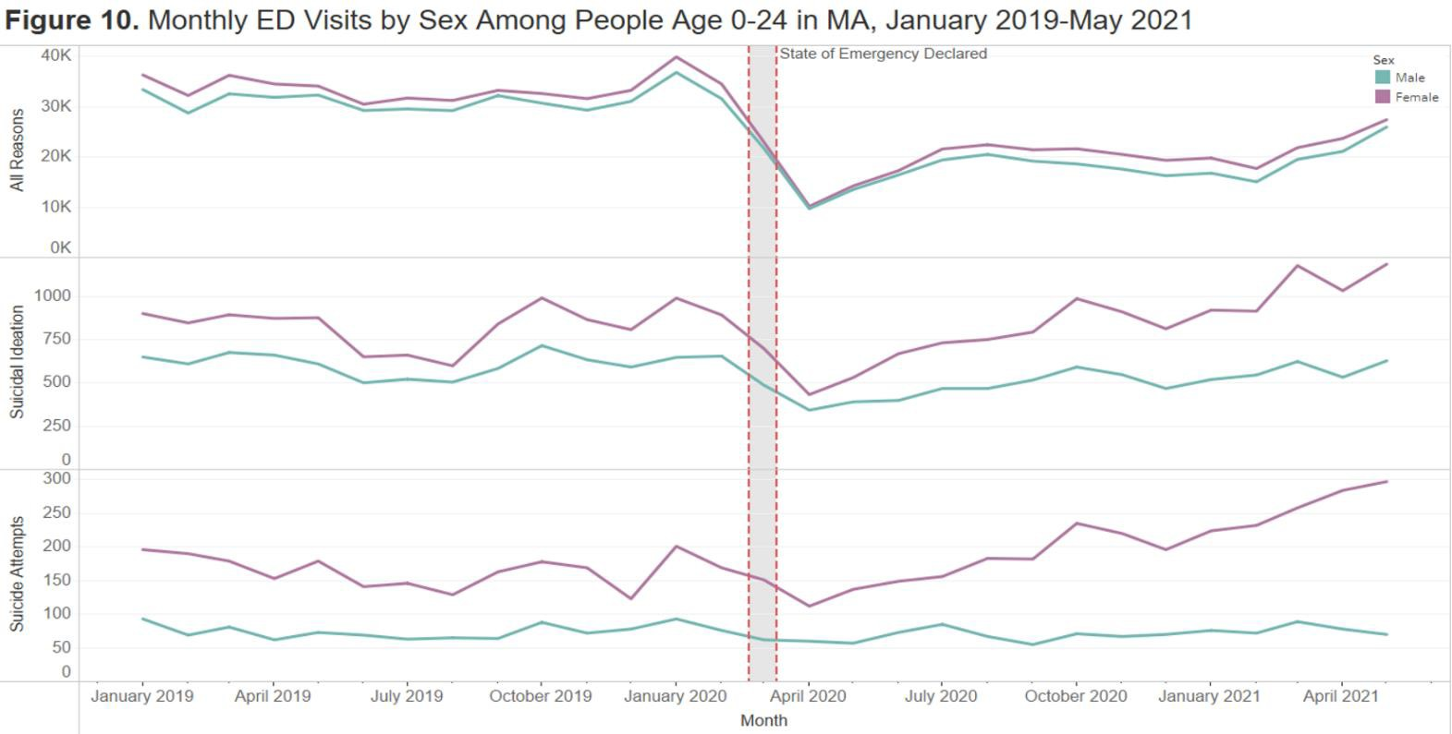
Source: Massachusetts Syndromic Surveillance Program

ED Visit Trends Among Youth Age 0-24
- Throughout 2019 and early 2020, ED visits among youth remained relatively stable, with females consistently having more visits than males. Although females experience higher rates of suicidal ideation and suicide attempts compared to males, females experience much lower rates of suicide deaths.
- ED visits sharply declined for youth during the start of the COVID-19 pandemic, even more so than other age groups. Between January 2020 and April 2020, total monthly ED visits declined 74%, ED visits for suicidal ideation declined 52%, and ED visits for suicide attempts declined 41%.
- Since April 2020, ED visits have started to rebound. While total ED visits for youth are still down 30% from what they were in January 2020, the same is not true for ED visits related to suicidal ideation and suicide attempts, especially among female youth. As of May 2021, ED visits for suicidal ideation are 10% higher, and ED visits for suicide attempts are 23% higher than what they were in January 2020.
- Increases in ED visits among youth are almost exclusively driven by increases in ED visits among female youth. As of May 2021, ED visits for suicidal ideation among female youth are 19% higher than what they were in January 2020, and ED visits for suicide attempts among female youth are 29% higher than what they were in January 2020.
- Increases in ED visits among females currently appear limited to female youth. In January 2019, female youth comprised 40% of suicidal ideation ED visits and 52% of suicide attempt ED visits among all females. As of May 2021, those proportions rose to 47% and 61%, respectively.

Suicide Prevention Program

The Suicide Prevention Program (SPP) at DPH employs the latest suicide prevention strategies using the public health approach and is funded by a specific line item in the Massachusetts State budget. The SPP uses data to help inform its prevention strategies.

In 2019 and 2020, Massachusetts had the third lowest suicide rate out of any state in the country. Factors that contribute to Massachusetts’ low rate include the Commonwealth’s low rate of household gun ownership, high rates of health care insurance coverage, better access to emergency medical care and behavioral health services, and a 15+ year history of state suicide prevention funding and planning.

One key public health strategy is to identify health disparities – when a disease, illness, or injury disproportionately affects a particular population. Analyzing data on suicides and non-fatal self-injuries enables the SPP to identify at-risk populations and target funding to those populations. The SPP issued a competitive procurement for FY15 that resulted in the funding of 20 community-based providers to address the needs of these vulnerable populations statewide. Due to changes in the field of suicide prevention and data, the SPP will be planning a re-procurement of services to best align strategies and services currently being offered with a contract start date of July 1, 2024.

Through Inter-agency Service Agreements (ISAs), the SPP funds activities specific to the populations served by the Executive Office of Elder Affairs, the Department of Mental Health, and the Department of Veterans’ Services’ SAVE Program (Statewide Advocacy for Veterans Empowerment).

The SAVE Program is comprised of workers (e.g. returning veterans or family members of returning veterans) who reach out to military personnel returning from deployment to provide education on available services and benefits and to screen for behavioral health issues. They are highly mobile and attend veterans’ gatherings across the state. SAVE is not limited to working only with returning veterans; they can serve any veteran. For example, despite the age differences when working with Vietnam War veterans, they still command credibility due to their military experience.

The SPP at DPH works collaboratively with these agencies as well as with the Department of Elementary and Secondary Education (DESE), the Department of Corrections (DOC), DPH’s Bureau of Substance Addiction Services (BSAS), the Office of Emergency Medical Services (OEMS), the Department of Children and Families (DCF), the Department of Youth Services (DYS), County Sheriff’s Departments, and the Massachusetts National Guard. An especially significant and close partner is the Department of Mental Health (DMH), which provides senior management staff participation in all aspects of suicide prevention efforts.

In May of 2021, Massachusetts was invited to participate in a national Governor’s Challenge hosted by the Substance Abuse and Mental Health Service Administration’s (SAMHSA) Service Members, Veterans and Families Division (SMVF). This challenge is to help states reduce the number of suicides among SMVF residents. MA’s team is lead by Commissioner Brooke Doyle (DMH) and Secretary Jon Santiago (Executive Office of Veterans' Services, EOVS) and includes representatives from various agencies and organizations such as EOVS, DMH, DPH, Home Base, Vet Center, VA, Riverside Community Care, and many others. There are four priority areas actively being addresses as part of the challenge: Identify (Ask the Question), Promote Connectedness and Improve Care Transitions, Increase Lethal Means Safety, and Training. All groups have developed plans to address each of the areas to support this effort.

Funding is also provided to the statewide Massachusetts Coalition for Suicide Prevention (MCSP) and its prevention activities. The Coalition develops and supports ten Regional Coalitions covering the entire Commonwealth. These Regional Coalitions provide local networking to ensure that prevention services reach all areas of the Commonwealth.

A primary strategy for preventing suicide is raising public awareness that suicide is preventable. “Gatekeeper”
training teaches everyone how to recognize signs of suicide and instills confidence in talking about suicide.

As behavioral health professionals are not required to complete suicide prevention or intervention as part of their licensing, the SPP has been offering trainings to help behavioral health professionals better identify someone who is suicidal and treat their suicidality. Additionally, education and screening training for other health professionals help them to identify at risk individuals in their practices and trainings. For example, Safety Planning Intervention teaches professionals how to create a proper safety plan with an individual who is in suicidal crisis.

The SPP introduces system-wide approaches to suicide that includes appropriate levels of training, protocols to follow, and postvention strategies to minimize further deaths if a suicide occurs. Schools, DYS, community mental health centers, and hospital systems are some examples of systems with which the SPP is working.

The SPP is currently the recipient of two federal grants. In April of 2022, SPP was awarded a two-year grant through the Substance Abuse and Mental Health Services Administration (SAMSHA) for the 988 State and Territorial Cooperative Agreement. This grant provided funding to states and territories to help increase staff support at crisis centers as part of the 988 Suicide and Crisis Lifeline.

The Comprehensive Suicide Prevention Grant through the CDC is a five-year grant awarded in September 2020 and is the first time the grant has been offered. Massachusetts was one of nine states and universities to first receive this funding, and the grant has since expanded to include an additional eight states and universities. The SPP’s goal is to reduce the number of suicidal incidents and deaths among males, especially within Hispanic/Latinx populations. The SPP worked closely with the Occupational Health Surveillance Program (OHSP) at DPH to identify the occupations with the highest suicide death rates in Massachusetts. As a result of this analysis, SPP and OHSP are currently creating an employer toolkit for industries with higher suicide rates. Continuing to identify gaps in systems will also be a priority in the final goal of reducing suicides.

Over the past seven years, the SPP has devoted resources to create suicide safer communities by providing assistance to healthcare and behavioral healthcare systems who wish to implement Zero Suicide. Zero Suicide is an aspirational goal in which quality improvement and system changes are made to ensure anyone in suicidal crisis receives the necessary care. The SPP has worked collaboratively with DMH to conduct Zero Suicide Learning Collaboratives, which provides instructional knowledge sharing and community building to reach the goal of Zero Suicide implementation. The SPP plans to continue providing support to any healthcare or behavioral healthcare system wishing to implement Zero Suicide.

In an effort to reduce the number of youth suicides and suicidal crises, the SPP continues to support a Youth Suicide Prevention Task Force. Along with the SPP, six youth serving agencies have dedicated resources to the task force. The agencies participating include DMH, DYS, DCF, DESE, Office of the Child Advocate (OCA), MassHealth, and DPH’s Child Youth Violence Program, Office of Sexual Health and Youth Development, and BSAS.

Conclusions

Suicide is a major public health problem. While Massachusetts has one of the lowest suicide rates in the country, the Commonwealth can continue to improve upon this work. Suicides have been tracked in the Massachusetts Violent Death Reporting System since 2003 and have been generally increasing, despite modest decreases in 2019 and 2020. Males continue to have higher suicide rates compared to females and made up 76.3% of suicides from 2019-2020. Suicides were most common among persons aged 45-54, with 39.9% of suicides occurring in that age range. However, suicides in non-White populations were more common among younger age groups. Among Black, non-Hispanics and Hispanics, suicides were most common among persons aged 25-34. Among Asian, non-Hispanics, suicides were most common among persons aged 15-24.

The means most commonly used in suicides were hanging/suffocation (46.5%), firearm (21.6%), and poisoning/overdose (17.9%). Suicides involving firearms were more prevalent among males (26.2%) than they were among females (7.0%), while suicides involving poisonings/overdoses were more prevalent among females (38.9%) than males (11.4%). For suicides by hanging/suffocation, rope/clothing lines (37.5%) were the most common ligature used. For suicides by firearm, handguns (82.4%) were the most common type of firearm used. For suicides by poisoning/overdose, opiates (21.6%) were the most common class of substances used.

Among all suicides, 20.1% of suicide decedents had made a prior suicide attempt, and 58.3% had a history of treatment for a mental health or substance use problem. Females were much more likely to have made a prior suicide attempt (34.6%) compared to males (15.6%). However, females were also much more likely to have had a history of treatment for a mental health or substance problem (73.8%) compared to males (53.5%).

MAVDRS will continue working with other data partners on capturing additional data required by the legislature and improving the data quality of existing data fields.

ED visits for suicidal ideation and suicide attempt rose in the latter part of 2020 for female youth ages 0-24 above what was seen in 2019 but there was not a corresponding increase in suicide deaths of female youth in 2020.
The Suicide Prevention Program at DPH frequently uses all of the data available at DPH, including MAVDRS, to help inform its ongoing prevention efforts and new strategies. This data helps the SPP target efforts towards populations with the greatest needs.

