Suicide Prevention
Facilitator Guide

This module has:
- Handout (1):
  - Case Scenario: Alex
- Breakout activity (1):
  - Alex Scenario

Slide 1 | Slide 1: Title Slide  Introduce Trainers
Slide 2 | Slide 2: Learning Objectives  Explain:  During this module you will:  - Learn to apply a shared alertness approach with suicidal individuals  - Recognize how to use evidence-based screening and assessment tools to identify suicide risk  - Learn to apply at least two methods for preventing suicide
Slide 3 | Slide 3: Suicide is a primary clinical risk we want to monitor and prevent for all our ACCS persons served.  Explain:  Indicate we do this by identifying risk factors early and continually re-evaluating their presence using the Columbia-Suicide Severity Rating Scale (C-SSRS) and by training all staff in a protocol for how to respond to risks (e.g., maybe QPR, it means reaching out to a clinician/supervisor).
Slide 4 | Slide 4: Activity  Ask:  What are your personal thoughts, beliefs, and attitudes about suicide and how do they impact my work with suicidal individuals?  Facilitator Instructions:  - Invite participants to self-reflect on this question.  - Participants do not have to share, but the facilitator should prompt a general discussion about this.  - For example, if a helping professional has strong religious values that make it difficult for them to understand how a person could think about taking their own life, how might that affect working with suicidal individuals?  - If a helping professional has lost a loved one to suicide, how might that impact their work with suicidal clients?
Slide 5 | Slide 5: Approaching Your Work  How do I react when a client talks about suicide?  Explain:  Be careful not to go into “alarm” mode or to be “dismissive”  - The person needs a steady, kind, and reasonable response  - Recognize the conflict between a person’s desire to end their psychological pain and your desire to prevent suicide and community culture  - Be comfortable asking questions that open a conversation  Facilitator Notes:  Review the following information:  - Dismissive - Examples of being dismissive  - “If you really want to end your life, you would not be here talking to me about it.”  - “If you really wanted to die, you would’ve done it already.”  - “You’re just looking for attention.”  - Potential Outcomes of Dismissiveness:  - May lead to ignoring or minimizing the client’s risk of suicide  - May lead to minimizing the concern and pain of the client  - May lead to a failure to conduct as thorough an evaluation as would be indicated  - Alarmed – Examples of Being Alarmed  - This reaction focuses on the fear of the client dying  - May lead to an over-interpretation of the client’s statement as a meaning of imminent risk of death  - May lead to intrusive interventions that are clinically contraindicated  - May cause client to withhold suicide thoughts
Slide 6 | Slide 6: Activity - Concerned Alertness  (approximately 7 minutes)  Facilitator Instructions:  - Explain that you want them to explore how a treatment team member can show concerned alertness in any or all of the three areas on the slide:  - in your mind,  - in the space,  - in your words.  - Allow participants to self-reflect on this and then share their thoughts. If training is:  -In-person: have them use post-it notes and put their written responses into each of those categories  -Virtual: can use Google board to display participants’ responses, annotate, or have them use the chat - without hitting enter until you tell them to so it is all shared at once  - Facilitator may provide some of these examples if needed:  - In Your Mind:  Respect and honor their vulnerability; understand how suicidal thoughts make sense for this person; understand the psychological pain; understand the underlying factors; understand the family; recognize conflict between the client’s desire to end their psychological pain and your desire to prevent suicide and community culture; remain hopeful  - In the Space:  Provide a safe atmosphere of sharing (welcoming, compassionate, non-judgmental); build rapport; listen thoroughly; validate; be empathic; provide understanding; provide time for a thorough evaluation; show your commitment to their recovery (provide information, resources, options)  - In Your Words:  How would you voice the above? (Consider making the point to avoid saying ‘but’ – anything before the word but doesn’t matter)
Slide 7 | Slide 7: Question, Persuade and Refer (QPR) Approach  Explain:  Question, Persuade and Refer (QPR) is not an intervention or assessment – it is a way to gather information and then pass that information to the appropriate party  Question:  - If you believe someone is considering suicide, ask them directly "Are you thinking about suicide or wanting to kill yourself?”  - Don’t say “Do you want to hurt yourself?” as self-harm can be non-lethal and it’s not the same as wanting to die.  - Also remember that if you ask someone if they want to kill themselves, this does NOT drive them toward that action. That’s a myth and is not accurate.  - Don’t be afraid to ask the question.  Persuade:  - Persuade the persons served to allow you to assist them in getting help right now. Say “Will you go with me to get help?” or “Will you let me assist you to get help?”  - Demonstrate caring concern. Another option can be to enlist their promise not to kill themselves until you’ve arranged help for them.  - If persuasion doesn’t work, call a local mental health center, crisis hotline, or emergency services.  Refer:  - Personally escort the person to __________[agency trainer - fill in your specific crisis options here]
Slide 8 | Slide 8: Suicide Risk Factors - Activity  Facilitator Note:  This activity uses 2 slides – show this blank slide first  Explain:  - Static risk factors are things we cannot change. These generally pertain to something in one’s history (e.g., childhood trauma).  - Dynamic risk factors are malleable and may be addressed/improved through intervention.  Facilitator Instructions:  Ask:  - What are some static risk factors?  - What are some Dynamic risk factors?  - Have the group state out loud, write in the chat, or annotate onto the slide if the training is virtual.  After responses – move to next slide
Slide 9  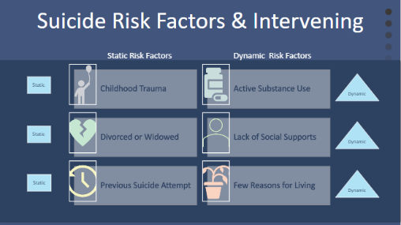 | SLIDE 9: Suicide Risk Factors & Intervening  Facilitator Note:  - Review the risk factors on the slide to provide examples of static and dynamic risk factors  Discuss the relevance to intervention:  - Indicate that ITT members should think of focusing on the dynamic risk factors and how they can intervene as a team to help reduce/treat these risks.  - Example:  If a person served feels they are lacking purpose, what can the team do to help shift that thinking to get them thinking about their purpose?
Slide 10 | SLIDE 10: WARNING SIGNS - Acute Suicidal Affective Disturbance (ASAD)  Explain:  There are also warning signs for suicide risk that may be imminent. It is important all staff working with ACCS persons served be aware of the signs:  - A drastic increase in suicidal intent over the course of hours or days (not weeks or months);  - Marked social isolation (e.g., social withdrawal, perceived liability on others) and/or  - Self-alienation (e.g., self-hatred, perceptions that self is an onerous burden);
Slide 11 | SLIDE 11: Warning Signs (continued)  Continue Explaining:  - Perceptions that the above criteria are hopelessly intractable;  - Two or more manifestations of overarousal:  - agitation, irritability, insomnia, nightmares.
Slide 12 | Slide 12: Screening: C-SSRS (Columbia-Suicide Severity Rating Scale)  Facilitator Note:  This slide uses animation to advance the bubbles on the left. Remember to advance the slide after each point below.  Explain:  - As discussed in the risk management module, all persons served must receive a screening for suicide risk with the C-SSRS upon intake into the program.  - Those who ‘screen in’ (meaning they score moderate to high) on the C-SSRS will receive a full assessment of suicide risk from their clinician to determine the intensity, length, and lethality of suicidal thoughts  - Remember from the Risk Management training – the  C-SSRS also should be administered whenever there is “cause for concern” and all treatment members should be familiar with administering the screen
Slide 13  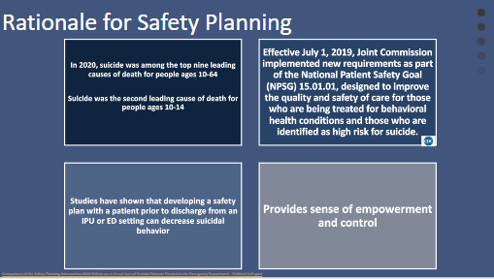 | Slide 13: Rationale for Safety Planning  Explain:  - All persons served who ‘screen in’ on the C-SSRS and are assessed as ‘safe to remain in the community’ should develop a Safety Plan with their team.  - Review points on the slide
Slide 14 | Slide 14: When Do We Introduce Safety Planning?  Explain:  - Repeat: All persons assessed for suicide risk and deemed to be safe to remain in the community will get a safety plan  - If the person scores very low or low, a safety plan ideally would still be completed within the first 30 days of intake into the program. A person has a right to refuse - completion of the plan should be collaborative. A safety plan is always completed with a client, never for a client. The mitigation plan is from the client’s point of view in their words (no jargon).  - At the very least, safety plans should be reviewed after a crisis event: In what ways was the plan useful? What might need to be changed to make it more effective?
Slide 15 | Slide 15: Involvement of ITT Members in Safety Planning  Explain:  - Every member of the ITT and every staff person working with the person served should have a copy of the person’s safety plan and be aware of their warning signs  - Encourage persons served to review their plans as needed and when warning signs occur (Where will they keep it? How will they remember to use it in a crisis?)  - When a person served is doing well, this should be reinforced by the ITT in connection with the safety plan.  - Coping skills listed on the safety plan should be known by the ITT to reinforce its practice regularly. Otherwise, the plan may be ineffective during a crisis event.  - See yourselves as coaches! You are the ones cheering them on, helping them practice their safety planning, etc.
Slide 16 | Slide 16: Six Components of a Safety Plan  Facilitator Note:  Slides 16 & 17 each list 3 components  Explain:  Briefly review the 6 components of a safety plan:  mainly the warning signs, coping skills and distractions, and the need for the plan to include supports
Slide 17 | Slide 17: Six Components of a Safety Plan (continued)
Slide 18 | Slide 18: Caring Contacts  Explain:  - Caring contacts can be very effective and may include some form of reaching out like a card, written message, or text (use technology)  Facilitator Note:  Next slide gives examples
Slide 19 | Slide 19: Caring Contacts - Examples  Facilitator Note:  Read through examples on slide
Slide 20 | Slide 20: Caring Contacts – Activity  Ask:  - Have you ever used a caring contact? How did it go?  - Request a few responses from those who have experience with caring contacts.
Slide 20 and 21  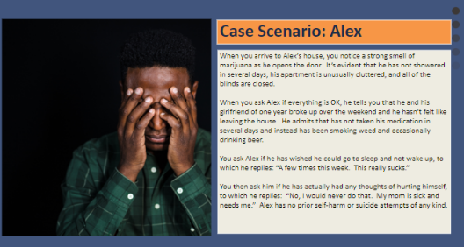 | Slide 21: Breakout Activity: Case Scenario - Alex  (10 minute breakout + discussion)  Refer to Handout:  - Case Scenario- Alex  Facilitator Instructions:  - Explain that this will be a group exercise to practice how to work with persons served around suicide risk.  - Read out loud the scenario.  - Separate participants into groups of 3 or 4.  - Instruct groups to:  - Pick a recorder/reporter for the group.  - Identify 3 risk factors that Alex is displaying.  - Discuss how they would continue this conversation with Alex in a caring and concerned way.  - After completing the C-SSRS with Alex, he scores “low”. What would you do next?  - Breakout for approximately 10 minutes to discuss these questions.  - Bring the groups back together for discussion and review. Ask a few to report what they decided.  Then:  - Indicate that Alex scored low for suicide risk, but he is still left with risk factors that need to be addressed.  - One approach would be to encourage development of a safety plan.  - If Alex is not interested, ask what coping skills he has tried in the past that worked for him? If none, suggest one or two coping skills (e.g., staying busy, doing an activity that interests him).  - Also, identify with Alex people he can use for support.  - Ask what else they can do to address some of his risk factors?  - Encourage use of medication – example: Ask how he has felt since he stopped taking it (e.g., insomnia).  - It is essential to report this situation and how you handled it to the ITT and his primary care.
Slide 23  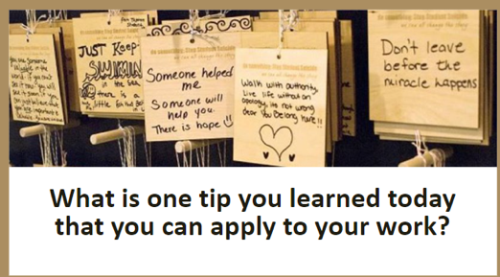 | Slide 23: What is one tip you learned today that you can apply to your work?

