Massachusetts Department of Public Health, Bureau of Infectious Disease and Laboratory Sciences
Summary for Barnstable County, Massachusetts, 2022
Barnstable County is a county in the Commonwealth of Massachusetts, established in 1685. Barnstable County consists of Cape Cod and associated islands. In 2020, the population was 228,996 (U.S. Census Bureau, 2020*).

Chlamydia
Chlamydia is the most frequently reported sexually transmitted infection (STI) both in the Commonwealth and nationally.

Since 2012, there has been an overall increase in reported chlamydia cases statewide except for 2020 due to COVID-19†, ranging from 23,930 cases in 2012 to 28,384 cases in 2022. Barnstable County also experienced an overall increase in reported chlamydia cases, ranging from 455 cases in 2012 to 604 cases in 2022. In 2022, the county incidence rate of chlamydia infection was 263.8 per 100,000, while the statewide rate was 403.8 per 100,000. These can be compared to the national rate of 495.0 per 100,000.‡

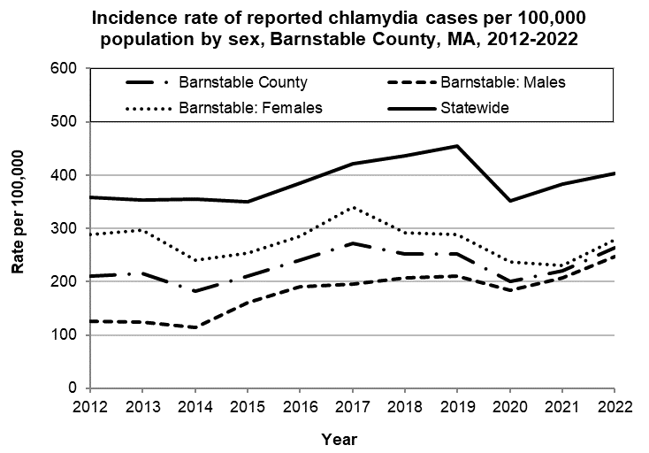
Data are current as of 12/15/2023 and are subject to change.
Population denominators: Strate S, et al. Small Area Population Estimates for 2011 through 2020 report, Oct 2016.
Data source: Massachusetts Department of Public Health/Bureau of Infectious Disease and Laboratory Sciences/Division of STD Prevention.

The county incidence rate among females remained higher compared to males. In 2022, the incidence rate of chlamydia among females in Barnstable County was 278.3 per 100,000 and 263.8 per 100,000 for males.

The chlamydia statewide incidence rate is highest among young adults. In 2022, the rate of chlamydia reached 2,591.6 per 100,000 among 20-to-24-year-old females in Barnstable County.

Provincetown, a town at the northern tip of Cape Cod, has the highest incidence rate of chlamydia among all cities and towns in Barnstable County (2,074.2 per 100,000).

Gonorrhea
Gonorrhea is the second most frequently reported STI both in the Commonwealth and nationally.

Since 2012, there has been an overall increase of reported gonorrhea cases, ranging from 2,665 cases in 2012 to 9,129 cases in 2022. Barnstable County did not experience an increase until 2013, ranging from 32 cases in 2013 to 179 cases in 2022. In 2022, the county incidence rate of gonorrhea infection was 90.4 per 100,000, while the overall state rate was 129.9 per 100,000. These can be compared to the national rate of 194.4 per 100,000.‡

The county incidence rate among males remained higher compared to females. In 2022, males accounted for 78.6% of all gonorrhea cases in Barnstable County with a rate of 148.2 per 100,000, about four times that of females (36.8 per 100,000).

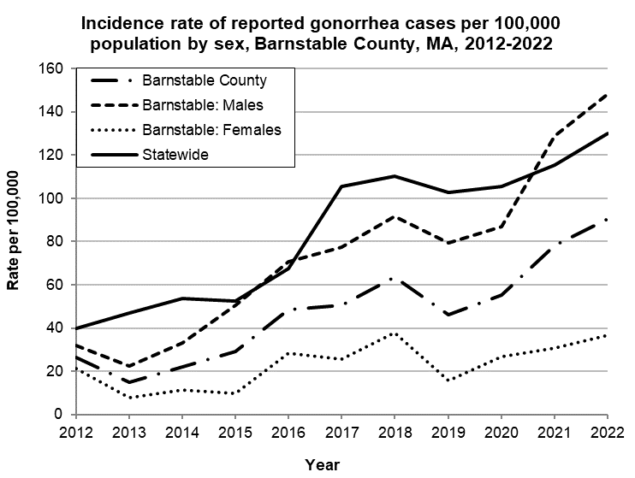
Data are current as of 12/15/2023 and are subject to change.
Population denominators: Strate S, et al. Small Area Population Estimates for 2011 through 2020 report, Oct 2016.
Data source: Massachusetts Department of Public Health/Bureau of Infectious Disease and Laboratory Sciences/Division of STD Prevention.

In 2022, the number of cases and incidence rate of gonorrhea in Barnstable County was highest among 35-to-39-year-olds (346.8 per 100,000). Provincetown had the highest incidence rate of gonorrhea among all cities and towns in Barnstable County (2101.5 per 100,000).

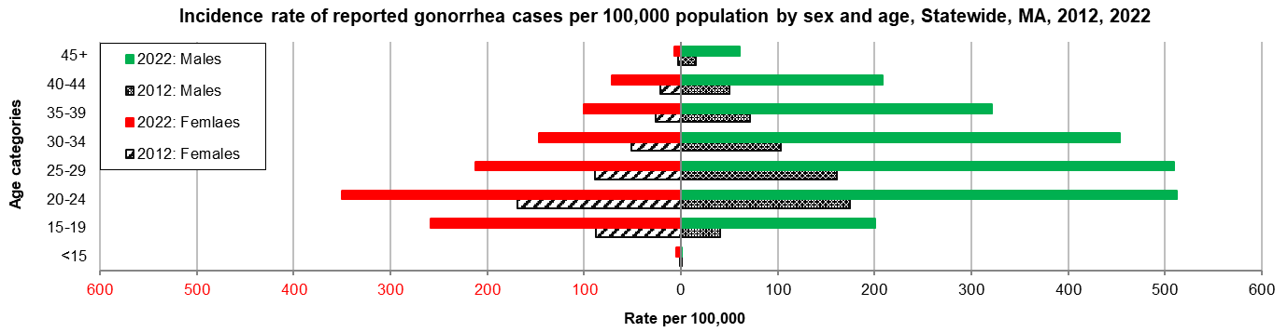
Data are current as of 12/15/2023 and are subject to change.
Population denominators: Strate S, et al. Small Area Population Estimates for 2011 through 2020 report, Oct 2016.
Data source: Massachusetts Department of Public Health/Bureau of Infectious Disease and Laboratory Sciences/Division of STD Prevention.

Early Syphilis¶
Early syphilis has been on the rise in the Commonwealth and nationally since the early 2000s.‡

Since 2012, there has been an overall increase of reported early syphilis cases, ranging from 561 cases in 2012 to 1,593 cases in 2022. Barnstable County has also seen an overall increase in reported early syphilis cases, with a peak in 2022, ranging from 14 cases in 2012 to 58 cases in 2022. In 2022, the county incidence rate of syphilis infection was 25.3 per 100,000, while the statewide rate was 22.7 per 100,000. These can be compared to the national rate of 41.2 per 100,000.‡

In 2022, the county rate of reported early syphilis among males was much higher compared to that among females. Males accounted for 89.7% of all early syphilis cases in Barnstable County with a rate of 47.6 per 100,000, more than 9 times that of females (5.0 per 100,000).

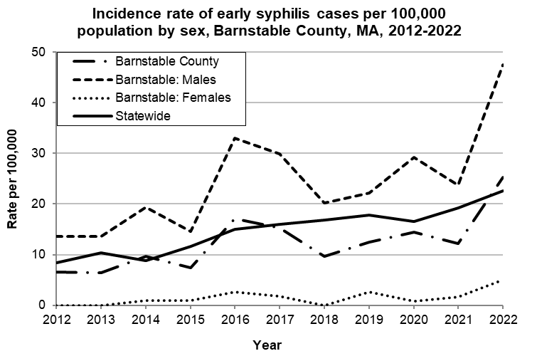
Data are current as of 12/15/2023 and are subject to change.
Population denominators: Strate S, et al. Small Area Population Estimates for 2011 through 2020 report, Oct 2016.
Data source: Massachusetts Department of Public Health/Bureau of Infectious Disease and Laboratory Sciences/Division of STD Prevention.

In 2022, the highest incidence rate of early syphilis was among 30-to-34-year-olds (120.8 per 100,000).
Provincetown had the highest incidence rate of early syphilis among all cities and towns in Barnstable County (545.9 per 100,000).
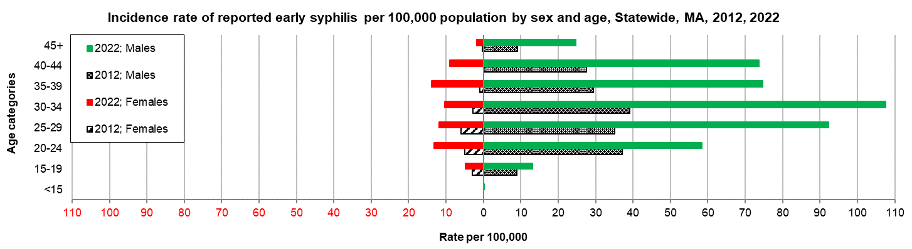
Data are current as of 12/15/2023 and are subject to change.
Population denominators: Strate S, et al. Small Area Population Estimates for 2011 through 2020 report, Oct 2016.
Data source: Massachusetts Department of Public Health/Bureau of Infectious Disease and Laboratory Sciences/Division of STD Prevention.

2022 Statewide Massachusetts
Chlamydia cases have increased by 32% from 2012 to 2019 and decreased by 22% in 2020. From 2020 to 2022, there was a 15% increase in cases. This is possibly due to factors such as increased service utilization after health care clinics reopened following the end of the COVID-19 public health emergency.

Gonorrhea cases have increased 243% from 2012 to 2022 and was reported primarily among males.

Early syphilis cases have increased 184% from 2012 to 2022. From 2017 to 2022, a range of 25% (in 2022) to 37% (in 2017) of early syphilis cases were co-infected with HIV. In 2020, 2021, and 2022 congenital syphilis cases numbered 10, 9, and 11, respectively, after remaining between 0 and 4 from 2011 to 2018.
________________
*2020 population estimates were used to calculate 2022 disease rates throughout this report because 2022 population estimates had not been released at the time this report was published.
†Please note the impact of the COVID-19 pandemic on infectious disease screening, treatment, and surveillance in the interpretation of 2020 and 2022 data.
‡ Source: CDC: Sexually Transmitted Disease Surveillance, 2022.
¶Early syphilis is defined as primary, secondary and early syphilis not diagnosed in the primary or secondary stages within one year of infection.

