Massachusetts Department of Public Health, Bureau of Infectious Disease and Laboratory Sciences
Summary for Berkshire County, Massachusetts, 2021
Berkshire County is a county in the Commonwealth of Massachusetts, established in 1761. Berkshire County is one of the eight counties in Massachusetts that exist only as a historical geographic region and has no county government. In 2020, the population was 129,026 (U.S. Census Bureau, 2020*).

Chlamydia
Chlamydia is the most frequently reported sexually transmitted infection (STI) both in the Commonwealth and nationally.

Since 2011, there has been an overall increase in chlamydia cases statewide and in Berkshire County, with the exception of 2020 due to COVID-19§. In 2021, the county rate was 220.5 per 100,000, while the statewide rate was 382.8 per 100,000. These can be compared to the national rate of 495.5 per 100,000.‡

The county incidence rate among women remained higher compared to men. In 2021, the incidence rate among women in Berkshire County was 228.1 per 100,000, nearly four times that of men with a rate of 64.1 per 100,000.

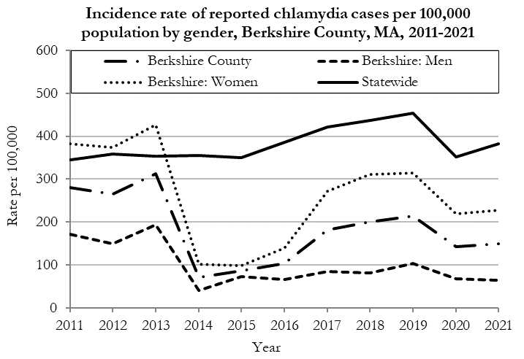
Data are current as of 10/24/2022 and are subject to change.
Population denominators: Strate S, et al. Small Area Population Estimates for 2011 through 2020 report, Oct 2016.
Data source: Massachusetts Department of Public Health/Bureau of Infectious Disease and Laboratory Sciences/Division of STD Prevention.

The chlamydia statewide incidence rate is highest among young adults. In 2021, the incidence rate of chlamydia was highest among 25 to 29-year-olds in Berkshire County (761.2 per 100,000).

Gonorrhea
Gonorrhea is the second most frequently reported STI both in the Commonwealth and nationally.

Since 2011, there has been an overall increase in gonorrhea cases statewide and in Berkshire County. In 2021, the county rate was 55.8 per 100,000, while the overall state rate was 115.2 per 100,000. These can be compared to the national rate of 214.0 per 100,000.‡

The differences in the incidence rates between men and women in past years were relatively small in Berkshire County. However, in 2021, the incidence rate among women (73.5 per 100,000) was double that of men (36.9 per 100,000). It is unclear what is driving this increase.

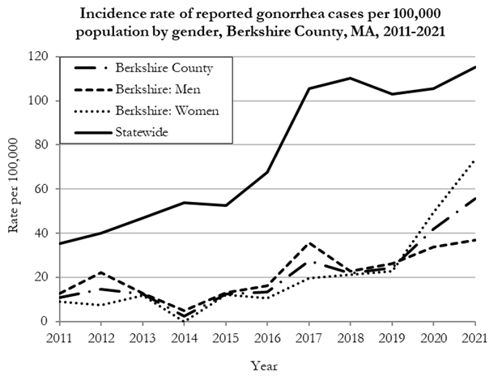
Data are current as of 10/24/2022 and are subject to change.
Population denominators: Strate S, et al. Small Area Population Estimates for 2011 through 2020 report, Oct 2016.
Data source: Massachusetts Department of Public Health/Bureau of Infectious Disease and Laboratory Sciences/Division of STD Prevention.

The gonorrhea incidence rate is highest among young adults in Massachusetts. In 2021, the incidence rate of gonorrhea in Berkshire County was highest among 25 to 29-year-olds (267.8 per 100,000).

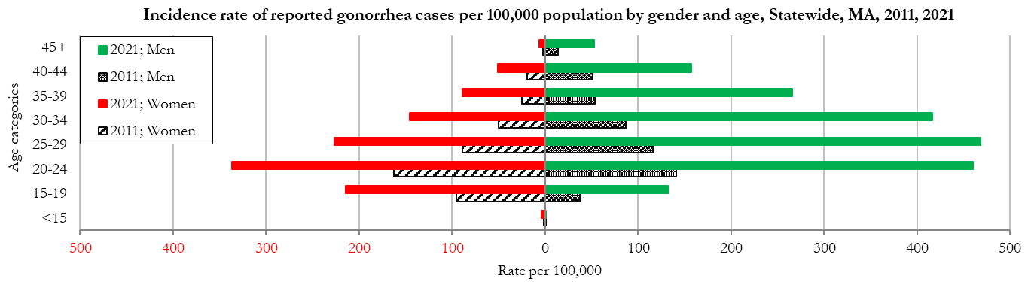
Data are current as of 10/24/2022 and are subject to change.
Population denominators: Strate S, et al. Small Area Population Estimates for 2011 through 2020 report, Oct 2016.
Data source: Massachusetts Department of Public Health/Bureau of Infectious Disease and Laboratory Sciences/Division of STD Prevention

Early Syphilis◊
Early syphilis has been on the rise in the Commonwealth and nationally since the early 2000s.‡

Since 2011, the statewide rate of reported early syphilis has increased. The rate in Berkshire County was relatively stable except for an increase in 2020 before decreasing in 2021 to 3.1 per 100,000, while the statewide rate was 19.2 per 100,000. These can be compared to the national rate of 31.8 per 100,000.‡

In 2021, the third early syphilis case was reported among females in Berkshire County since prior to 2011. The first case had been reported in 2018 and the second in 2020.

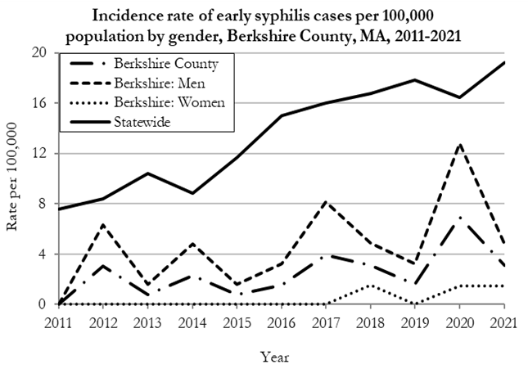
Data are current as of 10/24/2022 and are subject to change.
Population denominators: Strate S, et al. Small Area Population Estimates for 2011 through 2020 report, Oct 2016.
Data source: Massachusetts Department of Public Health/Bureau of Infectious Disease and Laboratory Sciences/Division of STD Prevention.

In 2021, the highest incidence rate statewide of early syphilis was among 30 to 34-year-old men (85.4 per 100,000).

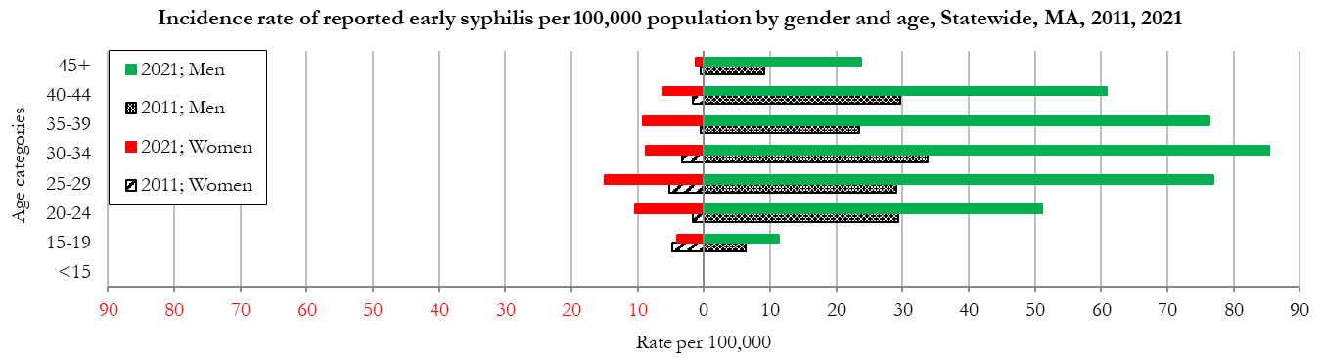Data are current as of 10/24/2022 and are subject to change.
Population denominators: Strate S, et al. Small Area Population Estimates for 2011 through 2020 report, Oct 2016.
Data source: Massachusetts Department of Public Health/Bureau of Infectious Disease and Laboratory Sciences/Division of STD Prevention

________________
* 2020 population estimates were used to calculate 2021 disease rates throughout this report because 2021 population estimates had not been released at the time this report was published.
‡ Source: CDC: Sexually Transmitted Disease Surveillance, 2021.
◊ Early syphilis is defined as primary, secondary and early syphilis not diagnosed in the primary or secondary stages within one year of infection.
§ Please note the impact of the COVID-19 pandemic on infectious disease screening, treatment, and surveillance in the interpretation of 2020 and 2021 data.
2021 Statewide Massachusetts
Chlamydia cases have increased by 38% from 2011 to 2019 and decreased by 22% in 2020 before increasing by 9% in 2021. This is possibly due to factors such as increased service utilization after health care clinics re-opened following the end of the COVID-19 public health emergency.

Gonorrhea cases have increased 245% from 2011 to 2021 and was reported primarily among men.

Early syphilis cases have increased 170% from 2011 to 2021. From 2016 to 2021, a range of 31% to 39% of early syphilis cases were co-infected with HIV. In 2019, 2020, and 2021 congenital syphilis cases numbered 9, 10, and 9, respectively, after remaining between 0 and 4 from 2011 to 2018.

