Massachusetts Department of Public Health, Bureau of Infectious Disease and Laboratory Sciences
Summary for Berkshire County, Massachusetts, 2022
Berkshire County is a county in the Commonwealth of Massachusetts, established in 1761. Berkshire County is one of the eight counties in Massachusetts that exist only as a historical geographic region and has no county government. In 2020, the population was 129,026 (U.S. Census Bureau, 2020*).

Chlamydia
Chlamydia is the most frequently reported sexually transmitted infection (STI) both in the Commonwealth and nationally.

Since 2012, there has been an overall increase in reported chlamydia cases statewide except for 2020 due to COVID-19†, ranging from 23,930 cases in 2012 to 28,384 cases in 2022. However, there has been an overall decrease in reported chlamydia cases in Berkshire County, ranging from 347 cases in 2012 to 268 cases in 2022. In 2022, the county incidence rate of chlamydia infection was 207.7 per 100,000, while the statewide rate was 403.8 per 100,000. These can be compared to the national rate of 495.0 per 100,000.‡

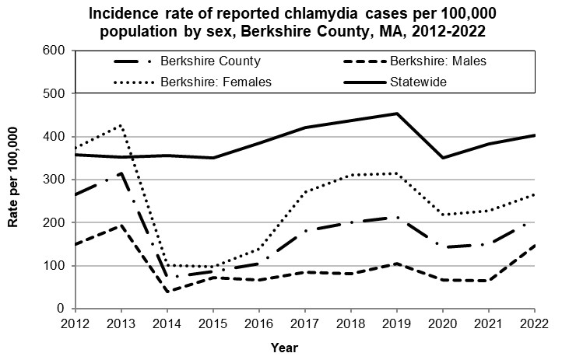
Data are current as of 12/15/2023 and are subject to change.
Population denominators: Strate S, et al. Small Area Population Estimates for 2012 through 2020 report, Oct 2016.
Data source: Massachusetts Department of Public Health/Bureau of Infectious Disease and Laboratory Sciences/Division of STD Prevention.

The county incidence rate among females remained higher compared to males. In 2022, the incidence rate among females in Berkshire County was 265.6 per 100,000, more than one and a half that of males with a rate of 145.9 per 100,000.

The chlamydia statewide incidence rate is highest among young adults. In 2022, the incidence rate of chlamydia was highest among 20-to-24-year-olds in Berkshire County (1,256.9 per 100,000).

Gonorrhea
Gonorrhea is the second most frequently reported STI both in the Commonwealth and nationally.

Since 2012, there has been an overall increase of reported gonorrhea cases, ranging from 2,665 cases in 2012 to 9,129 cases in 2022. Berkshire County also experienced an overall increase in reported gonorrhea cases, ranging from 19 cases in 2012 to 134 cases in 2022. In 2022, the county incidence rate of gonorrhea infection was 103.9 per 100,000, while the overall state rate was 129.9 per 100,000. These can be compared to the national rate of 194.4 per 100,000.‡

The differences in the incidence rates between males and females in past years were relatively small in Berkshire County. In 2022, the incidence rate among females was 100.5 per 100,000 and 105.8 per 100,000 among males.

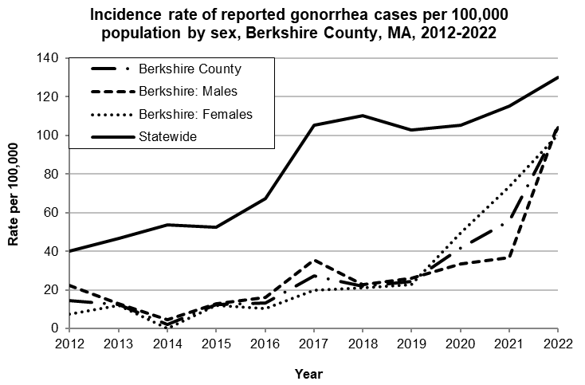
Data are current as of 12/15/2023 and are subject to change.
Population denominators: Strate S, et al. Small Area Population Estimates for 2012 through 2020 report, Oct 2016.
Data source: Massachusetts Department of Public Health/Bureau of Infectious Disease and Laboratory Sciences/Division of STD Prevention.

The gonorrhea incidence rate is highest among young adults in Massachusetts. In 2022, the incidence rate of gonorrhea in Berkshire County was highest among 30-to-34-year-olds (356.0 per 100,000).

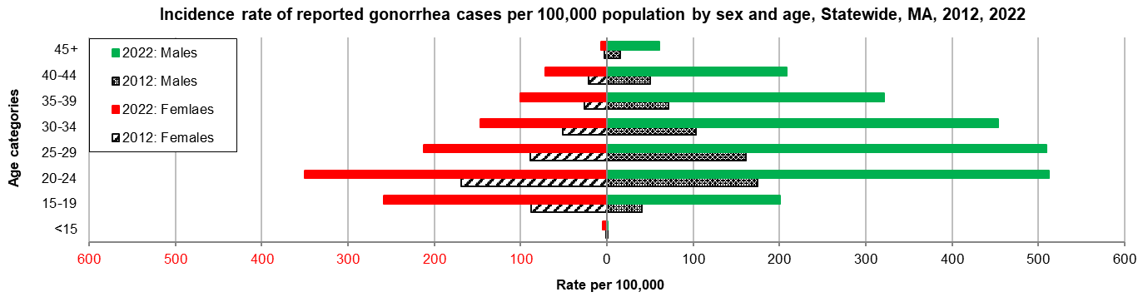
Data are current as of 12/15/2023 and are subject to change.
Population denominators: Strate S, et al. Small Area Population Estimates for 2012 through 2020 report, Oct 2016.
Data source: Massachusetts Department of Public Health/Bureau of Infectious Disease and Laboratory Sciences/Division of STD Prevention.

Early Syphilis¶
Early syphilis has been on the rise in the Commonwealth and nationally since the early 2000s.‡

Since 2012, there has been an overall increase in reported early syphilis cases statewide, ranging from 2,665 cases in 2012 to 9,129 cases in 2022. The incidence rate of reported early syphilis infection in Berkshire County was relatively stable except for an increase in 2020 and continued to increase in 2022 to 11.6 per 100,000, more than three times that of 2021 (3.1 per 100,000). The statewide rate was 22.7 per 100,000. These can be compared to the national rate of 41.2 per 100,000.‡

In 2022, the fourth early syphilis case was reported among females in Berkshire County since prior to 2012. The first case was reported in 2018 and the second in 2020.

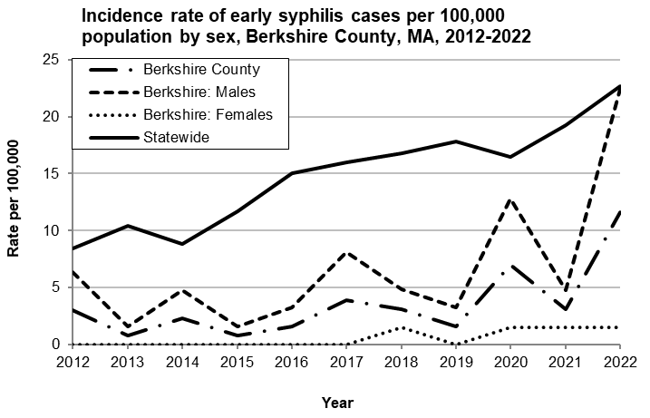
Data are current as of 12/15/2023 and are subject to change.
Population denominators: Strate S, et al. Small Area Population Estimates for 2012 through 2020 report, Oct 2016.
Data source: Massachusetts Department of Public Health/Bureau of Infectious Disease and Laboratory Sciences/Division of STD Prevention.

In 2022, the highest incidence rate statewide of early syphilis was among 30-to-34-year-old males (107.5 per 100,000).

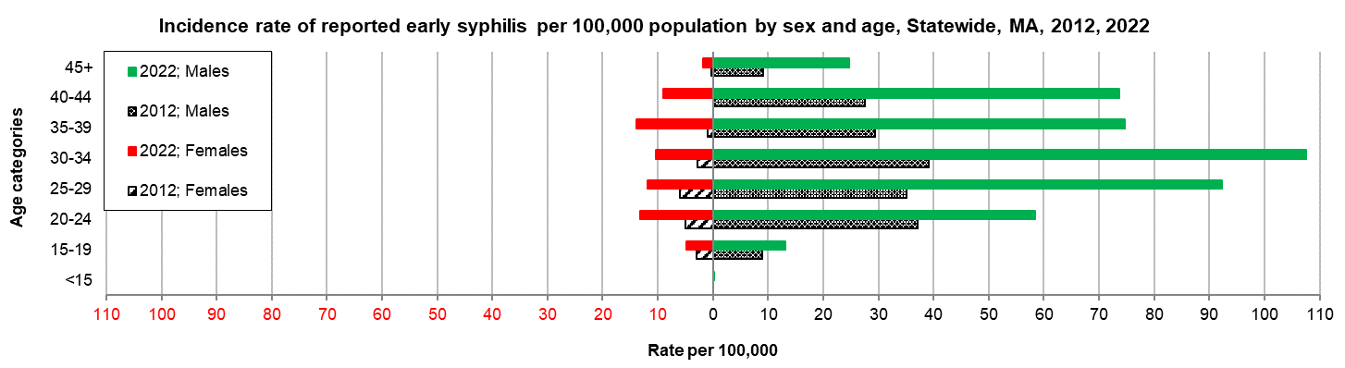
Data are current as of 12/15/2023 and are subject to change.
Population denominators: Strate S, et al. Small Area Population Estimates for 2012 through 2020 report, Oct 2016.
Data source: Massachusetts Department of Public Health/Bureau of Infectious Disease and Laboratory Sciences/Division of STD Prevention.

2022 Statewide Massachusetts
Chlamydia cases have increased by 32% from 2012 to 2019 and decreased by 22% in 2020. From 2020 to 2022, there was a 15% increase in cases. This is possibly due to factors such as increased service utilization after health care clinics re-opened following the end of the COVID-19 public health emergency.

Gonorrhea cases have increased 243% from 2012 to 2022 and was reported primarily among males.

Early syphilis cases have increased 184% from 2012 to 2022. From 2017 to 2022, a range of 25% (in 2022) to 37% (in 2017) of early syphilis cases were co-infected with HIV. In 2020, 2021, and 2022 congenital syphilis cases numbered 10, 9, and 11, respectively, after remaining between 0 and 4 from 2011 to 2018.
________________
*2020 population estimates were used to calculate 2022 disease rates throughout this report because 2022 population estimates had not been released at the time this report was published.
†Please note the impact of the COVID-19 pandemic on infectious disease screening, treatment, and surveillance in the interpretation of 2020 and 2022 data.
‡Source: CDC: Sexually Transmitted Disease Surveillance, 2022.
¶Early syphilis is defined as primary, secondary and early syphilis not diagnosed in the primary or secondary stages within one year of infection.

