Massachusetts Department of Public Health, Bureau of Infectious Disease and Laboratory Sciences
Summary for Dukes and Nantucket Counties, Massachusetts, 2021
Dukes and Nantucket County are both counties in the Commonwealth of Massachusetts. In 2020, the population of Dukes County was 20,600. In 2020, the population of Nantucket County was 14,255 making it the smallest county in terms of population in Massachusetts (U.S. Census Bureau, 2020*).

Chlamydia
Chlamydia is the most frequently reported sexually transmitted infection (STI) both in the Commonwealth and nationally.

Since 2011, there has been an overall increase in chlamydia cases statewide, with the exception of 2020 due to COVID-19§. There has also been an increase in chlamydia cases since 2014 in Dukes and Nantucket Counties. In 2021, the combined county rate was 324.2 per 100,000, while the statewide rate was 382.8 per 100,000. These can be compared to the national rate of 495.5 per 100,000.‡

The county incidence rate among women remained higher compared to men. In 2021, the incidence rate of chlamydia among women was 356.9 per 100,000 while men had a rate of 280.3 per 100,000.

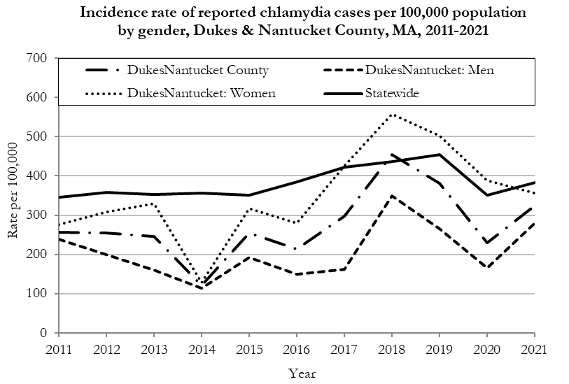
Data are current as of 10/24/2022 and are subject to change.
Population denominators: Strate S, et al. Small Area Population Estimates for 2011 through 2020 report, Oct 2016.
Data source: Massachusetts Department of Public Health/Bureau of Infectious Disease and Laboratory Sciences/Division of STD Prevention.

The chlamydia statewide incidence rate is highest among young adults. In 2021, the number of cases and incidence rate of chlamydia was highest among 20 to 24-year-olds in Dukes and Nantucket County (37 cases, 2,175.3 per 100,000).

Gonorrhea
Gonorrhea is the second most frequently reported STI both in the Commonwealth and nationally.

Since 2011, the overall Massachusetts rate of reported gonorrhea has continued to increase, with the single largest annual rate increase in 2017 and remaining relatively stable afterwards. On the other hand, Dukes and Nantucket County experienced a peak in 2019 followed by a sharp decrease in 2020 with a slight rebound in 2021.

In 2021, the combined Dukes and Nantucket County rates were 34.4 per 100,000, while the overall state rate was 115.2 per 100,000. These can be compared to the national rate of 214.0 per 100,000.‡

In 2021, men accounted for 83.3% of all gonorrhea cases in Dukes and Nantucket County, with a higher rate of 57.2 per 100,000 compared to that of women (11.5 per 100,000).

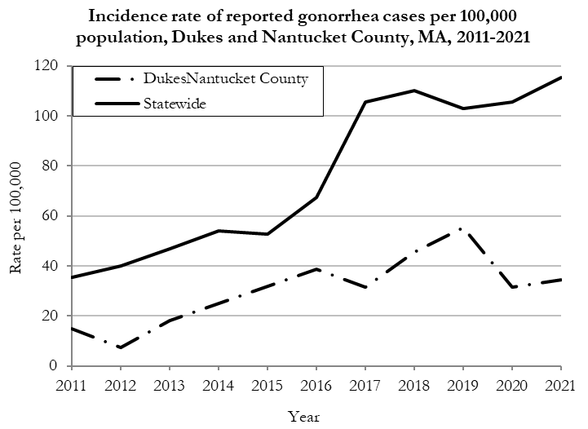
Data are current as of 10/24/2022 and are subject to change.
Population denominators: Strate S, et al. Small Area Population Estimates for 2011 through 2020 report, Oct 2016.
Data source: Massachusetts Department of Public Health/Bureau of Infectious Disease and Laboratory Sciences/Division of STD Prevention.

The gonorrhea statewide and county incidence rate is highest among young adults. In 2021, the incidence rate of gonorrhea in Dukes and Nantucket County was highest among 25 to 29-year-olds (239.1 per 100,000.)

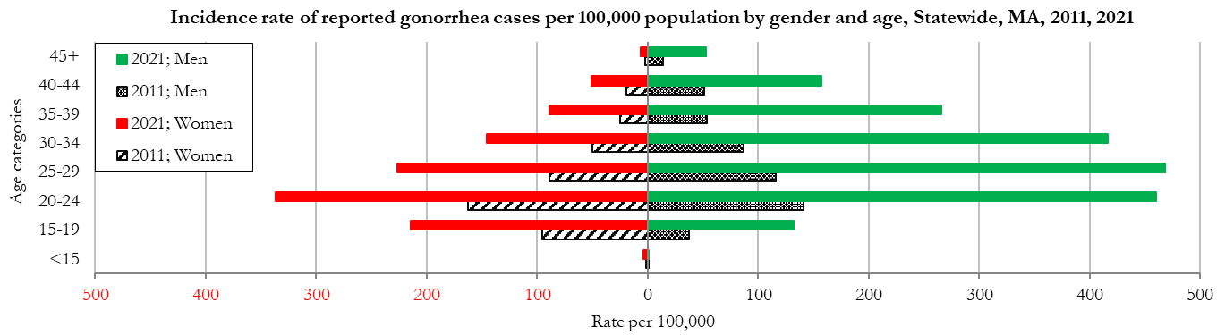
Data are current as of 10/24/2022 and are subject to change.
Population denominators: Strate S, et al. Small Area Population Estimates for 2011 through 2020 report, Oct 2016.
Data source: Massachusetts Department of Public Health/Bureau of Infectious Disease and Laboratory Sciences/Division of STD Prevention

Early Syphilis◊
Early syphilis has been on the rise in the Commonwealth and nationally since the early 2000s.‡

Since 2011, Dukes and Nantucket County combined have had 6 or fewer cases of early syphilis per year. In 2021, the combined counties rate was 5.7 per 100,000, greater than the statewide rate at 19.2 per 100,000. This can be compared to the national rate of 31.8 per 100,000.‡

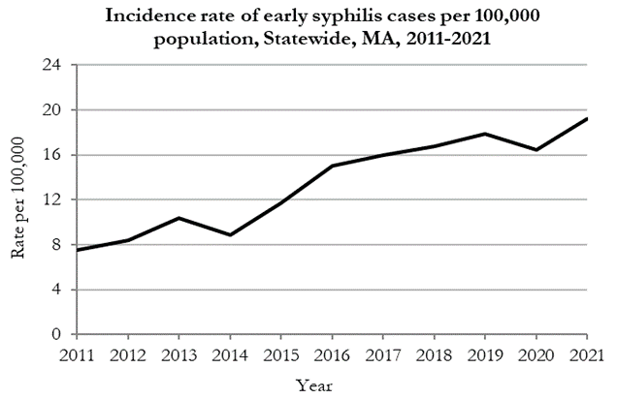
Data are current as of 10/24/2022 and are subject to change.
Population denominators: Strate S, et al. Small Area Population Estimates for 2011 through 2020 report, Oct 2016.
Data source: Massachusetts Department of Public Health/Bureau of Infectious Disease and Laboratory Sciences/Division of STD Prevention.

Age, sex, and race/ethnicity specific information for Dukes and Nantucket County are suppressed, and therefore not stated in this report.).

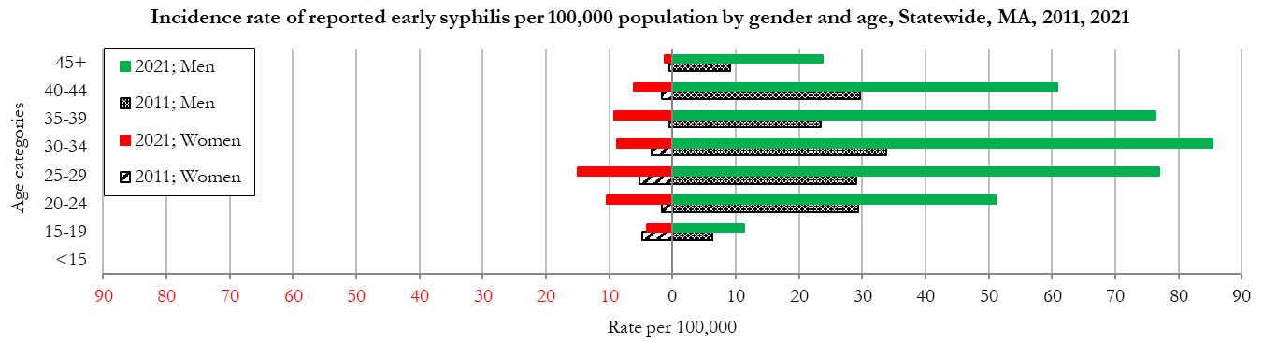
Data are current as of 10/24/2022 and are subject to change.
Population denominators: Strate S, et al. Small Area Population Estimates for 2011 through 2020 report, Oct 2016.
Data source: Massachusetts Department of Public Health/Bureau of Infectious Disease and Laboratory Sciences/Division of STD Prevention

________________
* 2020 population estimates were used to calculate 2021 disease rates throughout this report because 2021 population estimates had not been released at the time this report was published.
‡ Source: CDC: Sexually Transmitted Disease Surveillance, 2021.
◊ Early syphilis is defined as primary, secondary and early syphilis not diagnosed in the primary or secondary stages within one year of infection.
§ Please note the impact of the COVID-19 pandemic on infectious disease screening, treatment, and surveillance in the interpretation of 2020 and 2021 data.
2021 Statewide Massachusetts
Chlamydia cases have increased by 38% from 2011 to 2019 and decreased by 22% in 2020 before increasing by 9% in 2021. This is possibly due to factors such as increased service utilization after health care clinics re-opened following the end of the COVID-19 public health emergency.

Gonorrhea cases have increased 245% from 2011 to 2021 and was reported primarily among men.

Early syphilis cases have increased 170% from 2011 to 2021. From 2016 to 2021, a range of 31% to 39% of early syphilis cases were co-infected with HIV. In 2019, 2020, and 2021 congenital syphilis cases numbered 9, 10, and 9, respectively, after remaining between 0 and 4 from 2011 to 2018.

