***Massachusetts Department of Public Health, Bureau of Infectious Disease and Laboratory Sciences***

**Summary for Dukes and Nantucket Counties, Massachusetts, 2022**

Dukes and Nantucket Counties are both counties in the Commonwealth of Massachusetts. In 2020, the population of Dukes County was 20,600. In 2020, the population of Nantucket County was 14,255 making it the smallest county in terms of population in Massachusetts (U.S. Census Bureau, 2020*).

**Chlamydia**

Chlamydia is the most frequently reported sexually transmitted infection (STI) both in the Commonwealth and nationally.

**Since 2012, there has been an overall increase in reported chlamydia cases statewide except for 2020 due to COVID-19†, ranging from 23,930 cases in 2012 to 28,384 cases in 2022**. Dukes and Nantucket Counties also experienced an overall increase in reported chlamydia cases, ranging from 34 cases in 2012 to 147 in 2022. In 2022, the combined county incidence rate of chlamydia infection was 421.7 per 100,000, while the statewide rate was 403.8 per 100,000. These can be compared to the national rate of 495.0 per 100,000.‡

Incidence rate of reported chlamydia cases per 100,000 population by sex, Dukes and Nantucket County, MA, 2012–2022.

Graph above depicts chlamydia rates (per 100,000) in MA and Dukes and Nantucket County by gender between 2012 and 2022. There are four lines: (1) MA rates begins at 358.5 and finishes at 403.8; (2) Dukes and Nantucket County rates begins at 254.5 and finishes at 421.7; (3) Dukes and Nantucket County female rates begin at 308.5 and finishes at 558.3; (4) Dukes and Nantucket County male rates begin at 200.0 and finish at 286.0. 


Data are current as of 12/15/2023 and are subject to change.

Population denominators: Strate S, et al. Small Area Population Estimates for 2012 through 2020 report, Oct 2016.

Data source: Massachusetts Department of Public Health/Bureau of Infectious Disease and Laboratory Sciences/Division of STD Prevention.

**The county incidence rate among females remained higher** compared to males. In 2022, the incidence rate of chlamydia among females was 558.3 per 100,000 while males had a rate of 286.0 per 100,000.

**The chlamydia statewide incidence rate is highest among young adults.** In 2022, the number of cases and incidence rate of chlamydia was highest among 20-to-24-year-olds in Dukes and Nantucket Counties (49 cases, 2,880.9 per 100,000).

**Gonorrhea**

Gonorrhea is the second most frequently reported STI both in the Commonwealth and nationally.

**Since 2012, the overall Massachusetts rate of reported gonorrhea has continued to increase**, with the single largest annual rate increase in 2017 and remaining relatively stable afterwards. On the other hand, Dukes and Nantucket County experienced a peak in 2019 followed by a sharp decrease in 2020 with a slight rebound in 2021, and another dramatic increase in 2022.

**In 2022, the combined Dukes and Nantucket County rates were 77.5 per 100,000,** while the overall state rate was 129.9 per 100,000. These can be compared to the national rate of 194.4 per 100,000.‡

**In 2022, males accounted for 83.3% of all gonorrhea cases in Dukes and Nantucket Counties,** with a higher rate of 125.8 per 100,000 compared to that of females (28.8 per 100,000).

Incidence rate of reported gonorrhea cases per 100,000 population Dukes and Nantucket County, MA, 2012–2022.

Graph above depicts gonorrhea rates (per 100,000) in MA and Dukes and Nantucket County between 2012 and 2022. There are two lines: (1) MA rates begins at 39.9 and finishes at 129.9; (2) Dukes and Nantucket County rates begins at 7.4 and finishes at 77.5.


Data are current as of 12/15/2023 and are subject to change.

Population denominators: Strate S, et al. Small Area Population Estimates for 2012 through 2020 report, Oct 2016.

Data source: Massachusetts Department of Public Health/Bureau of Infectious Disease and Laboratory Sciences/Division of STD Prevention.

**The gonorrhea statewide and county incidence rate is highest among young adults**. In 2021, the incidence rate of gonorrhea in Dukes and Nantucket Counties was highest among 20-to-24-year-olds (352.8 per 100,000.)

Incidence rate of reported gonorrhea cases per 100,000 population by sex and age, Statewide, MA, 2012, 2022.

This graph shows the highest gonorrhea rate among male in 2012 was in the 20–24 year-old age group, which shifted to the 35–39-year-old age group by 2022. Among females, the age group with the highest gonorrhea rate was 20–24-year-olds during 2012 and 2022. 


Data are current as of 12/15/2023 and are subject to change.

Population denominators: Strate S, et al. Small Area Population Estimates for 2012 through 2020 report, Oct 2016.

Data source: Massachusetts Department of Public Health/Bureau of Infectious Disease and Laboratory Sciences/Division of STD Prevention

**Early Syphilis¶**

Early syphilis has been on the rise in the Commonwealth and nationally since the early 2000s.‡

**Since 2012, Dukes and Nantucket Counties combined have had 6 or fewer cases of early syphilis per year.** In 2022, the combined county incidence rate of early syphilis infection was 11.5 per 100,000, about double that of 2021 (5.7 per 100,000). These can be compared to the national rate of 41.2 per100,000.‡

Age, sex, and race/ethnicity specific information for Dukes and Nantucket Counties are suppressed, and therefore not stated in this report.

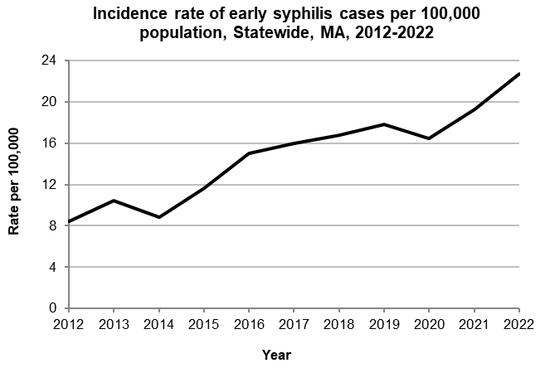

Data are current as of 12/15/2023 and are subject to change.

Population denominators: Strate S, et al. Small Area Population Estimates for 2012 through 2020 report, Oct 2016.

Data source: Massachusetts Department of Public Health/Bureau of Infectious Disease and Laboratory Sciences/Division of STD Prevention.

Incidence rate of reported early syphilis per 100,000 population by sex and age, Statewide, MA, 2012, 2022.

This graph shows the highest early syphilis rate among males in 2012 and 2022 was in the 30–34-year-old age group. The highest early syphilis among females in 2012 was in the 25–29 year-old age group, which shifted to the 35–39-year-old age group by 2022. 


Data are current as of 12/15/2023 and are subject to change.

Population denominators: Strate S, et al. Small Area Population Estimates for 2012 through 2020 report, Oct 2016.

Data source: Massachusetts Department of Public Health/Bureau of Infectious Disease and Laboratory Sciences/Division of STD Prevention.

**2022 Statewide Massachusetts**

Chlamydia cases have increased by 32% from 2012 to 2019 and decreased by 22% in 2020. From 2020 to 2022, there was a 15% increase in cases. This is possibly due to factors such as increased service utilization after health care clinics reopened following the end of the COVID-19 public health emergency.

Gonorrhea cases have increased 243% from 2012 to 2022 and was reported primarily among males.

Early syphilis cases have increased 184% from 2012 to 2022. From 2017 to 2022, a range of 25% (in 2022) to 37% (in 2017) of early syphilis cases were co-infected with HIV. In 2020, 2021, and 2022 congenital syphilis cases numbered 10, 9, and 11, respectively, after remaining between 0 and 4 from 2011 to 2018.

________________

*2020 population estimates were used to calculate 2022 disease rates throughout this report because 2022 population estimates had not been released at the time this report was published.

†Please note the impact of the COVID-19 pandemic on infectious disease screening, treatment, and surveillance in the interpretation of 2020 and 2022 data.

‡Source: CDC: Sexually Transmitted Disease Surveillance, 2022.

¶Early syphilis is defined as primary, secondary and early syphilis not diagnosed in the primary or secondary stages within one year of infection.