Massachusetts Department of Public Health, Bureau of Infectious Disease and Laboratory Sciences
Summary for Essex County, Massachusetts, 2024
Essex County, located in northeastern Massachusetts, was established in 1643 and encompasses urban, suburban, and coastal communities from the Merrimack Valley to Cape Ann. As of July 1, 2024, it has an estimated population of 823,938, up from 809,940 at the 2020 Census. As of 2024, the population is predominantly White, with 82.7% identifying as White alone. Other racial and ethnic groups include Black or African American alone (8.5%), Asian alone (4.3%), American Indian and Alaska Native alone (1.2%), Native Hawaiian and Other Pacific Islander alone (0.2%), and individuals reporting two or more races (3.2%). Hispanic or Latino residents make up about 25.7% of the population. In the county, 20.6% of residents are under 18 years old and 19.4% are 65 years and over. In comparison, Massachusetts’ population has 19.0% under 18 years old and 18.7% aged 65 and over. The county also exhibits a slightly higher proportion of females compared to males, with approximately 51.4% of the population identifying as female.¹

Quick Stats
Data are current as of 6/02/2025 and are subject to change.
Population denominators: Strate S, et al. Small Area Population Estimates for 2011 through 2020 report, Oct 2016.
Data source: Massachusetts Department of Public Health/Bureau of Infectious Disease and Laboratory Sciences/Division of STD Prevention.

Chlamydia
Chlamydia has the highest reported incidence among STIs in Massachusetts and nationally. It is a bacterial infection that can spread through vaginal, anal, or oral sexual contact with an infected partner and from pregnant person to child during birth. While most people with chlamydia have no signs or symptoms, some may experience dysuria; vaginal, penile, or anal discharge; or irregular bleeding. Chlamydia is easily treated with medication from a medical provider, but repeated infections are common. Women are at a greater risk of complications from repeated infections.²

Since 2015, there has been an overall increase in reported chlamydia cases statewide, except for 2020, when case counts temporarily dropped due to the impacts of the COVID-19 pandemic³. During this period, statewide case counts ranged from 23,944 cases in 2015 to 26,623 cases in 2024. After a dip in 2020, Essex County saw a rebound in reported chlamydia cases that stayed relatively constant through 2024. In 2024, the county incidence rate of chlamydia infection was 404.9 per 100,000, while the statewide rate was 378.7 per 100,000. These rates are lower compared to the national rate of 445.7 per 100,000.⁴

Between 2015 and 2024, the county incidence rate among females remained approximately twice as high as the rate among males. In 2024, the incidence rate of chlamydia among females in Essex County was 532.5 per 100,000 while males had a rate that was nearly half that (266.8 per 100,000).

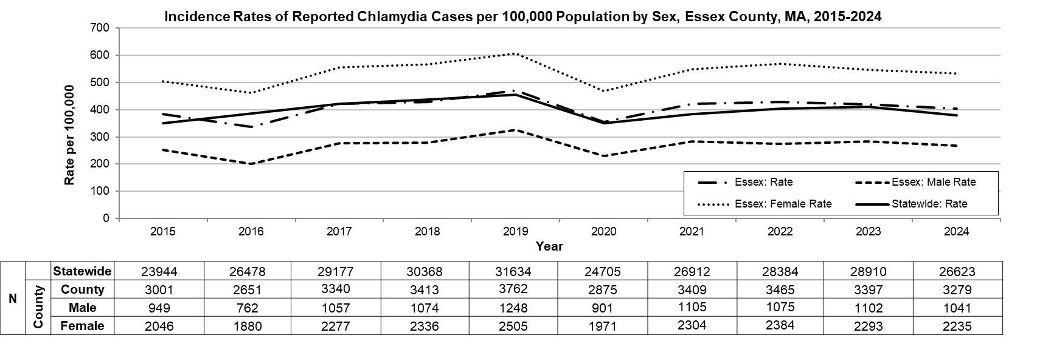
Data are current as of 6/02/2025 and are subject to change.
Population denominators: Strate S, et al. Small Area Population Estimates for 2011 through 2020 report, Oct 2016.
Data source: Massachusetts Department of Public Health/Bureau of Infectious Disease and Laboratory Sciences/Division of STD Prevention.

The statewide and county incidence rates of chlamydia are highest among young adults. In 2024, 1,757 chlamydia cases were reported among 20–29-year-olds, at a rate of 1,715.9 per 100,000, the highest among all age groups in Essex County. Among this age group, females accounted for 1,203 cases (68.5%), with a rate of 2386.1 per 100,000, while 553 cases (31.5%) were reported among males, at a rate of 1,063.9 per 100,000. Although the chart below represents rates by age group only, the highest burden is concentrated among 20-29-year-old females. Data by gender within each age group are not displayed due to suppression rules.

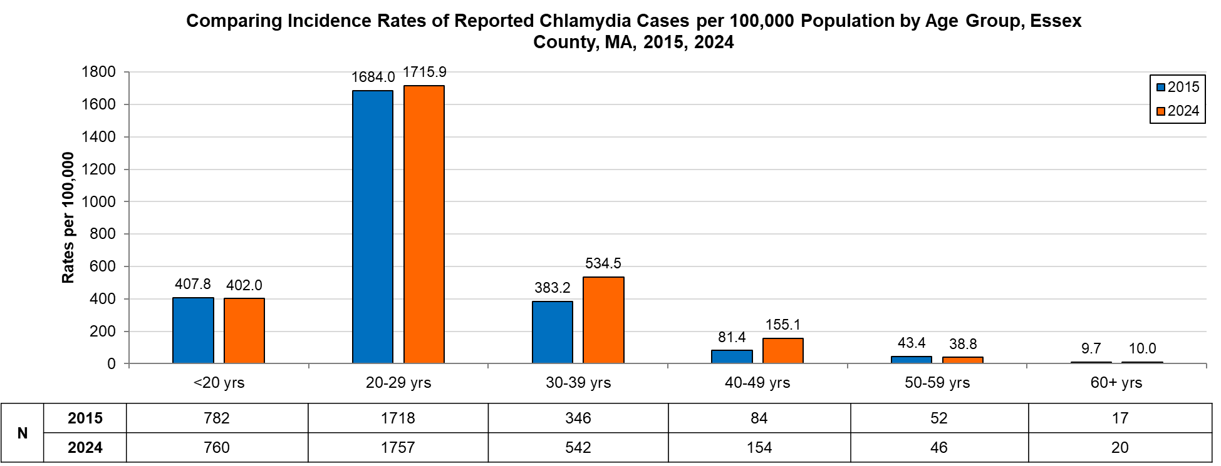
Data are current as of 6/02/2025 and are subject to change.
Population denominators: Strate S, et al. Small Area Population Estimates for 2011 through 2020 report, Oct 2016.
Data source: Massachusetts Department of Public Health/Bureau of Infectious Disease and Laboratory Sciences/Division of STD Prevention.

Gonorrhea
Gonorrhea has the second highest incidence among STIs reported both in Massachusetts and nationally. It can spread through vaginal, anal, or oral sexual contact with an infected partner or to an infant during birth. Symptoms of gonococcal infection can vary depending on the site of infection and may include dysuria, vaginal, penile, or anal discharge; irregular bleeding; abdominal or anal pain; and sore throat. Many infected individuals do not present with any symptoms of infection, though males are more likely than females to experience symptoms. Although gonorrhea infection is treatable, it has become more complex with increased antimicrobial non-susceptibility.²

Since 2015, there has been an overall increase in reported gonorrhea cases statewide, ranging from 3,592 cases in 2015 to 8,678 cases in 2024. Essex County also experienced an overall increase in reported gonorrhea cases, ranging from 264 in 2015 to a peak of 886 in 2023, before declining slightly to 785 in 2024. In 2024, the county incidence rate of gonorrhea infection was 96.9 per 100,000, while the statewide rate was 123.4 per 100,000. These rates are lower compared to the national rate of 159.8 per 100,000.⁴

Between 2015 and 2024, the county incidence rate among males was consistently higher compared to females. In 2024, males accounted for 58.6% of all gonorrhea cases in Essex County with a rate of 117.9 per 100,000, while females had a rate of 76.2 per 100,000.

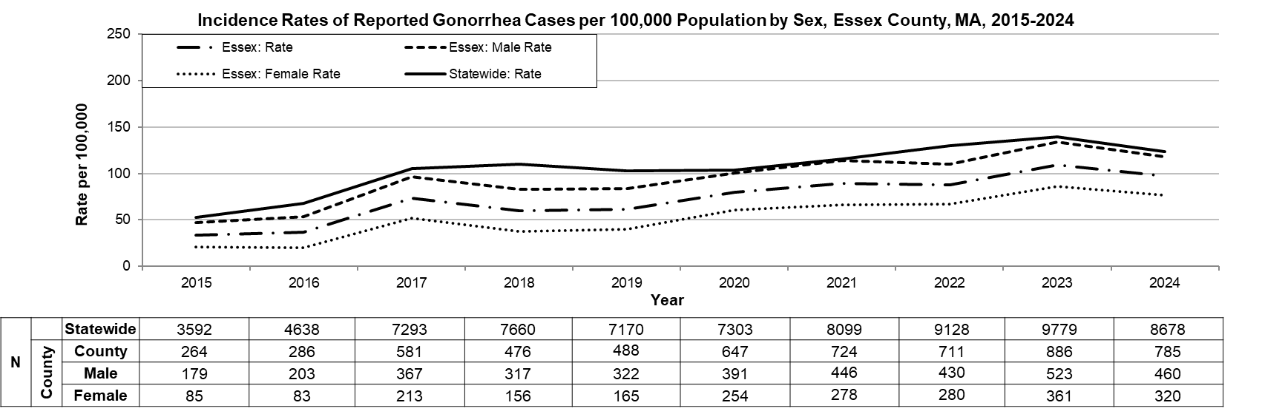
Data are current as of 6/02/2025 and are subject to change.
Population denominators: Strate S, et al. Small Area Population Estimates for 2011 through 2020 report, Oct 2016.
Data source: Massachusetts Department of Public Health/Bureau of Infectious Disease and Laboratory Sciences/Division of STD Prevention.

In 2024, 318 gonorrhea cases were reported among 20-29 year-olds, at a rate of 310.6 per 100,000, the highest among all age groups in Essex County. Within this age group, males accounted for 175 cases (55.0%), with a rate of 336.7 per 100,000, while 140 cases (44.0%) were reported among females, at a rate of 277.7 per 100,000. Although the chart below represents rates by age group only, the highest burden is concentrated among 20-29-year-old males. Data by gender within each age group are not displayed due to suppression rules.

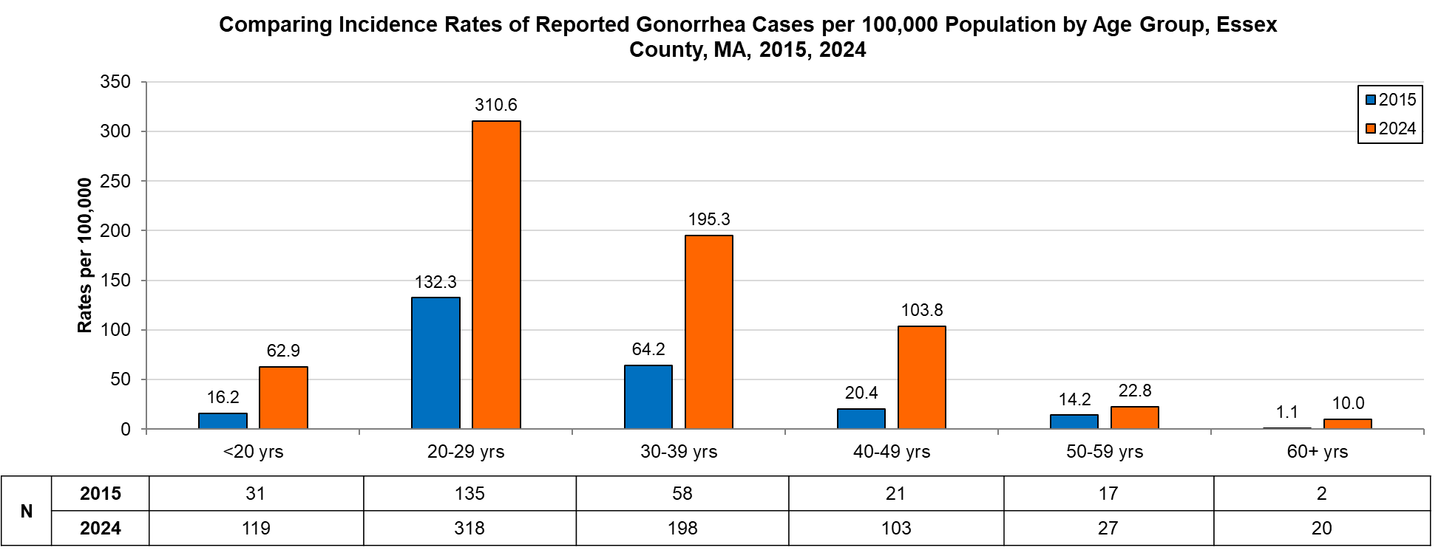
Data are current as of 6/02/2025 and are subject to change.
Population denominators: Strate S, et al. Small Area Population Estimates for 2011 through 2020 report, Oct 2016.
Data source: Massachusetts Department of Public Health/Bureau of Infectious Disease and Laboratory Sciences/Division of STD Prevention.

Infectious Syphilis⁵
Infectious Syphilis, which includes primary, secondary, and early non-primary, non-secondary stages, has been on the rise in the Commonwealth and nationally since the early 2000s, but in more recent years there has been a decrease. It can spread through sexual contact with an infected person. The first symptom of syphilis infection is a sore or chancre at the site of inoculation that is usually firm, round, and painless. The most recognized symptom of the second stage of infection is a body rash which can be present on the palms of hands and soles of feet. As with primary syphilis symptoms, secondary syphilis symptoms also resolve with or without treatment. After the secondary stage of syphilis, untreated infected individuals enter a time of latent syphilis that can last for years. Individuals with syphilis are thought to be most infectious for the first year after acquisition. Syphilis infection can also be transmitted to an infant during pregnancy and birth.²

Since 2015, there has been an overall increase of reported infectious syphilis cases statewide, ranging from 789 cases in 2015 to 1,329 cases in 2024. Essex County also experienced an overall increase of reported infectious syphilis cases, ranging from 155 in 2015 to 166 in 2024. In 2024, the county incidence rate of infectious syphilis was 20.5 per 100,000. The statewide rate was 18.9 per 100,000. These rates are lower compared to the national rate of 26.2 per 100,000 (based on CDC data for primary, secondary, and early non-primary, non-secondary syphilis).⁴

Between 2015 and 2024, the county rate of infectious syphilis among males was much higher compared to the rate among females. After a drop in 2020, the county rate of infectious syphilis among males rebounded higher than pre-COVID levels, to a peak of 33.3 per 100,000 in 2023. Females saw a gradual increase in incidence rate between 2021 and 2024, with no drop in 2020. In 2024, males accounted for 75.3% of all infectious syphilis cases in the county with a rate of 32.0 per 100,000, more than three times than that of females (9.3 per 100,000).

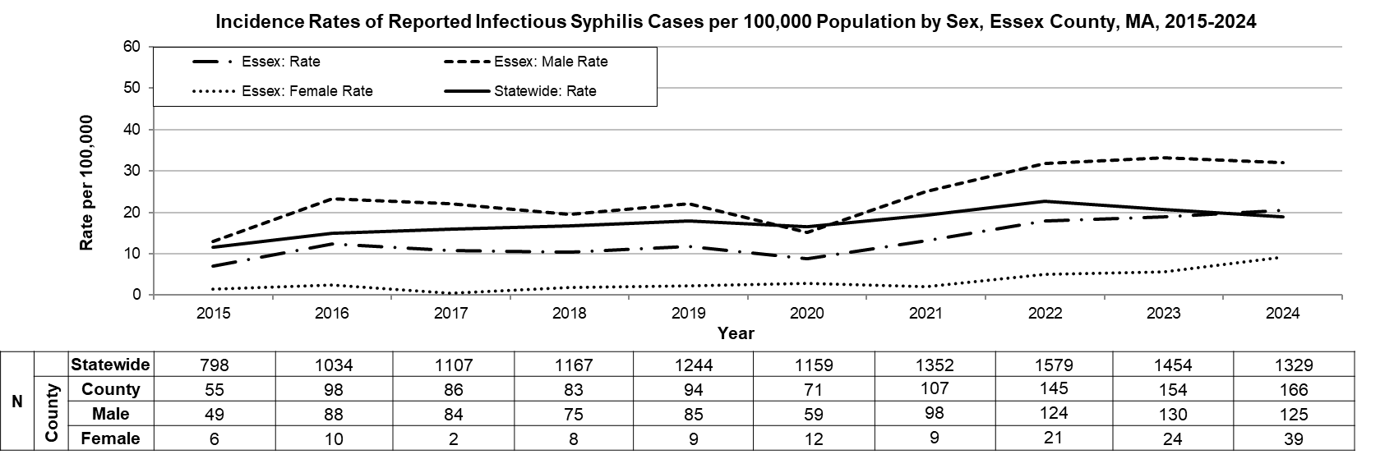
Data are current as of 6/02/2025 and are subject to change.
Population denominators: Strate S, et al. Small Area Population Estimates for 2011 through 2020 report, Oct 2016.
Data source: Massachusetts Department of Public Health/Bureau of Infectious Disease and Laboratory Sciences/Division of STD Prevention.

In 2024, 60 infectious syphilis cases were reported among 20–29-year-olds, at a rate of 58.6 per 100,000, the highest among all age groups in Essex County. Males accounted for 40 cases (66.7%) within this age group, with a rate of 77.0 per 100,000, while 19 cases (31.7%) were reported for females, at a rate of 37.7 per 100,000. Although the chart below represents rates by age group only, the highest burden is concentrated among 20-29-year-old males. Data by gender within each age group are not displayed due to suppression rules.

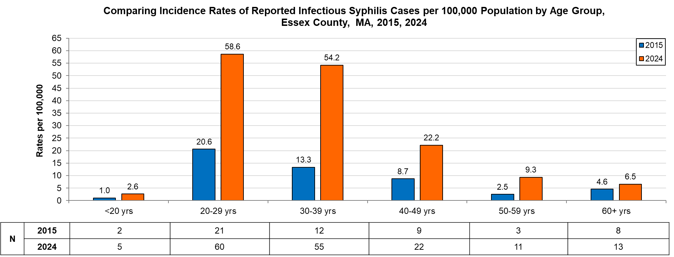
Data are current as of 6/02/2025 and are subject to change.
Population denominators: Strate S, et al. Small Area Population Estimates for 2011 through 2020 report, Oct 2016.
Data source: Massachusetts Department of Public Health/Bureau of Infectious Disease and Laboratory Sciences/Division of STD Prevention.

2024 Statewide Massachusetts
Chlamydia cases have increased by 18.5% from 2015 (n=23,944) to 2022 (n=28,384) and decreased by 6.2% in 2024 (n=26,623). From 2020 to 2024, there was a 7.8% increase in cases. This is possibly due to factors such as increased service utilization after health care clinics re-opened following the end of the COVID-19 public health emergency.

Gonorrhea cases have increased 233.3% from 2015 (n=3,592) to 2024, peaking at 9,779 cases in 2023 before declining to 8,678 cases in 2024. Unlike chlamydia, gonorrhea cases did not drop during the COVID-19 public health emergency. Between 2015 and 2024, the majority of gonorrhea cases were reported among males. There were 11 reported cases of Disseminated Gonococcal Infection (DGI) in 2024, an increase from 6 in 2022. In 2022, a novel strain of multi-drug-non-susceptible Neisseria gonorrhoeae was identified in two Massachusetts residents. As a result, Massachusetts DPH released a clinical alert in January 2023 requesting that clinicians perform gonococcal culture in addition to NAAT testing for symptomatic patients. Two additional multi-drug-non-susceptible cases of gonorrhea have been identified since then.

Infectious syphilis cases have increased 43.8% from 2015 (n=798) to 2024, peaking at 1,579 cases in 2022 before declining to 1,329 cases in 2024. Despite close follow-up of cases of syphilis in pregnant patients and their partners, breakthrough cases of congenital syphilis have increased in Massachusetts. From 2021 to 2024, the annual number of probable cases of congenital syphilis diagnosed in Massachusetts ranged from 9 to 18 after remaining between zero and four from 2011 to 2018. However, as of September 2023, Massachusetts ranks 44th among the 48 states reporting congenital syphilis incidence, indicating relatively better outcomes compared to many other states.

Among individuals of transgender experience and/or individuals who are nonbinary, 51 chlamydia, 91 gonorrhea, and 5 infectious syphilis cases were reported in Massachusetts.⁶
________________________________________________________________________________
¹ Source: U.S. Census Bureau. QuickFacts: Essex County, Massachusetts; Massachusetts. Population Estimates Program, July 1,2024 (Vintage 2024).
² Source: CDC: Sexually Transmitted Infections
³ Please note the impact of the COVID-19 pandemic on infectious disease screening, treatment, and surveillance in the interpretation of 2020-2023 data ⁴Source: CDC: Sexually Transmitted Infections Surveillance, 2024 (Provisional).
⁵ Infectious syphilis is defined as primary, secondary and early latent stages of syphilis within one year of infection.
⁶ Please note that reported numbers among individuals of transgender experience and individuals who are nonbinary are likely to be underestimates. Underreporting may occur due to the absence of appropriate gender identity options (e.g., individuals who are genderqueer, pangender, gender fluid, androgynous, etc.) in data collection systems.

