Massachusetts Department of Public Health, Bureau of Infectious Disease and Laboratory Sciences
Summary for Franklin County, Massachusetts, 2022
Franklin County is a county in the Commonwealth of Massachusetts, established in 1811. In 2020, the population was 71,029 making it the smallest county on the Massachusetts mainland in terms of population (U.S. Census Bureau, 2020*).

Chlamydia
Chlamydia is the most frequently reported sexually transmitted infection (STI) both in the Commonwealth and nationally.

Since 2012, there has been an overall increase in reported chlamydia cases statewide except for 2020 due to COVID-19†, ranging from 23,930 cases in 2012 to 28,384 cases in 2022. In 2022, the county incidence rate of chlamydia infection was 156.3 per 100,000, while the statewide rate was 403.8 per 100,000. These can be compared to the national rate of 495.0 per 100,000.‡

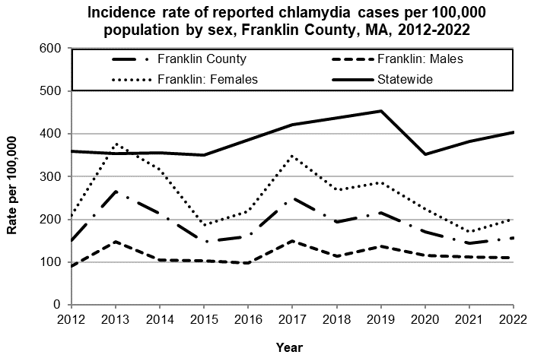
Data are current as of 12/15/2023 and are subject to change.
Population denominators: Strate S, et al. Small Area Population Estimates for 2012 through 2020 report, Oct 2016.
Data source: Massachusetts Department of Public Health/Bureau of Infectious Disease and Laboratory Sciences/Division of STD Prevention.

The county incidence rate among females remained higher compared to males. In 2022, the incidence rate of chlamydia among females in Franklin County was 200.4 per 100,000 while the rate among males was 109.8 per 100,000.

The chlamydia statewide and county incidence rate is highest among young adults. In 2022, the incidence rate of chlamydia was highest among 20-to-24-year-olds in Franklin County (1,065.1 per 100,000).

Gonorrhea
Gonorrhea is the second most frequently reported STI both in the Commonwealth and nationally.

Since 2012, there has been an overall increase of reported gonorrhea cases statewide, ranging from 2,665 cases in 2012 to 9,129 cases in 2022. In 2022, the county incidence rate of gonorrhea infection was 33.8 per 100,000, while the overall state rate was 129.9 per 100,000. These can be compared to the national rate of 194.4 per 100,000.‡

In 2022, males accounted for 50% of gonorrhea cases in Franklin County with a rate of 34.7 per 100,000. The rate for females was 32.9 per 100,000.

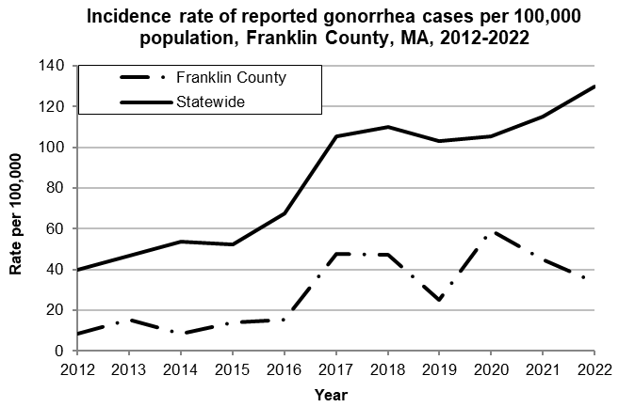
Data are current as of 12/15/2023 and are subject to change.
Population denominators: Strate S, et al. Small Area Population Estimates for 2012 through 2020 report, Oct 2016.
Data source: Massachusetts Department of Public Health/Bureau of Infectious Disease and Laboratory Sciences/Division of STD Prevention.

In 2022, the incidence rate of gonorrhea in Franklin County was highest among 20-to-24-year-olds (224.2 per 100,000).

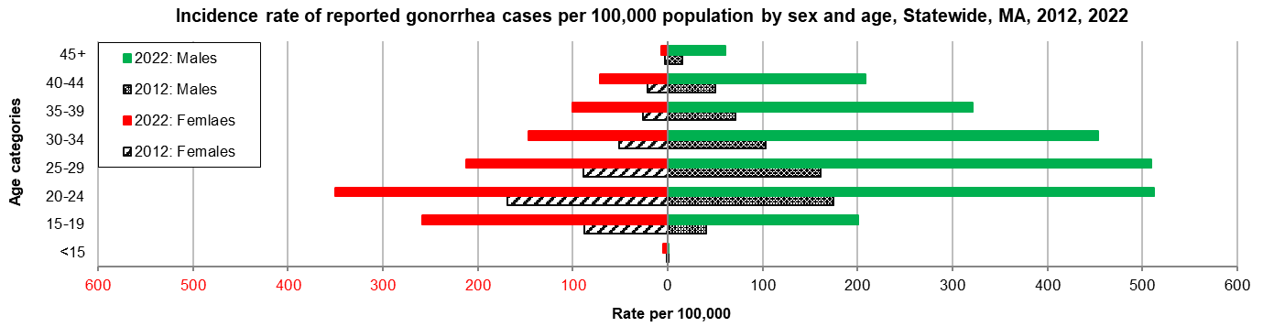
Data are current as of 12/15/2023 and are subject to change.
Population denominators: Strate S, et al. Small Area Population Estimates for 2012 through 2020 report, Oct 2016.
Data source: Massachusetts Department of Public Health/Bureau of Infectious Disease and Laboratory Sciences/Division of STD Prevention

Early Syphilis¶
Early syphilis has been on the rise in the Commonwealth and nationally since the early 2000s.‡

In 2022, Franklin County reached a peak in the number of early syphilis cases per year with 7 cases (9.9 per 100,000), while the statewide incidence rate of early syphilis infection was 22.7 per 100,000. These can be compared to the national rate of 41.2 per 100,000.‡

Age and gender specific information for Franklin County is suppressed, and therefore not stated in this report.

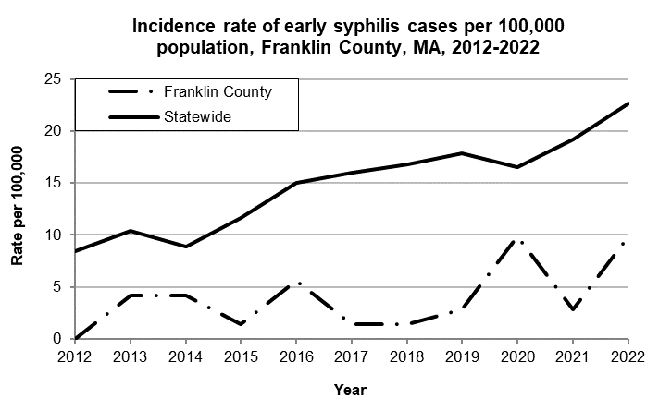
Data are current as of 12/15/2023 and are subject to change.
Population denominators: Strate S, et al. Small Area Population Estimates for 2012 through 2020 report, Oct 2016.
Data source: Massachusetts Department of Public Health/Bureau of Infectious Disease and Laboratory Sciences/Division of STD Prevention.

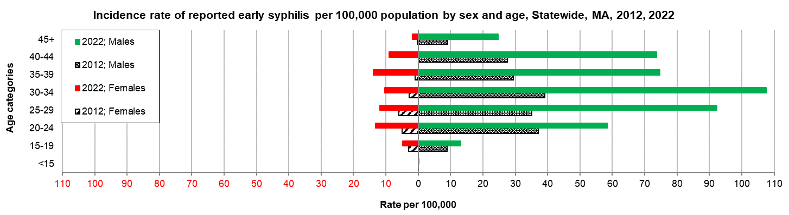
Data are current as of 12/15/2023 and are subject to change.
Population denominators: Strate S, et al. Small Area Population Estimates for 2012 through 2020 report, Oct 2016.
Data source: Massachusetts Department of Public Health/Bureau of Infectious Disease and Laboratory Sciences/Division of STD Prevention.

2022 Statewide Massachusetts
Chlamydia cases have increased by 32% from 2012 to 2019 and decreased by 22% in 2020. From 2020 to 2022, there was a 15% increase in cases. This is possibly due to factors such as increased service utilization after health care clinics reopened following the end of the COVID-19 public health emergency.

Gonorrhea cases have increased 243% from 2012 to 2022 and was reported primarily among males.

Early syphilis cases have increased 184% from 2012 to 2022. From 2017 to 2022, a range of 25% (in 2022) to 37% (in 2017) of early syphilis cases were co-infected with HIV. In 2020, 2021, and 2022 congenital syphilis cases numbered 10, 9, and 11, respectively, after remaining between 0 and 4 from 2011 to 2018.

________________
*2020 population estimates were used to calculate 2022 disease rates throughout this report because 2022 population estimates had not been released at the time this report was published.
†Please note the impact of the COVID-19 pandemic on infectious disease screening, treatment, and surveillance in the interpretation of 2020 and 2022 data.
‡Source: CDC: Sexually Transmitted Disease Surveillance, 2022.
¶Early syphilis is defined as primary, secondary and early syphilis not diagnosed in the primary or secondary stages within one year of infection.

