Massachusetts Department of Public Health, Bureau of Infectious Disease and Laboratory Sciences
Summary for Hampshire County, Massachusetts, 2021
Hampshire County is a county in the Commonwealth of Massachusetts, founded in 1662. Hampshire County does not have a county government. In 2020, the population was 162,308 (U.S. Census Bureau, 2020*).

Chlamydia
Chlamydia is the most frequently reported sexually transmitted infection (STI) both in the Commonwealth and nationally.

Since 2011, there has been an overall increase in chlamydia cases statewide and in Hampshire County, with the exception of 2020 due to COVID-19§. In 2020, Hampshire County saw its lowest rate since 2014. In 2021, the county rate was 224.3 per 100,000, while the statewide rate was 382.8 per 100,000. These can be compared to the national rate of 495.5 per 100,000.‡

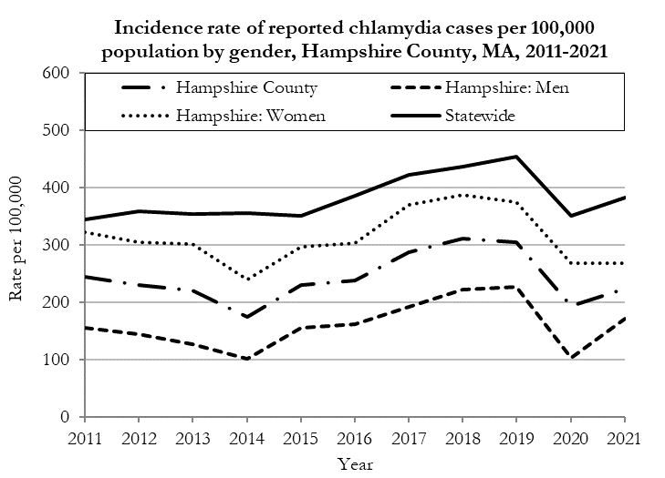

Data are current as of 10/24/2022 and are subject to change.
Population denominators: Strate S, et al. Small Area Population Estimates for 2011 through 2020 report, Oct 2016.
Data source: Massachusetts Department of Public Health/Bureau of Infectious Disease and Laboratory Sciences/Division of STD Prevention.

The chlamydia statewide and county incidence rate is highest among young adults. In 2021, the incidence rate of chlamydia was highest among 25 to 29-year-olds in Hampshire County (706.3 per 100,000).

Gonorrhea
Gonorrhea is the second most frequently reported STI both in the Commonwealth and nationally.

Since 2011, there has been an overall increase in gonorrhea cases statewide and in Hampshire County. In 2021, the county rate was 50.5 per 100,000, while the overall state rate was 115.2 per 100,000. These can be compared to the national rate of 214.0 per 100,000.‡

The county incidence rate among men remained higher compared to women. In 2021, men accounted for 74.4% of all gonorrhea cases in Hampshire County with a rate of 80.7 per 100,000 while women had a rate of 24.2 per 100,000.

In 2016, the male county incidence rate surpassed the overall statewide gonorrhea rate but returned to lower than statewide level by 2018.

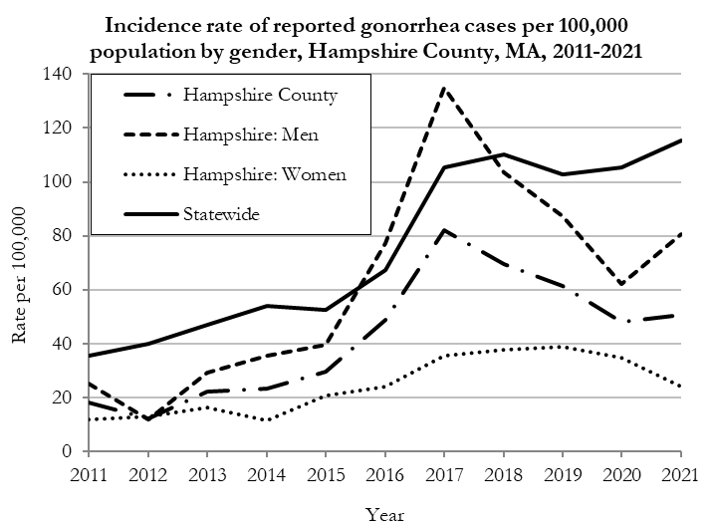

Data are current as of 10/24/2022 and are subject to change.
Population denominators: Strate S, et al. Small Area Population Estimates for 2011 through 2020 report, Oct 2016.
Data source: Massachusetts Department of Public Health/Bureau of Infectious Disease and Laboratory Sciences/Division of STD Prevention.

In 2021, the number of cases and the incidence rate of gonorrhea in Hampshire County was highest among 30 to 34-year-olds (206.0 per 100,000).

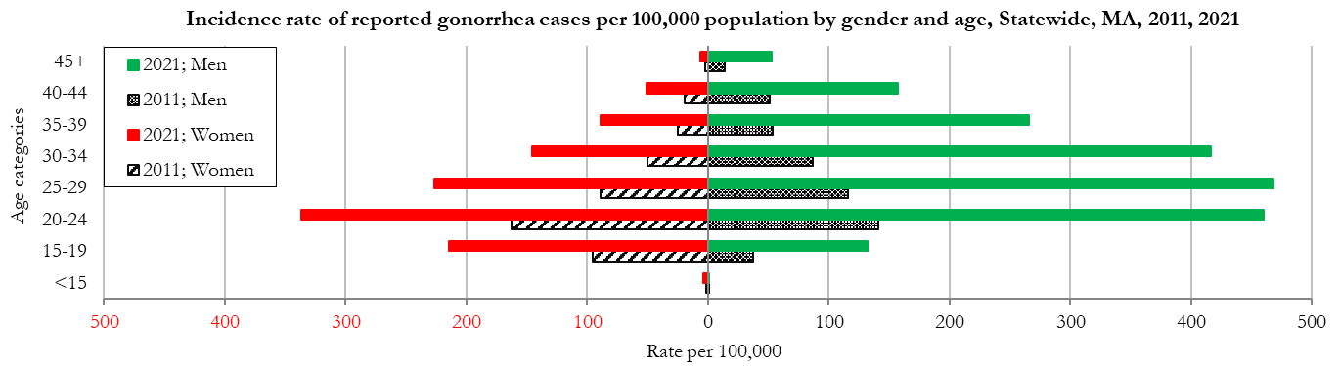
Data are current as of 10/24/2022 and are subject to change.
Population denominators: Strate S, et al. Small Area Population Estimates for 2011 through 2020 report, Oct 2016.
Data source: Massachusetts Department of Public Health/Bureau of Infectious Disease and Laboratory Sciences/Division of STD Prevention

Early Syphilis◊
Early syphilis has been on the rise in the Commonwealth and nationally since the early 2000s.‡

Since 2011, the rate of reported early syphilis has increased in Massachusetts. However, the county rate has fluctuated from a peak of 9.8 per 100,000 in 2016 to a low of 2.4 per 100,000 in 2019.

The county rate was 2.5 per 100,000 in 2021, while the statewide rate was 19.2 per 100,000. These can be compared to the national rate of 31.8 per 100,000.‡

In 2021, men accounted for 100.0% of all early syphilis cases in Hampshire County with a rate of 5.3 per 100,000.

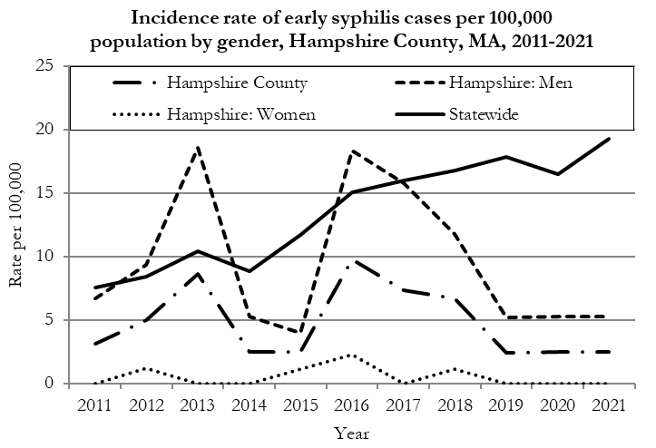
Data are current as of 10/24/2022 and are subject to change.
Population denominators: Strate S, et al. Small Area Population Estimates for 2011 through 2020 report, Oct 2016.
Data source: Massachusetts Department of Public Health/Bureau of Infectious Disease and Laboratory Sciences/Division of STD Prevention

In 2021, the highest incidence rate of early syphilis in Hampshire County was reported among 30 to 34-year-olds (12.1 per 100,000).

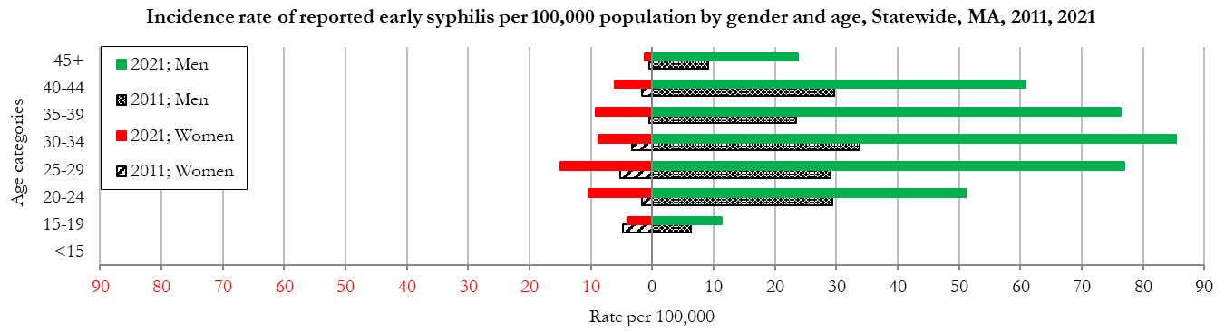
Data are current as of 10/24/2022 and are subject to change.
Population denominators: Strate S, et al. Small Area Population Estimates for 2011 through 2020 report, Oct 2016.
Data source: Massachusetts Department of Public Health/Bureau of Infectious Disease and Laboratory Sciences/Division of STD Prevention

________________
* 2020 population estimates were used to calculate 2021 disease rates throughout this report because 2021 population estimates had not been released at the time this report was published.
‡ Source: CDC: Sexually Transmitted Disease Surveillance, 2021.
◊ Early syphilis is defined as primary, secondary and early syphilis not diagnosed in the primary or secondary stages within one year of infection.
§ Please note the impact of the COVID-19 pandemic on infectious disease screening, treatment, and surveillance in the interpretation of 2020 and 2021 data.
2021 Statewide Massachusetts
Chlamydia cases have increased by 38% from 2011 to 2019 and decreased by 22% in 2020 before increasing by 9% in 2021. This is possibly due to factors such as increased service utilization after health care clinics re-opened following the end of the COVID-19 public health emergency.

Gonorrhea cases have increased 245% from 2011 to 2021 and was reported primarily among men.

Early syphilis cases have increased 170% from 2011 to 2021. From 2016 to 2021, a range of 31% to 39% of early syphilis cases were co-infected with HIV. In 2019, 2020, and 2021 congenital syphilis cases numbered 9, 10, and 9, respectively, after remaining between 0 and 4 from 2011 to 2018.

