Massachusetts Department of Public Health, Bureau of Infectious Disease and Laboratory Sciences
Summary for Hampshire County, Massachusetts, 2022
Hampshire County is a county in the Commonwealth of Massachusetts, founded in 1662. Hampshire County does not have a county government. In 2020, the population was 162,308 (U.S. Census Bureau, 2020*).

Chlamydia
Chlamydia is the most frequently reported sexually transmitted infection (STI) both in the Commonwealth and nationally.

Since 2012, there has been an overall increase in reported chlamydia cases statewide except for 2020 due to COVID-19†, overall ranging from 23,930 cases in 2012 to 28,384 cases in 2022. Hampshire County also experienced an increase in overall reported chlamydia cases, ranging from 371 in 2,012 to 413 in 2022. In 2020, Hampshire County saw its lowest rate of chlamydia infection since 2014. In 2022, the county incidence rate was 254.5 per 100,000, while the statewide rate was 403.8 per 100,000. These can be compared to the national rate of 495.0 per 100,000.‡

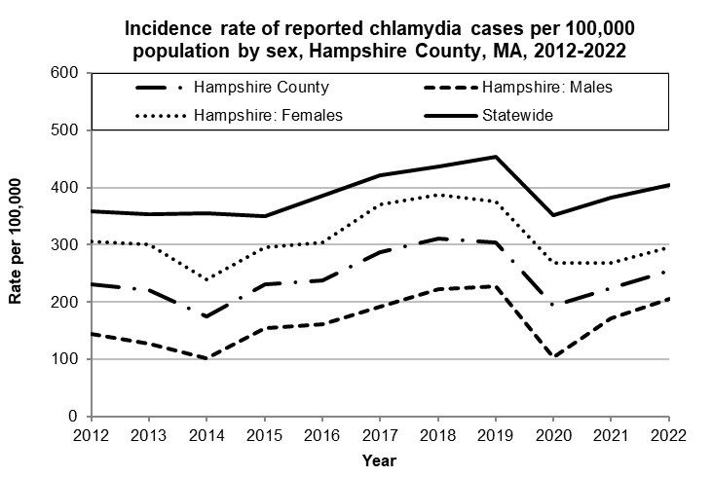
Data are current as of 12/15/2023 and are subject to change.
Population denominators: Strate S, et al. Small Area Population Estimates for 2012 through 2020 report, Oct 2016.
Data source: Massachusetts Department of Public Health/Bureau of Infectious Disease and Laboratory Sciences/Division of STD Prevention.

The county incidence rate among females remained higher compared to males. In 2022, the incidence rate among females in Hampshire County was 296.5 per 100,000, compared to the male incidence rate of 206.3 per 100,000.

The chlamydia statewide incidence rate is highest among young adults. In 2022, the incidence rate of chlamydia was highest among 20 to 24-year-olds in Hampshire County (762.8 per 100,000).

Gonorrhea
Gonorrhea is the second most frequently reported STI both in the Commonwealth and nationally.

Since 2012, there has been an overall increase of reported gonorrhea cases, ranging from 2,665 cases in 2012 to 9,129 cases in 2022. In 2022, the county incidence rate of gonorrhea infection was 55.5 per 100,000, while the overall state rate was 129.9 per 100,000. These can be compared to the national rate of 194.4 per 100,000.‡

The county incidence rate among males remained higher compared to females. In 2022, males accounted for 62.2% of all gonorrhea cases in Hampshire County with a rate of 74.0 per 100,000 while females had a rate of 39.2 per 100,000.

In 2016, the county incidence rate for males surpassed the overall statewide gonorrhea rate but returned to lower than statewide level by 2018.

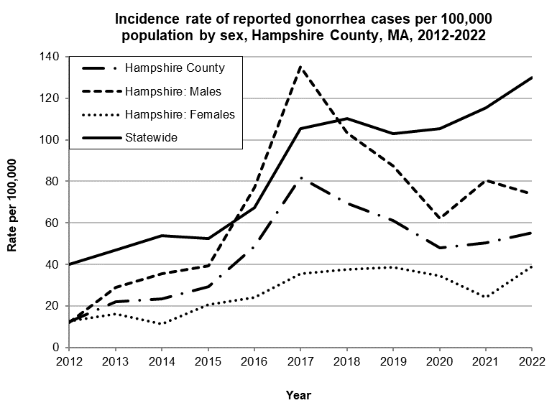
Data are current as of 12/15/2023 and are subject to change.
Population denominators: Strate S, et al. Small Area Population Estimates for 2012 through 2020 report, Oct 2016.
Data source: Massachusetts Department of Public Health/Bureau of Infectious Disease and Laboratory Sciences/Division of STD Prevention.

In 2022, the number of cases and the incidence rate of gonorrhea in Hampshire County was highest among 25-to-29-year-olds (157.0 per 100,000).

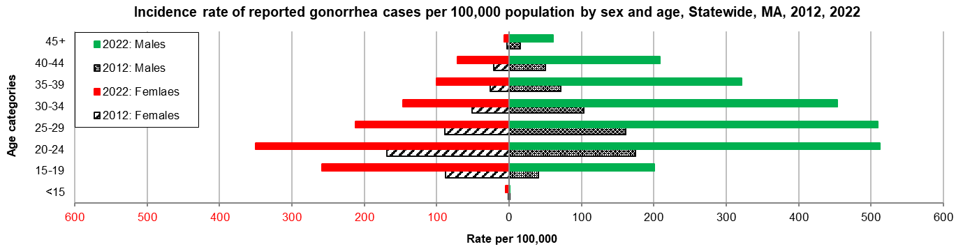
Data are current as of 12/15/2023 and are subject to change.
Population denominators: Strate S, et al. Small Area Population Estimates for 2012 through 2020 report, Oct 2016.
Data source: Massachusetts Department of Public Health/Bureau of Infectious Disease and Laboratory Sciences/Division of STD Prevention.

Early Syphilis¶
Early syphilis has been on the rise in the Commonwealth and nationally since the early 2000s.‡

Since 2012, the incidence rate of early syphilis infection has increased in Massachusetts. However, the county rate has fluctuated from a peak of 9.8 per 100,000 in 2016 to a low of 2.4 per 100,000 in 2019.

The county rate was 4.3 per 100,000 in 2022, while the statewide rate was 22.7 per 100,000. These can be compared to the national rate of 41.2 per 100,000.‡

In 2022, the rate was higher among males (5.3 per 100,000) compared to females (3.5 per 100,000).

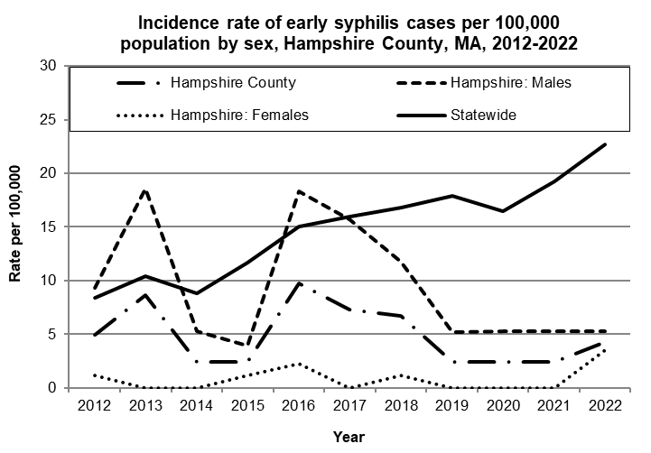
Data are current as of 12/15/2023 and are subject to change.
Population denominators: Strate S, et al. Small Area Population Estimates for 2012 through 2020 report, Oct 2016.
Data source: Massachusetts Department of Public Health/Bureau of Infectious Disease and Laboratory Sciences/Division of STD Prevention.

In 2022, the highest incidence rate of early syphilis in Hampshire County was reported among 40-to-44-year-olds (13.0 per 100,000).

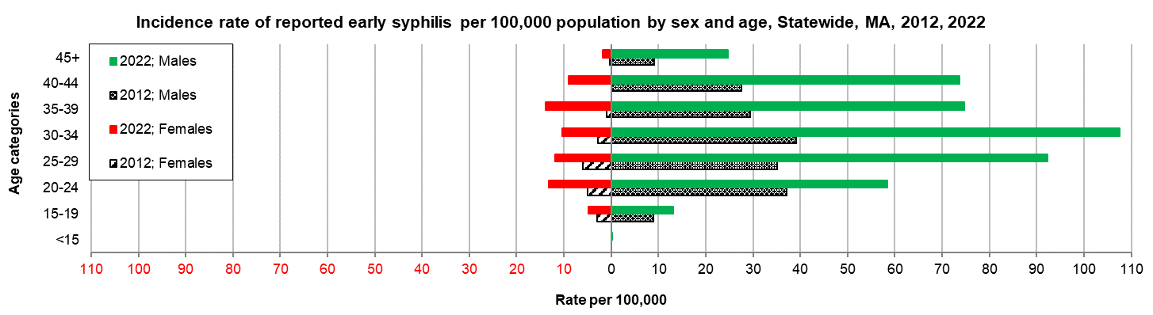
Data are current as of 12/15/2023 and are subject to change.
Population denominators: Strate S, et al. Small Area Population Estimates for 2012 through 2020 report, Oct 2016.
Data source: Massachusetts Department of Public Health/Bureau of Infectious Disease and Laboratory Sciences/Division of STD Prevention.

2022 Statewide Massachusetts
Chlamydia cases have increased by 32% from 2012 to 2019 and decreased by 22% in 2020. From 2020 to 2022, there was a 15% increase in cases. This is possibly due to factors such as increased service utilization after health care clinics reopened following the end of the COVID-19 public health emergency.

Gonorrhea cases have increased 243% from 2012 to 2022 and was reported primarily among males.

Early syphilis cases have increased 184% from 2012 to 2022. From 2017 to 2022, a range of 25% (in 2022) to 37% (in 2017) of early syphilis cases were co-infected with HIV. In 2020, 2021, and 2022 congenital syphilis cases numbered 10, 9, and 11, respectively, after remaining between 0 and 4 from 2011 to 2018.

________________
*2020 population estimates were used to calculate 2022 disease rates throughout this report because 2022 population estimates had not been released at the time this report was published.
†Please note the impact of the COVID-19 pandemic on infectious disease screening, treatment, and surveillance in the interpretation of 2020 and 2022 data.
‡Source: CDC: Sexually Transmitted Disease Surveillance, 2022.
¶Early syphilis is defined as primary, secondary and early syphilis not diagnosed in the primary or secondary stages within one year of infection.

