Massachusetts Department of Public Health, Bureau of Infectious Disease and Laboratory Sciences
Summary for Norfolk County, Massachusetts, 2022
Norfolk County is a county in the Commonwealth of Massachusetts. Norfolk County is the wealthiest county in Massachusetts (U.S. Census Bureau, 2020). In 2020, the population was 725,981 (U.S. Census Bureau, 2020*).

Chlamydia
Chlamydia is the most frequently reported sexually transmitted infection (STI) both in the Commonwealth and nationally.

Since 2012, there has been an overall increase in reported chlamydia cases statewide except for 2020 due to COVID-19†, ranging from 23,930 cases in 2012 to 28,384 cases in 2022. Norfolk County also experienced an overall increase in reported chlamydia cases, ranging from 1,491 in 2012 to 28,053 in 2022. In 2022, the county incidence rate of chlamydia infection was 282.8 per 100,000, while the statewide rate was 403.8 per 100,000. These can be compared to the national rate of 495.0 per 100,000.‡

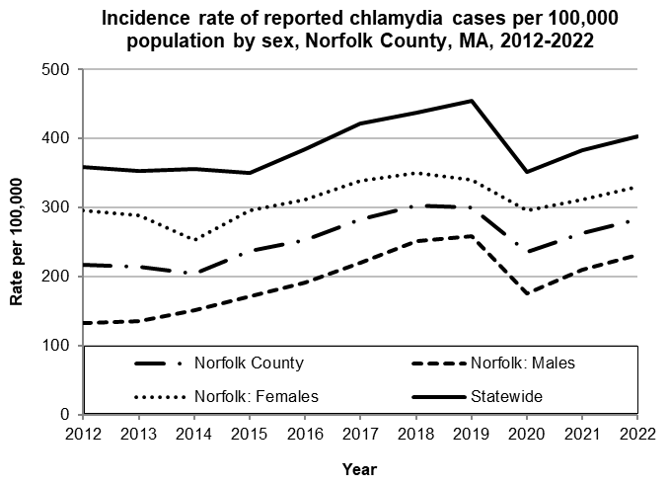
Data are current as of 12/15/2023 and are subject to change.
Population denominators: Strate S, et al. Small Area Population Estimates for 2012 through 2020 report, Oct 2016.
Data source: Massachusetts Department of Public Health/Bureau of Infectious Disease and Laboratory Sciences/Division of STD Prevention.

The county incidence rate among females remained higher compared to males. In 2022, the incidence rate of chlamydia among females in Norfolk County was 330.5 per 100,000 while males had a rate of 230.8 per 100,000.

The overall county rate and sex specific rates were consistently lower than the statewide rates.

The chlamydia statewide and county incidence rate is highest among young adults. In 2022, the incidence rate of chlamydia was highest among 20-to-24-year-olds in Norfolk County (1,841.5 per 100,000).

Gonorrhea
Gonorrhea is the second most frequently reported STI both in the Commonwealth and nationally.

Since 2012, there has been an overall increase of reported gonorrhea cases statewide, ranging from 2,665 cases in 2012 to 9,129 cases in 2022. Norfolk County also experienced an overall increase in reported gonorrhea cases, ranging from 166 in 2012 to 533 in 2022. In 2022, the county incidence rate of gonorrhea infection was 73.4 per 100,000, while the overall state rate was 129.9 per 100,000. These can be compared to the national rate of 194.4 per 100,000.‡

The county incidence rate among males remained higher compared to females. In 2022, males accounted for 72.3% of all gonorrhea cases in Norfolk County with a rate of 107.1 per 100,000 while females had a rate of 42.2 per 100,000.

In 2020, the overall county rate, and the rate among Norfolk County males decreased, while the statewide rate and rate among Norfolk County females increased.
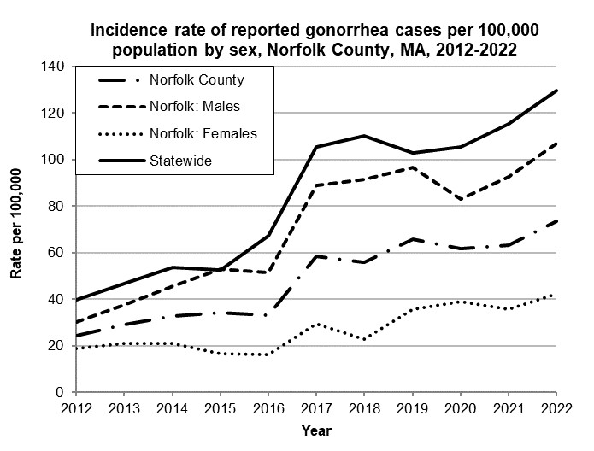
Data are current as of 12/15/2023 and are subject to change.
Population denominators: Strate S, et al. Small Area Population Estimates for 2012 through 2020 report, Oct 2016.
Data source: Massachusetts Department of Public Health/Bureau of Infectious Disease and Laboratory Sciences/Division of STD Prevention.

The gonorrhea statewide and county incidence rate is highest among young adults. In 2022, the number of cases and the incidence rate of gonorrhea in Norfolk County was highest among 20-to-24-year-olds (324.6 per 100,000).

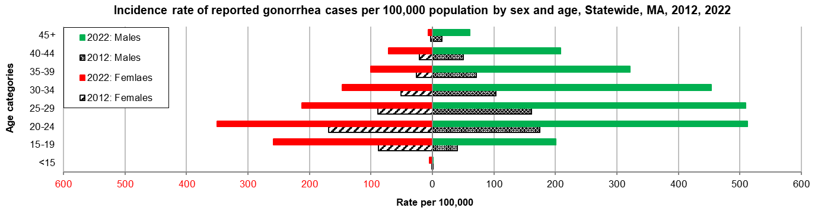
Data are current as of 12/15/2023 and are subject to change.
Population denominators: Strate S, et al. Small Area Population Estimates for 2012 through 2020 report, Oct 2016.
Data source: Massachusetts Department of Public Health/Bureau of Infectious Disease and Laboratory Sciences/Division of STD Prevention.

Early Syphilis¶
Early syphilis has been on the rise in the Commonwealth and nationally since the early 2000s.‡

Since 2012, there has been an overall increase of reported early syphilis cases statewide, ranging from 561 cases in 2012 to 1,593 cases in 2022. Norfolk County also experienced an overall increase of reported early syphilis cases, ranging from 30 cases in 2012 to 111 cases in 2022.

Since 2012, the statewide and county rates of reported syphilis have continued to increase. In 2022, the county incidence rate of early syphilis infection was 15.3 per 100,000, while the statewide rate was 22.7 per 100,000. These can be compared to the national rate of 41.2 per 100,000.‡

The county rate of early syphilis among males was much higher compared to the rate among females. In 2022, males accounted for 82.7% of all early syphilis cases with a rate of 26.1 per 100,000 while females had a rate of 5.0 per 100,000.

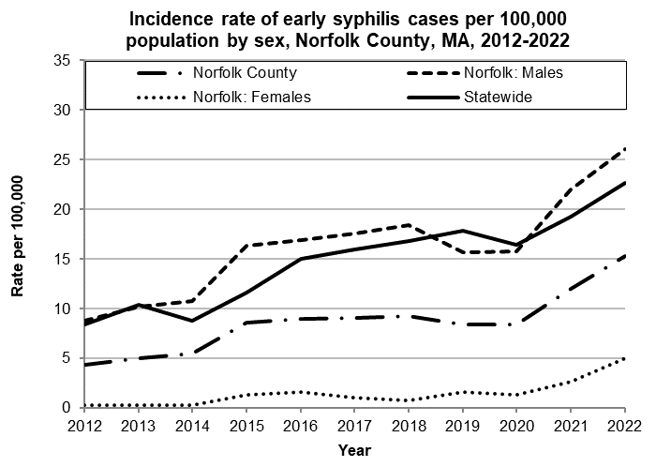
Data are current as of 12/15/2023 and are subject to change.
Population denominators: Strate S, et al. Small Area Population Estimates for 2012 through 2020 report, Oct 2016.
Data source: Massachusetts Department of Public Health/Bureau of Infectious Disease and Laboratory Sciences/Division of STD Prevention.

In 2022, the highest incidence rate of early syphilis in Norfolk County was reported among 25-to-29-year-olds (47.4 per 100,000).

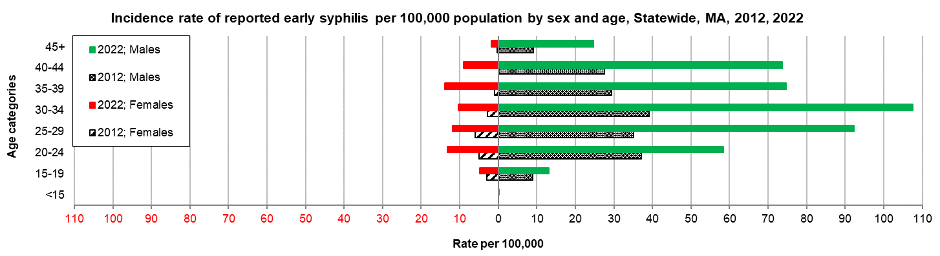
Data are current as of 12/15/2023 and are subject to change.
Population denominators: Strate S, et al. Small Area Population Estimates for 2012 through 2020 report, Oct 2016.
Data source: Massachusetts Department of Public Health/Bureau of Infectious Disease and Laboratory Sciences/Division of STD Prevention.

2022 Statewide Massachusetts
Chlamydia cases have increased by 32% from 2012 to 2019 and decreased by 22% in 2020. From 2020 to 2022, there was a 15% increase in cases. This is possibly due to factors such as increased service utilization after health care clinics reopened following the end of the COVID-19 public health emergency.

Gonorrhea cases have increased 243% from 2012 to 2022 and was reported primarily among males.

Early syphilis cases have increased 184% from 2012 to 2022. From 2017 to 2022, a range of 25% (in 2022) to 37% (in 2017) of early syphilis cases were co-infected with HIV. In 2020, 2021, and 2022 congenital syphilis cases numbered 10, 9, and 11, respectively, after remaining between 0 and 4 from 2011 to 2018.

________________
*2020 population estimates were used to calculate 2022 disease rates throughout this report because 2022 population estimates had not been released at the time this report was published.
†Please note the impact of the COVID-19 pandemic on infectious disease screening, treatment, and surveillance in the interpretation of 2020 and 2022 data.
‡Source: CDC: Sexually Transmitted Disease Surveillance, 2022.
¶Early syphilis is defined as primary, secondary and early syphilis not diagnosed in the primary or secondary stages within one year of infection.

