Massachusetts Department of Public Health, Bureau of Infectious Disease and Laboratory Sciences
Summary for Plymouth County, Massachusetts, 2021
Plymouth County is a county in the Commonwealth of Massachusetts, established in 1685. Its county seats are Plymouth and Brockton. In 2020, the population was 530,819 (U.S. Census Bureau, 2020*).

Chlamydia
Chlamydia is the most frequently reported sexually transmitted infection (STI) both in the Commonwealth and nationally.

Since 2011, there has been an overall increase in chlamydia cases statewide and in Plymouth County with the exception of 2020 due to COVID-19. In 2021, the county rate was 359.8 per 100,000, while the statewide rate was 382.8 per 100,000. These can be compared to the national rate of 495.5 per 100,000.**

The county incidence rate among women remained higher compared to men. In 2021, the incidence rate of chlamydia among women in Plymouth County was 457.1 per 100,000 while men had a rate of 256.0 per 100,000.

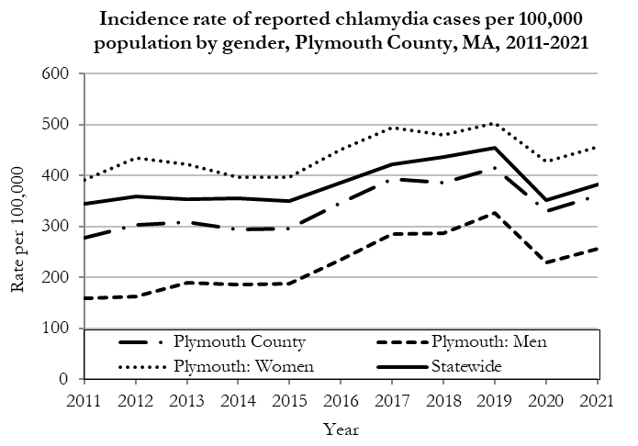

Data are current as of 10/24/2022 and are subject to change.
Population denominators: Strate S, et al. Small Area Population Estimates for 2011 through 2020 report, Oct 2016.
Data source: Massachusetts Department of Public Health/Bureau of Infectious Disease and Laboratory Sciences/Division of STD Prevention.

The chlamydia statewide and county incidence rate is highest among young adults. In 2021, the incidence rate of chlamydia was highest among 20 to 24-year-olds in Plymouth County (2,300.2 per 100,000).

Gonorrhea
Gonorrhea is the second most frequently reported STI both in the Commonwealth and nationally.

Since 2011, there has been an overall increase in gonorrhea cases statewide and in Plymouth County. In 2021, the county rate was 91.9 per 100,000, while the overall state rate was 115.2 per 100,000. These can be compared to the national rate of 214.0 per 100,000.**

The county incidence rate among men remained higher compared to women. In 2021, men accounted for 58.9% of all gonorrhea cases in Plymouth County with a rate of 111.3 per 100,000 while women had a rate of 73.2 per 100,000.

Since 2015, the gonorrhea incidence rate of men in Plymouth County has surpassed the overall statewide incidence rate, except in 2019 and 2021.

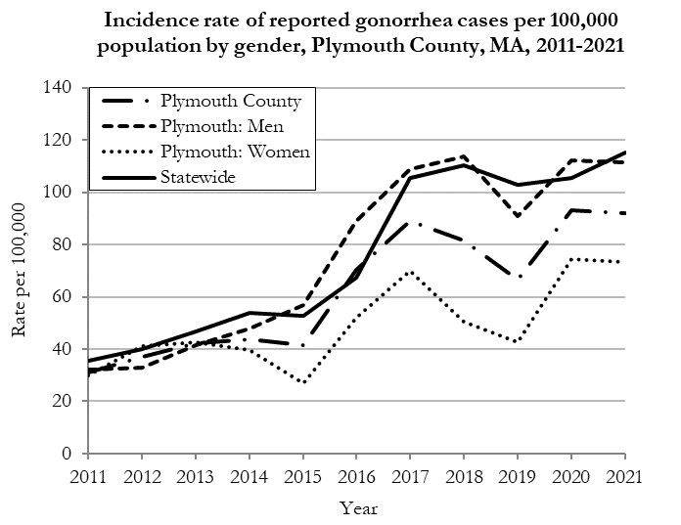
Data are current as of 10/24/2022 and are subject to change.
Population denominators: Strate S, et al. Small Area Population Estimates for 2011 through 2020 report, Oct 2016.
Data source: Massachusetts Department of Public Health/Bureau of Infectious Disease and Laboratory Sciences/Division of STD Prevention.

The gonorrhea statewide and county incidence rate is highest among young adults. In 2021, the number of cases and the incidence rate of gonorrhea in Plymouth County was highest among 20 to 24-year-olds (409.7 per 100,000).

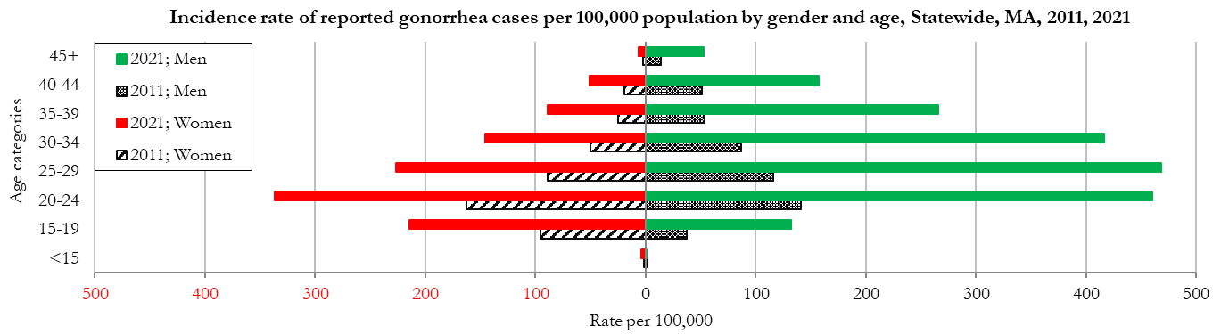
Data are current as of 10/24/2022 and are subject to change.
Population denominators: Strate S, et al. Small Area Population Estimates for 2011 through 2020 report, Oct 2016.
Data source: Massachusetts Department of Public Health/Bureau of Infectious Disease and Laboratory Sciences/Division of STD Prevention

Early Syphilis◊
Early syphilis has been on the rise in the Commonwealth and nationally since the early 2000s.‡

Since 2011, the statewide and county rates of reported syphilis has continued to increase. In 2021, the county rate was 14.9 per 100,000, while the statewide rate was 19.2 per 100,000. These can be compared to the national rate of 31.8 per 100,000.**

The county early syphilis rate among men was much higher compared to the rate among women. In 2021, men accounted for 83.5% of all early syphilis cases in Plymouth County with a rate of 25.6 per 100,000 while women had a rate of 4.8 per 100,000.
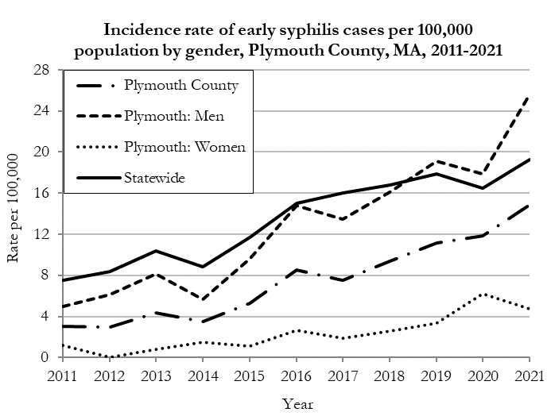
Data are current as of 10/24/2022 and are subject to change.
Population denominators: Strate S, et al. Small Area Population Estimates for 2011 through 2020 report, Oct 2016.
Data source: Massachusetts Department of Public Health/Bureau of Infectious Disease and Laboratory Sciences/Division of STD Prevention.

In 2021, the highest incidence rate of early syphilis in Plymouth County was reported among 30 to 34-year-olds (46.7 per 100,000).

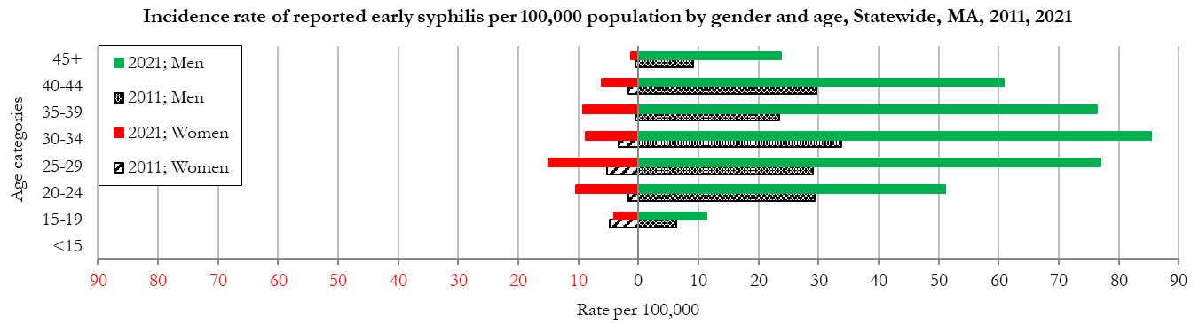
Data are current as of 10/24/2022 and are subject to change.
Population denominators: Strate S, et al. Small Area Population Estimates for 2011 through 2020 report, Oct 2016.
Data source: Massachusetts Department of Public Health/Bureau of Infectious Disease and Laboratory Sciences/Division of STD Prevention

________________
* 2020 population estimates were used to calculate 2021 disease rates throughout this report because 2021 population estimates had not been released at the time this report was published.
‡ Source: CDC: Sexually Transmitted Disease Surveillance, 2021.
◊ Early syphilis is defined as primary, secondary and early syphilis not diagnosed in the primary or secondary stages within one year of infection.
§ Please note the impact of the COVID-19 pandemic on infectious disease screening, treatment, and surveillance in the interpretation of 2020 and 2021 data.
2021 Statewide Massachusetts
Chlamydia cases have increased by 38% from 2011 to 2019 and decreased by 22% in 2020 before increasing by 9% in 2021. This is possibly due to factors such as increased service utilization after health care clinics re-opened following the end of the COVID-19 public health emergency.

Gonorrhea cases have increased 245% from 2011 to 2021 and was reported primarily among men.

Early syphilis cases have increased 170% from 2011 to 2021. From 2016 to 2021, a range of 31% to 39% of early syphilis cases were co-infected with HIV. In 2019, 2020, and 2021 congenital syphilis cases numbered 9, 10, and 9, respectively, after remaining between 0 and 4 from 2011 to 2018.

