Massachusetts Department of Public Health, Bureau of Infectious Disease and Laboratory Sciences
Summary for Suffolk County, Massachusetts, 2021
Suffolk County is a county in the Commonwealth of Massachusetts. In 2020, the population was 797,936 making it the third most populous county in terms of population in Massachusetts. Boston, the state capital and most populous city in New England, is located in this county (U.S. Census Bureau, 2020*).

Chlamydia
Chlamydia is the most frequently reported sexually transmitted infection (STI) both in the Commonwealth and nationally.

Since 2011, there has been an overall increase in chlamydia cases statewide and in Suffolk County, with the exception of 2020 due to COVID-19§. In 2021, the county rate was 220.5 per 100,000, while the statewide rate was 382.8 per 100,000. Among all counties in the Commonwealth, Suffolk County had the highest incidence rate of chlamydia in 2021 at 779.4 per 100,000, while the statewide rate was 382.8 per 100,000. These can be compared to the national rate of 495.5 per 100,000.‡

The county incidence rate among women remained higher compared to men. In 2021, the incidence rate of chlamydia among women in Suffolk County was 854.1 per 100,000 and 695.3 per 100,000 for men.

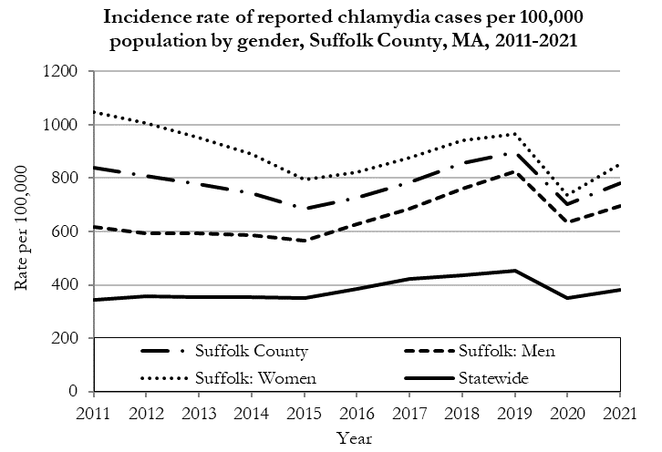
Data are current as of 10/24/2022 and are subject to change.
Population denominators: Strate S, et al. Small Area Population Estimates for 2011 through 2020 report, Oct 2016.
Data source: Massachusetts Department of Public Health/Bureau of Infectious Disease and Laboratory Sciences/Division of STD Prevention.

The chlamydia statewide and county incidence rate is highest among young adults. In 2021, the incidence rate of chlamydia was highest among 20 to 24-year-olds in Suffolk County (2,777.0 per 100,000).

Gonorrhea
Gonorrhea is the second most frequently reported STI both in the Commonwealth and nationally.

Since 2011, there has been an overall increase in gonorrhea cases statewide and in Suffolk County. In 2021, the county rate was 285.5 per 100,000, while the overall state rate was 115.2 per 100,000. These can be compared to the national rate of 214.0 per 100,000.‡

The county incidence rate among men remained higher than women and the overall state rate. In Suffolk County, men accounted for 75.1% of all gonorrhea cases in 2021 (441.4 per 100,000) while women had a rate of 136.9 per 100,000.

In 2021 the overall Suffolk County incidence rate, as well as both the male and female specific rates of gonorrhea, surpassed the statewide rate.
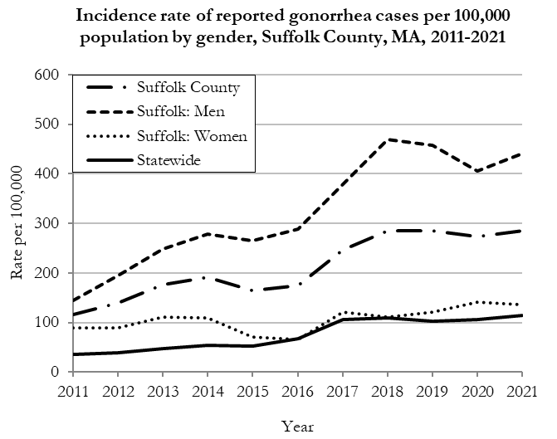
Data are current as of 10/24/2022 and are subject to change.
Population denominators: Strate S, et al. Small Area Population Estimates for 2011 through 2020 report, Oct 2016.
Data source: Massachusetts Department of Public Health/Bureau of Infectious Disease and Laboratory Sciences/Division of STD Prevention.

Among women in Suffolk County, the incidence rate of gonorrhea was highest among 20 to 24-year-olds (434.7 per 100,000) in 2021. Similarly, among men in Suffolk County, the incidence rate of gonorrhea was highest among 20 to 24-year-olds (895.5 per 100,000) in 2021

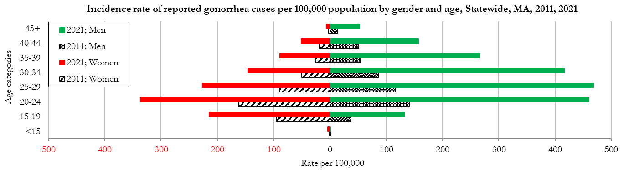
Data are current as of 10/24/2022 and are subject to change.
Population denominators: Strate S, et al. Small Area Population Estimates for 2011 through 2020 report, Oct 2016.
Data source: Massachusetts Department of Public Health/Bureau of Infectious Disease and Laboratory Sciences/Division of STD Prevention

Early Syphilis◊
Early syphilis has been on the rise in the Commonwealth and nationally since the early 2000s.‡

Since 2011, the statewide and county rate of reported early syphilis has increased. In 2021, the county rate was 47.9 per 100,000, The statewide rate was 19.2 per 100,000.These can be compared to the national rate of 31.8 per 100,000.‡

In 2021, the reported early syphilis rate among men was much higher compared to the rate among women in Suffolk County. Men accounted for 90.6% of all early syphilis cases (89.8 per 100,000) while women had a rate of 8.7 per 100,000.
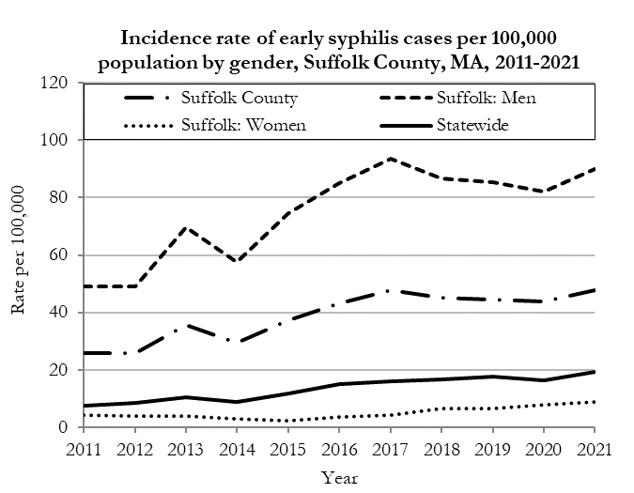
Data are current as of 10/24/2022 and are subject to change.
Population denominators: Strate S, et al. Small Area Population Estimates for 2011 through 2020 report, Oct 2016.
Data source: Massachusetts Department of Public Health/Bureau of Infectious Disease and Laboratory Sciences/Division of STD Prevention.

In 2021, the highest incidence of early syphilis in Suffolk County was reported among 35 to 39-year-olds (79.0 per 100,000).

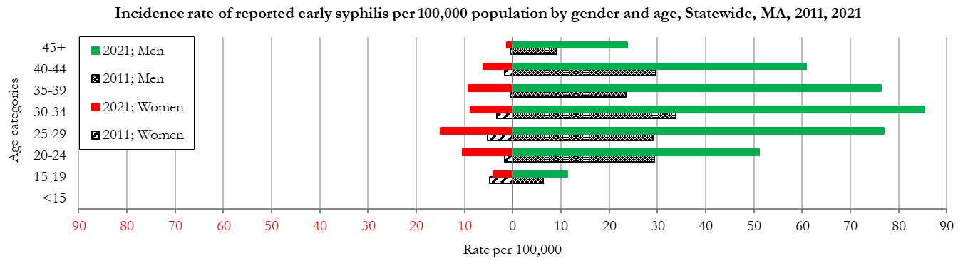
Data are current as of 10/24/2022 and are subject to change.
Population denominators: Strate S, et al. Small Area Population Estimates for 2011 through 2020 report, Oct 2016.
Data source: Massachusetts Department of Public Health/Bureau of Infectious Disease and Laboratory Sciences/Division of STD Prevention

________________
* 2020 population estimates were used to calculate 2021 disease rates throughout this report because 2021 population estimates had not been released at the time this report was published.
‡ Source: CDC: Sexually Transmitted Disease Surveillance, 2021.
◊ Early syphilis is defined as primary, secondary and early syphilis not diagnosed in the primary or secondary stages within one year of infection.
§ Please note the impact of the COVID-19 pandemic on infectious disease screening, treatment, and surveillance in the interpretation of 2020 and 2021 data.
2021 Statewide Massachusetts
Chlamydia cases have increased by 38% from 2011 to 2019 and decreased by 22% in 2020 before increasing by 9% in 2021. This is possibly due to factors such as increased service utilization after health care clinics re-opened following the end of the COVID-19 public health emergency.

Gonorrhea cases have increased 245% from 2011 to 2021 and was reported primarily among men.

Early syphilis cases have increased 170% from 2011 to 2021. From 2016 to 2021, a range of 31% to 39% of early syphilis cases were co-infected with HIV. In 2019, 2020, and 2021 congenital syphilis cases numbered 9, 10, and 9, respectively, after remaining between 0 and 4 from 2011 to 2018.

