Massachusetts Department of Public Health, Bureau of Infectious Disease and Laboratory Sciences
Summary for Suffolk County, Massachusetts, 2024
Suffolk County, located in eastern Massachusetts and encompassing Boston, Chelsea, Revere, and Winthrop, was established in 1643 and includes the state capital and surrounding urban communities. As of July 1, 2024, it has an estimated population of 793,144, down slightly from 800,937 at the 2020 Census. As of 2024, the population is racially and ethnically diverse, with 61.0% identifying as White alone, 23.5% as Black or African American alone, 10.4% as Asian alone, 0.8% as American Indian and Alaska Native alone, 0.2% as Native Hawaiian and Other Pacific Islander alone, and 4.1% reporting two or more races. Hispanic or Latino residents make up about 24.1% of the population. In the county, 15.8% of residents are under 18 years old and 13.9% are 65 years and over. In comparison, Massachusetts’ population has 19.0% under 18 years old and 18.7% aged 65 and over. The county also exhibits a slightly higher proportion of females compared to males, with approximately 51.8% of the population identifying as female.¹

Quick Stats
Data are current as of 6/02/2025 and are subject to change.
Population denominators: Strate S, et al. Small Area Population Estimates for 2011 through 2020 report, Oct 2016.
Data source: Massachusetts Department of Public Health/Bureau of Infectious Disease and Laboratory Sciences/Division of STD Prevention.

Chlamydia
Chlamydia has the highest reported incidence among STIs in Massachusetts and nationally. It is a bacterial infection that can spread through vaginal, anal, or oral sexual contact with an infected partner and from pregnant person to child during birth. While most people with chlamydia have no signs or symptoms, some may experience dysuria; vaginal, penile, or anal discharge; or irregular bleeding. Chlamydia is easily treated with medication from a medical provider, but repeated infections are common. Women are at a greater risk of complications from repeated infections.²

Since 2015, there has been an overall increase in reported chlamydia cases statewide, except for 2020, when case counts temporarily dropped due to the impacts of the COVID-19 pandemic³. During this period, statewide case counts ranged from 23,944 cases in 2015 to 26,623 cases in 2024. Suffolk County also experienced an overall increase in reported chlamydia cases, ranging from 5,373 cases in 2015 to 6,192 cases in 2024, with a peak of 7,285 in 2019. In 2024, the county incidence rate of chlamydia infection was 776.0 per 100,000, while the statewide rate was 378.7 per 100,000. While the statewide rate is lower compared to the national rate of 445.7 per 100,000, the county rate is higher than both the national and statewide rates.⁴ Since 2015, the incidence rate of Suffolk County has been consistently higher than the overall state incidence rate.

Between 2015 and 2024, the county incidence rate among females remained higher compared to males, overall county, and statewide. In 2024, the incidence rate of chlamydia among females was 910.1 per 100,000, compared to 631.2 per 100,000 among males.

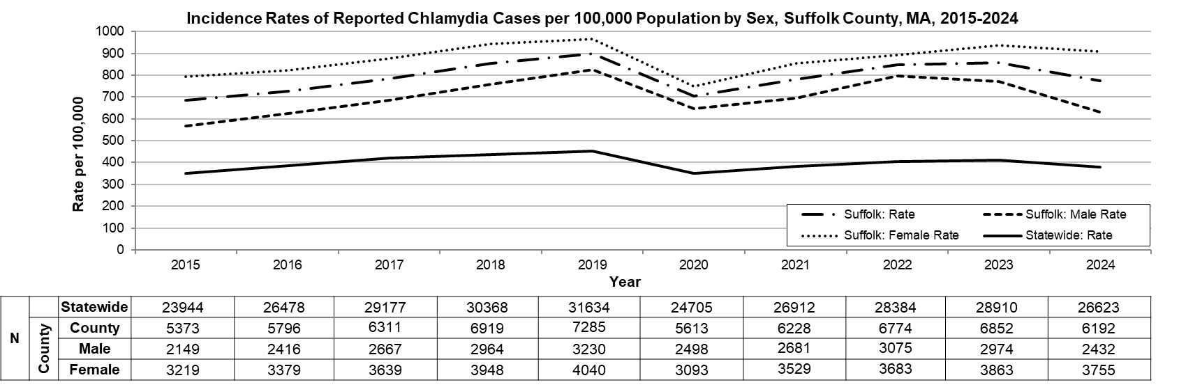
Data are current as of 6/02/2025 and are subject to change.
Population denominators: Strate S, et al. Small Area Population Estimates for 2011 through 2020 report, Oct 2016.
Data source: Massachusetts Department of Public Health/Bureau of Infectious Disease and Laboratory Sciences/Division of STD Prevention.

The statewide and county incidence rates of chlamydia are highest among young adults. In 2024, 3,159 chlamydia cases were reported among 20–29-year-olds, at a rate of 1,791.4 per 100,000, the highest among all age groups in Suffolk County. Females accounted for 1989 cases (63.0%) within this age group, with a rate of 2,192.1 per 100,000, while 1169 cases (37.0) were reported among males, at a rate of 1,365.5 per 100,000. Although the chart below represents rates by age group only, the highest burden is concentrated among 20-29-year-old females. Data by gender within each age group are not displayed due to suppression rules.

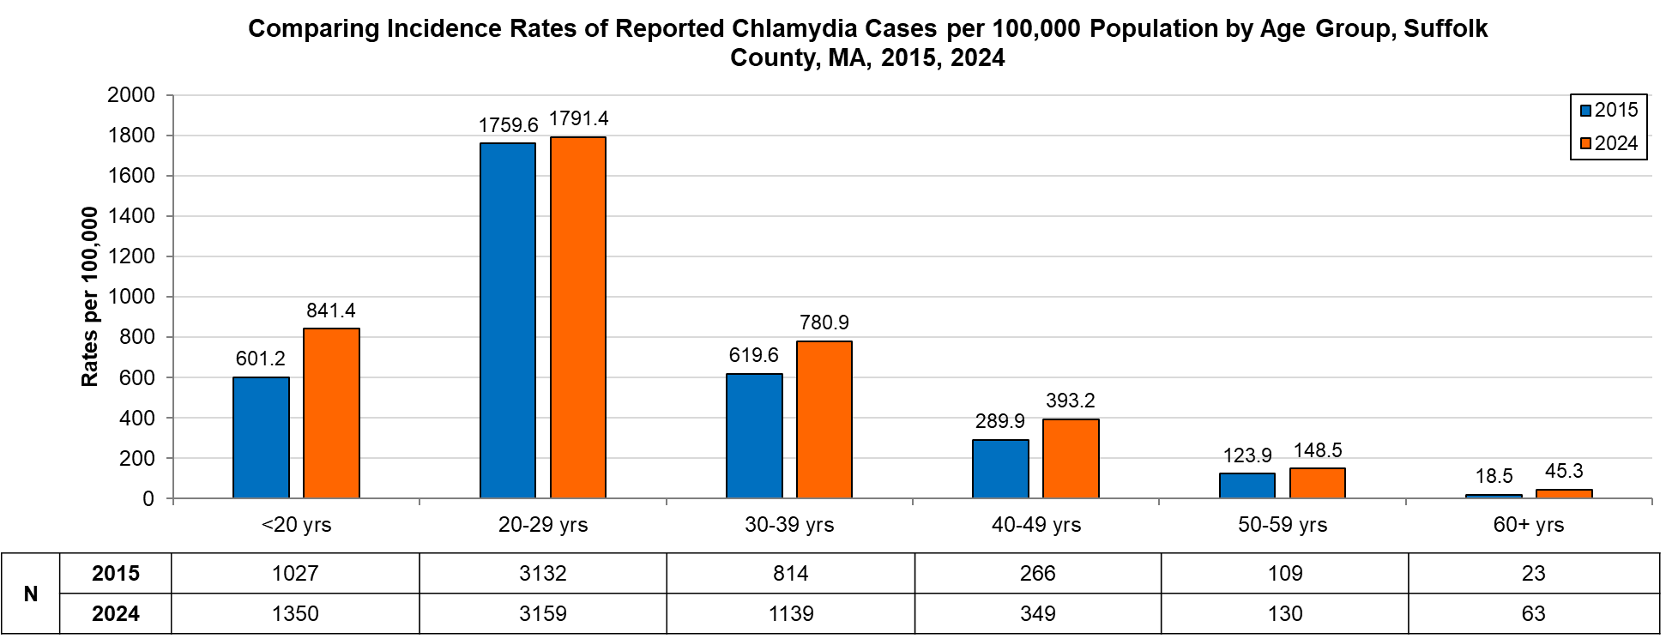
Data are current as of 6/02/2025 and are subject to change.
Population denominators: Strate S, et al. Small Area Population Estimates for 2011 through 2020 report, Oct 2016.
Data source: Massachusetts Department of Public Health/Bureau of Infectious Disease and Laboratory Sciences/Division of STD Prevention.

Gonorrhea
Gonorrhea has the second highest incidence among STIs reported both in Massachusetts and nationally. It can spread through vaginal, anal, or oral sexual contact with an infected partner or to an infant during birth. Symptoms of gonococcal infection can vary depending on the site of infection and may include dysuria, vaginal, penile, or anal discharge; irregular bleeding; abdominal or anal pain; and sore throat. Many infected individuals do not present with any symptoms of infection, though males are more likely than females to experience symptoms. Although gonorrhea infection is treatable, it has become more complex with increased antimicrobial non-susceptibility.²

Since 2015, there has been an overall increase in reported gonorrhea cases statewide, ranging from 3,592 cases in 2015 to 8,678 cases in 2024. In 2024, the county incidence rate of gonorrhea infection was 325.6 per 100,000, which surpassed the statewide rate of 123.4 per 100,000 and the national rate of 159.8 per 100,000.⁴

Between 2015 and 2024, the county incidence rate among males has been higher than that of females, the overall county, and statewide rates. In 2024, males accounted for approximately 73.2% of all gonorrhea cases in Suffolk County with a rate of 493.3 per 100,000, more than twice the rate among females (167.5 per 100,000).

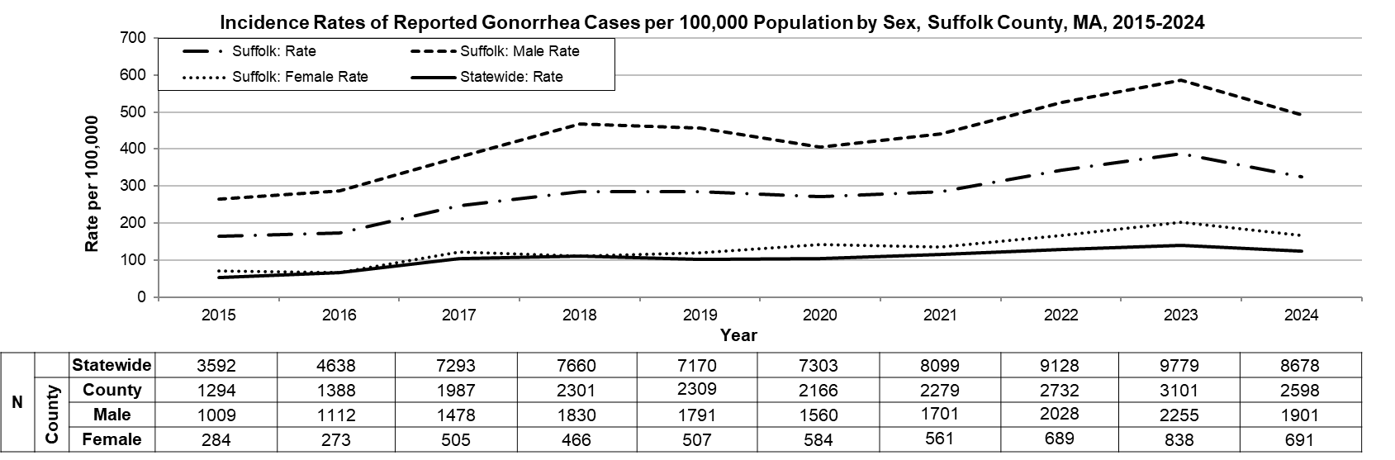
Data are current as of 6/02/2025 and are subject to change.
Population denominators: Strate S, et al. Small Area Population Estimates for 2011 through 2020 report, Oct 2016.
Data source: Massachusetts Department of Public Health/Bureau of Infectious Disease and Laboratory Sciences/Division of STD Prevention.

In 2024, 1,047 gonorrhea cases were reported among 20-29 year-olds, at a rate of 593.7 per 100,000, the highest among all age groups in Suffolk County. Females accounted for 299 cases (28.6%) within the age group, with a rate of 329.5 per 100,000, while 744 cases (71.1%) were reported for males, at a rate of 869.1 per 100,000. Although the chart below represents rates by age group only, the highest burden is concentrated among 20-29-year-old males. Data by gender within each age group are not displayed due to suppression rules.

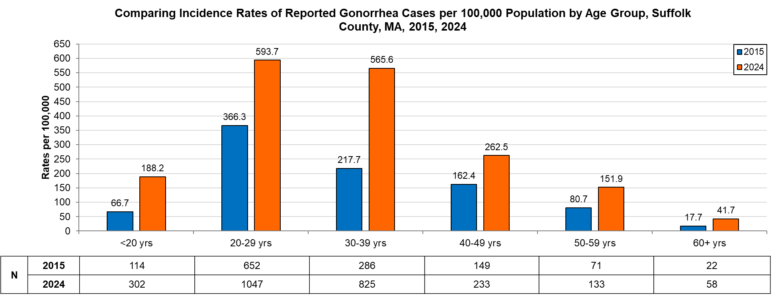
Data are current as of 6/02/2025 and are subject to change.
Population denominators: Strate S, et al. Small Area Population Estimates for 2011 through 2020 report, Oct 2016.
Data source: Massachusetts Department of Public Health/Bureau of Infectious Disease and Laboratory Sciences/Division of STD Prevention.

Infectious Syphilis⁵
Infectious Syphilis, which includes primary, secondary, and early non-primary, non-secondary stages, has been on the rise in the Commonwealth and nationally since the early 2000s, but in more recent years there has been a decrease. It can spread through sexual contact with an infected person. The first symptom of syphilis infection is a sore or chancre at the site of inoculation that is usually firm, round, and painless. The most recognized symptom of the second stage of infection is a body rash which can be present on the palms of hands and soles of feet. As with primary syphilis symptoms, secondary syphilis symptoms also resolve with or without treatment. After the secondary stage of syphilis, untreated infected individuals enter a time of latent syphilis that can last for years. Individuals with syphilis are thought to be most infectious for the first year after acquisition. Syphilis infection can also be transmitted to an infant during pregnancy and birth.²

Since 2015, there has been an overall increase of reported infectious syphilis cases statewide, ranging from 789 cases in 2015 to 1,329 cases in 2024. Suffolk County also experienced a slight overall increase in reported infectious syphilis cases, ranging from 293 in 2015 to a peak of 452 in 2022, before declining to 357 in 2024. In 2024, the county incidence rate of infectious syphilis was 44.7 per 100,000, which is higher than the statewide rate of 18.9 per 100,000 and the national rate of 26.2 per 100,000 (based on CDC data for primary, secondary, and early non-primary, non-secondary syphilis).⁴

Between 2015 and 2024, the county rate of infectious syphilis among males was much higher compared to the rate among females. In 2024, males accounted for 83.5% of all infectious syphilis cases in the county with a rate of 77.3 per 100,000, more than five times than that of females (14.3 per 100,000).
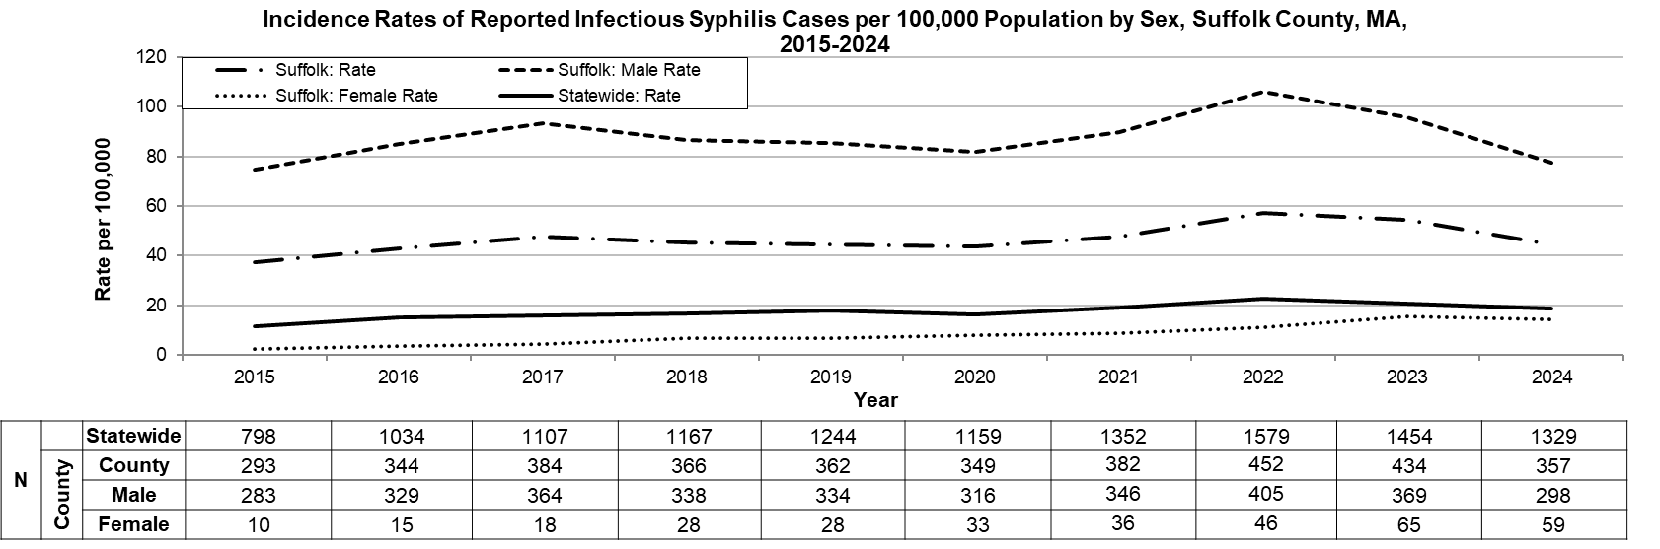
Data are current as of 6/02/2025 and are subject to change.
Population denominators: Strate S, et al. Small Area Population Estimates for 2011 through 2020 report, Oct 2016.
Data source: Massachusetts Department of Public Health/Bureau of Infectious Disease and Laboratory Sciences/Division of STD Prevention.

In 2024, 128 infectious syphilis cases were reported among 30–39-year-olds, at a rate of 87.8 per 100,000, the highest among all age groups in Suffolk County. Males accounted for 109 cases (85.2%) in this age group, with a rate of 148.7 per 100,000, while 19 cases (14.8%) were reported among females, at a rate of 26.2 per 100,000. Although the chart below represents rates by age group only, the highest burden is concentrated among 30-39-year-old males. Data by gender within each age group are not displayed due to suppression rules.

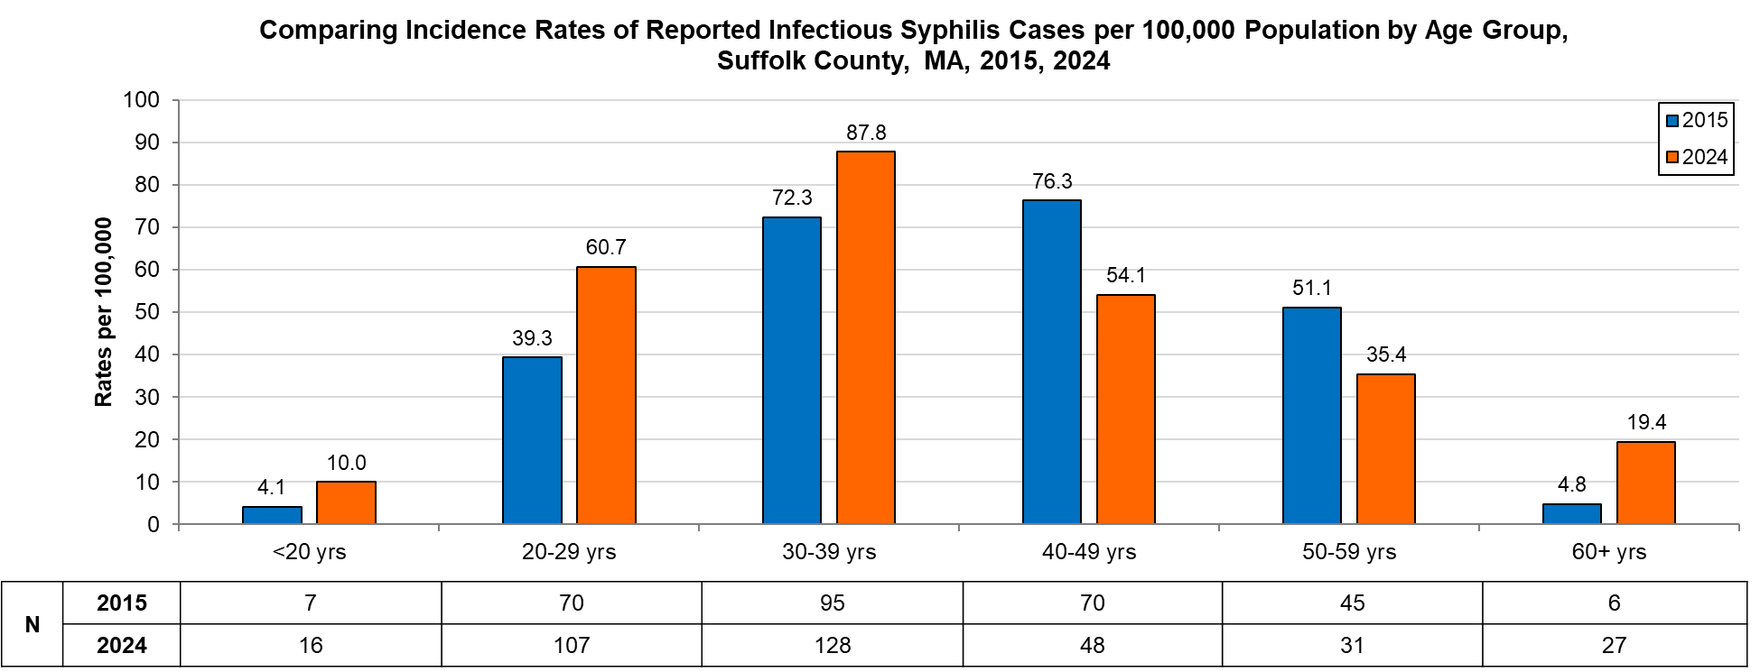
Data are current as of 6/02/2025 and are subject to change.
Population denominators: Strate S, et al. Small Area Population Estimates for 2011 through 2020 report, Oct 2016.
Data source: Massachusetts Department of Public Health/Bureau of Infectious Disease and Laboratory Sciences/Division of STD Prevention.

2024 Statewide Massachusetts
Chlamydia cases have increased by 18.5% from 2015 (n=23,944) to 2022 (n=28,384) and decreased by 6.2% in 2024 (n=26,623). From 2020 to 2024, there was a 7.8% increase in cases. This is possibly due to factors such as increased service utilization after health care clinics re-opened following the end of the COVID-19 public health emergency.

Gonorrhea cases have increased 233.3% from 2015 (n=3,592) to 2024, peaking at 9,779 cases in 2023 before declining to 8,678 cases in 2024. Unlike chlamydia, gonorrhea cases did not drop during the COVID-19 public health emergency. Between 2015 and 2024, the majority of gonorrhea cases were reported among males. There were 11 reported cases of Disseminated Gonococcal Infection (DGI) in 2024, an increase from 6 in 2022. In 2022, a novel strain of multi-drug-non-susceptible Neisseria gonorrhoeae was identified in two Massachusetts residents. As a result, Massachusetts DPH released a clinical alert in January 2023 requesting that clinicians perform gonococcal culture in addition to NAAT testing for symptomatic patients. Two additional multi-drug-non-susceptible cases of gonorrhea have been identified since then.

Infectious syphilis cases have increased 43.8% from 2015 (n=798) to 2024, peaking at 1,579 cases in 2022 before declining to 1,329 cases in 2024. Despite close follow-up of cases of syphilis in pregnant patients and their partners, breakthrough cases of congenital syphilis have increased in Massachusetts. From 2021 to 2024, the annual number of probable cases of congenital syphilis diagnosed in Massachusetts ranged from 9 to 18 after remaining between zero and four from 2011 to 2018. However, as of September 2023, Massachusetts ranks 44th among the 48 states reporting congenital syphilis incidence, indicating relatively better outcomes compared to many other states.

Among individuals of transgender experience and/or individuals who are nonbinary, 51 chlamydia, 91 gonorrhea, and 5 infectious syphilis cases were reported in Massachusetts.⁶
________________________________________________________________________________
¹ Source: U.S. Census Bureau. QuickFacts: Suffolk County, Massachusetts; Massachusetts. Population Estimates Program, July 1,2024 (Vintage 2024).
² Source: CDC: Sexually Transmitted Infections
³ Please note the impact of the COVID-19 pandemic on infectious disease screening, treatment, and surveillance in the interpretation of 2020-2023 data ⁴ Source: CDC: Sexually Transmitted Infections Surveillance, 2024 (Provisional).
⁵ Infectious syphilis is defined as primary, secondary and early latent stages of syphilis within one year of infection.
⁶ Please note that reported numbers among individuals of transgender experience and individuals who are nonbinary are likely to be underestimates. Underreporting may occur due to the absence of appropriate gender identity options (e.g., individuals who are genderqueer, pangender, gender fluid, androgynous, etc.) in data collection systems.

