Arbovirus Surveillance in Massachusetts 2014

Massachusetts Department of Public Health (MDPH)

Arbovirus Surveillance Program

**INTRODUCTION**

There are two mosquito-borne diseases of concern in Massachusetts, Eastern equine encephalitis (EEE), which was identified as a human disease in 1938, and West Nile virus (WNV) infection, which has been present since 2000. EEE is a rare but serious neuroinvasive disease that causes meningitis or encephalitis, and often results in death or severe disability. WNV infection is more common, though typically less severe than EEE; presentation of WNV ranges from febrile illness to neuroinvasive disease. Although up to 51 different species of mosquitoes have been identified in Massachusetts, only a few of these contribute to either WNV or EEE spread. For more information, visit the MDPH website to view [Common Mosquitoes That Can Spread Disease in Massachusetts](http://www.mass.gov/eohhs/docs/dph/cdc/arbovirus/mosquito-species-ma.pdf).

Currently there are no available vaccines to prevent human infections from either mosquito-borne virus. Personal protection measures that serve to reduce exposure to mosquitoes and thereby prevent human infection remain the mainstay of prevention. To estimate the risk of human disease during a mosquito season, the MDPH, in cooperation with the local Mosquito Control Projects, conducts surveillance for EEE and WNV using mosquito samples, and specimens from human and veterinary sources. Detailed information about surveillance for these diseases in Massachusetts is available on the MDPH website at [Arbovirus Surveillance and Control Plan](http://www.mass.gov/eohhs/docs/dph/cdc/arbovirus/arbovirus-surveillance-plan.pdf).

**EASTERN EQUINE ENCEPHALITIS VIRUS**

##### Humans

There were no human cases of EEE infection was identified in Massachusetts in 2014. There was one human case of EEE infection in 2013.

## Mosquito Samples

Of 5,039 mosquito samples collected in Massachusetts in 2014, 33 (0.7%) were positive for EEE virus in 2014. Positive mosquito samples included 24 (76%) *Culiseta melanura*, five (15%) *Coquillettidia perturbans*, two (6%) *Culex* species and one (3%) *Urotania sappherina*. Positive samples were identified from 13 towns in four counties. For a complete list of positive mosquito samples by city/town, please see the [Mosquito Summary by County and Municipality](http://www.mass.gov/eohhs/gov/departments/dph/programs/id/epidemiology/researchers/public-health-cdc-arbovirus-surveillance.html) report posted on the MDPH website.

## Animals

## Seven veterinary samples were submitted for arbovirus testing. Two animal cases of EEE infection were identified in Massachusetts in 2014.

|  |  |  |  |  |  |  |  |  |  |  |  |  |
| --- | --- | --- | --- | --- | --- | --- | --- | --- | --- | --- | --- | --- |
| |  |  |  |  | | --- | --- | --- | --- | | **City or Town** | **Animal Species** | **Onset Date** | **Virus Result** | | Freetown | Deer | 8/9/2014 | EEE | | Westminster | Horse | 10/5/2014 | EEE | |

## Birds

Although birds are not routinely tested as part of EEE surveillance, species such as emus or exotic quail may experience sudden illness and mortality due to EEE. Farmed birds showing these signs must be reported promptly to the Massachusetts Department of Agricultural Resources (MDAR).

**EEE Geographic Risk Levels**

EEE risk maps combine historical data and areas of mosquito habitat with current data on positive virus isolations (in humans, mosquitoes, etc.) and weather conditions. Risk levels are an estimate of the likelihood of an outbreak of human disease and are updated regularly with new surveillance data. Initial and final EEE risk levels from the 2014 season are provided in the following maps. This information will be used to help anticipate risk in 2015, and will be revised as 2015 surveillance data are collected. More detailed information about risk assessment and risk levels is available in the [Arbovirus Surveillance and Response Plan](http://www.mass.gov/eohhs/docs/dph/cdc/arbovirus/arbovirus-surveillance-plan.pdf) on the MDPH web site.

**Initial and Final 2014 EEE Risk Categories**

(As defined in Table 2 of the MDPH Arbovirus Surveillance and Response Plan which can be found at [www.mass.gov/dph/mosquito](http://www.mass.gov/dph/mosquito) under “Information for Local Boards of Health”)

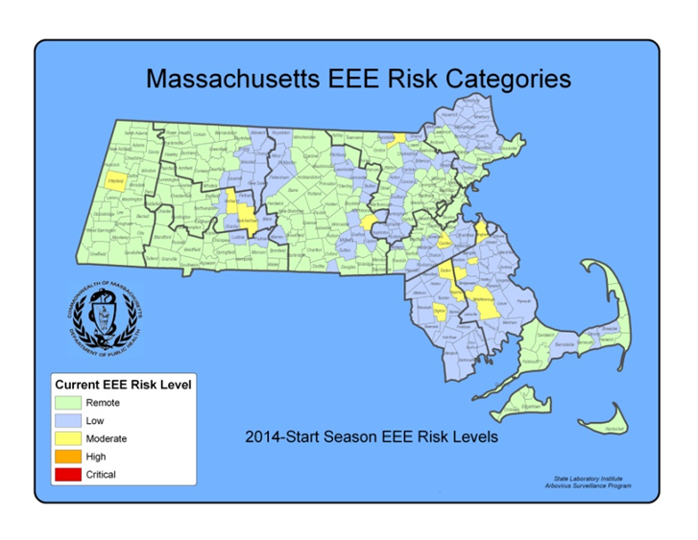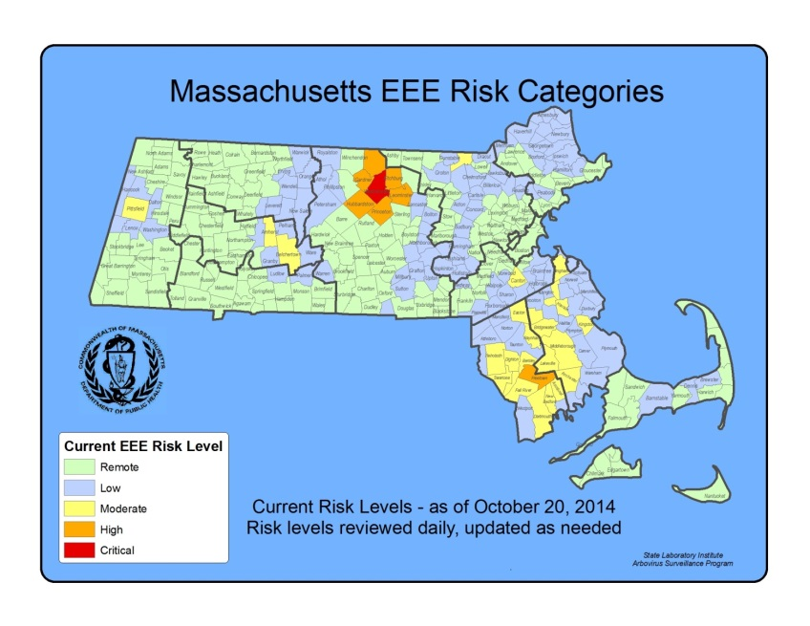

**2014 EEE SEASON DISCUSSION**

There were no confirmed human EEE cases in 2014, compared to one confirmed human case identified in 2013 and seven confirmed human cases in 2012. The number of confirmed human cases nationwide was lower in 2014 (eight) and 2013 (five) when compared to 2012 (15).

There was a similar decline in EEE virus positive mosquito samples from 267 in 2012 to 61 in 2013, down to 33 in 2014. In 2014, MDPH identified 24 EEE positive samples of *Culiseta melanura,* the enzootic vector of EEE, compared to 46 EEE positive samples of *Culiseta melanura* in 2013. Mosquito surveillance activities are highly adaptive to identifications of EEE virus, with more mosquito trapping and testing in years when EEE activity is increased, this makes year-to-year comparisons somewhat difficult. In general, years with increased EEE human infections can be associated with a similar increase in the percentage of *Cs. melanura* samples that test positive for EEE virus (see figure below).

**Why was there less EEE activity in 2013 and 2014 than 2012?**

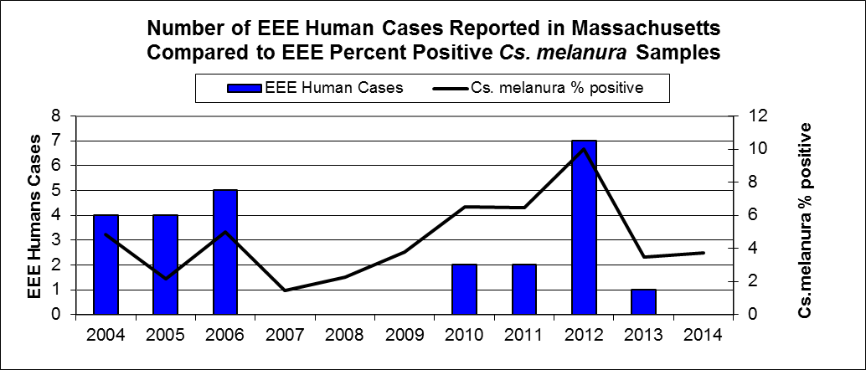

Historically, EEE outbreaks have rarely occurred over periods lasting more than three years, although evidence suggests that previously observed patterns may be changing and the situation must be monitored carefully. Intense EEE activity consistent with outbreaks occurred in 2004-2006 and 2010-2012. Outbreaks are probably supported, in part, by previously unexposed populations of birds that are susceptible to EEE virus infection, and therefore capable of maintaining the cycle of virus transmission. Current research suggests that each of these cycles is associated with the introduction of a new strain of EEE virus. After three years of intense virus activity, the population of susceptible birds may not have been adequate to maintain the virus cycle. Important factors impacting EEE virus cycles include large *Cs. melanura* mosquito populations which are more likely to support significant EEE activity, and weather conditions, such as significant precipitation events and prolonged periods of high temperature. In 2012, significant precipitation and prolonged periods of high temperature provided favorable conditions for mosquito development. In 2013, mosquito season began with above-average precipitation, but precipitation declined midway through the season and cooler evening temperatures occurred during prime transmission season; causing a delay in development of new mosquitoes. In 2014, limited spring and summer precipitation produced similar declines in the numbers of new mosquitoes.

In Massachusetts, human EEE is associated with *Culiseta melanura* activity. The map to the right illustrates that the area of highest risk for transmission of EEE continues to be southeastern Massachusetts which is the historic area of risk.

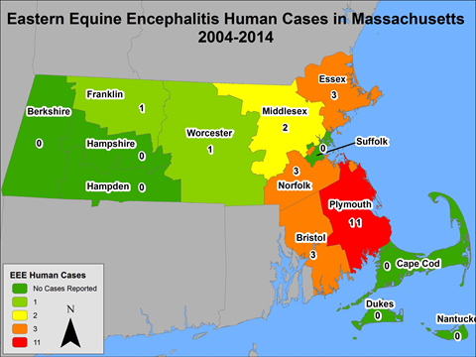

Over the last ten years, human EEE has occurred outside of the historic areas of risk and has shown significant variability in geographic patterns of occurrence during three successive time periods, indicated below. Cases are mapped by most likely county of exposure, rather than county of residence.



**What are the expectations for EEE in 2015?**

Mosquito abundance and vector-borne disease risk are affected by multiple environmental factors which vary over time and geographic location. The two most important contributors to mosquito development are precipitation and temperature. All species of mosquito depend on the presence of water for the first stages of life. Mosquito populations increase when precipitation is plentiful and decrease during dry periods. Warmer temperatures shorten both the time it takes for mosquitoes to develop from egg to adult and the time it takes for a mosquito to be able to transmit a pathogen after ingesting an infected blood meal.

Warm and wet winters increase the likelihood of mosquito survival and lead to higher spring mosquito numbers. Although the winter of 2015 saw historic snowfall totals, both the fall of 2014 and spring of 2015 were relatively dry. Reports from the field indicate below normal numbers of juvenile *Culiseta melanura* prior to the beginning of the season.

Mosquito populations alone are not sufficient to produce significant EEE risk; infected bird populations are also necessary. Unfortunately, less is known about the factors that lead to large numbers of infected birds, making this component of risk impossible to predict. At this time there is no efficient method to conduct surveillance for infection levels in wild birds.

Both the variability of New England weather and the inability to detect EEE virus infection levels in wild bird populations require that Massachusetts maintain a robust surveillance system to detect EEE virus in mosquitoes as a tool to assess risk of human disease.

**WEST NILE VIRUS**

**Humans**

There were six human cases of WNV infection identified in Massachusetts in 2014. The results are summarized in the table below.

|  |  |  |  |  |  |  |  |  |  |  |  |  |  |  |  |  |  |  |  |  |  |  |  |  |  |  |  |  |  |  |  |  |  |  |  |
| --- | --- | --- | --- | --- | --- | --- | --- | --- | --- | --- | --- | --- | --- | --- | --- | --- | --- | --- | --- | --- | --- | --- | --- | --- | --- | --- | --- | --- | --- | --- | --- | --- | --- | --- | --- |
| |  |  |  |  |  | | --- | --- | --- | --- | --- | | **County** | **Age Range** | **Onset Date** | **Virus Result** | **Clinical Presentation** | | Essex | 51-60 | 8/30/2014 | WNV | meningitis | | Middlesex | 41-50 | 9/28/2014 | WNV | meningoencephalitis | | Middlesex | 21-30 | 9/5/2014 | WNV | fever | | Middlesex | 41-50 | 8/22/2014 | WNV | meningoencephalitis | | Middlesex | 61-70 | 8/11/2014 | WNV | meningoencephalitis | | Middlesex | 41-50 | 9/15/2014 | WNV | meningitis | |

**Presumptive Viremic Blood Donors**

WNV is transmissible through blood transfusion. Since June 2003, blood banks have screened donated blood for WNV using direct tests for viral genetic material. Positive units are not used and donors are deferred from future donation for 120 days. The AABB (formerly the American Association of Blood Banks) notifies states of all presumptive viremic donors (PVDs) - individuals whose donated blood tests positive using a nucleic acid test (NAT).

There was one presumptive viremic donor identified in Massachusetts in 2013. The number of presumptive viremic donors nationwide was approximately the same in 2014 (321) compared with 2013 (304).

|  |  |
| --- | --- |
| **County** | **Donation Date** |
| Middlesex | 9/2/2014 |

## Mosquito Samples

Of 5,039 mosquito samples collected in Massachusetts in 2014, 56 (1.1%) were positive for WNV. Positive mosquito samples included 52 (93%) *Culex* species. Positive samples were identified in 29 towns in nine counties. For a complete list of positive mosquito samples by city/town, please see the 2014. [Mosquito Summary by County and Municipality](http://www.mass.gov/eohhs/gov/departments/dph/programs/id/epidemiology/researchers/public-health-cdc-arbovirus-surveillance.html) report posted on the MDPH website.

## Animals

Seven veterinary samples were submitted for arbovirus testing. There were no horses that tested positive for WNV in 2014.

**WNV Geographic Risk Levels**

WNV risk maps are produced by integrating historical data and areas of mosquito habitat with current data on positive virus identifications (in humans, mosquitoes, etc.) and weather conditions. Risk levels serve as a relative measure of the likelihood of an outbreak of human disease and are updated weekly based on that week’s surveillance data. Initial and final WNV risk levels from the 2014 season are provided in the following maps. This information will be used to help predict risk in 2015, and will be revised as 2015 surveillance data are collected. More detailed information about risk assessment and risk levels is available in the [Arbovirus Surveillance and Response Plan](http://www.mass.gov/eohhs/docs/dph/cdc/arbovirus/arbovirus-surveillance-plan.pdf) on the MDPH web site during the arbovirus season.

**Initial and Final 2014 WNV Risk Categories**

(As described in Table1 of the 2014 MDPH Arbovirus Surveillance and Response Plan which can be found at [www.mass.gov/dph/mosquito](http://www.mass.gov/dph/mosquito) under “Information for Local Boards of Health”)

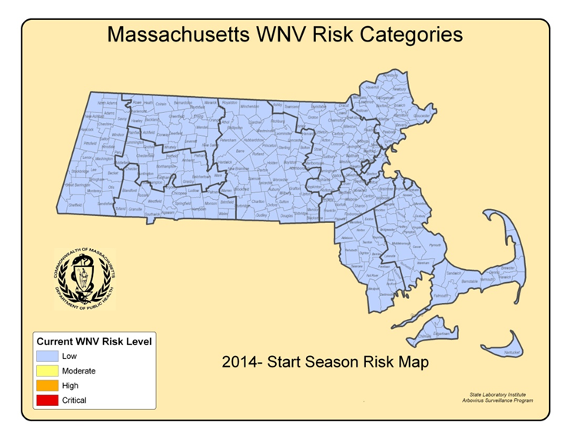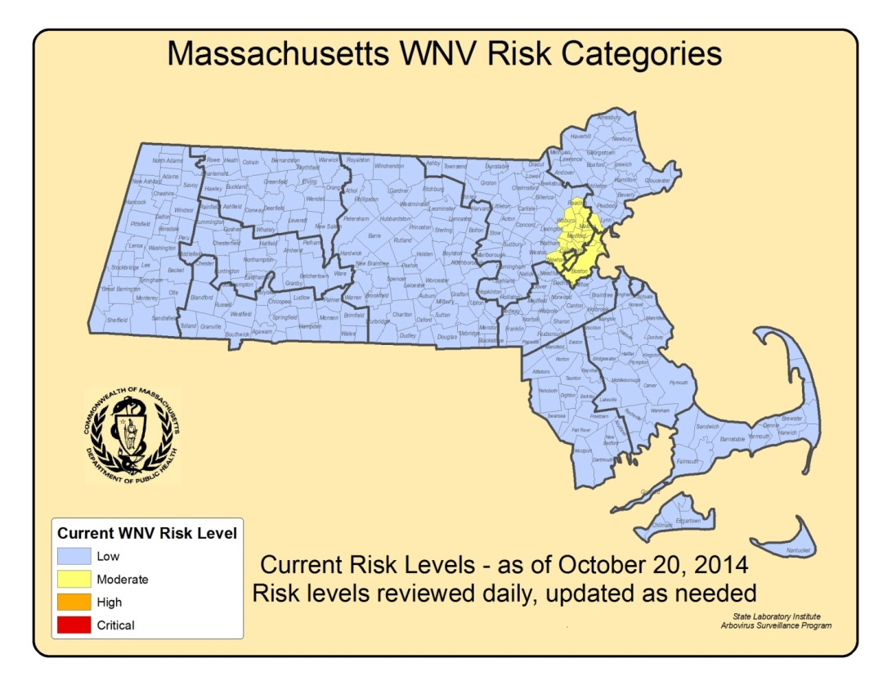

**2014 WNV SEASON DISCUSSION**

MDPH identified six confirmed human WNV infections in 2014 compared to eight confirmed cases in 2013 and 33 confirmed human cases identified in 2012. This decrease in human cases was also seen across the country, where the number of confirmed human cases nationwide was much lower in both 2014(1,935) and 2013 (2,271) compared to 2012 (5,387).

Of the 1,935 cases identified nationally in 2014, 1,149 (59%) were classified as neuroinvasive disease (such as meningitis or encephalitis) and 786 (41%) were classified as non-neuroinvasive disease. The majority of the cases were reported from nine states (California, Colorado, Illinois, Louisiana, Nebraska, and Texas). 43% of all cases were reported from California.

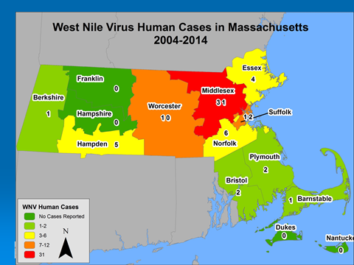

In Massachusetts, the vectors for WNV are primarily *Culex* species. *Culex* species are closely associated with human activity. The map to the right demonstrates transmission to humans is highest in counties with high population density.

**WNV Mosquito & Human Disease Correlation**

Of 5,039 mosquito samples collected in Massachusetts in 2014, 56 (1.1%) were positive for WNV. Positive mosquito samples included 52 (95 %) *Culex* species. Positive samples were identified in 29 towns.

In 2014, MDPH identified 52WNV positive *Culex* species mosquito samples as compared to 240 WNV positive *Culex* species mosquito samples in 2013. Considering the decrease in human cases of WNV infection that occurred from 2012 to 2013/2014, a decline in WNV positive mosquito samples might have also been anticipated. As the graph below demonstrates, the percentage of WNV positive *Culex* mosquito samples declined slightly from 2012 to 2013, with a sharper decline in 2014.

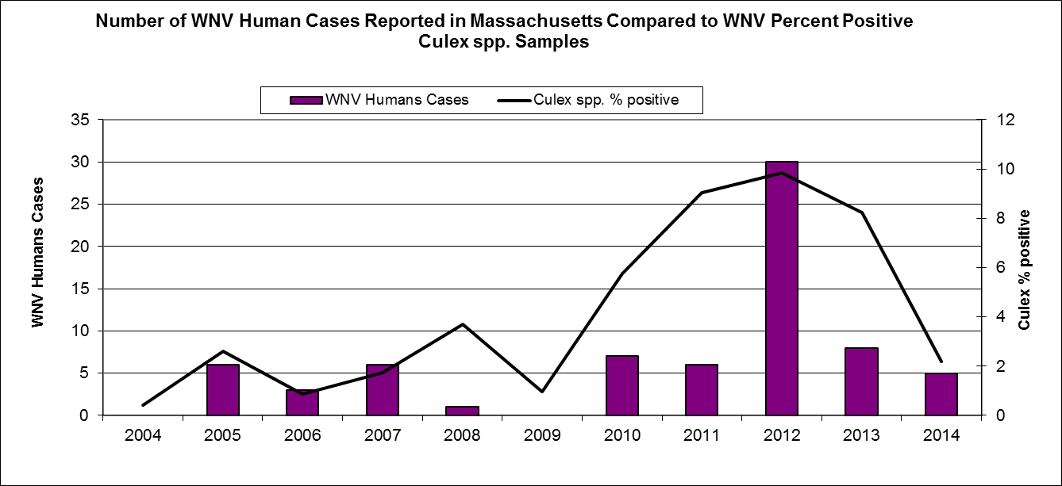

**What are the expectations for WNV in 2015?**

The primary determinants of human WNV disease risk during any particular season are populations of *Culex* mosquito species and the presence of infected birds. The two most important variables for mosquito development are precipitation and temperature. Warmer temperatures shorten both the time it takes for mosquitoes to develop from egg to adult and the time it takes for a mosquito to be able to transmit a pathogen after ingesting an infected blood meal. *Culex* mosquito populations tend to be greatest during seasons with periodic precipitation events separated by hot, dry days (giving rise to stagnant puddles that favor *Culex* breeding).

Mosquito populations alone are not sufficient to produce significant WNV risk; infected bird populations are also necessary. Unfortunately, less is known about the factors that lead to large numbers of infected birds making this component of risk impossible to predict and there is no efficient way to conduct surveillance for infection levels in wild birds.

The lack of useful pre-season predictive factors limits the ability of MDPH to make any accurate assessments regarding future WNV activity. Both the variability of New England weather, and the inability to detect WNV infection levels in wild bird populations, requires that Massachusetts maintain a robust surveillance system to detect WNV in mosquitoes as a primary tool to assess risk of human disease. MDPH continues to strive to identify reliable measures to aid in risk assessments.