Arbovirus Surveillance in Massachusetts 2015

Massachusetts Department of Public Health (MDPH)

Arbovirus Surveillance Program

INTRODUCTION

There are two mosquito-borne diseases of concern in Massachusetts, Eastern equine encephalitis (EEE), which was identified as a human disease in 1938, and West Nile virus (WNV) infection, which has been present since 2000. EEE is a rare but serious neuroinvasive disease that causes meningitis or encephalitis, and often results in death or severe disability. WNV infection is more common, though typically less severe than EEE; presentation of WNV ranges from febrile illness to neuroinvasive disease. Although up to 51 different species of mosquitoes have been identified in Massachusetts, only a few of these contribute to either WNV or EEE spread. For more information, visit the MDPH website to view Common Mosquitoes That Can Spread Disease in Massachusetts.

Currently there are no available vaccines to prevent human infections from either mosquito-borne virus. Personal protection measures that serve to reduce exposure to mosquitoes and thereby prevent human infection remain the mainstay of prevention. To estimate the risk of human disease during a mosquito season, the MDPH, in cooperation with the local Mosquito Control Projects, conducts surveillance for EEE and WNV using mosquito samples, and specimens from human and veterinary sources. Detailed information about surveillance for these diseases in Massachusetts is available on the MDPH website at Arbovirus Surveillance and Control Plan.

EASTERN EQUINE ENCEPHALITIS VIRUS

Humans
There were no human cases of EEE virus infection identified in Massachusetts in 2015 or 2014.

Mosquito Samples
Of 4,527 mosquito samples collected in Massachusetts in 2015, one sample (0.2%) was positive for EEE virus in 2015. The positive sample was identified in the town of Northbridge, located in Worcester County. For a complete list of positive mosquito samples by city/town, please see the 2015 Mosquito Summary by County and Municipality report posted on the MDPH website.

Animals

Eight veterinary samples were submitted for arbovirus testing. There were no animals that tested positive for EEE virus infection in Massachusetts.

Birds
Although birds are not routinely tested as part of EEE surveillance, species such as emus or exotic quail may experience sudden illness and mortality due to EEE. Farmed birds showing these signs must be reported promptly to the Massachusetts Department of Agricultural Resources (MDAR).

EEE Geographic Risk Levels
EEE risk maps combine historical data and areas of mosquito habitat with current data on positive virus isolations (in humans, mosquitoes, etc.) and weather conditions. Risk levels are an estimate of the likelihood of an outbreak of human disease and are updated weekly based on that week’s surveillance data. Initial and final EEE risk levels from the 2015 season are provided in the following maps. This information will be used to help anticipate risk in 2016, and will be revised as 2016 surveillance data are collected. More detailed information about risk assessment and risk levels is available in the Arbovirus Surveillance and Response Plan on the MDPH web site.

Initial and Final 2015 EEE Risk Categories

(As defined in Table 2 of the MDPH Arbovirus Surveillance and Response Plan which can be found at www.mass.gov/dph/mosquito under “Surveillance Summaries and Data”)

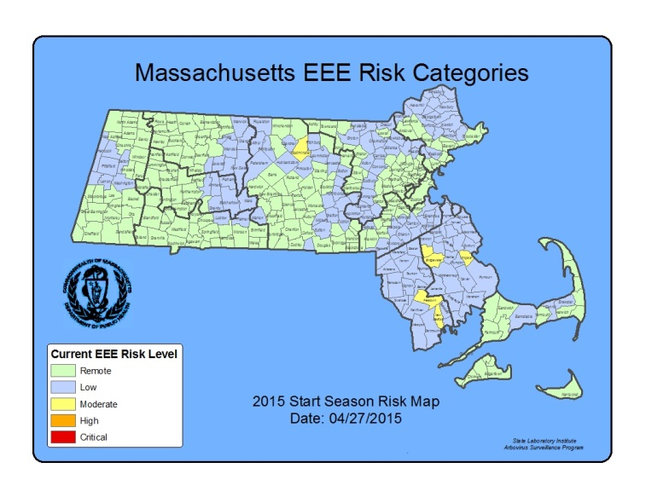
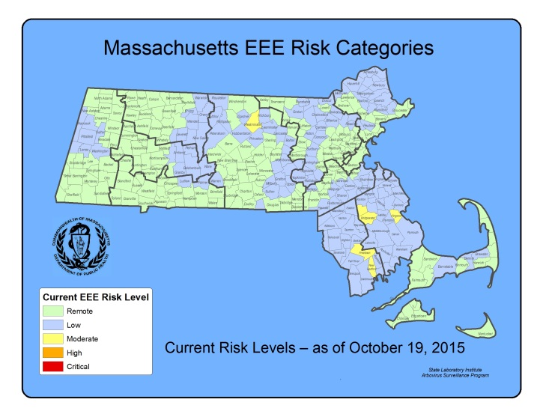

2015 EEE SEASON DISCUSSION

There were no confirmed human EEE cases in 2015 or 2014, compared to seven confirmed human cases in 2012; 2012 was the most recent outbreak year in Massachusetts. The number of confirmed human cases nationwide was lower in 2015 (five) and 2014 (eight) when compared to 2012 (15).

There was a similar decline in EEE virus positive mosquito samples from 267 in 2012 to 33 in 2014, down to 1 in 2015. In 2015, MDPH identified zero EEE positive samples of Culiseta melanura, the enzootic vector of EEE, compared to 24 EEE positive samples of Cs. melanura in 2014. Mosquito surveillance activities are highly adaptive to identifications of EEE virus, with more mosquito trapping and testing in years when EEE activity is increased, this makes year-to-year comparisons somewhat difficult. In general, years with increased EEE human infections are associated with an increase in the percentage of Cs. melanura samples positive for EEE virus (see figure below).

Why was there less EEE activity in 2013 - 2015 than in 2012?
Historically, EEE outbreaks have rarely occurred over periods lasting more than three years, although evidence suggests that previously observed patterns may be changing and the situation must be monitored carefully. Intense EEE activity consistent with outbreaks occurred in 2004-2006 and 2010-2012. Outbreaks are probably supported, in part, by previously unexposed populations of birds that are susceptible to EEE virus infection, and therefore capable of maintaining the cycle of virus transmission. Current research also suggests that each of these cycles is associated with the introduction of a new strain of EEE virus by migratory birds. After three years (2010-2012) of intense virus activity, the population of susceptible birds may not have been adequate to maintain the virus cycle in more recent years. Important factors also impacting EEE virus cycles include large Cs. melanura mosquito populations which are more likely to support significant EEE activity, and weather conditions, such as significant precipitation events and prolonged periods of high temperature. In 2012, significant precipitation and prolonged periods of high temperature provided favorable conditions for mosquito development. In 2013, mosquito season began with above-average precipitation, but precipitation declined midway through the season and cooler evening temperatures occurred during prime transmission season; causing a delay in development of new mosquitoes. In 2014, limited spring and summer precipitation produced similar declines in the numbers of new mosquitoes. In 2015, the mosquito season began with significant snowmelt but precipitation declined early in the season with few significant precipitation events in the summer. This led to loss of breeding habitat for mosquitos throughout the season with below average abundance rates.

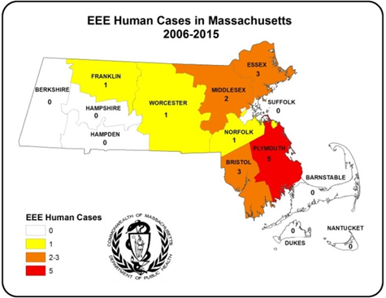
In Massachusetts, human EEE is associated with Culiseta melanura activity. The map to the right illustrates that the area of highest risk for transmission of EEE continues to be southeastern Massachusetts which has also been the historic area of risk.

Variability in Geographic Range of EEE
In Massachusetts over the last ten years, some human EEE cases have occurred outside of the historic area of risk and there have been year-to-year variations in the geographic pattern of disease occurrence. This is not unique to Massachusetts; during 2012-2015, human cases of EEE were reported from neighboring states including Connecticut, Maine, New Hampshire, New York, Rhode Island, and Vermont. Many of these cases were unusual in that they occurred in: states which rarely see EEE cases (Connecticut and Rhode Island); states where EEE cases are a very recent occurrence (Main, New Hampshire and Vermont); and in unusual areas in states that have historic areas of risk (New York). MDPH continues to perform adaptive surveillance activities to provide for early detection of EEE throughout the Commonwealth.

What are the expectations for EEE in 2016?
Mosquito abundance and vector-borne disease risk are affected by multiple environmental factors which vary over time and geographic location. The two most important contributors to mosquito development are precipitation and temperature. All species of mosquito depend on the presence of water for the first stages of life. Mosquito populations increase when precipitation is plentiful and decrease during dry periods. Warmer temperatures shorten both the time it takes for mosquitoes to develop from egg to adult and the time it takes for a mosquito to be able to transmit a pathogen after ingesting an infected blood meal.

Warm and wet winters increase the likelihood of mosquito survival and may lead to higher spring mosquito numbers. Following the summer and fall of 2015 which were drier than average, the winter of 2015-2016 was warmer than average, with significant rain events in the early spring. Early reports from the field indicate below average numbers of juvenile Cs. melanura.

Mosquito populations alone are not sufficient to produce significant EEE risk; infected bird populations are also necessary. Unfortunately, less is known about the factors that lead to large numbers of infected birds, making this component of risk impossible to predict. At this time there is no efficient method to conduct surveillance for infection levels in wild birds.

Both the variability of New England weather and the inability to detect EEE virus infection levels in wild bird populations require that Massachusetts maintain a robust surveillance system to detect EEE virus in mosquitoes as a tool to assess risk of human disease.

WEST NILE VIRUS

Humans
There were ten human cases of WNV infection identified in Massachusetts in 2015. The results are summarized in the table below.

County | Age Range | Onset Date | Virus Result | Clinical Presentation
Middlesex | 41-50 | 8/14/2015 | WNV | MENINGITIS
Suffolk | 41-50 | 9/3/2015 | WNV | MENINGOENCEPHALITIS
Suffolk | 41-50 | 9/4/2015 | WNV | FEVER
Suffolk | 51-60 | 9/6/2015 | WNV | MENINGOENCEPHALITIS
Suffolk | 61-70 | 9/7/2015 | WNV | MENINGOENCEPHALITIS
Suffolk | 91-100 | 9/13/2015 | WNV | MENINGOENCEPHALITIS
Suffolk | 91-100 | 9/15/2015 | WNV | FEVER
Middlesex | 81-90 | 9/15/2015 | WNV | MENINGOENCEPHALITIS
Suffolk | 21-30 | 9/16/2015 | WNV | FEVER
Worcester | 61-70 | 10/9/2015 | WNV | MENINGITIS

Presumptive Viremic Blood Donors
WNV is transmissible through blood transfusion. Since June 2003, blood banks have screened donated blood for WNV using a nucleic acid test (NAT) that identifies viral genetic material. Positive units are not used and donors are deferred from future donation for 120 days. The AABB (formerly the American Association of Blood Banks) notifies states of all presumptive viremic donors (PVDs), i.e., individuals whose donated blood tests positive using the NAT test.

There was one PVD identified in Massachusetts in 2015. The number of PVDs nationwide was approximately the same in 2015 (332) compared with 2014 (321).

County | Donation Date | Virus Result
Middlesex | 9/1/2015 | WNV

Mosquito Samples
Of 4,527 mosquito samples collected in Massachusetts in 2015, 164 (3.6%) were positive for WNV. Positive mosquito samples included 160 (98%) Culex species. Positive samples were identified in 60 towns in 13 counties. For a complete list of positive mosquito samples by city/town, please see the 2015 Mosquito Summary by County and Municipality report posted on the MDPH website.

Animals
Eight veterinary samples were submitted for arbovirus testing. There were no animals that tested positive for WNV in 2015.

WNV Geographic Risk Levels
WNV risk maps are produced by integrating historical data and areas of mosquito habitat with current data on positive virus identifications (in humans, mosquitoes, etc.) and weather conditions. Risk levels serve as a relative measure of the likelihood of an outbreak of human disease and are updated weekly based on that week’s surveillance data. Initial and final WNV risk levels from the 2015 season are provided in the following maps. This information will be used to help predict risk in 2016, and will be revised as 2016 surveillance data are collected. More detailed information about risk assessment and risk levels is available in the Arbovirus Surveillance and Response Plan on the MDPH web site during the arbovirus season.

Initial and Final 2015 WNV Risk Categories
(As described in Table 1 of the MDPH Arbovirus Surveillance and Response Plan which can be found at www.mass.gov/dph/mosquito under “Surveillance Summaries and Data”)

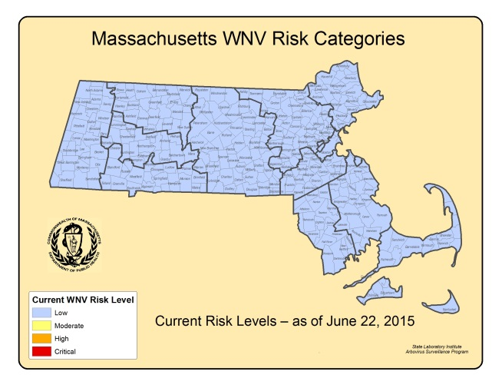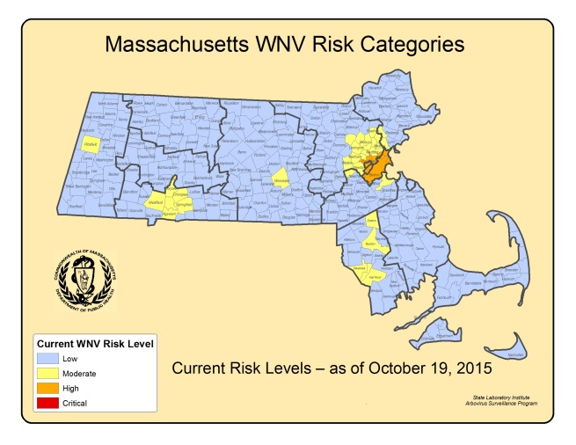
2015 WNV SEASON DISCUSSION

MDPH identified ten confirmed human WNV infections in 2015 compared to six confirmed cases in 2014. This increase in human cases was also seen across the country, where the number of confirmed human cases nationwide was in 2015 (2,060) was higher than in 2014 (1,935) but far fewer than the 2012 outbreak (5,674).

Of the 2,060 cases identified nationally in 2015, 1,360 (66%) were classified as neuroinvasive disease (such as meningitis or encephalitis) and 700 (34%) were classified as non-neuroinvasive disease. The majority of the cases were reported from three states (California, Colorado, and Texas). 35% of all cases were reported from California.

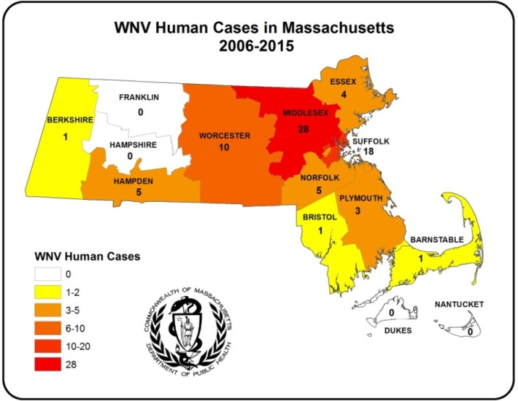
In Massachusetts, the vectors for WNV are primarily Culex species. Culex species are closely associated with human activity. The map to the right demonstrates transmission to humans is highest in counties with high population density.

WNV Mosquito & Human Disease Correlation

In 2015, MDPH identified 160 WNV positive Culex species mosquito samples as compared to 52 WNV positive Culex species mosquito samples in 2014. In general, years with increased WNV human infections are associated with an increase in the percentage of Culex samples positive for WNV (see figure below). Considering the increase in human cases of WNV infection that occurred from 2014-2015, an increase in WNV positive mosquito samples might be expected. As the graph below demonstrates, the percentage of WNV positive Culex mosquito samples decreased sharply from a peak in 2012, associated with a notably hot summer resulting in a national outbreak, to a low in 2014 with a notable uptick in 2015.

What are the expectations for WNV in 2016?

The primary determinants of human WNV disease risk during any particular season are populations of Culex mosquito species and the presence of infected birds. The two most important variables for mosquito development are precipitation and temperature. Warmer temperatures shorten both the time it takes for mosquitoes to develop from egg to adult and the time it takes for a mosquito to be able to transmit a pathogen after ingesting an infected blood meal. Culex mosquito populations tend to be greatest during seasons with periodic precipitation events separated by hot, dry days (giving rise to stagnant puddles that favor Culex breeding).

Mosquito populations alone are not sufficient to produce significant WNV risk; infected bird populations are also necessary. Unfortunately, less is known about the factors that lead to large numbers of infected birds making this component of risk impossible to predict and there is no efficient way to conduct surveillance for infection levels in wild birds.

The lack of useful pre-season predictive factors limits the ability of MDPH to make any accurate assessments regarding future WNV activity. Both the variability of New England weather, and the inability to detect WNV infection levels in wild bird populations, requires that Massachusetts maintain a robust surveillance system to detect WNV in mosquitoes as a primary tool to assess risk of human disease. MDPH continues to strive to identify reliable measures to aid in risk assessments.

