Arbovirus Surveillance in Massachusetts 2018

Massachusetts Department of Public Health (MDPH)

Arbovirus Surveillance Program

INTRODUCTION

There are two mosquito-borne diseases of concern in Massachusetts, Eastern equine encephalitis (EEE), which was identified as a human disease in 1938, and West Nile virus (WNV) infection, which has been present in the United States since 1999. EEE is a rare but serious neuroinvasive disease that causes meningitis or encephalitis, and often results in death or severe disability. WNV infection is more common, though typically less severe than EEE; presentation of WNV ranges from febrile illness to neuroinvasive disease. Although 51 different species of mosquitoes have been identified in Massachusetts, only a few of these contribute to either WNV or EEE spread. For more information, visit the MDPH website to view Common Mosquitoes That Can Spread Disease in Massachusetts.

Currently, there are no available vaccines to prevent human infections from either mosquito-borne virus. Personal protection measures that serve to reduce exposure to mosquitoes and thereby prevent human infection remain the mainstay of prevention. To estimate the risk of human disease during a mosquito season, the MDPH, in cooperation with the local Mosquito Control Projects, conducts surveillance for EEE and WNV using mosquito samples, and specimens from human and veterinary sources. Detailed information about surveillance for these diseases in Massachusetts is available on the MDPH website at Arbovirus Surveillance and Control Plan.

EASTERN EQUINE ENCEPHALITIS VIRUS

Humans
No human cases of EEE virus infection have been identified in Massachusetts since 2013.

Mosquito Samples
Of 5,921 mosquito samples tested in Massachusetts in 2018, two samples (0.03%) were positive for EEE virus in 2018. The positive samples were identified in the towns of Hubbardston and Lakeville. For a complete list of positive mosquito samples by city/town, please see the 2018 Mosquito Summary by County and Municipality report posted on the MDPH website.

Animals

Fourteen samples were submitted for arbovirus testing. There were two animals that tested positive for EEE virus infection in 2018, a turkey in Hubbardston and a horse in East Brookfield.

Birds
Although birds are not routinely tested as part of EEE surveillance, species such as emus or exotic quail may experience sudden illness and mortality due to EEE. Farmed birds showing these signs must be reported promptly to the Massachusetts Department of Agricultural Resources (MDAR). A wild turkey in Hubbardston was reported in 2018 and tested positive for EEE.

EEE Geographic Risk Levels
EEE risk maps combine historical data and areas of mosquito habitat with current data on positive virus isolations (in humans, mosquitoes, etc.) and weather conditions. Risk levels are an estimate of the likelihood of an outbreak of human disease and are updated weekly based on surveillance data. Initial and final EEE risk levels from the 2018 season are shown in the following maps. This information will be used to help anticipate risk in 2019, and will be revised as 2019 surveillance data are collected. More detailed information about risk assessment and risk levels is available in the Arbovirus Surveillance and Response Plan on the MDPH web site.

Initial and Final 2018 EEE Risk Categories

(As defined in Table 2 of the MDPH Arbovirus Surveillance and Response Plan which can be found at www.mass.gov/dph/mosquito under “Surveillance Summaries and Data”)

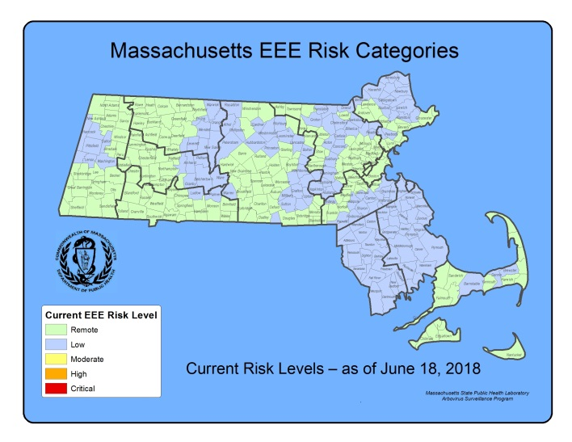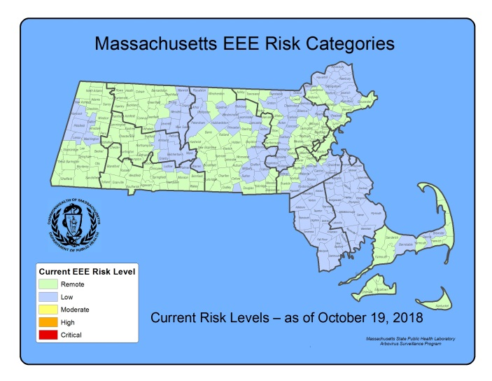

2018 EEE SEASON DISCUSSION
There were no confirmed human EEE cases in 2018 or 2017, compared to seven confirmed human cases in 2012 and one in 2013; 2012 was the most recent outbreak year in Massachusetts. The number of confirmed human cases nationwide was lower in 2018 (five) and 2017 (five) when compared to 2012 (15).

There was a similar decline in EEE virus positive mosquito samples from 267 in 2012 to two in 2018. In 2018, MDPH identified two EEE positive sample of Culiseta melanura, the enzootic vector of EEE. Mosquito surveillance activities are highly adaptive to identifications of EEE virus, with more mosquito trapping and testing in years when EEE activity is increased, this makes year-to-year comparisons somewhat difficult. In general, years with increased EEE human infections are associated with an increase in the percentage of Cs. melanura samples positive for EEE virus (see figure below).

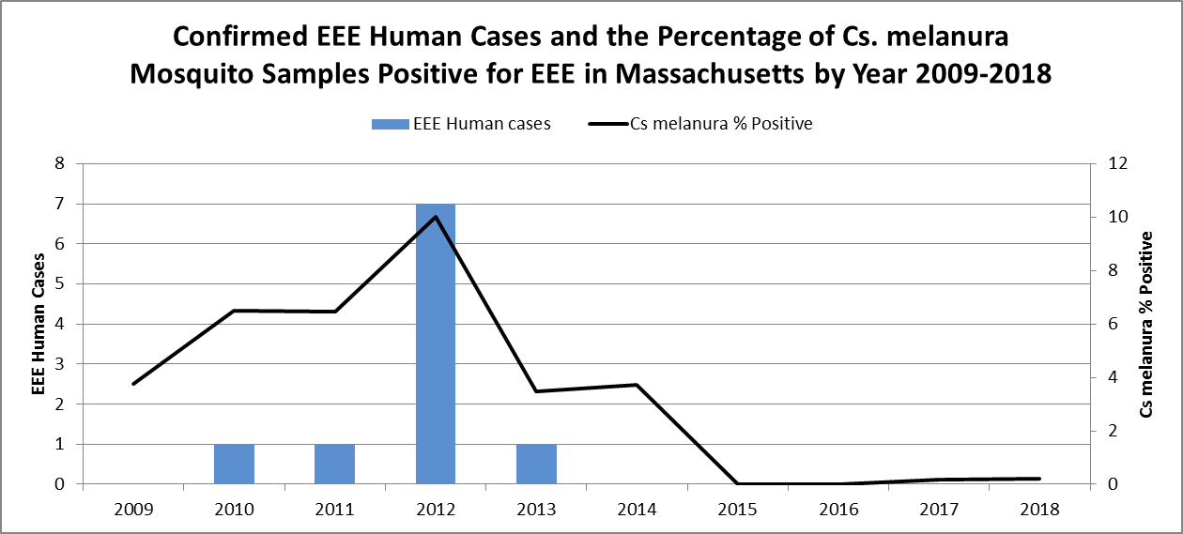

Why has there been less EEE activity since 2012?
Historically, EEE outbreaks have rarely occurred during periods lasting more than three years, although evidence suggests that previously observed patterns may be changing and the situation must be monitored carefully. Intense EEE activity consistent with outbreaks occurred in 2004-2006 and 2010-2012. Outbreaks are probably supported, in part, by previously unexposed populations of birds that are susceptible to EEE virus infection, and therefore capable of maintaining the cycle of virus transmission. Current research also suggests that each of these cycles is associated with the introduction of a new strain of EEE virus by migratory birds. After three years (2010-2012) of intense virus activity, the population of susceptible birds may not have been adequate to maintain the virus cycle in more recent years. Important factors also impacting EEE virus cycles include large Cs. melanura mosquito populations which are more likely to support significant EEE activity, and weather conditions, such as significant precipitation events and prolonged periods of high temperature. In 2012, significant precipitation and prolonged periods of high temperatures provided favorable conditions for mosquito development. In 2017, average precipitation in winter, spring, and summer combined with above-average summer temperatures increased available breeding habitat for the traditional vectors of EEE and led to above average mosquito abundance rates throughout the breeding season. In 2018, the mosquito season began with above average precipitation events. Precipitation events remained consistently above average and summer temperatures were above average for the entire breeding season. Breeding habitat for Cs. melanura increased compared to prior years with abundance levels of Cs. melanura fully rebounding from the impact of drought conditions seen in 2016.

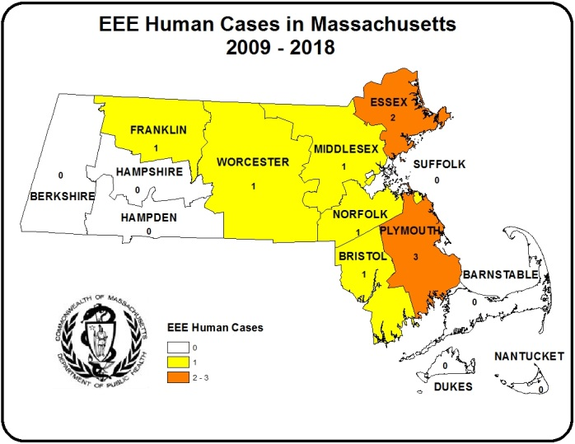
In Massachusetts, human EEE infection is associated with Culiseta melanura activity. The map to the right illustrates that one area at highest risk for transmission of EEE is Southeastern Massachusetts which has also been the historic area of risk. Northeastern Massachusetts has become an area of high risk more recently.

Variability in Geographic Range of EEE
In Massachusetts over the last ten years, some human EEE cases have occurred outside of the historic area of risk and there have been year-to-year variations in the geographic pattern of disease occurrence. This is not unique to Massachusetts; during 2013-2016, human cases of EEE were reported from neighboring states including Connecticut, Maine, New Hampshire, New York, Rhode Island, and Vermont. Many of these cases were unusual in that they occurred in: states which rarely see EEE cases (Connecticut and Rhode Island); states where EEE cases are a very recent occurrence (Maine, New Hampshire and Vermont); and in atypical areas in states that have historic areas of risk (New York). MDPH continues to perform adaptive surveillance activities to provide for early detection of EEE throughout the Commonwealth.

What are the expectations for EEE in 2019?
Mosquito abundance and vector-borne disease risk are affected by multiple environmental factors which vary over time and geographic location. The two most important contributors to mosquito development are precipitation and temperature. All species of mosquito depend on the presence of water for the first stages of life. Mosquito populations increase when precipitation is plentiful and decrease during dry periods. Warmer temperatures shorten both the time it takes for mosquitoes to develop from egg to adult and the time it takes for a mosquito to be able to transmit pathogens after ingesting an infected blood meal.

Warm and wet winters increase the likelihood of mosquito survival and may lead to higher spring mosquito numbers. The summer and fall of 2018 brought above average temperatures and precipitation events leading to extensive breeding habitat for the traditional vectors of EEE. A preliminary assessment of the winter of 2018-2019 has average temperatures combined with above average precipitation events. Early reports from the field indicate above average numbers of juvenile Cs. melanura.

Mosquito populations alone are not sufficient to produce significant EEE risk; infected bird populations are also necessary. Unfortunately, less is known about the factors that lead to large numbers of infected birds, making this component of risk impossible to predict. At this time there is no efficient method to conduct surveillance for infection levels in wild birds.

Both the variability of New England weather and the inability to detect EEE virus infection levels in wild bird populations require that Massachusetts maintain a robust surveillance system every year to detect EEE virus in mosquitoes as a tool to assess risk of human disease.

WEST NILE VIRUS

Humans
There were forty-nine human cases of WNV infection identified in Massachusetts in 2018. The results are summarized in the table below.

County | Age Range | Onset Date | Virus Result | Clinical Presentation
Barnstable | 81-90 | 8/30/2018 | WNV | Fever
Barnstable | 61 - 70 | 9/16/2018 | WNV | Meningoencephalitis
Barnstable | 71-80 | 9/28/2018 | WNV | Encephalitis
Barnstable | 71-80 | 10/28/2018 | WNV | Meningitis
Berkshire | 61 - 70 | 8/26/2018 | WNV | Encephalitis
Bristol | 61 - 70 | 8/18/2018 | WNV | Meningoencephalitis
Bristol | 51-60 | 9/1/2018 | WNV | Meningoencephalitis
Essex | 21 - 30 | 8/21/2018 | WNV | Meningitis
Essex | 71 - 80 | 8/26/2018 | WNV | Meningitis
Essex | 61 - 70 | 8/27/2018 | WNV | Meningoencephalitis
Essex | 61-70 | 8/31/2018 | WNV | Meningoencephalitis
Essex | 41-50 | 9/17/2018 | WNV | Fever
Essex | 71-80 | 9/21/2018 | WNV | Meningitis
Essex | 81-90 | 9/26/2018 | WNV | Encephalitis
Essex | 51-60 | 10/9/2018 | WNV | Meningoencephalitis
Franklin | 71-80 | 9/19/2018 | WNV | Encephalitis
Hampshire | 71-80 | 9/12/2018 | WNV | Meningitis
Hampshire | 71-80 | 10/1/2018 | WNV | Meningoencephalitis
Middlesex | 61-70 | 7/23/2018 | WNV | Fever
Middlesex | 51-60 | 8/1/2018 | WNV | Meningitis
Middlesex | 71-80 | 8/19/2018 | WNV | Meningitis
Middlesex | 31 - 40 | 8/21/2018 | WNV | Fever
Middlesex | 31-40 | 8/23/2018 | WNV | Meningitis
Middlesex | 61 - 70 | 8/24/2018 | WNV | Meningitis
Middlesex | 21 - 30 | 8/30/2018 | WNV | Meningitis
Middlesex | 61 - 70 | 9/3/2018 | WNV | Meningoencephalitis
Middlesex | 61 - 70 | 9/4/2018 | WNV | Fever
Middlesex | 71-80 | 9/5/2018 | WNV | Encephalitis
Middlesex | 41-50 | 9/8/2018 | WNV | Meningitis
Middlesex | 61 - 70 | 9/17/2018 | WNV | Meningoencephalitis
Middlesex | 51 - 60 | 9/18/2018 | WNV | Encephalitis
Middlesex | 31 - 40 | 9/21/2018 | WNV | Meningitis
Middlesex | 51 - 60 | 9/22/2018 | WNV | Fever
Middlesex | 51 - 60 | 9/24/2018 | WNV | Meningitis
Middlesex | 61 - 70 | 9/27/2018 | WNV | Meningitis
Norfolk | 61 - 70 | 9/16/2018 | WNV | Meningitis
Plymouth | 61 - 70 | 9/15/2018 | WNV | Encephalitis
Plymouth | 61 - 70 | 10/8/2018 | WNV | Meningitis
Suffolk | 61 - 70 | 7/28/2018 | WNV | Encephalitis
Suffolk | 41 - 50 | 8/12/2018 | WNV | Encephalitis
Suffolk | 81 - 90 | 8/17/2018 | WNV | Meningoencephalitis
Suffolk | 51 - 60 | 8/23/2018 | WNV | Encephalitis
Suffolk | 61 - 70 | 9/2/2018 | WNV | Meningitis
Suffolk | 31 - 40 | 9/4/2018 | WNV | Meningoencephalitis
Suffolk | 51 - 60 | 9/12/2018 | WNV | Meningitis
Suffolk | 81 - 90 | 9/13/2018 | WNV | Meningitis
Suffolk | 51 - 60 | 9/17/2018 | WNV | Encephalitis
Worcester | 71 - 80 | 8/10/2018 | WNV | Meningitis
Worcester | 41 - 50 | 9/20/2018 | WNV | Meningitis

Presumptive Viremic Blood Donors
WNV is transmissible through blood transfusion. Since June 2003, blood banks have screened donated blood for WNV using a nucleic acid test (NAT) that identifies viral genetic material. Positive units are not used and donors are deferred from future donation for 120 days. The AABB (formerly the American Association of Blood Banks) notifies states of all presumptive viremic donors (PVDs), i.e., individuals whose donated blood tests positive using the NAT test.

There were two PVD identified in Massachusetts in 2018. The number of PVDs nationwide increased in 2018 (357) from 2017 (247).
County | Donation Date | Virus Result
Barnstable | 8/27/2018 | WNV
Bristol | 9/22/2018 | WNV

Mosquito Samples
Of 5,921 mosquito samples collected in Massachusetts in 2018, 579 (9.8%) were positive for WNV. Positive mosquito samples included 522 (90%) Culex species. Positive samples were identified in 153 towns in 13 counties. For a complete list of positive mosquito samples by city/town, please see the 2018 Mosquito Summary by County and Municipality report posted on the MDPH website.

Animals
Fourteen veterinary samples were submitted for arbovirus testing. There were two animals that tested positive for WNV in 2018, a horse in Bernardston and a horse in Granby.

WNV Geographic Risk Levels
WNV risk maps are produced by integrating historical data and areas of mosquito habitat with current data on positive virus identifications (in humans, mosquitoes, etc.) and weather conditions. Risk levels serve as a relative measure of the likelihood of an outbreak of human disease and are updated weekly based on that week’s surveillance data. Initial and final WNV risk levels from the 2018 season are provided in the following maps. This information will be used to help predict risk in 2019, and will be revised as 2019 surveillance data are collected. More detailed information about risk assessment and risk levels is available in the Arbovirus Surveillance and Response Plan on the MDPH web site during the arbovirus season.

Initial and Final 2018 WNV Risk Categories
(As described in Table 1 of the MDPH Arbovirus Surveillance and Response Plan which can be found at www.mass.gov/dph/mosquito under “Surveillance Summaries and Data”)

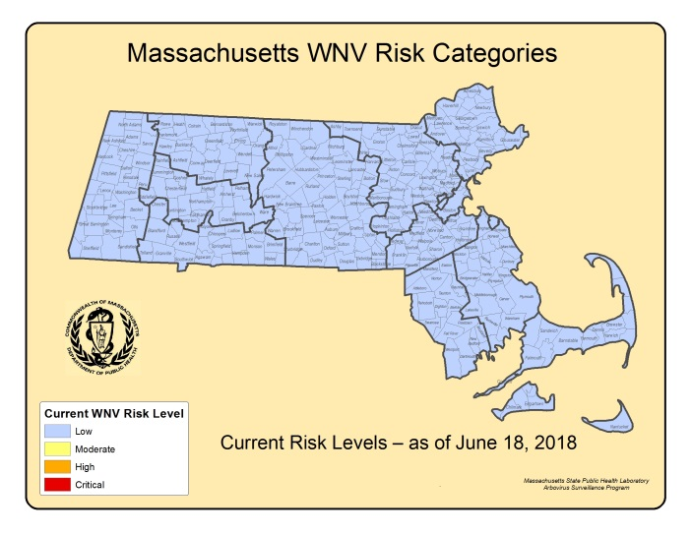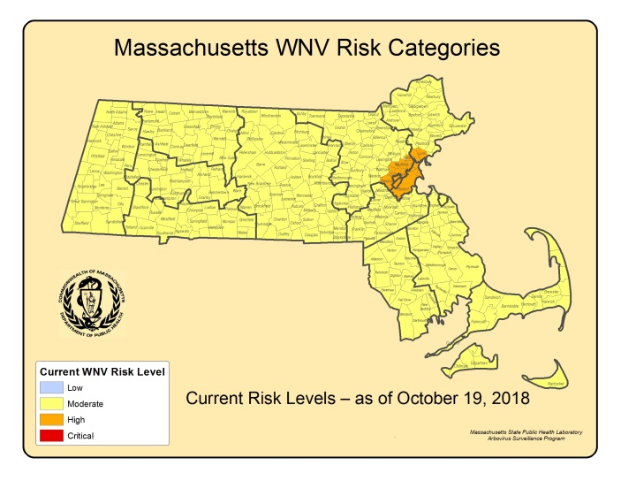
2018 WNV SEASON DISCUSSION
MDPH identified forty-nine confirmed human WNV infections in 2018 compared to six confirmed WNV cases in 2017. The 2018 WNV season stands out as the highest annual human case count since WNV arrived in MA in 2001. Above average precipitation events coupled with above average temperatures created conditions favorable to container breeding Culex mosquito species which transmit WNV. The number of confirmed human cases nationwide in 2018 (2,544) was an increase from 2017 (2,002) but far fewer than the 2012 outbreak (5,674).

Of the cases identified nationally in 2018, 1,594 (63%) were classified as neuroinvasive disease (defined as meningitis or encephalitis) and 950 (37%) were classified as non-neuroinvasive disease. A major portion of the cases (33%) were reported from four states (Nebraska, California, North Dakota and Illinois). 10% of all cases were reported from Nebraska.

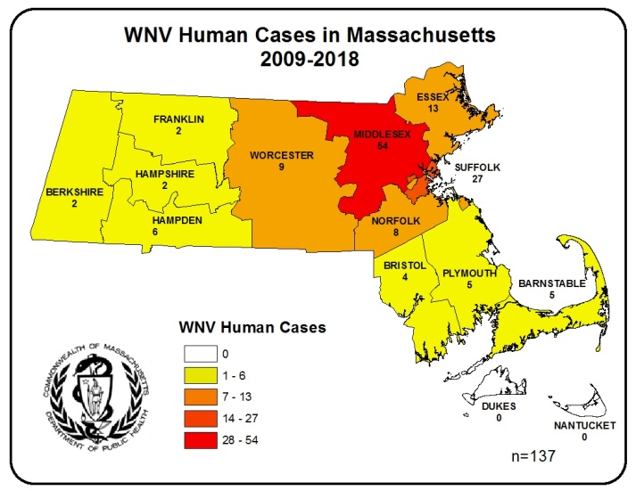
In Massachusetts, the vectors for WNV are primarily Culex species. Culex species are closely associated with human activity. The map to the right illustrates that transmission to humans is generally highest in counties with higher population densities.

WNV Positive Mosquitoes and Correlation with Human Disease
In 2018, MDPH identified 522 WNV positive Culex species mosquito samples compared to 277 WNV positive Culex species mosquito samples in 2017. In general, years with increased WNV human infections are associated with an increase in the percentage of Culex samples positive for WNV (see figure below). Considering the increase in human cases of WNV infection that occurred from 2014-2016, an increase in WNV positive mosquito samples might be expected. As the graph below demonstrates, the percentage of WNV positive Culex mosquito samples decreased sharply from a peak in 2012, associated with a notably hot summer resulting in a national outbreak, to a low in 2014 with an uptick in 2015, 2016 and 2017. In 2018 the increase in confirmed human cases compared to WNV positive mosquito samples matched the expected trend.

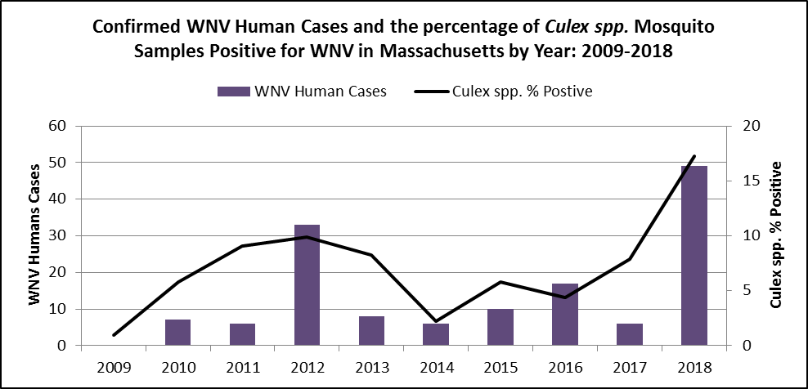

What are the expectations for WNV in 2019?
The primary determinants of human WNV disease risk during any particular season are populations of Culex mosquito species and the presence of infected birds. The two most important variables for mosquito development are precipitation and temperature. Warmer temperatures shorten both the time it takes for mosquitoes to develop from egg to adult and the time it takes for a mosquito to be able to transmit a pathogen after ingesting an infected blood meal. Culex mosquito populations tend to be greatest during seasons with periodic precipitation events (giving rise to stagnant puddles and containers that favor Culex breeding), separated by hot, dry days

Mosquito populations alone are not sufficient to produce significant WNV risk; infected bird populations are also necessary. Unfortunately, less is known about the factors that lead to large numbers of infected birds making this component of risk impossible to predict and there is no efficient way to conduct surveillance for infection levels in wild birds.

The lack of useful pre-season predictive factors limits the ability of MDPH to make any accurate assessments regarding future WNV activity. Both the variability of New England weather, and the inability to detect WNV infection levels in wild bird populations, requires that Massachusetts maintain a robust surveillance system to detect WNV in mosquitoes as a primary tool to assess risk of human disease. MDPH continues to strive to identify reliable measures to aid in risk assessments.

Invasive Mosquito Species Surveillance

MDPH and its partners are taking proactive measures to conduct surveillance for invasive mosquito species that are expanding their geographic range northward, especially for Aedes albopictus. Ae. albopictus is an aggressive mammal-biting species that was introduced to North America from Asia around 1985. This species has been implicated in the transmission of arboviruses such as dengue, chikungunya, yellow fever, and Zika, in some parts of the world. Where it occurs, this species is generally more abundant in urban areas, breeding in artificial containers, such as birdbaths, discarded tires, buckets, clogged gutters, catch basins, and other standing water sources. These mosquitoes are aggressive biters that actively seek out mammals, including humans, during daytime hours.

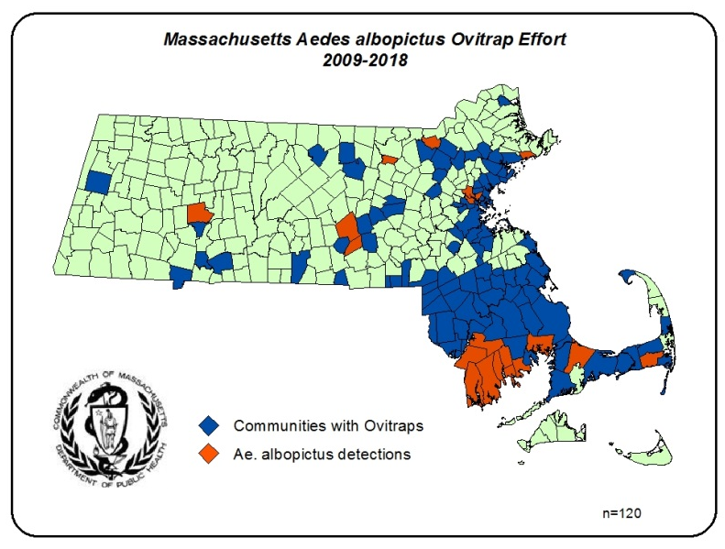
Limited detections of Ae. albopictus were first identified in Southeastern MA in 2009. Since these initial detections, additional findings have been recorded outside Southeastern MA. With the use of ovitraps Ae. albopictus has now been detected in 20 communities throughout the state since 2009. MDPH will continue to conduct routine surveillance activities to monitor for the presence and expansion of Ae. albopictus and other invasive mosquito species.

Zika Virus Surveillance

The global Zika virus outbreak began in South America in December 2015. Throughout 2016 – 2017 Zika virus spread across much of the globe. In 2018 the Zika virus outbreak diminished substantially worldwide. Zika virus is transmitted by Aedes mosquitoes. Symptoms appear in only 20% of cases, the majority of patients experience no symptoms. Those individuals that do experience symptoms typically have low-grade fever, muscle and or joint pain, rash, conjunctivitis, nausea, and diarrhea. The disease resolves with supportive treatment. However, in pregnant women who become infected with Zika virus, it is possible for the virus to spread to the developing fetus. When this happens, it can result in birth defects, including abnormal brain and head development (microcephaly).

In 2018, the Massachusetts State Public Health Laboratory tested 360 residents for Zika virus compared to 3,013 in 2017. Of the 360 samples submitted for testing seven (1.9%) were positive. All cases were investigated and determined to be travel associated. There have been no cases of Zika virus acquired locally from mosquitoes in Massachusetts. Since Zika virus is not a locally transmitted mosquito-borne disease, there are no plans to test mosquitoes in Massachusetts for Zika virus.

