Arbovirus Surveillance in Massachusetts, 2019

Massachusetts Department of Public Health (DPH)

Arbovirus Surveillance Program

INTRODUCTION

There are two mosquito-borne diseases of concern in Massachusetts, Eastern equine encephalitis (EEE), which was identified as a human disease in 1938, and West Nile virus (WNV) infection, which has been present in the United States since 1999. EEE is a rare but serious neuroinvasive disease that causes meningitis or encephalitis, and often results in death or severe disability. WNV infection is more common, though typically less severe than EEE; presentation of WNV ranges from febrile illness to neuroinvasive disease. Although 51 different species of mosquitoes have been identified in Massachusetts, only a few of these contribute to either WNV or EEE spread. For more information, visit the DPH website to view Common Mosquitoes That Can Spread Disease in Massachusetts.

Currently, there are no available vaccines to prevent human infections from either of these mosquito-borne viruses. Personal protection measures that serve to reduce exposure to mosquitoes and thereby prevent human infection remain the mainstay of prevention. To estimate the risk of human disease during a mosquito season, DPH, in cooperation with the local Mosquito Control Districts (MCD), conducts surveillance for EEE and WNV using mosquito samples and specimens from human and veterinary sources. Detailed information about surveillance for these diseases in Massachusetts is available on the DPH website at Arbovirus Surveillance and Control Plan.

EASTERN EQUINE ENCEPHALITIS VIRUS

Humans
There were twelve human cases of EEE with six deaths identified in Massachusetts in 2019. The results are summarized in the table below.

County | Age Range | Onset Date | Virus Result | Clinical Presentation
Bristol | 50 - 59 | 8/10/2019 | EEE | Meningoencephalitis
Bristol | 50 - 59 | 9/6/2019 | EEE | Encephalitis
Bristol | 70 - 79 | 9/12/2019 | EEE | Encephalitis
Essex | 70 - 79 | 9/9/2019 | EEE | Encephalitis
Hampden | 70 - 79 | 8/16/2019 | EEE | Encephalitis
Hampden | 70 - 79 | 9/15/2019 | EEE | Encephalitis
Middlesex | 70 - 79 | 8/31/2019 | EEE | Meningoencephalitis
Middlesex | <18 | 9/1/2019 | EEE | Encephalitis
Plymouth | 60 - 69 | 8/4/2019 | EEE | Encephalitis
Worcester | 20 - 29 | 7/30/2019 | EEE | Meningitis
Worcester | 60 - 69 | 9/1/2019 | EEE | Meningoencephalitis
Worcester | 70 - 79 | 9/12/2019 | EEE | Encephalitis

The six deaths included five males and one female with an average age of 70 (range 57-78 years/old).

Mosquito Samples
Of 8,295 mosquito samples tested in Massachusetts in 2019, 428 samples (5.16%) were positive for EEE virus. Positive mosquito samples included 196 (46%) Culiseta melanura followed by 140 (33%) Coquillettidia perturbans. Positive samples were identified in 76 towns in eight counties. For a complete list of positive mosquito samples by city/town, please see the 2019 Mosquito Summary by County and Municipality report posted on the DPH website.

Animals

Fourteen animal samples were submitted for arbovirus testing. There were nine domestic animals that tested positive for EEE virus infection in 2019, as summarized below. One white-tailed deer fawn also tested positive during the season in a municipality at significantly elevated risk for EEE.

County | City | Onset Date | Virus | Species
Bristol | Norton | 8/11/2019 | EEE | Goat
Essex | Methuen | 8/22/2019 | EEE | Horse
Middlesex | Holliston | 8/23/2019 | EEE | Horse
Norfolk | Medfield | 8/24/2019 | EEE | Horse
Worcester | Mendon | 8/16/2019 | EEE | Horse
Worcester | Uxbridge | 8/22/2019 | EEE | Horse
Worcester | Brookfield | 8/27/2019 | EEE | Horse
Worcester | Douglas | 8/23/2019 | EEE | Horse
Worcester | Spencer | 9/27/2019 | EEE | Horse

Birds
Although birds are not routinely tested as part of EEE surveillance, species such as emus or exotic quail may experience sudden illness and mortality due to EEE. Farmed birds showing these signs must be reported promptly to the Massachusetts Department of Agricultural Resources (MDAR). A bare-eyed pigeon from a zoological collection and a flock of pheasants, each from municipalities at significantly elevated risk for EEE, tested positive for the virus.

EEE Geographic Risk Levels
EEE risk maps combine historical data and areas of mosquito habitat with current data on positive virus isolations (in humans, mosquitoes, etc.) and weather conditions. Risk levels are an estimate of the likelihood of an outbreak of human disease and are updated weekly based on surveillance data. Initial and final EEE risk levels from the 2019 season are shown in the following maps. This information will be used to help anticipate risk in 2020, and will be revised as 2020 surveillance data are collected. More detailed information about risk assessment and risk levels is available in the Arbovirus Surveillance and Response Plan on the DPH web site.

Initial and Final 2019 EEE Risk Categories
(As defined in Table 2 of the DPH Arbovirus Surveillance and Response Plan)

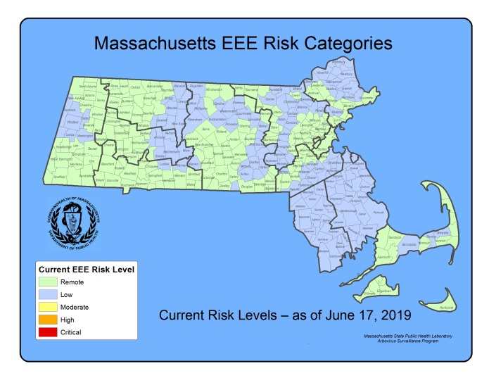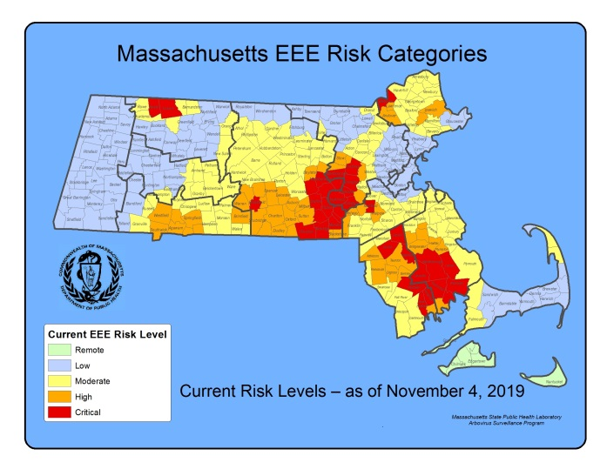

2019 EEE SEASON DISCUSSION
DPH confirmed twelve human EEE cases with six deaths in 2019. Prior to 2019, 2012 was the most recent outbreak year in Massachusetts with seven confirmed human cases. The number of confirmed human cases nationwide was higher in 2019 (38) when compared to 2012 (15).

Of the 38 confirmed cases identified nationally in 2019, 15 (39%) resulted in death. A majority of the cases (58%) were reported from two states (Massachusetts and Michigan). Additional cases were also reported by Connecticut (11%), New Jersey (11%), and Rhode Island (8%). Alabama, Georgia, Indiana, North Carolina, and Tennessee all reported a single case each.

There was a similar increase in EEE virus positive mosquito samples from 267 in 2012 to 428 in 2019. In 2019, DPH identified 196 EEE positive samples of Cs. melanura, the primary bird-biting vector species of EEE, as well as 140 EEE positive samples of Cq. perturbans the most important mammal-biting EEE vector. Mosquito surveillance activities are highly adaptive to identifications of EEE virus, with more mosquito trapping and testing in years when EEE activity is increased, this makes year-to-year comparisons somewhat difficult. In general, years with increased EEE human infections are associated with an increase in the percentage of Cs. melanura samples positive for EEE virus, as was seen in 2019 (see figure below).
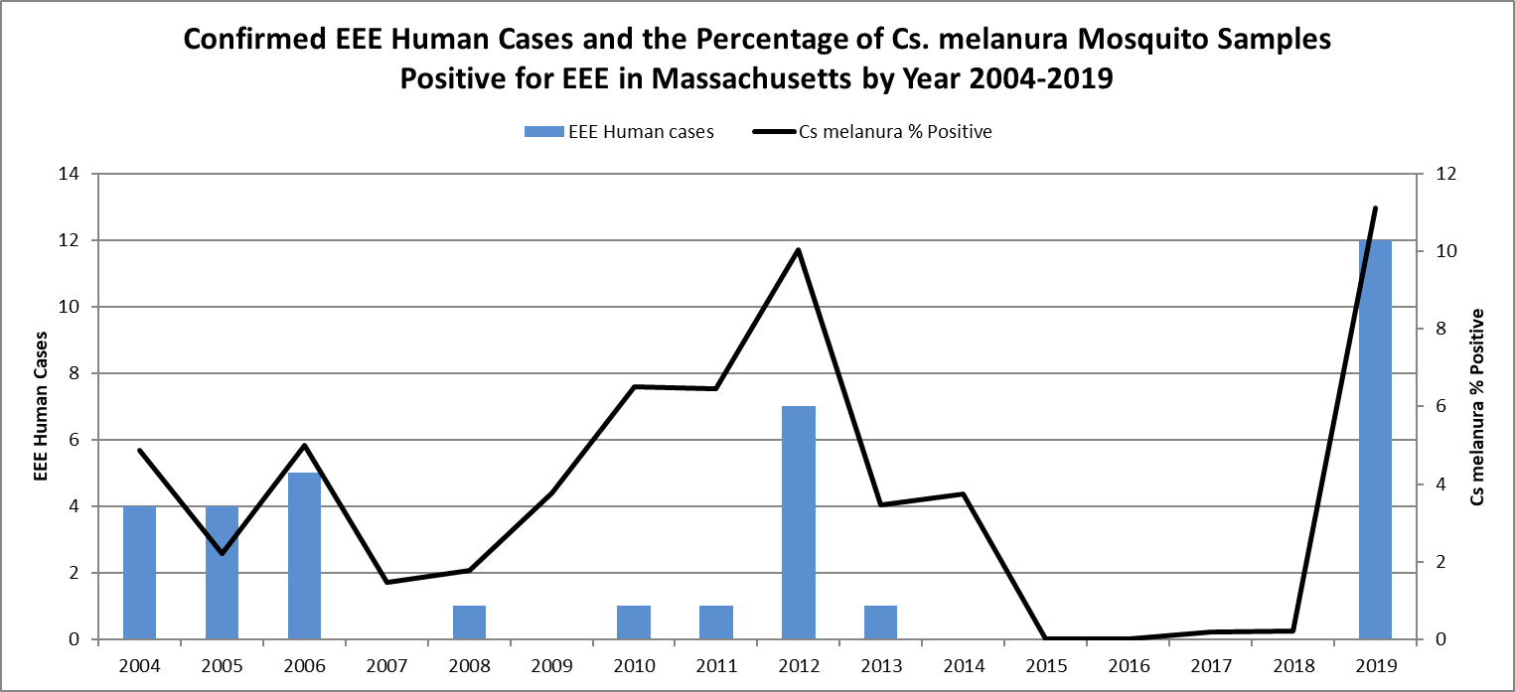
Why did EEE increase in 2019?
EEE outbreaks are supported by three main components: birds, which have no or minimal immunity to the virus; large populations of bird- and mammal-biting mosquito vectors; and favorable weather conditions including significant precipitation events in the prior fall and spring and prolonged periods of high temperatures. Previously unexposed populations of birds are susceptible to EEE virus infection, and therefore are capable of maintaining the cycle of virus transmission. Current research also suggests that each EEE outbreak cycle is associated with the introduction of a new strain of EEE virus by migratory birds. The last major EEE outbreak ended in 2012 providing ample time for populations of birds that lacked immunity to EEE to increase.

The 2018 arbovirus season ended with large populations of Cs. melanura. This species overwinters as larvae in woodland crypts, water-filled voids under the roots of trees. The winter of 2018-2019 was mild with above average temperatures and steady precipitation events. The spring of 2019 had average temperatures and above-average precipitation events, leading to the largest Cs. melanura emergence since 2012. Cq. perturbans populations also exhibited low mortality associated with favorable winter weather conditions and had high emergence rates. This was also true for other vector species possibly associated with EEE transmission including Culex salinarius and Ochlerotatus canadensis.

Response to EEE in 2019
DPH and partnering agencies were prepared for and aware that 2019 might be a significant year for EEE. Weather conditions were favorable, the virus had been largely absent from Massachusetts since 2012, making it likely that the majority of host birds would be susceptible to EEE, and there was evidence of a possible introduction of EEE virus to Massachusetts at the very end of the 2018 season.

The first Eastern equine encephalitis virus (EEE) isolations were collected on 7/15/19 in Easton, Freetown, and New Bedford, all in the primary enzootic mosquito vector, Cs. melanura. These isolations were followed by a rapid geographic expansion in EEE mosquito detections throughout Bristol and Plymouth Counties from 7/20/19 – 7/26/19. In the week of 7/27/19 the first detections of EEE mammal biting species were identified in Aedes vexans, Culex salinarius, and Cq. perturbans. The first EEE positive human case occurred in Worcester County with a symptom onset of 7/30/19. The first EEE positive animal was identified with a symptom onset of 8/11/19.

Due to the rapidly expanding EEE activity observed in 7/20/19 – 7/26/19 and in accordance with the 2019 Massachusetts Arbovirus Surveillance Plan, DPH, the Massachusetts Department of Agricultural Resources (MDAR), the State Reclamation and Mosquito Control Board (SRMCB) Mosquito Control Districts (MCD) and the Mosquito Advisory Group (MAG) met to discuss options for public health communication and EEE control resources. Aerial intervention targeting the intense Bristol and Plymouth County EEE foci was selected as the most viable control option available. Following the declaration of a Public Health Hazard by DPH the first aerial adulticiding interventions conducted by MDAR began on 8/8/19. As EEE risk increased throughout the season in Bristol County, Plymouth County, and areas of Central and Western Massachusetts additional targeted aerial adulticiding interventions occurred to reduce risk. A total of six aerial adulticiding interventions were completed during the 2019 season.

Efficacy of Aerial Interventions
DPH and partnering agencies assess each aerial treatment to determine if was effective in reducing the total population of mosquitoes. This work is conducted by setting mosquito traps pre-treatment and post-treatment at control and target locations. DPH also examines trends post-spraying to determine if viral intensity within the spray zone decreases. The table below shows each aerial intervention and the percent achieved control.

Percentage Control by Intervention and Species
Aerial Intervention Location | Start Date | End Date | % Total Control
Bristol / Plymouth | 8/8/2019 | 8/11/2019 | 58
Bristol / Plymouth | 8/21/2019 | 8/25/2019 | 25
Middlesex / Worcester | 8/26/2019 | 8/27/2019 | 20
Middlesex / Norfolk / Worcester | 9/10/2019 | 9/18/2019 | ND
Hampden/ Hampshire / Worcester | 9/15/2019 | 9/17/2019 | ND
Bristol / Plymouth | 9/18/2019 | 9/24/2019 | 53
ND = Control not detected; calculations affected by small sample sizes

Interpreting Efficacy and Data Limitations
The 2019 arbovirus season was unique in that six large-scale aerial spray events occurred in one season with some interventions in different geographic locations overlapping in time. Surveillance resources including personnel and equipment were limiting factors. One significant challenge during the 2019 operations was in selecting control sites for control. Since the operations focused on control of Cs. melanura and Cq. perturbans and due to the large geographic spray zones areas which encompassed much of their habitat, it became difficult to locate comparable habitat for these species outside of the spray zone which can negatively impact the percent total control.

Weather, including low evening temperatures and rain events was the main disruptive factor in both the aerial adulticiding operations and aerial adulticiding efficacy. Mosquitos are sensitive to low temperatures and conserve energy by not flying at lower temperatures. Products used for mosquito control are not labelled for use below 50ºF but mosquito species respond differently to temperature with some species becoming increasingly inactive at temperatures below 60ºF. The result is that efficacy begins to decrease substantially at temperatures below 60ºF. Several aerial interventions were halted on multiple consecutive evenings due to low temperatures.

Many of the aerial interventions took place over several nights and encompassed hundreds of thousands of acres. Longer term operations increase the likelihood of mosquito emergences occurring within a spray window and migration of mosquitoes into treated zones following the operations. Simply put, the longer the window of aerial adulticiding, the lower the overall efficacy.

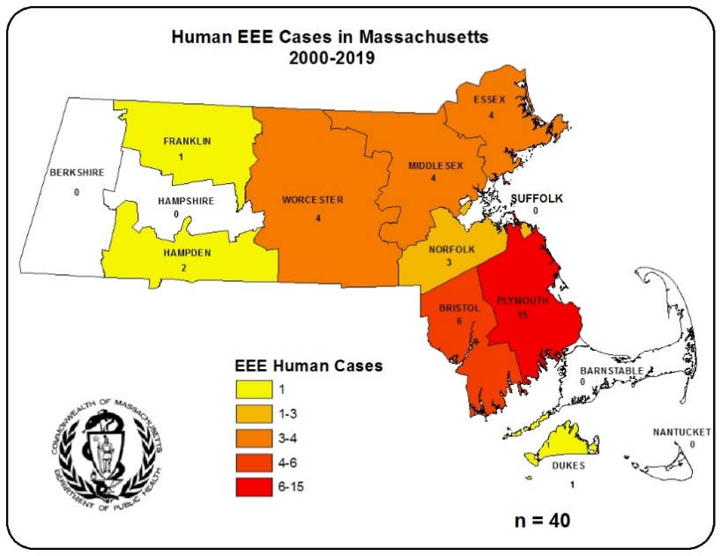
In Massachusetts, human EEE infection is associated with Cs. melanura activity. The map to the right illustrates that southeastern Massachusetts remains the area of highest EEE transmission. However, EEE appears to be spreading from the historic area of risk. Northeastern, Central and Western Massachusetts have become areas of high risk more recently.

Variability in Geographic Range of EEE
In Massachusetts over the last ten years an increasing number of human EEE cases have occurred outside of the historic area of risk, and there have been year-to-year variations in the geographic pattern of disease occurrence. In 2019 in Massachusetts, seven cases occurred outside the historic area of risk. This is not unique to Massachusetts; during 2013-2016 human cases of EEE were reported from neighboring states including Connecticut, Maine, New Hampshire, New York, Rhode Island, and Vermont. Many of these cases were unusual in that they occurred in: states which rarely see EEE cases (Connecticut and Rhode Island); states where EEE cases are a very recent occurrence (Maine, New Hampshire, and Vermont); and in atypical areas in states that have historic areas of risk (New York).

MCDs in Massachusetts are focused in the eastern part of the state, including Southeastern Massachusetts where EEE activity has been concentrated. However, 40% of municipalities statewide do not have access to a MCD. Historically, DPH has offered mosquito trapping in these underserved communities but some areas may go extended periods of time without surveillance activities. For 2020DPH has increased its capability to provide routine testing for larger portions of the state providing for broader arbovirus surveillance coverage. DPH will continue to perform adaptive surveillance activities to provide for early detection of EEE throughout the Commonwealth.

What are the expectations for EEE in 2020?
The 2019 season ended with warm fall conditions accompanied by significant precipitation events. The winter was mild with insulating snow cover for the short duration cold periods. In Spring 2020, larval surveillance activities for Cs. melanura have shown large populations. Multiple sustained rain events with cooler spring temperatures will probably delay emergence of EEE vector species for 1-2 weeks but will not increase mortality. It is expected that large populations of Cs. melanura will exist in early Summer and bird populations will likely consist of susceptible birds both of which will support amplification of virus. It is anticipated that EEE transmission to humans will occur. Unexpected weather patterns including drought or cold weather could limit transmission. Early detection along with early public awareness will be key for the prevention of human disease.

WEST NILE VIRUS

Humans
There were five human cases of WNV infection identified in Massachusetts in 2019. The results are summarized in the table below.

County | Age Range | Onset Date | Virus Result | Clinical Presentation
Bristol | 60-69 | 9/18/2019 | WNV | Fever
Middlesex | 60 - 69 | 9/1/2019 | WNV | Meningoencephalitis
Middlesex | 60 - 69 | 9/15/2019 | WNV | Fever
Plymouth | 50 - 59 | 9/4/2019 | WNV | Fever
Plymouth | 50-59 | 9/20/2019 | WNV | Meningitis

Presumptive Viremic Blood Donors
WNV is transmissible through blood transfusion. Since June 2003, blood banks have screened donated blood for WNV using a nucleic acid test (NAT) that identifies viral genetic material. Positive units are not used and donors are deferred from future donation for 120 days. The AABB (formerly the American Association of Blood Banks) notifies states of all presumptive viremic donors (PVDs), i.e., individuals whose donated blood tests positive using the NAT test.

There were three PVD identified in Massachusetts in 2019. The number of PVDs nationwide decreased in 2019 (100) from 2018 (372).

Mosquito Samples
Of 8,295 mosquito samples collected in Massachusetts in 2019, 87 (1.04%) were positive for WNV. Positive mosquito samples included 56 (64%) Culex species, followed by 23 (26%) Culiseta melanura. Positive samples were identified in 45 towns in 12 counties. For a complete list of positive mosquito samples by city/town, please see the 2019 Mosquito Summary by County and Municipality report posted on the DPH website.

Animals
Fifteen veterinary samples were submitted for arbovirus testing. One wild peregrine falcon tested positive for WNV. Although birds are not tested for WNV for surveillance purposes, this falcon was clinically ill and was tested for diagnostic purposes.

WNV Geographic Risk Levels
WNV risk maps are produced by integrating historical data and areas of mosquito habitat with current data on positive virus identifications (in humans, mosquitoes, etc.) and weather conditions. Risk levels serve as a relative measure of the likelihood of an outbreak of human disease and are updated weekly based on that week’s surveillance data. Initial and final WNV risk levels from the 2019 season are provided in the following maps. This information will be used to help predict risk in 2020, and will be revised as 2020 surveillance data are collected. More detailed information about risk assessment and risk levels is available in the Arbovirus Surveillance and Response Plan on the DPH web site during the arbovirus season.

Initial and Final 2019 WNV Risk Categories
(As described in Table 1 of the DPH Arbovirus Surveillance and Response Plan which can be found at www.mass.gov/dph/mosquito under “Surveillance Plan and historical data”)

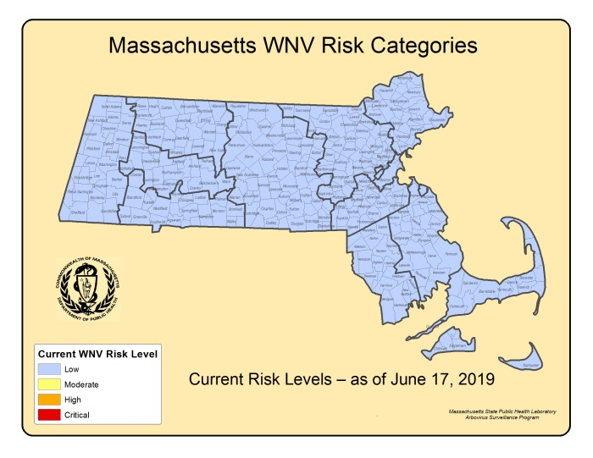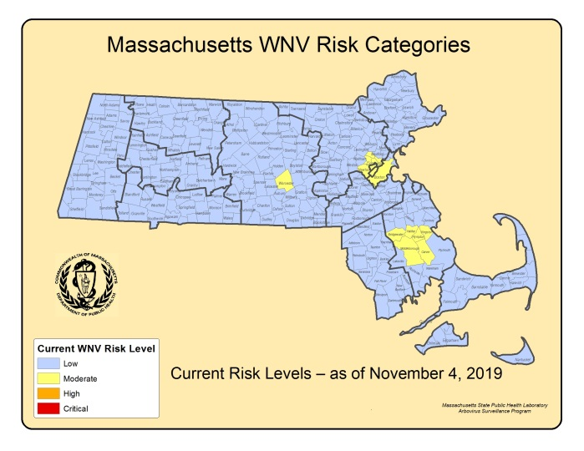
2019 WNV SEASON DISCUSSION
DPH identified five confirmed human WNV infections in 2019 compared to 49 confirmed WNV cases in 2018. Culex pipiens, the primary mosquito vector of WNV, had smaller populations in 2019 as compared to 2018. Periodic low temperature events coupled with consistent precipitation likely slowed larval development and limited amplification of the virus. The number of confirmed human cases nationwide in 2019 (917) was a decrease from 2018 (2,647).

Of the cases identified nationally in 2019, 607 (66%) were classified as neuroinvasive disease (defined as meningitis or encephalitis) and 310 (34%) were classified as non-neuroinvasive disease. A major portion of the cases (56%) were reported from three states (California, Arizona, and Colorado). Twenty-three percent of all cases were reported from California.

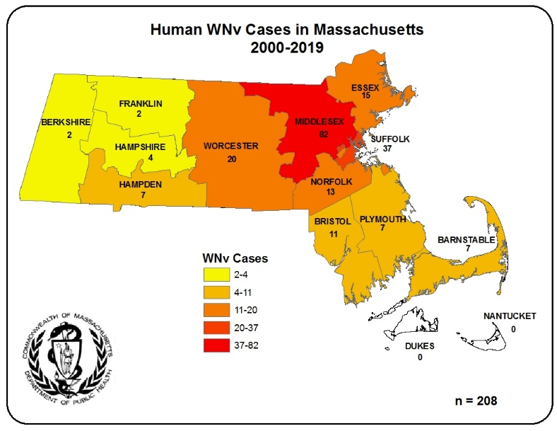
In Massachusetts, the vectors for WNV are primarily Culex species. Culex species are closely associated with human activity. The map to the right illustrates that transmission to humans is generally highest in counties with higher population densities.

WNV Positive Mosquitoes and Correlation with Human Disease
In 2019, DPH identified 87 WNV positive mosquito samples, including 56 Culex species, compared to 522 WNV positive Culex species mosquito samples in 2018. In general, years with increased WNV human infections are associated with an increase in the percentage of Culex samples positive for WNV (see figure below).

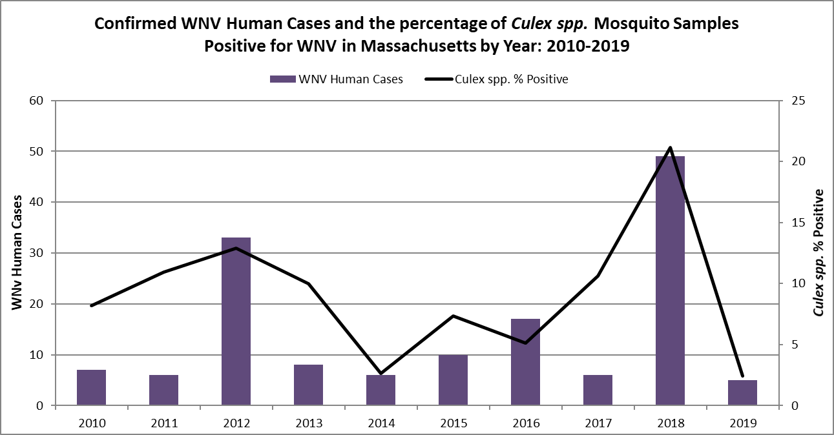

What are the expectations for WNV in 2020?
The primary determinants of human WNV disease risk during any particular season are populations of Culex mosquito species and the presence of infected birds. The two most important variables for mosquito development are precipitation and temperature. Warmer temperatures shorten both the time it takes for mosquitoes to develop from egg to adult and the time it takes for a mosquito to be able to transmit a pathogen after ingesting an infected blood meal. Culex mosquito populations tend to be greatest during seasons with periodic precipitation events (giving rise to stagnant puddles and water-filled containers that favor Culex breeding), separated by hot, dry days.

Mosquito populations alone are not sufficient to produce significant WNV risk; infected bird populations are also necessary. Unfortunately, less is known about the factors that lead to large numbers of infected birds making this component of risk impossible to predict and there is no efficient way to conduct surveillance for infection levels in wild birds.

The lack of useful pre-season predictive factors limits the ability of DPH to make any accurate assessments regarding future WNV activity. Both the variability of New England weather, and the inability to detect WNV infection levels in wild bird populations, requires that Massachusetts maintain a robust surveillance system to detect WNV in mosquitoes as a primary tool to assess risk of human disease. DPH continues to strive to identify reliable measures to aid in risk assessments.

Invasive Mosquito Species Surveillance

DPH and its partners are taking proactive measures to conduct surveillance for invasive mosquito species that are expanding their geographic range northward, especially for Aedes albopictus. Ae. albopictus is an aggressive mammal-biting species that was introduced to North America from Asia around 1985. This species has been implicated in the transmission of arboviruses such as dengue, chikungunya, yellow fever, and Zika in some parts of the world. Where it occurs, this species is generally more abundant in urban areas, breeding in artificial containers, such as birdbaths, discarded tires, buckets, clogged gutters, catch basins, and other standing water sources. These mosquitoes are aggressive biters that actively seek out mammals, including humans, during daytime hours.
Limited detections of Ae. albopictus were first identified in Southeastern MA in 2009. Since these initial detections, additional findings have been recorded outside Southeastern MA. With the use of ovitraps Ae. albopictus has now been detected in 20 communities throughout the state since 2009. DPH will continue to conduct routine surveillance activities to monitor for the presence and expansion of Ae. albopictus and other invasive mosquito species.

