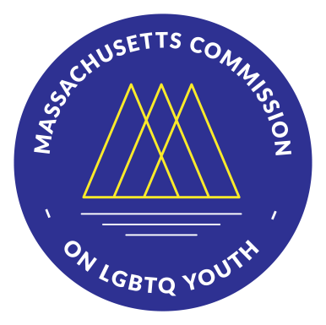
Massachusetts Commission on
LGBTQ Youth

Summary of Fiscal Year
2019 Recommendations

The Massachusetts Commission on LGBTQ Youth was founded in 1992 and works towards making the Commonwealth a place in which all youth can thrive. The Commission issues recommendations before the start of each fiscal year, and this year (in addition to specific recommendations issued to 18 different agencies) has issued core recommendations to the Legislature and Executive Branch to work on achieving together. These core recommendations have four thematic areas reflecting our commitment to racial justice: reducing bias, preventing and treating homelessness, reforming criminal justice, and improving health.

Turn over for more
Full report at Mass.gov/annual-recommendations
I would like to see more education for medical personnel so they don’t make assumptions on the teen’s identity and orientation in basic physical exams and counseling.

– Parent
Core Recommendations on Homelessness:
1. Restore to previous levels the budget line items for prevention of youth homelessness and services for youth experiencing homelessness.
2. Prioritize funds allocated to homelessness prevention and services for release as early in the fiscal year as possible.
3. Improve access to state IDs for youth experiencing homelessness.
4. Create a bill of rights for people experiencing homelessness.
5. Improve the Youth Count survey and ensure LGBTQ inclusion.
The disparities facing LGBTQ youth in the Commonwealth are vast and varied, but most are closely tied – in one way or another – to the rejection and exclusion of these young people from broader society... To address this social exclusion, the Commonwealth must both treat the immediate needs of youth facing exclusion as well as work on the larger, more difficult project of making Massachusetts a more just and equitable place for all.

– Excerpt from annual report section, “State of LGBTQ Youth in the Commonwealth”
Core Recommendations on Reducing Bias:
1. Require basic LGBTQ competency training for all state employees and contractors.
2. Adopt policies that recognize gender identity diversity in state workplaces.
3. Eliminate discrimination on the basis of gender identity and sexual orientation in all settings.
4. Establish an interagency collaboration to address familial rejection of LGBTQ youth.
Learn more about the Commission at
Mass.gov/cgly
Follow us on social media
@MassLGBTQYouth
Download the full report at
Mass.gov/annual-recommendations
The Commission also issues recommendations on things like training, data collection, and nondiscrimination to:
Department of Early Education and Childhood | Department of Elementary and Secondary Education
Department of Higher Education | Department of Children and Families | Commission for the Blind
Commission for the Deaf and Hard of Hearing | Rehabilitation Commission | Department of Mental Health Department of Public Health | Office of Refugees and Immigrants | Department of Transitional Assistance Department of Youth Services | Executive Office of Public Safety and Security | Registry of Motor Vehicles Regional Transit Authorities | Board of Library Commissioners | Department of Career Services
Department of Housing and Community Development

Core Recommendations on Criminal Justice:
1. Support organizations seeking to eliminate the school-to-prison pipeline and explore how to develop a comprehensive state plan to do so.
2. Increase collection of data on sexual orientation and gender identity throughout the juvenile and criminal justice systems.
3. Ensure that memorandums of understanding (MOUs) regarding school resource officers (SROs) address LGBTQ disparities.
4. Decriminalize consensual sexual relations among parties close in age.
5. Issue guidance on reporting consensual sexual relations between minors.
The education for LGBTQ issues is lacking at best. The information we receive in health classes is either overgeneralized or inaccurate. I remember in 10th grade I was essentially teaching my health class for my teacher because he just wasn't well educated on what he was talking about.

– High School Student
Conversion therapy has proven to be psychologically damaging to LGBTQ youth and poses a public health risk in mental health to a vulnerable population. Massachusetts should be leading on this issue... The LGBTQ youth of Massachusetts can’t wait any longer.

– Youth Advocate
Core Recommendations on Health:
1. Ban the harmful and discredited practice of conversion therapy.
2. Ensure that comprehensive, age-appropriate, and LGBTQ-inclusive sexual health education is given in every school district and supported with adequate funding.
3. Provide level or increased funding for the HIV line item (4512-0103) that provides critical services for LGBTQ youth, particularly LGBTQ youth of color.
4. Prioritize funds allocated to sexual health for release as early in the fiscal year as possible.
5. Ensure that the response to the opioid crisis takes into account the specific needs of LGBTQ youth.

