Summary of Unintentional and Undetermined Intent Drug Overdose Deaths in Massachusetts – 2019
2,221 total deaths (32.2 per 100,000 population)

Who died of a drug overdose?

Female 26%

What drugs¹ were identified?
What circumstances⁴ were documented?

of deaths occurred in the decedent's home
67%

Male 74%

Current or past substance use/misuse

55%
83%

Female Male

<15

15-24

25-34

0% 0%

1%
20%
4%
7%
Additional drug classes detected among drug overdose deaths by COD drug²
Bystander present⁵

Mental health diagnosis⁵
29%
Naloxone administered
25%

41%

35-44

45-54

55-64

65+

White, non-Hispanic
Hispanic Black, non-Hispanic Other, non-Hispanic

1% 2%

14%
7%
2%

77%

93% of all deaths involved any opioids. 77% of all deaths had more than one drug class present. 70% of all deaths with illicitly manufactured fentanyls (IMFs) listed as cause of death also had another drug class present; the most common drug class present with IMFs was cocaine.
81% of decedents had at least one potential opportunity for…
12%
17%
19%
4%
6%
6%

How many drug overdose deaths occurred by month³?
Ever treated for substance use disorder⁵
21%
Recent opioid use relapse⁷
15%
Prior overdose⁵
12%
Current pain treatment
10%
Recent release from institution⁵˒⁶
7%
Fatal drug use witnessed⁵
7%
Homeless

81% of decedents had at least one potential

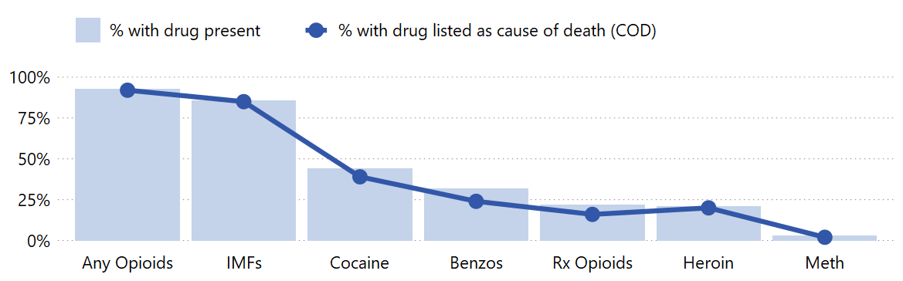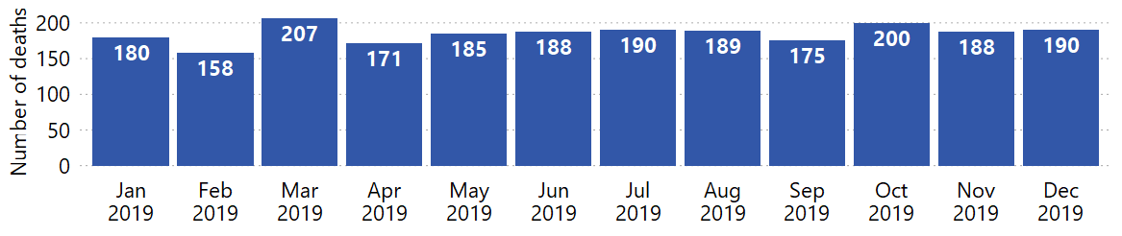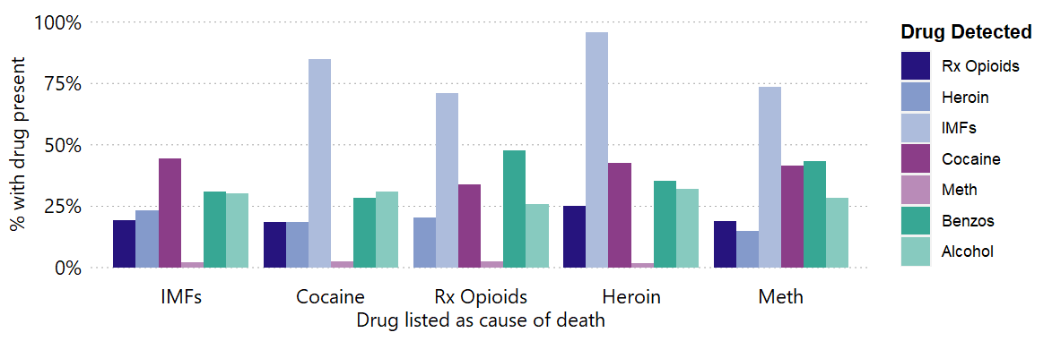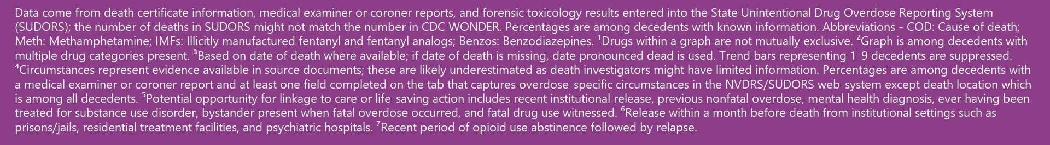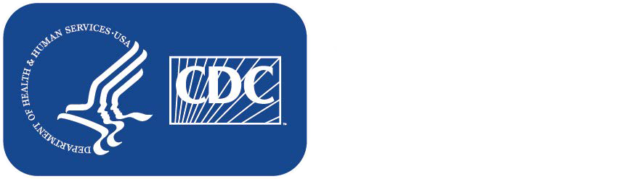27% of people who died of a drug overdose were 25-34 years old, 77% were White, non-Hispanic, and 74% were male.
/
opportunity for linkage to care prior to death or implementation of a life-saving action⁵ at the time of overdose.

