INDOOR AIR QUALITY ASSESSMENT

Sunderland Elementary School
1 Swampfield Drive
Sunderland, Massachusetts

Prepared by:
Massachusetts Department of Public Health
Bureau of Environmental Health
Indoor Air Quality Program
December 2018

BACKGROUND
Building: | Sunderland Elementary School (SES)
Address: | 1 Swampfield Drive, Sunderland, Massachusetts
Assessment Requested by: | Steve Ball, Health Agent, Sunderland Board of Health
Reason for Request: | General indoor air quality (IAQ) concerns, with a focus on water damage/mold.
Date of Assessment: | November 9, 2018
Massachusetts Department of Public Health/Bureau of Environmental Health (MDPH/BEH) Staff Conducting Assessment: | Michael Feeney, Director, IAQ Program
Date of Building Construction: | 1988
Building Description: | SES is a one -story, multi wing building. The school is built on a concrete slab.
Windows: | Openable

METHODS
Please refer to the IAQ Manual and appendices for methods, sampling procedures, and interpretation of results (MDPH, 2015).

RESULTS and DISCUSSION
The following is a summary of indoor air testing results (Table 1).
- Carbon dioxide levels were above the MDPH recommended level of 800 parts per million (ppm) in about a third of areas surveyed, which can indicate a lack of air exchange at the time of assessment. It is also important to note that several classrooms had low/no occupancy, which can reduce carbon dioxide levels.
- Temperature was within or very close to the MDPH recommended range of 70°F to 78°F in all occupied areas tested.
- Relative humidity was below the MDPH recommended range of 40 to 60% in areas tested the day of assessment.
- Carbon monoxide levels were non-detectable (ND) in all areas tested.
- Particulate matter (PM2.5) concentrations measured were below the National Ambient Air Quality (NAAQS) level of 35 μg/m³ in all but one area tested.

Ventilation
A heating, ventilating and air conditioning (HVAC) system has several functions. First it provides heating and, if equipped, cooling. Second, it is a source of fresh air. Finally, an HVAC system will dilute and remove normally-occurring indoor environmental pollutants by not only introducing fresh air, but by filtering the airstream and ejecting stale air to the outdoors via exhaust ventilation. Even if an HVAC system is operating as designed, point sources of respiratory irritation may exist and cause symptoms in sensitive individuals.

Fresh air in classrooms is supplied by air-handling units (AHUs) located above the ceiling system. Fresh air is provided by ceiling-mounted diffusers connected to the AHUs by ductwork. Exhaust ventilation is provided by wall-mounted exhaust grilles ducted back to AHUs.

To maximize air exchange, BEH recommends that both supply and exhaust ventilation operate continuously during periods of occupancy. In order to have proper ventilation with a mechanical ventilation system, the systems must be balanced after installation to provide an adequate amount of fresh air to the interior of a room while removing stale air from the room. It is recommended that HVAC systems be re-balanced every five years to ensure adequate air systems function (SMACNA, 1994). At the time of this assessment, no information regarding balancing was available.

Microbial/Moisture Concerns
It is important to note that the Boston area experienced an unprecedented period of extended hot, humid weather. According to the Washington Post, “[d]ata…show[s]…cities in the Northeast have witnessed such humidity levels for record-challenging duration...[i]ncluding Albany, Boston, Burlington Portland and Providence” during the summer of 2018 (WP, 2018). “Boston and nearby locations… [saw]…historic numbers of those warm nights with low temperatures at or above 70 degrees…Providence and Blue Hill Observatory have already broken their annual records” (WP, 2018). If a building does not have either adequate exhaust ventilation and/or air chilling capacity to remove/reduce relative humidity from outside air, then hot, moist air can be introduced into a building and linger to increase occupant discomfort as well as possibly moisten materials that may lead to mold growth.
After the summer of 2018, mold growth was visible in the PT/OT room. The OT/PT room is a converted girl’s locker room (Picture 1), as is the adjacent storeroom. Both areas have former shower rooms with open, disused drains (Picture 2) that likely have dry drain traps. The purpose of a trap is to prevent odors, and other pollutants from migrating from the sewer system into interior space. Without water in the trap, water vapor from the sewer can readily enter the former locker rooms and moisten porous materials to cause mold growth in such materials as wall-to-to-call carpeting in a section of the former boy’s locker room (Picture 3). Of note were musical instrument cases that appeared mold-colonized (Picture 4). A number of classrooms had warped corkboard (Picture 5) as well as bowing ceiling tiles, which indicates exposure to water vapor during hot, humid weather. Also noted were paper bags stored directly on the floor in the boy’s locker room (Picture 6), which can become moistened during summer months due to condensation on cool surfaces.
It is very likely that the building slab floor is prone to condensation during hot, humid weather. As mentioned, the HVAC system has no cooling capacity. This condition can contribute to moisture build up in the building. Moisture that is introduced by the univents is recirculated within the space, resulting in increased relative humidity and reduced occupant comfort. Over time, chronic moisture from condensation can lead to water damage to building materials.
Moisture from humid air will condense and accumulate on the surface of building materials that have temperatures at or below the dew point. As noted by Mr. Ball, Sunderland has a high water table and the SES has a documented history regarding its construction. It is likely the floor has neither insulation nor a vapor barrier between the cement and soil. In this condition, the cement floor frequently will have a temperature similar to the soil beneath the slab (<60°F). If the temperature of the cement is below the dew point, then the surface will become moistened with condensation. The dew point is the temperature that air must reach for saturation to occur. For example, during humid weather when the temperature is 85°F and relative humidity is 90%, the dew point is approximately 82°F. Surfaces with a temperature at or below 82°F are prone to condensation formation.
One room had water-damaged gypsum wallboard (GW) that is attributed to a failed/leaking stop cock. Chronically moistened GW can support mold growth.
In order for mold growth to occur, materials must be exposed to chronic moisture. Relative humidity in excess of 70 percent for extended periods of time, even in the absence of other sources of water, can provide an environment for mold and fungal growth (ASHRAE, 1989). In general, the US Environmental Protection Agency (US EPA) and the American Conference of Governmental Industrial Hygienists (ACGIH) recommends that porous materials (e.g., GW, carpeting) be dried with fans and heating within 24 to 48 hours of becoming wet (US EPA, 2008; ACGIH, 1989). If porous materials are not dried within this time frame, mold growth may occur.

Other Conditions
Exposure to low levels of total volatile organic compounds (TVOCs) may produce eye, nose, throat, and/or respiratory irritation in some sensitive individuals. Levels of TVOCs measured in the building were not detected (below the detection level of the instrument) at the time of the assessment. BEH/IAQ staff also examined rooms for products containing VOCs. BEH/IAQ staff noted hand sanitizers, cleaners and dry erase materials in use within the building (Table 1). These products have the potential to be irritants to the eyes, nose, throat, and respiratory system of sensitive individuals.
During the assessment, a classroom had a measurement above the NAAQS for PM 2.5 (Table 1). The source of the PM2.5 was a fragrance oil diffuser device. The use of oil diffusers is not recommended since these products can cause eye, nose and respiratory system irritation as detailed in the guideline Clean Air is Odor-free - Removing fragrances to improve indoor air quality in schools and offices, which is included as Appendix A.
If present, carpets should be cleaned annually (or semi-annually in soiled/high traffic areas) in accordance with Institute of Inspection, Cleaning and Restoration Certification (IICRC) recommendations, (IICRC, 2012). Regular cleaning with a high efficiency particulate air (HEPA) filtered vacuum in combination with an annual cleaning will help to reduce accumulation and potential aerosolization of materials from carpeting. Area carpets too worn to be effectively cleaned should be replaced.

RECOMMENDATIONS
The conditions within the SES require both short-term and long-term strategies. Short-term recommendations can be implemented as soon as practicable to improve IAQ. Long-term strategies may require planning and capital to prevent the reoccurrence of conditions conducive to HVAC leaks/condensation and mold growth. In view of the findings at the time of the visit, the following recommendations are made:

Short-Term Recommendations
- Seal all floor drains in the former locker rooms with an air tight plate.
- Remove carpet in the former boy’s locker room and GW in Picture 7 in a manner consistent with recommendation delineated in the US EPA guideline “Mold Remediation in Schools and Commercial Buildings”, available at: http://www.epa.gov/mold/mold-remediation-schools-and-commercial-buildings-guide. It is not recommended to use carpeting in this location.
- Replace mold-colonized instrument cases.
- Ensure stop cock in Picture 7 is replaced/repaired.
- Refrain from storing cardboard boxes directly on floors or in other locations with chronic moisture to prevent moistening/mold growth.
- Remove water-damaged cork board as needed.
- Replace water-damaged ceiling tiles after leaks are discovered and repaired. During summer months closely monitor conditions of excess relative humidity (e.g., > 70% for extended periods of time) to prevent condensation/mold growth. Operate AC systems/dehumidifiers as needed.
- Clean area carpets annually or semi-annually in soiled high traffic areas as per the recommendations of the Institute of Inspection, Cleaning and Restoration Certification (IICRC, 2012). Replace those with excessive wear.
- Consider reducing the use of hand sanitizers, air deodorizers, and other scented materials in use within the office since these products have the potential to be irritants to the eyes, nose, throat, and respiratory system of sensitive individuals.
- Utilize the information in the MDPH guidance document “Preventing Mold Growth in Massachusetts Schools During Hot, Humid Weather,” attached as Appendix B.
- Refer to resource manual and other related indoor air quality documents located on the MDPH’s website for further building-wide evaluations and advice on maintaining public buildings. These documents are available at http://mass.gov/dph/iaq.

Long Term Recommendations
- Consider replacing wall-to-wall carpeting with a flooring material that is resistant to mold growth.

REFERENCES
ASHRAE. 2012. American Society of Heating, Refrigeration and Air Conditioning Engineers (ASHRAE) Standard 52.2-2012 -- Method of Testing General Ventilation Air-Cleaning Devices for Removal Efficiency by Particle Size (ANSI Approved). 2012.
IICRC. 2012. Institute of Inspection Cleaning and Restoration Certification. Institute of Inspection, Cleaning and Restoration Certification. Carpet Cleaning: FAQ.
MDPH. 2015. Massachusetts Department of Public Health. Indoor Air Quality Manual: Chapters I-III. Available at: http://www.mass.gov/eohhs/gov/departments/dph/programs/environmental-health/exposure-topics/iaq/iaq-manual/.
SMACNA. 1994. HVAC Systems Commissioning Manual. 1st ed. Sheet Metal and Air Conditioning Contractors’ National Association, Inc., Chantilly, VA.
US EPA. 2008. Mold Remediation in Schools and Commercial Buildings. US Environmental Protection Agency, Office of Air and Radiation, Indoor Environments Division, Washington, D.C. EPA 402-K-01-001. http://www.epa.gov/mold/mold-remediation-schools-and-commercial-buildings-guide.
WP. 2018. ‘It’s been relentless’: Smothering summer humidity in the Northeast has crushed records. Washington Post, Washington, DC. https://www.washingtonpost.com/news/capital-weather-gang/wp/2018/08/30/its-been-relentless-smothering-summer-humidity-in-the-northeast-has-crushed-records/

Picture 1
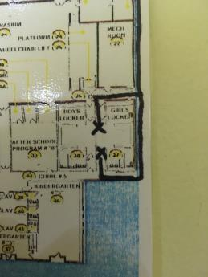
Location of OP/PT room and storage in former locker rooms
Picture 2
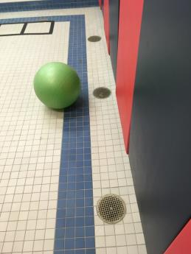
Open drains in OP/PT room
Picture 3
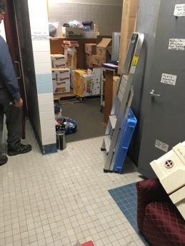
Wall-to-wall carpeting in store room in former boys’ locker room
Picture 4
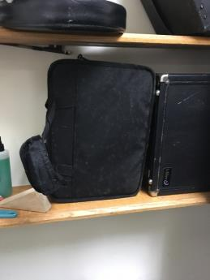
Mold-colonized instrument cases
Picture 5
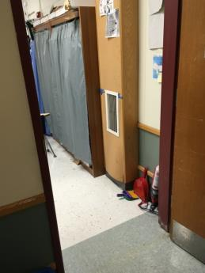
Warped cork board in classroom
Picture 6
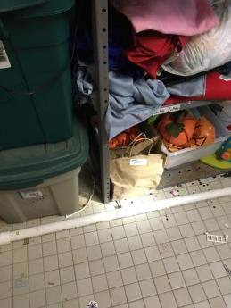
Paper on floor of storeroom
Picture 7
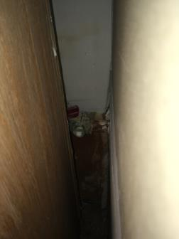
Reportedly leaking stopcock, note water-damaged gypsum wallboard

Location | Carbon  Dioxide  (ppm) | Carbon Monoxide  (ppm) | Temp  (°F) | Relative  Humidity  (%) | PM2.5  (µg/m³) | Occupants  in Room | Windows  Openable | Ventilation |  | Remarks
 |  |  |  |  |  |  |  | Supply | Exhaust
Background/  Outdoors | 388 | ND |  |  | 10
Cafeteria | 951 | ND | 71 | 33 | 6 | 100+ | Y | Y | Y
Copier room | 554 | ND | 71 | 30 | 6 | 0 | N | Y | Y | Carpeting
Gym | 464 | ND | 71 | 27 | 4 | 0 | N | Y | Y
Gym office | 492 | ND | 71 | 30 | 4 | 0 | N | Y | N
Library | 642 | ND | 71 | 30 | 6 | 18 | Y | Y | Y
Main office | 611 | ND | 70 | 31 | 7 | 1 | Y | Y | Y
Nurse’s office | 617 | ND | 70 | 31 | 7 | 0 | Y | Y | Y | Bowed ceiling tiles
Principal’s office | 611 | ND | 70 | 30 | 6 | 1 | Y | Y | Y
PT/OT | 480 | ND | 72 | 27 | 5 |  | N | Y | Y | Floor drains
Staff lounge | 768 | ND | 72 | 31 | 7 | 7 | N | Y | Y | Bowed ceiling tiles
Store room | 472 | ND | 69 | 30 | 4 | 0 | N | Y | Y | Floor drains  Carpeting
0 | 431 | ND | 70 | 30 | 5 | 0 | N | Y | Y | Bowed ceiling tiles  Mold-colonized cases
01 | 590 | ND | 71 | 32 | 6 | 5 | Y | Y | Y
03 | 522 | ND | 71 | 31 | 7 | 0 | Y | Y | Y
04 | 734 | ND | 71 | 32 | 4 | 0 | Y | N | N
05 | 535 | ND | 71 | 30 | 8 | 10 | Y | Y | Y | Bowed ceiling tiles
06 | 901 | ND | 71 | 34 | 4 | 2 | Y | Y | Y | Bowed ceiling tiles  Warped cork board
07 | 596 | ND | 70 | 30 | 8 | 6 | N | Y | Y
08 | 1048 | ND | 71 | 36 | 5 | 19 | Y | Y | Y
09 | 559 | ND | 70 | 30 | 8 | 2 | Y | Y | Y | Bowed ceiling tiles  Warped cork board
10 | 772 | ND | 71 | 33 | 5 | 1 | Y | Y | Y | Exhaust blocked by desk
11 | 623 | ND | 71 | 29 | 6 | 0 | Y | Y | Y
12 | 899 | ND | 71 | 33 | 6 | 20 | Y | Y | Y | Bowed ceiling tiles
13 | 814 | ND | 72 | 32 | 6 | 2 | Y | Y | Y | Carpeting, bowed ceiling tiles
14 | 808 | ND | 71 | 34 | 86 | 2 | Y | Y | Y | Oil diffuser
15 | 929 | ND | 72 | 32 | 7 | 16 | Y | Y | Y | Water-damaged gypsum wallboard
16 | 962 | ND | 71 | 36 | 9 | 21 | Y | Y | Y
17 | 561 | ND | 72 | 30 | 8 | 5 | Y | Y | Y
18 | 832 | ND | 71 | 34 | 8 | 1 | Y | Y | Y
19 | 648 | ND | 71 | 31 | 8 | 0 | Y | Y | Y
21 | 720 | ND | 72 | 33 | 7 | 18 | Y | Y | Y
23 | 774 | ND | 72 | 32 | 6 | 0 | Y | Y | Y | Bowed ceiling tiles

