APPENDIX 6 NOTICE OF INTENT

APPENDIX 7 CERTIFICATE OF ORGANIZATION

BETH ISRAEL LAHEY HEALTH, INC.

BILH- 25101614-AS ARTICLES OF INCORPORATION

Articles of Organization – 11/27/2018 https://corp.sec.state.ma.us/CorpWeb/CorpSearch/CorpSearchRedirector.aspx?Action=PDF&Pat h=CORP_DRIVE1/2018/1127/001517515/0003/201848640920_1.pdf

Articles of Amendment – 7/19/2019 https://corp.sec.state.ma.us/CorpWeb/CorpSearch/CorpSearchRedirector.aspx?Action=PDF&Pat h=CORP_DRIVE1/2019/0719/001716104/0001/201915220970_1.pdf

Articles of Amendment – 1/19/2022 https://corp.sec.state.ma.us/CorpWeb/CorpSearch/CorpSearchRedirector.aspx?Action=PDF&Pat h=CORP_DRIVE1/2022/0119/000000000/1391/202297128210_1.pdf

Articles of Amendment – 3/29/2024 https://corp.sec.state.ma.us/CorpWeb/CorpSearch/CorpSearchRedirector.aspx?Action=PDF&Pat h=CORP_DRIVE1/2024/0329/000000003/2244/202465383320_1.pdf

APPENDIX 8 ACO LETTER

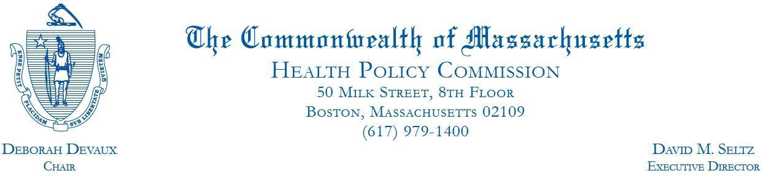
December 27, 2023 Eryn Eddy
Beth Israel Lahey Health Performance Network 109 Brookline Avenue Suite 300
Boston, MA 02215

RE: ACO LEAP Re-Certification Dear Mrs. Eddy:
Congratulations! The Health Policy Commission (HPC) is pleased to inform you that Beth Israel Lahey Health Performance Network meets the requirements for ACO Certification under our Learning, Equity, and Patient-Centeredness (LEAP) standards. This certification is effective from January 1, 2024, through December 31, 2025.
The ACO Certification program, in alignment with other state agencies including MassHealth, is designed to accelerate care delivery transformation in Massachusetts and promote a high quality, efficient health system. ACOs participating in the program have met a set of objective criteria focused on core ACO capabilities demonstrating dedication to patient-centered care, use of evidence-based and data-driven strategies to improve care delivery, and commitment to addressing long-standing health inequities. Beth Israel Lahey Health Performance Network meets those criteria.

The HPC will promote Beth Israel Lahey Health Performance Network as a Certified ACO on our website and in our marketing and public materials. Enclosed you will find an ACO Certification logo for your organization to use in accordance with the attached Terms of Use. We hope you will use the logo on promotional materials when you highlight your ACO Certification to your patients, payers, and others.

The HPC looks forward to your continued engagement in the ACO Certification program over the next two years.

Thank you for your dedication to providing accountable, coordinated health care to your patients, and to continued learning and improvement over time. If you have any questions about this letter or the ACO Certification program, please do not hesitate to contact Mike Stanek, Associate Director, at HPC-Certification@mass.gov or (617) 757-1649.

Best wishes,

David Seltz Executive Director

APPENDIX 9 AFFIDAVIT

 Version: 7-6-17

Massachusetts Department of Public Health

Determination of Need

Affidavit of Truthfulness and Compliance

with Law and Disclosure Form 100.405 (B)
Instructions: Complete Information below. When complete check the box "This document is ready to print:". This will date stamp and lock the form. Print Form. Each person must sign and date the form. When all signatures have been collected, scan the document and e-mail to: dph.don@state.ma.us Include all attachments as requested.
Application Number: BILH-25102211-AS
Original Application Date: 12/02/2025
Applicant Name: Beth Israel Lahey Health, Inc.
Application Type: Ambulatory Surgery
Applicant's Business Type: Corporation
Is the Applicant the sole member or sole shareholder of the Health Facility(ies) that are the subject of this Application? Yes

The undersigned certifies under the pains and penalties of perjury:
- The Applicant is the sole corporate member or sole shareholder of the Health Facility(ies) that are the subject of this Application;
- I have read [been informed of the contents of] 105 CMR 100.000, the Massachusetts Determination of Need Regulation;
- I understand and agree to the expected and appropriate conduct of the Applicant pursuant to 105 CMR 100.800;
- I have read [been informed of the contents of] this application for Determination of Need including all exhibits and attachments, and certify that [have been informed that] all of the information contained herein is accurate and true;
- I have submitted the correct Filing Fee and understand it is nonrefundable pursuant to 105 CMR 100.405(B);
- I have submitted the required copies of this application to the Determination of Need Program, and, as applicable, to all Parties of Record and other parties as required pursuant to 105 CMR 100.405(B);
- I have caused, as required, notices of intent to be published and duplicate copies to be submitted to all Parties of Record, and all carriers or third-party administrators, public and commercial, for the payment of health care services with which the Applicant contracts, and with Medicare and Medicaid, as required by 105 CMR 100.40S(C), et seq.;
- I have caused [have been informed that] proper notification and submissions to the Secretary of Environmental Affairs pursuant to 105 CMR 100.405(E) and 301 CMR 11.00;
- If subject to M.G.L c. 6D, § 13 and 958 CMR 7 .00, I have submitted such Notice of Material Change to the HPC – in accordance with 105 CMR 100.40S(G);
- Pursuant to 105 CMR 100.210(A)(3), I certify that both the Applicant and the Proposed Project are in material and substantial compliance and good standing with relevant federal, state, and local laws and regulations, as well as with all previously issued Notices of Determination of Need and the terms and Conditions attached therein; [issued in compliance with 105 CMR 100.00, the Massachusetts Determination of Need Regulation effective January 27, 2017 and amended December 28, 2018]
- I have read [been informed of the contents of] and understand the limitations on solicitation of funding from the general public prior to receiving a Notice of Determination of Need as established in 105 CMR 100.415;
- I understand that, if Approved, the Applicant, as Holder of the DoN, shall become obligated to all Standard Conditions pursuant to 105 CMR 100310, as well as any applicable Other Conditions as outlined within 105 CMR 100.000 or that otherwise become a part of the final Action pursuant to 105 CMR 100.360;
- Pursuant to 105 CMR 100.705(A), I certify that the Applicant has Sufficient Interest in the Site or facility; and
- Pursuant to 105 CMR 100.70S(A), I certify that the Proposed Project is authorized under applicable zoning by-laws or ordinances, whether or not a special permit is required; or,
  - If the Proposed Project is not authorized under applicable zoning by-laws or ordinances, a variance has been received to permit such Proposed Project; or,
  - The Proposed Project is exempt from zoning by-laws or ordinances.

Corporation
All parties must sign. Add additional names as needed.

Kevin Table, MD <Signature on File> 12/1/2025
CEO for Corporation Name: Signature: Date:

Ann-Ellen Hornbridge, JD <Signature on File> 12/1/2025
Board Chair for Corporation Name: Signature: Date:

This document is ready to print: Yes Date/time Stamp: [blank]

APPENDIX 10 FILING FEE

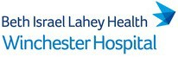

October 23, 2025

Fabiola Catulle, Application Manager Determination of Need Program Department of Public Health
67 Forest Street
Marlborough, MA 01752
Re: DoN Application No. BILH-25102211-AS
To: Commonwealth of Massachusetts

Please find the enclosed payment in the amount of $3,825.15 for the applicate for DoN # BILH-25102211-AS that has been submitted by Beth Israel Lahey Health for a project by Winchester Hospital.

Please contact me at catharine.a.robertson@lahey.org or 781-756-2114 if there are any questions.

Thank you,
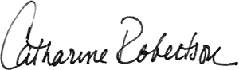
Catharine Robertson
Vice President of Ambulatory Services Winchester Hospital

View Supplier Payment 11:24 AM
11/05/2025
Page 1 of 1

Supplier Payment Supplier Payment: COMMONWEALTH OF MASSACHUSETTS - Remit-To: 67 FOREST ST DIV OF LICENSURE & CERTIFICATION MARLBORO MA 01752: 11/03/2025
Status Complete Reconciliation Status Unreconciled
Payment Information
Company Beth Israel Lahey Health, Inc.
Payee COMMONWEALTH OF MASSACHUSETTS - Remit-To: 67 FOREST ST DIV OF LICENSURE & CERTIFICATION MARLBORO MA 01752
Payment Date 11/03/2025 Payment Amount 3,825.15
Currency USD Memo
[redacted]

Transaction Reference 315716
Invoices Paid
Invoice | Invoice Date | Supplier's Invoice Number | Invoice Amount | Discount Due Date | Invoice Due Date | Discount Taken | Payment Amount
Supplier Invoice: V2500729331 | 10/23/2025 | BILH-25102211-AS | 3,825.15 |  | 10/23/2025 | 0.00 | 3,825.15

