Dana-Farber Cancer Institute DFCI-25090516-RS

Attachment 1

Evidence of Community Engagement


A Proposed Proton Therapy Center at Dana-Farber Cancer Institute

Patient & Family Advisory Councils
September 9, 2025



Overview of Proton Beam Therapy

- Proton therapy is a highly specialized form of radiation that precisely and effectively treats tumors with a minimal dose to surrounding healthy tissues.

- It is a safe radiation treatment.

- For some patients, proton therapy may be the best and only treatment available.

- Proton therapy is especially beneficial to pediatric cancer patients because it delivers targeted radiation while minimizing the impact on developing organs and structures.

2

Crucial Therapy for Pediatric Patients

- Children’s developing bodies are especially susceptible to radiation damage. Proton therapy delivers more precise, targeted radiation, allowing tumors to be treated without impacting nearby healthy tissue.

- Proton therapy provides pediatric patients a treatment option that minimizes impact on long- term growth and development.

- Proton therapy helps pediatric patients survive cancer and maintain a better quality of life as they grow.

3

Addressing a Gap in Access to Care



There is only enough proton therapy capacity now to meet less than a quarter of existing demand in Massachusetts.

Patients needing proton therapy today often must travel long distances, bear significant costs, face delays in care, or forgo this type of treatment. Travel is not feasible for many patients, who are already vulnerable.

The proposed Proton Therapy Center would ensure this revolutionary treatment is more available locally and conveniently to those who need it most.

4

Dana-Farber is Best Suited to Build a Proton Therapy Center

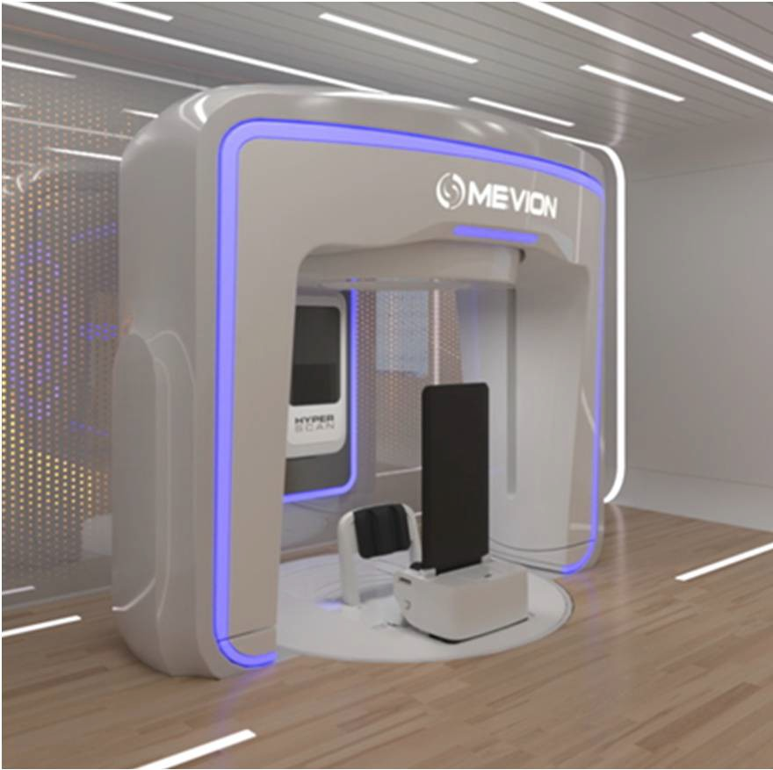
- Our proposed proton therapy center seeks to provide patients, especially those with complex or sensitive cases with the most effective treatment options, improved health outcomes, and enhanced quality of life, while
also contributing to cost-effective, high-value cancer care.

- This center, located in the Longwood Medical Area, will be the first in the region to deliver proton therapy to patients in a seated or inclined position, moving the patient around the proton beam rather than moving the proton beam around the patient.

- The center’s proximity to Boston Children’s Hospital and the Jimmy Fund Clinic at Dana-Farber provides convenient access to pediatric oncology patients.

- By decreasing the size and cost of proton therapy, this life- saving treatment will become more accessible to cancer patients who need it most.
5

What's Next?


The process to develop this proton therapy center at Dana-Farber includes:

  - Filing a Determination of Need (DON) with Massachusetts Department of Public Health
  - Public Meetings
  - Department of Public Health decision
  - TTG Recruitment

We hope to start the regulatory process this fall. The process takes approximately six months.
If approved, we would begin building the center in Spring 2026 and see the first patients in Summer 2027.

6

Dana-Farber Cancer Institute DFCI-25090516-RS

Attachment 2 Notice of Intent

Public Announcements Concerning Proposed Health Care Projects

Oct. 3, 2025
Dana-Farber Cancer Institute, Inc. (the “Applicant”), located at 450 Brookline Avenue, Boston, Massachusetts 02215, intends to file a Notice of Determination of Need (the “Application”) with the Massachusetts Department of Public Health with respect to a substantial change in service in connection with the proposed construction of an approximately 4,500 square-foot proton therapy center, servicing adult and pediatric patients, to be located at 35 Binney Street, Boston, Massachusetts 02215 (the “Proposed Project”), including (i) a state-of-the-art upright single-gantry proton therapy system with a dedicated accelerator which includes a computed tomography (“CT”) scanner for image-guidance; (ii) vertical CT for simulation and treatment planning; and (iii) clinical and administrative spaces. The total value of the Proposed Project is $50,500,663. The Proposed Project will expand availability of proton therapy services for the Applicant’s adult and pediatric cancer patients. The Applicant does not anticipate that the Proposed Project will have a material impact on price for the Applicant’s existing Patient Panel. Any ten Taxpayers of Massachusetts may register in connection with the intended Application by not later than November 3, 2025, or 30 days from the Filing Date, whichever is later, by contacting the Department of Public Health, Determination of Need Program at DPH.DON@mass.gov or, 67 Forest St, Marlborough, Massachusetts 01752.

Dana-Farber Cancer Institute DFCI-25090516-RS

Attachment 6
Articles of Incorporation

Per instruction from the Department of Public Health, the Applicant is providing links to its corporate documents on the Massachusetts Secretary of State’s website. Please use the following links to access the Applicant’s Articles of Organization, Restated Articles of Organization, and related amendments, on the Secretary of State’s website:

Restated Articles of Organization: https://corp.sec.state.ma.us/CorpWeb/CorpSearch/CorpSearchRedirector.aspx? Action=PDF&Path=CORP_DRIVE1/2013/1115/000486402/0003/020500291377_1.pdf

Articles of Amendment
- 1998 Amendment: https://corp.sec.state.ma.us/CorpWeb/CorpSearch/CorpSearchRedirector.aspx? Action=PDF&Path=CORP_DRIVE1/2012/0509/000413014/0306/0205031533
96_1.pdf

2018
Amendment:https://corp.sec.state.ma.us/CorpWeb/CorpSearch/CorpSearchRe director.aspx?Action=PDF&Path=CORP_DRIVE1/2018/0227/001416811/000 1/201886757510_1.pdf

Dana-Farber Cancer Institute DFCI-25090516-RS

Attachment 7
Affidavit of Truthfulness

 Version: 7-6-17

Massachusetts Department of Public Health

Determination of Need

Affidavit of Truthfulness and Compliance

with Law and Disclosure Form 100.405 (B)
Instructions: Complete Information below. When complete check the box "This document is ready to print:". This will date stamp and lock the form. Print Form. Each person must sign and date the form. When all signatures have been collected, scan the document and e-mail to: dph.don@state.ma.us Include all attachments as requested.
Application Number: DFCI-25090516-RS
Original Application Date: 10/17/25
Applicant Name: Dana-Farber Cancer Institute, Inc.
Application Type: Hospital/ Clinic Substantial Capital Expenditure
Applicant's Business Type: Corporation
Is the Applicant the sole member or sole shareholder of the Health Facility(ies) that are the subject of this Application? Yes

The undersigned certifies under the pains and penalties of perjury:
- The Applicant is the sole corporate member or sole shareholder of the Health Facility(ies) that are the subject of this Application;
- I have been informed of the contents of 105 CMR 100.000, the Massachusetts Determination of Need Regulation;
- I understand and agree to the expected and appropriate conduct of the Applicant pursuant to 105 CMR 100.800;
- I have been informed of the contents of this application for Determination of Need including all exhibits and attachments, and certify that all of the information contained herein is accurate and true;
- I have submitted the correct Filing Fee and understand it is nonrefundable pursuant to 105 CMR 100.405(B);
- I have submitted the required copies of this application to the Determination of Need Program, and, as applicable, to all Parties of Record and other parties as required pursuant to 105 CMR 100.405(B);
- I have been informed that, as required, notices of intent to be published and duplicate copies to be submitted to all Parties of Record, and all carriers or third-party administrators, public and commercial, for the payment of health care services with which the Applicant contracts, and with Medicare and Medicaid, as required by 105 CMR 100.405(C), et seq.;
- I have been informed that proper notification and submissions to the Secretary of Environmental Affairs pursuant to 105 CMR 100.405(E) and 301 CMR 11.00;
- If subject to M.G.L. c. 6D, § 13 and 958 CMR 7.00, I have submitted such Notice of Material Change to the HPC – in accordance with 105 CMR 100.405(G);
- Pursuant to 105 CMR 100.21 0(A)(3), I certify that both the Applicant and the Proposed Project are in material and substantial compliance and good standing with relevant federal, state, and local laws and regulations, as well as with all Notices of Determination of Need issued in compliance with 105 CMR 100.00.
- I have been informed of the contents of and understand the limitations on solicitation of funding from the general public prior to receiving a Notice of Determination of Need as established in 105 CMR 100.415;
- I understand that, if Approved, the Applicant, as Holder of the DoN, shall become obligated to all Standard Conditions pursuant to 105 CMR 100.310, as well as any applicable Other Conditions as outlined within 105 CMR 100.000 or that otherwise become a part of the Final Action pursuant to 105 CMR 100.360;
- Pursuant to 105 CMR 100.?0S(A), I certify that the Applicant has Sufficient Interest in the Site or facility; and
- Pursuant to 105 CMR 100.705(A), I certify that the Proposed Project is authorized under applicable zoning by-laws or ordinances, whether or not a special permit is required; or,
  - If the Proposed Project is not authorized under applicable zoning by-laws or ordinances, a variance has been received to permit such Proposed Project; or,
  - The Proposed Project is exempt from zoning by-laws or ordinances.

Corporation
Attach a copy of Articles of Organization/Incorporation, as amended

Benjamin Ebert, MD, PhD <Signature on File> 10/14/2025
CEO for Corporation Name Signature: Date:

Board Chair for Corporation Name Signature: Date:

Version: 7-6-17

Massachusetts Department of Public Health

Determination of Need

Affidavit of Truthfulness and Compliance

with Law and Disclosure Form 100.405 (B)
Instructions: Complete Information below. When complete check the box "This document is ready to print:". This will date stamp and lock the form. Print Form. Each person must sign and date the form. When all signatures have been collected, scan the document and e-mail to: dph.don@state.ma.us Include all attachments as requested.
Application Number: DFCI-25090516-RS
Original Application Date: 10/17/25
Applicant Name: Dana-Farber Cancer Institute, Inc.
Application Type: Hospital/ Clinic Substantial Capital Expenditure
Applicant's Business Type: Corporation
Is the Applicant the sole member or sole shareholder of the Health Facility(ies) that are the subject of this Application? Yes

The undersigned certifies under the pains and penalties of perjury:
- The Applicant is the sole corporate member or sole shareholder of the Health Facility(ies) that are the subject of this Application;
- I have been informed of the contents of 105 CMR 100.000, the Massachusetts Determination of Need Regulation;
- I understand and agree to the expected and appropriate conduct of the Applicant pursuant to 105 CMR 100.800;
- I have been informed of the contents of this application for Determination of Need including all exhibits and attachments, and certify that all of the information contained herein is accurate and true;
- I have submitted the correct Filing Fee and understand it is nonrefundable pursuant to 105 CMR 100.405(B);
- I have submitted the required copies of this application to the Determination of Need Program, and, as applicable, to all Parties of Record and other parties as required pursuant to 105 CMR 100.405(B);
- I have been informed that, as required, notices of intent to be published and duplicate copies to be submitted to all Parties of Record, and all carriers or third-party administrators, public and commercial, for the payment of health care services with which the Applicant contracts, and with Medicare and Medicaid, as required by 105 CMR 100.405(C), et seq.;
- I have been informed that proper notification and submissions to the Secretary of Environmental Affairs pursuant to 105 CMR 100.405(E) and 301 CMR 11.00;
- If subject to M.G.L. c. 6D, § 13 and 958 CMR 7.00, I have submitted such Notice of Material Change to the HPC – in accordance with 105 CMR 100.405(G);
- Pursuant to 105 CMR 100.21 0(A)(3), I certify that both the Applicant and the Proposed Project are in material and substantial compliance and good standing with relevant federal, state, and local laws and regulations, as well as with all Notices of Determination of Need issued in compliance with 105 CMR 100.00.
- I have been informed of the contents of and understand the limitations on solicitation of funding from the general public prior to receiving a Notice of Determination of Need as established in 105 CMR 100.415;
- I understand that, if Approved, the Applicant, as Holder of the DoN, shall become obligated to all Standard Conditions pursuant to 105 CMR 100.310, as well as any applicable Other Conditions as outlined within 105 CMR 100.000 or that otherwise become a part of the Final Action pursuant to 105 CMR 100.360;
- Pursuant to 105 CMR 100.?0S(A), I certify that the Applicant has Sufficient Interest in the Site or facility; and
- Pursuant to 105 CMR 100.705(A), I certify that the Proposed Project is authorized under applicable zoning by-laws or ordinances, whether or not a special permit is required; or,
  - If the Proposed Project is not authorized under applicable zoning by-laws or ordinances, a variance has been received to permit such Proposed Project; or,
  - The Proposed Project is exempt from zoning by-laws or ordinances.

Corporation
Attach a copy of Articles of Organization/Incorporation, as amended

CEO for Corporation Name Signature: Date:

<Signature on File> 10/17/2025
Joshua Berkenstein
Board Chair for Corporation Name Signature: Date:

Dana-Farber Cancer Institute DFCI-25090516-RS

Attachment 8
Evidence of Filing Fee

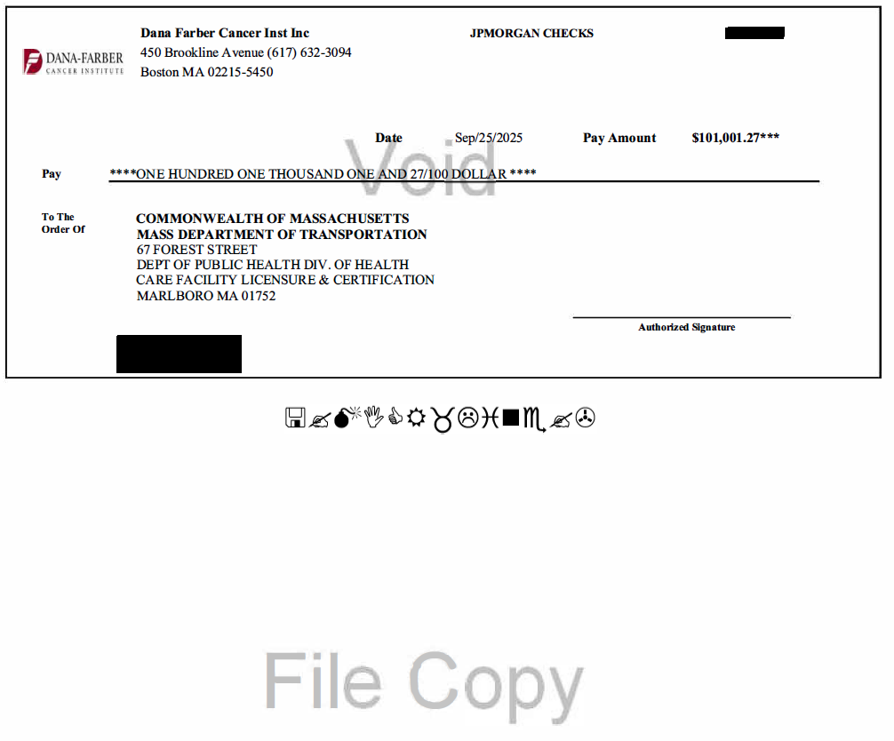

Dana-Farber Cancer Institute DFCI-25090516-RS

Attachment 9
Community Health Needs Assessment

Per the instructions from the Department of Public Health, the Applicant is providing links to its most recent community health needs assessment (“CHNA”).

- Applicant Cancer-Focused CHNA Link: https://dfci.widen.net/s/5f7xwzhvn6/dana- farber-final-cancer-chna-report-25.pdf

