Attachment 1:

Community Engagement Consultation: Presentation to South Shore Hospital PFAC, December 11, 2025





High Quality Diagnostic Care Provided Locally
PET/CT Services Provided by Shields Health and South Shore Health in the Town of Weymouth

Who we are:
- Lou Masella, Vice President PET/CT Network, Shields Health

- Haley Cammarata, Sr. Director of Operations, Shields Health

- Art Mombourquette, South Shore Health



Our vision:
- Welcome and thank you for your interest in this project

- We are excited to share our plans to provide full-week PET/CT services in the Town of Weymouth

- This project will use a combination of inside space and a mobile PET/CT unit aligned within the existing building multiple days per week

- PET/CT services will provide greater local access to cancer treatment and memory services

- The service will operate on an outpatient fee schedule which will lower the cost of services

- Today’s presentation is an opportunity to introduce you to some of the individuals involved, solicit your feedback & any answer questions

What is a mobile PET/CT?
- PET/CT is a radiology based imaging tool which is valuable in staging cancer, evaluating Alzheimer’s disease, and also has cardiac applications.

- With a growing demand for cancer care, timeliness to treatment is critical and is commonly referenced as a quality measure.

- Providing PET/CT in a mobile environment provides care locally. Expanding access is critical to maintaining local care.

- Patients would continue to check in at radiology and then would enter the mobile environment that is temporarily attached to the building, enclosed from the outside elements.


Benefits of a mobile PET/CT service
Keeps care to the communit
- Efficient weekly offered care minimizes time to treatment
- Shifts appropriate care from inpatient to outpatient
Increases accessibility of care

04
- Easy, convenient location
- Transportation assistance
- Provides local option for physicians and patients
y

03
- Greater scheduling
- Highly experienced technical staff
- State of the art equipment
Provides greater patient
experience

02
Outpatient reimbursement with a high value service creates high patient satisfaction with lower out of pocket responsibility
High Value
●

01

Summary: PET/CT Services in the Town of Weymouth
- PET/CT Service multiple days per week, expanding with demand
- Cancer staging, Alzheimer’s disease evaluation, cardiac applications
- Located in the Town of Weymouth
- Mobile environment built to transition seamlessly from a building
- Lower cost of care




Next Steps
WE WANT YOUR INPUT
on expanding patient access
WE WILL KEEP YOU INFORMED
as the project progresses

Attachment 2: Notice of Intent

Account Number: | 1511235
Customer Name: | Shields Health Care Group
Customer | Shields Health Care Group
Address:
 | 700 Congress ST # 204
 | Kerry Whelan
 | Quincy MA 02169-0928
Contact Name: | Kerry Whelan
Contact Phone:
Contact Email: | kerry@shields.com
PO Number: | Kerry Whelan

Date: | 12/18/2025
Order Number: | 11934503
Prepayment Amount: | $ 0.00

Column Count: | 1.0000
Line Count: | 42.0000
Height in Inches: | 4.3500


Not an Invoice
Order Confirmation

Print
Product | #Insertions | Start - End | Category
NEO QUI The Patriot Ledger | 1 | 12/23/2025 - 12/23/2025 | Public Notices
NEO wickedlocal.com | 1 | 12/23/2025 - 12/23/2025 | Public Notices

Total Cash Order Confirmation Amount Due $217.94

As an incentive for customers, we provide a discount off the total order cost equal to the 3.99% service fee if you pay with | Tax Amount  Service Fee 3.99% | $0.00  $8.70
Cash/Check/ACH. Pay by Cash/Check/ACH and save! | Cash/Check/ACH Discount | -$8.70
 | Payment Amount by Cash/Check/ACH | $217.94
 | Payment Amount by Credit Card | $226.64

Order Confirmation Amount | $217.94
1/2

Ad Preview
55 Fogg Road
LEGAL NOTICE
Public Announcement
Concerning a Proposed
Health Care Project
Shields Imaging of Eastern
Massachusetts, LLC ("Applicant")
located at 700
Congress Street, Suite 204,
Quincy, MA 02169 intends to
file a Notice of Determination
of Need Application
("Application") for the
acquisition of a PETCT unit
and five additional days of
PET/CT services at Shields
Imaging of Massachusetts,
LLC located at 55 Fogg
Road, South Weymouth, MA
02190. The total value of
the Project is $1,099,871.
The Applicant does not
anticipate any price or
service impacts on the
Applicant's existing Patient
Panel as a result of the
Proposed Project. Any ten
Taxpayers of Massachusetts
may register in connection
with the intended Application
by no later than January
22, 2026 or 30 days from the
Filing Date, whichever is
later, by contacting the
Department of Public
Health, Determination of
Need Program at, 67 Forest
Street, Marlborough, MA
01752.
AD# 11934503
PL 12/23/2025

Shields Health website: https://shields.com/locations/south-shore-hospital/
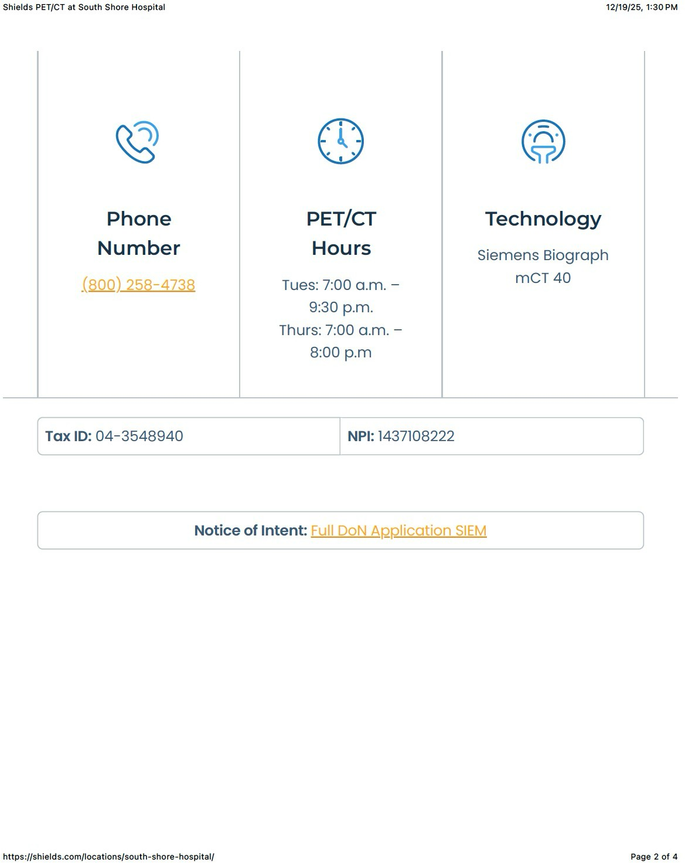

LOCALiQ
NEW ENGLAND

PO Box 631210 Cincinnati, OH 45263-1210

AFFIDAVIT OF PUBLICATION

KenyWhclan
Shields Health Care Group

700 Congress ST# 204
Quincy MA 02 I 69-0928

STATE OF MASSACHUSETTS, COUNTY OF NORFOLK

The Patriot Ledger, a newspaper printed and published in the city of Quincy, and of general circulation in the County of Norfolk, State of Massachusetts, and personal knowledge of the facts herein state and that the notice hereto annexed was Published in said newspapers in the issue:

12/23/2025

and that the fees charged are legal.

Sworn to and subscribed before on 12/23/2025

[signature on file]
Legal Clerk
[signature on file]
Notary, State of WI, County of Brown
8-25-26

My commission expires

Publication Cost: | $217.94
Tax Amount: | $0.00
Payment Cost: | $217.94
Order No: | 11934503 | # of Copies:
Customer No: | 1511235 | 0
PO#: | Kerry Whelan

THIS IS NOT AN INVOICE!
Please do not use this form for payment remittance.
55 Fogg Road
LEGAL NOTICE
Public Announcement Concerning a Proposed Health Care Project
Shields Imaging of Eastern Massachusetts, LLC ("Appli-cant") located at 700 Congress Street, Suite 204, Quincy, MA 02169 intends to file a Notice of Determina-tion of Need Application ("Application") for the acquisition of a PETCT unit and five additional days of PET/CT services at Shields Imaging of Massachusetts, LLC located at 55 Fogg Road, South Weymouth, MA 02190. The total value of the Project is $1,099,871. The Applicant does not anticipate any price or service impacts on the Applicant's existing Patient Panel as a result of the Proposed Project. Any ten Taxpayers of Massachusetts may register in connection with the intended Applica-tion by no later than January 22, 2026 or 30 days from the Filing Date, whichever is later, by contacting the Department of Public Health, Determination of Need Program at, 67 Forest Street, Marlborough, MA 01752.
AD#l 1934503 PL 12/23/2025

Page 1 of 1

SIEM-25121212-RE

Attachment 3: Application Filing Fee Check

page 10

SIEM-25121212-RE

Attachment 4: Certificate of Organization

Certificate OF ORGANIZATION

Shields Imaging of Eastern Massachusetts, LLC

Articles of Organization (2001):

https://corp.sec.state.ma.us/CorpWeb/CorpSearch/CorpSummary.aspx?sys value=WR3OgVzZ6BjV0uS0oseOBk.S9Lh6lEJK4vJlCGKYNlM-

 Version: 7-6-17

Massachusetts Department of Public Health

Determination of Need

Affidavit of Truthfulness and Compliance

with Law and Disclosure Form 100.405 (B)
Instructions: Complete Information below. When complete check the box "This document is ready to print:". This will date stamp and lock the form. Print Form. Each person must sign and date the form. When all signatures have been collected, scan the document and e-mail to: dph.don@state.ma.us Include all attachments as requested.
Application Number: 25121212-RE
Original Application Date: 02/01/2001
Applicant Name: Shields Imaging of Eastern Massachusetts, LLC
Application Type: DoN-Required Equipment
Applicant's Business Type: LLC
Is the Applicant the sole member or sole shareholder of the Health Facility(ies) that are the subject of this Application? No
Describe the role/relationship: NA

The undersigned certifies under the pains and penalties of perjury:
- The Applicant is NA;
- I have read 105 CMR 100.000, the Massachusetts Determination of Need Regulation;
- I understand and agree to the expected and appropriate conduct of the Applicant pursuant to 105 CMR 100.800;
- I have read this application for Determination of Need including all exhibits and attachments, and certify that all of the information contained herein is accurate and true;
- I have caused, as required, notices of intent to be published and duplicate copies to be submitted to all Parties of Record, and all carriers or third-party administrators, public and commercial, for the payment of health care services with which the Applicant contracts, and with Medicare and Medicaid, as required by 105 CMR 100.40S(C), et seq.;
- If subject to M.G.L c. 6D, § 13 and 958 CMR 7 .00, I have submitted such Notice of Material Change to the HPC – in accordance with 105 CMR 100.40S(G);
- Pursuant to 105 CMR 100.210(A)(3), I certify that both the Applicant and the Proposed Project are in material and substantial compliance and good standing with relevant federal, state, and local laws and regulations, as well as with all previously issued Notices of Determination of Need and the terms and Conditions attached therein;
- I have read and understand the limitations on solicitation of funding from the general public prior to receiving a Notice of Determination of Need as established in 105 CMR 100.415;
- I understand that, if Approved, the Applicant, as Holder of the DoN, shall become obligated to all Standard Conditions pursuant to 105 CMR 100310, as well as any applicable Other Conditions as outlined within 105 CMR 100.000 or that otherwise become a part of the final Action pursuant to 105 CMR 100.360;
- Pursuant to 105 CMR 100.705(A), I certify that the Applicant has Sufficient Interest in the Site or facility; and
- Pursuant to 105 CMR 100.70S(A), I certify that the Proposed Project is authorized under applicable zoning by-laws or ordinances, whether or not a special permit is required; or,
  - If the Proposed Project is not authorized under applicable zoning by-laws or ordinances, a variance has been received to permit such Proposed Project; or,
  - The Proposed Project is exempt from zoning by-laws or ordinances.

LLC
All parties must sign. Add additional names as needed.

Thomas Shields <Signature on File> 12/12/2025
Name: Signature: Date:

This document is ready to print: [unchecked] Date/time Stamp: [blank]

Affidavit of Truthfulness Shields Imaging of Eastern Massachusetts, LLC 25121212-RE Page 1 of 1

