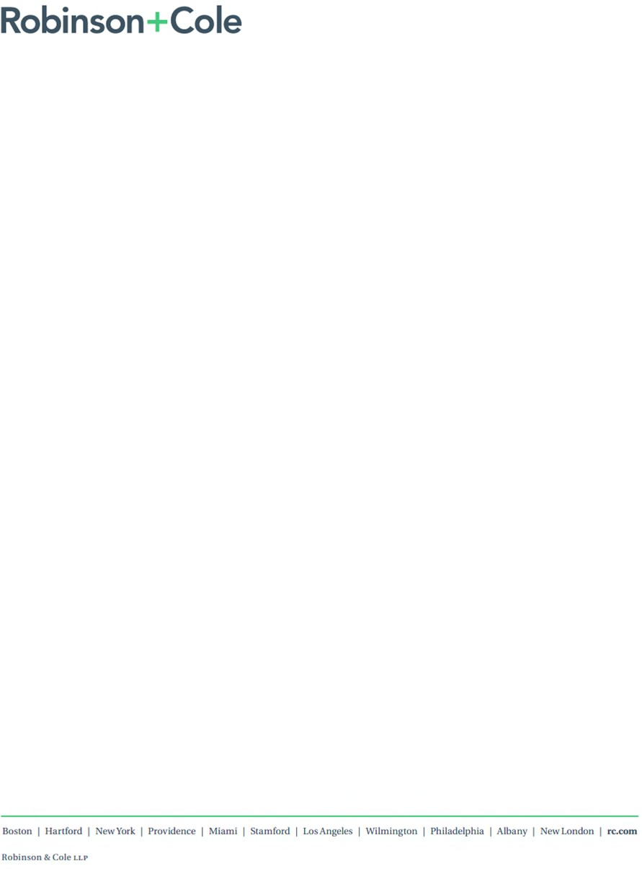
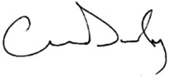

CONOR O. DUFFY
One State Street Hartford, CT 06103
Main (860) 275-8200
Fax (860) 275-8299
cduffy@rc.com Direct (860) 275-8342

Also admitted in Massachusetts

February 17, 2026

Via E-Mail - dph.don@state.ma.us

Massachusetts Department of Public Health Determination of Need Program
250 Washington Street
Boston, MA 02108

Re: Southcoast Health System, Inc. Determination of Need Application Submission No. SHS-26021610-RE

Dear Sir or Madam:

Southcoast Health System, Inc. (“Applicant”) hereby submits its application for a Determination of Need under 105 CMR 100.000 et seq (“DoN Application”) to the Department of Public Health in connection with a proposed project to reactivate a dormant linear accelerator at the Southcoast Hospitals Group, Inc. Cancer Center located at 206 Mill Road, Fairhaven, Massachusetts, 02719 (“Cancer Center”). Reactivation of a dormant linear accelerator would result in Applicant operating two linear accelerators at the Cancer Center.

If you have any questions or need any additional information, please contact me by e-mail at cduffy@rc.com.

Sincerely,

Conor Duffy cc: Renee Clark, EVP & COO, Southcoast Health
William Burns, Executive Director, External Affairs & Planning, Southcoast Health


Massachusetts Department of Public Health February 17, 2026
Page 2

Lisa Boyle, Esq.
Teryl Smith, Director, Bureau of Health Care Safety and Quality – teryl.a.smith@mass.gov Stephen Davis, Director, Division of Health Care Facility Licensure and Certification – stephen.davis@mass.gov
Center for Health Information and Analysis – Legal@chiamass.gov Health Policy Commission – HPC-Notice@mass.gov
Office of the Attorney General – HCD-6D-NOTICE@mass.gov
Jin Pantano, EOHHS, MassHealth Office of Providers and Plans – jin.pantano2@mass.gov Hai Nguyen, EOHHS, MassHealth Office of Providers and Plans – hai.nguyen@mass.gov
Enclosures: DoN Application with supporting documentation

B. Notice of Intent

Significant rise in influenza-like illness (ILI) activity – patients,
 guests and visitors are strongly encouraged to wear a mask when 
visiting any of our locations…
English

Careers | G84iv4in-7g44|-55P4ro4vider Referrals | Urgent Care |
 MyChart 



← Back to Blog

Public Announcement Concerning a Proposed Health Care Project


Southcoast Health Public Announcements
January 30, 2026

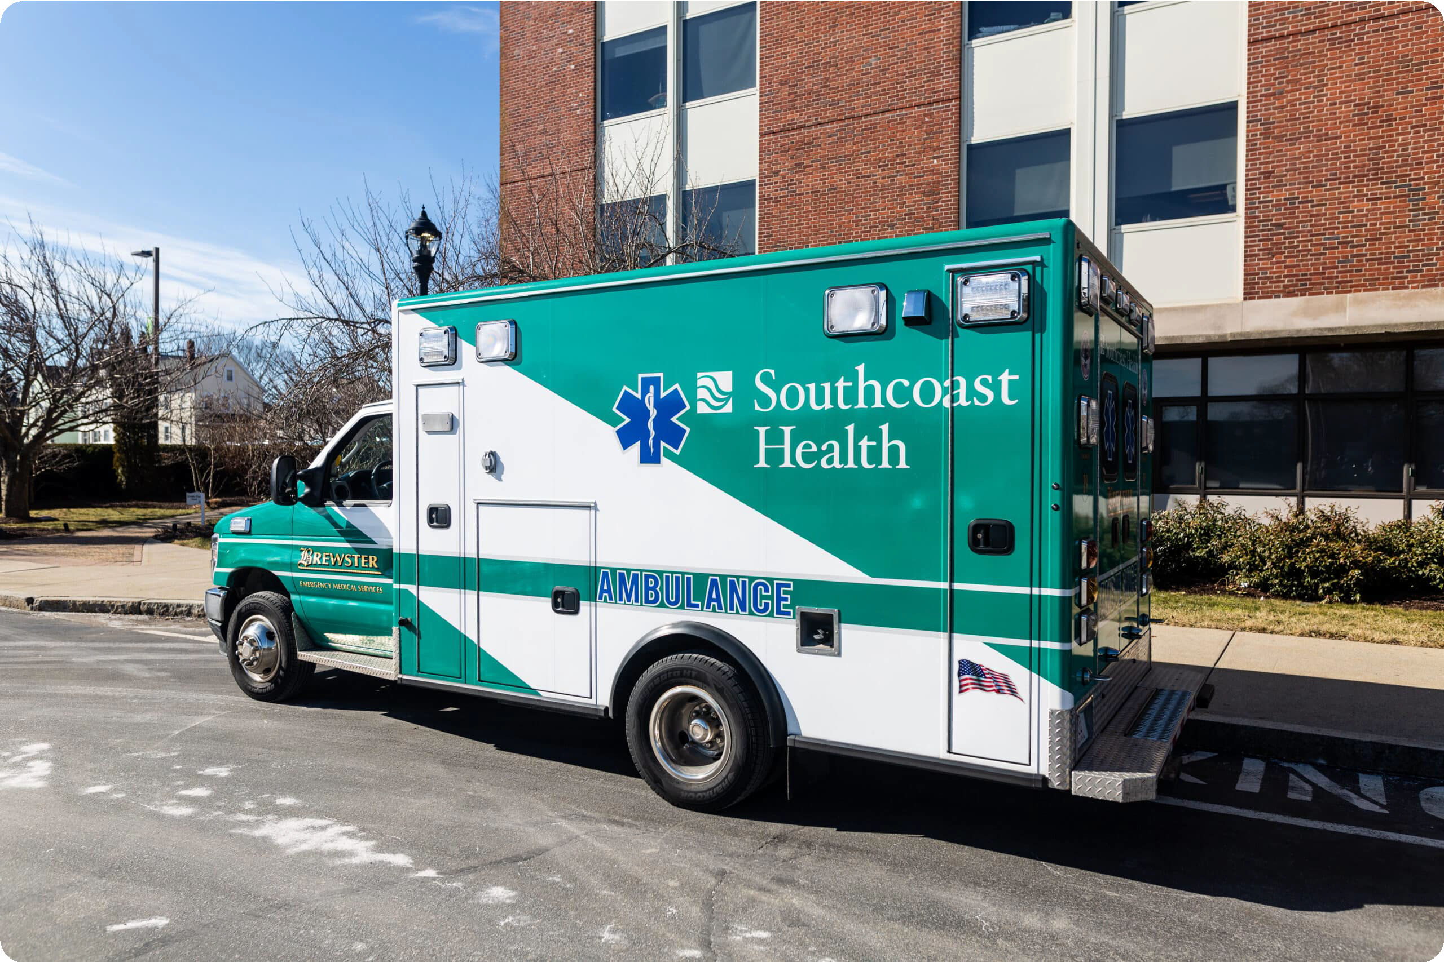

Southcoast Health System, Inc. (“Applicant”), located at 101 Page Street, New Bedford, Massachusetts 02740, intends to file a Notice of Determination of Need Application with the Massachusetts Department of Public Health with respect to a Proposed Project involving DoN-Required Equipment at the Southcoast Hospitals Group, Inc. Cancer Center (“Center”) located at 206 Mill Road, Fairhaven, Massachusetts, 02719.
Through the Proposed Project, the Applicant will expand access to advanced oncology treatment by reactivating a dormant linear accelerator at the Center. The Total Value of the Proposed Project is $0 based on total capital expenditures. The Applicant does not anticipate that the Proposed Project will have a material price or service impact on the Applicant’s existing patient panel, aside from improving access to advanced oncology services.
Any ten Taxpayers of Massachusetts may register in connection with the intended Application by no later than March 18, 2026 or 30 days from the Filing Date, whichever is later, by contacting the Department of Public Health Determination of Need Program at Department of Public Health, Attention: Program Director, Determination of Need Program, 67 Forest St., Marlborough, Massachusetts 01752 or DPH.DON@State.MA.US.

C. Articles of Organization

Southcoast Health System, Inc.

Articles of Merger (1996): https://corp.sec.state.ma.us/CorpWeb/CorpSearch/CorpSearchRedirector.aspx?Action=PDF&P ath=CORP_DRIVE1/2013/1011/000486337/0006/020502701588_1.pdf

D. Affidavit of Truthfulness

 Version: 7-6-17

Massachusetts Department of Public Health

Determination of Need

Affidavit of Truthfulness and Compliance

with Law and Disclosure Form 100.405 (B)
Instructions: Complete Information below. When complete check the box "This document is ready to print:". This will date stamp and lock the form. Print Form. Each person must sign and date the form. When all signatures have been collected, scan the document and e-mail to: dph.don@state.ma.us Include all attachments as requested.
Application Number: SHS-26021610-RE
Original Application Date: February 17, 2026
Applicant Name: Southcoast Health System, Inc.
Application Type: DoN-Required Equipment
Applicant's Business Type: Corporation
Is the Applicant the sole member or sole shareholder of the Health Facility(ies) that are the subject of this Application? Yes

The undersigned certifies under the pains and penalties of perjury:
- The Applicant is the sole corporate member or sole shareholder of the Health Facility(ies) that are the subject of this Application;
- I have read [been informed of the contents of] 105 CMR 100.000, the Massachusetts Determination of Need Regulation;
- I understand and agree to the expected and appropriate conduct of the Applicant pursuant to 105 CMR 100.800;
- I have read [been informed of the contents of] this application for Determination of Need including all exhibits and attachments, and certify that [have been informed that] all of the information contained herein is accurate and true;
- I have submitted the correct Filing Fee and understand it is nonrefundable pursuant to 105 CMR 100.405(B);
- I have submitted the required copies of this application to the Determination of Need Program, and, as applicable, to all Parties of Record and other parties as required pursuant to 105 CMR 100.405(B);
- I have caused, as required, notices of intent to be published and duplicate copies to be submitted to all Parties of Record, and all carriers or third-party administrators, public and commercial, for the payment of health care services with which the Applicant contracts, and with Medicare and Medicaid, as required by 105 CMR 100.40S(C), et seq.;
- I have caused [have been informed that] proper notification and submissions to the Secretary of Environmental Affairs pursuant to 105 CMR 100.405(E) and 301 CMR 11.00;
- If subject to M.G.L c. 6D, § 13 and 958 CMR 7 .00, I have submitted such Notice of Material Change to the HPC – in accordance with 105 CMR 100.40S(G);
- Pursuant to 105 CMR 100.210(A)(3), I certify that both the Applicant and the Proposed Project are in material and substantial compliance and good standing with relevant federal, state, and local laws and regulations, as well as with all previously issued Notices of Determination of Need and the terms and Conditions attached therein; [issued in compliance with 105 CMR 100.00, the Massachusetts Determination of Need Regulation effective January 27, 2017 and amended December 28, 2018]
- I have read [been informed of the contents of] and understand the limitations on solicitation of funding from the general public prior to receiving a Notice of Determination of Need as established in 105 CMR 100.415;
- I understand that, if Approved, the Applicant, as Holder of the DoN, shall become obligated to all Standard Conditions pursuant to 105 CMR 100310, as well as any applicable Other Conditions as outlined within 105 CMR 100.000 or that otherwise become a part of the final Action pursuant to 105 CMR 100.360;
- Pursuant to 105 CMR 100.705(A), I certify that the Applicant has Sufficient Interest in the Site or facility; and
- Pursuant to 105 CMR 100.70S(A), I certify that the Proposed Project is authorized under applicable zoning by-laws or ordinances, whether or not a special permit is required; or,
  - If the Proposed Project is not authorized under applicable zoning by-laws or ordinances, a variance has been received to permit such Proposed Project; or,
  - The Proposed Project is exempt from zoning by-laws or ordinances.

Corporation
All parties must sign. Add additional names as needed.

David O. McCreasy <Signature on File> Feb 13, 2026
CEO for Corporation Name: Signature: Date:

Carmen Sylvester <Signature on File> 02/13/2026 4:50 PM EST
Board Chair for Corporation Name: Signature: Date:

This document is ready to print: [unchecked] Date/time Stamp: [blank]

E. Filing Fee Check

