Maria Paiewonsky, Institute for Community Inclusion, University of Massachusetts Boston.

Students with intellectual disabilities (ID), who, until recently, had few opportunities to continue their education beyond high school, are now pursuing college. This is possible because of expanding ideas about how postsecondary education can benefit a wide range of students.

* Supported education

Supported education strategies were first introduced in the late 1990s as wrap-around supports that could promote college success for students with psychiatric disabilities (Collins, Mowbray, & Bybee, 1999). These supports, which are defined as individualized and structured, include core services in career planning, academic survival skills, and outreach services and resources (Mowbray, Collins, Bellamy, Megivern, Bybee, & Szilvagyi, 2005).

Supported education is grounded in three principles:

1. Increasing individual skills
2. Increasing support from the environment
3. Maximizing the fit between the individual and environment

* Supported education for students with ID

For students with ID, wrap-around services, which are comprehensive support services, are most effective when each person providing services or support is clear what the services are, what supports are being used by the student, and who is responsible for providing those supports. The following is a description of the typical supported education roles and services that are made available to students with ID who are participating in inclusive postsecondary education.

School transition coordinator

Supported education strategies are often initiated even before students come to college. As indicated in Table 1: Supported Education, a school transition coordinator assists students to prepare for college by assessing their career interests, helping them explore college options, and preparing them for the differences between high school and college, including support services and student responsibilities.

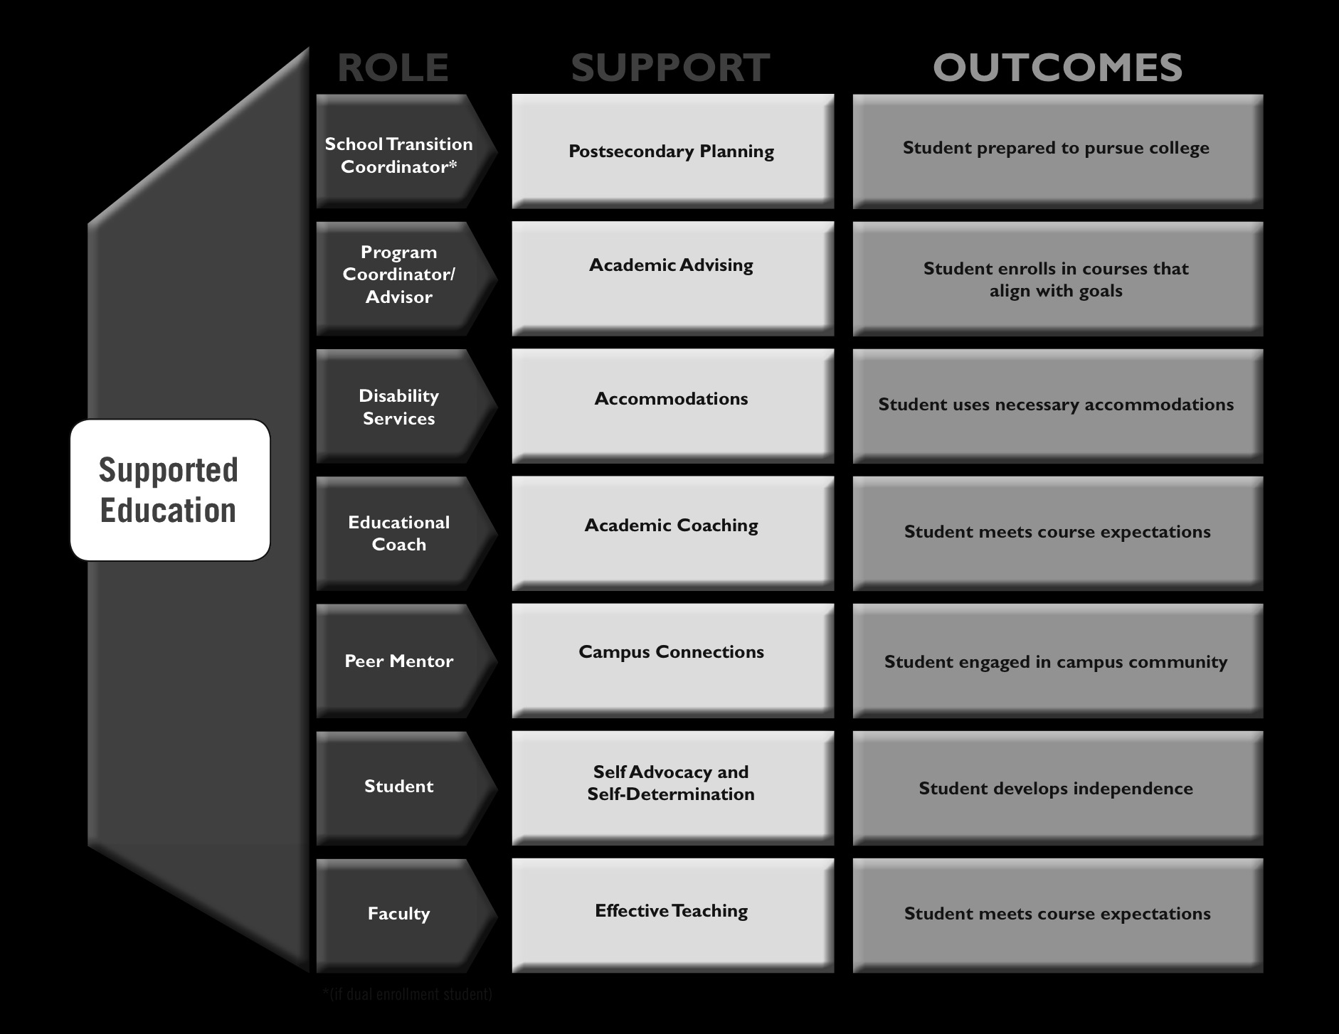

Transition staff also arrange new travel arrangements for students. This may be by assisting the student to apply for paratransit services (door-to-door, shared-ride services), or by coordinating travel training for students who are going to learn to use public transportation to get to college.

College program coordinator

A program coordinator, who may also serve as an academic advisor, is often the first person the student meets at college. The coordinator helps students to align career or job aspirations with college courses, and directs them to the disability services office to determine if they are eligible for academic accommodations. The college program coordinator often arranges for the student to sign up for the typical college orientation, and tells the student about the college’s academic and non-academic supports and services.

Disability services counselor

The disability services counselor conducts an intake meeting with the student, and reviews documents that will help the counselor to make a determination about student eligibility for accommodations.

If the student *is* eligible for accommodations, the disability services counselor will prepare a packet for them. This packet includes a letter to the faculty assigned to the course the student will be entering, explaining necessary accommodations, and instructions on how the student can access academic support resources on campus.

Disability services staff also share information with students about the adaptive computer lab on campus, where students can access course materials with specialized software such as JAWS (screen-reading software) and Kurzweil (text-to-speech software).

Educational coach

In some cases, students may work with an educational coach. Before the beginning of the semester, the student and the coach meet to determine what supports the coach may need to provide to the student as he or she adjusts to the campus and course expectations.

They may decide that initially the coach will support the student in class, usually to help him or her adjust to the pace of in-class and out-of-class assignments. When the student and coach agree, the coach will be available for consultation as needed, but will not come to class with the student.

Coaches may be hired by the college, or in some cases by the partner school, but in every case, students and coaches work to fade coach support (Paiewonsky, Mecca, Daniels, et al., 2010).

Peer mentor

Outside of the classroom, some students connect with a peer mentor. The mentor can support them as they adjust to the new role and responsibilities of being a college student, and can give them direction on how to connect to peers and engage in campus activities.

Throughout this process of support, students’ own skills in self-advocacy and self-determination are reinforced, in preparation for academic and college success (Kleinert, Jones, Sheppard-Jones, et al., 2012).

Student

Students have the most important role in supported education: using their own self-determination and self-advocacy skills. These skills, which are introduced in K–12 settings and in the community, will now be used in postsecondary settings.

Students receive encouragement from supported education staff to use self-determination and self-advocacy skills. These skills enable students to communicate their evolving career and personal interests, advocate for appropriate accommodations, and communicate effectively with faculty, educational coaches, and peer mentors.

Faculty

Faculty are expected to use effective teaching practices to develop course syllabi and to promote a culture of collaborative learning and collective intelligence in their courses. In this way, they are providing all students a supported education environment that leads to engaged and successful learning.

* References

Collins, M. E., Mowbray, C. T., & Bybee, D. (1999). Establishing individualized goals in a supported education intervention: Program influences on goal-setting and attainment. *Research on Social Work Practice, 9*(4), 483–507.

Kleinert, H., Jones, M., Sheppard-Jones, K., Harp, B., and Harrison, E. (2012). Students with intellectual disabilities going to college? Absolutely! *TEACHING Exceptional Children, 44*(5), 26–35.

Mowbray, C. T., Collins, M. E., Bellamy, C. D., Megivern, D. A., Bybee, D. & Szilvagyi, S. (2005). Supported education for adults with psychiatric disabilities: An innovation for social work and psychological rehabilitation practice. *Social Work, 50*(1), 7–20.

Paiewonsky, M., Mecca, K., Daniels, T., Katz, C., Nash, J., Hanson, T., & Gragoudas, S. (2010). *Students and educational coaches: Developing a support plan for college.* Think College Insight Brief, Issue No. 4. Boston, MA: University of Massachusetts Boston, School for Global Inclusion and Social Development, Institute for Community Inclusion.