Helping MassHealth members with their renewals
Executive Office of Health and Human Services

Slide 2

Agenda
Today, we will:
- Explain what a MassHealth renewal is
- Discuss why renewals are especially important this upcoming year (2023 – 2024)
- Share what you can do you to support MassHealth members in preparing for and understanding how to complete renewals
- Discuss special considerations for members experiencing homelessness
Note on members experiencing homelessness:
We realize for this population there are differences in how organizations can support families and individuals experiencing homelessness. Where possible we have noted distinctions throughout this presentation.
Slide 3

Who this information is for
- This presentation contains information for individuals working in the community who typically interact with MassHealth members
- It is intended to give these individuals helpful tips for how they can help MassHealth members understand how to complete their renewal
- These tips cover basic assistance – such as reminding members of important deadlines, helping them understand written instructions, and directing them towards official MassHealth resources
- They do not imply that individuals may access a MassHealth's member’s private information or act on their behalf
  - All individuals using this guide should remember that a MassHealth’s member private health information (PHI) is protected under HIPAA Privacy Rules. This means that individuals working with MassHealth members should not distribute MassHealth member information internally or externally unless authorized to do so.
- Furthermore, the right to access or update a MassHealth’s member’s information is reserved for officially designated representatives, certain MassHealth employees, and Certified Application Counselors (CAC) / Navigators
  - If you or your organization is interested in becoming a CAC, see page 21
- However, you do not need to be an official representative or CAC to meaningfully help a member. The tips in this presentation will help you, as an individual, have an important and positive impact on MassHealth members

Slide 4

What is a MassHealth renewal?
- Federal law requires MassHealth to regularly check whether members are still eligible for MassHealth. This ‘check’ is called a “renewal” (also sometimes called an “annual review”).
- Renewals and annual reviews need to occur every year
- Members get their renewal forms in the mail
  - Renewals occur at the household level, and are sent to the Head of Household
  - Some members may be automatically renewed. This means that MassHealth will automatically process a member’s renewal by matching their information against state and federal data. In this case, MassHealth does not need any new information and no action is needed.
  - If MassHealth does not have enough information to automatically renew a member, members will need to report new information. They will get a renewal form in a blue envelope. If members do not reply, their coverage may end

Slide 5

Why are we talking about renewals this year?
- At the beginning of the COVID-19 public health emergency (PHE), the federal government implemented continuous coverage requirements
- In response to these requirements, MassHealth put protections in place in February 2020 that prevented members’ MassHealth coverage from ending.
- The federal government ended continuous coverage requirements on April 1, 2023. At this time, MassHealth returned to our standard annual eligibility renewal processes
- All members will be renewed by MassHealth to ensure they still qualify for their current benefit. However, many members will be automatically renewed, including those who receive Social Security Insurance (see next page for more details)
- These renewals are taking place over 12 months, from April 2023 – 2024. This means that members could get their renewal forms in the mail at any time during this 1 year period

Slide 6

A note on automatic renewals
- Whenever possible, MassHealth will attempt to automatically process a member’s renewal through multiple avenues
  - Certain members who belong to the following categories may be automatically renewed in the April 2023-April 2024 redeterminations cycle:
  - Members receiving SSI through the U.S. Social Security Administration because they are 65 and older and have limited income/resources
  - Members receiving SSI through the U.S. Social Security Administration because they are disabled and have limited income/resources
  - Members receiving TANF (Temporary Assistance of Needy Families) through DTA
  - Members who are currently or formerly in the custody of the Department of Children & Families (DCF) who are:
    - Ages 0-18
    - Ages 18-22 and adopted (previously in DCF custody)
    - Ages 18-26 and not adopted (former foster youth)
- Children and youth in custody of the Department of Youth Services (DYS)
- However, if these members receive a blue envelope with a renewal notice, or any other mail with a call to action from MassHealth, they must respond

Slide 7

A note on what it means to return to standard eligibility rules
- While federal continuous coverage requirements were in place, MassHealth did not redetermine member eligibility when they received information that may have impacted their eligibility
- Under standard eligibility rules, when a member updates their account with new information that may affect their eligibility (e.g., change in income), MassHealth must promptly redetermine the member’s eligibility
- As of April 1, 2023, when members report information that may affect their eligibility such as income or pregnancy, the benefits for their household may stay the same, increase, decrease, or end
- All members can call MassHealth at 800-841-2900 (TDD/TTY: 711) to update their contact information without impacting their eligibility

Slide 8

There are two ways you can help members stay covered
- Help them PREPARE for renewals
While members are waiting for their renewals to arrive in the mail, there are steps that you, as a trusted advisor, can take to make sure they have the information they need
- Help them understand how to COMPLETE renewals
You can help MassHealth members understand how to complete their renewals – whether that means sitting side by side and helping them understand instructions on a form, or directing them to a MassHealth-specific renewal resource

Slide 9

How to help MassHealth members prepare for renewals

When you interact with members one on one
- Tell them to call to give MassHealth their phone number and email address, if they have one
- Remind them to check locations where they may have mail sent and update their address if they have moved since 2020
- Tell them they can come to you for help when mail from MassHealth arrives
In spaces where members visit
- Post flyers telling members about the upcoming renewals
- You can find flyers in the Phase 2 toolkit that MassHealth has distributed to you
- If you haven't yet received a toolkit, you can download one at https://www.mass.gov/info- details/redeterminations-outreach-toolkit-phase-2

Slide 10

More details: members should call MassHealth customer service to update their contact information
- It is important that members update their contact information so MassHealth can reach them when it is time for their renewal
- To update their address, phone, or email address, members should call MassHealth Customer Service at (800)-841-2900, TDD/TY: 711
Note that the Head of Household (HOH) can update MassHealth information on behalf of the entire household. Individual household members may update information that is applicable to themselves only.

Slide 11

More details: overview of member renewal timelines
- Selected for Renewal & Auto-renewal attempted
  - Whenever possible, MassHealth will automatically process a member’s renewal by matching their information against state and federal data sets
- Renewal Notices in Blue Envelope (45 days to respond)
  - If a member’s renewal cannot be automatically processed, they will receive a blue envelope in the mail with a renewal form to complete and return to MassHealth.
  - Typically, members have 45 days to respond to renewal notices (members in a Long-term Care facility have 30 days to respond)
- Request for Information (RFI) (90 days to respond)
  - If members respond to renewal notices but MassHealth still needs more information from the member, members have an additional 90 days to respond to that request for information
- Termination Notice
  - Typically, members have at least 14 days after receiving a termination notice before their benefits stop
- Renewal Reconsideration Period (90-days)
  - During the reconsideration period a member who has been closed for failure to respond to their renewal notice can contact MassHealth to complete their renewal and will be reinstated to the day that they were closed, as long as they contact MassHealth within 90 days of their MassHealth coverage terminating

Slide 12

More details: All members can choose to initiate a redetermination before they receive their blue envelope

- If a member chooses to initiate a redetermination by providing updated eligibility information, their coverage may stay the same, increase, decrease, or end
- Any member can elect to be redetermined at any time (e.g., before they receive their blue envelope) by providing MassHealth with updated eligibility information.
  - Choosing to be redetermined before they receive a blue envelope will reset a member’s renewal ‘clock’, meaning that their next renewal will be due 12 months from the date they choose to be redetermined
- Allowing members to complete their redetermination without waiting for their blue envelope has important benefits:
  - Reduces the number of members losing coverage due to non-response
  - Improves income information used to determine subsidy eligibility on the Connector, for members no longer eligible for MassHealth
- Any MassHealth member can update their contact information without going through a full redetermination.
  - Updating their contact information is critical to ensure that MassHealth can reach members when it is their time to renew
  - All members can call MassHealth at 800-841-2900 (TDD/TTY: 711) to update their contact information without impacting their eligibility

Slide 13

More details: how to help members complete their renewal
Members under 65 years old
- Help members go online to www.mahix.org/individual (or the individualized link provided in the notice in the blue envelope) [Easiest way!]*
- Help members complete the application and mail it back to Health Insurance Processing Center, PO Box 4405, Taunton, MA 02780 or fax it to 1-857-323-8300
- Have members call the MassHealth Customer Service center at (800) 841-2900, TDD/TTY: 711
- Help members schedule an appointment with a MassHealth representative. Use our online scheduling tool at: http://www.mass.gov/info-details/schedule-an-appointment-with-a-masshealth-representative
Members over 65 residing in the community and of any age receiving nursing facility care or in HCBS waivers
- If the member’s renewal notice has an eSubmission number, you can help them submit their renewal online via document upload or fillable form at https://mhesubmission.ehs.mass.gov/esb [Easiest way!]
- Help members complete the application and mail it back to Health Insurance Processing Center, PO Box 4405, Taunton, MA 02780 or fax it to 1-857-323-8300
- Have members call the MassHealth Customer Service center at (800) 841-2900, TDD/TTY: 711
- Help members schedule an appointment with a MassHealth representative. Use our online scheduling tool at: http://www.mass.gov/info-details/schedule-an-appointment-with-a-masshealth-representative
Note that you will have 45 calendar days to fill it out and send it back to MassHealth.
Slide 14

Tell families experiencing homelessness to look out for the blue envelope!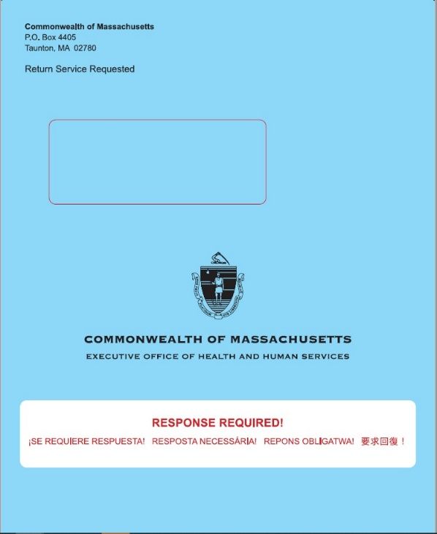
Also tell members to watch for an auto-renewal notice (which they may get instead of a blue envelope if they are automatically renewed) and any other mail that could be from MassHealth, such as Requests for Information or Verification (arrive in white envelopes)

Slide 15

How to help people experiencing homelessness complete their renewal
Note: Some members may have their coverage auto-renewed, which means they won't receive a blue envelope and won't need to take any action to renew their coverage.
Help them read & understand mail from MassHealth
- Help them understand the contents of their blue envelope, renewal notice, or other MassHealth forms
  - If they are vision-impaired, read them the phone number to call to request a large print or braille version, and help them update their notice preferences
  - Help translate language as necessary (forms will arrive in multiple languages)
  - Circle the date they must renew by
  - Walk through the instructions with them and make sure they understand what action they need to take
Make a concrete plan
- Help the member decide how they will complete their renewal – online, via phone, via paper, etc.
  - Online renewals are the fastest & easiest when possible – you can help members with this!
  - See following pages for more information on how members can complete renewals
- Make a concrete plan with the member about how they will gather the supporting documentation and when they will submit the renewal by (i.e., a concrete date)
Connect them with support resources
- If a member has questions on their renewal that you cannot answer, connect them with MassHealth resources that exist to support them
- These resources include (see following pages for more details):
  - The MassHealth Enrollment Centers (MECs)
  - Certified Application Counselors and Navigators
  - The MassHealth Customer Service Center

Slide 16

More details: resources that exist to help members with their renewals
Resource | Description
- MassHealth Enrollment Centers (MECs) | - MassHealth Enrollment Centers (MECs) provide members with phone, virtual, or in-person assistance with their applications from MassHealth staff  - We recommend that members schedule an appointment ahead of time at http://www.mass.gov/info-details/schedule-an-appointment-with-a-masshealth-representative. Appointments can be via phone, virtual, or (starting in July) in-person  - There are 6 MECs across the State – find the nearest one online at https://www.mass.gov/service-details/masshealth-enrollment-centers-mecs
- Certified Application Counselors or Navigators | - Certified Application Counselors (CACs) and Navigators are a community-based resource to help members apply for and renew health insurance benefits. They are trained by MassHealth but are not MassHealth staff  - People who need help to keep their MassHealth coverage and people who are no longer eligible for MassHealth can get help from CACs and Navigators  - Help from CACs and Navigators is free but may require an appointment. You can also go online to find the nearest organization at https://my.mahealthconnector.org/enrollment-assisters
- MassHealth Customer Service Center | - If the member has questions about their MassHealth renewal you cannot answer, you can have them call the MassHealth Customer Service center.  - Phone number: (800) 841-2900; TDD/TTY: 711  - Hours: Monday-Friday 8am-5pm. Assistance is available in English, Spanish, Haitian Creole, Portuguese, Mandarin, Vietnamese, Arabic, and members may request a translator for any other language.
Slide 17

MassHealth Contact Information Mailing Details
MassHealth is focused on gathering up to date contact information. Updated and accurate contact information is crucial to ensuring MassHealth can reach members once they are selected for renewal and that member’s receive the most robust benefit they are eligible for.
In early 2023, MassHealth completed a one-time contact information data match with a contracted vendor who specializes in address verification. Through this process, MassHealth compared all head of household mailing addresses and phone numbers against this third-party data (which aggregates information from trusted sources such as the U.S. Postal Service credit bureaus, etc.).
- For head of households whose mailing address on file with MassHealth did not match the third-party data, MassHealth sent a one-time mailed notice to both the address acquired through the vendor and the member address in the MassHealth system (see example notice below).
- For head of households whose phone number on file with MassHealth did not match the third-party data, MassHealth sent a one-time mailed notice to the member address in the MassHealth system (see example notice below).
To address member concerns that these notices were potentially a “scam,” MassHealth is adding language to our contact center “hold” message and adding banners to select web pages (see language below).
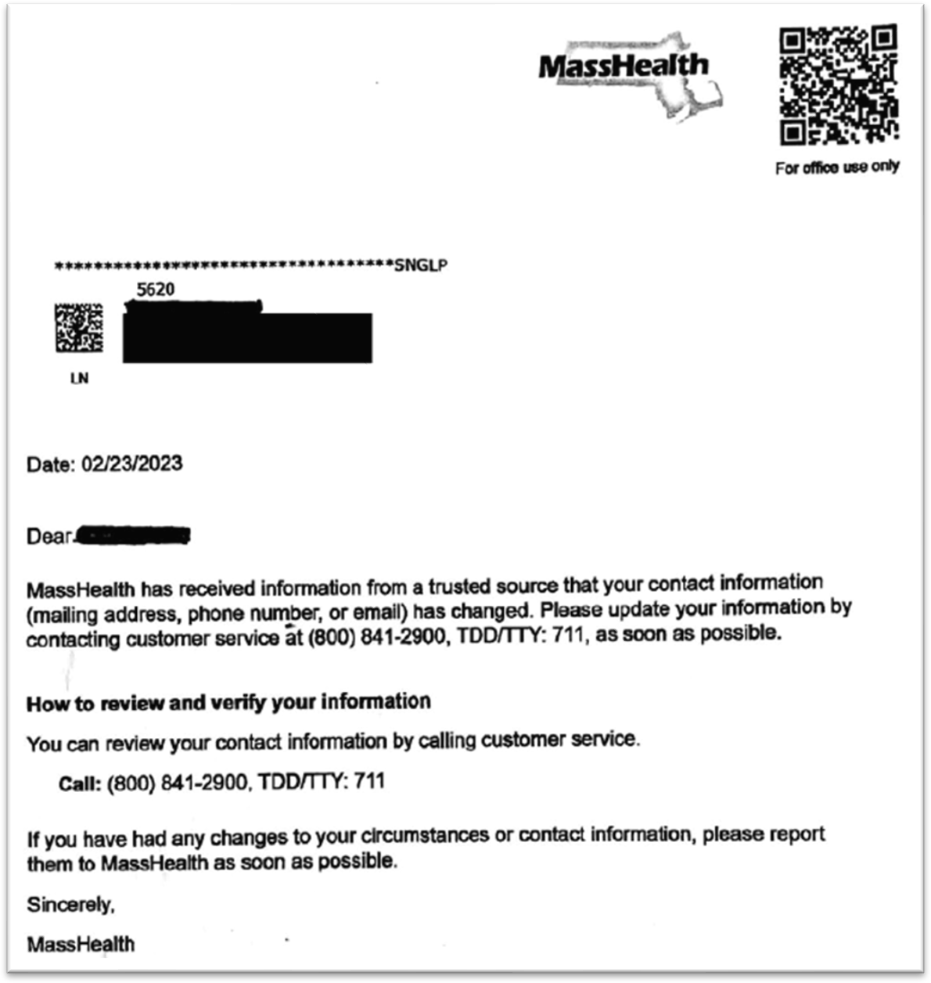
MassHealth suggests that members who receive this notice check that MassHealth has the most accurate information on file.

Slide 18

If members no longer qualify for MassHealth, you can help them find affordable coverage
- Even if a member thinks that they are likely no longer eligible for MassHealth, they should still complete their renewal form because it will help MassHealth determine other affordable healthcare options for them
- For members under 65, affordable plan options are available through the MA Health Connector
  - Members can visit https://www.mahealthconnector.org/ or call Customer Service at 1-877- MA ENROLL (1-877-623-7773) to learn more or enroll in a plan
  - Losing MassHealth coverage is a Qualifying Life Event (QLE), which allows members to enroll in a plan through the Health Connector outside of the regular Open Enrollment Period
- For members over 65, other affordable options are available
  - Individuals who do not qualify for Medicare may be eligible for Connector coverage . For those eligible for Medicare, loss of MassHealth is a Special Enrollment Period (SEP) that allows individuals to enroll in Medicare outside of standard enrollment periods
  - Members who lost MassHealth because they lost Social Security Income (SSI) due to certain conditions may be able to re-apply
  - If members are no longer eligible for MassHealth, they may qualify for the Medicare Savings Program (MSP) (sometimes known as “MassHealth Buy-in”), which is a federally funded program that pays for some or all of Medicare recipient’s premiums, deductibles, co-payments, and co-insurance
  - Other programs that members may qualify for include: the Frail Elder Waiver (FEW), the Program of All Inclusive Care for the Elderly (PACE), Prescription Advantage, and other programs / services run through Aging Services Access Points (ASAPs)

Slide 19

These details and more are captured in the “MassHealth Renewal Help Guide”
Find it online!
https://www.mass.gov/lists/masshealth-redetermination-resources

Slide 20

You can also visit our renewal website
mass.gov/masshealthrenew

Slide 21

Other ways you can help
- Sign up for the MassHealth Eligibility Redeterminations Email List - Sign up to receive emails for the latest news and updates on MassHealth’s redetermination process: http://www.mass.gov/forms/masshealth-eligibility-redeterminations-email-list-sign-up
- Join the Massachusetts Health Care Training Forum (MTF) email list and attend trainings - MTF aims to communicate accurate, timely information relating to MassHealth policies and operations, other state programs, and public assistance programs and services to all health care organizations and community-based agencies. Upcoming sessions will focus on MassHealth redeterminations.
  - Click here to join the email list: www.surveymonkey.com/r/MTFListservNEW2021
  - For more information, visit the MTF website: https://www.masshealthmtf.org/
- Become part of the CAC program - Certified Application Counselors (CACs) help people apply for health insurance benefits, enroll in health plans, and maintain health insurance coverage. In Massachusetts, the CAC Program is a joint program, administered by MassHealth and supported by the Massachusetts Health Connector.
  - The CAC Program is a voluntary program, no one pays for the help they receive from a CAC.
  - Individuals do not need a CAC to apply for or receive benefits. CACs help people apply for health insurance benefits, enroll in health plans, and maintain health insurance coverage
  - Individuals alone cannot become CACs. Your organization must partner with MassHealth and the Massachusetts Health connector, and then individuals within your organization can be trained as CACs
If you are interested in the CAC Program email us at mahealthconnectortraining@massmail.state.ma.us

Slide 22

Final tips and reminders
- If members are under 65, the fastest and easiest way to renew their coverage is online using their MA Login Account at http://www.mahix.org/individual.
- If members are over 65 or in a nursing facility or HCBS waiver, they can find information about the best way to renew their coverage by visiting http://www.mass.gov/masshealthSACA
- Remind members to tell MassHealth if they need to update their contact information
- Due to the large number of renewals that need to be done this year, members may have longer than usual hold times at the Customer Service center
- Members may not get their renewal forms right away – be on the lookout from now until April 2024
- Please use the resources available to help you help members (the MECs, the Customer Service center, CACs / Navigators). MassHealth thanks you for your invaluable help making sure members keep the best coverage they qualify for

Note that you may, upon request, help members read their mail and understand instructions. You may not access their private information or act on their behalf, unless you are an Authorized Representative Designee (ARD)
*The 90-day renewal reconsideration period only applies for failure to respond to a renewal notice but DOES NOT apply for failure to respond to RFIs, verifications, or other types of notices.
*If a member has eligibility for MassHealth through another program, such as Social Security Insurance (SSI), they will not be able to create an MA Login Account.
Renewals for members in long term care facilities are due in 30 days

