Executive Office of Health and Human Services
Supporting MassHealth members with disabilities with their renewals

CONFIDENTIAL; FOR POLICY DEVELOPMENT PURPOSES ONLY

Agenda

Today, we will:

- Explain what a MassHealth renewal is

- Discuss why renewals are especially important this upcoming year (2023 – 2024)

- Share what you can do you to support MassHealth members in preparing for and understanding how to complete renewals

- Discuss special considerations for members with disabilities

Who this information is for

- This presentation contains information for individuals working in the community who typically interact with MassHealth members

- It is intended to give these individuals helpful tips for how they can help MassHealth members understand how to complete their renewal

- These tips cover basic assistance – such as reminding members of important deadlines, helping them understand written instructions, and directing them towards official MassHealth resources

- They do not imply that individuals may access a MassHealth’s member’s private information or act on their behalf
‒ All individuals using this guide should remember that a MassHealth’s member private health information (PHI) is protected under HIPAA Privacy Rules. This means that individuals working with MassHealth members should not distribute MassHealth member information internally or externally unless authorized to do so.

- Furthermore, the right to access or update a MassHealth’s member’s information is reserved for officially designated representatives, certain MassHealth employees, and Certified Application Counselors (CAC) / Navigators
‒ If you or your organization is interested in becoming a CAC, see page 18

- However, you do not need to be an official representative or CAC to meaningfully help a member. The tips in this guide will help you, as an individual, have an important and positive impact on MassHealth members

What is a MassHealth renewal?

  - Federal law requires MassHealth to regularly check whether members are still eligible for MassHealth. This ‘check’ is called a “renewal” (also sometimes called an “annual review”)

Renewals and annual reviews need to occur every year

  - Members get their renewal forms in the mail
‒ Renewals occur at the household level, and are sent to the Head of Household
‒ Some members may be automatically renewed. This means that MassHealth will automatically process a member’s renewal by matching their information against state and federal data. In this case, MassHealth does not need any new information and no action is needed.
‒ If MassHealth does not have enough information to automatically renew a member, members will need to report new information. They will get a renewal form in a blue envelope. If members do not reply, their coverage may end

Why are we talking about renewals this year?

- At the beginning of the COVID-19 public health emergency (PHE), the federal government implemented continuous coverage requirements

- In response to these requirements, MassHealth put protections in place in February 2020 that prevented members’ MassHealth coverage from ending.

- The federal government ended continuous coverage requirements on April 1, 2023. At this time,
MassHealth returned to our standard annual eligibility renewal processes

- All members will be renewed by MassHealth to ensure they still qualify for their current benefit. However, many members will be automatically renewed, including those who receive Social Security Insurance (see next page for more details)

- These renewals are taking place over 12 months, from April 2023 – 2024. This means that
members could get their renewal forms in the mail at any time during this 1 year period

A note on automatic renewals
- Whenever possible, MassHealth will attempt to automatically process a member’s renewal through multiple avenues

- Certain members who belong to the following categories may be automatically renewed in the April 2023-April 2024 redeterminations cycle:
‒ Members receiving SSI through the U.S. Social Security Administration because they are 65 and older and have limited income/resources
‒ Members receiving SSI through the U.S. Social Security Administration because they are disabled and
have limited income/resources
‒ Members receiving TANF (Temporary Assistance of Needy Families) through DTA
‒ Members who are currently or formerly in the custody of the Department of Children & Families (DCF) who are:
‒ Ages 0-18
‒ Ages 18-22 and adopted (previously in DCF custody)
‒ Ages 18-26 and not adopted (former foster youth)
‒ Children and youth in custody of the Department of Youth Services (DYS)

- However, if these members receive a blue envelope with a renewal notice, or any other mail with a call to action from MassHealth, they must respond

A note on what it means to return to standard eligibility rules

  - W hile federal continuous coverage requirements were in place, MassHealth did not redetermine member eligibility when they received information that may have impacted their eligibility

  - Under standard eligibility rules, when a member updates their account with new information that may affect their eligibility (e.g., change in income), MassHealth must promptly redetermine the member’s eligibility

  - As of April 1, 2023, when members report information that may affect their eligibility such as income or pregnancy, the benefits for their household may stay the same, increase, decrease, or end

  - All members can call MassHealth at 800-841-2900 (TDD/TTY: 711) to update their contact information without impacting their eligibility

There are two ways you can help members stay covered

1
2

While members are waiting for their renewals to arrive in the mail, there are steps that you, as a trusted advisor, can take to make sure they have the information they need
Help them PREPARE for renewals

You can help MassHealth members understand how to complete their renewals** – whether that means sitting side by side and helping them understand instructions on a form, or directing them to a MassHealth-specific renewal resource
Help them understand how to COMPLETE
renewals

**Note that you may, upon request, help members read their mail and understand instructions. You may not access their private information or act on their behalf, unless you are an Authorized Representative Designee (ARD)

How to help MassHealth members prepare for renewals
1

When you interact with members one on one

In spaces where members visit
In member-facing communications (e.g., listserves, newsletters)

- Ask them if they’ve moved in the past few years (since 2020) and tell them to call MassHealth to update their contact information

- Remind them to read all mail that could be from MassHealth, and to be on the look-out for a blue envelope

- Tell them they can come to you for help when mail from MassHealth arrives
- Post flyers telling members about the upcoming renewals
‒ You can find flyers in the Phase 2 toolkit that MassHealth has distributed to you
‒ If you haven't yet received a toolkit, you can download one at https://www.mass.gov/info- details/redeterminations- outreach-toolkit-phase-2
- Send an email blast on a regular basis (e.g., ~monthly April – April) educating members about the upcoming renewals
‒ You can find a sample email in the Phase 2 toolkit – please customize this as appropriate for your audience
‒ Add a line about how members can come to you for support when they receive their renewal
‒ If you haven't yet received a toolkit, you can download
one at https://www.mass.gov/info
-details/redeterminations- outreach-toolkit-phase-2

More details: members should call MassHealth customer service to update their contact information

  - It is important that members update their contact information so MassHealth can reach them when it is time for their renewal

  - To update their address, phone, or email address, members should call MassHealth Customer Service at (800)-841-2900, TDD/TY: 711

Note that the Head of Household (HOH) can update MassHealth information on behalf of the entire household. Individual household members may update information that is applicable to themselves only.

More details: overview of member renewal timelines

Selected for Renewal & Auto-renewal attempted
- Whenever possible, MassHealth will automatically process a member’s renewal by matching their information against state and federal data sets

Renewal Notices in
Blue Envelope (45 days to respond)
  - If a member’s renewal cannot be automatically processed, they will receive a blue envelope in the mail with a renewal form to complete and return to MassHealth.
  - Typically, members have 45 days to respond to renewal notices (members in a Long-term Care facility have 30 days to respond)

Request for Information (RFI)
(90 days to respond)
  - If members respond to renewal notices but MassHealth still needs more information from the member, members have an additional 90 days to respond to that request for information

Termination Notice
  - Typically, members have at least 14 days after receiving a termination notice before their benefits stop

Renewal Reconsideration Period
(90-days)*
  - During the reconsideration period a member who has been closed for failure to respond to their renewal notice can contact MassHealth to complete their renewal and will be reinstated to the day that they were closed, as long as they contact MassHealth within 90 days of their MassHealth coverage terminating

*The 90-day renewal reconsideration period only applies for failure to respond to a renewal notice but DOES NOT apply for failure to respond to RFIs, verifications, or other types of notices.

More details: All members can choose to initiate a
redetermination before they receive their blue envelope

- If a member chooses to initiate a redetermination by providing updated eligibility information, their coverage may stay the same, increase, decrease, or end

- Any member can elect to be redetermined at any time (e.g., before they receive their blue envelope) by providing
MassHealth with updated eligibility information.
  - Choosing to be redetermined before they receive a blue envelope will reset a member’s renewal ‘clock’, meaning that their next renewal will be due 12 months from the date they choose to be redetermined

- Allowing members to complete their redetermination without waiting for their blue envelope has important benefits:
  - Reduces the number of members losing coverage due to non-response
  - Improves income information used to determine subsidy eligibility on the Connector, for members no longer eligible for MassHealth

- Any MassHealth member can update their contact information without going through a full redetermination.
  - Updating their contact information is critical to ensure that MassHealth can reach members when it is their time to renew
  - All members can call MassHealth at 800-841-2900 (TDD/TTY: 711) to update their contact information without impacting their eligibility

More details: how to help members complete their renewal
Members under 65 years old
Members over 65 residing in the community and of any age receiving nursing facility care or in HCBS waivers

- Help members go online to www.mahix.org/individual (or the individualized link provided in the notice in the blue envelope) [Easiest way!]*
- Help members complete the application and mail it back to Health Insurance Processing Center, PO Box 4405, Taunton, MA 02780 or fax it to 1-857-323-8300
- Have members call the MassHealth Customer Service center at (800) 841-2900, TDD/TTY: 711
- Help members schedule an appointment with a MassHealth representative. Use our online scheduling tool at: www.mass.gov/info-details/schedule-an-appointment- with-a-masshealth-representative
- If the member’s renewal notice has an eSubmission number, you can help them submit their renewal online via document upload or fillable form at https://mhesubmission.ehs.mass.gov/esb [Easiest way!]
- Help members complete the application and mail it back to MassHealth Enrollment Center, PO Box 290794, Charlestown, MA 02129 or fax it to 1-617-887-8799
- Have members call the MassHealth Customer Service center at (800) 841-2900, TDD/TTY: 711

- Help members schedule an appointment with a MassHealth representative. Use our online scheduling tool at: www.mass.gov/info-details/schedule-an-appointment- with-a-masshealth-representative

Note that you will have 45 calendar days** to fill it out and send it back to MassHealth
* Referred eligible members who receive eligibility from another agency will not have access to an online account
** Renewals for members in long term care facilities are due in 30 days

Tell members to look out for the blue envelope!

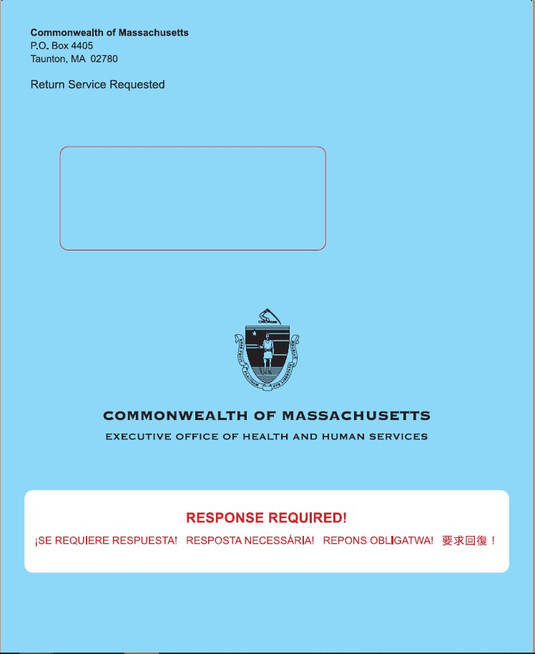
Also tell members to watch for an auto-renewal notice (which they may get instead of a blue envelope if they are automatically renewed) and any other mail that could be from MassHealth, such as Requests for Information or Verification (arrive in white envelopes)

How to help MassHealth members complete their renewal
NEW
2

Connect them with support resources

Make a concrete plan
Note: Some members may have their coverage auto-renewed, which means they won't receive a blue envelope and won't need to take any action to renew their coverage.

Help them read & understand mail from MassHealth

- Help them understand the contents of their blue envelope, renewal notice, or other MassHealth forms
‒ If they are vision-impaired, read them the phone number to call to request a large print or braille version, and help them update their notice preferences
‒ Help translate language as necessary (forms will arrive in multiple languages)
‒ Circle the date they must renew by
‒ Walk through the instructions with them and make sure they understand what action they need to take

Help the member decide how they will complete their renewal– online, via phone, via paper, etc.
‒ Online renewals are the fastest & easiest when possible – you can help members with this!
‒ See following pages for more information on how members can complete renewals

- Make a concrete plan with the member about how they will gather the supporting documentation and when they will submit the renewal by (i.e., a concrete date)
  - If a member has questions on their renewal that you cannot answer, connect them with MassHealth resources that exist to support them

  - These resources include (see following pages for more details):
‒ The MassHealth Enrollment
Centers (MECs)
‒ Certified Application Counselors and Navigators
‒ The MassHealth Customer Service Center

More details: resources that exist to help members with their renewals
RESOURCE DESCRIPTION

    - MassHealth Enrollment Centers (MECs) provide members with phone, virtual, or in-person assistance with their applications from MassHealth staff

MassHealth
1 Enrollment Centers (MECs)
    - We recommend that members schedule an appointment ahead of time at www.mass.gov/info- details/schedule-an-appointment-with-a-masshealth-representative. Appointments can be via phone, virtual, or (starting in July) in-person
    - There are 6 MECs across the State – find the nearest one online at https://www.mass.gov/service-
details/masshealth-enrollment-centers-mecs

    - Certified Application Counselors (CACs) and Navigators are a community-based resource to help members apply for and renew health insurance benefits. They are trained by MassHealth but are not MassHealth staff
2
Certified Application Counselors or Navigators
    - People who need help to keep their MassHealth coverage and people who are no longer eligible for MassHealth can get help from CACs and Navigators
    - Help from CACs and Navigators is free but may require an appointment. You can also go online to find the nearest organization at https://my.mahealthconnector.org/enrollment-assisters

    - If the member has questions about their MassHealth renewal you cannot answer, you can have them call the MassHealth Customer Service center.

MassHealth
3 Customer Service Center

Phone number: (800) 841-2900; TDD/TTY: 711
    - Hours: Monday-Friday 8am-5pm. Assistance is available in English, Spanish, Haitian Creole, Portuguese, Mandarin, Vietnamese, Arabic, and members may request a translator for any other language.

More details: Language and translation supports

- The redetermination member-facing toolkit (including flyers, posters, and key messaging) is available in 9 languages - English, Spanish, Portuguese, Haitian Creole, Vietnamese, Khmer, Chinese, Arabic, Cape Verdean Creole

Outreach in various languages
- Community outreach through HCFA will include local language television & radio stations
- Grants to community-based organizations (CBOs) will include those focused on immigrants & refugees
- MassHealth will publish vlogs incorporating ASL, and offer live ASL translation during redetermination webinars recorded & published online

- Renewal forms will be mailed in English or Spanish, and are available in large print or Braille. Renewal packages will include Babel notices (notice that the document contains key information translated into multiple languages)

Translation services
- For members who require translation of forms, members can receive free translation services by calling the Customer Service Center at (800) 841-2900; TDD/TTY: 711

- The contact center has representatives who speak English, Spanish, and Haitian Creole, and access to a language line where an interpreter will join the call. Interpreter services are available in Portuguese, Mandarin, Vietnamese, and Arabic. Members may also request a translator for any other language.

Support resources offering various languages
- MassHealth will publish a list of CAC organizations who speak foreign languages
- For individuals who speak ASL, MassHealth offers on-demand VRI in-person at the MassHealth Enrollment Centers

More details: Plans are also reaching out to members to support renewals

MassHealth is coordinating closely with health plans and community partners and began regular office hours meetings in February 2023. Collaborations include:
Toolkit outlining best practices for member outreach:
Assistance updating member contact information:
Consistent data exchangeregarding redeterminations

- Plans will conduct calls, emails, and/or text messaging to alert members about their upcoming renewal, including live outbound calls
- Plans will partner with primary care physicians and other providers to raise awareness about the importance of responding to MassHealth requests. This may include providing member-facing materials to provider offices
- Plans will ensure inbound call protocols are in place to ask members about renewals and direct members to renewal support resources
- Plans are also encouraged to explore additional ways to outreach members, such as mailed letters, in-person enrollment events,
or media buys
- Plans will work to validate and update member contact information and share all new contact information with MassHealth
  - MassHealth will send files each week to plans and community partners that identify members who have had their eligibility protected during the MOE period as well as members who will receive renewal packages that week
  - Plans will use these files to support member outreach, both inbound and outbound

Special considerations for persons with disabilities preparing for renewals

Renewal Element | Actions Needed
Agreements to share  information | - Members may have a family member or someone else in their life assist them with managing their MassHealth. For MassHealth to share information with another person, they will need to complete either the Permission to Share Information (PSI) form or the Authorized Representative Designation (ARD) form.  - Permission to Share Information (PSI) form – this form allows MassHealth to share information about your eligibility with the person listed on the form (the “designee”) (https://www.mass.gov/doc/masshealth-permission-to-share-information-psi-form-english- 0/download)  - Authorized Representative Designation (ARD) form – this form allows MassHealth to share information with the person listed on the form (the “designee”) and also for that person to make decisions for you (https://www.mass.gov/doc/authorized-representative- designation-form-english-0/download)  - PSI forms expire after 12 months. If someone who assist a member needs to renew their PSI or ARD
Accommodations | - MassHealth has accommodations for older adults and people with disabilities. These accommodations include:  - A Disability Ombudsman that can provide personal assistance by explaining MassHealth processes and requirements and helping applicants or members filling out forms over the telephone. The Ombudsman can also arrange meetings with MassHealth staff, si gn language interpretation, or CART services. The Ombudsman can be reached at ADAaccomodations@state.ma.us; Voice: 617-847- 3468, TTY: 617-847-3788  - A TTY/TTD phone number for members who are deaf or hard of hearing  - The option to request large print or braille renewal forms by calling MassHealth Customer Service at (800) 841-2900  - On demand Video Remote Interpreting (VRI) and Assistive Listening Devices (ALDs) at all MassHealth Enrollment Centers (MECs)
Proof of disability | - If a member had a disability determination completed by Disability Evaluation Services (DES) or the Social Security Administration , the member may not need to submit additional proof  - If a member is older than the age of 18 and have had a disability determination completed by DES that has expired, they may have to complete a disability review to continue eligibility. MassHealth will let the member know of the steps they need to take and what kind of documentation is needed  - If a member has not been determined disabled by the Social Security Administration or DES , and have an injury, illness, or disability that is expected to last more than 12-months, they should report this on their renewal. MassHealth will send a member more information when we get their completed renewal form

If members no longer qualify for MassHealth, you can help them find affordable coverage
- Even if a member thinks that they are likely no longer eligible for MassHealth, they should still complete their renewal form because it will help MassHealth determine other affordable healthcare options for them

- For members under 65, affordable plan options are available through the MA Health Connector
‒ Members can visit https://www.mahealthconnector.org/ or call Customer Service at 1-877- MA ENROLL (1-877-623-7773) to learn more or enroll in a plan
‒ Losing MassHealth coverage is a Qualifying Life Event (QLE), which allows members to enroll in a plan through the Health Connector outside of the regular Open Enrollment Period

- For members over 65, other affordable options are available
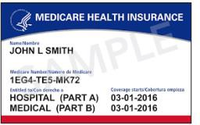
‒ Individuals who do not qualify for Medicare may be eligible for Connector coverage. For those eligible for Medicare, loss of MassHealth is a Special Enrollment Period (SEP) that allows individuals to enroll in Medicare outside of standard enrollment periods
‒ Members who lost MassHealth because they lost Social Security Income (SSI) due to certain conditions may be able to re-apply
‒ If members are no longer eligible for MassHealth, they may qualify for the Medicare Savings Program (MSP) (sometimes known as “MassHealth Buy-in”), which is a federally funded program that pays for some or all of Medicare recipient’s premiums, deductibles, co-payments, and co-insurance
‒ Other programs that members may qualify for include: the Frail Elder Waiver (FEW), the Program of All Inclusive Care for the Elderly (PACE), Prescription Advantage, and other programs / services run through Aging Services Access Points (ASAPs)

If members want to share their information with a third party or have the third party complete their renewal on their behalf, they must fill out a PSI or ARD form

Permission to Share Information (PSI) Form – This form allows MassHealth to share information about a member’s eligibility with the persons listed on the form (the “designee”).
Authorized Representative Designation (ARD) Form – This form allows MassHealth to share information with the person listed on the form, the “designee,” and also for that person to make decisions for the member

More details:
- Signed PSI and ARD forms give MassHealth permission to alert the designee when a member is up for renewal
‒ PSI designees receive a notification in the mail that the member is up for renewal
‒ ARD designees receive both a notice and a blank renewal form
- Both the PSI and ARD forms allow the member’s designee to help the member call MassHealth
‒ A PSI designee can call MassHealth with the member on the phone and get verbal consent for them to make changes on the
member’s behalf
‒ An ARD designee can call by themselves to make changes on behalf of the member
- Members should make sure their PSI/ARD forms are up-to-date
‒ The PSI forms ends 12 months after MassHealth receives them unless otherwise specified, so new ones may need to be completed before a member’s renewal
‒ The ARD forms are valid until the member chooses to change them
- If a member is in a long-term care facility, the PSI form is generally the right option for allowing facility staff to help them with applications or renewals
- The PSI and ARD forms can be found online

These details and more are captured in the “MassHealth Renewal Help Guide”

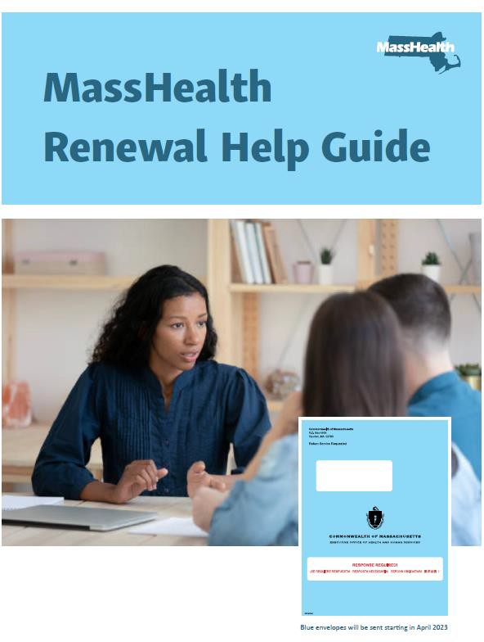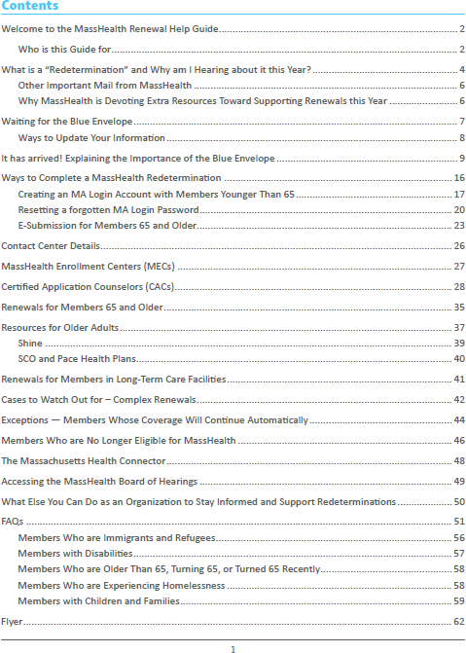

https://www.mass.gov/doc/masshealth-renewal-help-guide/download

You can also visit our renewal website

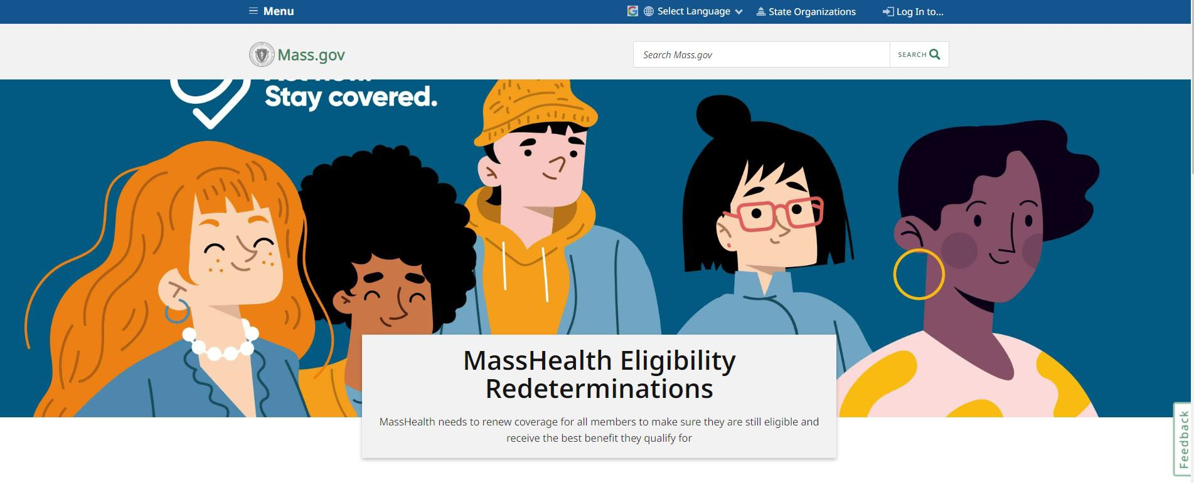

mass.gov/masshealthrenew

And access the Phase 2 Redeterminations Outreach Toolkit

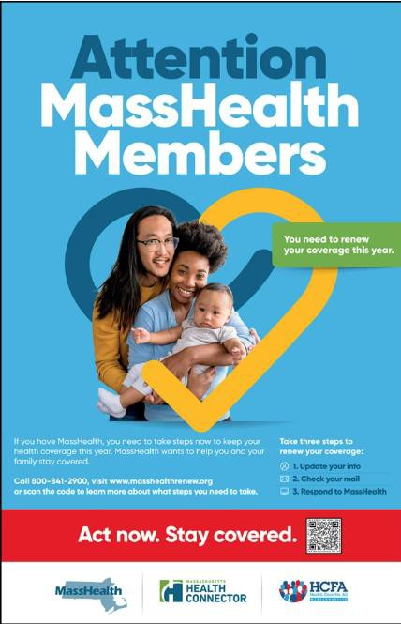
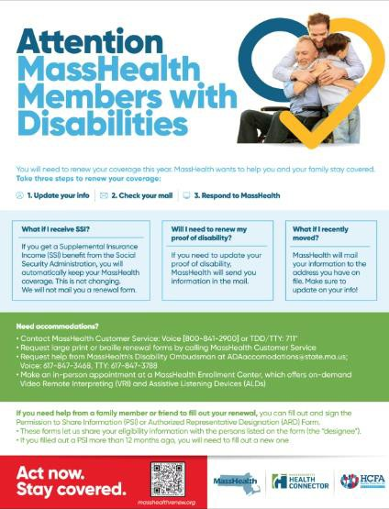

https://www.mass.gov/info-details/redeterminations-outreach-toolkit-phase-2

Other ways you can help

- Sign up for the MassHealth Eligibility Redeterminations Email List - Sign up to receive emails for the latest news and updates on MassHealth’s redetermination process: www.mass.gov/forms/masshealth-eligibility-redeterminations-email-list-sign- up

- Join the Massachusetts Health Care Training Forum (MTF) email list and attend trainings - MTF aims to communicate accurate, timely information relating to MassHealth policies and operations, other state programs, and public assistance programs and services to all health care organizations and community-based agencies. Upcoming sessions will focus on MassHealth redeterminations.
  - Click here to join the email list: www.surveymonkey.com/r/MTFListservNEW2021
  - For more information, visit the MTF website: https://www.masshealthmtf.org/

- Become part of the CAC program - Certified Application Counselors (CACs) help people apply for health insurance benefits, enroll in health plans, and maintain health insurance coverage. In Massachusetts, the CAC Program is a joint program, administered by MassHealth and supported by the Massachusetts Health Connector.
  - The CAC Program is a voluntary program, no one pays for the help they receive from a CAC.
  - Individuals do not need a CAC to apply for or receive benefits. CACs help people apply for health insurance benefits, enroll in health plans, and maintain health insurance coverage
  - Individuals alone cannot become CACs. Your organization must partner with MassHealth and the Massachusetts Health connector, and then individuals within your organization can be trained as CACs

If you are interested in the CAC Program email us at mahealthconnectortraining@massmail.state.ma.us.

Final tips and reminders

If members are under 65, the fastest and easiest way to renew their coverage is online using their MA Login Account at www.mahix.org/individual.
11.

If members are over 65 or in a nursing facility or HCBS waiver, they can find information about the best way to renew their coverage by visiting www.mass.gov/masshealthSACA
21.

Remind members to tell MassHealth if they need to update their contact information
31.

Due to the large number of renewals that need to be done this year, members may have longer than usual hold times at the Customer Service center
41.

Members may not get their renewal forms right away – be on the lookout from now until April 2024
51.

Please use the resources available to help you help members (the MECs, the Customer Service center, CACs / Navigators). MassHealth thanks you for your invaluable help making sure members keep the best coverage they qualify for
61.

