**Grants Management Home Page**

**Supportive and Social Day Program Expansion Grant Home Page**

**Application Form**



**Subcontractor(s) & Partners Form**

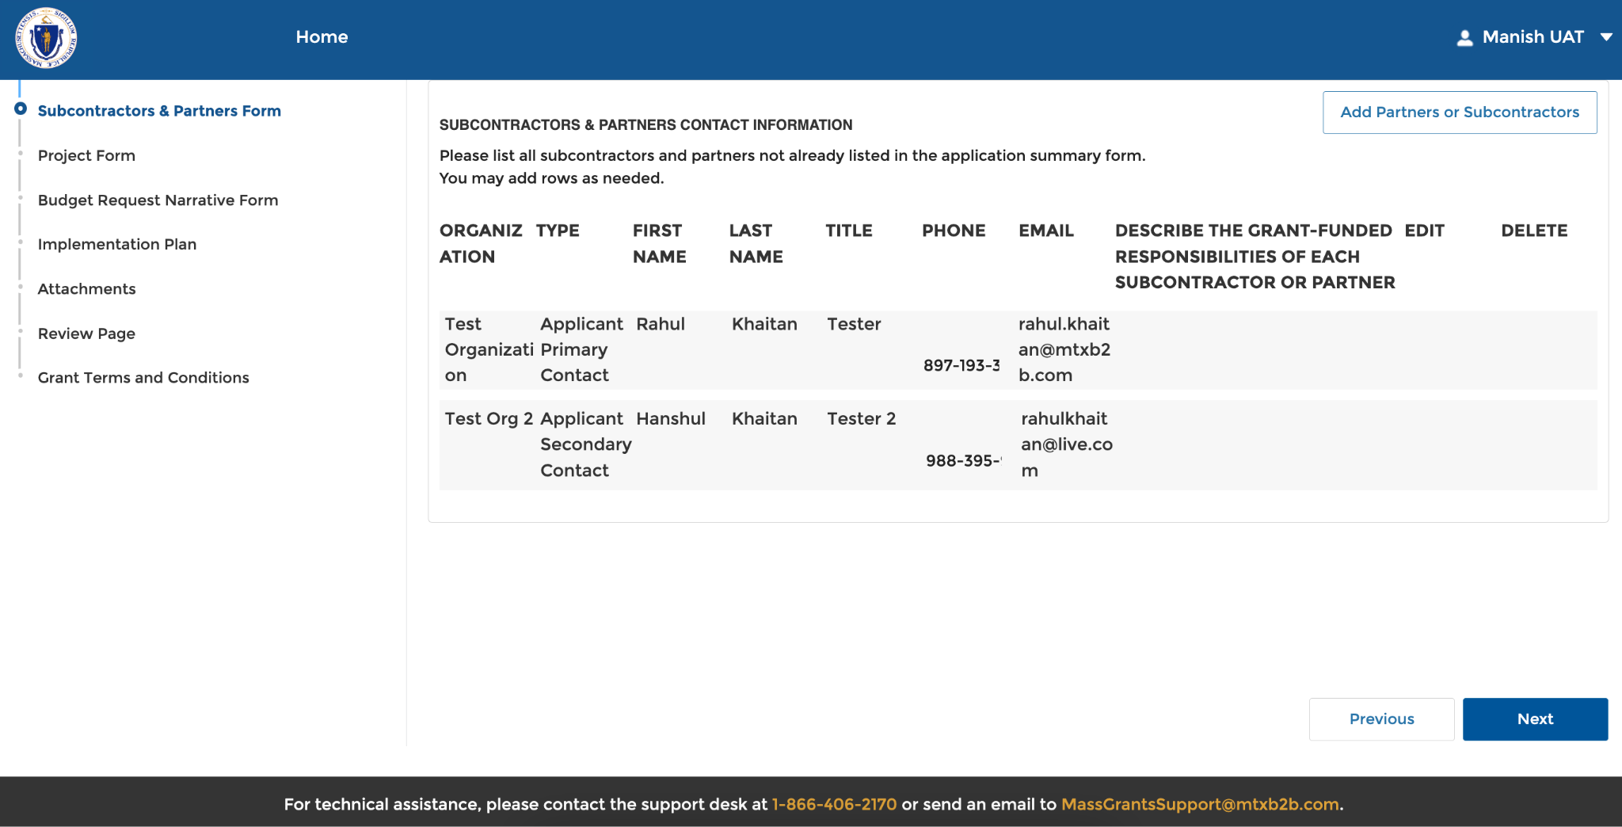

**Project Form, Category 1: Planning**

**Project Form, Category 2: Expansion and Category 3: New Program Launch**

**Budget Request Narrative Form, Category 1: Planning**

**Budget Request Narrative Form, Category 2: Expansion**

**Budget Request Narrative Form, Category 3: New Program Launch**

**Implementation Page**

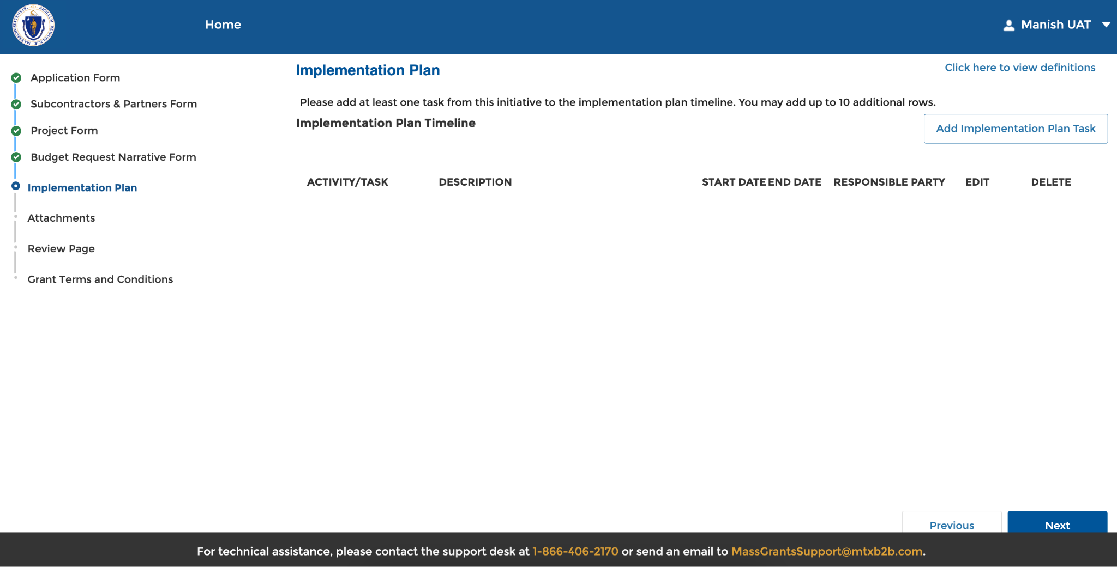

**Attachments: Optional Documents for All Categories**

**Attachments: Required Documents for Category 3: New Program Launch Only**

**Review Page**

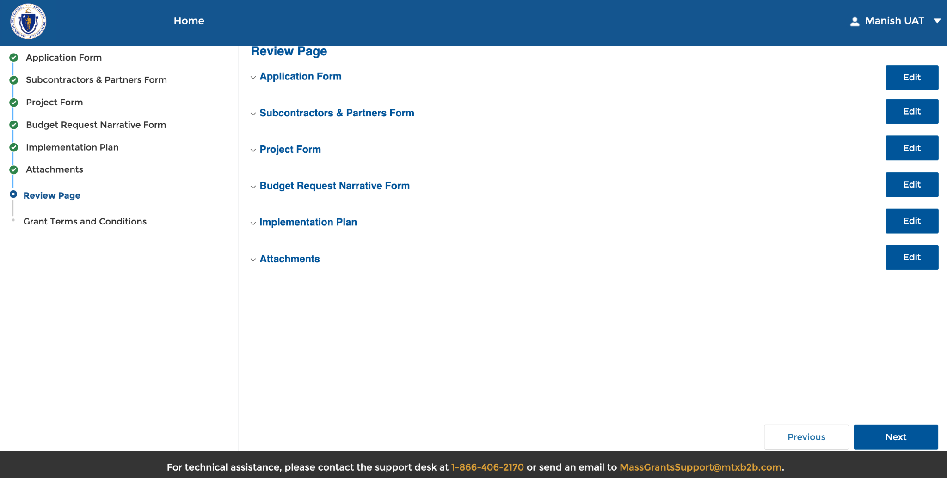

**Grant Terms and Conditions**

**Application Submitted Successfully Confirmation Page**

