Massachusetts Department of Environmental Protection
Bureau of Water Resources – Surface Water Discharge (NPDES) Permitting Program
WM 05, 06, 07
Surface Water Discharge (NPDES Individual) Permit Application

 |  |  | To be filed by all persons required to obtain a permit to discharge Industrial or Non-Industrial Wastewater to waters of the Commonwealth.
 |  |  | A. Facility Information
Important: When filling out forms on the computer, use only the tab key to move your cursor - do not use the return key.  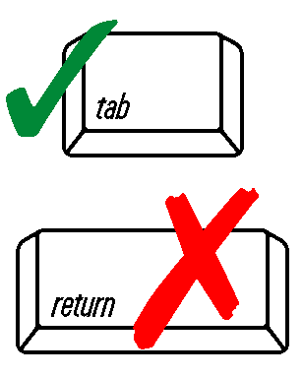 |  |  | 1. Permit # (if known), name, address, and telephone number of facility producing the discharge:
 |  |  | Permit # (if known)
 |  |  | Name
 |  |  | Street address
 |  |  | City |  |  | State | Zip Code
 |  |  | Telephone number (including extension) |  |  | E-mail address (optional)
 |  |  | Billing address (if different):
 |  |  | Street/PO Box
 |  |  | City |  |  | State | Zip Code
 |  |  |  | Discharge Site:
DEP Use Only |  |  |  | Facility Name
Application # |  |  |  | Street address
 |  |  |  | City |  | State | Zip Code
Date Received |  |  |  | Ownership: Individual Corporation Partnership Other (specify):
 |  |  |  | Status: Private Public Other (specify):
 |  |  |  | Major/Minor: Major Minor
 |  |  |  | 2. Contact Person:
 |  |  |  | Give the name, title, and work telephone number of a person who is thoroughly familiar with the operation of the facility, with the facts reported in this application, and can be contacted by the Surface Water Discharge (NPDES) Program if necessary.
 |  |  |  | Name |  | Title
 |  |  |  | Telephone Number (including extension)
 |  |  |  | A. Facility Information (cont.)
 |  |  |  | 3. Facility Status:
 |  |  |  | Existing Proposed
 |  |  |  | 4. Does the project affect a site of historic or archeological significance, as defined in regulations of the Massachusetts Historical Commission, 950 CMR 71.00?
 |  |  |  | Yes No
 |  |  |  | 5. Does this project require a filing under 301 CRM 11.00, the Massachusetts Environmental Policy Act (MEPA)?
 |  |  |  | Yes No
 |  |  |  | If yes, has a filing been made?
 |  |  |  | Yes No
6. Submit a copy of the required US EPA Forms to MassDEP:
The Forms are located at the following link: https://www.epa.gov/npdes-permits/epa-npdes-permit-forms-attachments-new-england

 |  |  |  | B. Certification
 |  |  |  | "I certify under penalty of law that this document and all attachments were prepared under my direction or supervision in accordance with a system designed to assure that qualified personnel properly gather and evaluate the information submitted. Based on my inquiry of the person or persons who manage the system, or those persons directly responsible for gathering the information, the information submitted is, to the best of my knowledge and belief, true, accurate, and complete. I am aware that there are significant penalties for submitting false information, including the possibility of fine and imprisonment for knowing violations. "
 |  |  |  | Signature of applicant |  | Date Signed
 |  |  |  | Printed name of applicant |  | Title
 |  |  |  | Name of Preparer |  | Title
 |  |  |  | Telephone Number (including extension)

