Massachusetts Department of Public Health
Bureau of Infectious Disease and Laboratory Sciences
Surveillance Data Overview of Sexually Transmitted Infections, Massachusetts, 2000-2022

Please note that while the content of this report is the same as the pdf version, the format and pagination have been modified significantly to optimize use with screen readers to ensure access for blind or visually impaired audiences.

Massachusetts Department of Public Health
Bureau of Infectious Disease and Laboratory Sciences
Division of STD Prevention and HIV Surveillance
March 2024

Bureau of Infectious Disease and Laboratory Sciences
Division of STD Prevention and HIV Surveillance
Massachusetts Department of Public Health

Jamaica Plain Campus/State Public Health Laboratory
305 South Street
Jamaica Plain, MA 02130

Questions about this report
Tel: (617) 983-6490

To reach the Reporting and Partner Services Line
Tel: (617) 983-6999
Contents
Slide 1 (title page) - Surveillance Data Overview of Sexually Transmitted Infections, Massachusetts, 2000-2022 4
Slide 2 - Outline 4
Slide 3 (title page) - Chlamydia, Gonorrhea, and Infectious Syphilis: Years 2000 to 2022 4
Slide 4 - Rate of Confirmed Chlamydia Cases, Massachusetts, 2000 to 2022¹ 4
Slide 5 - Confirmed Chlamydia Rates by Gender1, Massachusetts, 2010 to 20222 6
Slide 6 - Chlamydia among Individuals of Transgender Experience,^{1,2} Massachusetts, 2015 to 2022³ 7
Slide 7 - Confirmed Chlamydia Rates by County and Statewide, Massachusetts, 2020-2022¹ 8
Slide 8 - Average Age of Confirmed Chlamydia Cases by Gender¹, Massachusetts, 2012 to 2022² 9
Slide 9 - Rate of Confirmed Gonorrhea Cases, Massachusetts, 2000 to 20221 10
Slide 10 - Confirmed Gonorrhea Rates by Gender¹, Massachusetts, 2010 to 2022² 12
Slide 11: Gonorrhea Among Individuals of Transgender Experience¹, Massachusetts, 2015 to 2022² 14
Slide 12: Confirmed Gonorrhea Rates by County and Statewide, Massachusetts, 2020-2022¹ 15
Slide 13: Confirmed and Probable Infectious Syphilis¹ Rates, Massachusetts, 2000 to 2022² 16
Slide 14: Confirmed and Probable Infectious Syphilis¹ Rates by Gender², Massachusetts, 2010 to 2022³ 18
Slide 15: Infectious Syphilis¹ Reported Cases by Race/Ethnicity², Massachusetts, 2015-2022³ 20
Slide 16: Confirmed and Probable Infectious Syphilis1 Among Individuals of Transgender Experience2, Massachusetts, 2015 to 20223, 4 21
Slide 17: Confirmed and Probable Infectious Syphilis¹ Rates by County and Statewide, Massachusetts, 2020-2022² 22
Slide 18 – Confirmed and Probable Infectious Syphilis¹ Rates by Stage of Infection, Massachusetts, 2010–2022² 24
Slide 19 – Infectious Syphilis¹ Reported Cases by Gender of Sex Partners, Massachusetts, 2015-2022² 26
Slide 20 - Congenital Syphilis Cases and Rate of Confirmed and Probable Infectious Syphilis¹ Among Individuals Thought to be Capable of Pregnancy Ages 15 to 49 Years, Massachusetts, 2010-2022² 28
Slide 21 (title page) - Chlamydia, Gonorrhea, and Infectious Syphilis: Years 2018 to 2022 30
Slide 22 - Social Vulnerability Index 30
Slide 23 - Confirmed Chlamydia Case Percentages by Social Vulnerability Index, Massachusetts, 2018-2022¹ 31
Slides 24 - Confirmed Chlamydia Case Percentages by Social Vulnerability Index and Gender, Massachusetts, 2018- 2022^{1,2} 32
Slide 25: Confirmed Gonorrhea Case Percentages by Social Vulnerability Index, Massachusetts, 2018-2022¹ 33
Slide 26: Confirmed Gonorrhea Case Percentages by Social Vulnerability Index and Gender, Massachusetts, 2018-2022^{1,2} 34
Slide 27: Confirmed and Probably Infectious Syphilis¹ Case Percentages by Social Vulnerability Index, Massachusetts, 2018- 2022² 35
Slide 28: Confirmed and Probable Infectious Syphilis¹ Case Percentages by Social Vulnerability Index and Gender², Massachusetts, 2018-2022³ 36
Slide 29: Confirmed and Probable Infectious Syphilis¹ Case Percentages by Social Vulnerability Index and Race, Massachusetts, 2018- 2022² 37
Slide 30: Section Break, Description of 2022 STI Cases 38
Slide 31: Incident Rate of Confirmed Chlamydia Cases, per 100,000 Persons¹ by City/Town², Massachusetts, 2022³ 38
Slide 32: Incident Rate of Confirmed Chlamydia Cases, per 100,000 Persons¹ by City/Town², Massachusetts, 2018 39
Slide 33: Confirmed Chlamydia Case Rates per 100,000 Population by Gender¹ and Age, Massachusetts, 2022² 40
Slide 34: Incident Rate of Confirmed Gonorrhea Cases, per 100,000 Persons¹ by City/Town², Massachusetts, 2022³ 41
Slide 35: Incident Rate of Confirmed Gonorrhea Cases, per 100,000 Persons¹ by City/Town², Massachusetts, 2018 42
Slide 36: Confirmed Gonorrhea Case Rates per 100,000 Population by Gender¹ and Age, Massachusetts, 2022² 43
Slide 37: Incident Rate of Infectious Syphilis1 Cases, per 100,000 Persons2 by City/Town, Massachusetts, 20223 44
Slide 38: Incident Rate of Infectious Syphilis¹ Cases, per 100,000 Persons² by City/Town, Massachusetts, 2018 45
Slide 39: Confirmed and Probable Infectious Syphilis¹ Cases per 100,000 Population by Gender² and Age, Massachusetts, 2022³ 46
Slide 40: Comparison of the Rate of Confirmed and Probable Infectious Syphilis¹ Cases by Gender² and Race and Ethnicity³, Massachusetts, 2022⁴ 47
Slide 41: Section Break, HIV Co-infection 48
Slide 42: 2022¹ HIV² Co-Infection with Chlamydia and Gonorrhea 48
Slide 43: 2022¹ HIV² Co-Infection with Infectious Syphilis³ 49
Slide 44: Comparison of Infectious Syphilis¹ Cases by HIV² Co-Infection and Age³, Massachusetts, 2022⁴ 50
Slide 45: Comparison of Infectious Syphilis¹ Cases by HIV² Co-Infection and Race/Ethnicity, Massachusetts, 2022³ 51
Slide 46: 2022 Summary Slide 52
Slide 47: Technical Data Notes 53
Slide 49: Coronavirus 2019 (COVID-19): Impact of Other Reportable Infections 55
Slide 50: Closing Slide 55

Slide Descriptions

Slide 1 (title page) - Surveillance Data Overview of Sexually Transmitted Infections, Massachusetts, 2000-2022

Slide 2 - Outline
Sexually Transmitted Infection (STI) Trends and Descriptions:
General STI Trends Through 2022
Chlamydia
Gonorrhea
Infectious syphilis
Descriptions of 2022 STI Cases
Social Vulnerability Index Trends (2022)
HIV/STI Co-infection and Sexual Risk (2022)
Summary
Technical Notes

Slide 3 (title page) - Chlamydia, Gonorrhea, and Infectious Syphilis: Years 2000 to 2022

Slide 4 - Rate of Confirmed Chlamydia Cases, Massachusetts, 2000 to 2022¹
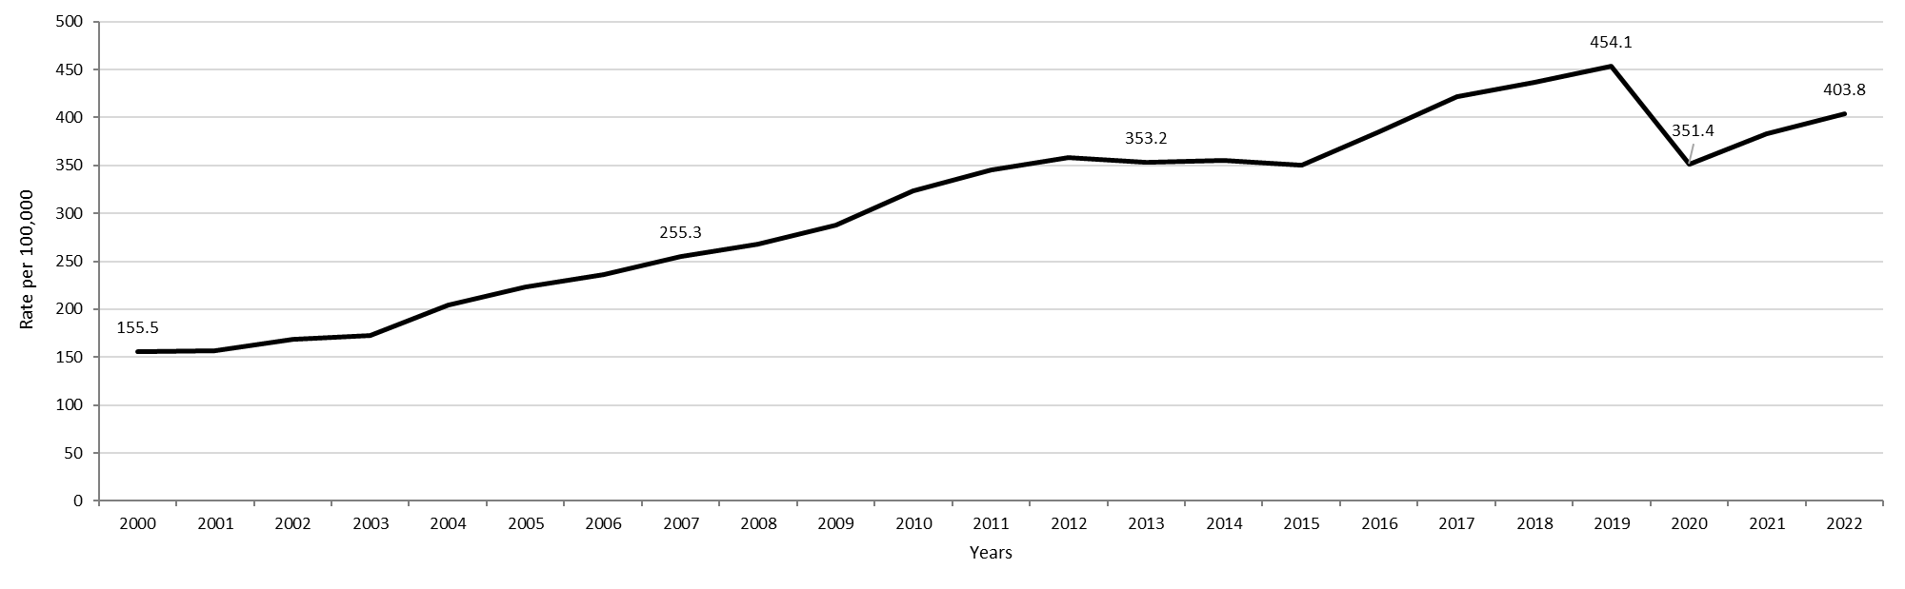
Table: Chlamydia Annual Case Counts
Year | Count
2000 | 9,872
2001 | 9,969
2002 | 10,755
2003 | 11,041
2004 | 13,120
2005 | 14,386
2006 | 15,253
2007 | 16,566
2008 | 17,441
2009 | 18,796
2010 | 21,211
2011 | 22,851
2012 | 23,930
2013 | 23,789
2014 | 24,143
2015 | 23,944
2016 | 26,478
2017 | 29,177
2018 | 30,360
2019 | 31,633
2020 | 24,701
2021 | 26,912
2022 | 28,384
Highlights: Graph depicts the rate per 100,000 population of confirmed cases of chlamydia in Massachusetts between 2000 and 2022. It begins at a low of 155.5 in 2000 and then climbs to a high of 454.1 in 2019. It drops to 382.8 in 2021, followed by a rise to 403.8 in 2022.

Footnotes For Slide 4
Data are current as of 07/18/2023 and are subject to change.
Data Source: Massachusetts Department of Public Health/Bureau of Infectious Disease and Laboratory Sciences/Division of STD Prevention and STD-HIV Surveillance.
Population denominators estimated by the University of Massachusetts Donahue Institute using a modified Hamilton-Perry model (Strate S, et al. Small Area Population Estimates for 2011 through 2020 report, Oct 2016).
1. Please consider the impact of the COVID-19 pandemic on infectious disease screening, treatment and surveillance in the interpretation of 2020-2022 data.

Slide 5 - Confirmed Chlamydia Rates by Gender1, Massachusetts, 2010 to 20222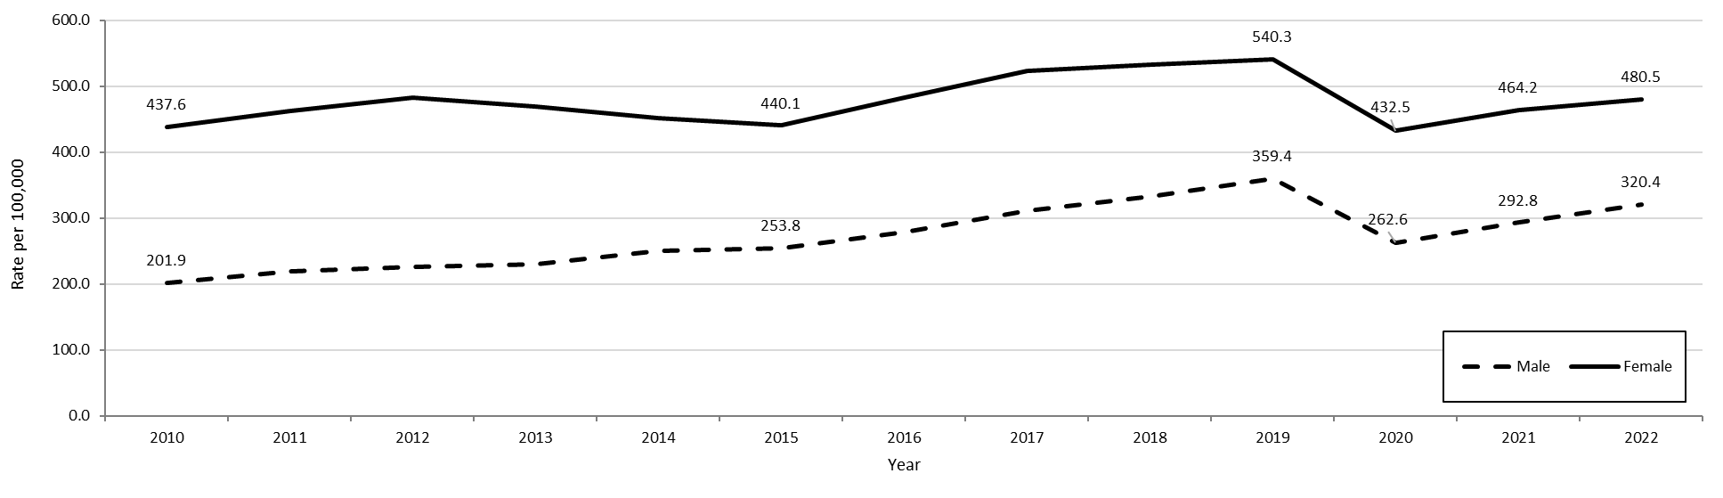
Table: Chlamydia Annual Case Counts by Current Gender
Year | Females | Males
2010 | 436 | 29
2011 | 454 | 46
2012 | 515 | 46
2013 | 656 | 55
2014 | 545 | 53
2015 | 732 | 65
2016 | 947 | 87
2017 | 1,040 | 67
2018 | 1,055 | 110
2019 | 1,102 | 139
2020 | 1,028 | 130
2021 | 1,201 | 150
2022 | 1,357 | 233
Highlights: Graph depicts the rate per 100,000 population of confirmed cases of chlamydia in Massachusetts between 2000 and 2022. It begins at a low of 155.5 in 2000 and then climbs to a high of 454.1 in 2019. It drops to 382.8 in 2021, followed by a rise to 403.8 in 2022.
Footnotes For Slide 5
Data are current as of 07/18/2023 and are subject to change.
Data Source: Massachusetts Department of Public Health/Bureau of Infectious Disease and Laboratory Sciences/Division of STD Prevention and STD-HIV Surveillance.
Population denominators estimated by the University of Massachusetts Donahue Institute using a modified Hamilton-Perry model (Strate S, et al. Small Area Population Estimates for 2011 through 2020 report, Oct 2016).
1. In 2022, there were 38 individuals of transgender experience reported in our data system who do not have current gender documented. These cases were excluded since population estimates for individuals of transgender experience are not available at this time.
2. Please consider the impact of the COVID-19 pandemic on infectious disease screening, treatment and surveillance in the interpretation of 2020-2022 data.

Slide 6 - Chlamydia among Individuals of Transgender Experience,^{1,2} Massachusetts, 2015 to 2022³
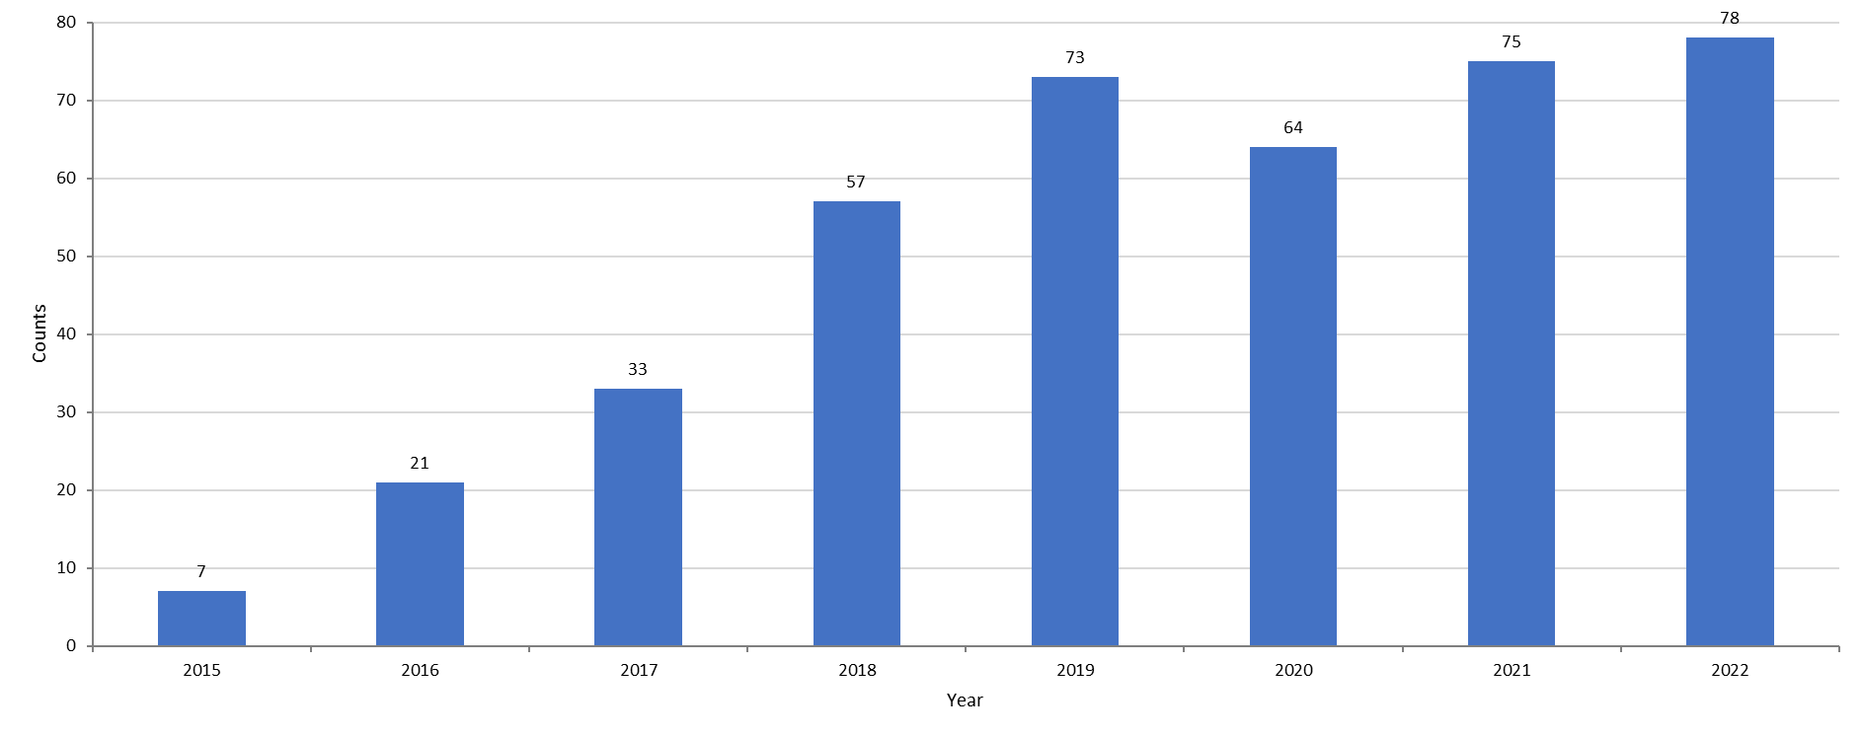
Highlights: Graph depicts the rate per 100,000 population of confirmed cases of chlamydia in Massachusetts between 2000 and 2022. It begins at a low of 155.5 in 2000 and then climbs to a high of 454.1 in 2019. It drops to 382.8 in 2021, followed by a rise to 403.8 in 2022.

Footnotes for Slide 6
Data are current as of 07/18/2023 and are subject to change.
Data Source: Massachusetts Department of Public Health/Bureau of Infectious Disease and Laboratory Sciences/Division of STD Prevention and STD-HIV Surveillance.
1. Prior to 2015 MA DSTDP was not able to capture expanded gender identity including individuals of transgender experience within our data system.
2. All individuals of transgender experience are included in this graph regardless of current gender.
3. Please consider the impact of the COVID-19 pandemic on infectious disease screening, treatment and surveillance in the interpretation of 2020-2022 data.

Slide 7 - Confirmed Chlamydia Rates by County and Statewide, Massachusetts, 2020-2022¹
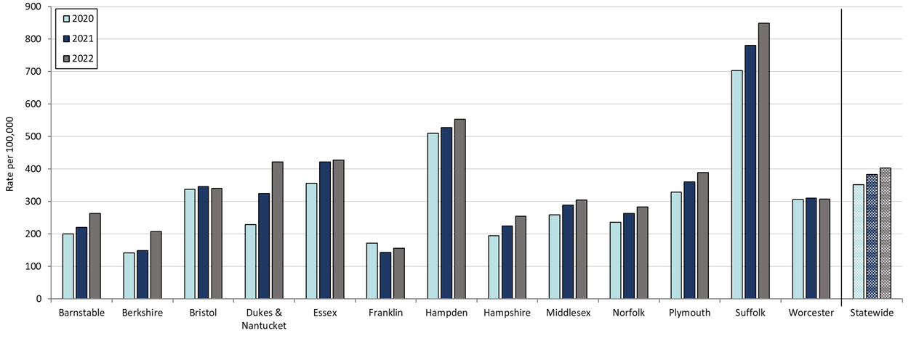
Table: Rates of Chlamydia by County and Statewide
County | 2020 | 2022
Barnstable | 200.0 | 263.8
Berkshire | 142.6 | 207.7
Bristol | 336.8 | 339.8
Dukes/Nantucket | 229.5 | 421.7
Essex | 355.6 | 427.5
Franklin | 171.8 | 156.3
Hampden | 510.5 | 553.2
Hampshire | 194.1 | 254.5
Middlesex | 259.3 | 304.8
Norfolk | 235.7 | 282.8
Plymouth | 329.1 | 388.8
Suffolk | 702.1 | 848.3
Worcester | 306.0 | 308.2
Statewide | 351.4 | 403.8
Highlights: Graph depicts rate per 100,000 population of chlamydia cases reported in Massachusetts by county comparing 2020 through 2022. The rate is highest in Suffolk County with a rate of 848.3 in 2022 followed by Hampden County with a rate of 553.2 in 2022. The lowest rates were in Franklin and Berkshire County.
Footnotes for Slide 7
Data are current as of 07/18/2023 and are subject to change.
Data Source: Massachusetts Department of Public Health/Bureau of Infectious Disease and Laboratory Sciences/Division of STD Prevention and STD-HIV Surveillance.
Population denominators estimated by the University of Massachusetts Donahue Institute using a modified Hamilton-Perry model (Strate S, et al. Small Area Population Estimates for 2011 through 2020 report, Oct 2016).
1. Please consider the impact of the COVID-19 pandemic on infectious disease screening, treatment and surveillance in the interpretation of 2020-2022 data.

Slide 8 - Average Age of Confirmed Chlamydia Cases by Gender¹, Massachusetts, 2012 to 2022²
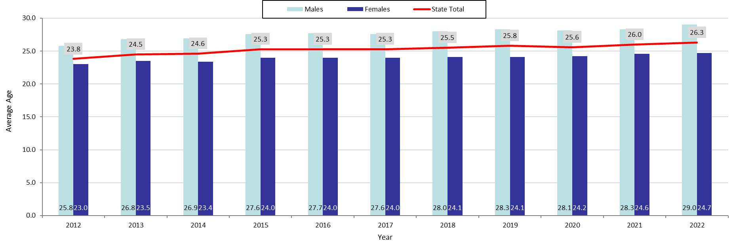
Table: Chlamydia Annual Case Counts by Gender
Year | Female | Male
2012 | 16,590 | 7,302
2013 | 16,275 | 7,494
2014 | 15,781 | 8,258
2015 | 15,489 | 8,414
2016 | 17,094 | 9,318
2017 | 18,644 | 10,463
2018 | 19,062 | 11,252
2019 | 19,408 | 12,155
2020 | 15,677 | 8,949
2021 | 16,799 | 9,989
2022 | 17,388 | 10,928
Highlights: Graph depicts the average age of confirmed chlamydia cases by year between 2012 and 2022. The lowest average age is 23.8 years old for the year 2012 and then rises to a high average age of 26.3 years old in 2022. In 2022, 56.1% of confirmed chlamydia cases were reported among individuals 15 - 24 years old.
Footnotes for Slide 8
Data are current as of 07/18/2023 and are subject to change.
Data Source: Massachusetts Department of Public Health/Bureau of Infectious Disease and Laboratory Sciences/Division of STD Prevention and STD-HIV Surveillance.
1. Individuals of transgender experience that did not have complete gender data as of 10/24/2022 may not be included within this slide.
2. Please consider the impact of the COVID-19 pandemic on infectious disease screening, treatment and surveillance in the interpretation of 2020-2022 data.

Slide 9 - Rate of Confirmed Gonorrhea Cases, Massachusetts, 2000 to 20221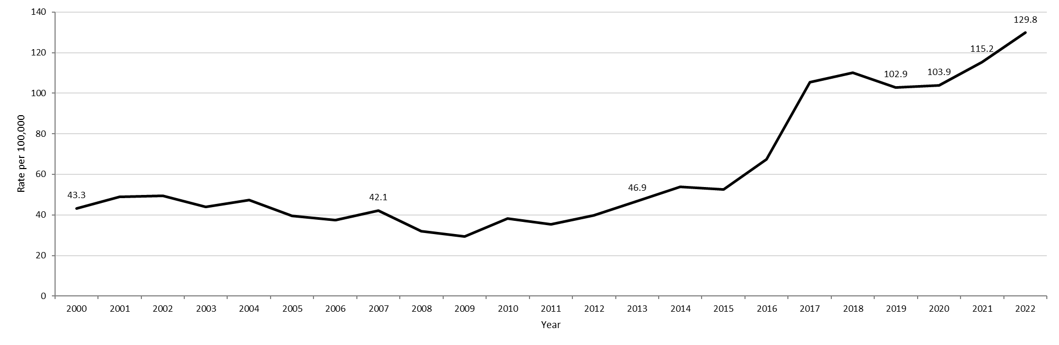
Table: Gonorrhea Annual Case Counts
Year | Count
2000 | 2,748
2001 | 3,121
2002 | 3,156
2003 | 2,819
2004 | 3,038
2005 | 2,542
2006 | 2,429
2007 | 2,729
2008 | 2,077
2009 | 1,917
2010 | 2,495
2011 | 2,345
2012 | 2,665
2013 | 3,156
2014 | 3,657
2015 | 3,592
2016 | 4,638
2017 | 7,293
2018 | 7,660
2019 | 7,170
2020 | 7,303
2021 | 8,099
2022 | 9,218
Highlights: Graph depicts the rate per 100,000 population of confirmed cases of gonorrhea in Massachusetts between 2000 and 2022. It begins at 43.3 in 2000, drops to a low of 29.4 in 2009 and climbs to a high of 129.8 in 2022.

Footnotes for Slide 9
Data are current as of 07/18/2023 and are subject to change.
Data Source: Massachusetts Department of Public Health/Bureau of Infectious Disease and Laboratory Sciences/Division of STD Prevention and STD-HIV Surveillance.
Population denominators estimated by the University of Massachusetts Donahue Institute using a modified Hamilton-Perry model (Strate S, et al. Small Area Population Estimates for 2011 through 2020 report, Oct 2016).
1. Please consider the impact of the COVID-19 pandemic on infectious disease screening, treatment and surveillance in the interpretation of 2020-2022 data.

Slide 10 - Confirmed Gonorrhea Rates by Gender¹, Massachusetts, 2010 to 2022²
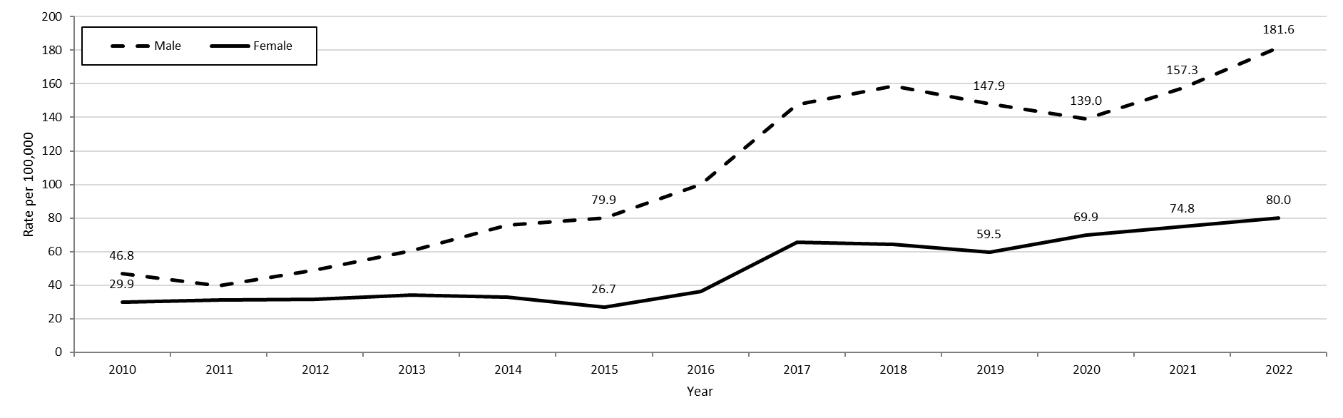
Table: Gonorrhea Annual Case Counts by Current Gender
Year | Females | Males
2010 | 1,012 | 1,483
2011 | 1,069 | 1,275
2012 | 1,085 | 1,579
2013 | 1,181 | 1,969
2014 | 1,144 | 2,500
2015 | 940 | 2,648
2016 | 1,283 | 3,344
2017 | 2,328 | 4,952
2018 | 2,293 | 5,347
2019 | 2,132 | 5,002
2020 | 2,526 | 4,741
2021 | 2,707 | 5,367
2022 | 2,894 | 6,196
Highlights: Graph depicts the rates per 100,000 population of confirmed cases of gonorrhea in Massachusetts by gender identity between 2010 and 2022. There are two lines, one for females that begins at 29.9 in 2010 and climbs to 80.0 in 2022 and another for males that begins at 46.8 in 2010 and climbs to 181.6 in 2022.
Note: There were cases reported among transgender individuals in 2014 through 2022. In 2022, there were 34 cases of gonorrhea among transgender identified individuals not included on this slide.

Footnotes for Slide 10
Data are current as of 07/18/2023 and are subject to change.
Data Source: Massachusetts Department of Public Health/Bureau of Infectious Disease and Laboratory Sciences/Division of STD Prevention and STD-HIV Surveillance.
Population denominators estimated by the University of Massachusetts Donahue Institute using a modified Hamilton-Perry model (Strate S, et al. Small Area Population Estimates for 2011 through 2020 report, Oct 2016).
1. In 2022, there were 34 individuals of transgender experience reported in our data system who do not have current gender documented. These cases were excluded since population estimates for individuals of transgender experience are not available at this time. There were 4 individuals with unknown gender which are not included in this slide.
2. Please consider the impact of the COVID-19 pandemic on infectious disease screening, treatment and surveillance in the interpretation of 2020-2022 data.

Slide 11: Gonorrhea Among Individuals of Transgender Experience¹, Massachusetts, 2015 to 2022²
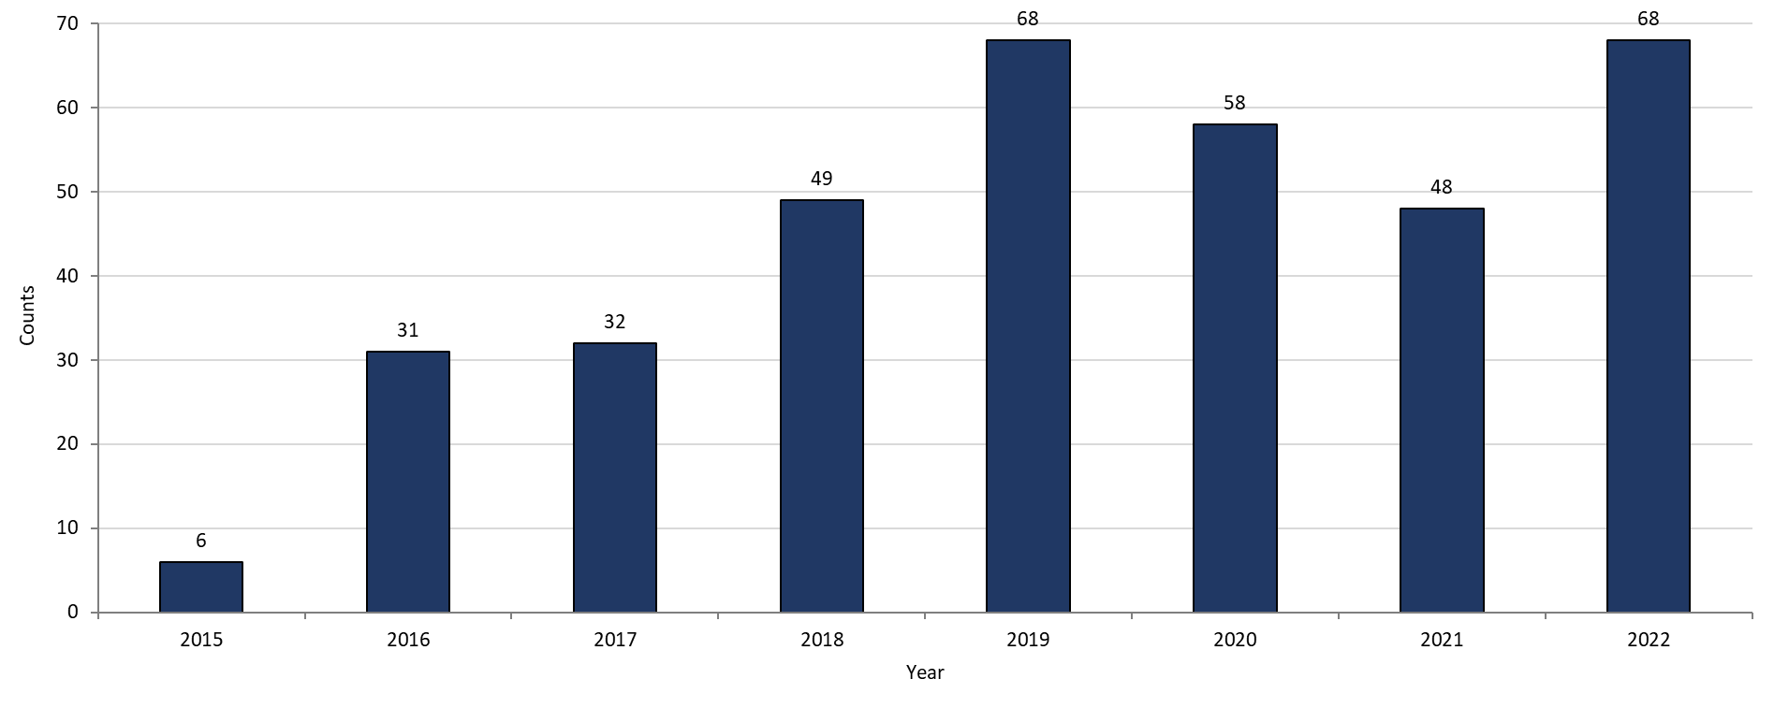
Highlights: Graph shows the number of confirmed gonorrhea cases among transgender individuals in Massachusetts between 2015 and 2022. The case counts are 6, 31, 32, 49, 68, 58, 48, and 68 for 2015, 2016, 2017, 2018, 2019, 2020, 2021, and 2022, respectively.

Footnotes for Slide 11
Data are current as of 07/18/2023 and are subject to change.
Data Source: Massachusetts Department of Public Health/Bureau of Infectious Disease and Laboratory Sciences/Division of STD Prevention and STD-HIV Surveillance.
1. All individuals of transgender experience are included in this graph regardless of current gender.
2. Please consider the impact of the COVID-19 pandemic on infectious disease screening, treatment and surveillance in the interpretation of 2020-2022 data.

Slide 12: Confirmed Gonorrhea Rates by County and Statewide, Massachusetts, 2020-2022¹
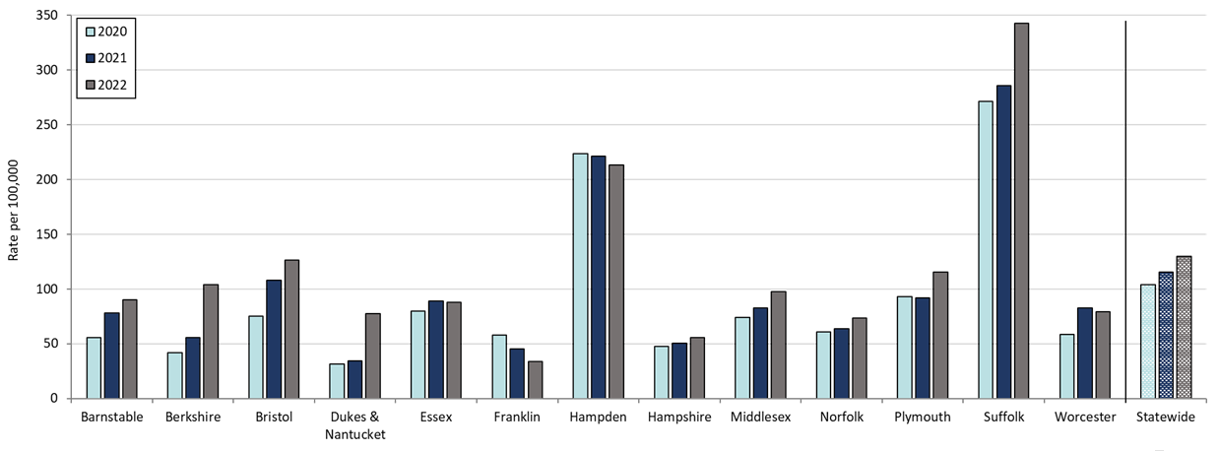
Table: Rates of Gonorrhea by County and Statewide
County | 2020 | 2022
Barnstable | 55.5 | 90.4
Berkshire | 41.9 | 103.9
Bristol | 75.1 | 126.2
Dukes/Nantucket | 31.6 | 77.5
Essex | 79.8 | 87.8
Franklin | 57.7 | 33.8
Hampden | 223.9 | 213.4
Hampshire | 47.4 | 55.5
Middlesex | 74.0 | 97.6
Norfolk | 60.9 | 73.4
Plymouth | 92.9 | 115.7
Suffolk | 271.3 | 343.0
Worcester | 58.2 | 79.3
Statewide | 103.9 | 129.8
Highlights: Graph depicts rate per 100,000 population of gonorrhea cases reported in Massachusetts by county comparing 2020 through 2022. The rate is highest in Suffolk County with a rate of 343.0 in 2022 followed by Hampden County with a rate of 213.4 in 2022. The lowest rates were in Hampshire and Franklin counties.
Footnotes for Slide 12
Data are current as of 07/18/2023 and are subject to change.
Data Source: Massachusetts Department of Public Health/Bureau of Infectious Disease and Laboratory Sciences/Division of STD Prevention and STD-HIV Surveillance.
Population denominators estimated by the University of Massachusetts Donahue Institute using a modified Hamilton-Perry model (Strate S, et al. Small Area Population Estimates for 2011 through 2020 report, Oct 2016).
1. Please consider the impact of the COVID-19 pandemic on infectious disease screening, treatment and surveillance in the interpretation of 2020-2022 data.

Slide 13: Confirmed and Probable Infectious Syphilis¹ Rates, Massachusetts, 2000 to 2022²
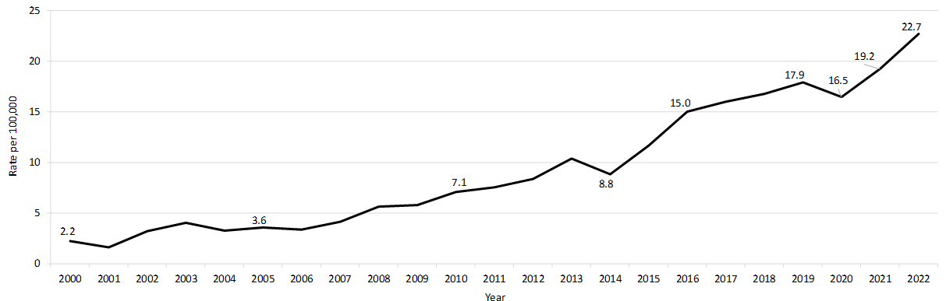
Table: Infectious Syphilis Annual Case Counts
Year | Count
2000 | 141
2001 | 105
2002 | 207
2003 | 258
2004 | 209
2005 | 231
2006 | 217
2007 | 268
2008 | 367
2009 | 379
2010 | 465
2011 | 500
2012 | 561
2013 | 701
2014 | 600
2015 | 798
2016 | 1,034
2017 | 1,107
2018 | 1,167
2019 | 1,244
2020 | 1,159
2021 | 1,352
2022 | 1,593
Highlight: Graph depicts the rate per 100,000 population of confirmed and probable cases of infectious syphilis in Massachusetts between 2000 and 2022. It begins at 2.2 in 2000, drops to a low of 1.6 in 2001, and climbs to a high of 22.7 in 2022.

Footnotes for Slide 13
Data are current as of 07/18/2023 and are subject to change.
Data Source: Massachusetts Department of Public Health/Bureau of Infectious Disease and Laboratory Sciences/Division of STD Prevention and STD-HIV Surveillance.
Population denominators estimated by the University of Massachusetts Donahue Institute using a modified Hamilton-Perry model (Strate S, et al. Small Area Population Estimates for 2011 through 2020 report, Oct 2016).
1. Infectious syphilis is defined as primary, secondary and early latent stages of syphilis within one year of infection.
2. Please consider the impact of the COVID-19 pandemic on infectious disease screening, treatment and surveillance in the interpretation of 2020-2022 data.

Slide 14: Confirmed and Probable Infectious Syphilis¹ Rates by Gender², Massachusetts, 2010 to 2022³
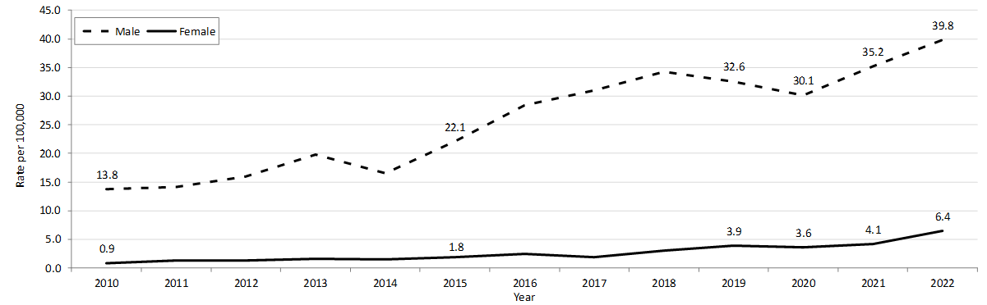Table: Infectious Syphilis Annual Case Counts by Current Gender
Year | Females | Males
2010 | 436 | 29
2011 | 454 | 46
2012 | 515 | 46
2013 | 656 | 55
2014 | 545 | 53
2015 | 732 | 65
2016 | 947 | 87
2017 | 1,040 | 67
2018 | 1,055 | 110
2019 | 1,102 | 139
2020 | 1,028 | 130
2021 | 1,201 | 150
2022 | 1,357 | 233
Highlights: Graph depicts the rates per 100,000 population of confirmed and probable cases of syphilis in Massachusetts by gender identity between 2010 and 2022. There are two lines, one for females that begins at 0.9 in 2010 and remains relatively stable with a high of 6.4 in 2022. Another line is for males that begins at 13.8 in 2010 and climbs to a high of 39.8 in 2022.
Note: Infectious syphilis is defined as primary, secondary and early latent stages of syphilis within one year of infection.
There were cases reported among transgender individuals in 2014 through 2022. They are classified on this slide based on their current gender. In 2022, there were 3 cases of infectious syphilis among transgender identified individuals not included on this slide as MA DSTDP does not have current gender information for those individuals.

Footnotes for Slide 14
Data are current as of 07/18/2023 and are subject to change.
Data Source: Massachusetts Department of Public Health/Bureau of Infectious Disease and Laboratory Sciences/Division of STD Prevention and STD-HIV Surveillance.
Population denominators estimated by the University of Massachusetts Donahue Institute using a modified Hamilton-Perry model (Strate S, et al. Small Area Population Estimates for 2011 through 2020 report, Oct 2016).
1. Infectious syphilis is defined as primary, secondary and early latent stages of syphilis within one year of infection.
2. In 2022, there were 3 individuals of transgender experience reported in our data system who do not have current gender documented. These cases were excluded since population estimates for individuals of transgender experience are not available at this time.
3. Please consider the impact of the COVID-19 pandemic on infectious disease screening, treatment and surveillance in the interpretation of 2020-2022 data.

Slide 15: Infectious Syphilis¹ Reported Cases by Race/Ethnicity², Massachusetts, 2015-2022³
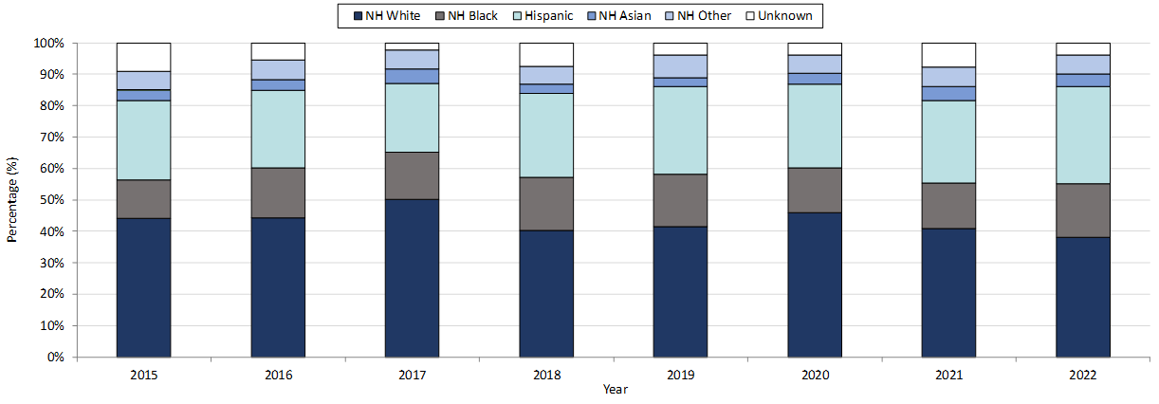
Table: Infectious Syphilis Annual Case Counts
Year | Count
2015 | 789
2016 | 1,034
2017 | 1,107
2018 | 1,167
2019 | 1,244
2020 | 1,159
2021 | 1,352
2022 | 1,593
Highlights: Graph depicts the proportion of Massachusetts reported confirmed and probable infectious syphilis cases broken down by race/ethnicity for the years 2015 through 2022. The highest percentage of cases for each year identified as Non-Hispanic White making up a high of 50.1% of cases in 2017 and a resulting 38.1% of cases in 2022. In total, over the seven year period, the proportion of cases by race/ethnicity were from highest to lowest: Non-Hispanic White, Hispanic, Non-Hispanic Black, Non-Hispanic Other, and Unknown.
Note: Infectious syphilis is defined as primary, secondary and early latent (non-primary/non-secondary) stages of syphilis within one year of infection.
Footnotes for Slide 15
Data are current as of 07/18/2023 and are subject to change.
Data Source: Massachusetts Department of Public Health/Bureau of Infectious Disease and Laboratory Sciences/Division of STD Prevention and STD-HIV Surveillance.
Note: National Notifiable Diseases Surveillance System (NNDSS) Congenital Syphilis case definition was updated in 2014.
1. Infectious syphilis is defined as primary, secondary and early latent stages of syphilis within one year of infection.
2. Other Race/Ethnicity includes individuals who identify as American Indian/ Pacific Islander/ Alaskan Native.
3. Please consider the impact of the COVID-19 pandemic on infectious disease screening, treatment and surveillance in the interpretation of 2020-2022 data.
Slide 16: Confirmed and Probable Infectious Syphilis1 Among Individuals of Transgender Experience2, Massachusetts, 2015 to 20223, 4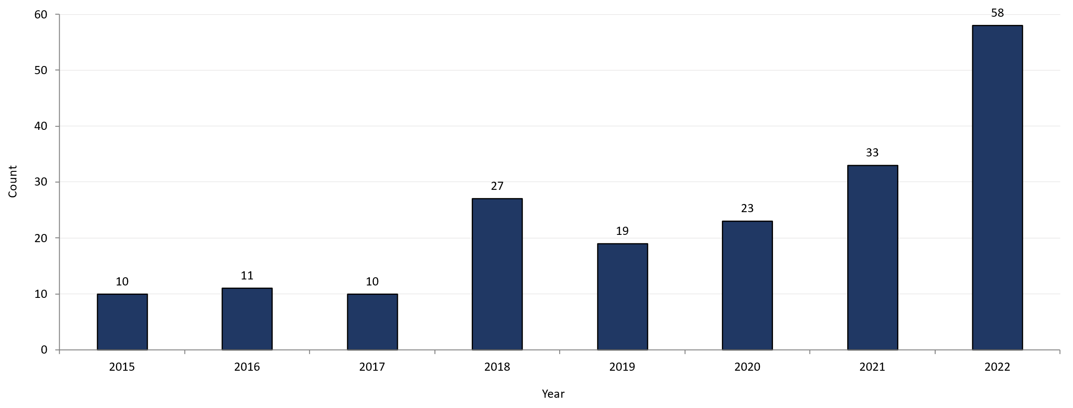
Highlights: Graph shows the number of confirmed and probable infectious syphilis cases among transgender individuals in Massachusetts between 2015 and 2022. The case counts are 10, 11, 10, 27, 19, 23, 33, and 58 for 2015, 2016, 2017, 2018, 2019, 2020, 2021, and 2022 respectively.
*Infectious syphilis is defined as primary, secondary and early latent stages of syphilis within one year of infection.

Footnotes for Slide 16
Data are current as of 07/18/2023 and are subject to change.
Data Source: Massachusetts Department of Public Health/Bureau of Infectious Disease and Laboratory Sciences/Division of STD Prevention and STD-HIV Surveillance.
1. Infectious syphilis is defined as primary, secondary and early latent stages of syphilis within one year of infection.
2. All individuals of transgender experience are included in this graph regardless of current gender.
3. Please consider the impact of the COVID-19 pandemic on infectious disease screening, treatment and surveillance in the interpretation of 2020-2022 data.
4. In 2022, a retrospective verification project was conducted to improve data quality in capturing current gender information.

Slide 17: Confirmed and Probable Infectious Syphilis¹ Rates by County and Statewide, Massachusetts, 2020-2022²
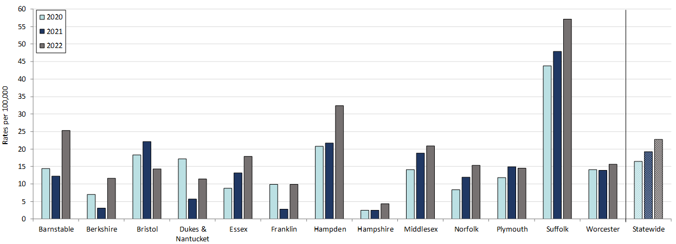
Table: Confirmed and Probable Infectious Syphilis Rates by County and Statewide
County | 2020 | 2022
Barnstable | 14.4 | 25.3
Berkshire | 7.0 | 11.6
Bristol | 18.3 | 14.3
Dukes/Nantucket | 17.2 | 11.5
Essex | 8.8 | 17.9
Franklin | 9.9 | 9.9
Hampden | 20.8 | 32.4
Hampshire | 2.5 | 4.3
Middlesex | 14.2 | 20.9
Norfolk | 8.4 | 15.3
Plymouth | 11.9 | 14.5
Suffolk | 43.7 | 57.1
Worcester | 14.2 | 15.7
Statewide | 16.5 | 22.7
Highlights: Graph depicts rate per 100,000 population of infectious syphilis cases reported in Massachusetts by county comparing 2020 through 2022. The rate is highest in Suffolk County with a rate of 57.1 in 2022 followed by Hampden County with a rate of 32.4 in 2022. The lowest rates were in Hampshire and Franklin County.

Footnotes for Slide 17
Data are current as of 07/18/2023 and are subject to change.
Data Source: Massachusetts Department of Public Health/Bureau of Infectious Disease and Laboratory Sciences/Division of STD Prevention and STD-HIV Surveillance.
Population denominators estimated by the University of Massachusetts Donahue Institute using a modified Hamilton-Perry model (Strate S, et al. Small Area Population Estimates for 2011 through 2020 report, Oct 2016).
1. Infectious syphilis is defined as primary, secondary and early latent stages of syphilis within one year of infection.
2. Please consider the impact of the COVID-19 pandemic on infectious disease screening, treatment and surveillance in the interpretation of 2020-2022 data.

Slide 18 – Confirmed and Probable Infectious Syphilis¹ Rates by Stage of Infection, Massachusetts, 2010–2022²
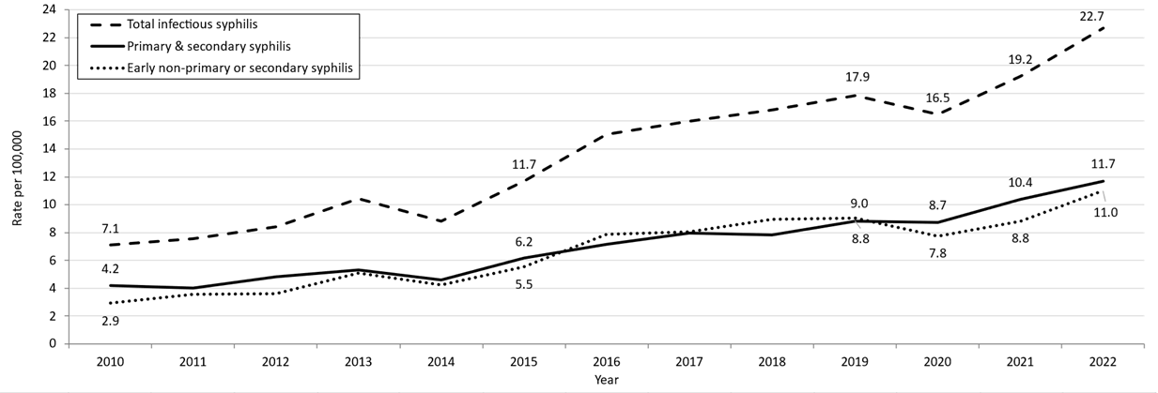
Table: Infectious Syphilis Annual Case Counts
Year | Count
2010 | 465
2011 | 500
2012 | 561
2013 | 701
2014 | 600
2015 | 798
2016 | 1,034
2017 | 1,107
2018 | 1,167
2019 | 1,244
2020 | 1,159
2021 | 1,352
2022 | 1,593
Highlights: Graph depicts the differences between the rate of infectious syphilis diagnosed in the primary and secondary stage compared to those cases diagnosed in the early non-primary and non-secondary stages reported in Massachusetts from 2010 to 2022. There are three lines on the graph. One line for primary and secondary cases starting with a rate of 4.2 per 100,000 in 2010 and peaking with a rate of 11.7 in 2022. Another line for non-primary non-secondary cases starting with a rate of 2.9 in 2010, peaking with a rate of 11.0 in 2012. The final line shows the total infectious syphilis starting with a rate of 7.1 in 2010 and peaking at a rate of 22.7 in 2022.
Note: Infectious syphilis is defined as primary, secondary and early latent (non-primary/non-secondary) stages of syphilis within one year of infection.

Footnotes for Slide 18
Data are current as of 07/18/2023 and are subject to change.
Data Source: Massachusetts Department of Public Health/Bureau of Infectious Disease and Laboratory Sciences/Division of STD Prevention and STD-HIV Surveillance.
Population denominators estimated by the University of Massachusetts Donahue Institute using a modified Hamilton-Perry model (Strate S, et al. Small Area Population Estimates for 2011 through 2020 report, Oct 2016).
1. Infectious syphilis is defined as primary, secondary and early latent stages of syphilis within one year of infection.
2. Please consider the impact of the COVID-19 pandemic on infectious disease screening, treatment and surveillance in the interpretation of 2020-2022 data.

Slide 19 – Infectious Syphilis¹ Reported Cases by Gender of Sex Partners, Massachusetts, 2015-2022²
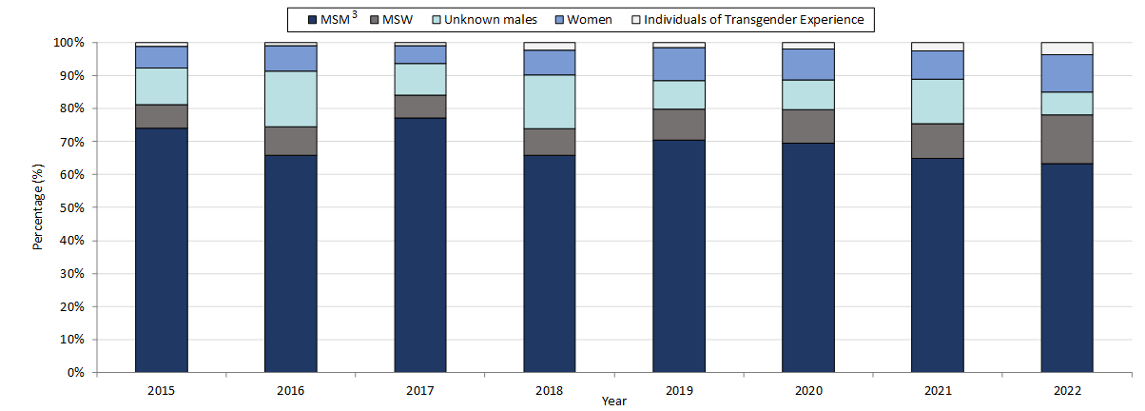
Table: Infectious Syphilis Annual Case Counts
Year | Count
2015 | 798
2016 | 1,034
2017 | 1,107
2018 | 1,167
2019 | 1,244
2020 | 1,159
2021 | 1,352
2022 | 1,593
Highlights: Graph depicts the proportion of Massachusetts reported confirmed and probable infectious syphilis cases broken down by gender of sex partners for the years 2015 through 2022. The highest percentage of cases for each year reported male sex partners and are classified as MSM (men who have sex with men) making up a high of 77% of cases in 2017 and a resulting 63% of cases in 2022. In total, over the seven-year period, the proportion of cases by gender of sex partners were from highest to lowest: MSM, MSW (men who have sex with women), unknown males, women, and transgender individuals. For 2022, the order in frequency from highest to lowest is: MSM, MSW, women, unknown males, and individuals of transgender experience.
Note: Infectious syphilis is defined as primary, secondary and early latent (non-primary/non-secondary) stages of syphilis within one year of infection.

Footnotes for Slide 19
Data are current as of 07/18/2023 and are subject to change.
Data Source: Massachusetts Department of Public Health/Bureau of Infectious Disease and Laboratory Sciences/Division of STD Prevention and STD-HIV Surveillance.
Note: National Notifiable Diseases Surveillance System (NNDSS) Congenital Syphilis case definition was updated in 2014.
1. Infectious syphilis is defined as primary, secondary and early latent stages of syphilis within one year of infection.
2. Please consider the impact of the COVID-19 pandemic on infectious disease screening, treatment and surveillance in the interpretation of 2020-2022 data.
3. The MSM (men who have sex with men) category includes MSMT, MSMW, MSMWT, and MST with “W” referring to women and “T” referring to individuals of transgender experience.

Slide 20 - Congenital Syphilis Cases and Rate of Confirmed and Probable Infectious Syphilis¹ Among Individuals Thought to be Capable of Pregnancy Ages 15 to 49 Years, Massachusetts, 2010-2022²
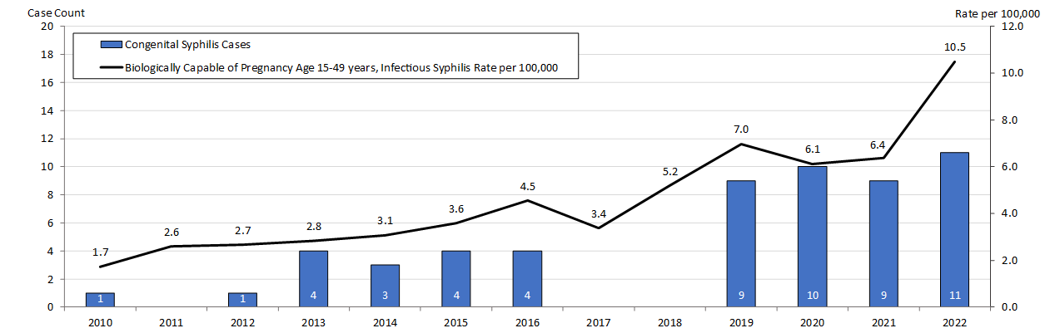
Table: Infectious Syphilis Cases Among Individuals Biologically Capable of Pregnancy
Year | Count
2010 | 28
2011 | 42
2012 | 43
2013 | 46
2014 | 50
2015 | 50
2016 | 74
2017 | 55
2018 | 85
2019 | 114
2020 | 101
2021 | 105
2022 | 173
Highlights: Graph depicts the case count for confirmed and probable congenital syphilis cases reported in Massachusetts between 2010 and 2022. The case counts are 1, 0, 1, 4, 3, 4, 4, 0, 0, 9, 10, 9, 11 for 2010, 2022, 2012, 2013, 2014, 2015, 2016, 2017, 2018, 2019, 2020, 2021, and 2022, respectively. Additionally, the graph shows a line depicting the rate per 100,000 population of confirmed and probable infectious syphilis among individuals thought to be capable of pregnancy ages 15 to 49 years which starts with a rate of 1.7 in 2010, peaks in 2022 with a rate of 10.5.
Note: Infectious syphilis is defined as primary, secondary and early latent (non-primary/non-secondary) stages of syphilis within one year of infection.

Footnotes for Slide 20
Data are current as of 07/18/2023 and are subject to change.
Data Source: Massachusetts Department of Public Health/Bureau of Infectious Disease and Laboratory Sciences/Division of STD Prevention.
Population denominators estimated by the University of Massachusetts Donahue Institute using a modified Hamilton-Perry model (Strate S, et al. Small Area Population Estimates for 2011 through 2020 report, Oct 2016).
Note: National Notifiable Diseases Surveillance System (NNDSS) Congenital Syphilis case definition was updated in 2014.
1. Infectious syphilis is defined as primary, secondary and early latent stages of syphilis within one year of infection.
2. Please consider the impact of the COVID-19 pandemic on infectious disease screening, treatment and surveillance in the interpretation of 2020-2022 data.
3. Count refers to individuals thought to be capable of pregnancy ages 15 to 49 years, the denominator for the yearly calculated congenital syphilis rate.

Slide 21 (title page) - Chlamydia, Gonorrhea, and Infectious Syphilis: Years 2018 to 2022

Slide 22 - Social Vulnerability Index
Patient addresses were manually cleaned and geocoded utilizing SAS 9.4
Social Vulnerability Index (SVI) was based on the patient’s home address.
It characterizes community resilience/ability to withstand external hazards.
SVI incorporates 15 demographic and socioeconomic variables from the US census.
Patients’ census tracts are given a percentile rank and grouped as low, moderately low, moderately high, and high.
Higher percentile scores represent greater community vulnerability.
The CDC/ATSDR SVI database from 2018 was matched to cases from 2018-2019.
The CDC/ATSDR SVI database from 2020 was matched to cases from 2020-2022.

Slide 23 - Confirmed Chlamydia Case Percentages by Social Vulnerability Index, Massachusetts, 2018-2022¹
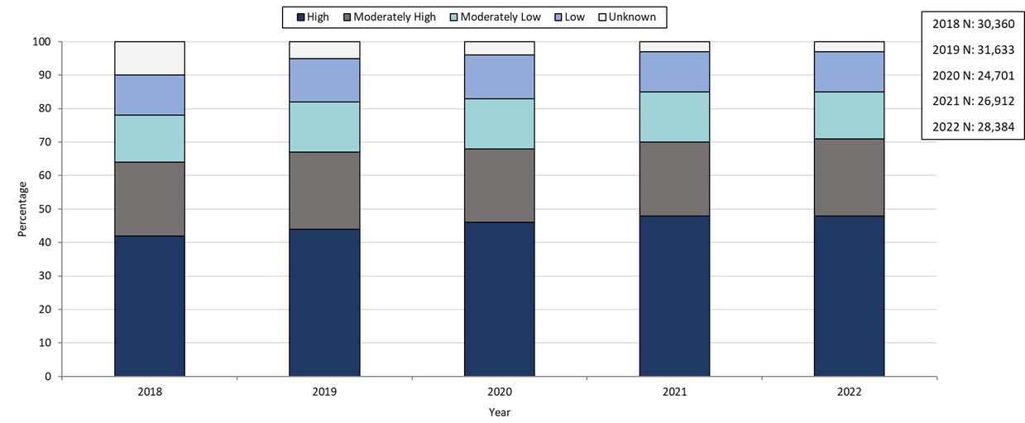
Table: Chlamydia Annual Case Counts
Year | Count
2018 | 30,369
2019 | 31,634
2020 | 24,705
2021 | 26,912
2022 | 28,384
Highlights: Graph depicts the proportion of Massachusetts reported confirmed chlamydia cases broken down by SVI quartile for the years 2018 through 2022. The High SVI group is largest for each year, making up 41 to 48% of cases each year. Each year, the order in frequency from highest to lowest is: High, Moderately High, Moderately Low, Low, and Unknown SVI.

Footnotes for Slide 23
Data are current as of 07/18/2023 and are subject to change.
Data Source: Massachusetts Department of Public Health/Bureau of Infectious Disease and Laboratory Sciences/Division of STD Prevention and STD-HIV Surveillance.
1. Please consider the impact of the COVID-19 pandemic on infectious disease screening, treatment and surveillance in the interpretation of 2020, 2021, and 2022 data.

Slides 24 - Confirmed Chlamydia Case Percentages by Social Vulnerability Index and Gender, Massachusetts, 2018- 2022^{1,2}
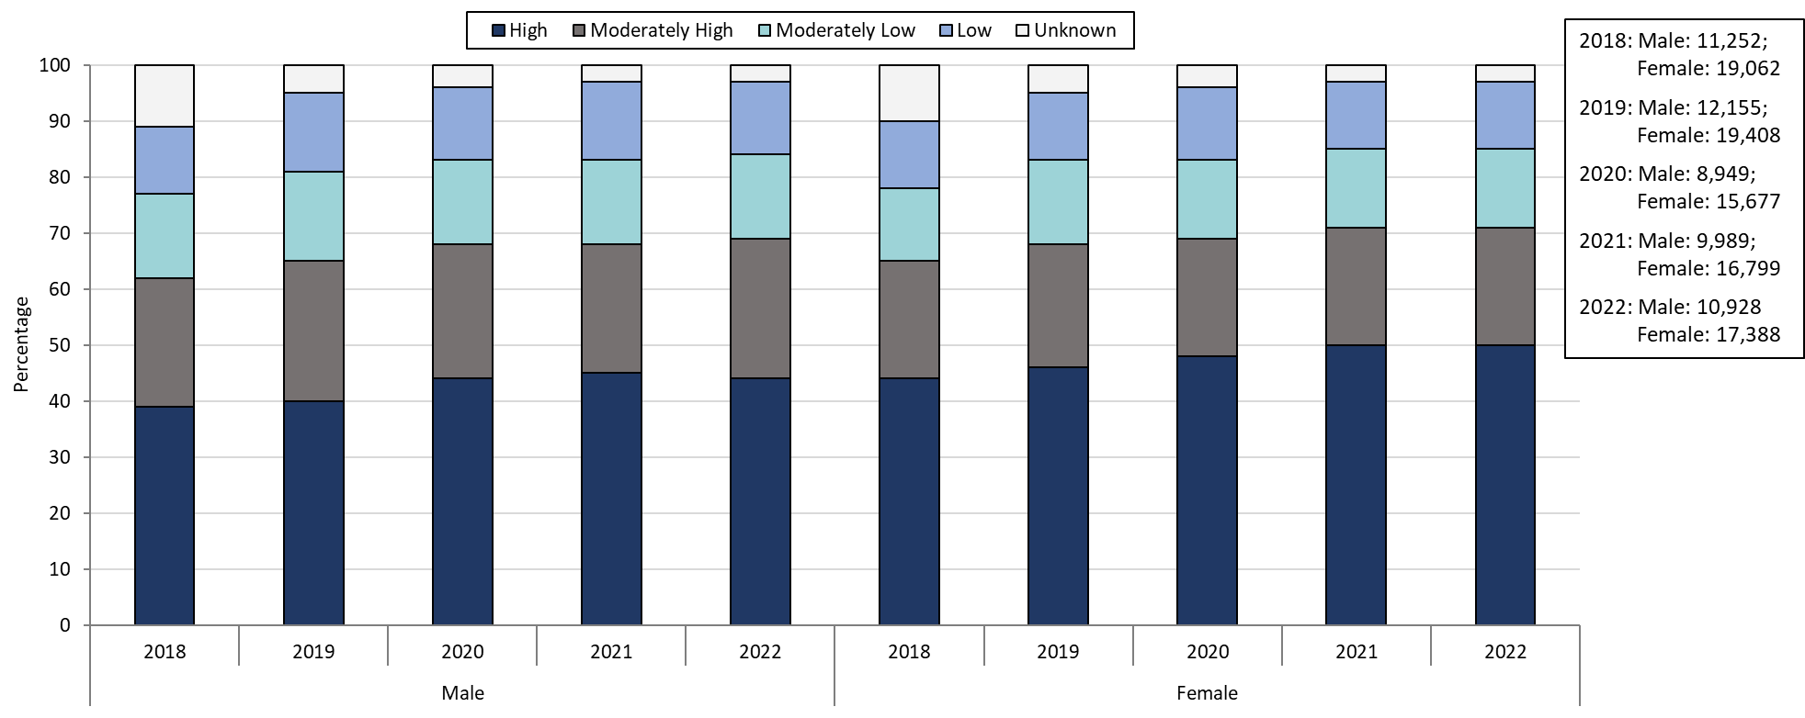
Table: Chlamydia Case Couts by Gender
Year | Females | Males
2018 | 19,062 | 11,252
2019 | 19,408 | 12,155
2020 | 15,677 | 8,949
2021 | 16,799 | 9,989
2022 | 17,388 | 10,928
Highlights: Graph depicts the proportion of Massachusetts reported confirmed chlamydia cases broken down by SVI quartile and gender for the years 2018 through 2022. In 2022, 50% of female cases are High SVI, compared to 44% in males. 21% of female cases in 2022 are Moderately High SVI, 14% are Moderately Low SVI, 12% are Low SVI, and 3% are Unknown SVI. 25% of male cases in 2022 are Moderately High SVI, 15% are Moderately Low SVI, 13% are Low SVI, and 3% are Unknown SVI.

Footnotes for Slide 24
Data are current as of 07/18/2023 and are subject to change.
Data Source: Massachusetts Department of Public Health/Bureau of Infectious Disease and Laboratory Sciences/Division of STD Prevention and STD-HIV Surveillance.
1. Please consider the impact of the COVID-19 pandemic on infectious disease screening, treatment and surveillance in the interpretation of 2020, 2021, and 2022 data.
2. Individuals of transgender experience that do not have complete gender data may not be included within this slide.

Slide 25: Confirmed Gonorrhea Case Percentages by Social Vulnerability Index, Massachusetts, 2018-2022¹
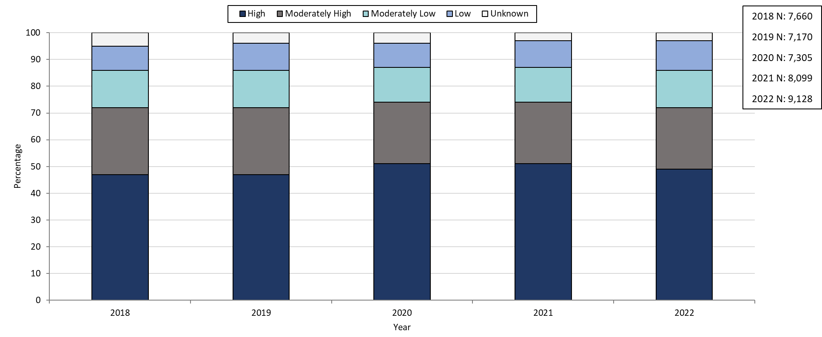
Table: Gonorrhea Annual Case Counts
Year | Count
2018 | 7,660
2019 | 7,170
2020 | 7,303
2021 | 8,099
2022 | 9,218
Highlights: Graph depicts the proportion of Massachusetts reported confirmed gonorrhea cases broken down by SVI quartile for the years 2018 through 2022. The High SVI group is largest for each year, making up 47 to 51% of cases each year. Each year, the order in frequency from highest to lowest is: High, Moderately High, Moderately Low, Low, and Unknown SVI.
Footnotes for Slide 25
Data are current as of 07/18/2023 and are subject to change.
Data Source: Massachusetts Department of Public Health/Bureau of Infectious Disease and Laboratory Sciences/Division of STD Prevention and STD-HIV Surveillance.
1. Please consider the impact of the COVID-19 pandemic on infectious disease screening, treatment and surveillance in the interpretation of 2020, 2021, and 2022 data.

Slide 26: Confirmed Gonorrhea Case Percentages by Social Vulnerability Index and Gender, Massachusetts, 2018-2022^{1,2}
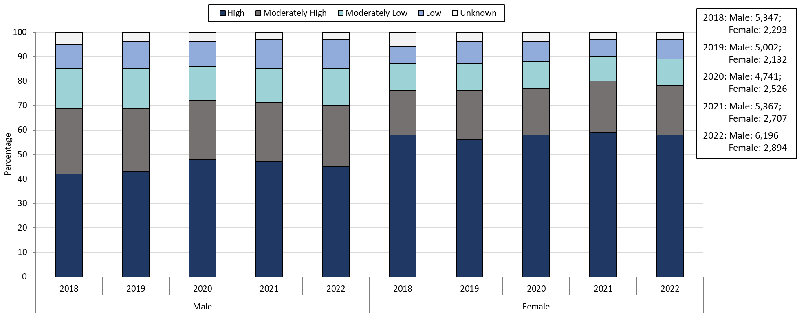

Table: Gonorrhea Annual Case Counts by Current Gender
Year | Females | Males
2018 | 2,293 | 5,347
2019 | 2,132 | 5,002
2020 | 2,526 | 4,741
2021 | 2,707 | 5,367
2022 | 2,894 | 6,196
Highlights: Graph depicts the proportion of Massachusetts reported confirmed gonorrhea cases broken down by SVI quartile and gender for the years 2018 through 2022. In 2022, 58% of female cases are High SVI, compared to 45% in males. 20% of female cases in 2022 are Moderately High SVI, 11% are Moderately Low SVI, 8% are Low SVI, and 3% are Unknown SVI. 25% of male cases in 2022 are Moderately High SVI, 15% are Moderately Low SVI, 12% are Low SVI, and 3% are Unknown SVI.
Footnotes for Slide 26
Data are current as of 07/18/2023 and are subject to change.
Data Source: Massachusetts Department of Public Health/Bureau of Infectious Disease and Laboratory Sciences/Division of STD Prevention and STD-HIV Surveillance.
1. Please consider the impact of the COVID-19 pandemic on infectious disease screening, treatment and surveillance in the interpretation of 2020, 2021, and 2022 data.
2. Individuals of transgender experience that do not have complete gender data may not be included within this slide.

Slide 27: Confirmed and Probably Infectious Syphilis¹ Case Percentages by Social Vulnerability Index, Massachusetts, 2018- 2022²
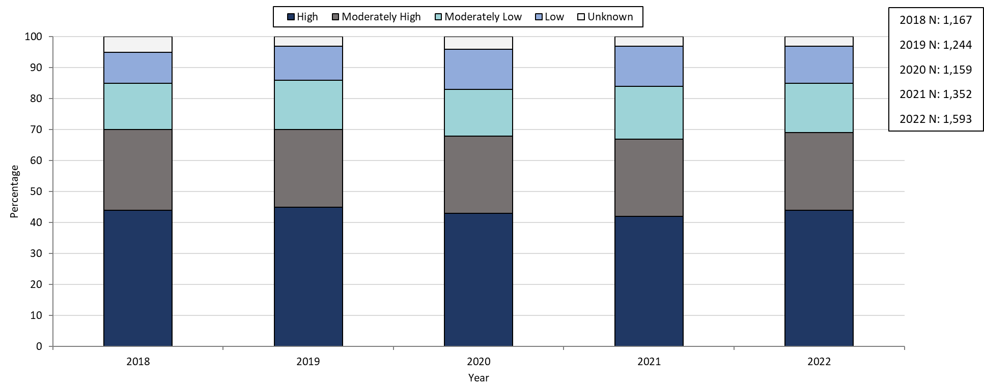
Table: Infectious Syphilis Annual Case Counts
Year | Count
2018 | 1,167
2019 | 1,244
2020 | 1,159
2021 | 1,352
2022 | 1,593
Highlights: Graph depicts the proportion of Massachusetts reported confirmed and probable infectious syphilis cases broken down by SVI quartile for the years 2018 through 2022. The High SVI group is largest for each year, making up 42 to 45% of cases each year. Each year, the order in frequency from highest to lowest is: High, Moderately High, Moderately Low, Low, and Unknown SVI.

Footnotes for Slide 27
Data are current as of 07/18/2023 and are subject to change.
Data Source: Massachusetts Department of Public Health/Bureau of Infectious Disease and Laboratory Sciences/Division of STD Prevention and STD-HIV Surveillance.
1. Infectious syphilis is defined as primary, secondary and early latent stages of syphilis within one year of infection.
2. Please consider the impact of the COVID-19 pandemic on infectious disease screening, treatment and surveillance in the interpretation of 2020, 2021, and 2022 data

Slide 28: Confirmed and Probable Infectious Syphilis¹ Case Percentages by Social Vulnerability Index and Gender², Massachusetts, 2018-2022³
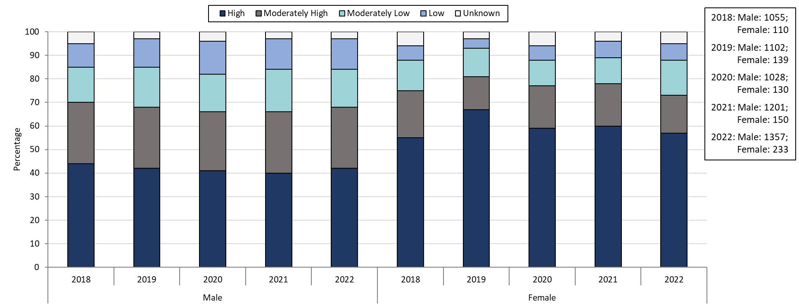
Table: Infectious Syphilis Annual Case Counts by Current Gender
Year | Females | Males
2018 | 1,055 | 110
2019 | 1,102 | 139
2020 | 1,028 | 130
2021 | 1,201 | 150
2022 | 1,357 | 233
Highlights: Graph depicts the proportion of Massachusetts reported confirmed and probable infectious syphilis cases broken down by SVI quartile and gender for the years 2018 through 2022. In 2022, 57% of female cases are High SVI, compared to 42% in males. 16% of female cases in 2022 are Moderately High SVI, 15% are Moderately Low SVI, 7% are Low SVI, and 5% are Unknown SVI. 26% of male cases in 2022 are Moderately High SVI, 16% are Moderately Low SVI, 13% are Low SVI, and 3% are Unknown SVI.

Footnotes for Slide 28
Data are current as of 07/18/2023 and are subject to change.
Data Source: Massachusetts Department of Public Health/Bureau of Infectious Disease and Laboratory Sciences/Division of STD Prevention and STD-HIV Surveillance.
1. Infectious syphilis is defined as primary, secondary and early latent stages of syphilis within one year of infection.
2. Individuals of transgender experience that do not have complete gender data may not be included within this slide.
3. Please consider the impact of the COVID-19 pandemic on infectious disease screening, treatment and surveillance in the interpretation of 2020, 2021, and 2022 data.

Slide 29: Confirmed and Probable Infectious Syphilis¹ Case Percentages by Social Vulnerability Index and Race, Massachusetts, 2018- 2022²
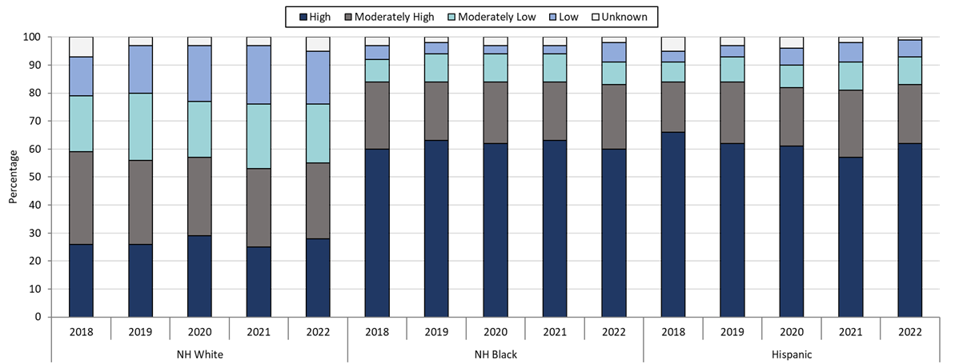
Table: Infectious Syphilis Annual Case Counts by Selected Race and Ethnicity
Year(N) | NH White | NH Black | Hispanic
2018 | 469 | 196 | 314
2019 | 518 | 207 | 347
2020 | 532 | 169 | 308
2021 | 554 | 197 | 356
2022 | 607 | 270 | 493
Highlights: Graph depicts the proportion of Massachusetts reported confirmed and probable infectious syphilis cases broken down by SVI quartile and race for the years 2018 through 2022. Each year, NH White cases have a lower proportion of High SVI cases compared to NH Black and Hispanic cases. In 2022, 28% of NH White cases are High SVI, compared to 60% of NH Black cases and 62% of Hispanic cases.

Footnotes for Slide 29
Data are current as of 07/18/2023 and are subject to change.
Data Source: Massachusetts Department of Public Health/Bureau of Infectious Disease and Laboratory Sciences/Division of STD Prevention and STD-HIV Surveillance.
1. Infectious syphilis is defined as primary, secondary and early latent stages of syphilis within one year of infection.
2. Please consider the impact of the COVID-19 pandemic on infectious disease screening, treatment and surveillance in the interpretation of 2020, 2021, and 2022 data.

Slide 30: Section Break, Description of 2022 STI Cases
Geographic Distribution by Age, Gender, Sexual Risk Categories, and Race-Ethnicity

Slide 31: Incident Rate of Confirmed Chlamydia Cases, per 100,000 Persons¹ by City/Town², Massachusetts, 2022³
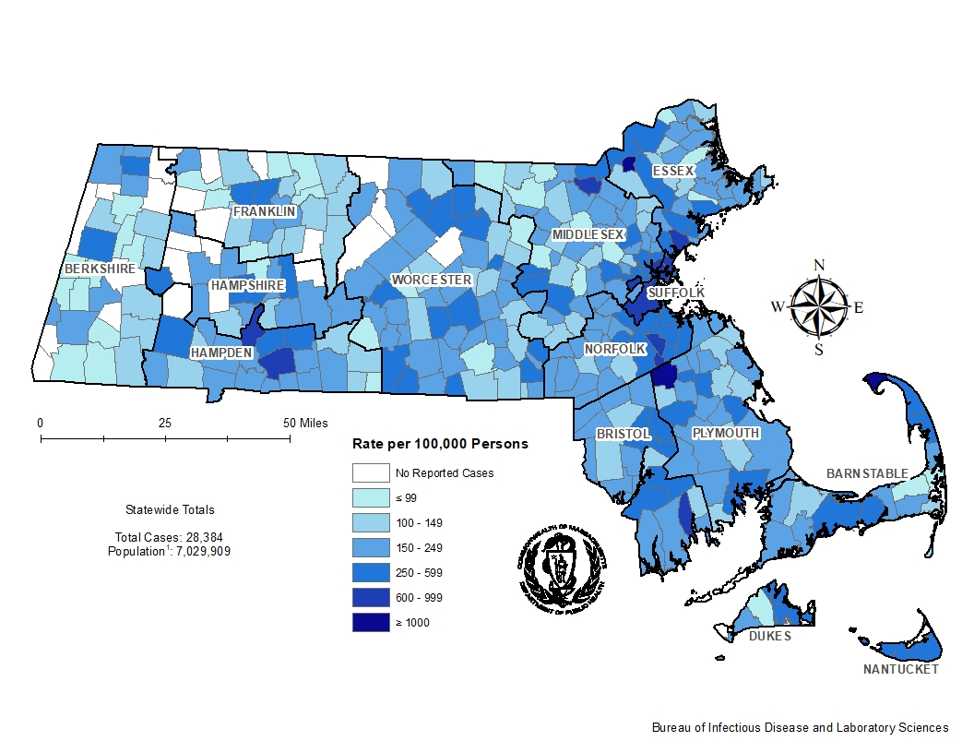
Highlights: Map of Massachusetts cities and towns color-coded to indicate the areas of the state with the highest chlamydia case rates in 2022. The cities that have the highest rates (greater than 600 per 100,000 persons) are Provincetown, Brockton, Lawrence, Springfield, Boston, Chelsea, Lynn, Everett, Holyoke, Randolph, Revere, New Bedford, Avon, and Lowell.

Footnotes for Slide 31
Data are current as of 07/18/2023 and are subject to change.
Data Source: Massachusetts Department of Public Health/Bureau of Infectious Disease and Laboratory Sciences/Division of STD Prevention and STD-HIV Surveillance.
1. Population denominators estimated by the University of Massachusetts Donahue Institute using a modified Hamilton-Perry model (Strate S, et al. Small Area Population Estimates for 2011 through 2020 report, Oct 2016).
2. There are no city/towns with <10 cases of chlamydia that fall within the top two rate categories (≥600 cases per 100,000).
3. Please consider the impact of the COVID-19 pandemic on infectious disease screening, treatment and surveillance in the interpretation of 2022 data.

Slide 32: Incident Rate of Confirmed Chlamydia Cases, per 100,000 Persons¹ by City/Town², Massachusetts, 2018
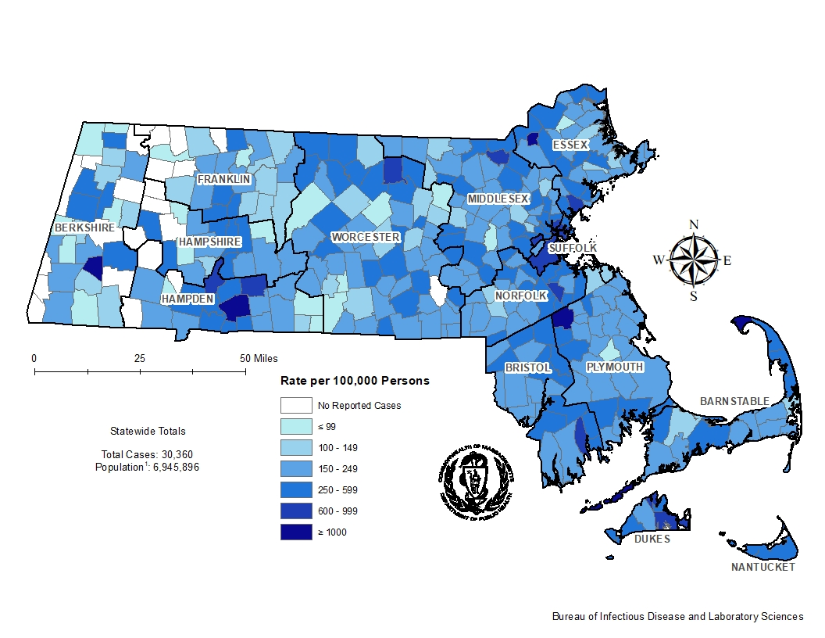
Highlights: Map of Massachusetts cities and towns color-coded to indicate the areas of the state with the highest chlamydia case rates in 2018. The cities that have the highest rates (greater than 600 per 100,000 persons) are Tyringham, Provincetown, Gosnold, Brockton, Lawrence, Springfield, Boston, Chelsea, Everett, Holyoke, Edgartown, Lynn, Randolph, Tisbury, Lowell, Fitchburg, New Bedford, and Ludlow.

Footnotes for Slide 32
Data are current as of 07/18/2023 and are subject to change.
Data Source: Massachusetts Department of Public Health/Bureau of Infectious Disease and Laboratory Sciences/Division of STD Prevention and STD-HIV Surveillance.
1. Population denominators estimated by the University of Massachusetts Donahue Institute using a modified Hamilton-Perry model (Strate S, et al. Small Area Population Estimates for 2011 through 2020 report, Oct 2016).
2. There are no city/towns with <10 cases of chlamydia that fall within the top two rate categories (≥600 cases per 100,000).

Slide 33: Confirmed Chlamydia Case Rates per 100,000 Population by Gender¹ and Age, Massachusetts, 2022²
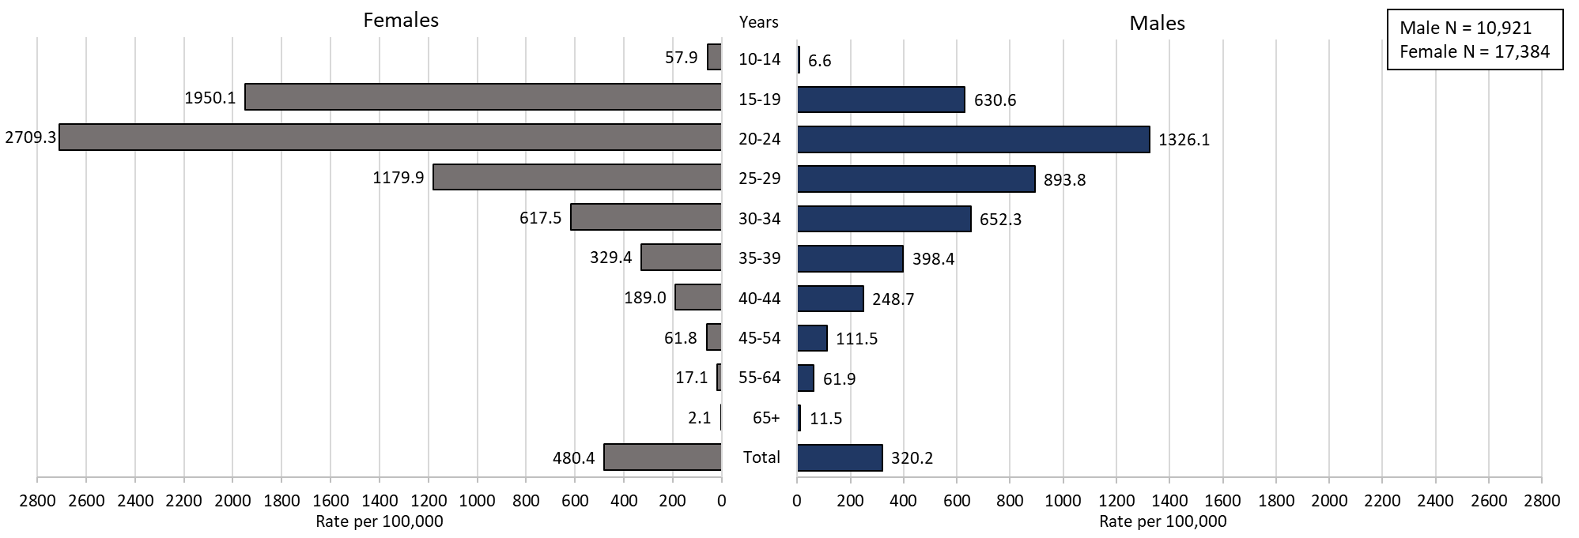

Highlights: Graph depicts chlamydia case rates per 100,000 population by age categories for the overall state, males, and females. For the overall state, the highest rate is among those 20-24 years. When looking at the gender specific rates, the age categories with the highest rates are 20-24 years for both males and females.
Footnotes for Slide 33
Data are current as of 07/18/2023 and are subject to change.
Data Source: Massachusetts Department of Public Health/Bureau of Infectious Disease and Laboratory Sciences/Division of STD Prevention and STD-HIV Surveillance.
Population denominators estimated by the University of Massachusetts Donahue Institute using a modified Hamilton-Perry model (Strate S, et al. Small Area Population Estimates for 2011 through 2020 report, Oct 2016).
1. In 2022, there were 38 individuals of transgender experience documented in our data system and MA DSTDP does not have current gender information for those individuals and 3 individuals had unknown age. These cases were excluded since rate for this population cannot be calculated at this time.
2. Please consider the impact of the COVID-19 pandemic on infectious disease screening, treatment and surveillance in the interpretation of 2022 data.

Slide 34: Incident Rate of Confirmed Gonorrhea Cases, per 100,000 Persons¹ by City/Town², Massachusetts, 2022³
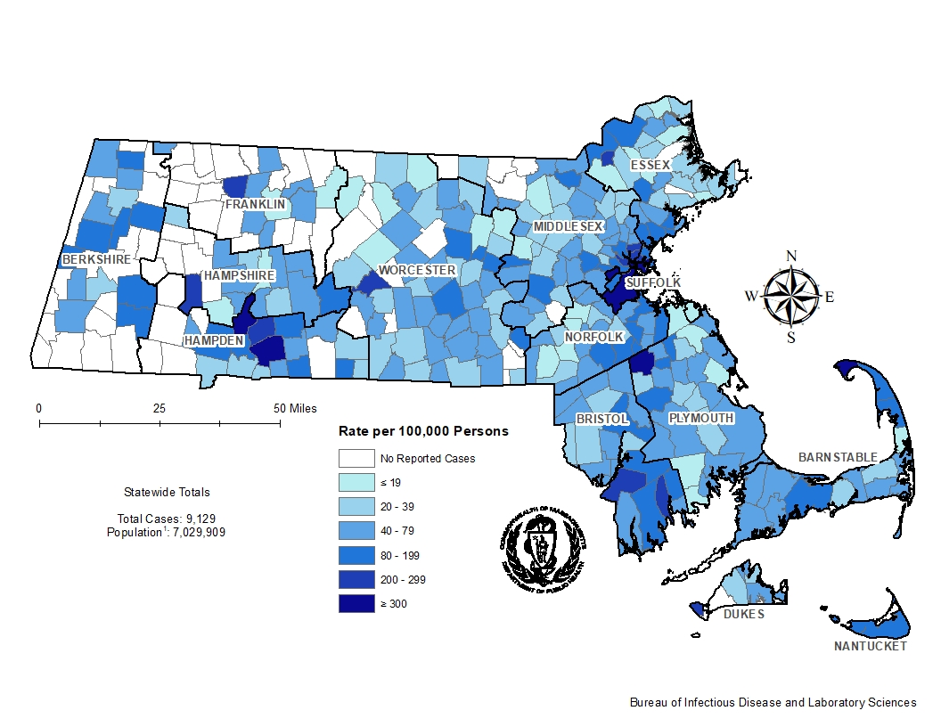
Highlights: Map of Massachusetts cities and towns color-coded to indicate the areas of the state with the highest gonorrhea case rates in 2022. The city with the highest rate (>500 per 100,000 persons) is Provincetown. Other cities that have the high rates (>300 per 100,000 persons) are Springfield, Brockton, Boston, and Holyoke.
Footnotes for Slide 34
Data are current as of 07/18/2023 and are subject to change.
Data Source: Massachusetts Department of Public Health/Bureau of Infectious Disease and Laboratory Sciences/Division of STD Prevention and STD-HIV Surveillance.
1. Population denominators estimated by the University of Massachusetts Donahue Institute using a modified Hamilton-Perry model (Strate S, et al. Small Area Population Estimates for 2011 through 2020 report, Oct 2016).
2. There are four city/towns with <10 cases of gonorrhea that fall within the top two rate categories (≥200 cases per 100,000): Shelburne, Huntington, Aquinnah, and New Braintree.
3. Please consider the impact of the COVID-19 pandemic on infectious disease screening, treatment and surveillance in the interpretation of 2022 data.

Slide 35: Incident Rate of Confirmed Gonorrhea Cases, per 100,000 Persons¹ by City/Town², Massachusetts, 2018
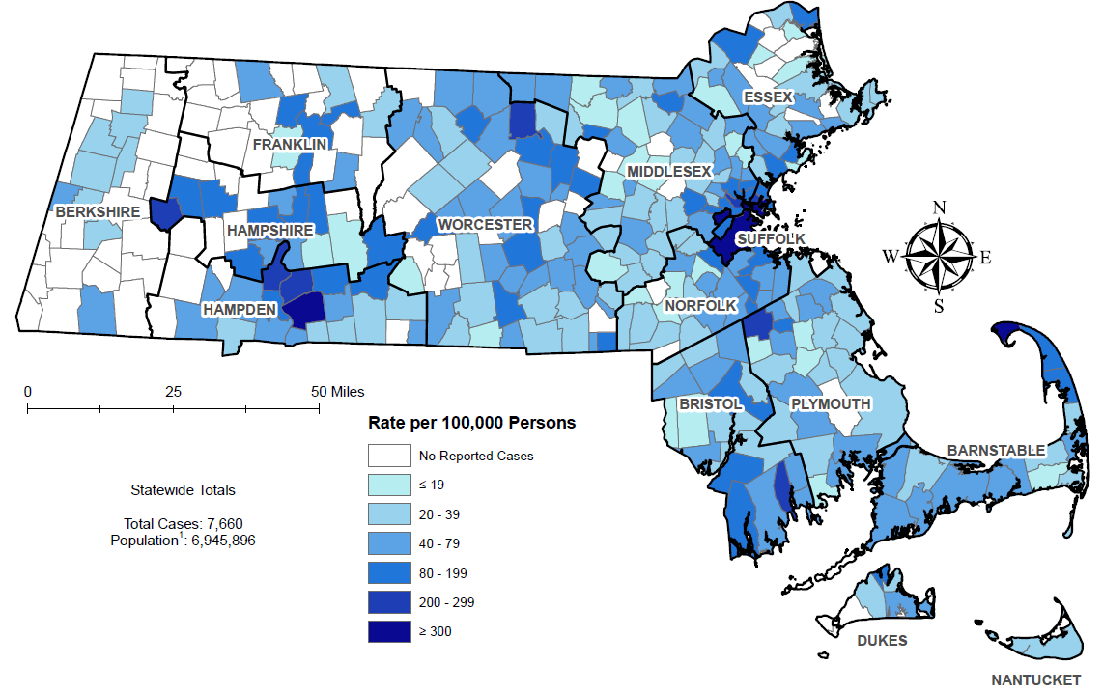
Highlights: Map of Massachusetts cities and towns color-coded to indicate the areas of the state with the highest gonorrhea case rates in 2018. The city with the highest rate (>500 per 100,000 persons) is Provincetown. Other cities that have the high rates (>300 per 100,000 persons) are Springfield and Brockton.
Footnotes for Slide 35
Data are current as of 07/18/2023 and are subject to change.
Data Source: Massachusetts Department of Public Health/Bureau of Infectious Disease and Laboratory Sciences/Division of STD Prevention and STD-HIV Surveillance.
1. Population denominators estimated by the University of Massachusetts Donahue Institute using a modified Hamilton-Perry model (Strate S, et al. Small Area Population Estimates for 2011 through 2020 report, Oct 2016).
2. There is one city/town with <10 cases of gonorrhea that fall within the top two rate categories (≥200 cases per 100,000): Middlefield.

Slide 36: Confirmed Gonorrhea Case Rates per 100,000 Population by Gender¹ and Age, Massachusetts, 2022²
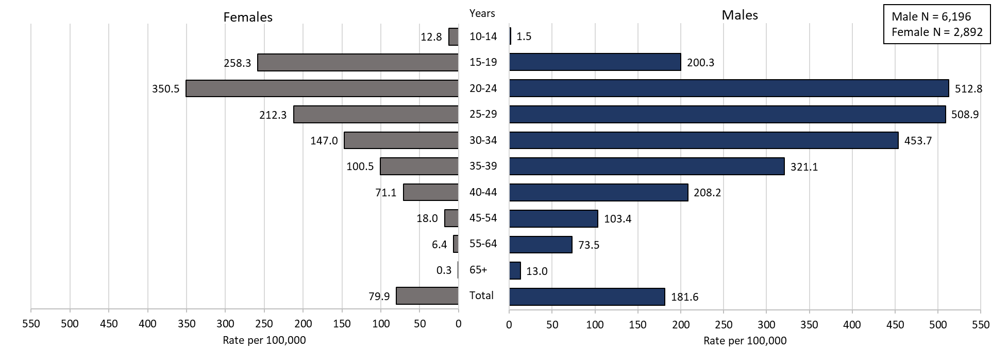

Highlights: Graph depicts gonorrhea case rates per 100,000 population by age categories for the overall state, males, and females. For the overall state, the highest rate is among those 20-24 years. When looking at the gender specific rates, the age categories with the highest rates are 20 to 24 years for both males and females.
Footnotes for Slide 36
Data are current as of 07/18/2023 and are subject to change.
Data Source: Massachusetts Department of Public Health/Bureau of Infectious Disease and Laboratory Sciences/Division of STD Prevention and STD-HIV Surveillance.
Population denominators estimated by the University of Massachusetts Donahue Institute using a modified Hamilton-Perry model (Strate S, et al. Small Area Population Estimates for 2011 through 2020 report, Oct 2016).
1. In 2022, there were 34 individuals of transgender experience documented in our data system and MA DSTDP does not have current gender information for those individuals and 4 other individuals had unknown gender. 2 individuals had unknown age. These cases were excluded since rate for this population cannot be calculated at this time.
2. Please consider the impact of the COVID-19 pandemic on infectious disease screening, treatment and surveillance in the interpretation of 2022 data.

Slide 37: Incident Rate of Infectious Syphilis1 Cases, per 100,000 Persons2 by City/Town, Massachusetts, 20223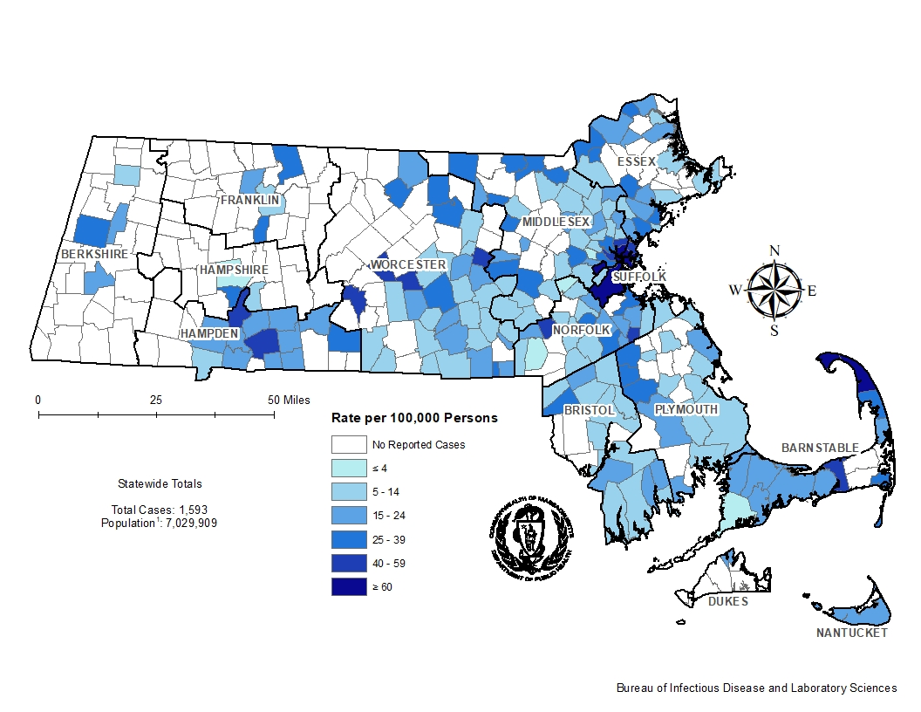
Highlights: Map of Massachusetts counties color-coded to indicate the areas of the state with the highest infectious syphilis case rates in 2022. The cities that have the highest rates (greater than 40 per 100,000 persons) are Provincetown, Truro, Chelsea, Everett, Boston, Springfield, Oakham, West Brookfield, Revere, Berlin, Somerville, Millis, Holbrook, Malden, and Dennis.
Footnotes for Slide 37
Data are current as of 07/18/2023 and are subject to change.
Data Source: Massachusetts Department of Public Health/Bureau of Infectious Disease and Laboratory Sciences/Division of STD Prevention and STD-HIV Surveillance.
1. Infectious syphilis is defined as primary, secondary and early latent stages of syphilis within one year of infection.
2. Population denominators estimated by the University of Massachusetts Donahue Institute using a modified Hamilton-Perry model (Strate S, et al. Small Area Population Estimates for 2011 through 2020 report, Oct 2016).
3. There are seven city/towns with <10 cases of syphilis that fall within the top two rate categories (≥40 cases per 100,000): Truro, Oakham, West Brookfield, Berlin, Millis, Holbrook, and Dennis.
4. Please consider the impact of the COVID-19 pandemic on infectious disease screening, treatment and surveillance in the interpretation of 2022 data.

Slide 38: Incident Rate of Infectious Syphilis¹ Cases, per 100,000 Persons² by City/Town, Massachusetts, 2018
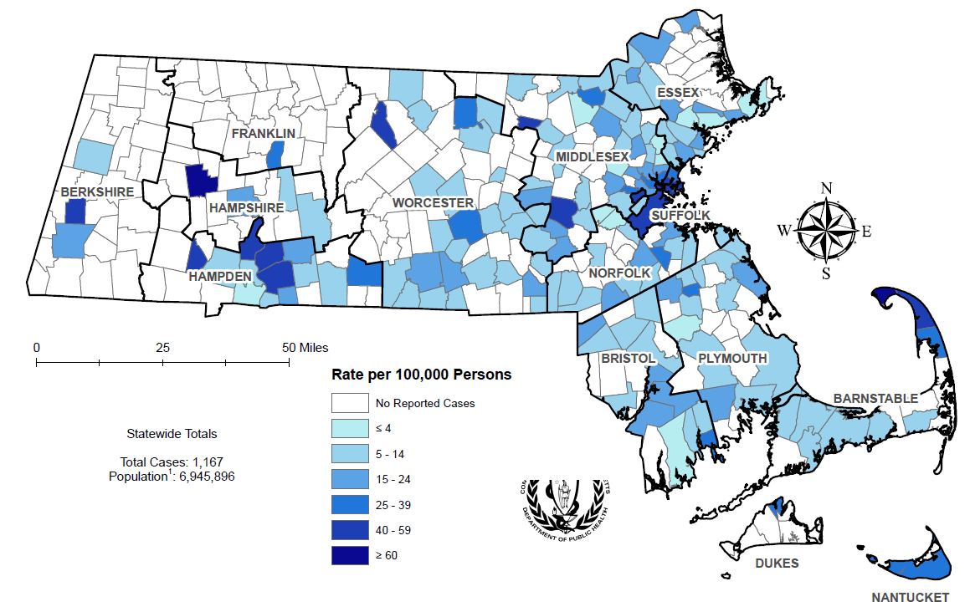
Highlights: Map of Massachusetts counties color-coded to indicate the areas of the state with the highest infectious syphilis case rates in 2018. The cities that have the highest rates (greater than 40 per 100,000 persons) are Provincetown, Chesterfield, Winthrop, Phillipston, Strockbridge, Russell, Truro, Springfield, Ayer, Holyoke, Framingham, Boston, Chicopee, and Chelsea.

Footnotes for Slide 38
Data are current as of 07/18/2023 and are subject to change.
Data Source: Massachusetts Department of Public Health/Bureau of Infectious Disease and Laboratory Sciences/Division of STD Prevention and STD-HIV Surveillance.
1. Infectious syphilis is defined as primary, secondary and early latent stages of syphilis within one year of infection.
2. Population denominators estimated by the University of Massachusetts Donahue Institute using a modified Hamilton-Perry model (Strate S, et al. Small Area Population Estimates for 2011 through 2020 report, Oct 2016).
3. There are eight city/towns with <10 cases of syphilis that fall within the top two rate categories (≥40 cases per 100,000): Chesterfield, Winthrop, Phillipston, Strockbridge, Russell, Truro, Springfield, and Ayer.

Slide 39: Confirmed and Probable Infectious Syphilis¹ Cases per 100,000 Population by Gender² and Age, Massachusetts, 2022³
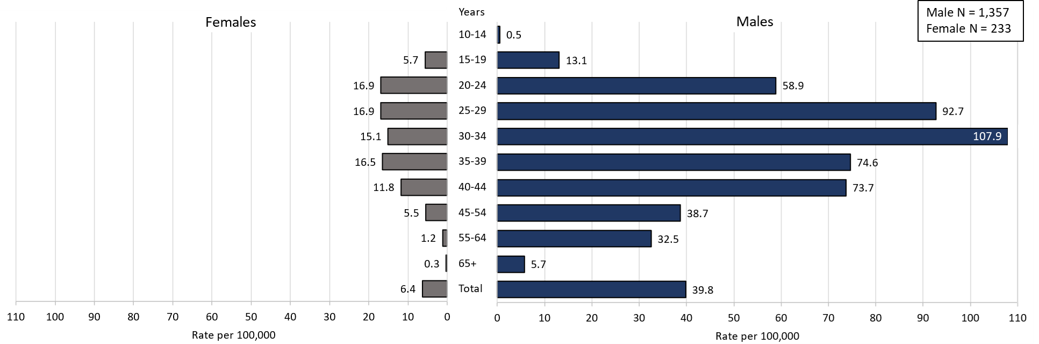

Highlights: Graph depicts infectious syphilis rates per 100,000 population by age categories for the overall state, males, and females. For the overall state, the highest rate is among those 30-34 years. When looking at the gender specific rates, the age categories with the highest rates are 25 to 29 years for females and 30 to 34 years for males.

Footnotes for Slide 39
Data are current as of 07/18/2023 and are subject to change.
Data Source: Massachusetts Department of Public Health/Bureau of Infectious Disease and Laboratory Sciences/Division of STD Prevention and STD-HIV Surveillance.
Population denominators estimated by the University of Massachusetts Donahue Institute using a modified Hamilton-Perry model (Strate S, et al. Small Area Population Estimates for 2011 through 2020 report, Oct 2016).
1. Infectious syphilis is defined as primary, secondary and early latent stages of syphilis within one year of infection.
2. In 2022, there were 3 individuals of transgender experience documented in our data system and MA DSTDP does not have current gender information for those individuals. These cases were excluded since rate for this population cannot be calculated at this time.
3. Please consider the impact of the COVID-19 pandemic on infectious disease screening, treatment and surveillance in the interpretation of 2022 data.

Slide 40: Comparison of the Rate of Confirmed and Probable Infectious Syphilis¹ Cases by Gender² and Race and Ethnicity³, Massachusetts, 2022⁴
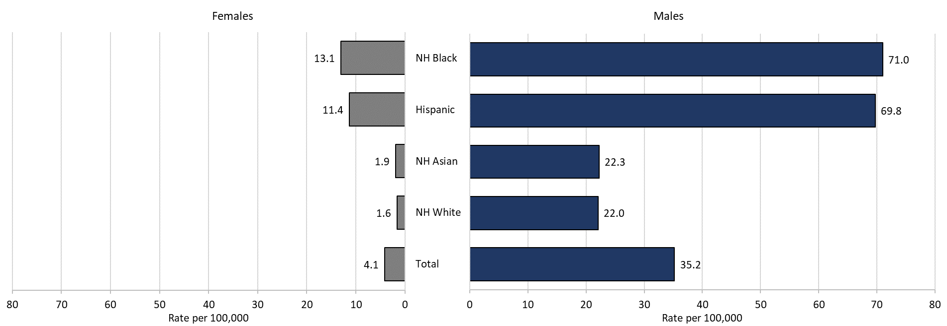
Table: Infectious syphilis 2022 case counts by race and ethnicity and gender
 | Males | Females | Total
Total | 1357 | 233 | 1590
NH White | 532 | 74 | 606
NH Asian | 59 | 6 | 65
Hispanic | 416 | 77 | 493
NH Black | 219 | 51 | 270

Highlights: Graph depicts infectious syphilis rates per 100,000 population by age and race/ethnicity categories for the overall state, males, and females. For all infectious syphilis cases, the highest rate is among Non-Hispanic/Latinx Black and Hispanic/Latinx for both male and females.
Footnotes for Slide 40
Data are current as of 07/18/2023 and are subject to change.
Data Source: Massachusetts Department of Public Health/Bureau of Infectious Disease and Laboratory Sciences/Division of STD Prevention and STD-HIV Surveillance.
Population denominators estimated by the University of Massachusetts Donahue Institute using a modified Hamilton-Perry model (Strate S, et al. Small Area Population Estimates for 2011 through 2020 report, Oct 2016).
1. Infectious syphilis is defined as primary, secondary and early latent stages of syphilis within one year of infection.
2. In 2022, there were 3 individuals of transgender experience documented in our data system and MA DSTDP does not have current gender information for those individuals. These cases were excluded since rate for this population cannot be calculated at this time.
3. Those cases reported among non-Hispanic/Latinx individuals with other race categories were excluded based on small counts (6.4% of cases). Cases with unknown race and ethnicity were excluded because rates could not be calculated (3.8% of cases).
4. Please consider the impact of the COVID-19 pandemic on infectious disease screening, treatment and surveillance in the interpretation of 2022 data.

Slide 41: Section Break, HIV Co-infection

Slide 42: 2022¹ HIV² Co-Infection with Chlamydia and Gonorrhea
Chlamydia with HIV Co-Infection
  - 2.2% of chlamydia cases were HIV co-infection (N = 28,384)
  - As age increases the proportion of HIV co-infection increases
    - <1% of cases in their 20s are HIV co-infected
    - 20% of cases 50+ are HIV co-infected
Gonorrhea with HIV Co-Infection
  - 7.7% of gonorrhea cases were HIV co-infection (N = 9,128)
  - As age increases the proportion of HIV co-infection increases
    - 3% of cases in their 20s are HIV co-infected
    - 23% of cases 50+ are HIV co-infected

Footnotes for Slide 42
Data are current as of 07/18/2023 and are subject to change.
Data Source: Massachusetts Department of Public Health/Bureau of Infectious Disease and Laboratory Sciences/Division of STD Prevention and STD-HIV Surveillance.
1. Please consider the impact of the COVID-19 pandemic on infectious disease screening, treatment and surveillance in the interpretation of 2022 data.
2. HIV status is based on a full year match with HIV Surveillance data.

Slide 43: 2022¹ HIV² Co-Infection with Infectious Syphilis³
25% of infectious syphilis cases were co-infected with HIV (N = 1,593)
As age increases the proportion of HIV co-infection increases
  - 12.8% of cases in their 20s are HIV co-infected
  - 53.9% of cases 50+ are HIV co-infected
Of individuals co-infected with HIV and infectious syphilis, 81.9% were MSM⁴ (N = 397), compared with 56.4% for those with no known HIV diagnosis (N = 1196).
Of known MSM individuals infected with infectious syphilis (N = 1000), 32.5% were co-infected with HIV.
8.1% of co-infected individuals were newly diagnosed with HIV within 30 days of infectious syphilis event date; 91.7% had a prior HIV diagnosis.

Footnotes for Slide 43
Data are current as of 07/18/2023 and are subject to change.
Data Source: Massachusetts Department of Public Health/Bureau of Infectious Disease and Laboratory Sciences/Division of STD Prevention and STD-HIV Surveillance.
1. Please consider the impact of the COVID-19 pandemic on infectious disease screening, treatment and surveillance in the interpretation of 2022 data.
2. HIV status is based on a full year match with HIV Surveillance data.
3. Infectious syphilis is defined as primary, secondary and early latent stages of syphilis within one year of infection.
4. The MSM (men who have sex with men) category includes MSMT, MSMW, and MSMWT with “W” referring to women and “T” referring to individuals of transgender experience.

Slide 44: Comparison of Infectious Syphilis¹ Cases by HIV² Co-Infection and Age³, Massachusetts, 2022⁴
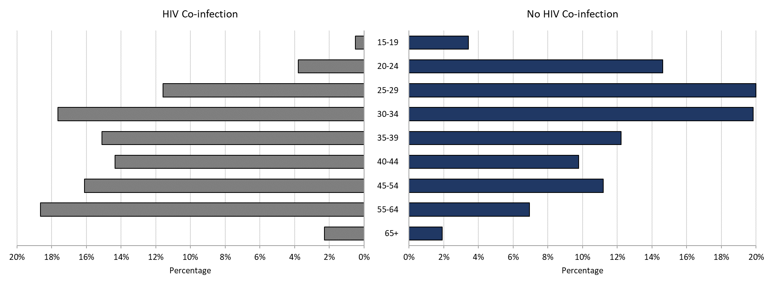

Highlights: Graph depicts infectious syphilis case percentages for age categories by HIV co-infection status. The proportion of infectious syphilis cases with HIV co-infection were highest among those age 55 to 64 as well as those age 30 to 34. The proportion of cases with HIV co-infection were lowest among those 15 to 19 years followed by those over the age of 65 years.

Footnotes for Slide 44
Data are current as of 07/18/2023 and are subject to change.
Data Source: Massachusetts Department of Public Health/Bureau of Infectious Disease and Laboratory Sciences/Division of STD Prevention and STD-HIV Surveillance.
1. Infectious syphilis is defined as primary, secondary and early latent stages of syphilis within one year of infection.
2. HIV status is based on a full year match with HIV Surveillance data.
3. Individuals younger than 15 years are not included within this slide due to low case counts.
4. Please consider the impact of the COVID-19 pandemic on infectious disease screening, treatment and surveillance in the interpretation of 2022 data.

Slide 45: Comparison of Infectious Syphilis¹ Cases by HIV² Co-Infection and Race/Ethnicity, Massachusetts, 2022³
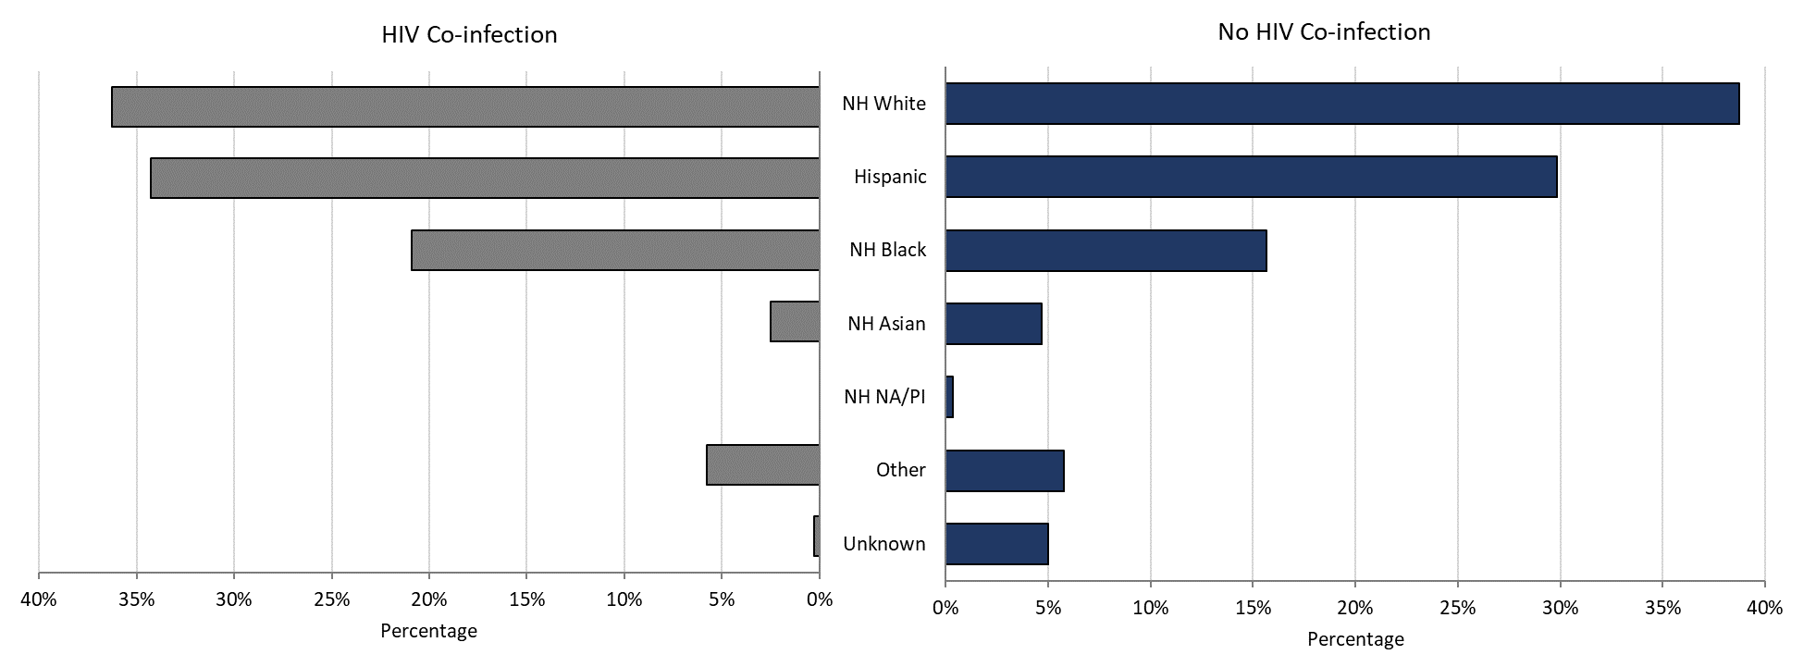

Highlights: Graph depicts infectious syphilis case percentages for race/ethnicity categories by HIV co-infection status. The proportion of infectious syphilis cases with HIV co-infection is highest among Non-Hispanic Whites followed by Hispanic and then Non-Hispanic Black individuals.
Footnotes for Slide 45
Data are current as of 07/18/2023 and are subject to change.
Data Source: Massachusetts Department of Public Health/Bureau of Infectious Disease and Laboratory Sciences/Division of STD Prevention.
1. Infectious syphilis is defined as primary, secondary and early latent stages of syphilis within one year of infection.
2. HIV status is based on a full year match with HIV Surveillance data.
3. Please consider the impact of the COVID-19 pandemic on infectious disease screening, treatment and surveillance in the interpretation of 2022 data.

Slide 46: 2022 Summary Slide
Chlamydia: The 2022 Massachusetts state rate was 403.8 per 100,000
  - The highest rate of chlamydia cases was among females 20 to 24 years with a rate of 2,709.3 cases per 100,000 population*
  - Gonorrhea: The 2022 Massachusetts state rate was 129.8 per 100,000
  - The highest rate of gonorrhea cases was among males 20 to 24 years with a rate of 512.8 cases per 100,000 population
  - Infectious Syphilis: The 2022 Massachusetts state rate was 22.7 per 100,000
  - The highest rate of infectious syphilis cases was among males 30 to 34 years with a rate of 107.9 cases per 100,000 population
- Congenital syphilis cases maintained the increased number of reportable cases seen from 2019 to 2022
  - The overall increases in infectious syphilis rates in individuals believed to be biologically capable of pregnancy and the increase in reportable congenital syphilis cases led to a recommendation for universal third trimester screening in 2020, on top of routine screening for syphilis upon entry into prenatal care in Massachusetts.

Footnotes for Slide 46
Data Source: Massachusetts Department of Public Health/Bureau of Infectious Disease and Laboratory Sciences/Division of STD Prevention.
Data are current as of 07/18/2023 and are subject to change
* Population based on 2019 University of Massachusetts Donahue Institute Estimates

Slide 47: Technical Data Notes

- STI and HIV specific laboratory and case management information are reported directly to the Department of Public Health and maintained in the Massachusetts integrated disease surveillance and case management system, MAVEN
  - The majority (>90%) of laboratory test results are reported via electronic laboratory reporting
  - Case management information is reported via electronic medical record feeds, case reporting forms and collected by epidemiologists
  - Data are routinely reviewed, cleaned, and analyzed by surveillance epidemiologists
  - Routine reports are shared with internal and external stakeholders
  - All data are collected and maintained according to strict confidentiality and security requirements

Slide 48: Technical Data Notes (Continued)
- Case classifications (confirmed, probable or suspect) are based on CSTE/CDC case definitions for nationally notifiable infectious diseases.
  - For full STI case classifications, see: https://www.cdc.gov/std/statistics/2019/case-definitions.htm
  - All data in this report are accurate as of their analysis date and are subject to change. Common reasons for data changes include amendments to reporting and routine data cleaning.
- Transgender individuals are included in current gender identity categories, except where noted due to incomplete information on current gender identity. Nonbinary gender identity is captured but suppressed according to Massachusetts privacy and confidentiality rules. Collection of transgender data categories began in mid-2014.
- Gender of sex partners categories for this report include: MSM = men who have sex with men, MSW = men who have sex with women, WSM = women who have sex with men, Other = include transgender sexual risk categories and females who have sex with females or both male and female partners, and Unknown are cases reported without sexual risk. These categories are based on patient and provider report and do not necessarily reflect an individual’s sexual identity in relation to gender (i.e. gay, bisexual, heterosexual, etc).

Slide 49: Coronavirus 2019 (COVID-19): Impact of Other Reportable Infections
When reviewing 2020-2022 data for Massachusetts, please note the impact of the coronavirus 2019 (COVID-19) pandemic on infectious disease screening, treatment, and surveillance. Nationally, CDC observed a sharp decline in reported STD cases from March-April 2020, compared to March-April 2019.
Three factors were cited as likely contributing to the initial decrease in reported cases:
  - Reduced screening – many health care clinics limited in-person visits to symptomatic cases or closed
  - Limited resources – many state and local health department STD staff were redirected from routine STD responsibilities to COVID-19 activities, which affected STD tracking capacity and reporting
  - Stay-at-home orders (March 24 through April 7th, 2020) – which were intended to reduce COVID-19 spread may have influenced sexual behaviors and reduced STD transmission¹
As the impact of the COVID-19 pandemic continues, it’s full effect on case reporting and efforts to control the spread of infectious disease in the Commonwealth has yet to be determined. As such, please interpret 2020 infectious disease data with caution.

Footnotes for Slide 49
CDC Press Release, July 16, 2021: Trends in STD case reports during the U.S. COVID-19 pandemic, January-December 2020 available at: https://www.cdc.gov/nchhstp/newsroom/2021/2020-std-trend-report.html”

Slide 50: Closing Slide
If you have questions or to request more information: call the Massachusetts Department of Public Health, Division of STD Prevention, at 617-983-6940

Providers may use this number to report individuals newly diagnosed with a notifiable sexually transmitted infection, including HIV, or request partner services. Partner services is a free and confidential service for individuals recently diagnosed with a priority infection. The client-centered program offers counseling, linkage to other health and social services, anonymous notification of partners who were exposed and assistance with getting testing and treatment. For more information, see: https://www.mass.gov/service-details/partner-services-program-information-for-healthcare-providers)

