Massachusetts Department of Public Health
Bureau of Infectious Disease and Laboratory Sciences
Surveillance Data Overview of Sexually Transmitted Infections, Massachusetts, 2000-2024

Please note that while the content of this report is the same as the pdf version, the format and pagination have been modified significantly to optimize use with screen readers to ensure access for blind or visually impaired audiences.

Massachusetts Department of Public Health
Bureau of Infectious Disease and Laboratory Sciences
Division of STD Prevention and HIV Surveillance
March 2024

Bureau of Infectious Disease and Laboratory Sciences
Division of STD Prevention and HIV Surveillance
Massachusetts Department of Public Health

Jamaica Plain Campus/State Public Health Laboratory
305 South Street
Jamaica Plain, MA 02130

Questions about this report
Tel: (617) 983-6490

To reach the Reporting and Partner Services Line

Tel: (617) 983-6999

Contents
Slide 1 (title page) – Surveillance Data Overview of Sexually Transmitted Infections, Massachusetts, 2000-2024 4
Slide 2 – Outline 4
Slide 3 (title page) – Massachusetts STI Trends, Chlamydia: 2000 - 2024 4
Slide 4 – Rate of Confirmed Chlamydia Cases, Massachusetts, 2000 to 2024¹ 5
Slide 5 – Confirmed Chlamydia Rates by Gender¹, Massachusetts, 2010 to 2024² 6
Slide 6 – Chlamydia Among Individuals of Transgender Experience,^{1, 2} Massachusetts, 2015-2024³ 7
Slide 7 – Confirmed Chlamydia Rates by County and Statewide, Massachusetts, 2022-2024¹ 8
Slide 8 – Massachusetts STI Trends, Gonorrhea: 2000 - 2024 9
Slide 9 – Rate of Confirmed Gonorrhea Cases, Massachusetts, 2000-2024¹ 9
Slide 10 – Rate of Confirmed Gonorrhea Cases by Gender¹, Massachusetts, 2010-2024² 10
Slide 11 – Gonorrhea Among Individuals of Transgender Experience¹, Massachusetts, 2015-2024² 11
Slide 12 – Confirmed Gonorrhea Rates by County and Statewide, Massachusetts, 2022-2024¹ 12
Slide 13 – Massachusetts STI Trends, Infectious Syphilis: 2000 - 2024 13
Slide 14 – Confirmed and Probable Infectious Syphilis¹ Rates, Massachusetts, 2000-2024² 13
Slide 15 – Confirmed and Probable Infectious Syphilis¹ Rates by Gender,² Massachusetts, 2010-2024³ 14
Slide 16 – Infectious Syphilis¹ Reported Cases by Race/Ethnicity², Massachusetts, 2015-2024³ 16
Slide 17 – Confirmed and Probable Infectious Syphilis¹ Among Individuals of Transgender Experience², Massachusetts, 2015-2024^{3, 4} 17
Slide 18 – Confirmed and Probable Infectious Syphilis¹ Rates by Stage of Infection, Massachusetts, 2010–2024² 18
Slide 19 – Confirmed and Probable Infectious Syphilis¹ Rates by Stage of Infection, Massachusetts, 2015-2024² 19
Slide 20 – Infectious Syphilis¹ Reported Cases by Sexual Risk Categories, Massachusetts, 2015-2024² 20
Slide 21 – Congenital Syphilis Cases and Rate of Confirmed and Probable Infectious Syphilis¹ Among Persons of Reproductive Potential Ages 15 to 49 Years, Massachusetts, 2010-2024² 21
Slide22 – Congenital Syphilis Cases Averted, Massachusetts, 2019-2024¹ 22
Slide 23 – Massachusetts SVI Trends 23
Slide 24 – Social Vulnerability Index 23
Slide 25 – Confirmed Chlamydia Case Percentages by Social Vulnerability Index, Massachusetts, 2020-2024¹ 23
Slide 26 – Confirmed Chlamydia Case Percentages by Social Vulnerability Index and Gender, Massachusetts, 2020-2024^{1, 2} 24
Slide 27 – Confirmed Gonorrhea Case Percentages by Social Vulnerability Index, Massachusetts, 2020-2024¹ 25
Slide 28 – Confirmed Gonorrhea Case Percentages by Social Vulnerability Index and Gender, Massachusetts, 2020-2024^{1, 2} 26
Slide 29 – Confirmed and Probably Infectious Syphilis¹ Case Percentages by Social Vulnerability Index, Massachusetts, 2020-2024² 26
Slide 30 – Confirmed and Probable Infectious Syphilis¹ Case Percentages by Social Vulnerability Index and Gender², Massachusetts, 2020-2024³ 27
Slide 31 – Confirmed and Probable Infectious Syphilis¹ Case Percentages by Social Vulnerability Index and Race², Massachusetts, 2020-2024³ 28
Slide 32 - Description of 2024 STI Cases 29
Slide 33 – Incidence Rate of Confirmed Chlamydia Cases, per 100,000 Persons¹ by City/Town², Massachusetts, 2024 29
Slide 34 – Absolute Rate Difference¹ Comparing 2024 to 2020 for Confirmed Chlamydia Cases, per 100,000 Persons² by City/Town, Massachusetts 30
Slide 35 – Confirmed Chlamydia Case Rates per 100,000 Population by Gender¹ and Age, Massachusetts, 2024 31
Slide 36 – Incidence Rate of Confirmed Gonorrhea Cases, per 100,000 Persons¹ by City/Town², Massachusetts, 2024 32
Slide 37 – Absolute Rate Difference¹ Comparing 2024 to 2020 for Confirmed Gonorrhea Cases, per 100,000 Persons² by City/Town, Massachusetts 33
Slide 38 – Confirmed Gonorrhea Case Rates per 100,000 Population by Gender¹ and Age, Massachusetts, 2024 34
Slide 39 – Incident Rate of Infectious Syphilis¹ Cases, per 100,000 Persons² by City/Town³, Massachusetts, 2024 35
Slide 40 – Absolute Rate Difference¹ Comparing 2024 to 2020 for Infectious Syphilis² Cases, per 100,000 Persons³ by City/Town, Massachusetts 36
Slide 41 – Confirmed and Probable Infectious Syphilis¹ Cases per 100,000 Population by Gender² and Age, Massachusetts, 2024 37
Slide 42 – Comparison of the Rate of Confirmed and Probable Infectious Syphilis¹ Cases by Gender² and Race and Ethnicity³, Massachusetts, 2024 38
Slide 43 – HIV Co-infection 38
Slide 44 – 2024 HIV¹ Co-Infection with Chlamydia and Gonorrhea 38
Slide 45 – 2024 HIV¹ Co-Infection with Infectious Syphilis² 39
Slide 46 – Comparison of Infectious Syphilis¹ Cases by HIV² Co-Infection and Age³, Massachusetts, 2024 39
Slide 47 – Comparison of Infectious Syphilis¹ Cases by HIV² Co-Infection and Race/Ethnicity, Massachusetts, 2024 40
Slide 48 – 2024 Summary 41
Slide 49 – Technical Data Notes 41
Slide 50 – Technical Data Notes (Continued) 41
Slide 51 – Coronavirus 2019 (COVID-19): Impact of Other Reportable Infections 42
Slide 52 – Closing Slide 42

Slide Descriptions

Slide 1 (title page) – Surveillance Data Overview of Sexually Transmitted Infections, Massachusetts, 2000-2024

Slide 2 – Outline
Sexually Transmitted Infection (STI) Trends and Descriptions:​
- General STI Trends Through 2024​
  - Chlamydia​
  - Gonorrhea​
  - Infectious syphilis​
- Descriptions of 2024 STI Cases​
  - Social Vulnerability Index Trends (2024)​
  - HIV/STI Co-infection and Sexual Risk (2024)​
- 2024 Summary​
- Technical Notes

Slide 3 (title page) – Massachusetts STI Trends, Chlamydia: 2000 - 2024

Slide 4 – Rate of Confirmed Chlamydia Cases, Massachusetts, 2000 to 2024¹
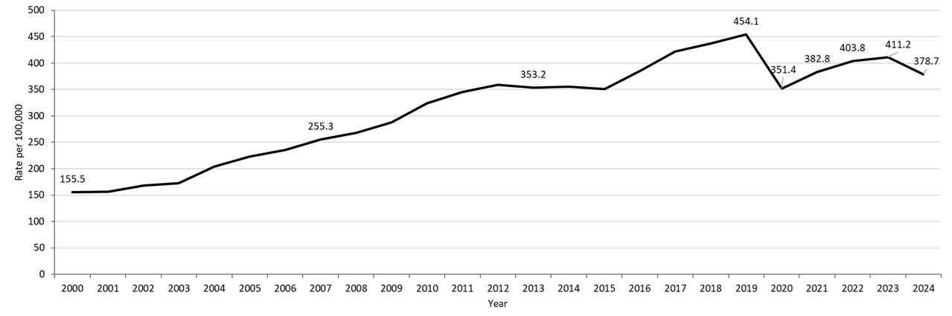

Table: Chlamydia Annual Case Counts
Year | Count
2000 | 9,872
2001 | 9,969
2002 | 10,755
2003 | 11,041
2004 | 13,120
2005 | 14,386
2006 | 15,253
2007 | 16,566
2008 | 17,441
2009 | 18,796
2010 | 21,211
2011 | 22,851
2012 | 23,930
2013 | 23,789
2014 | 24,143
2015 | 23,944
2016 | 26,478
2017 | 29,177
2018 | 30,360
2019 | 31,633
2020 | 24,701
2021 | 26,912
2022 | 28,384
2023 | 28,910
2024 | 26,623

Footnotes For Slide 4
Data are current as of 06/02/2025 and are subject to change.
Data Source: Massachusetts Department of Public Health/Bureau of Infectious Disease and Laboratory Sciences/ Division of STD Prevention and STD-HIV Surveillance.
Population denominators estimated by the University of Massachusetts Donahue Institute using a modified Hamilton-Perry model (Strate S, et al. Small Area Population Estimates for 2011 through 2020 report, Oct 2016).
1. Please consider the impact of the COVID-19 pandemic on infectious disease screening, treatment and surveillance in the interpretation of 2020-2022 data.

Slide 5 – Confirmed Chlamydia Rates by Gender¹, Massachusetts, 2010 to 2024²
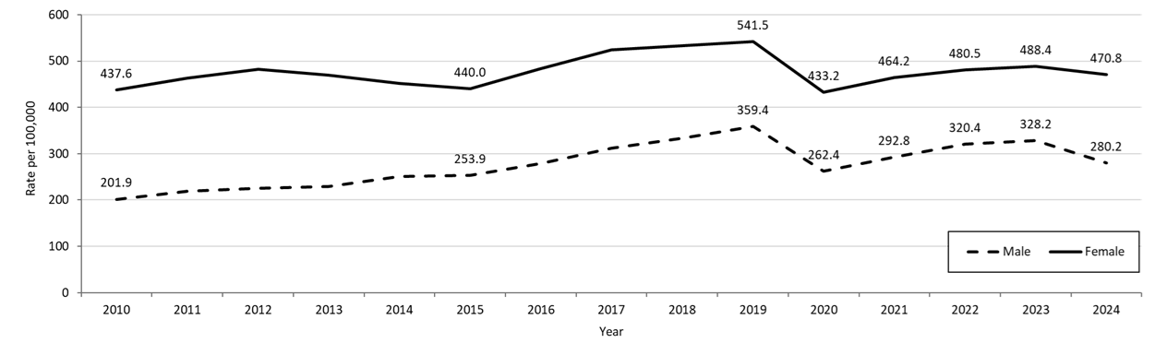

Table: Chlamydia Annual Case Counts by Current Gender
Year | Females | Males
2010 | 14,795 | 6,392
2011 | 15,803 | 7,030
2012 | 16,590 | 7,302
2013 | 16,275 | 7,494
2014 | 15,781 | 8,258
2015 | 15,489 | 8,414
2016 | 17,094 | 9,318
2017 | 18,644 | 10,463
2018 | 19,062 | 11,252
2019 | 19,408 | 12,155
2020 | 15,677 | 8,949
2021 | 16,799 | 9,989
2022 | 17,388 | 10,928
2023 | 17,675 | 11,194
2024 | 17,037 | 9,557
Note: There were cases reported among transgender individuals in 2014 through 2024. In 2024, there were 9 cases of chlamydia among transgender identified individuals and 17 other individuals with unknown gender not included on this slide.
Footnotes For Slide 5
Data are current as of 06/02/2025 and are subject to change.
Data Source: Massachusetts Department of Public Health/Bureau of Infectious Disease and Laboratory Sciences/ Division of STD Prevention and STD-HIV Surveillance.
Population denominators estimated by the University of Massachusetts Donahue Institute using a modified Hamilton-Perry model (Strate S, et al. Small Area Population Estimates for 2011 through 2020 report, Oct 2016).
1. In 2024, there were 9 individuals of transgender experience reported in our data system who do not have current gender documented. These cases were excluded since population estimates for individuals of transgender experience are not available at this time. There were 17 other individuals with unknown gender which are not included in this slide.
2. Please consider the impact of the COVID-19 pandemic on infectious disease screening, treatment and surveillance in the interpretation of 2020-2022 data.

Slide 6 – Chlamydia Among Individuals of Transgender Experience,^{1, 2} Massachusetts, 2015-2024³

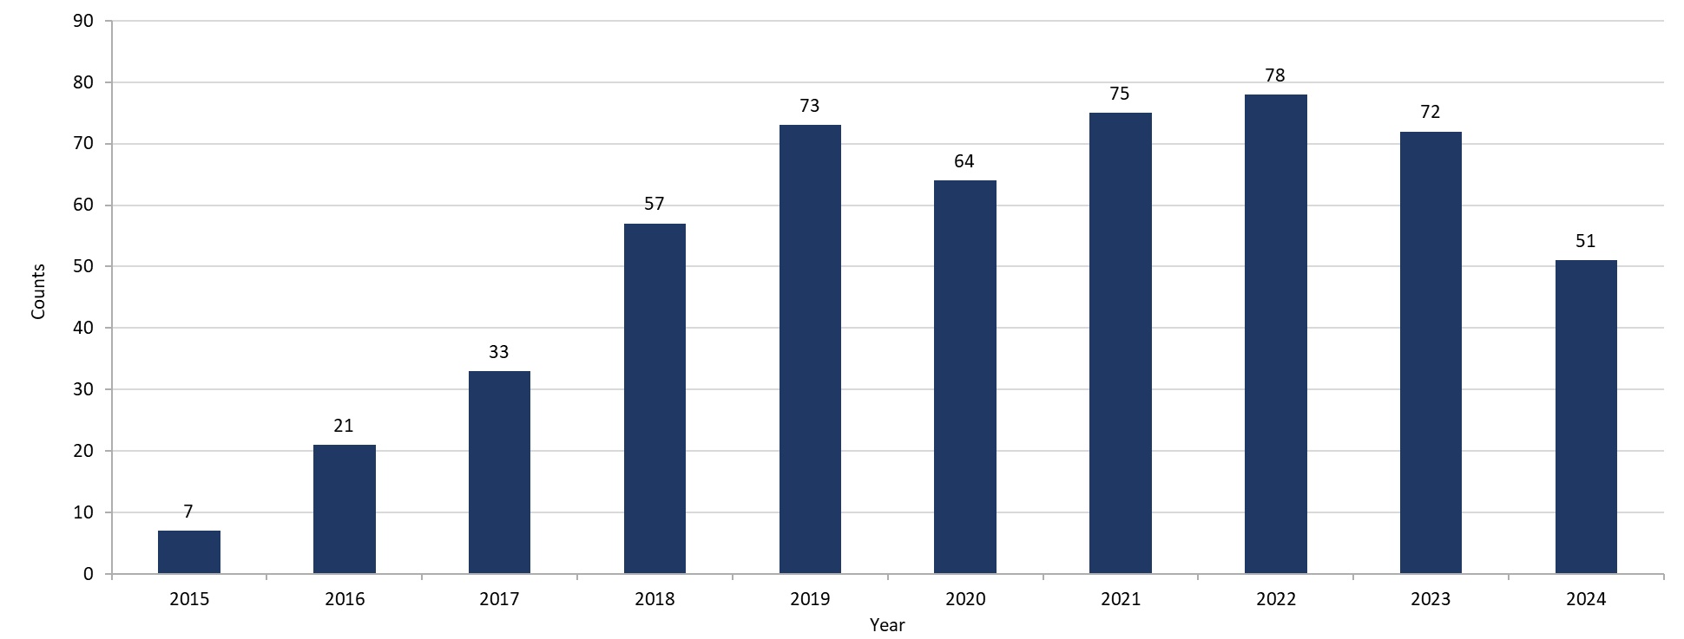
Footnotes for Slide 6
Data are current as of 06/02/2025 and are subject to change.
Data Source: Massachusetts Department of Public Health/Bureau of Infectious Disease and Laboratory Sciences/ Division of STD Prevention and STD-HIV Surveillance.
1. Prior to 2015 MA DSTDP was not able to capture expanded gender identity including individuals of transgender experience within our data system.
2. All individuals of transgender experience are included in this graph regardless of current gender.
3. Please consider the impact of the COVID-19 pandemic on infectious disease screening, treatment and surveillance in the interpretation of 2020-2022 data.

Slide 7 – Confirmed Chlamydia Rates by County and Statewide, Massachusetts, 2022-2024¹
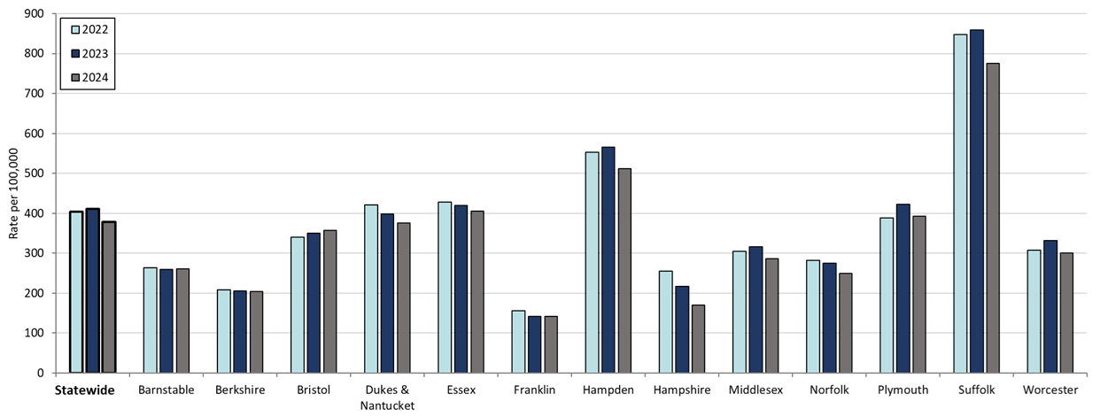
Table: Rates of Chlamydia by County and Statewide
County | 2022 | 2023 | 2024
Barnstable | 263.8 | 259.39 | 260.7
Berkshire | 207.7 | 206.16 | 203.9
Bristol | 339.8 | 350.48 | 357.7
Dukes/Nantucket | 421.7 | 398.8 | 375.8
Essex | 427.5 | 419.47 | 404.9
Franklin | 156.3 | 142.2 | 142.2
Hampden | 553.2 | 565.45 | 511.1
Hampshire | 254.5 | 216.87 | 170.0
Middlesex | 304.8 | 316.36 | 286.0
Norfolk | 282.8 | 275.08 | 248.9
Plymouth | 388.8 | 422.18 | 392.4
Suffolk | 848.3 | 858.72 | 776.0
Worcester | 308.2 | 331.4 | 300.0
Statewide | 403.8 | 411.24 | 378.7

Footnotes for Slide 7
Data are current as of 06/02/2025 and are subject to change.
Data Source: Massachusetts Department of Public Health/Bureau of Infectious Disease and Laboratory Sciences/ Division of STD Prevention and STD-HIV Surveillance.
Population denominators estimated by the University of Massachusetts Donahue Institute using a modified Hamilton-Perry model (Strate S, et al. Small Area Population Estimates for 2011 through 2020 report, Oct 2016).
1. Please consider the impact of the COVID-19 pandemic on infectious disease screening, treatment and surveillance in the interpretation of 2022 data.

Slide 8 – Massachusetts STI Trends, Gonorrhea: 2000 - 2024

Slide 9 – Rate of Confirmed Gonorrhea Cases, Massachusetts, 2000-2024¹

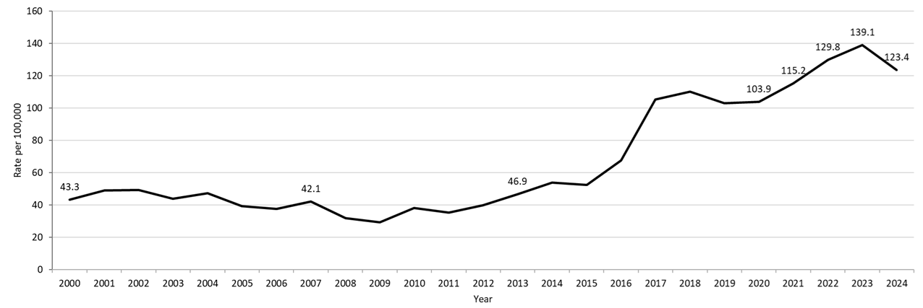
Table: Gonorrhea Annual Case Counts
Year | Count
2000 | 2,748
2001 | 3,121
2002 | 3,156
2003 | 2,819
2004 | 3,038
2005 | 2,542
2006 | 2,429
2007 | 2,729
2008 | 2,077
2009 | 1,917
2010 | 2,495
2011 | 2,345
2012 | 2,665
2013 | 3,156
2014 | 3,657
2015 | 3,592
2016 | 4,638
2017 | 7,293
2018 | 7,660
2019 | 7,170
2020 | 7,303
2021 | 8,099
2022 | 9,218
2023 | 9,779
2024 | 8,678

Footnotes for Slide 9
Data are current as of 06/02/2025 and are subject to change.
Data Source: Massachusetts Department of Public Health/Bureau of Infectious Disease and Laboratory Sciences/ Division of STD Prevention and STD-HIV Surveillance.
Population denominators estimated by the University of Massachusetts Donahue Institute using a modified Hamilton-Perry model (Strate S, et al. Small Area Population Estimates for 2011 through 2020 report, Oct 2016).
1. Please consider the impact of the COVID-19 pandemic on infectious disease screening, treatment and surveillance in the interpretation of 2020-2022 data.

Slide 10 – Rate of Confirmed Gonorrhea Cases by Gender¹, Massachusetts, 2010-2024²
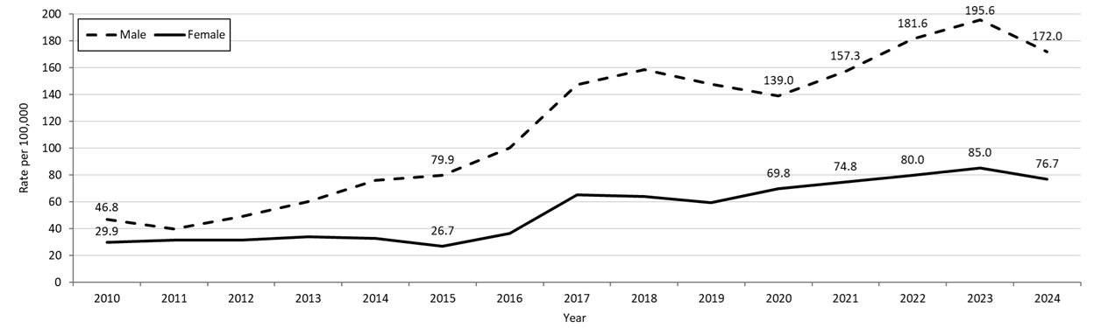
Table: Gonorrhea Annual Case Counts by Current Gender
Year | Females | Males
2010 | 1,012 | 1,483
2011 | 1,069 | 1,275
2012 | 1,085 | 1,579
2013 | 1,181 | 1,969
2014 | 1,144 | 2,500
2015 | 940 | 2,648
2016 | 1,283 | 3,344
2017 | 2,328 | 4,952
2018 | 2,293 | 5,347
2019 | 2,132 | 5,002
2020 | 2,526 | 4,741
2021 | 2,707 | 5,367
2022 | 2,894 | 6,196
2023 | 3,077 | 6,672
2024 | 2,776 | 5,867
Note: There were cases reported among transgender individuals in 2014 through 2024. In 2024, there were 26 cases of gonorrhea among transgender identified individuals and 9 other individuals with unknown gender not included on this slide.
Footnotes for Slide 10
Data are current as of 06/02/2025 and are subject to change.
Data Source: Massachusetts Department of Public Health/Bureau of Infectious Disease and Laboratory Sciences/ Division of STD Prevention and STD-HIV Surveillance.
Population denominators estimated by the University of Massachusetts Donahue Institute using a modified Hamilton-Perry model (Strate S, et al. Small Area Population Estimates for 2011 through 2020 report, Oct 2016).
1. In 2024, there were 26 individuals of transgender experience reported in our data system who do not have current gender documented. These cases were excluded since population estimates for individuals of transgender experience are not available at this time. There were 9 other individuals with unknown gender which are not included in this slide.
2. Please consider the impact of the COVID-19 pandemic on infectious disease screening, treatment and surveillance in the interpretation of 2020-2022 data.

Slide 11 – Gonorrhea Among Individuals of Transgender Experience¹, Massachusetts, 2015-2024²
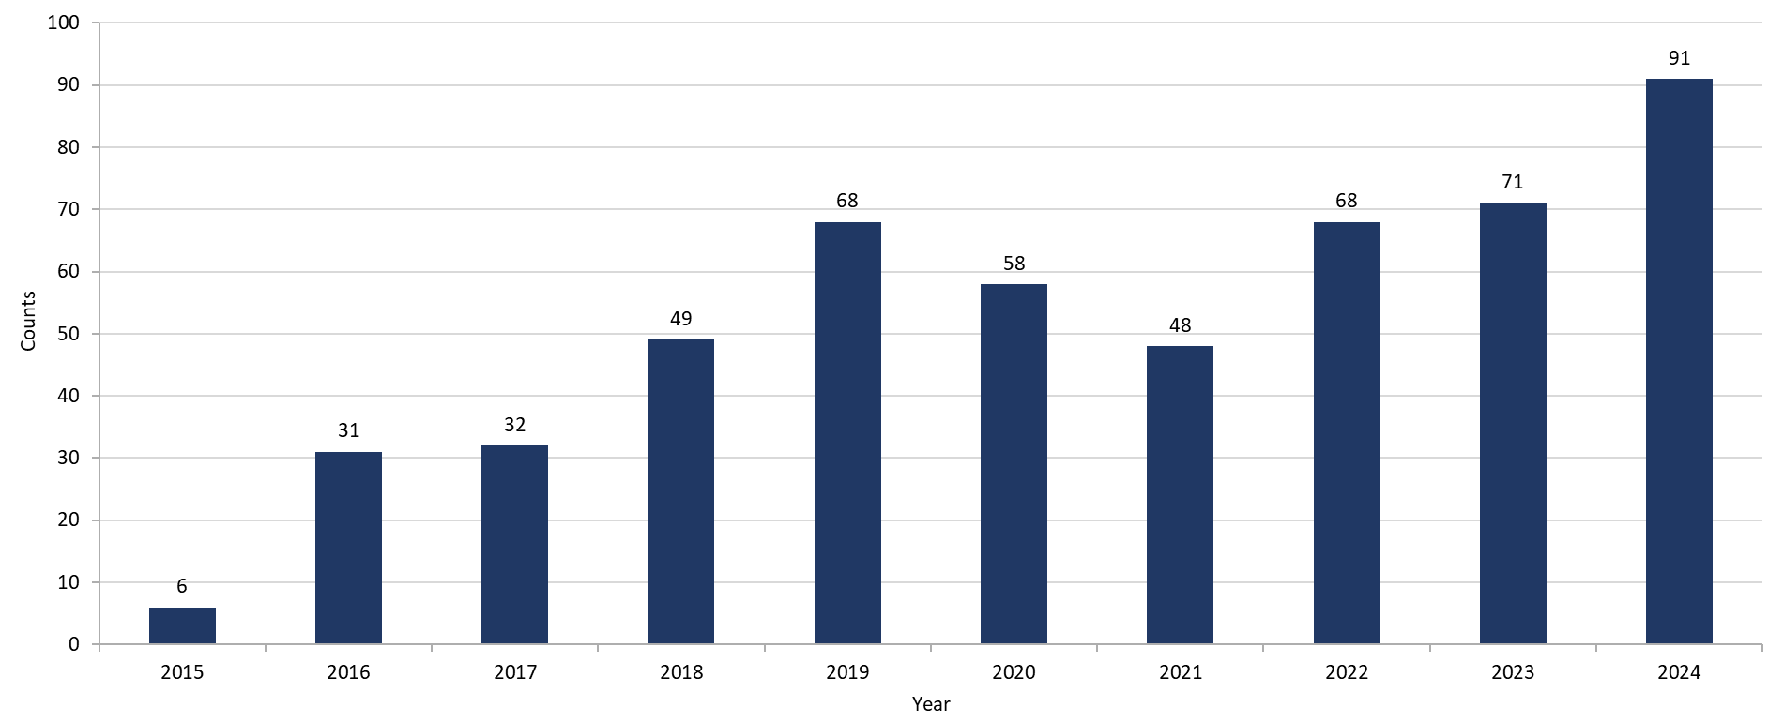

Footnotes for Slide 11
Data are current as of 06/02/2025 and are subject to change.
Data Source: Massachusetts Department of Public Health/Bureau of Infectious Disease and Laboratory Sciences/ Division of STD Prevention and STD-HIV Surveillance.
1. All individuals of transgender experience are included in this graph regardless of current gender.
2. Please consider the impact of the COVID-19 pandemic on infectious disease screening, treatment and surveillance in the interpretation of 2020-2022 data.

Slide 12 – Confirmed Gonorrhea Rates by County and Statewide, Massachusetts, 2022-2024¹
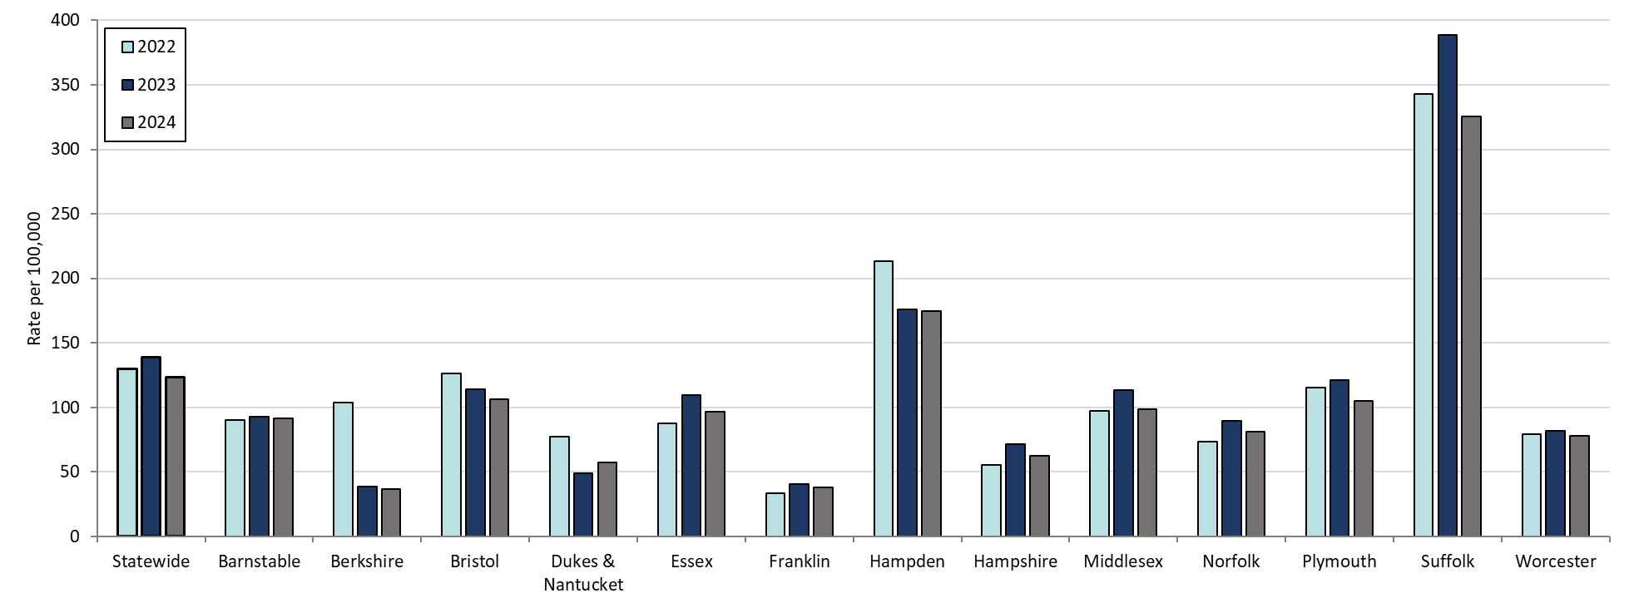
Table: Rates of Gonorrhea by County and Statewide
County | 2022 | 2023 | 2024
Barnstable | 90.4 | 92.6 | 91.7
Berkshire | 103.9 | 38.8 | 36.4
Bristol | 126.2 | 114.1 | 106.4
Dukes/Nantucket | 77.5 | 48.8 | 57.4
Essex | 87.8 | 109.4 | 96.9
Franklin | 33.8 | 40.8 | 38.0
Hampden | 213.4 | 175.8 | 175.0
Hampshire | 55.5 | 71.5 | 62.2
Middlesex | 97.6 | 113.4 | 98.8
Norfolk | 73.4 | 89.5 | 81.3
Plymouth | 115.7 | 120.9 | 104.7
Suffolk | 343.0 | 388.6 | 325.6
Worcester | 79.3 | 81.9 | 77.8
Statewide | 129.8 | 139.1 | 123.4
Footnotes for Slide 12
Data are current as of 06/02/2025 and are subject to change.
Data Source: Massachusetts Department of Public Health/Bureau of Infectious Disease and Laboratory Sciences/ Division of STD Prevention and STD-HIV Surveillance.
Population denominators estimated by the University of Massachusetts Donahue Institute using a modified Hamilton-Perry model (Strate S, et al. Small Area Population Estimates for 2011 through 2020 report, Oct 2016).
1. Please consider the impact of the COVID-19 pandemic on infectious disease screening, treatment and surveillance in the interpretation of 2022 data.

Slide 13 – Massachusetts STI Trends, Infectious Syphilis: 2000 - 2024

Slide 14 – Confirmed and Probable Infectious Syphilis¹ Rates, Massachusetts, 2000-2024²
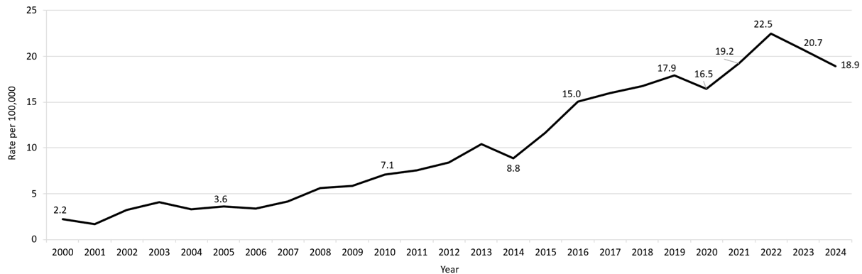
Table: Infectious Syphilis Annual Case Counts
Year | Count
2000 | 141
2001 | 105
2002 | 207
2003 | 258
2004 | 209
2005 | 231
2006 | 217
2007 | 268
2008 | 367
2009 | 379
2010 | 465
2011 | 500
2012 | 561
2013 | 701
2014 | 600
2015 | 798
2016 | 1,034
2017 | 1,107
2018 | 1,167
2019 | 1,244
2020 | 1,159
2021 | 1,352
2022 | 1,593
2023 | 1,449
2024 | 1,329

Footnotes for Slide 14
Data are current as of 06/02/2025 and are subject to change.
Data Source: Massachusetts Department of Public Health/Bureau of Infectious Disease and Laboratory Sciences/ Division of STD Prevention and STD-HIV Surveillance.
Population denominators estimated by the University of Massachusetts Donahue Institute using a modified Hamilton-Perry model (Strate S, et al. Small Area Population Estimates for 2011 through 2020 report, Oct 2016).
1. Infectious syphilis is defined as primary, secondary and early latent stages of syphilis within one year of infection.
2. Please consider the impact of the COVID-19 pandemic on infectious disease screening, treatment and surveillance in the interpretation of 2020-2022 data.

Slide 15 – Confirmed and Probable Infectious Syphilis¹ Rates by Gender,² Massachusetts, 2010-2024³
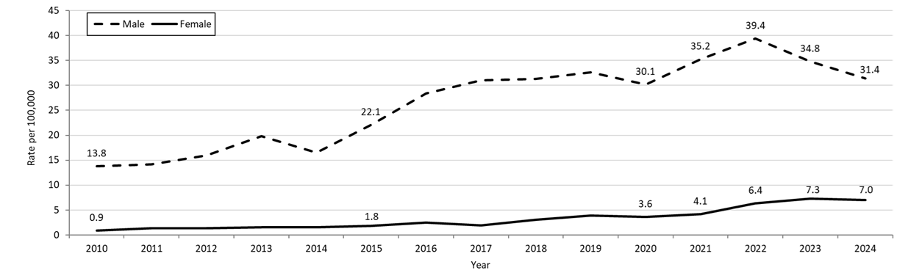

Table: Infectious Syphilis Annual Case Counts by Current Gender
Year | Females | Males
2010 | 29 | 436
2011 | 46 | 454
2012 | 46 | 515
2013 | 55 | 646
2014 | 53 | 545
2015 | 65 | 732
2016 | 87 | 947
2017 | 67 | 1,040
2018 | 110 | 1,055
2019 | 139 | 1,102
2020 | 130 | 1,028
2021 | 150 | 1,201
2022 | 233 | 1,357
2023 | 264 | 1,183
2024 | 253 | 1,071

Note: Infectious syphilis is defined as primary, secondary and early latent stages of syphilis within one year of infection.
There were cases reported among transgender individuals in 2015 through 2024. They are classified on this slide based on their current gender. In 2024, there were 5 cases of infectious syphilis among transgender identified individuals not included on this slide as MA DSTDP does not have current gender information for those individuals.

Footnotes for Slide 15
Data are current as of 06/02/2025 and are subject to change.
Data Source: Massachusetts Department of Public Health/Bureau of Infectious Disease and Laboratory Sciences/ Division of STD Prevention and STD-HIV Surveillance.
Population denominators estimated by the University of Massachusetts Donahue Institute using a modified Hamilton-Perry model (Strate S, et al. Small Area Population Estimates for 2011 through 2020 report, Oct 2016).
1. Infectious syphilis is defined as primary, secondary and early latent stages of syphilis within one year of infection.
2. In 2024, there were 5 individuals of transgender experience reported in our data system who do not have current gender documented. These cases were excluded since population estimates for individuals of transgender experience are not available at this time.
3. Please consider the impact of the COVID-19 pandemic on infectious disease screening, treatment and surveillance in the interpretation of 2020-2022 data.

Slide 16 – Infectious Syphilis¹ Reported Cases by Race/Ethnicity², Massachusetts, 2015-2024³
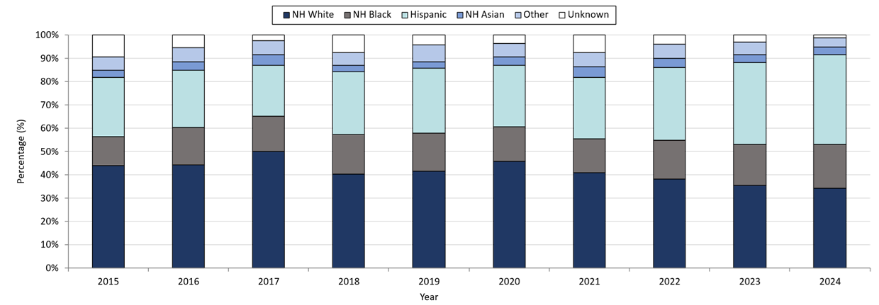

Table: Infectious Syphilis Annual Case Counts
Year | Count
2015 | 789
2016 | 1,034
2017 | 1,107
2018 | 1,167
2019 | 1,244
2020 | 1,159
2021 | 1,352
2022 | 1,593
2023 | 1,449
2024 | 1,329

Note: Infectious syphilis is defined as primary, secondary and early latent (non-primary/non-secondary) stages of syphilis within one year of infection.

Footnotes for Slide 16
Data are current as of 06/02/2025 and are subject to change.
Data Source: Massachusetts Department of Public Health/Bureau of Infectious Disease and Laboratory Sciences/ Division of STD Prevention and STD-HIV Surveillance.
Note: National Notifiable Diseases Surveillance System (NNDSS) Congenital Syphilis case definition was updated in 2014.
1. Infectious syphilis is defined as primary, secondary and early latent stages of syphilis within one year of infection.
2. Other Race/Ethnicity includes individuals who identify as American Indian/ Pacific Islander/ Alaskan Native.
3. Please consider the impact of the COVID-19 pandemic on infectious disease screening, treatment and surveillance in the interpretation of 2020-2022 data.

Slide 17 – Confirmed and Probable Infectious Syphilis¹ Among Individuals of Transgender Experience², Massachusetts, 2015-2024^{3, 4}
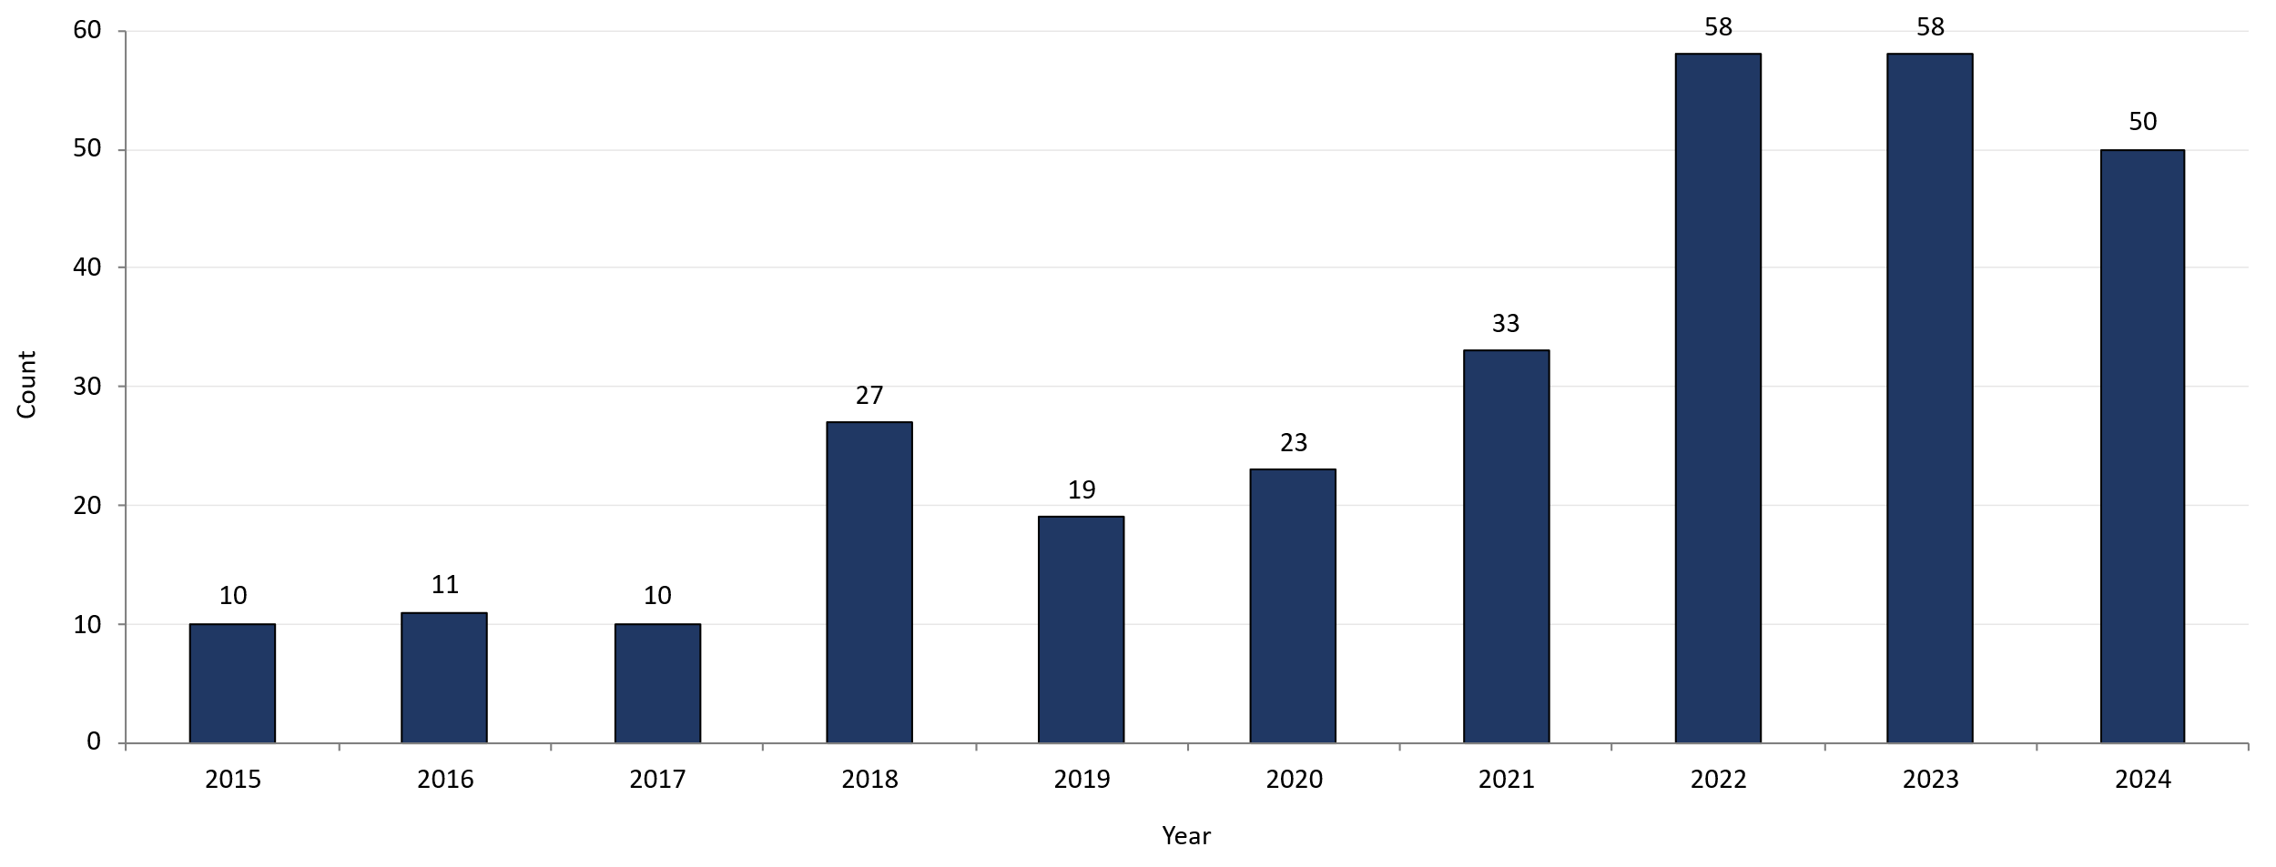

Footnotes for Slide 17
Data are current as of 06/02/2025 and are subject to change.
Data Source: Massachusetts Department of Public Health/Bureau of Infectious Disease and Laboratory Sciences/ Division of STD Prevention and STD-HIV Surveillance.
1. Infectious syphilis is defined as primary, secondary and early latent stages of syphilis within one year of infection.
2. All individuals of transgender experience are included in this graph regardless of current gender.
3. Please consider the impact of the COVID-19 pandemic on infectious disease screening, treatment and surveillance in the interpretation of 2020-2022 data.
4. In 2022, a retrospective verification project was conducted to improve data quality in capturing current gender information.

Slide 18 – Confirmed and Probable Infectious Syphilis¹ Rates by Stage of Infection, Massachusetts, 2010–2024²
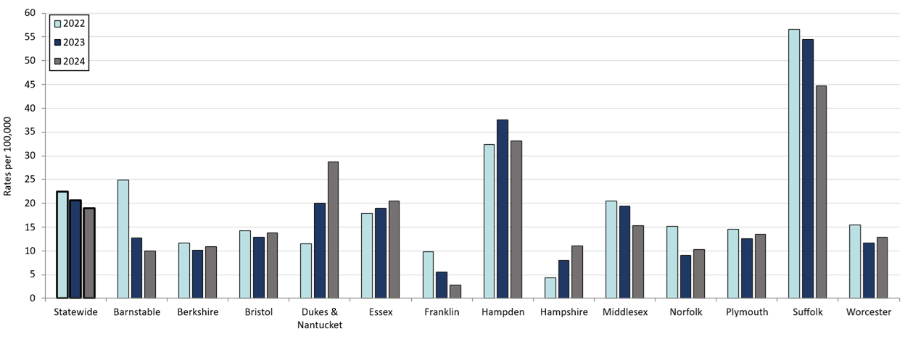
Table: Confirmed and Probable Infectious Syphilis Rates by County and Statewide
County | 2022 | 2023 | 2024
Barnstable | 24.9 | 12.7 | 10.0
Berkshire | 11.6 | 10.1 | 10.9
Bristol | 14.2 | 12.8 | 13.8
Dukes/Nantucket | 11.5 | 20.1 | 28.7
Essex | 17.9 | 19.0 | 20.5
Franklin | 9.9 | 5.6 | 2.8
Hampden | 32.4 | 37.6 | 33.1
Hampshire | 4.3 | 8.0 | 11.1
Middlesex | 20.5 | 19.4 | 15.3
Norfolk | 15.2 | 9.1 | 10.3
Plymouth | 14.5 | 12.6 | 13.4
Suffolk | 56.6 | 54.4 | 44.7
Worcester | 15.5 | 11.7 | 12.8
Statewide | 22.5 | 20.7 | 18.9

Footnotes for Slide 18
Data are current as of 06/02/2025 and are subject to change.
Data Source: Massachusetts Department of Public Health/Bureau of Infectious Disease and Laboratory Sciences/ Division of STD Prevention and STD-HIV Surveillance.
Population denominators estimated by the University of Massachusetts Donahue Institute using a modified Hamilton-Perry model (Strate S, et al. Small Area Population Estimates for 2011 through 2020 report, Oct 2016).
1. Infectious syphilis is defined as primary, secondary and early latent stages of syphilis within one year of infection.
2. Please consider the impact of the COVID-19 pandemic on infectious disease screening, treatment and surveillance in the interpretation of 2022 data.

Slide 19 – Confirmed and Probable Infectious Syphilis¹ Rates by Stage of Infection, Massachusetts, 2015-2024²
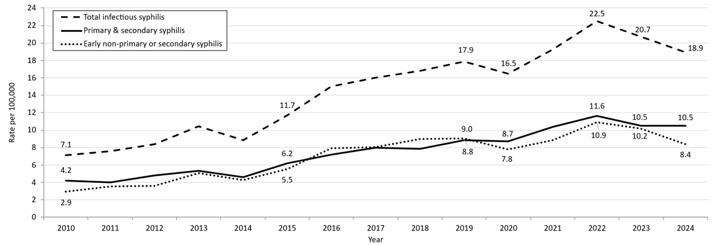
Table: Infectious Syphilis Annual Case Counts
Year | Count
2010 | 465
2011 | 500
2012 | 561
2013 | 701
2014 | 600
2015 | 798
2016 | 1,034
2017 | 1,107
2018 | 1,167
2019 | 1,244
2020 | 1,159
2021 | 1,352
2022 | 1,579
2023 | 1,449
2024 | 1,329
Note: Infectious syphilis is defined as primary, secondary and early latent (non-primary/non-secondary) stages of syphilis within one year of infection.
Footnotes for Slide 19
Data are current as of 06/02/2025 and are subject to change.
Data Source: Massachusetts Department of Public Health/Bureau of Infectious Disease and Laboratory Sciences/ Division of STD Prevention and STD-HIV Surveillance.
Population denominators estimated by the University of Massachusetts Donahue Institute using a modified Hamilton-Perry model (Strate S, et al. Small Area Population Estimates for 2011 through 2020 report, Oct 2016).
1. Infectious syphilis is defined as primary, secondary and early latent stages of syphilis within one year of infection.
2. Please consider the impact of the COVID-19 pandemic on infectious disease screening, treatment and surveillance in the interpretation of 2020-2022 data.

Slide 20 – Infectious Syphilis¹ Reported Cases by Sexual Risk Categories, Massachusetts, 2015-2024²

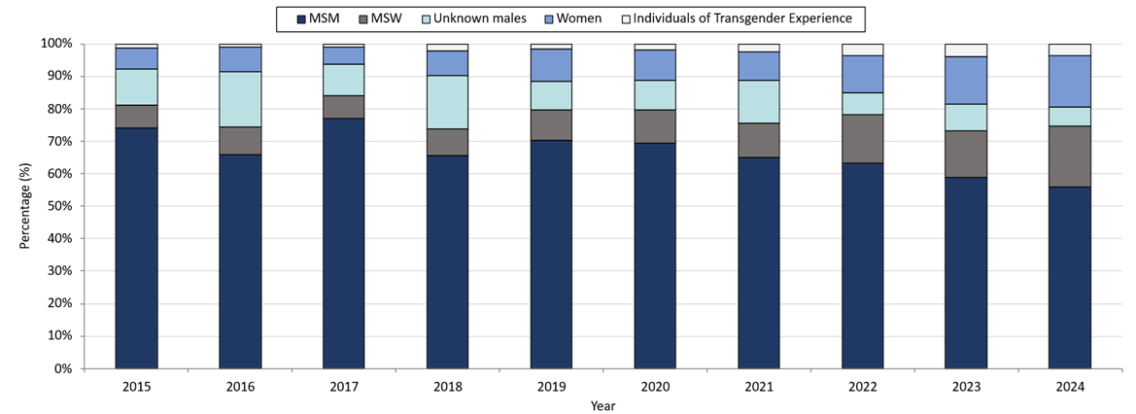

Table: Infectious Syphilis Annual Case Counts
Year | Count
2015 | 798
2016 | 1,034
2017 | 1,107
2018 | 1,167
2019 | 1,244
2020 | 1,159
2021 | 1,352
2022 | 1,593
2023 | 1,449
Note: Infectious syphilis is defined as primary, secondary and early latent (non-primary/non-secondary) stages of syphilis within one year of infection.
Footnotes for Slide 20
Data are current as of 06/02/2025 and are subject to change.
Data Source: Massachusetts Department of Public Health/Bureau of Infectious Disease and Laboratory Sciences/ Division of STD Prevention and STD-HIV Surveillance.
Note: National Notifiable Diseases Surveillance System (NNDSS) Congenital Syphilis case definition was updated in 2014.
1. Infectious syphilis is defined as primary, secondary and early latent stages of syphilis within one year of infection.
2. Please consider the impact of the COVID-19 pandemic on infectious disease screening, treatment and surveillance in the interpretation of 2020-2022 data.
3. The MSM (men who have sex with men) category includes MSMT, MSMW, MSMWT, and MST with “W” referring to women and “T” referring to individuals of transgender experience.

Slide 21 – Congenital Syphilis Cases and Rate of Confirmed and Probable Infectious Syphilis¹ Among Persons of Reproductive Potential Ages 15 to 49 Years, Massachusetts, 2010-2024²

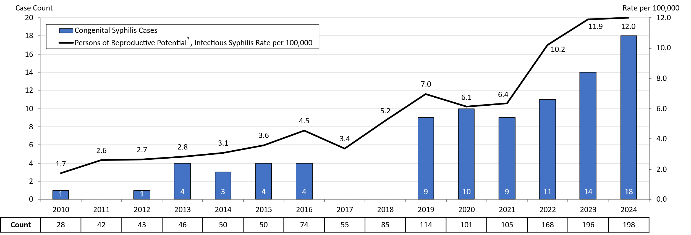

Table: Infectious Syphilis Cases Among Persons of Reproductive Potential
Year | Count
2010 | 28
2011 | 42
2012 | 43
2013 | 46
2014 | 50
2015 | 50
2016 | 74
2017 | 55
2018 | 85
2019 | 114
2020 | 101
2021 | 105
2022 | 173
2023 | 196
2024 | 198
Note: Infectious syphilis is defined as primary, secondary and early latent (non-primary/non-secondary) stages of syphilis within one year of infection.

Footnotes for Slide 21
Data are current as of 06/02/2025 and are subject to change.
Data Source: Massachusetts Department of Public Health/Bureau of Infectious Disease and Laboratory Sciences/ Division of STD Prevention.
Population denominators estimated by the University of Massachusetts Donahue Institute using a modified Hamilton-Perry model (Strate S, et al. Small Area Population Estimates for 2011 through 2020 report, Oct 2016).
Note: National Notifiable Diseases Surveillance System (NNDSS) Congenital Syphilis case definition was updated in 2014.
1. Infectious syphilis is defined as primary, secondary and early latent stages of syphilis within one year of infection.
2. Please consider the impact of the COVID-19 pandemic on infectious disease screening, treatment and surveillance in the interpretation of 2020-2022 data.
3. Persons of Reproductive Potential refers to individuals thought to be capable of pregnancy ages 15 to 49 years and not known to be assigned sex male at birth.

Slide 22 – Congenital Syphilis Cases Averted, Massachusetts, 2019-2024¹
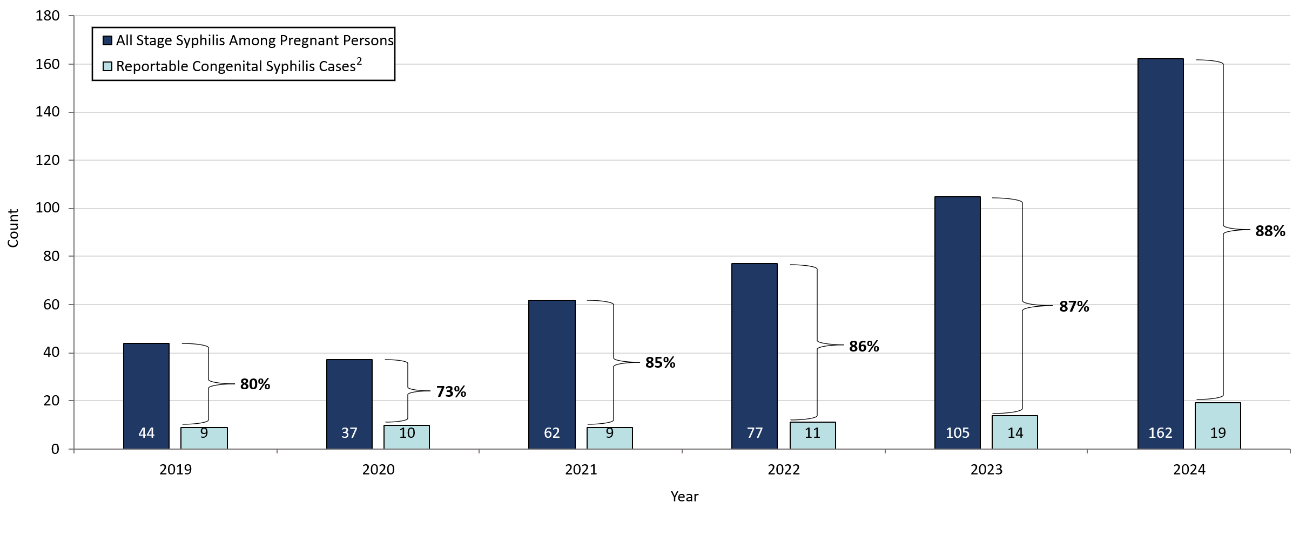
Footnotes for Slide 22
Data are current as of 6/02/2025 and are subject to change.
Data Source: Massachusetts Department of Public Health/Bureau of Infectious Disease and Laboratory Sciences/ Division of STD Prevention and STD-HIV Surveillance.
1. Please consider the impact of the COVID-19 pandemic on infectious disease screening, treatment and surveillance in the interpretation of 2020-2022 data.
2. To review the case definition for reportable congenital syphilis please visit, https://ndc.services.cdc.gov/case-definitions/congenital-syphilis-2015/
Note: “Cases averted” includes all pregnant persons who received treatment for any stage of syphilis during pregnancy. Individuals with uncertain or questionable treatment histories may also be included, as their risk status cannot be fully verified.

Slide 23 – Massachusetts SVI Trends
Chlamydia, Gonorrhea, and Infectious Syphilis: Years 2018 to 2024

Slide 24 – Social Vulnerability Index

- Patient addresses were manually cleaned and geocoded utilizing SAS 9.4
- Social Vulnerability Index (SVI) was based on the patient’s home address.
  - It characterizes community resilience/ability to withstand external hazards.
  - SVI incorporates 15 demographic and socioeconomic variables from the US census.
  - Patients’ census tracts are given a percentile rank and grouped as low, moderately low, moderately high, and high.
  - Higher percentile scores represent greater community vulnerability.
  - The CDC/ATSDR SVI database from 2020 was matched to cases from 2020-2021.
  - The CDC/ATSDR SVI database from 2022 was matched to cases from 2022-2024.

Slide 25 – Confirmed Chlamydia Case Percentages by Social Vulnerability Index, Massachusetts, 2020-2024¹

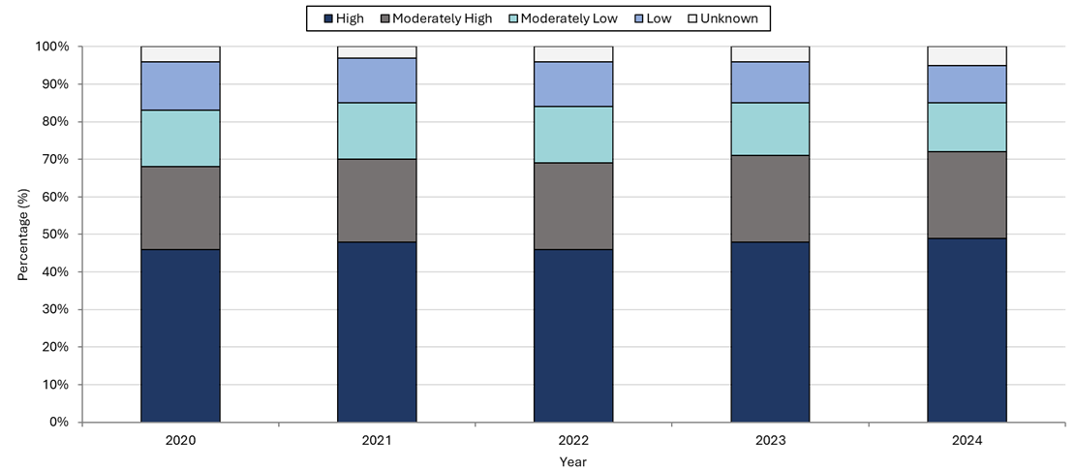

Footnotes for Slide 25
Data are current as of 06/02/2025 and are subject to change.
Data Source: Massachusetts Department of Public Health/Bureau of Infectious Disease and Laboratory Sciences/ Division of STD Prevention and STD-HIV Surveillance.
1. Please consider the impact of the COVID-19 pandemic on infectious disease screening, treatment and surveillance in the interpretation of 2020-2022 data.
2. Unknown category is made up of cases with addresses that were missing, addresses that could not be geocoded, addresses associated with shelters or correctional facilities, or who reported homelessness.

Slide 26 – Confirmed Chlamydia Case Percentages by Social Vulnerability Index and Gender, Massachusetts, 2020-2024^{1, 2}

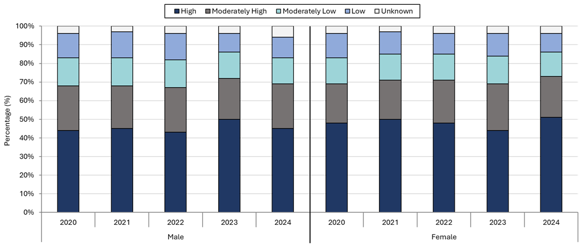

Footnotes for Slide 26
Data are current as of 06/02/2025 and are subject to change.
Data Source: Massachusetts Department of Public Health/Bureau of Infectious Disease and Laboratory Sciences/ Division of STD Prevention and STD-HIV Surveillance.
1. Please consider the impact of the COVID-19 pandemic on infectious disease screening, treatment and surveillance in the interpretation of 2020-2022 data.
2. Individuals of transgender experience that do not have complete gender data may not be included within this slide.
3. Unknown category is made up of cases with addresses that were missing, addresses that could not be geocoded, addresses associated with shelters or correctional facilities, or who reported homelessness.

Slide 27 – Confirmed Gonorrhea Case Percentages by Social Vulnerability Index, Massachusetts, 2020-2024¹

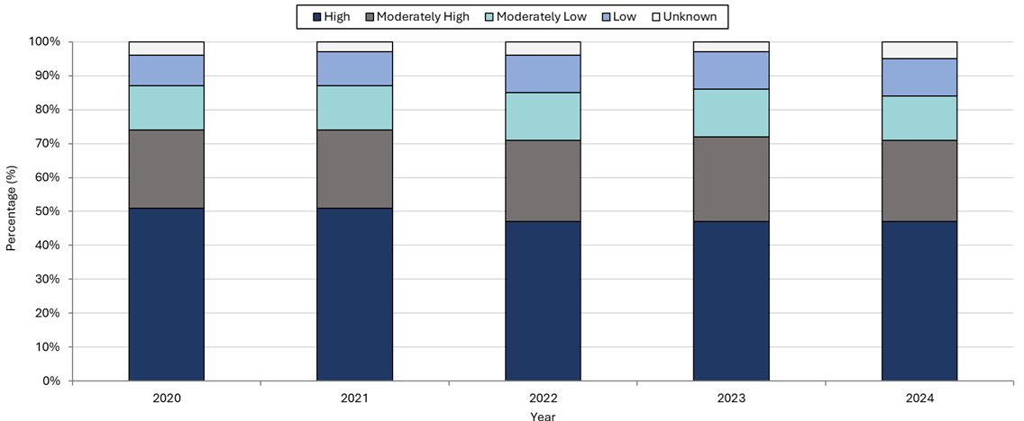
Footnotes for Slide 27
Data are current as of 06/02/2025 and are subject to change.
Data Source: Massachusetts Department of Public Health/Bureau of Infectious Disease and Laboratory Sciences/ Division of STD Prevention and STD-HIV Surveillance.
1. Please consider the impact of the COVID-19 pandemic on infectious disease screening, treatment and surveillance in the interpretation of 2020-2022 data.
2. Unknown category is made up of cases with addresses that were missing, addresses that could not be geocoded, addresses associated with shelters or correctional facilities, or who reported homelessness.

Slide 28 – Confirmed Gonorrhea Case Percentages by Social Vulnerability Index and Gender, Massachusetts, 2020-2024^{1, 2}
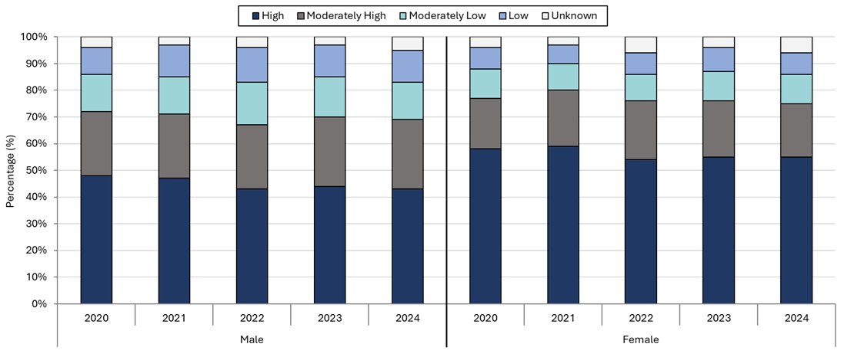
Footnotes for Slide 28
Data are current as of 06/02/2025 and are subject to change.
Data Source: Massachusetts Department of Public Health/Bureau of Infectious Disease and Laboratory Sciences/ Division of STD Prevention and STD-HIV Surveillance.
1. Please consider the impact of the COVID-19 pandemic on infectious disease screening, treatment and surveillance in the interpretation of 2020-2022 data.
2. Individuals of transgender experience that do not have complete gender data may not be included within this slide.
3. Unknown category is made up of cases with addresses that were missing, addresses that could not be geocoded, addresses associated with shelters or correctional facilities, or who reported homelessness.

Slide 29 – Confirmed and Probably Infectious Syphilis¹ Case Percentages by Social Vulnerability Index, Massachusetts, 2020-2024²

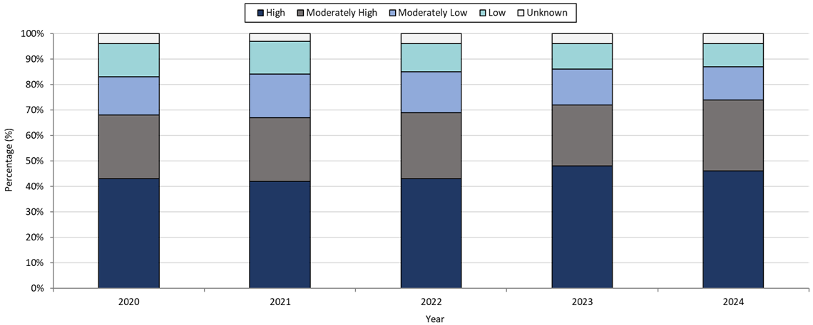

Footnotes for Slide 29
Data are current as of 06/02/2025 and are subject to change.
Data Source: Massachusetts Department of Public Health/Bureau of Infectious Disease and Laboratory Sciences/ Division of STD Prevention and STD-HIV Surveillance.
1. Infectious syphilis is defined as primary, secondary and early latent stages of syphilis within one year of infection.
2. Please consider the impact of the COVID-19 pandemic on infectious disease screening, treatment and surveillance in the interpretation of 2020-2022 data.
3. Unknown category is made up of cases with addresses that were missing, addresses that could not be geocoded, addresses associated with shelters or correctional facilities, or who reported homelessness.

Slide 30 – Confirmed and Probable Infectious Syphilis¹ Case Percentages by Social Vulnerability Index and Gender², Massachusetts, 2020-2024³

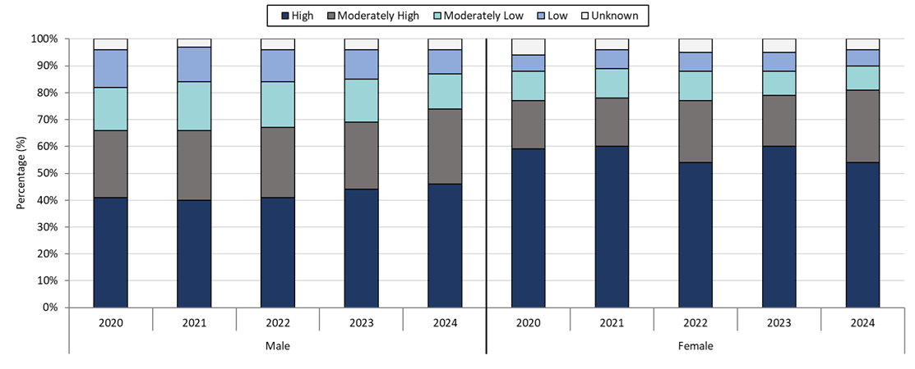
Footnotes for Slide 30
Data are current as of 06/02/2025 and are subject to change.
Data Source: Massachusetts Department of Public Health/Bureau of Infectious Disease and Laboratory Sciences/ Division of STD Prevention and STD-HIV Surveillance.
1. Infectious syphilis is defined as primary, secondary and early latent stages of syphilis within one year of infection.
2. Individuals of transgender experience that do not have complete gender data may not be included within this slide.
3. Please consider the impact of the COVID-19 pandemic on infectious disease screening, treatment and surveillance in the interpretation of 2020-2022 data.
4. Unknown category is made up of cases with addresses that were missing, addresses that could not be geocoded, addresses associated with shelters or correctional facilities, or who reported homelessness.

Slide 31 – Confirmed and Probable Infectious Syphilis¹ Case Percentages by Social Vulnerability Index and Race², Massachusetts, 2020-2024³
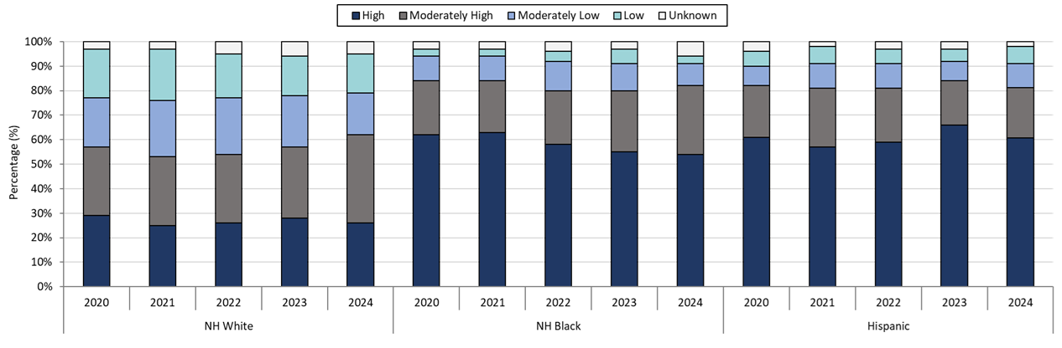

Footnotes for Slide 31
Data are current as of 06/02/2025 and are subject to change.
Data Source: Massachusetts Department of Public Health/Bureau of Infectious Disease and Laboratory Sciences/ Division of STD Prevention and STD-HIV Surveillance.
1. Infectious syphilis is defined as primary, secondary and early latent stages of syphilis within one year of infection.
2. 98 individuals with reported race/ethnicity of NH Asian, Pacific Islander/American Indian/Alaskan Native, or Unknown were not included.
3. Please consider the impact of the COVID-19 pandemic on infectious disease screening, treatment and surveillance in the interpretation of 2020-2022 data.
4. Unknown category includes cases with missing addresses, addresses that couldn’t be geocoded, addresses linked to shelters or correctional facilities, or individuals reporting homelessness.

Slide 32 - Description of 2024 STI Cases
Geographic Distribution
Age, Gender, Sexual Risk Categories, and Race-Ethnicity

Slide 33 – Incidence Rate of Confirmed Chlamydia Cases, per 100,000 Persons¹ by City/Town², Massachusetts, 2024
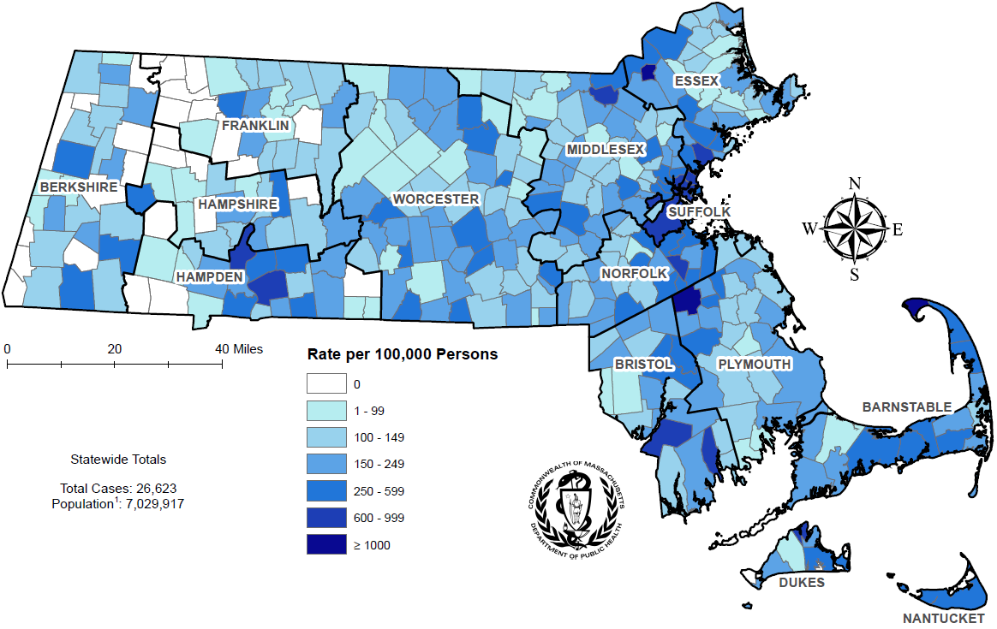

Footnotes for Slide 33
Data are current as of 06/02/2025 and are subject to change.
Data Source: Massachusetts Department of Public Health/Bureau of Infectious Disease and Laboratory Sciences/ Division of STD Prevention and STD-HIV Surveillance.
1. Population denominators estimated by the University of Massachusetts Donahue Institute using a modified Hamilton-Perry model (Strate S, et al. Small Area Population Estimates for 2011 through 2020 report, Oct 2016).
2. There are no city/towns with <10 cases of chlamydia that fall within the top two rate categories (≥600 cases per 100,000).

Slide 34 – Absolute Rate Difference¹ Comparing 2024 to 2020 for Confirmed Chlamydia Cases, per 100,000 Persons² by City/Town, Massachusetts

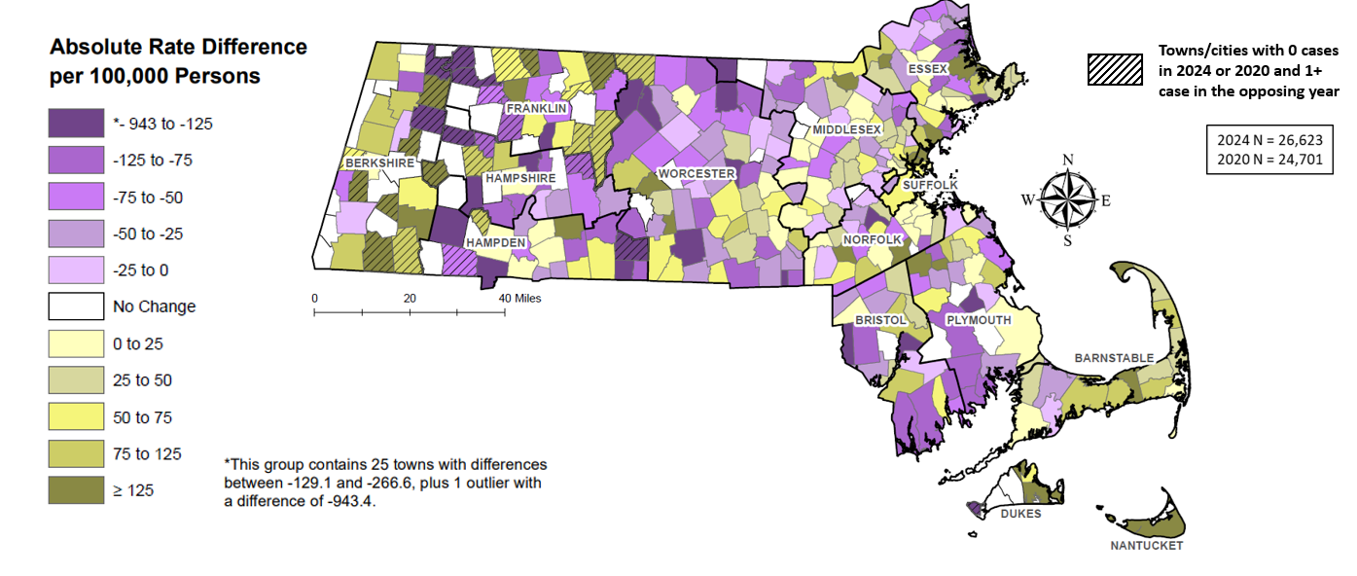

Footnotes for Slide 34
Data are current as of 06/02/2025 and are subject to change.
Data Source: Massachusetts Department of Public Health/Bureau of Infectious Disease and Laboratory Sciences/ Division of STD Prevention and STD-HIV Surveillance.
1. The darker the color in the scheme, the greater the difference between 2024 and 2020 chlamydia case rates with purple coloring indicating rates were higher in 2020 and gold coloring indicating rates were higher in 2024.
2. Population denominators estimated by the University of Massachusetts Donahue Institute using a modified Hamilton-Perry model (Strate S, et al. Small Area Population Estimates for 2011 through 2020 report, Oct 2016).

Slide 35 – Confirmed Chlamydia Case Rates per 100,000 Population by Gender¹ and Age, Massachusetts, 2024

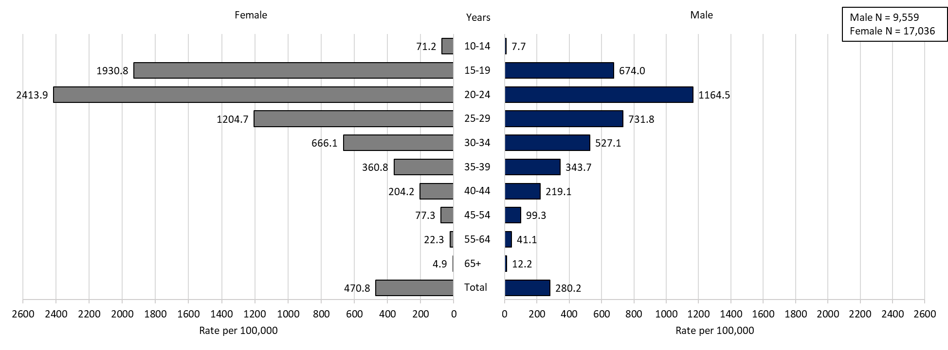

Footnotes for Slide 35
Data are current as of 06/02/2025 and are subject to change.
Data Source: Massachusetts Department of Public Health/Bureau of Infectious Disease and Laboratory Sciences/ Division of STD Prevention and STD-HIV Surveillance.
Population denominators estimated by the University of Massachusetts Donahue Institute using a modified Hamilton-Perry model (Strate S, et al. Small Area Population Estimates for 2011 through 2020 report, Oct 2016).
1. In 2024, there were 9 individuals of transgender experience and 17 other individuals documented in our data system that MA DSTDP does not have current gender information for. 2 individuals had unknown age. These cases were excluded since rate for this population cannot be calculated at this time.

Slide 36 – Incidence Rate of Confirmed Gonorrhea Cases, per 100,000 Persons¹ by City/Town², Massachusetts, 2024
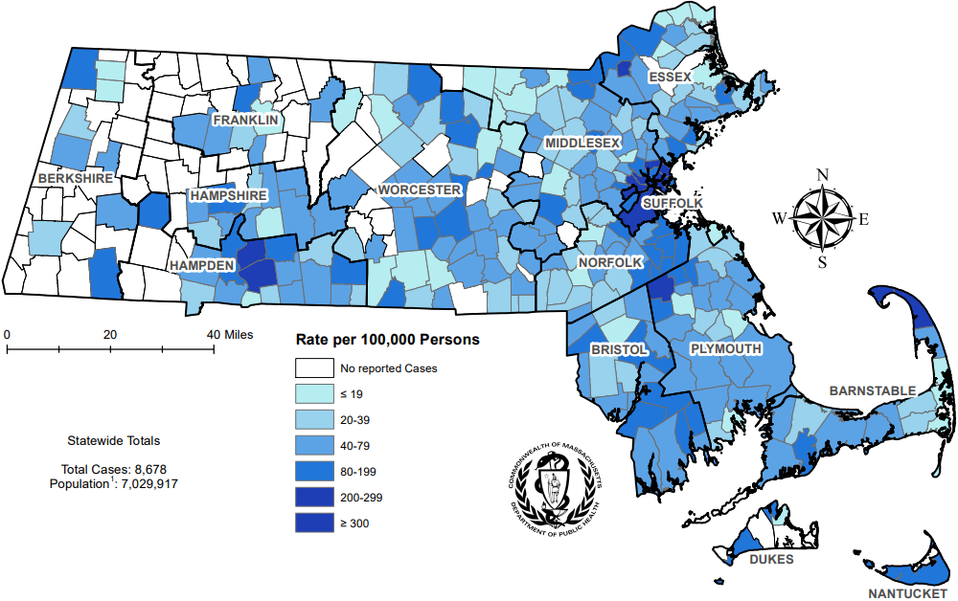

Footnotes for Slide 36
Data are current as of 06/02/2025 and are subject to change.
Data Source: Massachusetts Department of Public Health/Bureau of Infectious Disease and Laboratory Sciences/ Division of STD Prevention and STD-HIV Surveillance.
1. Population denominators estimated by the University of Massachusetts Donahue Institute using a modified Hamilton-Perry model (Strate S, et al. Small Area Population Estimates for 2011 through 2020 report, Oct 2016).
2. There are two city/towns with <10 cases of gonorrhea that fall within the top two rate categories (≥200 cases per 100,000): Chesterfield and Tyringham.

Slide 37 – Absolute Rate Difference¹ Comparing 2024 to 2020 for Confirmed Gonorrhea Cases, per 100,000 Persons² by City/Town, Massachusetts
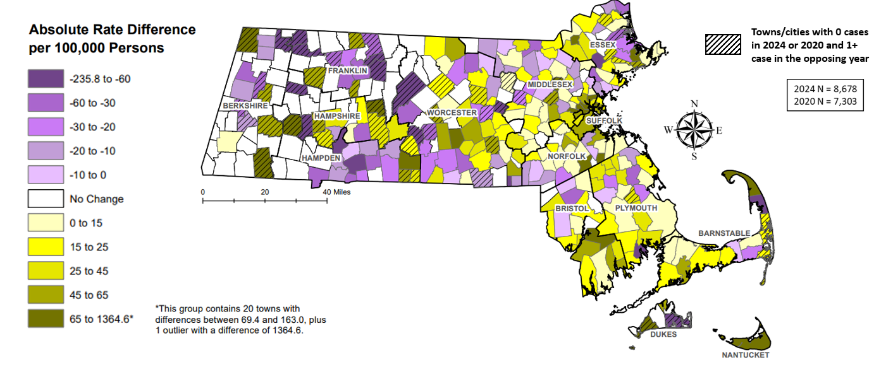

Footnotes for Slide 37
Data are current as of 06/02/2025 and are subject to change.
Data Source: Massachusetts Department of Public Health/Bureau of Infectious Disease and Laboratory Sciences/ Division of STD Prevention and STD-HIV Surveillance.
1. The darker the color in the scheme, the greater the difference between 2024 and 2020 gonorrhea case rates with purple coloring indicating rates were higher in 2020 and gold coloring indicating rates were higher in 2024.
2. Population denominators estimated by the University of Massachusetts Donahue Institute using a modified Hamilton-Perry model (Strate S, et al. Small Area Population Estimates for 2011 through 2020 report, Oct 2016).

Slide 38 – Confirmed Gonorrhea Case Rates per 100,000 Population by Gender¹ and Age, Massachusetts, 2024

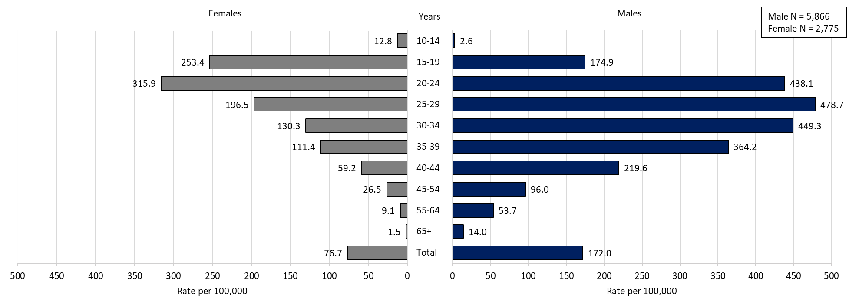

Footnotes for Slide 38
Data are current as of 06/02/2025 and are subject to change.
Data Source: Massachusetts Department of Public Health/Bureau of Infectious Disease and Laboratory Sciences/ Division of STD Prevention and STD-HIV Surveillance.
Population denominators estimated by the University of Massachusetts Donahue Institute using a modified Hamilton-Perry model (Strate S, et al. Small Area Population Estimates for 2011 through 2020 report, Oct 2016).
1. In 2024, there were 26 individuals of transgender experience and 9 other individuals documented in our data system that MA DSTDP does not have current gender information for. 2 individuals had unknown age. These cases were excluded since rate for this population cannot be calculated at this time.

Slide 39 – Incident Rate of Infectious Syphilis¹ Cases, per 100,000 Persons² by City/Town³, Massachusetts, 2024

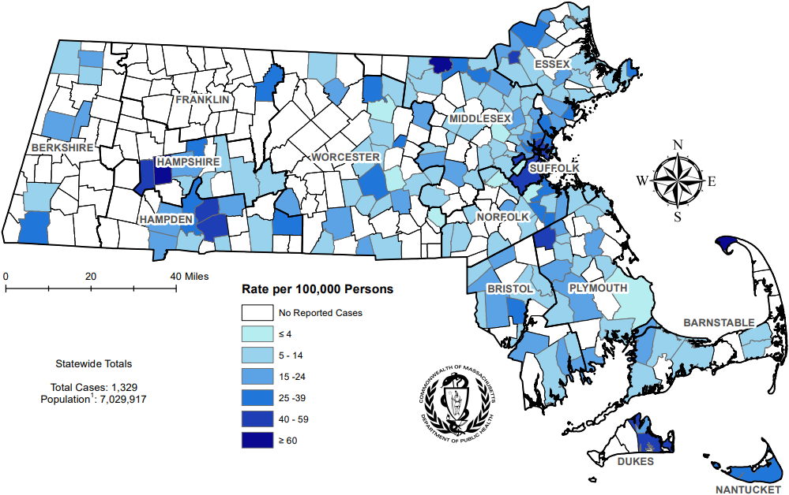

Footnotes for Slide 39
Data are current as of 06/02/2025 and are subject to change.
Data Source: Massachusetts Department of Public Health/Bureau of Infectious Disease and Laboratory Sciences/ Division of STD Prevention and STD-HIV Surveillance.
1. Infectious syphilis is defined as primary, secondary and early latent stages of syphilis within one year of infection.
2. Population denominators estimated by the University of Massachusetts Donahue Institute using a modified Hamilton-Perry model (Strate S, et al. Small Area Population Estimates for 2011 through 2020 report, Oct 2016).
3. There are seven city/towns with <10 cases of syphilis that fall within the top two rate categories (≥40 cases per 100,000): Chesterfield, Tisbury, Boxborough, Oakham, Becket, Huntington, and Winthrop.

Slide 40 – Absolute Rate Difference¹ Comparing 2024 to 2020 for Infectious Syphilis² Cases, per 100,000 Persons³ by City/Town, Massachusetts

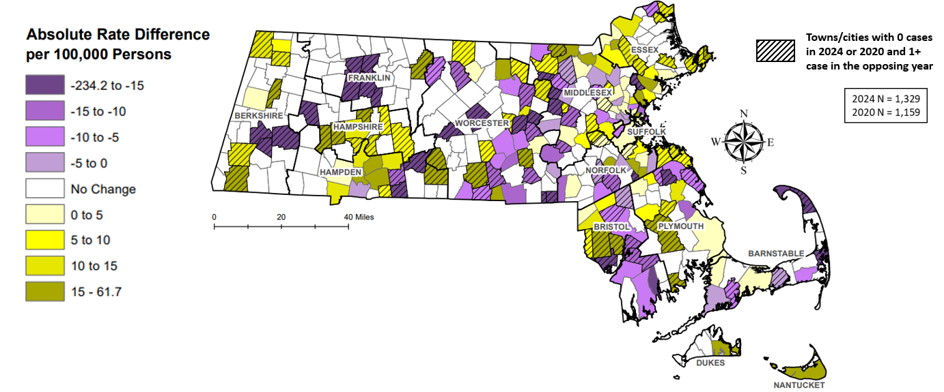

Footnotes for Slide 40
Data are current as of 06/02/2025 and are subject to change.
Data Source: Massachusetts Department of Public Health/Bureau of Infectious Disease and Laboratory Sciences/ Division of STD Prevention and STD-HIV Surveillance.
1. The darker the color in the scheme, the greater the difference between 2024 and 2020 infectious syphilis case rates with purple coloring indicating rates were higher in 2020 and gold coloring indicating rates were higher in 2024.
2. Infectious syphilis is defined as primary, secondary and early latent stages of syphilis within one year of infection.
3. Population denominators estimated by the University of Massachusetts Donahue Institute using a modified Hamilton-Perry model (Strate S, et al. Small Area Population Estimates for 2011 through 2020 report, Oct 2016).

Slide 41 – Confirmed and Probable Infectious Syphilis¹ Cases per 100,000 Population by Gender² and Age, Massachusetts, 2024

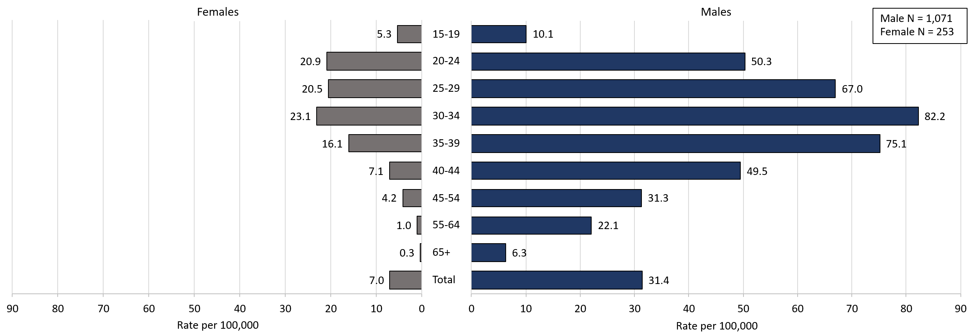

Footnotes for Slide 41
Data are current as of 06/02/2025 and are subject to change.
Data Source: Massachusetts Department of Public Health/Bureau of Infectious Disease and Laboratory Sciences/ Division of STD Prevention and STD-HIV Surveillance.
Population denominators estimated by the University of Massachusetts Donahue Institute using a modified Hamilton-Perry model (Strate S, et al. Small Area Population Estimates for 2011 through 2020 report, Oct 2016).
1. Infectious syphilis is defined as primary, secondary and early latent stages of syphilis within one year of infection.
2. In 2024, there were 5 individuals of transgender experience documented in our data system and MA DSTDP does not have current gender information for those individuals. These cases were excluded since rate for this population cannot be calculated at this time.

Slide 42 – Comparison of the Rate of Confirmed and Probable Infectious Syphilis¹ Cases by Gender² and Race and Ethnicity³, Massachusetts, 2024

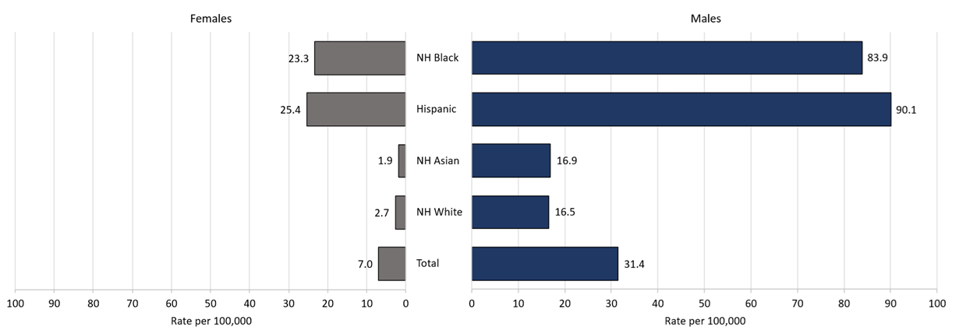

 | Male | Females | Total
Total | 1071 | 253 | 1324
NH White | 385 | 68 | 453
NH Asian | 41 | 5 | 46
Hispanic | 395 | 112 | 507
NH Black | 195 | 57 | 252

Footnotes for Slide 42
Data are current as of 06/02/2025 and are subject to change.
Data Source: Massachusetts Department of Public Health/Bureau of Infectious Disease and Laboratory Sciences/ Division of STD Prevention and STD-HIV Surveillance.
Population denominators estimated by the University of Massachusetts Donahue Institute using a modified Hamilton-Perry model (Strate S, et al. Small Area Population Estimates for 2011 through 2020 report, Oct 2016).
1. Infectious syphilis is defined as primary, secondary and early latent stages of syphilis within one year of infection.
2. In 2024, there were 5 individuals of transgender experience documented in our data system and MA DSTDP does not have current gender information for those individuals. These cases were excluded since rate for this population cannot be calculated at this time.
3. Those cases reported among non-Hispanic/Latinx individuals with other race categories were excluded based on small counts (3.8% of cases). Cases with unknown race and ethnicity were excluded because rates could not be calculated (1.2% of cases).

Slide 43 – HIV Co-infection

Slide 44 – 2024 HIV¹ Co-Infection with Chlamydia and Gonorrhea
- Chlamydia with HIV Co-Infection
  - 2.1% of chlamydia cases were HIV co-infected (N = 26,623)
  - As age increases the proportion of HIV co-infection increases
    - 1.1% of cases in their 20s are HIV co-infected
    - 13.0% of cases 50+ are HIV co-infected
- Gonorrhea with HIV Co-Infection
  - 8.0% of gonorrhea cases were co-infected with HIV (N = 8,678)
  - As age increases the proportion of HIV co-infection increases
    - 4.6% of cases in their 20s are HIV co-infected
    - 19.7% of cases 50+ are HIV co-infected

Slide 45 – 2024 HIV¹ Co-Infection with Infectious Syphilis²
- 25.8% of infectious syphilis cases were co-infected with HIV (N = 1,329)
- As age increases the proportion of HIV co-infection increases
  - 15.8% of cases in their 20s are HIV co-infected
  - 39.6% of cases 50+ are HIV co-infected
- Of individuals co-infected with HIV and infectious syphilis, 79.9% were MSM³ (N = 343), compared with 47.5% for those with no known HIV diagnosis (N = 986).
- Of known MSM individuals infected with infectious syphilis (N = 742), 36.9% were co-infected with HIV.
- 11.7% of co-infected individuals were newly diagnosed with HIV within 30 days of infectious syphilis event date; 88.3% had a prior HIV diagnosis.

Slide 46 – Comparison of Infectious Syphilis¹ Cases by HIV² Co-Infection and Age³, Massachusetts, 2024

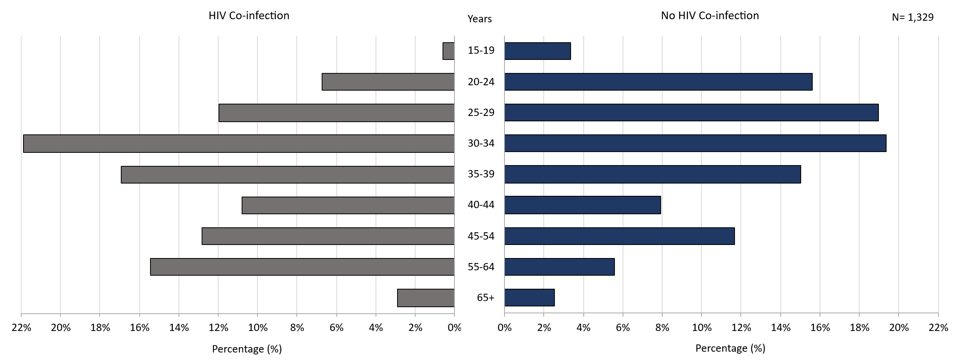
Footnotes for Slide 46
Data are current as of 06/02/2025 and are subject to change.
Data Source: Massachusetts Department of Public Health/Bureau of Infectious Disease and Laboratory Sciences/ Division of STD Prevention and STD-HIV Surveillance.
1. Infectious syphilis is defined as primary, secondary and early latent stages of syphilis within one year of infection.
2. HIV status is based on a full year match with HIV Surveillance data.
3. Individuals younger than 15 years are not included within this slide due to low case counts.

Slide 47 – Comparison of Infectious Syphilis¹ Cases by HIV² Co-Infection and Race/Ethnicity, Massachusetts, 2024

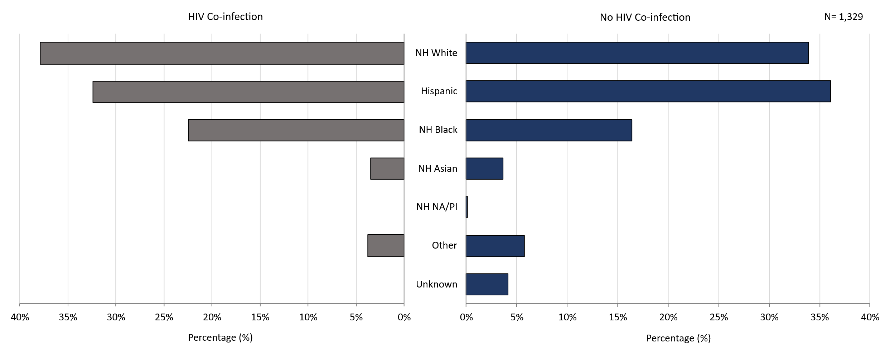
Footnotes for Slide 47
Data are current as of 06/02/2025 and are subject to change.
Data Source: Massachusetts Department of Public Health/Bureau of Infectious Disease and Laboratory Sciences/ Division of STD Prevention and STD-HIV Surveillance.
1. Infectious syphilis is defined as primary, secondary and early latent stages of syphilis within one year of infection.
2. HIV status is based on a full year match with HIV Surveillance data.
3. Individuals younger than 15 years are not included within this slide due to low case counts.

Slide 48 – 2024 Summary
- Chlamydia: The 2024 Massachusetts state rate was 378.7 per 100,000
  - The highest rate of chlamydia cases was among females 20 to 24 years with a rate of 2,413.9 cases per 100,000 population*
- Gonorrhea: The 2024 Massachusetts state rate was 123.4 per 100,000
  - The highest rate of gonorrhea cases was among males 25 to 29 years with a rate of 478.7 cases per 100,000 population
- Infectious Syphilis: The 2024 Massachusetts state rate was 18.9 per 100,000
  - The highest rate of infectious syphilis cases was among males 30 to 34 years with a rate of 82.2 cases per 100,000 population
- Congenital syphilis cases maintained the increased number of reportable cases seen from 2019 to 2024
  - The overall increases in infectious syphilis rates in individuals believed to be biologically capable of pregnancy and the increase in reportable congenital syphilis cases led to a recommendation for universal third trimester screening in 2020, on top of routine screening for syphilis upon entry into prenatal care in Massachusetts.

Slide 49 – Technical Data Notes
- STI and HIV specific laboratory and case management information are reported directly to the Department of Public Health and maintained in the Massachusetts integrated disease surveillance and case management system, MAVEN
- The majority (>90%) of laboratory test results are reported via electronic laboratory reporting
- Case management information is reported via electronic medical record feeds, case reporting forms and collected by epidemiologists
- Data are routinely reviewed, cleaned, and analyzed by surveillance epidemiologists
- Routine reports are shared with internal and external stakeholders
- All data are collected and maintained according to strict confidentiality and security requirements

Slide 50 – Technical Data Notes (Continued)
- Case classifications (confirmed, probable or suspect) are based on CSTE/CDC case definitions for nationally notifiable infectious diseases.
  - For full STI case classifications, see: https://www.cdc.gov/std/statistics/2019/case-definitions.htm
  - All data in this report are accurate as of their analysis date and are subject to change. Common reasons for data changes include amendments to reporting and routine data cleaning.
- Transgender individuals are included in current gender identity categories, except where noted due to incomplete information on current gender identity. Nonbinary gender identity is captured but suppressed according to Massachusetts privacy and confidentiality rules. Collection of transgender data categories began in mid-2014.
- Gender of sex partners categories for this report include: MSM = men who have sex with men, MSW = men who have sex with women, WSM = women who have sex with men, Other = include transgender sexual risk categories and females who have sex with females or both male and female partners, and Unknown are cases reported without sexual risk. These categories are based on patient and provider report and do not necessarily reflect an individual’s sexual identity in relation to gender (i.e. gay, bisexual, heterosexual, etc).

Slide 51 – Coronavirus 2019 (COVID-19): Impact of Other Reportable Infections
- When reviewing 2020-2022 data for Massachusetts, please note the impact of the coronavirus 2019 (COVID-19) pandemic on infectious disease screening, treatment, and surveillance. Nationally, CDC observed a sharp decline in reported STD cases from March-April 2020, compared to March-April 2019.
- Three factors were cited as likely contributing to the initial decrease in reported cases:
  - Reduced screening – many health care clinics limited in-person visits to symptomatic cases or closed
  - Limited resources – many state and local health department STD staff were redirected from routine STD responsibilities to COVID-19 activities, which affected STD tracking capacity and reporting
  - Stay-at-home orders (March 24 through April 7th, 2020) – which were intended to reduce COVID-19 spread may have influenced sexual behaviors and reduced STD transmission¹
- As the impact of the COVID-19 pandemic continues, it’s full effect on case reporting and efforts to control the spread of infectious disease in the Commonwealth has yet to be determined. As such, please interpret 2020 infectious disease data with caution.

Slide 52 – Closing Slide
If you have questions or to request more information: call the Massachusetts Department of Public Health, Division of STD Prevention, at 617-983-6940.

Providers may use this number to report individuals newly diagnosed with a notifiable sexually transmitted infection, including HIV, or request partner services. Partner services is a free and confidential service for individuals recently diagnosed with a priority infection. The client-centered program offers counseling, linkage to other health and social services, anonymous notification of partners who were exposed and assistance with getting testing and treatment. For more information, see: https://www.mass.gov/service-details/partner-services-program-information-for-healthcare-providers)

