**Massachusetts Department of Public Health**

**Bureau of Infectious Disease and Laboratory Sciences**

**Surveillance Data Overview of Sexually Transmitted Infections, Massachusetts, 2000-2023**

*Please note that while the content of this report is the same as the pdf version, the format and pagination have been modified significantly to optimize use with screen readers to ensure access for blind or visually impaired audiences.*

Massachusetts Department of Public Health

Bureau of Infectious Disease and Laboratory Sciences

Division of STD Prevention and HIV Surveillance

March 2024

**Bureau of Infectious Disease and Laboratory Sciences**

**Division of STD Prevention and HIV Surveillance**  
**Massachusetts Department of Public Health**

**Jamaica Plain Campus/State Public Health Laboratory**

305 South Street  
Jamaica Plain, MA 02130

**Questions about this report**

Tel: (617) 983-6490

**To reach the Reporting and Partner Services Line[1]**

Tel: (617) 983-6999

Contents

**Slide 1** **(title page)** - Surveillance Data Overview of Sexually Transmitted Infections, Massachusetts, 2000-2023 4

Slide 2 - Outline 4

Slide 3 (title page) - Chlamydia, Gonorrhea, and Infectious Syphilis: Years 2000 to 2022 4

Slide 4 - Rate of Confirmed Chlamydia Cases, Massachusetts, 2000 to 20231 5

Slide 5 - Rate of Confirmed Chlamydia Cases by Gender1,Massachusetts, 2010 to 20232 6

Slide 6 - Chlamydia among Individuals of Transgender Experience,1,2 Massachusetts, 2015 to 20233 7

Slide 7 - Confirmed Chlamydia Rates by County and Statewide,Massachusetts, 2020-20231 9

Slide 8 - Average Age of Confirmed Chlamydia Cases by Gender1, Massachusetts, 2012 to 20232 10

Slide 9 - Rate of Confirmed Gonorrhea Cases, Massachusetts, 2000 to 20231 11

Slide 10 - Rate of Confirmed Gonorrhea Cases by Gender1,Massachusetts, 2010-20232 12

Slide 11: Gonorrhea Among Individuals of Transgender Experience1, Massachusetts, 2015 to 20232 14

Slide 12: Confirmed Gonorrhea Rates by County and Statewide,Massachusetts, 2020-20231 15

Slide 13: Rate of Confirmed and Probable Infectious Syphilis1 Cases by Gender,2 Massachusetts, 2010-20233 16

16

Slide 14: Rate of Confirmed and Probable Infectious Syphilis1 Cases by Gender,2 Massachusetts, 2010-20233 18

Slide 15: Infectious Syphilis1 Reported Cases by Race/Ethnicity2, Massachusetts, 2015-20233 20

Slide 16: Confirmed and Probable Infectious Syphilis1 Among Individuals of Transgender Experience2, Massachusetts, 2015 to 20233, 4 21

Slide 17: Confirmed and Probable Infectious Syphilis1 Rates by County and Statewide,Massachusetts, 2020-20232 22

Slide 18 – Confirmed and Probable Infectious Syphilis1 Rates by Stage of Infection, Massachusetts, 2010–20232 24

Slide 19 – Infectious Syphilis1 Reported Cases by Gender of Sex Partners, Massachusetts, 2015-20232 26

Slide 20 - Congenital Syphilis Cases and Rate of Confirmed and Probable Infectious Syphilis1 Among Persons of Reproductive Potential Ages 15 to 49 Years, Massachusetts, 2010-20232 27

Slide 21 (title page) - Comparison of Pregnant Person with All Stage Syphilis and Reportable Congenital Syphilis with Proportion of Congenital Cases Averted, Massachusetts, 2019 – 2023 28

Slide 22 (title page) - Chlamydia, Gonorrhea, and Infectious Syphilis: Years 2018 to 2023 29

Slide 23 - Social Vulnerability Index 29

Slide 24 - Confirmed Chlamydia Case Percentages by Social Vulnerability Index, Massachusetts, 2018-20231 31

Slides 25- Confirmed Chlamydia Case Percentages by Social Vulnerability Index and Gender, Massachusetts, 2018- 20231,2 32

Slide 26: Confirmed Gonorrhea Case Percentages by Social Vulnerability Index, Massachusetts, 2018-20231 33

Slide 27: Confirmed Gonorrhea Case Percentages by Social Vulnerability Index and Gender, Massachusetts, 2018-20231,2 34

Slide 28: Confirmed and Probably Infectious Syphilis1 Case Percentages by Social Vulnerability Index, Massachusetts, 2018- 20232 35

Slide 29: Confirmed and Probable Infectious Syphilis1 Case Percentages by Social Vulnerability Index and Gender2, Massachusetts, 2018-20233 36

Slide 30: Confirmed and Probable Infectious Syphilis1 Case Percentages by Social Vulnerability Index and Race, Massachusetts, 2018- 20232 37

Slide 31: Section Break, Description of 2023 STI Cases 38

Slide 32: Incident Rate of Confirmed Chlamydia Cases, per 100,000 Persons1 by City/Town2, Massachusetts, 20233 38

Slide 33: Absolute Rate Difference1 Comparing 2023 to 2019 for Confirmed Chlamydia Cases, per 100,000 Persons2 by City/Town, Massachusetts 39

Slide 34: Confirmed Chlamydia Case Rates per 100,000 Population by Gender1 and Age, Massachusetts, 20232 40

Slide 35: Incident Rate of Confirmed Gonorrhea Cases, per 100,000 Persons1 by City/Town2, Massachusetts, 20233 41

Slide 36: Absolute Rate Difference1 Comparing 2023 to 2019 for Confirmed Gonorrhea Cases, per 100,000 Persons2 by City/Town, Massachusetts 42

Slide 37: Confirmed Gonorrhea Case Rates per 100,000 Population by Gender1 and Age, Massachusetts, 20232 43

Slide 38: Incident Rate of Infectious Syphilis1 Cases, per 100,000 Persons2 by City/Town, Massachusetts, 20233 44

Slide 39: Absolute Rate Difference1 Comparing 2023 to 2019 for Infectious Syphilis2 Cases, per 100,000 Persons3 by City/Town, Massachusetts 45

Slide 40: Confirmed and Probable Infectious Syphilis1 Cases per 100,000 Population by Gender2 and Age, Massachusetts, 20233 46

Slide 41: Comparison of the Rate of Confirmed and Probable Infectious Syphilis1 Cases by Gender2 and Race and Ethnicity3, Massachusetts, 20234 47

Slide 42: Section Break, HIV Co-infection 48

Slide 43: 20231 HIV2 Co-Infected Chlamydia and Gonorrhea Cases 48

Slide 44: 20231 HIV2 Co-Infected Infectious Syphilis Cases3 48

Slide 45: Comparison of Infectious Syphilis1 Cases by HIV2 Co-Infection Status and Age3, Massachusetts, 20234 49

Slide 46: Comparison of Infectious Syphilis1 Cases by HIV2 Co-Infection and Race/Ethnicity, Massachusetts, 20233 50

Slide 47: 2023 Summary Slide 50

Slide 48: Technical Data Notes 52

Slide 50: Coronavirus 2019 (COVID-19): Impact of Other Reportable Infections 53

Slide 51: Closing Slide 53

**Slide Descriptions**

# **Slide 1** **(title page)** - Surveillance Data Overview of Sexually Transmitted Infections, Massachusetts, 2000-2023

# Slide 2 - Outline

Sexually Transmitted Infection (STI) Trends and Descriptions:

General STI Trends Through 2023

Chlamydia

Gonorrhea

Infectious syphilis

Descriptions of 2023 STI Cases

Social Vulnerability Index Trends (2023)

HIV/STI Co-infection and Sexual Risk (2023)

Summary

Technical Notes

# Slide 3 (title page) - Chlamydia, Gonorrhea, and Infectious Syphilis: Years 2000 to 2022

# Slide 4 - Rate of Confirmed Chlamydia Cases, Massachusetts, 2000 to 20231

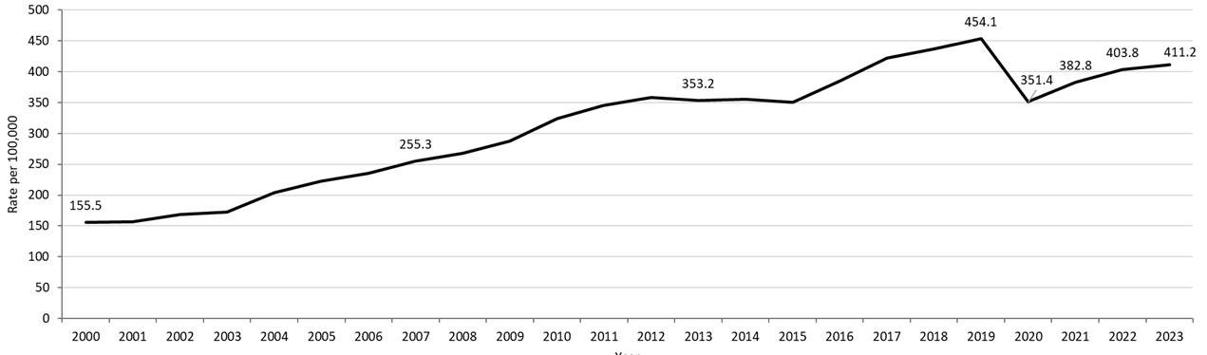

**Table: Chlamydia Annual Case Counts**

|  |  |
| --- | --- |
| **Year** | **Count** |
| 2000 | 9,872 |
| 2001 | 9,969 |
| 2002 | 10,755 |
| 2003 | 11,041 |
| 2004 | 13,120 |
| 2005 | 14,386 |
| 2006 | 15,253 |
| 2007 | 16,566 |
| 2008 | 17,441 |
| 2009 | 18,796 |
| 2010 | 21,211 |
| 2011 | 22,851 |
| 2012 | 23,930 |
| 2013 | 23,789 |
| 2014 | 24,143 |
| 2015 | 23,944 |
| 2016 | 26,478 |
| 2017 | 29,177 |
| 2018 | 30,360 |
| 2019 | 31,633 |
| 2020 | 24,701 |
| 2021 | 26,912 |
| 2022 | 28,384 |
| 2023 | 28,910 |

**Highlights:** Graph depicts the rate per 100,000 population of confirmed cases of chlamydia in Massachusetts between 2000 and 2023. It begins at low of 155.5 in 2000 and then climbs to a high of 454.1 in 2019. It drops to 382.8 in 2021, followed by a rise to 411.2 in 2023.

**Footnotes For Slide 4**

Data are current as of 08/01/2024 and are subject to change.

Data Source: Massachusetts Department of Public Health/Bureau of Infectious Disease and Laboratory Sciences/ Division of STD Prevention and STD-HIV Surveillance.

Population denominators estimated by the University of Massachusetts Donahue Institute using a modified Hamilton-Perry model (Strate S, et al. Small Area Population Estimates for 2011 through 2020 report, Oct 2016).

1. Please consider the impact of the COVID-19 pandemic on infectious disease screening, treatment and surveillance in the interpretation of 2020-2023 data.

## Slide 5 - Rate of Confirmed Chlamydia Cases by Gender1,Massachusetts, 2010 to 20232

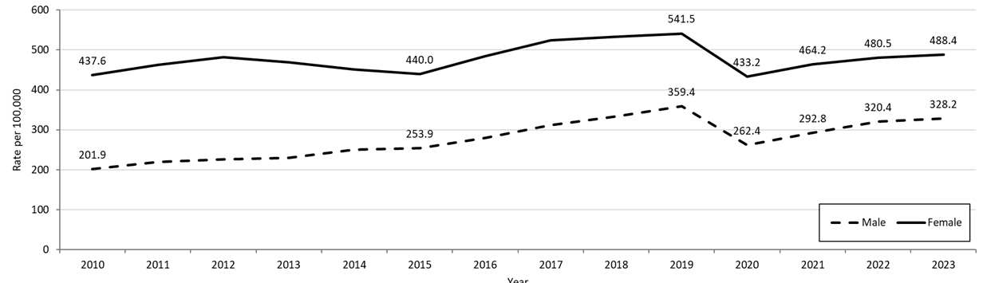**Table: Chlamydia Annual Case Counts by Current Gender**

|  |  |  |
| --- | --- | --- |
| **Year** | **Females** | **Males** |
| 2010 | 14,795 | 6,392 |
| 2011 | 15,803 | 7,302 |
| 2012 | 16,590 | 7,302 |
| 2013 | 16,275 | 7,494 |
| 2014 | 15,781 | 8,258 |
| 2015 | 15,489 | 8,414 |
| 2016 | 17,094 | 9,318 |
| 2017 | 18,644 | 10,463 |
| 2018 | 19,062 | 11,252 |
| 2019 | 19,408 | 12,155 |
| 2020 | 15,677 | 8,949 |
| 2021 | 16,799 | 9,989 |
| 2022 | 17,388 | 10,928 |
| 2023 | 17,675 | 11,194 |

**Highlights:** Graph depicts the rates per 100,000 population of chlamydia in Massachusetts by gender identity between 2012 and 2023. There are two lines, one for females that begins at 437.6 in 2010 and climbs to 541.5 in 2019 and another for males that begins at 201.9 in 2010 and climbs to 359.4 in 2019. In 2023, females had a rate of 488.4 and males had a rate of 328.2.

Note: There were cases reported among transgender individuals in 2014 through 2023. In 2023, there were 20 cases of chlamydia among transgender identified individuals not included on this slide.

**Footnotes For Slide 5**

Data are current as of 08/01/2024 and are subject to change.

Data Source: Massachusetts Department of Public Health/Bureau of Infectious Disease and Laboratory Sciences/ Division of STD Prevention and STD-HIV Surveillance.

Population denominators estimated by the University of Massachusetts Donahue Institute using a modified Hamilton-Perry model (Strate S, et al. Small Area Population Estimates for 2011 through 2020 report, Oct 2016).

1. In 2023, there were 20 individuals of transgender experience reported in our data system who do not have current gender documented. These cases were excluded since population estimates for individuals of transgender experience are not available at this time.  There were 21 other individuals with unknown gender which are not included in this slide.

2. Please consider the impact of the COVID-19 pandemic on infectious disease screening, treatment and surveillance in the interpretation of 2020-2023 data.

## Slide 6 - Chlamydia among Individuals of Transgender Experience,1,2 Massachusetts, 2015 to 20233

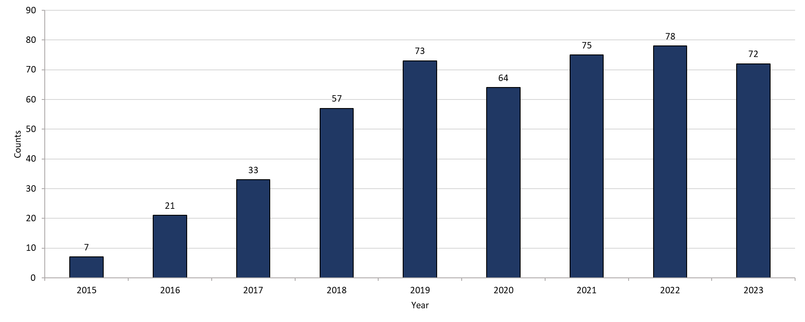

**Highlights:** Graph shows the number of chlamydia cases among transgender individuals in Massachusetts between 2015 and 2023. The case counts 7, 21, 33, 57, 73, 64, 75, 78, and 72 for 2015, 2016, 2017, 2018, 2019, 2020, 2021, 2022, and 2023, respectively.

**Footnotes for Slide 6**

Data are current as of 08/01/2024 and are subject to change.

Data Source: Massachusetts Department of Public Health/Bureau of Infectious Disease and Laboratory Sciences/ Division of STD Prevention and STD-HIV Surveillance.

1. Prior to 2015 MA DSTDP was not able to capture expanded gender identity including individuals of transgender experience within our data system.
2. All individuals of transgender experience are included in this graph regardless of current gender.
3. Please consider the impact of the COVID-19 pandemic on infectious disease screening, treatment and surveillance in the interpretation of 2020-2023 data.

## Slide 7 - Confirmed Chlamydia Rates by County and Statewide,Massachusetts, 2020-20231

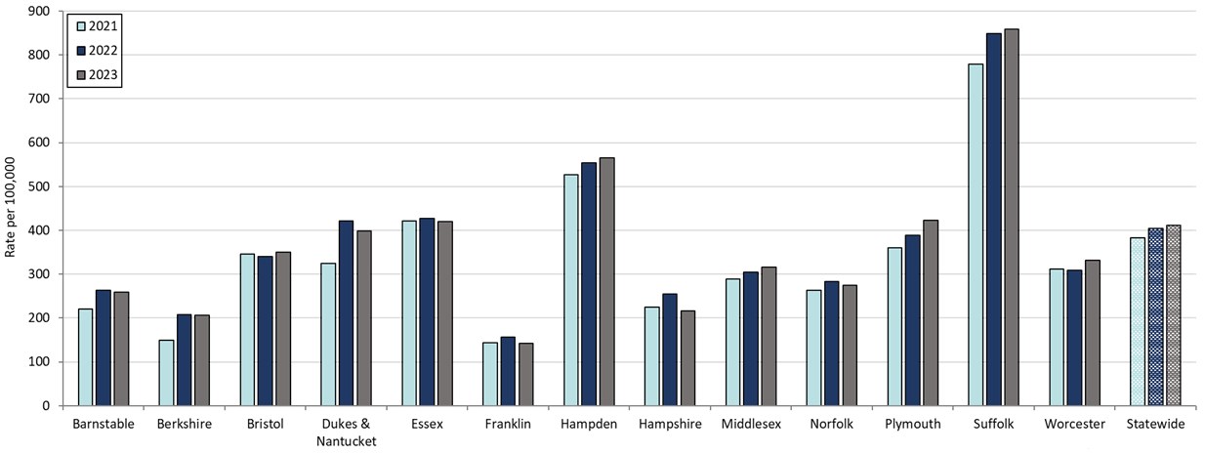

**Table: Rates of Chlamydia by County and Statewide**

|  |  |  |  |
| --- | --- | --- | --- |
| **County** | **2021** | **2022** | **2023** |
| Barnstable | 200.0 | 263.8 | 259.39 |
| Berkshire | 142.6 | 207.7 | 206.16 |
| Bristol | 336.8 | 339.8 | 350.48 |
| Dukes/Nantucket | 229.5 | 421.7 | 398.8 |
| Essex | 355.6 | 427.5 | 419.47 |
| Franklin | 171.8 | 156.3 | 142.2 |
| Hampden | 510.5 | 553.2 | 565.45 |
| Hampshire | 194.1 | 254.5 | 216.87 |
| Middlesex | 259.3 | 304.8 | 316.36 |
| Norfolk | 235.7 | 282.8 | 275.08 |
| Plymouth | 329.1 | 388.8 | 422.18 |
| Suffolk | 702.1 | 848.3 | 858.72 |
| Worcester | 306.0 | 308.2 | 331.4 |
| Statewide | 351.4 | 403.8 | 411.24 |

**Highlights:** Graph depicts rate per 100,000 population of chlamydia cases reported in Massachusetts by county comparing 2021 through 2023. The rate is highest in Suffolk county with a rate of 858.7 in 2023 followed by Hampden county with a rate of 565.4 in 2023. The lowest rates were in Franklin and Berkshire county.

**Footnotes for Slide 7**

Data are current as of 08/01/2024 and are subject to change.

Data Source: Massachusetts Department of Public Health/Bureau of Infectious Disease and Laboratory Sciences/ Division of STD Prevention and STD-HIV Surveillance.

Population denominators estimated by the University of Massachusetts Donahue Institute using a modified Hamilton-Perry model (Strate S, et al. Small Area Population Estimates for 2011 through 2020 report, Oct 2016).

1. Please consider the impact of the COVID-19 pandemic on infectious disease screening, treatment and surveillance in the interpretation of 2021-2023 data.

## Slide 8 - Average Age of Confirmed Chlamydia Cases by Gender1, Massachusetts, 2012 to 20232

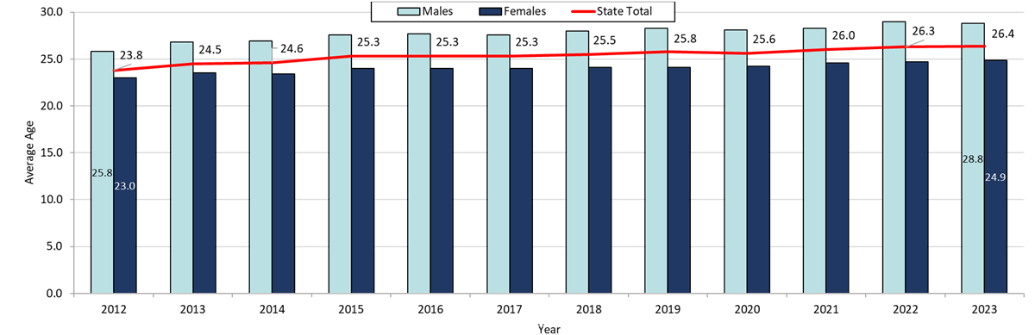

**Table: Chlamydia Annual Case Counts by Gender**

|  |  |  |
| --- | --- | --- |
| **Year** | **Female** | **Male** |
| 2012 | 16,590 | 7,302 |
| 2013 | 16,275 | 7,494 |
| 2014 | 15,781 | 8,258 |
| 2015 | 15,489 | 8,414 |
| 2016 | 17,094 | 9,318 |
| 2017 | 18,644 | 10,463 |
| 2018 | 19,062 | 11,252 |
| 2019 | 19,408 | 12,155 |
| 2020 | 15,677 | 8,949 |
| 2021 | 16,799 | 9,989 |
| 2022 | 17,388 | 10,928 |
| 2023 | 17,675 | 11,194 |

**Highlights:** Graph depicts the average age of confirmed chlamydia cases by year between 2012 and 2023. The lowest average age is 23.8 years old for the year 2012 and then rises to a high average age of 26.4 years old in 2023.

**Footnotes for Slide 8**

Data are current as of 08/01/2024 and are subject to change.

Data Source: Massachusetts Department of Public Health/Bureau of Infectious Disease and Laboratory Sciences/ Division of STD Prevention and STD-HIV Surveillance.

1. Individuals of transgender experience that did not have complete gender data as of 08/01/2024 may not be included within this slide.

2. Please consider the impact of the COVID-19 pandemic on infectious disease screening, treatment and surveillance in the interpretation of 2020-2023 data.

## Slide 9 - Rate of Confirmed Gonorrhea Cases, Massachusetts, 2000 to 20231

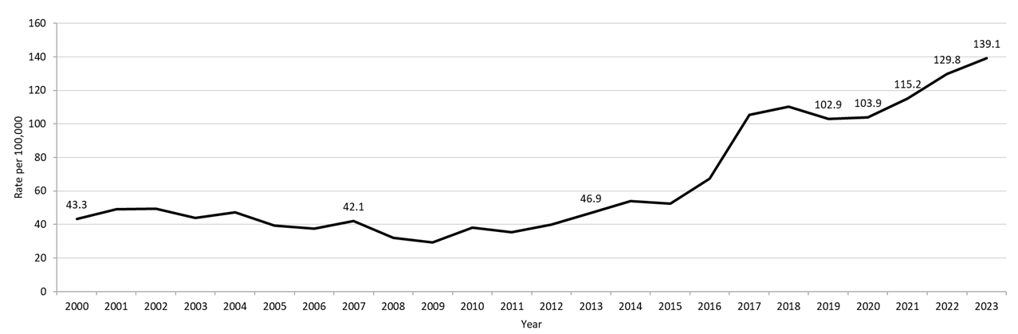

**Table: Gonorrhea Annual Case Counts**

|  |  |
| --- | --- |
| **Year** | **Count** |
| 2000 | 2,748 |
| 2001 | 3,121 |
| 2002 | 3,156 |
| 2003 | 2,819 |
| 2004 | 3,038 |
| 2005 | 2,542 |
| 2006 | 2,429 |
| 2007 | 2,729 |
| 2008 | 2,077 |
| 2009 | 1,917 |
| 2010 | 2,495 |
| 2011 | 2,345 |
| 2012 | 2,665 |
| 2013 | 3,156 |
| 2014 | 3,657 |
| 2015 | 3,592 |
| 2016 | 4,638 |
| 2017 | 7,293 |
| 2018 | 7,660 |
| 2019 | 7,170 |
| 2020 | 7,303 |
| 2021 | 8,099 |
| 2022 | 9,218 |
| 2023 | 9,779 |

**Highlights:** Graph depicts the rate per 100,000 population of confirmed cases of gonorrhea in Massachusetts between 2000 and 2023. It begins at 43.3 in 2000, drops to a low of 29.4 in 2009 and climbs to a high of 139.1 in 2023.

**Footnotes for Slide 9**

Data are current as of 08/01/2024 and are subject to change.

Data Source: Massachusetts Department of Public Health/Bureau of Infectious Disease and Laboratory Sciences/ Division of STD Prevention and STD-HIV Surveillance.

Population denominators estimated by the University of Massachusetts Donahue Institute using a modified Hamilton-Perry model (Strate S, et al. Small Area Population Estimates for 2011 through 2020 report, Oct 2016).

1. Please consider the impact of the COVID-19 pandemic on infectious disease screening, treatment and surveillance in the interpretation of 2020-2023 data.

## Slide 10 - Rate of Confirmed Gonorrhea Cases by Gender1,Massachusetts, 2010-20232

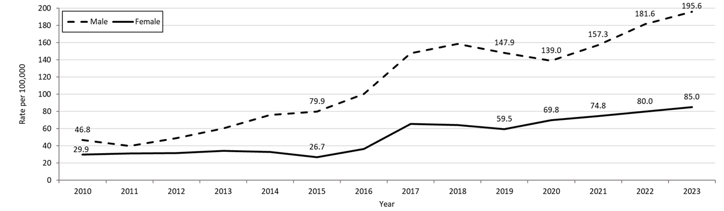

**Table: Gonorrhea Annual Case Counts by Current Gender**

|  |  |  |
| --- | --- | --- |
| **Year** | **Females** | **Males** |
| 2010 | 1,012 | 1,483 |
| 2011 | 1,069 | 1,275 |
| 2012 | 1,085 | 1,579 |
| 2013 | 1,181 | 1,969 |
| 2014 | 1,144 | 2,500 |
| 2015 | 940 | 2,648 |
| 2016 | 1,283 | 3,344 |
| 2017 | 2,328 | 4,952 |
| 2018 | 2,293 | 5,347 |
| 2019 | 2,132 | 5,002 |
| 2020 | 2,526 | 4,741 |
| 2021 | 2,707 | 5,367 |
| 2022 | 2,894 | 6,196 |
| 2023 | 3,077 | 6,672 |

**Highlights:** Graph depicts the rates per 100,000 population of confirmed cases of gonorrhea in Massachusetts by gender identity between 2010 and 2023. There are two lines, one for females that begins at 29.9 in 2010 and climbs to 85.0 in 2023 and another for males that begins at 46.8 in 2010 and climbs to 195.6 in 2023. Note: There were cases reported among transgender individuals in 2014 through 2023. In 2023, there were 22 cases of gonorrhea among transgender identified individuals not included on this slide.

**Footnotes for Slide 10**

Data are current as of 08/01/2024 and are subject to change.

Data Source: Massachusetts Department of Public Health/Bureau of Infectious Disease and Laboratory Sciences/ Division of STD Prevention and STD-HIV Surveillance.

Population denominators estimated by the University of Massachusetts Donahue Institute using a modified Hamilton-Perry model (Strate S, et al. Small Area Population Estimates for 2011 through 2020 report, Oct 2016).

1. In 2023, there were 22 individuals of transgender experience reported in our data system who do not have current gender documented. These cases were excluded since population estimates for individuals of transgender experience are not available at this time. There were 8 other individuals with unknown gender which are not included in this slide.

2. Please consider the impact of the COVID-19 pandemic on infectious disease screening, treatment and surveillance in the interpretation of 2020-2023 data.

## Slide 11: Gonorrhea Among Individuals of Transgender Experience1, Massachusetts, 2015 to 20232

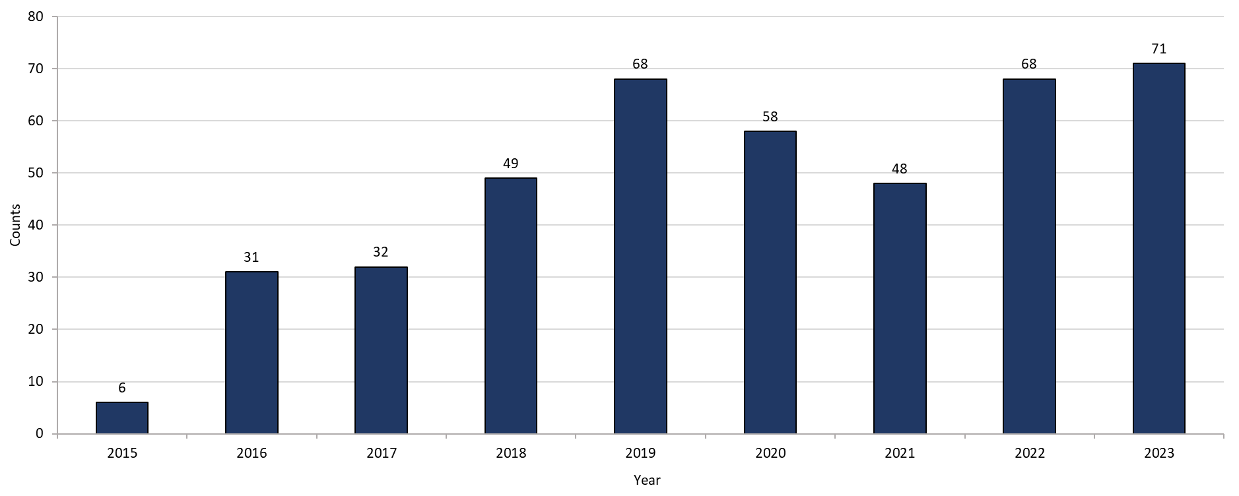

**Highlights:** Graph shows the number of confirmed gonorrhea cases among transgender individuals in Massachusetts between 2015 and 2023. The case counts are 6, 31, 32, 49, 68, 58, 48, 68, and 71 for 2015, 2016, 2017, 2018, 2019, 2020, 2021, 2022, and 2023, respectively.

**Footnotes for Slide 11**

Data are current as of 08/01/2024 and are subject to change.

Data Source: Massachusetts Department of Public Health/Bureau of Infectious Disease and Laboratory Sciences/ Division of STD Prevention and STD-HIV Surveillance.

1. All individuals of transgender experience are included in this graph regardless of current gender.
2. Please consider the impact of the COVID-19 pandemic on infectious disease screening, treatment and surveillance in the interpretation of 2020-2023 data

## Slide 12: Confirmed Gonorrhea Rates by County and Statewide,Massachusetts, 2020-20231

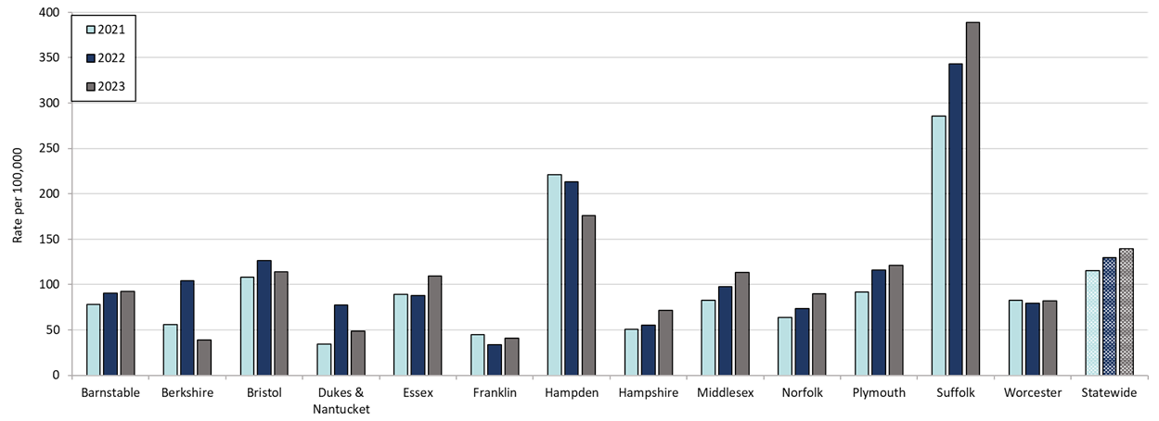

**Table: Rates of Gonorrhea by County and Statewide**

|  |  |  |  |
| --- | --- | --- | --- |
| **County** | **2021** | **2022** | **2023** |
| Barnstable | 55.5 | 90.4 | 92.6 |
| Berkshire | 41.9 | 103.9 | 38.8 |
| Bristol | 75.1 | 126.2 | 114.1 |
| Dukes/Nantucket | 31.6 | 77.5 | 48.8 |
| Essex | 79.8 | 87.8 | 109.4 |
| Franklin | 57.7 | 33.8 | 40.8 |
| Hampden | 223.9 | 213.4 | 175.8 |
| Hampshire | 47.4 | 55.5 | 71.5 |
| Middlesex | 74.0 | 97.6 | 113.4 |
| Norfolk | 60.9 | 73.4 | 89.5 |
| Plymouth | 92.9 | 115.7 | 120.9 |
| Suffolk | 271.3 | 343.0 | 388.6 |
| Worcester | 58.2 | 79.3 | 81.9 |
| Statewide | 103.9 | 129.8 | 139.1 |

**Highlights:** Graph depicts rate per 100,000 population of gonorrhea cases reported in Massachusetts by county comparing 2021 through 2023. The rate is highest in Suffolk county with a rate of 388.6 in 2023 followed by Hampden county with a rate of 175.8 in 2023. The lowest rates were in Berkshire and Franklin counties.

**Footnotes for Slide 12**

Data are current as of 08/01/2024 and are subject to change.

Data Source: Massachusetts Department of Public Health/Bureau of Infectious Disease and Laboratory Sciences/ Division of STD Prevention and STD-HIV Surveillance.

Population denominators estimated by the University of Massachusetts Donahue Institute using a modified Hamilton-Perry model (Strate S, et al. Small Area Population Estimates for 2011 through 2020 report, Oct 2016).

1. Please consider the impact of the COVID-19 pandemic on infectious disease screening, treatment and surveillance in the interpretation of 2021-2023 data.

## Slide 13: Rate of Confirmed and Probable Infectious Syphilis1 Cases by Gender,2 Massachusetts, 2010-20233

# Graph depicts the rate per 100,000 population of confirmed and probable cases of infectious syphilis in Massachusetts between 2000 and 2022. It begins at 2.2 in 2000, drops to a low of 1.6 in 2001, and climbs to a high of 22.7 in 2022.

**Table: Infectious Syphilis Annual Case Counts**

|  |  |
| --- | --- |
| **Year** | **Count** |
| 2000 | 141 |
| 2001 | 105 |
| 2002 | 207 |
| 2003 | 258 |
| 2004 | 209 |
| 2005 | 231 |
| 2006 | 217 |
| 2007 | 268 |
| 2008 | 367 |
| 2009 | 379 |
| 2010 | 465 |
| 2011 | 500 |
| 2012 | 561 |
| 2013 | 701 |
| 2014 | 600 |
| 2015 | 798 |
| 2016 | 1,034 |
| 2017 | 1,107 |
| 2018 | 1,167 |
| 2019 | 1,244 |
| 2020 | 1,159 |
| 2021 | 1,352 |
| 2022 | 1,593 |
| 2023 | 1,449 |

**Highlight:** Graph depicts the rate per 100,000 population of confirmed and probable cases of infectious syphilis in Massachusetts between 2000 and 2022. It begins at 2.2 in 2000, drops to a low of 1.6 in 2001, and climbs to a high of 22.7 in 2022.

**Footnotes for Slide 13**

Data are current as of 07/18/2023 and are subject to change.

Data Source: Massachusetts Department of Public Health/Bureau of Infectious Disease and Laboratory Sciences/Division of STD Prevention and STD-HIV Surveillance.

Population denominators estimated by the University of Massachusetts Donahue Institute using a modified Hamilton-Perry model (Strate S, et al. Small Area Population Estimates for 2011 through 2020 report, Oct 2016).

1. Infectious syphilis is defined as primary, secondary and early latent stages of syphilis within one year of infection.

2. Please consider the impact of the COVID-19 pandemic on infectious disease screening, treatment and surveillance in the interpretation of 2020-2022 data.

## Slide 14: Rate of Confirmed and Probable Infectious Syphilis1 Cases by Gender,2 Massachusetts, 2010-20233

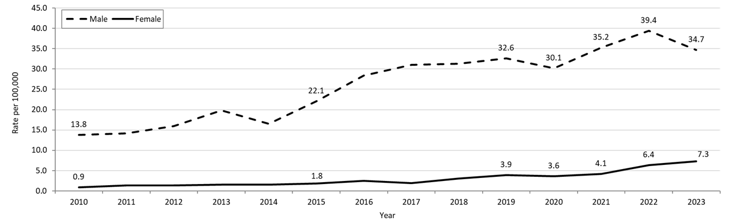

**Table: Infectious Syphilis Annual Case Counts by Current Gender**

|  |  |  |
| --- | --- | --- |
| **Year** | **Females** | **Males** |
| 2010 | 29 | 436 |
| 2011 | 46 | 454 |
| 2012 | 46 | 515 |
| 2013 | 55 | 656 |
| 2014 | 53 | 545 |
| 2015 | 65 | 732 |
| 2016 | 87 | 947 |
| 2017 | 67 | 1,040 |
| 2018 | 110 | 1,055 |
| 2019 | 139 | 1,102 |
| 2020 | 130 | 1,028 |
| 2021 | 150 | 1,201 |
| 2022 | 233 | 1,357 |
| 2023 | 264 | 1,183 |

**Highlights:** Graph depicts the rates per 100,000 population of confirmed and probable cases of syphilis in Massachusetts by gender identity between 2010 and 2023. There are two lines, one for females that begins at 0.9 in 2010 and remains relatively stable with a high of 7.3 in 2023. Another line is for males that begins at 13.8 in 2010 and climbs to a high of 39.4 in 2022 before falling to 34.7 in 2023.

Note: Infectious syphilis is defined as primary, secondary and early latent stages of syphilis within one year of infection.

There were cases reported among transgender individuals in 2014 through 2023. They are classified on this slide based on their current gender. In 2023, there were 2 cases of infectious syphilis among transgender identified individuals not included on this slide as MA DSTDP does not have current gender information for those individuals.

**Footnotes for Slide 14**

Data are current as of 07/17/2024 and are subject to change.

Data Source: Massachusetts Department of Public Health/Bureau of Infectious Disease and Laboratory Sciences/ Division of STD Prevention and STD-HIV Surveillance.

Population denominators estimated by the University of Massachusetts Donahue Institute using a modified Hamilton-Perry model (Strate S, et al. Small Area Population Estimates for 2011 through 2020 report, Oct 2016).

1. Infectious syphilis is defined as primary, secondary and early latent stages of syphilis within one year of infection.

2. In 2023, there were 2 individuals of transgender experience reported in our data system who do not have current gender documented. These cases were excluded since population estimates for individuals of transgender experience are not available at this time.

3. Please consider the impact of the COVID-19 pandemic on infectious disease screening, treatment and surveillance in the interpretation of 2020-2023 data.

## Slide 15: Infectious Syphilis1 Reported Cases by Race/Ethnicity2, Massachusetts, 2015-20233

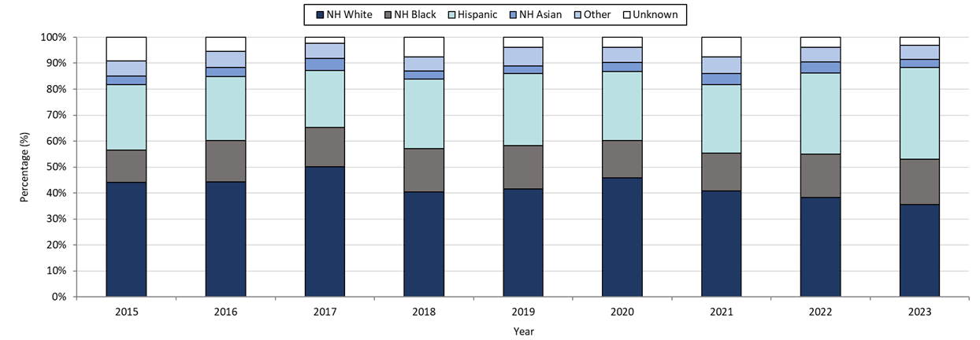

**Table: Infectious Syphilis Annual Case Counts**

|  |  |
| --- | --- |
| **Year** | **Count** |
| 2015 | 789 |
| 2016 | 1,034 |
| 2017 | 1,107 |
| 2018 | 1,167 |
| 2019 | 1,244 |
| 2020 | 1,159 |
| 2021 | 1,352 |
| 2022 | 1,593 |
| 2023 | 1,449 |

**Highlights:** Data are current as of 07/17/2024 and are subject to change.

Data Source: Massachusetts Department of Public Health/Bureau of Infectious Disease and Laboratory Sciences/ Division of STD Prevention and STD-HIV Surveillance.

Note: National Notifiable Diseases Surveillance System (NNDSS) Congenital Syphilis case definition was updated in 2014.

1. Infectious syphilis is defined as primary, secondary and early latent stages of syphilis within one year of infection.

2. Other Race/Ethnicity includes individuals who identify as American Indian/ Pacific Islander/ Alaskan Native.

3. Please consider the impact of the COVID-19 pandemic on infectious disease screening, treatment and surveillance in the interpretation of 2020-2023 data.

**Footnotes for Slide 15**

Graph depicts the proportion of Massachusetts reported confirmed and probable infectious syphilis cases broken down by race/ethnicity for the years 2015 through 2023. The highest percentage of cases for each year identified as Non-Hispanic White making up a high of 50.1% of cases in 2017 and a resulting 35.5% of cases in 2023. In total, over the nine-year period, the proportion of cases by race/ethnicity were from highest to lowest: Non-Hispanic White, Hispanic, Non-Hispanic Black, Non-Hispanic Other, and Unknown.

Note: Infectious syphilis is defined as primary, secondary and early latent (non-primary/non-secondary) stages of syphilis within one year of infection.

3. Please consider the impact of the COVID-19 pandemic on infectious disease screening, treatment and surveillance in the interpretation of 2020-2022 data.

Slide 16: Confirmed and Probable Infectious Syphilis1 Among Individuals of Transgender Experience2, Massachusetts, 2015 to 20233, 4

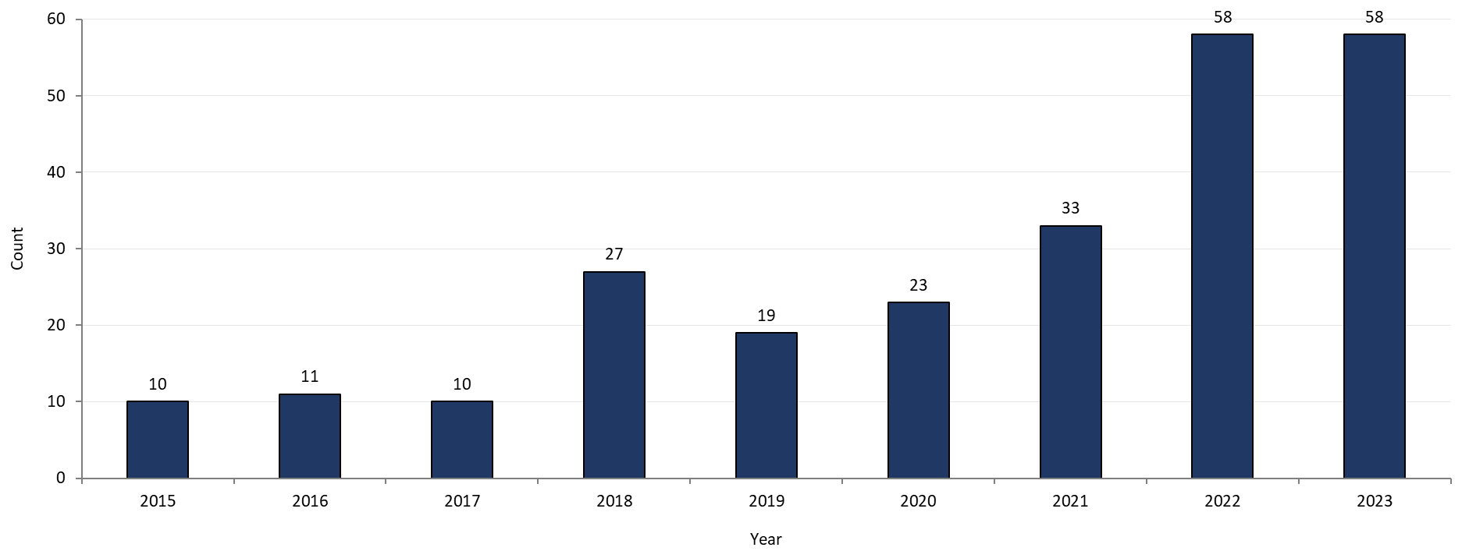

**Highlights:** Graph shows the number of confirmed and probable infectious syphilis cases among transgender individuals in Massachusetts between 2015 and 2023. The case counts are 10, 11, 10, 27, 19, 23, 33, 58, and 58 for 2015, 2016, 2017, 2018, 2019, 2020, 2021, 2022, and 2023 respectively.

*Infectious syphilis is defined as primary, secondary and early latent stages of syphilis within one year of infection.

**Footnotes for Slide 16**

Data are current as of 07/17/2024 and are subject to change.

Data Source: Massachusetts Department of Public Health/Bureau of Infectious Disease and Laboratory Sciences/Division of STD Prevention and STD-HIV Surveillance.

1. Infectious syphilis is defined as primary, secondary and early latent stages of syphilis within one year of infection.

2. All individuals of transgender experience are included in this graph regardless of current gender.

3. Please consider the impact of the COVID-19 pandemic on infectious disease screening, treatment and surveillance in the interpretation of 2020-2023 data.

4. In 2022, a retrospective verification project was conducted to improve data quality in capturing current gender information.

## Slide 17: Confirmed and Probable Infectious Syphilis1 Rates by County and Statewide,Massachusetts, 2020-20232

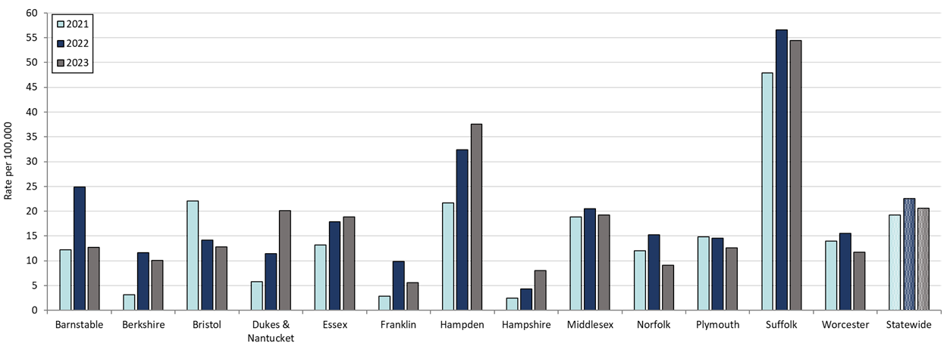

**Table: Confirmed and Probable Infectious Syphilis Rates by County and Statewide**

|  |  |  |  |
| --- | --- | --- | --- |
| **County** | **2021** | **2022** | **2023** |
| Barnstable | 12.2 | 24.9 | 12.7 |
| Berkshire | 3.1 | 11.6 | 10.1 |
| Bristol | 22.1 | 14.2 | 12.8 |
| Dukes/Nantucket | 5.7 | 11.5 | 20.1 |
| Essex | 13.2 | 17.9 | 18.8 |
| Franklin | 2.8 | 9.9 | 5.6 |
| Hampden | 21.7 | 32.4 | 37.6 |
| Hampshire | 2.5 | 4.3 | 8.0 |
| Middlesex | 18.8 | 20.5 | 19.2 |
| Norfolk | 12.0 | 15.2 | 9.1 |
| Plymouth | 14.9 | 14.5 | 12.6 |
| Suffolk | 47.9 | 56.6 | 54.4 |
| Worcester | 13.9 | 15.5 | 11.7 |
| Statewide | 19.1 | 22.5 | 20.6 |

**Highlights:** Graph depicts rate per 100,000 population of infectious syphilis cases reported in Massachusetts by county comparing 2021 through 2023. The rate is highest in Suffolk county with a rate of 56.6 in 2022 before falling to 54.4 in 2023, followed by Hampden county with a rate of 37.6 in 2023. The lowest rates were in Hampshire and Franklin county.

**Footnotes for Slide 17**

Data are current as of 07/17/2024 and are subject to change.

Data Source: Massachusetts Department of Public Health/Bureau of Infectious Disease and Laboratory Sciences/ Division of STD Prevention and STD-HIV Surveillance.

Population denominators estimated by the University of Massachusetts Donahue Institute using a modified Hamilton-Perry model (Strate S, et al. Small Area Population Estimates for 2011 through 2020 report, Oct 2016).

1. Infectious syphilis is defined as primary, secondary and early latent stages of syphilis within one year of infection.

2. Please consider the impact of the COVID-19 pandemic on infectious disease screening, treatment and surveillance in the interpretation of 2021-2023 data.

## Slide 18 – Confirmed and Probable Infectious Syphilis1 Rates by Stage of Infection, Massachusetts, 2010–20232

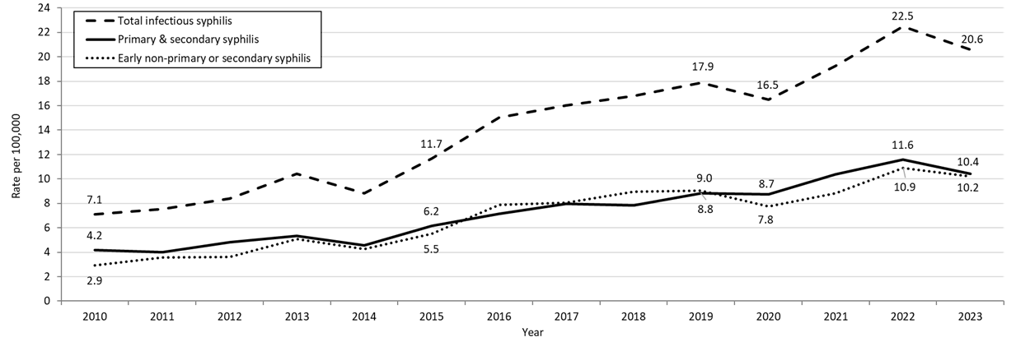

**Table: Infectious Syphilis Annual Case Counts**

|  |  |
| --- | --- |
| **Year** | **Count** |
| 2010 | 465 |
| 2011 | 500 |
| 2012 | 561 |
| 2013 | 701 |
| 2014 | 600 |
| 2015 | 798 |
| 2016 | 1,034 |
| 2017 | 1,107 |
| 2018 | 1,167 |
| 2019 | 1,244 |
| 2020 | 1,159 |
| 2021 | 1,352 |
| 2022 | 1,579 |
| 2023 | 1,449 |

**Highlights:** Graph depicts the differences between the rate of infectious syphilis diagnosed in the primary and secondary stage compared to those cases diagnosed in the early non-primary and non-secondary stages reported in Massachusetts from 2010 to 2023. There are three lines on the graph. One line for primary and secondary cases starting with a rate of 4.2 per 100,000 in 2010 and peaking with a rate of 11.6 in 2022, before falling to 10.4 in 2023. Another line for non-primary non-secondary cases starting wit a rate of 2.9 in 2010, peaking with a rate of 10.9 in 2022, before falling to 10.2 in 2023. The final line shows the total infectious syphilis starting with a rate of 7.1 in 2010 and peaking at a rate of 22.5 in 2022, before falling to 20.6 in 2023.

Note: Infectious syphilis is defined as primary, secondary and early latent (non-primary/non-secondary) stages of syphilis within one year of infection.

**Footnotes for Slide 18**

Data are current as of 07/17/2024 and are subject to change.

Data Source: Massachusetts Department of Public Health/Bureau of Infectious Disease and Laboratory Sciences/Division of STD Prevention and STD-HIV Surveillance.

Population denominators estimated by the University of Massachusetts Donahue Institute using a modified Hamilton-Perry model (Strate S, et al. Small Area Population Estimates for 2011 through 2020 report, Oct 2016).

1. Infectious syphilis is defined as primary, secondary and early latent stages of syphilis within one year of infection.

2. Please consider the impact of the COVID-19 pandemic on infectious disease screening, treatment and surveillance in the interpretation of 2020-2023 data.

## Slide 19 – Infectious Syphilis1 Reported Cases by Gender of Sex Partners, Massachusetts, 2015-20232

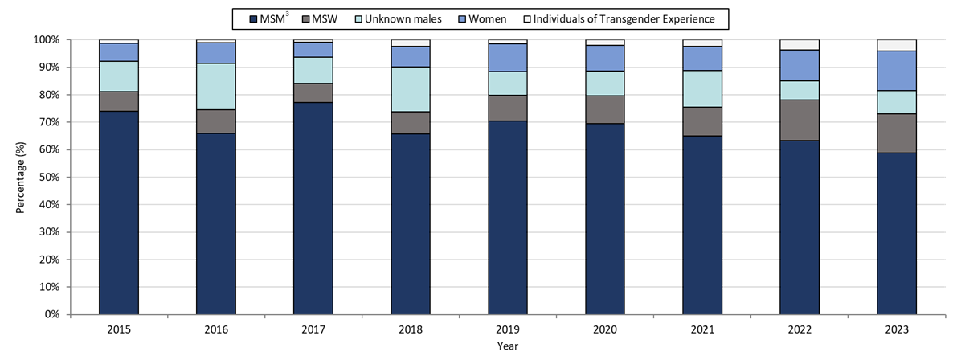

**Table: Infectious Syphilis Annual Case Counts**

|  |  |
| --- | --- |
| **Year** | **Count** |
| 2015 | 798 |
| 2016 | 1,034 |
| 2017 | 1,107 |
| 2018 | 1,167 |
| 2019 | 1,244 |
| 2020 | 1,159 |
| 2021 | 1,352 |
| 2022 | 1,593 |
| 2023 | 1,449 |

**Highlights:** Graph depicts the proportion of Massachusetts reported confirmed and probable infectious syphilis cases broken down by gender of sex partners for the years 2015 through 2023. The highest percentage of cases for each year reported male sex partners and are classified as MSM (men who have sex with men) making up a high of 77% of cases in 2017 and a resulting 58.8% of cases in 2023. In total, over the nine-year period, the proportion of cases by gender of sex partners were from highest to lowest: MSM, MSW (men who have sex with women), unknown males, women, and transgender individuals. For 2023, the order in frequency from highest to lowest is: MSM, women, MSW, unknown males, and individuals of transgender experience.

Note: Infectious syphilis is defined as primary, secondary and early latent (non-primary/non-secondary) stages of syphilis within one year of infection.

**Footnotes for Slide 19**

Data are current as of 07/17/2024 and are subject to change.

Data Source: Massachusetts Department of Public Health/Bureau of Infectious Disease and Laboratory Sciences/Division of STD Prevention and STD-HIV Surveillance.

Note: National Notifiable Diseases Surveillance System (NNDSS) Congenital Syphilis case definition was updated in 2014.

1. Infectious syphilis is defined as primary, secondary and early latent stages of syphilis within one year of infection.

2. Please consider the impact of the COVID-19 pandemic on infectious disease screening, treatment and surveillance in the interpretation of 2020-2023 data.

3. The MSM (men who have sex with men) category includes MSMT, MSMW, MSMWT, and MST with “W” referring to women and “T” referring to individuals of transgender experience

## Slide 20 - Congenital Syphilis Cases and Rate of Confirmed and Probable Infectious Syphilis1 Among Persons of Reproductive Potential Ages 15 to 49 Years, Massachusetts, 2010-20232

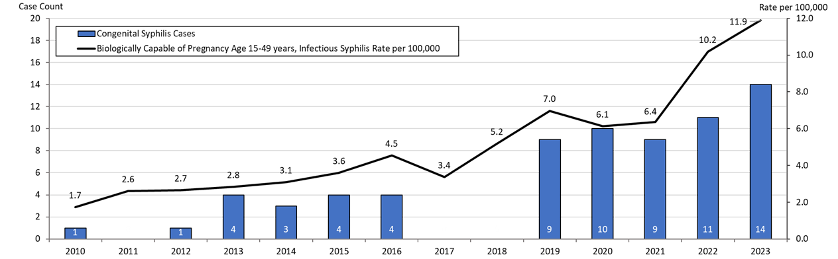

**Table: Infectious Syphilis Cases Among Individuals Biologically Capable of Pregnancy**

|  |  |
| --- | --- |
| **Year** | **Count** |
| 2010 | 28 |
| 2011 | 42 |
| 2012 | 43 |
| 2013 | 46 |
| 2014 | 50 |
| 2015 | 50 |
| 2016 | 74 |
| 2017 | 55 |
| 2018 | 85 |
| 2019 | 114 |
| 2020 | 101 |
| 2021 | 105 |
| 2022 | 173 |
| 2023 | 196 |

**Highlights:** Graph depicts the case count for confirmed and probable congenital syphilis cases reported in Massachusetts between 2010 and 2023. The case counts are 1, 0, 1, 4, 3, 4, 4, 0, 0, 9, 10, 9, 11, and 14 for 2010, 2022, 2012, 2013, 2014, 2015, 2016, 2017, 2018, 2019, 2020, 2021, 2022, and 2023, respectively. Additionally, the graph shows a line depicting the rate per 100,000 population of confirmed and probable infectious syphilis among individuals thought to be capable of pregnancy ages 15 to 49 years which starts with a rate of 1.7 in 2010 and peaks in 2023 with a rate of 11.9.

Note: Infectious syphilis is defined as primary, secondary and early latent (non-primary/non-secondary) stages of syphilis within one year of infection.

**Footnotes for Slide 20**

Data are current as of 07/17/2024 and are subject to change.

Data Source: Massachusetts Department of Public Health/Bureau of Infectious Disease and Laboratory Sciences/Division of STD Prevention.

Population denominators estimated by the University of Massachusetts Donahue Institute using a modified Hamilton-Perry model (Strate S, et al. Small Area Population Estimates for 2011 through 2020 report, Oct 2016).

Note: National Notifiable Diseases Surveillance System (NNDSS) Congenital Syphilis case definition was updated in 2014.

1. Infectious syphilis is defined as primary, secondary and early latent stages of syphilis within one year of infection.

2. Please consider the impact of the COVID-19 pandemic on infectious disease screening, treatment and surveillance in the interpretation of 2020-2023 data.

3. Persons of Reproductive Potential refers to individuals thought to be capable of pregnancy ages 15 to 49 years and not known to be assigned sex male at birth.

## Slide 21 (title page) - Comparison of Pregnant Person with All Stage Syphilis and Reportable Congenital Syphilis with Proportion of Congenital Cases Averted, Massachusetts, 2019 – 2023

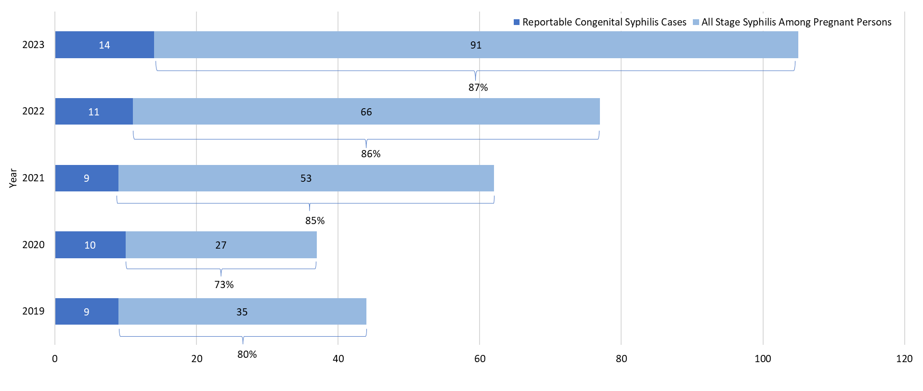

**Highlights:** Graph depicts the case count for confirmed and probable congenital syphilis cases reported in Massachusetts between 2019 and 2023. The case counts are 9, 10, 9, 11, and 14 for 2019, 2020, 2021, 2022, and 2023, respectively. Additionally, the graph shows the number of all stage syphilis cases among pregnant individuals who did not have a probable or confirmed congenital syphilis cases by year and the percentage of congenital syphilis cases averted. The number of all stage syphilis among pregnant person was who were not reportable congenital cases are 35, 27, 53, 66, and 91 for 2019, 2020, 2021, 2022, and 2023, respectively. With the proportion of congenital cases averted of 80%, 73%, 85%, 86%, and 87% for 2019, 2020, 2021, 2022, and 2023, respectively.

**Footnotes for Slide 21**

Data are current as of 07/17/2024 and are subject to change.

Data Source: Massachusetts Department of Public Health/Bureau of Infectious Disease and Laboratory Sciences/ Division of STD Prevention.

Population denominators estimated by the University of Massachusetts Donahue Institute using a modified Hamilton-Perry model (Strate S, et al. Small Area Population Estimates for 2011 through 2020 report, Oct 2016).

Please consider the impact of the COVID-19 pandemic on infectious disease screening, treatment and surveillance in the interpretation of 2020-2023 data.

## Slide 22 (title page) - Chlamydia, Gonorrhea, and Infectious Syphilis: Years 2018 to 2023

## Slide 23 - Social Vulnerability Index

Patient addresses were manually cleaned and geocoded utilizing SAS 9.4

Social Vulnerability Index (SVI) was based on the patient’s home address.

It characterizes community resilience/ability to withstand external hazards.

SVI incorporates 15 demographic and socioeconomic variables from the US census.

Patients’ census tracts are given a percentile rank and grouped as low, moderately low, moderately high, and high.

 Higher percentile scores represent greater community vulnerability.

The CDC/ATSDR SVI database from 2018 was matched to cases from 2018-2019.

The CDC/ATSDR SVI database from 2020 was matched to cases from 2020-2022.

## Slide 24 - Confirmed Chlamydia Case Percentages by Social Vulnerability Index, Massachusetts, 2018-20231

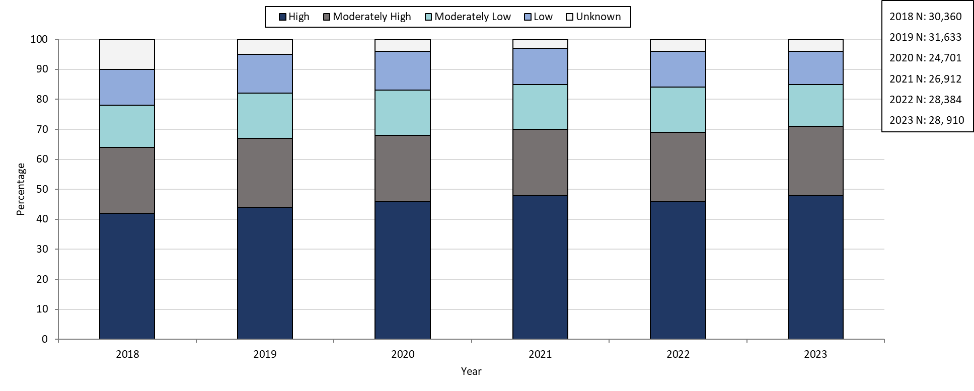

**Table: Chlamydia Annual Case Counts**

|  |  |
| --- | --- |
| Year | Count |
| 2018 | 30,369 |
| 2019 | 31,634 |
| 2020 | 24,705 |
| 2021 | 26,912 |
| 2022 | 28,384 |
| 2023 | 28,910 |

**Highlights:** Graph depicts the proportion of Massachusetts reported confirmed chlamydia cases broken down by SVI quartile for the years 2018 through 2023. The High SVI group is largest for each year, making up 41 to 48% of cases each year. Each year, the order in frequency from highest to lowest is: High, Moderately High, Moderately Low, Low, and Unknown SVI.

**Footnotes for Slide 24**

Data are current as of 08/01/2024 and are subject to change.

Data Source: Massachusetts Department of Public Health/Bureau of Infectious Disease and Laboratory Sciences/ Division of STD Prevention and STD-HIV Surveillance.

1. Please consider the impact of the COVID-19 pandemic on infectious disease screening, treatment and surveillance in the interpretation of 2020-2023 data.

## Slides 25- Confirmed Chlamydia Case Percentages by Social Vulnerability Index and Gender, Massachusetts, 2018- 20231,2

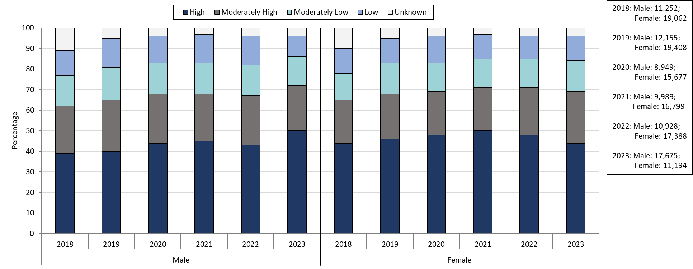

**Table: Chlamydia Case Couts by Gender**

|  |  |  |
| --- | --- | --- |
| **Year** | **Females** | **Males** |
| 2018 | 19,062 | 11,252 |
| 2019 | 19,408 | 12,155 |
| 2020 | 15,677 | 8,949 |
| 2021 | 16,799 | 9,989 |
| 2022 | 17,388 | 10,928 |
| 2023 | 17,675 | 11,194 |

**Highlights:** Graph depicts the proportion of Massachusetts reported confirmed chlamydia cases broken down by SVI quartile and gender for the years 2018 through 2023. In 2023, 44% of female cases are High SVI, compared to 50% in males. 25% of female cases in 2023 are Moderately High SVI, 15% are Moderately Low SVI, 12% are Low SVI, and 4% are Unknown SVI. 25% of male cases in 2023 are Moderately High SVI, 15% are Moderately Low SVI, 13% are Low SVI, and 3% are Unknown SVI.

**Footnotes for Slide 25**

Data are current as of 08/01/2024 and are subject to change.

Data Source: Massachusetts Department of Public Health/Bureau of Infectious Disease and Laboratory Sciences/ Division of STD Prevention and STD-HIV Surveillance.

1. Please consider the impact of the COVID-19 pandemic on infectious disease screening, treatment and surveillance in the interpretation of 2020-2023 data.
2. Individuals of transgender experience that do not have complete gender data may not be included within this slide

## Slide 26: Confirmed Gonorrhea Case Percentages by Social Vulnerability Index, Massachusetts, 2018-20231

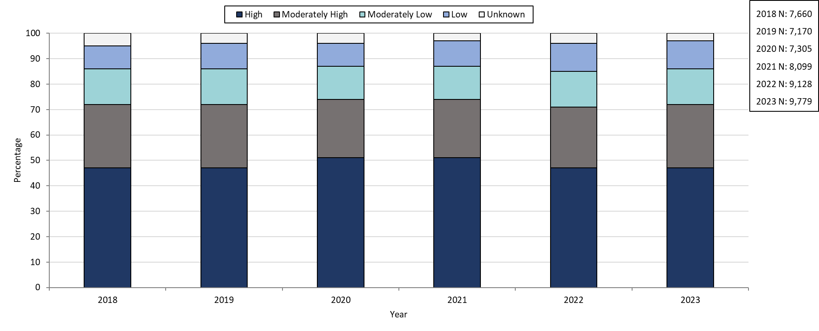

**Table: Gonorrhea Annual Case Counts**

|  |  |
| --- | --- |
| **Year** | **Count** |
| 2018 | 7,660 |
| 2019 | 7,170 |
| 2020 | 7,303 |
| 2021 | 8,099 |
| 2022 | 9,218 |
| 2023 | 9,779 |

**Highlights:** Graph depicts the proportion of Massachusetts reported confirmed gonorrhea cases broken down by SVI quartile for the years 2018 through 2023. The High SVI group is largest for each year, making up 47 to 51% of cases each year. Each year, the order in frequency from highest to lowest is: High, Moderately High, Moderately Low, Low, and Unknown SVI.

**Footnotes for Slide 26**

Data are current as of 08/01/2024 and are subject to change.

Data Source: Massachusetts Department of Public Health/Bureau of Infectious Disease and Laboratory Sciences/ Division of STD Prevention and STD-HIV Surveillance.

1. Please consider the impact of the COVID-19 pandemic on infectious disease screening, treatment and surveillance in the interpretation of 2020-2023 data.

## Slide 27: Confirmed Gonorrhea Case Percentages by Social Vulnerability Index and Gender, Massachusetts, 2018-20231,2

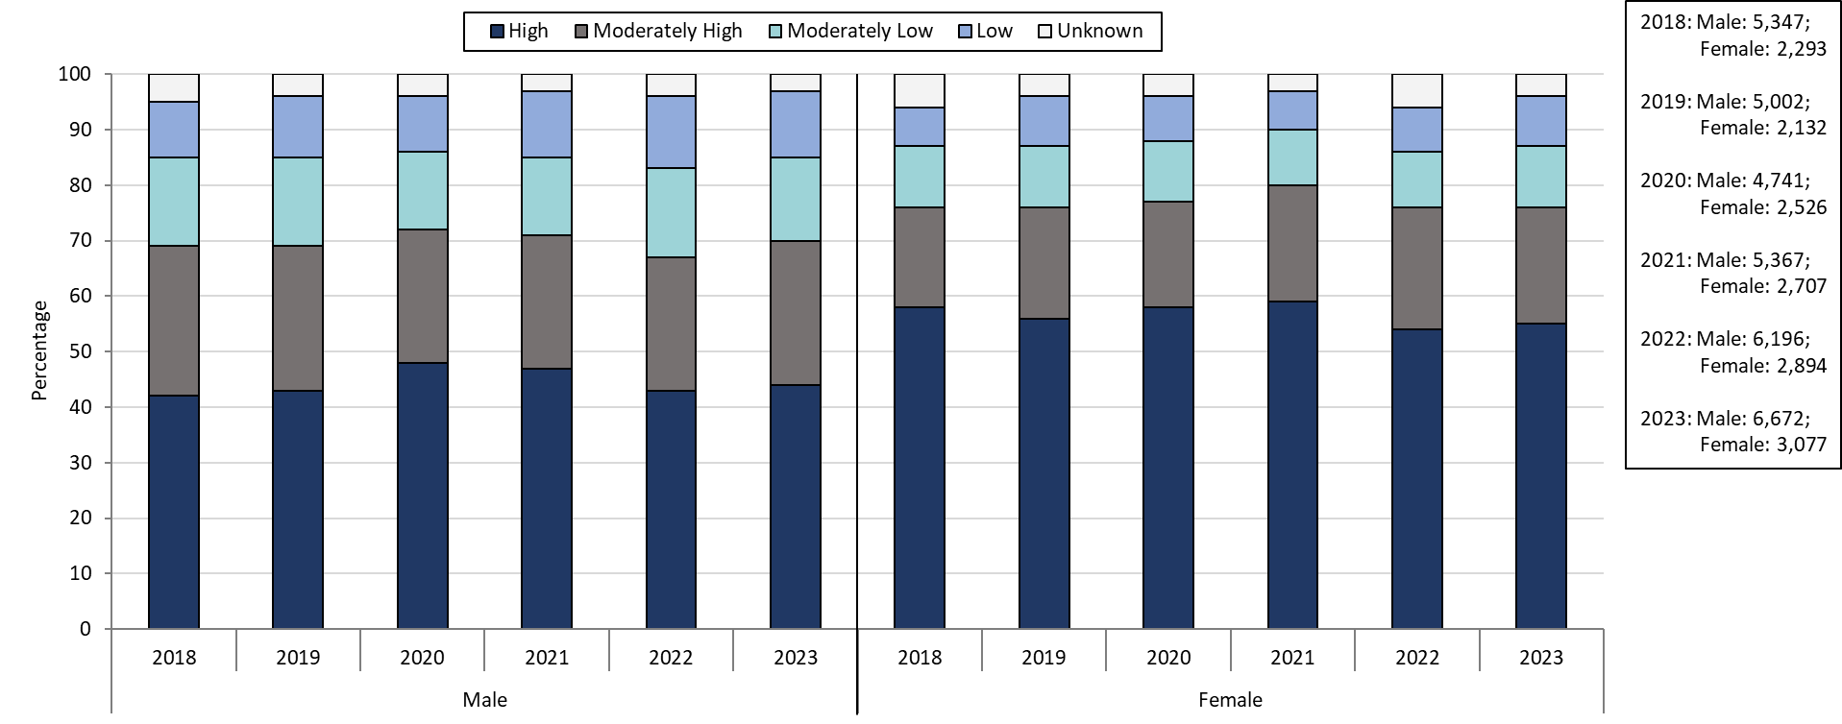

**Table: Gonorrhea Annual Case Counts by Current Gender**

|  |  |  |
| --- | --- | --- |
| **Year** | **Females** | **Males** |
| 2018 | 2,293 | 5,347 |
| 2019 | 2,132 | 5,002 |
| 2020 | 2,526 | 4,741 |
| 2021 | 2,707 | 5,367 |
| 2022 | 2,894 | 6,196 |
| 2023 | 3,077 | 6,672 |

**Highlights:** Graph depicts the proportion of Massachusetts reported confirmed gonorrhea cases broken down by SVI quartile and gender for the years 2018 through 2023. In 2023, 55% of female cases are High SVI, compared to 44% in males. 21% of female cases in 2023 are Moderately High SVI, 11% are Moderately Low SVI, 9% are Low SVI, and 4% are Unknown SVI. 26% of male cases in 2023 are Moderately High SVI, 15% are Moderately Low SVI, 12% are Low SVI, and 3% are Unknown SVI.

**Footnotes for Slide 27**

Data are current as of 08/01/2024 and are subject to change.

Data Source: Massachusetts Department of Public Health/Bureau of Infectious Disease and Laboratory Sciences/ Division of STD Prevention and STD-HIV Surveillance.

1. Please consider the impact of the COVID-19 pandemic on infectious disease screening, treatment and surveillance in the interpretation of 2020-2023 data.
2. Individuals of transgender experience that do not have complete gender data may not be included within this slide.

## Slide 28: Confirmed and Probably Infectious Syphilis1 Case Percentages by Social Vulnerability Index, Massachusetts, 2018- 20232

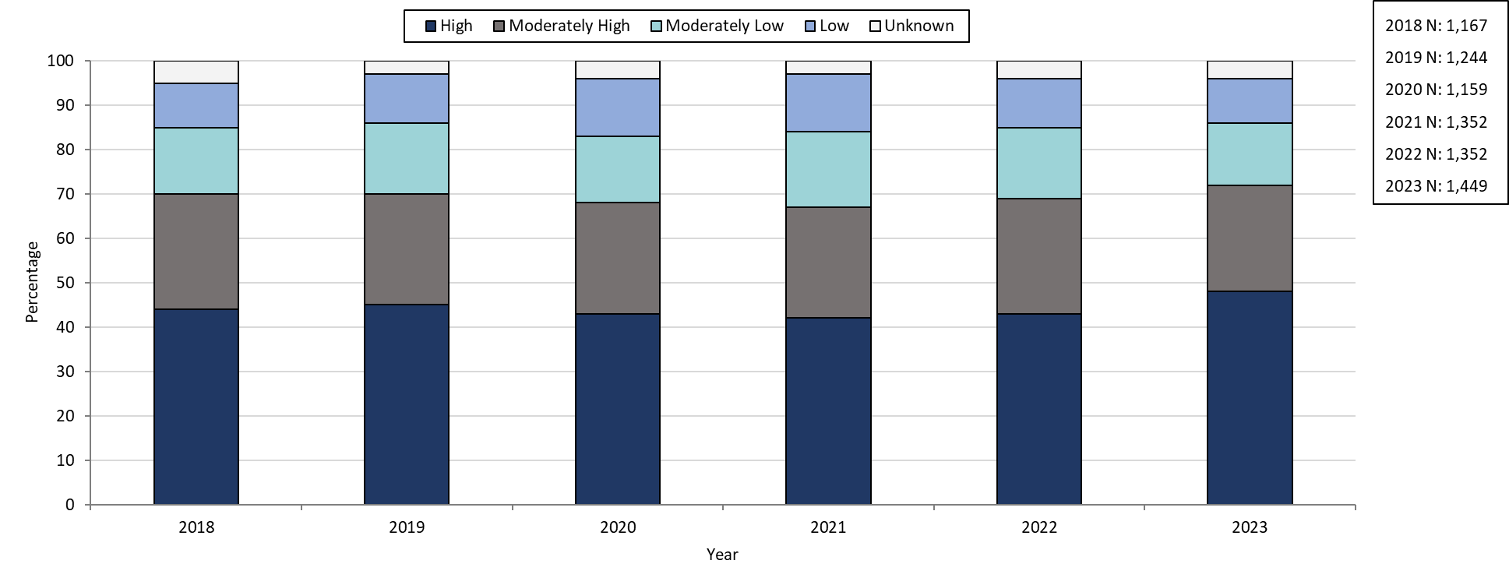

**Table: Infectious Syphilis Annual Case Counts**

|  |  |
| --- | --- |
| **Year** | **Count** |
| 2018 | 1,167 |
| 2019 | 1,244 |
| 2020 | 1,159 |
| 2021 | 1,352 |
| 2022 | 1,593 |
| 2023 | 1,449 |

**Highlights:** Graph depicts the proportion of Massachusetts reported confirmed and probable infectious syphilis cases broken down by SVI quartile for the years 2018 through 2023. The High SVI group is largest for each year, making up 42 to 48% of cases each year. Each year, the order in frequency from highest to lowest is: High, Moderately High, Moderately Low, Low, and Unknown SVI.

**Footnotes for Slide 28**

Data are current as of 07/17/2024 and are subject to change.

Data Source: Massachusetts Department of Public Health/Bureau of Infectious Disease and Laboratory Sciences/ Division of STD Prevention and STD-HIV Surveillance.

1. Infectious syphilis is defined as primary, secondary and early latent stages of syphilis within one year of infection.

2. Please consider the impact of the COVID-19 pandemic on infectious disease screening, treatment and surveillance in the interpretation of 2020-2023 data.

## Slide 29: Confirmed and Probable Infectious Syphilis1 Case Percentages by Social Vulnerability Index and Gender2, Massachusetts, 2018-20233

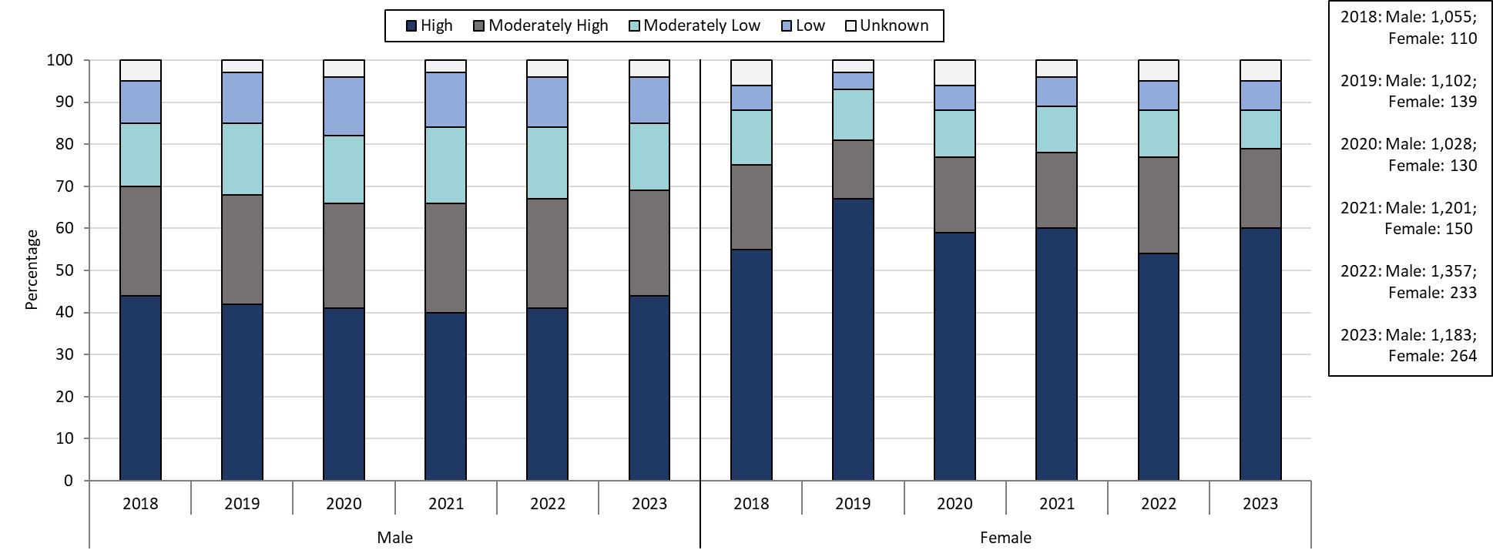

**Table: Infectious Syphilis Annual Case Counts by Current Gender**

|  |  |  |
| --- | --- | --- |
| **Year** | **Females** | **Males** |
| 2018 | 1,055 | 110 |
| 2019 | 1,102 | 139 |
| 2020 | 1,028 | 130 |
| 2021 | 1,201 | 150 |
| 2022 | 1,357 | 233 |
| 2023 | 1,183 | 264 |

**Highlights:** Graph depicts the proportion of Massachusetts reported confirmed and probable infectious syphilis cases broken down by SVI quartile and gender for the years 2018 through 2023. In 2023, 60% of female cases are High SVI, compared to 44% in males. 19% of female cases in 2023 are Moderately High SVI, 9% are Moderately Low SVI, 7% are Low SVI, and 5% are Unknown SVI. 25% of male cases in 2023 are Moderately High SVI, 16% are Moderately Low SVI, 11% are Low SVI, and 4% are Unknown SVI.

**Footnotes for Slide 29**

Data are current as of 07/17/2024 and are subject to change.

Data Source: Massachusetts Department of Public Health/Bureau of Infectious Disease and Laboratory Sciences/ Division of STD Prevention and STD-HIV Surveillance.

1. Infectious syphilis is defined as primary, secondary and early latent stages of syphilis within one year of infection.

2. Individuals of transgender experience that do not have complete gender data may not be included within this slide.

3. Please consider the impact of the COVID-19 pandemic on infectious disease screening, treatment and surveillance in the interpretation of 2020-2023 data.

## Slide 30: Confirmed and Probable Infectious Syphilis1 Case Percentages by Social Vulnerability Index and Race, Massachusetts, 2018- 20232

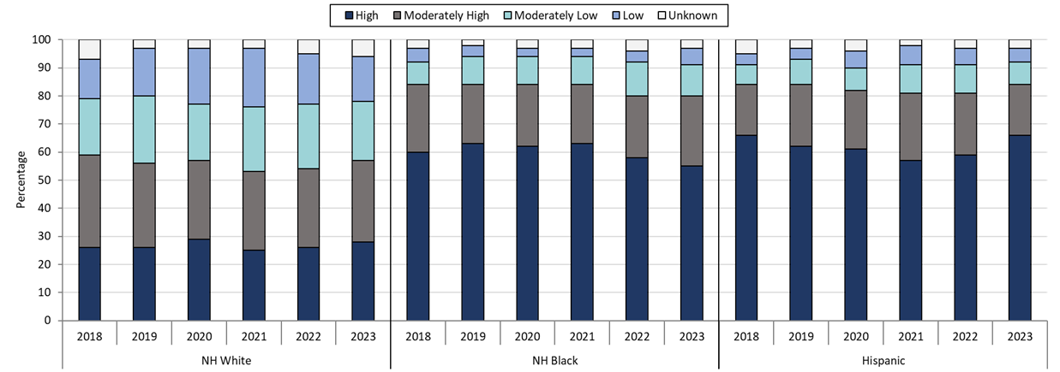

**Table:** **Infectious Syphilis Annual Case Counts by Selected Race and Ethnicity**

|  |  |  |  |
| --- | --- | --- | --- |
| Year(N) | NH White | NH Black | Hispanic |
| 2018 | 469 | 196 | 314 |
| 2019 | 518 | 207 | 347 |
| 2020 | 532 | 169 | 308 |
| 2021 | 554 | 197 | 356 |
| 2022 | 607 | 270 | 493 |
| 2023 | 514 | 225 | 510 |

**Highlights:** Graph depicts the proportion of Massachusetts reported confirmed and probable infectious syphilis cases broken down by SVI quartile and race for the years 2018 through 2023. Each year, NH White cases have a lower proportion of High SVI cases compared to NH Black and Hispanic cases. In 2023, 28% of NH White cases are High SVI, compared to 55% of NH Black cases and 66% of Hispanic cases.

**Footnotes for Slide 30**

Data are current as of 07/17/2024 and are subject to change.

Data Source: Massachusetts Department of Public Health/Bureau of Infectious Disease and Laboratory Sciences/ Division of STD Prevention and STD-HIV Surveillance.

1. Infectious syphilis is defined as primary, secondary and early latent stages of syphilis within one year of infection.

2. Please consider the impact of the COVID-19 pandemic on infectious disease screening, treatment and surveillance in the interpretation of 2020-2023 data.

## Slide 31: Section Break, Description of 2023 STI Cases

Geographic Distribution by Age, Gender, Sexual Risk Categories, and Race-Ethnicity

## Slide 32: Incident Rate of Confirmed Chlamydia Cases, per 100,000 Persons1 by City/Town2, Massachusetts, 20233

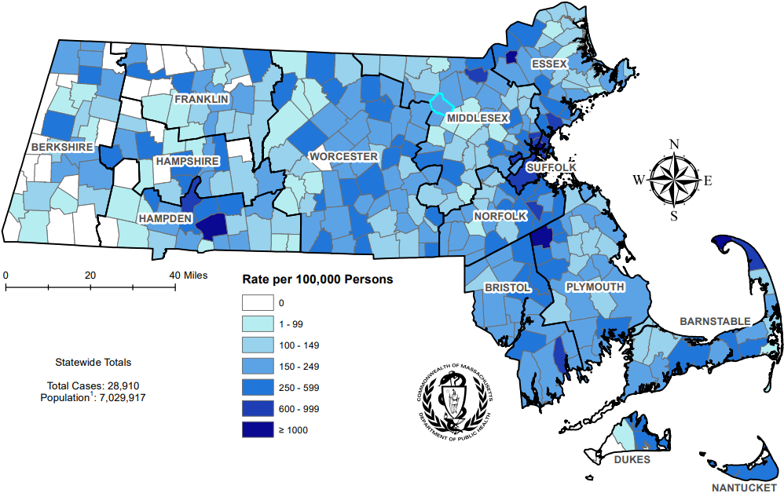

**Highlights:** Map of Massachusetts cities and towns color-coded to indicate the areas of the state with the highest chlamydia case rates in 2023. The cities that have the highest rates (greater than 600 per 100,000 persons) are Provincetown, Brockton, Springfield, Chelsea, Lawrence, Boston, Everett, Lynn, Holyoke, Truro, Randolph, Revere, Lowell, Malden, and New Bedford.

**Footnotes for Slide 32**

Data are current as of 08/01/2024 and are subject to change.

Data Source: Massachusetts Department of Public Health/Bureau of Infectious Disease and Laboratory Sciences/ Division of STD Prevention and STD-HIV Surveillance.

1. Population denominators estimated by the University of Massachusetts Donahue Institute using a modified Hamilton-Perry model (Strate S, et al. Small Area Population Estimates for 2011 through 2020 report, Oct 2016).

2. There are no city/towns with <10 cases of chlamydia that fall within the top two rate categories (≥600 cases per 100,000).

3. Please consider the impact of the COVID-19 pandemic on infectious disease screening, treatment and surveillance in the interpretation of 2023 data.

## Slide 33: Absolute Rate Difference1 Comparing 2023 to 2019 for Confirmed Chlamydia Cases, per 100,000 Persons2 by City/Town, Massachusetts

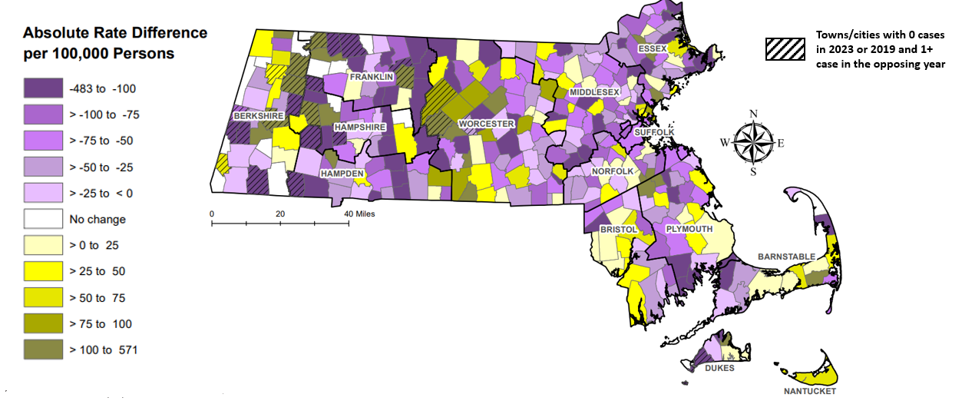

**Highlights:** Map of Massachusetts cities and towns color-coded to indicate the range of absolute rate differences per 100,000 persons comparing 2023 chlamydia case rates to 2019 case rates. The darker the color in the scheme, the greater the difference between 2023 and 2019 case rates with purple coloring indicating rates were higher in 2019 and the gold coloring indicating rates were higher in 2023. The majority of cities and towns saw a drop in chlamydia case rates in 2023 compared with 2019 with the largest declines (less than -200 per 100,000 persons) occurring in Granville, Huntington, Lawrence, Amherst, West Boylston, Leverett, Gill, and New Salem; the greatest rate increases (greater than 200 per 100,000 persons) were seen in Truro, Chesterfield, Montgomery, Holbrook, and Nahant. The cities and towns that had zero cases for 2023 or 2019 and one or more cases for the opposing year are indicated on the map with a slash mark to acknowledge the absolute rate difference should be examined with caution.

**Footnotes for Slide 33**

Data are current as of 08/01/2024 and are subject to change.

Data Source: Massachusetts Department of Public Health/Bureau of Infectious Disease and Laboratory Sciences/ Division of STD Prevention and STD-HIV Surveillance.

1. The darker the color in the scheme, the greater the difference between 2023 and 2019 chlamydia case rates with purple coloring indicating rates were higher in 2019 and gold coloring indicating rates were higher in 2023.

2. Population denominators estimated by the University of Massachusetts Donahue Institute using a modified Hamilton-Perry model (Strate S, et al. Small Area Population Estimates for 2011 through 2020 report, Oct 2016).

## Slide 34: Confirmed Chlamydia Case Rates per 100,000 Population by Gender1 and Age, Massachusetts, 20232

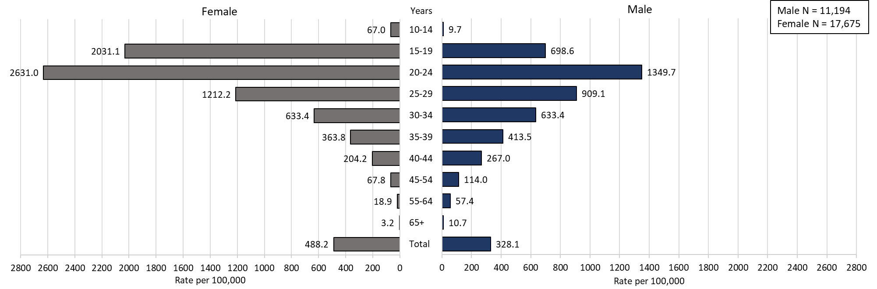

**Highlights:** Graph depicts chlamydia case rates per 100,000 population by age categories for the overall state, males, and females. For the overall state, the highest rate is among those 20-24 years. When looking at the gender specific rates, the age categories with the highest rates are 20-24 years for both males and females.

**Footnotes for Slide 34**

Data are current as of 08/01/2024 and are subject to change.

Data Source: Massachusetts Department of Public Health/Bureau of Infectious Disease and Laboratory Sciences/Division of STD Prevention and STD-HIV Surveillance.

Population denominators estimated by the University of Massachusetts Donahue Institute using a modified Hamilton-Perry model (Strate S, et al. Small Area Population Estimates for 2011 through 2020 report, Oct 2016).

1. In 2023, there were 20 individuals of transgender experience and 21 other individuals documented in our data system that MA DSTDP does not have current gender information for. 6 individuals had unknown age. These cases were excluded since rate for this population cannot be calculated at this time.

2. Please consider the impact of the COVID-19 pandemic on infectious disease screening, treatment and surveillance in the interpretation of 2023 data.

## Slide 35: Incident Rate of Confirmed Gonorrhea Cases, per 100,000 Persons1 by City/Town2, Massachusetts, 20233

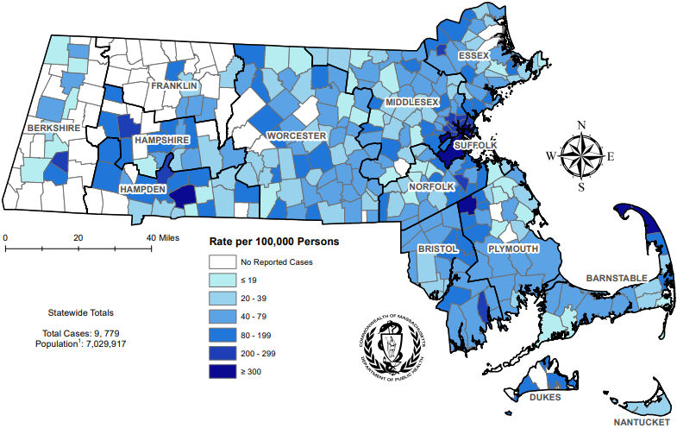

**Highlights:** Map of Massachusetts cities and towns color-coded to indicate the areas of the state with the highest gonorrhea case rates in 2023. The city with the highest rate (>500 per 100,000 persons) is Provincetown. Other cities that have the high rates (>300 per 100,000 persons) are Truro, Boston, Brockton, Chelsea, and Springfield.

**Footnotes for Slide 35**

Data are current as of 08/01/2024 and are subject to change.

Data Source: Massachusetts Department of Public Health/Bureau of Infectious Disease and Laboratory Sciences/Division of STD Prevention and STD-HIV Surveillance.

1. Population denominators estimated by the University of Massachusetts Donahue Institute using a modified Hamilton-Perry model (Strate S, et al. Small Area Population Estimates for 2011 through 2020 report, Oct 2016).

2. There are two city/towns with <10 cases of gonorrhea that fall within the top two rate categories (≥200 cases per 100,000): Chesterfield and Tyringham.

3. Please consider the impact of the COVID-19 pandemic on infectious disease screening, treatment and surveillance in the interpretation of 2023 data.

## Slide 36: Absolute Rate Difference1 Comparing 2023 to 2019 for Confirmed Gonorrhea Cases, per 100,000 Persons2 by City/Town, Massachusetts

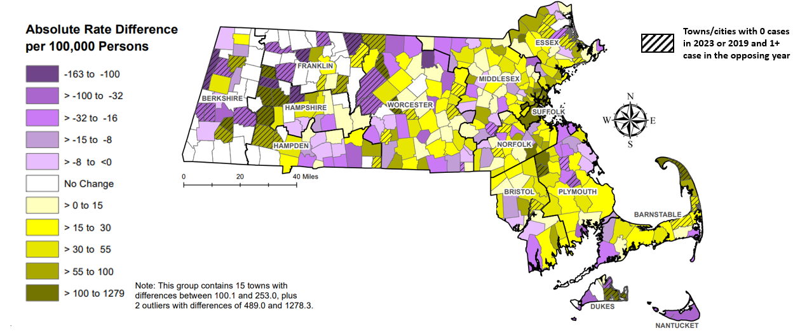

**Highlights:** Map of Massachusetts cities and towns color-coded to indicate the range of absolute rate differences per 100,000 persons comparing 2023 gonorrhea case rates to 2019 case rates. The darker the color in the scheme, the greater the difference between 2023 and 2019 case rates with purple coloring indicating rates were higher in 2019 and the gold coloring indicating rates were higher in 2023. The majority of cities and towns saw a rise in gonorrhea case rates in 2023 compared with 2019 with the greatest increases (greater than 100 per 100,000 persons) occurring in Provincetown, Brockton, Revere, Malden, Lawrence, Boston, and Stoughton; the largest rate decline (less than -100 per 100,000 persons) was seen in Fitchburg. The cities and towns that had zero cases for 2023 or 2019 and one or more cases for the opposing year are indicated on the map with a slash mark to acknowledge the absolute rate difference should be examined with caution.

**Footnotes for Slide 36**

Data are current as of 08/01/2024 and are subject to change.

Data Source: Massachusetts Department of Public Health/Bureau of Infectious Disease and Laboratory Sciences/Division of STD Prevention and STD-HIV Surveillance.

1. The darker the color in the scheme, the greater the difference between 2023 and 2019 gonorrhea case rates with purple coloring indicating rates were higher in 2019 and gold coloring indicating rates were higher in 2023.

2. Population denominators estimated by the University of Massachusetts Donahue Institute using a modified Hamilton-Perry model (Strate S, et al. Small Area Population Estimates for 2011 through 2020 report, Oct 2016).

## Slide 37: Confirmed Gonorrhea Case Rates per 100,000 Population by Gender1 and Age, Massachusetts, 20232

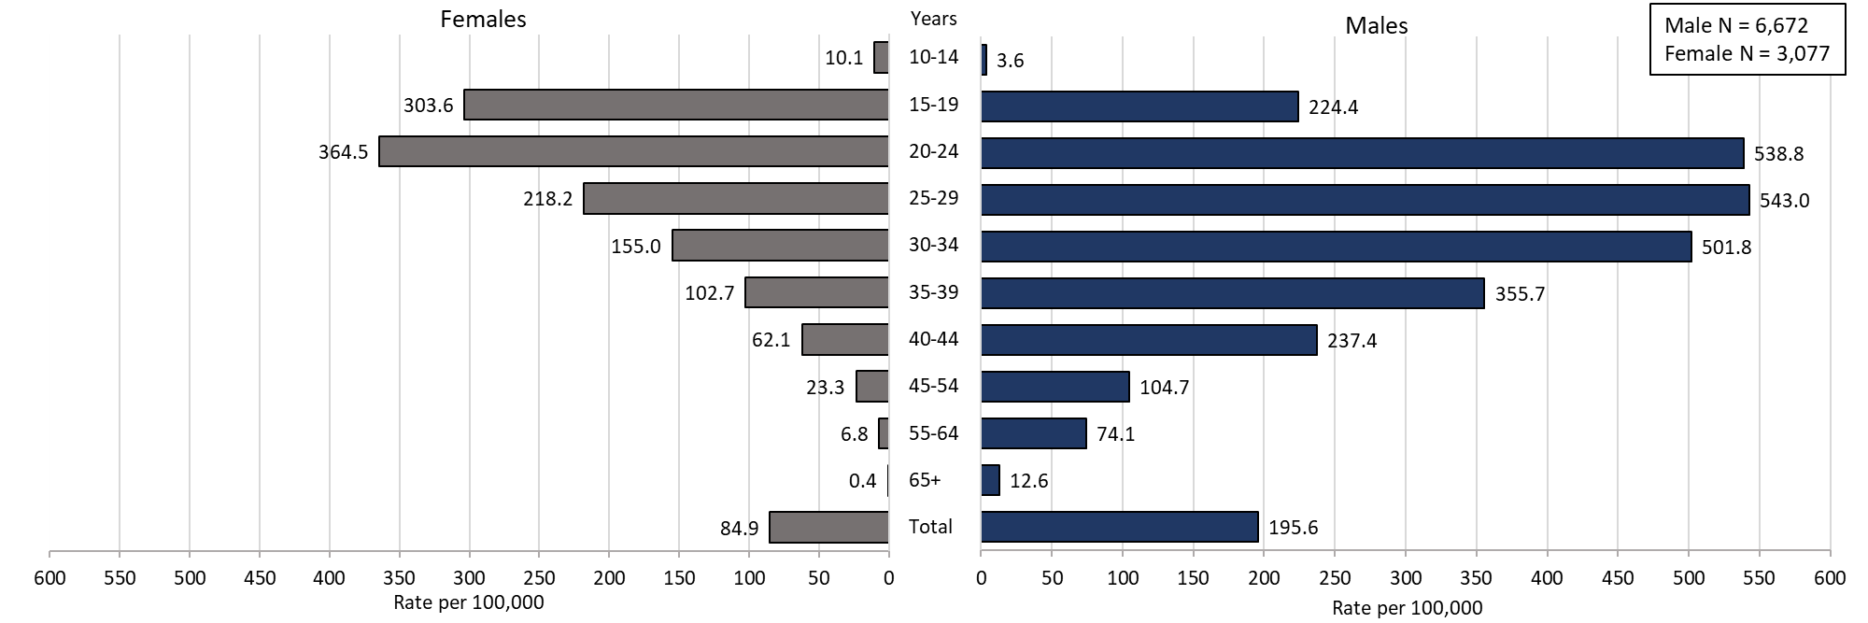

**Highlights:** Graph depicts gonorrhea case rates per 100,000 population by age categories for the overall state, males, and females. For the overall state, the highest rate is among those 20-24 years. When looking at the gender specific rates, the age categories with the highest rates are 20 to 24 years for females and 25 to 29 years for males.

**Footnotes for Slide 37**

Data are current as of 08/01/2024 and are subject to change.

Data Source: Massachusetts Department of Public Health/Bureau of Infectious Disease and Laboratory Sciences/Division of STD Prevention and STD-HIV Surveillance.

Population denominators estimated by the University of Massachusetts Donahue Institute using a modified Hamilton-Perry model (Strate S, et al. Small Area Population Estimates for 2011 through 2020 report, Oct 2016).

1. In 2023, there were 22 individuals of transgender experience and 8 other individuals documented in our data system that MA DSTDP does not have current gender information for. 3 individuals had unknown age. These cases were excluded since rate for this population cannot be calculated at this time.

2. Please consider the impact of the COVID-19 pandemic on infectious disease screening, treatment and surveillance in the interpretation of 2023 data.

Slide 38: Incident Rate of Infectious Syphilis1 Cases, per 100,000 Persons2 by City/Town, Massachusetts, 20233

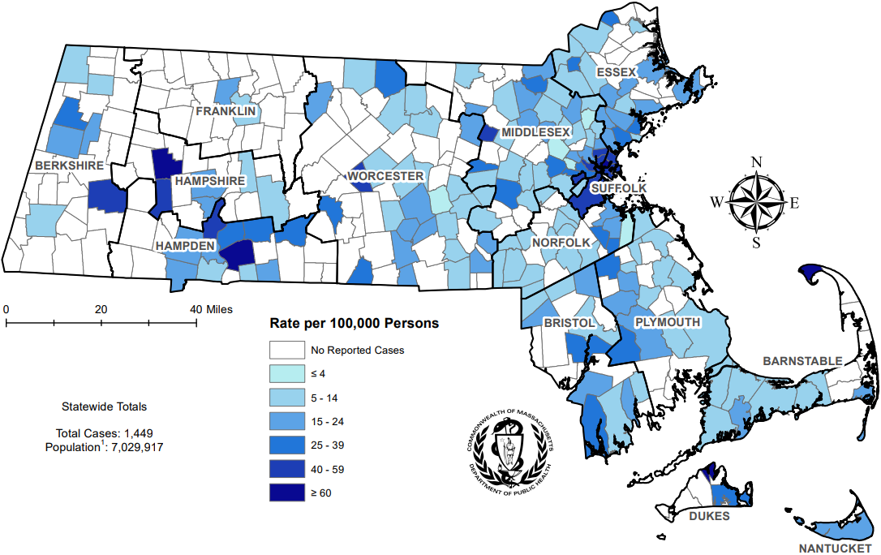

**Highlights:** Map of Massachusetts counties color-coded to indicate the areas of the state with the highest infectious syphilis case rates in 2023. The cities that have the highest rates (greater than 40 per 100,000 persons excluding towns with less than 10 cases) are Provincetown, Chelsea, Springfield, Boston, Holyoke, Revere, Malden, Somerville, and Everett.

**Footnotes for Slide 38**

Data are current as of 07/17/2024 and are subject to change.

Data Source: Massachusetts Department of Public Health/Bureau of Infectious Disease and Laboratory Sciences/Division of STD Prevention and STD-HIV Surveillance.

1. Infectious syphilis is defined as primary, secondary and early latent stages of syphilis within one year of infection.

2. Population denominators estimated by the University of Massachusetts Donahue Institute using a modified Hamilton-Perry model (Strate S, et al. Small Area Population Estimates for 2011 through 2020 report, Oct 2016).

3. There are seven city/towns with <10 cases of syphilis that fall within the top two rate categories (≥40 cases per 100,000): Chesterfield, Tisbury, Boxborough, Oakham, Becket, Huntington, and Winthrop,.

4. Please consider the impact of the COVID-19 pandemic on infectious disease screening, treatment and surveillance in the interpretation of 2023 data.

## Slide 39: Absolute Rate Difference1 Comparing 2023 to 2019 for Infectious Syphilis2 Cases, per 100,000 Persons3 by City/Town, Massachusetts

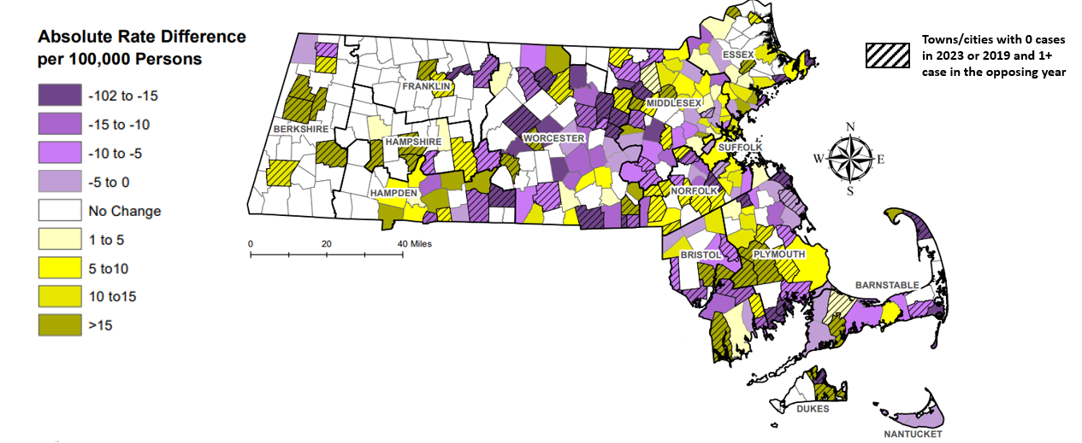

**Highlights:** Map of Massachusetts cities and towns color-coded to indicate the range of absolute rate differences per 100,000 persons comparing 2023 infectious syphilis case rates to 2019 case rates. The darker the color in the scheme, the greater the difference between 2023 and 2019 case rates with purple coloring indicating rates were higher in 2019 and the gold coloring indicating rates were higher in 2023. An approximately even number of cities and towns saw a rise and fall in infectious syphilis case rates in 2023 compared with 2019 with the greatest increases (greater than 20 per 100,000 persons) occurring in Provincetown, Chelsea, Springfield, Salem, Winthrop, and Hudson; the largest rate declines (less than -20 per 100,000 persons) were seen in Nahant, Chatham, Rutland, Leicester, and Ayer. The cities and towns that had zero cases for 2023 or 2019 and one or more cases for the opposing year are indicated on the map with a slash mark to acknowledge the absolute rate difference should be examined with caution.

**Footnotes for Slide 39**

Data are current as of 07/17/2024 and are subject to change.

Data Source: Massachusetts Department of Public Health/Bureau of Infectious Disease and Laboratory Sciences/Division of STD Prevention and STD-HIV Surveillance.

1. The darker the color in the scheme, the greater the difference between 2023 and 2019 infectious syphilis case rates with purple coloring indicating rates were higher in 2019 and gold coloring indicating rates were higher in 2023.

2. Infectious syphilis is defined as primary, secondary and early latent stages of syphilis within one year of infection.

3. Population denominators estimated by the University of Massachusetts Donahue Institute using a modified Hamilton-Perry model (Strate S, et al. Small Area Population Estimates for 2011 through 2020 report, Oct 2016).

3. There are eight city/towns with <10 cases of syphilis that fall within the top two rate categories (≥40 cases per 100,000): Chesterfield, Winthrop, Phillipston, Strockbridge, Russell, Truro, Springfield, and Ayer.

## Slide 40: Confirmed and Probable Infectious Syphilis1 Cases per 100,000 Population by Gender2 and Age, Massachusetts, 20233

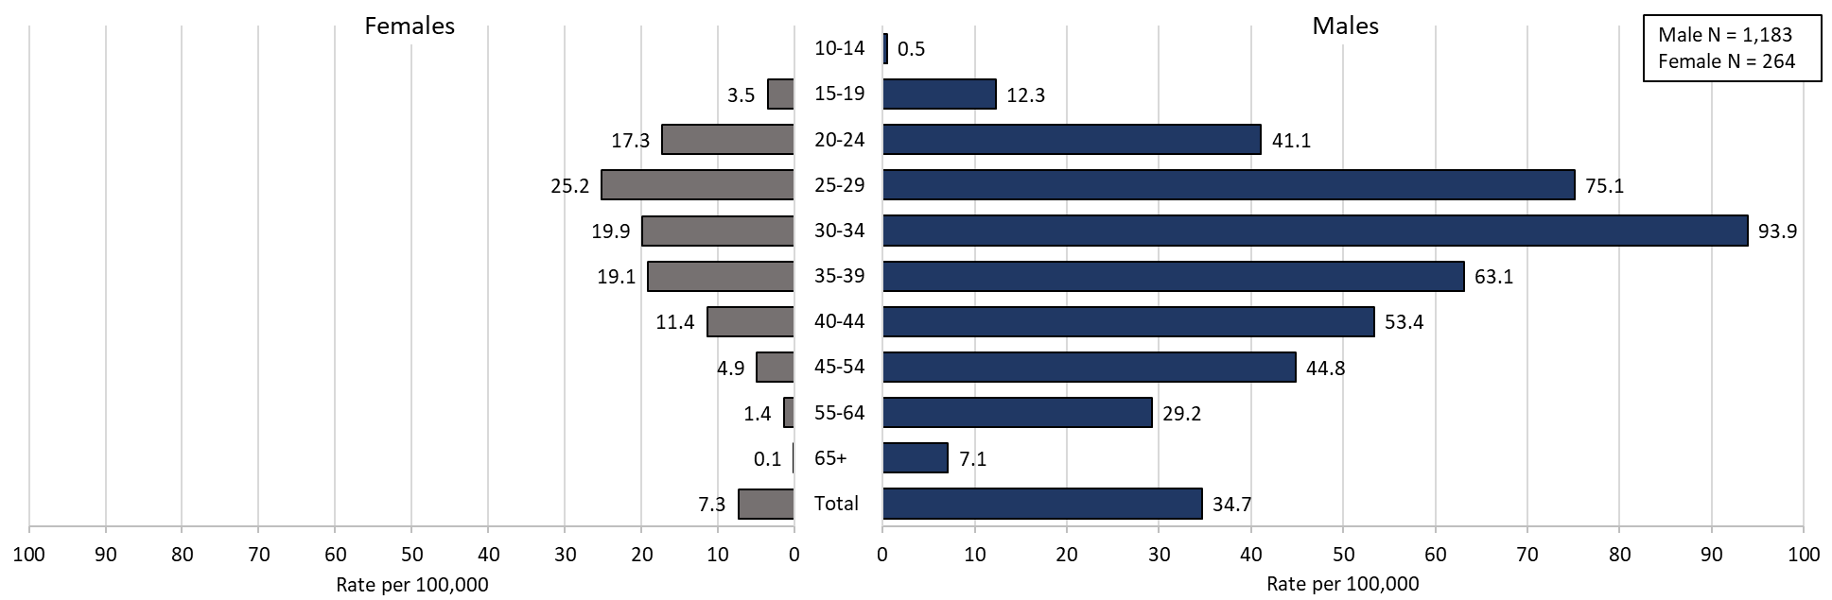

**Highlights:** Graph depicts infectious syphilis rates per 100,000 population by age categories for the overall state, males, and females. For the overall state, the highest rate is among those 30-34 years. When looking at the gender specific rates, the age categories with the highest rates are 25 to 29 years for females and 30 to 34 years for males.

**Footnotes for Slide 40**

Data are current as of 07/17/2024 and are subject to change.

Data Source: Massachusetts Department of Public Health/Bureau of Infectious Disease and Laboratory Sciences/Division of STD Prevention and STD-HIV Surveillance.

Population denominators estimated by the University of Massachusetts Donahue Institute using a modified Hamilton-Perry model (Strate S, et al. Small Area Population Estimates for 2011 through 2020 report, Oct 2016).

1. Infectious syphilis is defined as primary, secondary and early latent stages of syphilis within one year of infection.

2. In 2023, there were 2 individuals of transgender experience documented in our data system and MA DSTDP does not have current gender information for those individuals. These cases were excluded since rate for this population cannot be calculated at this time.

3. Please consider the impact of the COVID-19 pandemic on infectious disease screening, treatment and surveillance in the interpretation of 2023 data.

# Slide 41: Comparison of the Rate of Confirmed and Probable Infectious Syphilis1 Cases by Gender2 and Race and Ethnicity3, Massachusetts, 20234

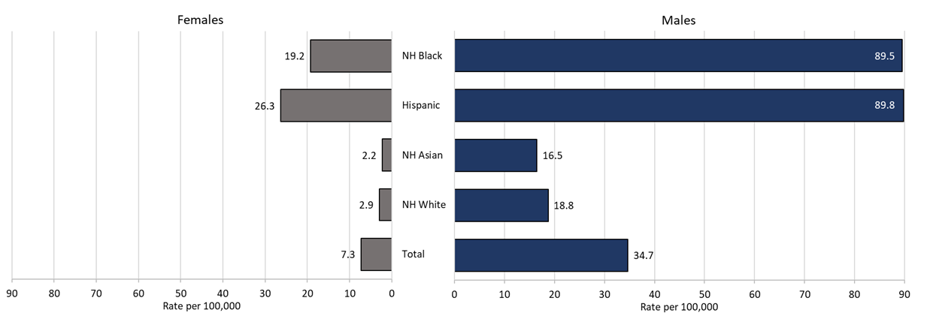

**Table: Infectious syphilis 2023 case counts by race and ethnicity and gender**

|  |  |  |  |
| --- | --- | --- | --- |
|  | Males | Females | Total |
| Total | 1,183 | 264 | 1,447 |
| NH White | 439 | 73 | 512 |
| NH Asian | 40 | 6 | 46 |
| Hispanic | 394 | 116 | 510 |
| NH Black | 208 | 47 | 255 |

**Highlights:** Graph depicts infectious syphilis rates per 100,000 population by age and race/ethnicity categories for the overall state, males, and females. For all infectious syphilis cases, the highest rate is among Hispanic/Latinx and Non-Hispanic/Latinx Black for both male and females.

**Footnotes for Slide 41**

Data are current as of 07/17/2024 and are subject to change.

Data Source: Massachusetts Department of Public Health/Bureau of Infectious Disease and Laboratory Sciences/Division of STD Prevention and STD-HIV Surveillance.

Population denominators estimated by the University of Massachusetts Donahue Institute using a modified Hamilton-Perry model (Strate S, et al. Small Area Population Estimates for 2011 through 2020 report, Oct 2016).

1. Infectious syphilis is defined as primary, secondary and early latent stages of syphilis within one year of infection.
2. In 2023, there were 2 individuals of transgender experience documented in our data system and MA DSTDP does not have current gender information for those individuals. These cases were excluded since rate for this population cannot be calculated at this time.
3. Those cases reported among non-Hispanic/Latinx individuals with other race categories were excluded based on small counts (5.4% of cases). Cases with unknown race and ethnicity were excluded because rates could not be calculated (3.1% of cases).
4. Please consider the impact of the COVID-19 pandemic on infectious disease screening, treatment and surveillance in the interpretation of 2023 data.

# Slide 42: Section Break, HIV Co-infection

STI and HIV Co-infection for Chlamydia, Gonorrhea, and Infectious Syphilis by Age and Sexual Risk Categories

# Slide 43: 20231 HIV2 Co-Infected Chlamydia and Gonorrhea Cases

Chlamydia with HIV Co-Infection

* + 2.3% of chlamydia cases were HIV co-infection (N = 28,910)
  + As age increases the proportion of HIV co-infection increases
    - 1.1% of cases in their 20s are HIV co-infected
    - 16.4% of cases 50+ are HIV co-infected

Gonorrhea with HIV Co-Infection

* + 7.4% of gonorrhea cases were co-infected with HIV (N = 9,779)
  + As age increases the proportion of HIV co-infection increases
    - 3.8% of cases in their 20s are HIV co-infected
    - 19.9% of cases 50+ are HIV co-infected

**Footnotes for Slide 43**

Data are current as of 08/01/2023 and are subject to change. Data Source: Massachusetts Department of Public Health/Bureau of Infectious Disease and Laboratory Sciences/Division of STD Prevention and STD-HIV Surveillance.

1. Please consider the impact of the COVID-19 pandemic on infectious disease screening, treatment and surveillance in the interpretation of 2023 data.

2. HIV status is based on a full year match with HIV Surveillance data.

# Slide 44: 20231 HIV2 Co-Infected Infectious Syphilis Cases3

26.4% of infectious syphilis cases were co-infected with HIV (N = 1,449)

As age increases the proportion of HIV co-infection increases

* + 12.6% of cases in their 20s are HIV co-infected
  + 42.8% of cases 50+ are HIV co-infected

Of individuals co-infected with HIV and infectious syphilis, 77.8% were MSM4 (N = 382), compared with 52.0% for those with no known HIV diagnosis (N = 1067).

Of known MSM individuals infected with infectious syphilis (N = 852), 34.9% were co-infected with HIV.

8.6% of co-infected individuals were newly diagnosed with HIV within 30 days of infectious syphilis event date; 91.4% had a prior HIV diagnosis.

**Footnotes for Slide 44**

Data are current as of 07/17/2024 and are subject to change. Data Source: Massachusetts Department of Public Health/Bureau of Infectious Disease and Laboratory Sciences/Division of STD Prevention and STD-HIV Surveillance.

1. Please consider the impact of the COVID-19 pandemic on infectious disease screening, treatment and surveillance in the interpretation of 2023 data.

2. HIV status is based on a full year match with HIV Surveillance data.

3. Infectious syphilis is defined as primary, secondary and early latent stages of syphilis within one year of infection.

4. The MSM (men who have sex with men) category includes MSMT,  MSMW, and MSMWT with “W” referring to women and “T” referring to individuals of transgender experience.

# Slide 45: Comparison of Infectious Syphilis1 Cases by HIV2 Co-Infection Status and Age3, Massachusetts, 20234

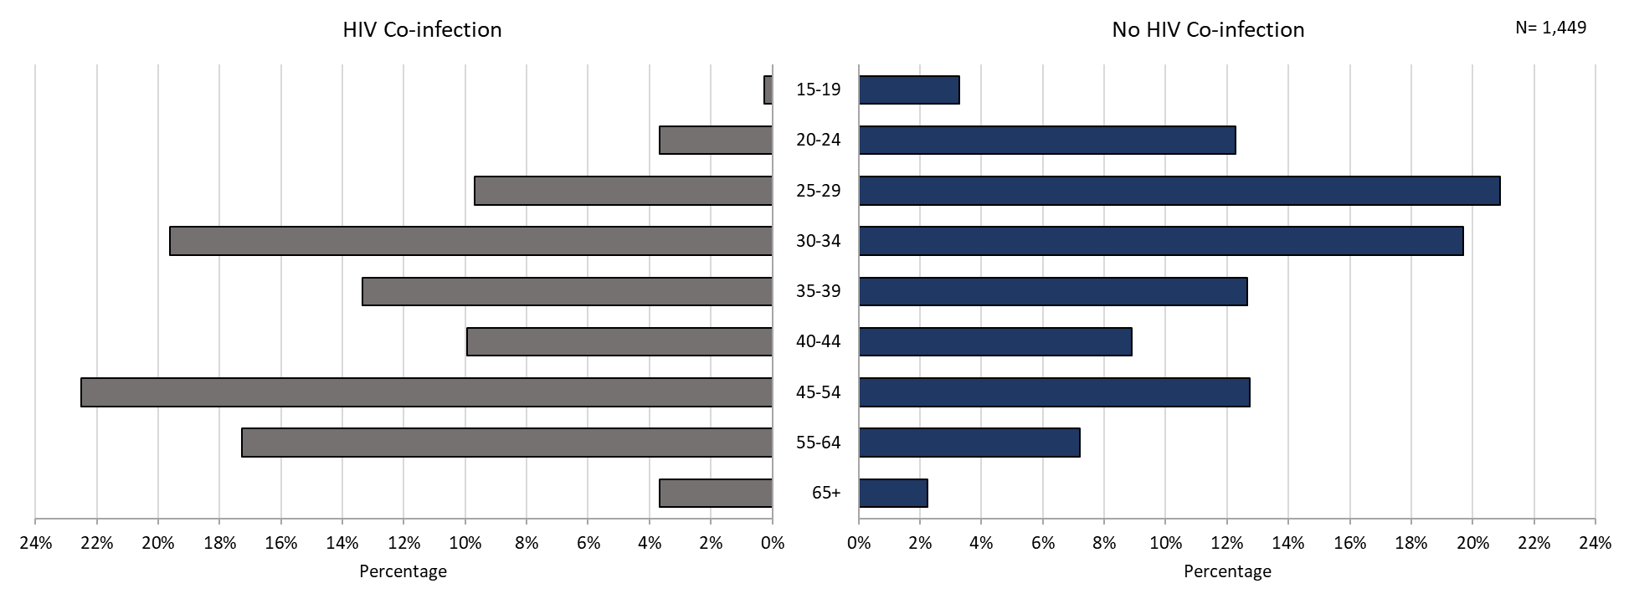

**Highlights:** Graph depicts infectious syphilis case percentages for age categories by HIV co-infection status. The proportion of infectious syphilis cases with HIV co-infection were highest among those age 45 to 54 followed by those age 30 to 34. The proportion of cases with HIV co-infection were lowest among those 15 to 19 years followed by those age 20 to 24 years as well as those over the age of 65 years.

**Footnotes for Slide 45**

Data are current as of 07/17/2024 and are subject to change.

Data Source: Massachusetts Department of Public Health/Bureau of Infectious Disease and Laboratory Sciences/Division of STD Prevention and STD-HIV Surveillance.

1. Infectious syphilis is defined as primary, secondary and early latent stages of syphilis within one year of infection.

2. HIV status is based on a full year match with HIV Surveillance data.

3. Individuals younger than 15 years are not included within this slide due to low case counts.

4. Please consider the impact of the COVID-19 pandemic on infectious disease screening, treatment and surveillance in the interpretation of 2023 data.

# Slide 46: Comparison of Infectious Syphilis1 Cases by HIV2 Co-Infection and Race/Ethnicity, Massachusetts, 20233

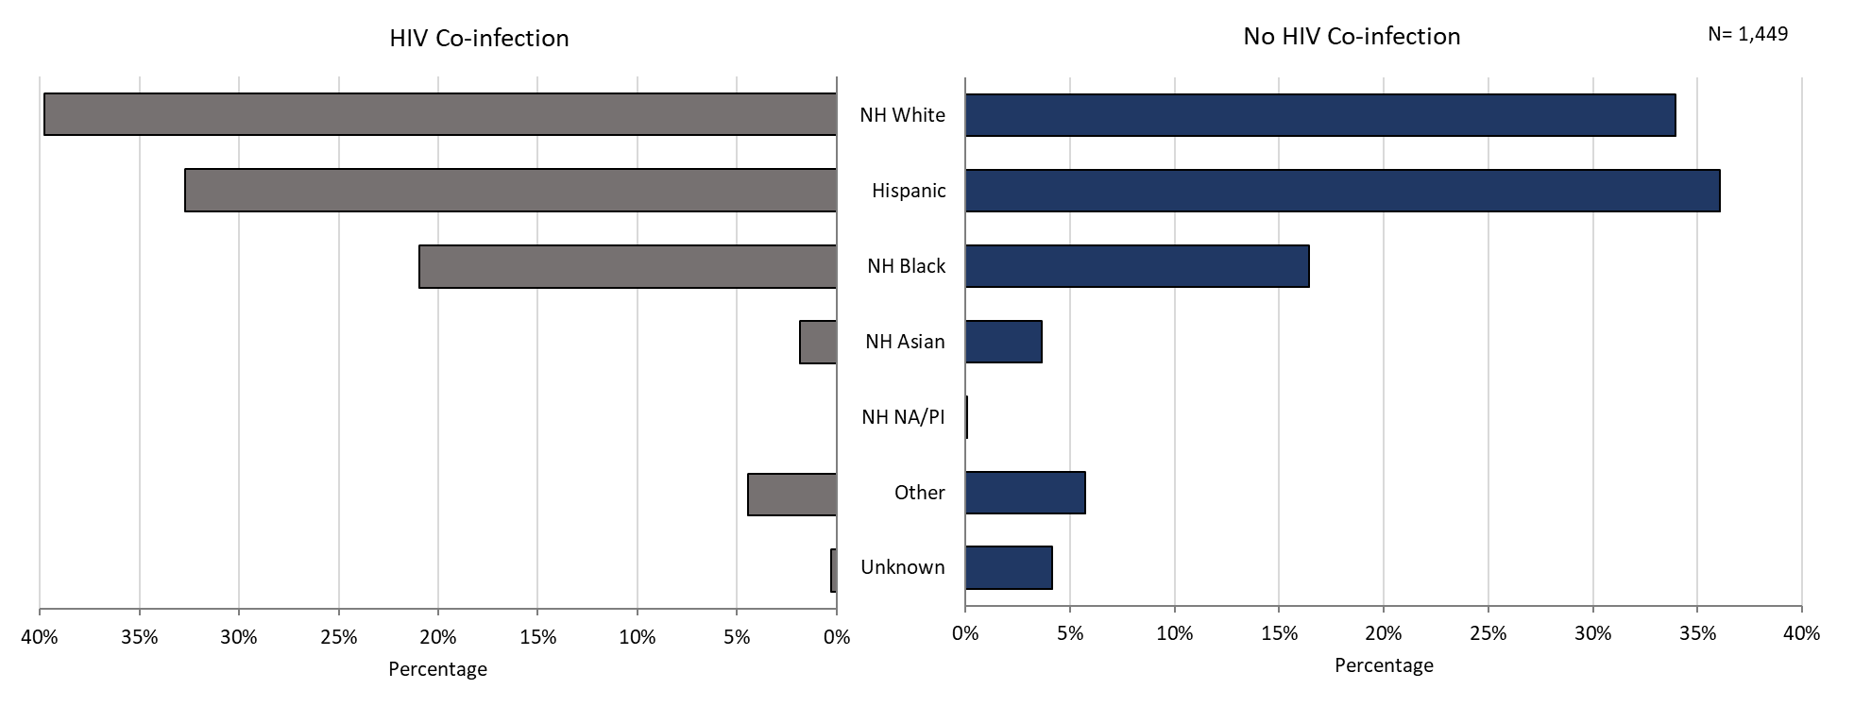

**Highlights:** Graph depicts infectious syphilis case percentages for race/ethnicity categories by HIV co-infection status. The proportion of infectious syphilis cases with HIV co-infection is highest among Non-Hispanic Whites followed by Hispanic and then Non-Hispanic Black individuals.

**Footnotes for Slide 46**

Data are current as of 07/17/2024 and are subject to change.

Data Source: Massachusetts Department of Public Health/Bureau of Infectious Disease and Laboratory Sciences/Division of STD Prevention.

1. Infectious syphilis is defined as primary, secondary and early latent stages of syphilis within one year of infection.

2. HIV status is based on a full year match with HIV Surveillance data.

3. Please consider the impact of the COVID-19 pandemic on infectious disease screening, treatment and surveillance in the interpretation of 2023 data

# Slide 47: 2023 Summary Slide

* Chlamydia: The 2023 Massachusetts state rate was 411.2 per 100,000
  + The highest rate of chlamydia cases was among females 20 to 24 years with a rate of 2,631.0 cases per 100,000 population*
  + Gonorrhea: The 2023 Massachusetts state rate was 139.1 per 100,000
  + The highest rate of gonorrhea cases was among males 25 to 29 years with a rate of 543.0 cases per 100,000 population
  + Infectious Syphilis: The 2023 Massachusetts state rate was 20.6 per 100,000
  + The highest rate of infectious syphilis cases was among males 30 to 34 years with a rate of 93.9 cases per 100,000 population
* Congenital syphilis cases maintained the increased number of reportable cases seen from 2019 to 2023
  + The overall increases in infectious syphilis rates in persons of reproductive potential based on age and reported sex assigned at birth and the increase in reportable congenital syphilis cases led to a recommendation for universal third trimester screening in 2020, on top of routine screening for syphilis upon entry into prenatal care in Massachusetts.

**Footnotes for Slide 47**

Data Source: Massachusetts Department of Public Health/Bureau of Infectious Disease and Laboratory Sciences/Division of STD Prevention.

Data are current as of 08/01/2024 and are subject to change

* Population based on 2019 University of Massachusetts Donahue Institute Estimates

# Slide 48: Technical Data Notes

* STI and HIV specific laboratory and case management information are reported directly to the Department of Public Health and maintained in the Massachusetts integrated disease surveillance and case management system, MAVEN
  + The majority (>90%) of laboratory test results are reported via electronic laboratory reporting
  + Case management information is reported via electronic medical record feeds, case reporting forms and collected by epidemiologists
  + Data are routinely reviewed, cleaned, and analyzed by surveillance epidemiologists
  + Routine reports are shared with internal and external stakeholders
  + All data are collected and maintained according to strict confidentiality and security requirements

Slide 49: Technical Data Notes (Continued)

* Case classifications (confirmed, probable or suspect) are based on CSTE/CDC case definitions for nationally notifiable infectious diseases.
  + For full STI case classifications, see: <https://www.cdc.gov/std/statistics/2019/case-definitions.htm>
  + All data in this report are accurate as of their analysis date and are subject to change. Common reasons for data changes include amendments to reporting and routine data cleaning.
* Transgender individuals are included in current gender identity categories, except where noted due to incomplete information on current gender identity. Nonbinary gender identity is captured but suppressed according to Massachusetts privacy and confidentiality rules. Collection of transgender data categories began in mid-2014.
* Gender of sex partners categories for this report include: MSM = men who have sex with men, MSW = men who have sex with women, WSM = women who have sex with men, Other = include transgender sexual risk categories and females who have sex with females or both male and female partners, and Unknown are cases reported without sexual risk. These categories are based on patient and provider report and do not necessarily reflect an individual’s sexual identity in relation to gender (i.e. gay, bisexual, heterosexual, etc).

# Slide 50: Coronavirus 2019 (COVID-19): Impact of Other Reportable Infections

When reviewing 2020-2023 data for Massachusetts, please note the impact of the coronavirus 2019 (COVID-19) pandemic on infectious disease screening, treatment, and surveillance. Nationally, CDC observed a sharp decline in reported STD cases from March-April 2020, compared to March-April 2019.

Three factors were cited as likely contributing to the initial decrease in reported cases:

* + Reduced screening – many health care clinics limited in-person visits to symptomatic cases or closed
  + Limited resources – many state and local health department STD staff were redirected from routine STD responsibilities to COVID-19 activities, which affected STD tracking capacity and reporting
  + Stay-at-home orders (March 24 through April 7th, 2020) – which were intended to reduce COVID-19 spread may have influenced sexual behaviors and reduced STD transmission1

As the impact of the COVID-19 pandemic continues, it’s full effect on case reporting and efforts to control the spread of infectious disease in the Commonwealth has yet to be determined. As such, please interpret 2020 infectious disease data with caution.

**Footnotes for Slide 50**

1. CDC Press Release, July 16, 2021: Trends in STD case reports during the U.S. COVID-19 pandemic, January-December 2020 available at: <https://www.cdc.gov/nchhstp/newsroom/2021/2020-std-trend-report.html>”

# Slide 51: Closing Slide

If you have questions or to request more information: call the Massachusetts Department of Public Health, Division of STD Prevention, at 617-983-6940

1. Providers may use this number to report individuals newly diagnosed with a notifiable sexually transmitted infection, including HIV, or request partner services. Partner services is a free and confidential service for individuals recently diagnosed with a priority infection. The client-centered program offers counseling, linkage to other health and social services, anonymous notification of partners who were exposed and assistance with getting testing and treatment. For more information, see: <https://www.mass.gov/service-details/partner-services-program-information-for-healthcare-providers>)