SURVEYING A LAKE WATERSHED

Data Collection Forms

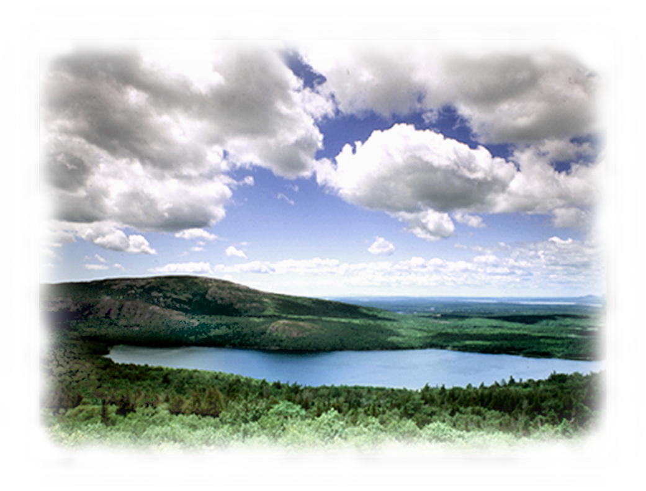

GUIDANCE FOR COMMUNITY VOLUNTEERS IN MASSACHUSETTS

Data sheets based on materials from

Massachusetts Department of Environmental Protection
Massachusetts Riverways Programs, Adopt-A-Stream Program,
Department of Fisheries, Wildlife, and Environmental Law Enforcement
Massachusetts Water Watch Partnership
Maine Department of Environmental Protection

2001

Tips for Surveying a Lake and Pond Watershed

The purposes of this survey are to organize residents and officials of communities to work together to solve problems and to protect resources of lakes and ponds. The survey, a cooperative venture, is a primary step in this process. In addition, the success of the survey depends upon volunteers and landowners. Before the survey takes place, all landowners need to be invited to participate in the survey, notified of purposes of the survey, and have an opportunity to give permission for volunteers to walk their property.

This survey form is designed for use with the Massachusetts Volunteers Guide for Surveying a Lake Watershed and Preparing an Action Plan (2001). To ensure that the survey is successful, volunteers should be aware of the following safety tips.

Safety and Legalities
- Always walk with someone.
- Watch out for irate dogs. Walk cautiously and practice good dog etiquette.
- Do not drink the water.
- Lifejackets are required by law for each person in any canoe or boat.
- From September 15 to May 15 all canoe or kayak occupants must wear a U.S. Coast Guard Approved Personal Flotation Device.
- Wear long-sleeved shirts and pants to protect against, ticks, mosquitoes, poison ivy, and nettles.
- Wear insect repellent if necessary.
- Consider landowner rights. Ask permission to cross private land, posted or not.
- Do not enter posted areas without permission. Take advantage of public access points.

Environment:
- Don’t walk on unstable banks; your footsteps could speed erosion.
- Be aware of wildlife and animal homes, for both of your sakes.

NEVER PUT YOURSELF IN DANGER TO GATHER SURVEY INFORMATION.
If at anytime you feel uncomfortable about the bank or waterbody conditions or surroundings, please STOP your survey. You and your safety are much more valuable than any of the objectives of the watershed survey.

Checklist: What to take on your survey
Optional
___ Rubber boots or waders
___ Yardstick or measuring tape (useful for pipes)
___ Compass
___ Field guides (in ziplock bags)
___ Food, for energy!

___ A buddy
___ Data forms and topo map
___ Clipboard or other surface for writing
___ Two pencils – color is good to mark on maps
___ Long-sleeved, snag-free clothing /pants (for bugs
and thorns)
___ Sunblock
___ Sunglasses (polarized to see into the water better)
___ Lifejackets & paddles if canoeing
___ Camera and film
___ Gloves
___ Copy of letter sent out to landowners
___Flashlight for checking culverts

Fill out your data sheets, get them to your team leader, and attend action planning meeting, which will be held on: ____________________

LAKE and POND WATERSHED PRESURVEY FORM

Lake and Watershed Name: _____________________________________________________________________
Survey Area Number: _________________________________________________________________________
Surveyors Names: ____________________________________________________________________________

A. Description of the Area from a Topographic Map (Maps will be available at the training session.)

- Do you see developed (white) and undeveloped areas (green)? What % of each do you see?
_____% developed _____ % undeveloped

- Are the banks of either the tributary or shoreline steep, (How close together are the contour lines?)
indicating a potential for increased runoff or erosion?
____Yes ____No

- How many tributaries enter or cross your area?

- What kinds of development are shown on the map? (Include major development in the watershed, as well as the shoreline, that could have an impact on the lake.)

B. General Categories of Land Uses in your Area
___ % Construction
___ % Residential
___ % Roads
___ % Agricultural land

___ % Urban
___ % Logging/forestry
___ % Other (please specify, e.g. , rural, open, or recreational)_____________________________________

C. If Residential (Estimate % of area;information will be available at the training.)
___Multifamily ____year round
___<1/4 acre lots ____seasonal
___1/2-1 acre lots
___>1 acre

D. Is the area sewered? _____ or unsewered _____?

E. Watershed History and Characteristics What do people know about this area?
General description: ______________________________________________________________________
______________________________________________________________________
Historical information:_____________________________________________________________________
_____________________________________________________________________
Problems to look for during site visit: (e.g., If there is a new development near a stream, you will want to look
upstream and downstream of the site for evidence of erosion and sedimentation and excessive vegetation in the stream.
If you see erosion downstream of the development you may be able to track the problem back to its source.)
1. ______________________________________________________________________________________
______________________________________________________________________________________
2. ______________________________________________________________________________________
______________________________________________________________________________________
3. ______________________________________________________________________________________
______________________________________________________________________________________
LAKE and POND WATERSHED SURVEY FORM

Lake and Watershed: ______________________________ Survey Date:_______________________________
Surveyors Names: ________________________________
Area Number: ___________________________________
Site Location: Beginning ___________________________ End: _____________________________________
Weather Today: _____________________________Weather (past 2-5 days)______________________________
Landowners Contacted During Survey: ____yes ____no
Description: Is the lake or pond a… (Please check)
___Naturally occurring lake or pond ___Lake or pond created by a dam ___Salt pond

A. General Categories of land uses on the Problem Site (Identify the land use category on the problem site.
May be more than one land use.)
___ % Agricultural land

___ % Urban
___ % Logging/forestry
___ % Construction
___ % Residential
___ % Roads
___ % Other (please specify, e.g. , rural, open, or recreational)_____________________________________

A.1. Specific Land Use on the Problem Site (Estimate % of site in each use. May be more than one land use.)

___commercial
___industrial
___junk yard
___railroad
___bridge
___highway
___dirt road
___local road
___parking lot
___golf course
___grazing/pasture
___park or beach
___protected open space
___undeveloped land
___meadow
___forest
___wetland
___other (specify)___________

A.2. If Residential (Estimate % of site that is…)
___Multifamily ___year round
___<1/4 acre lots ___seasonal
___1/2-1 acre lots
___>1 acre (400 x 100 feet)

B. Site characteristics
1. Dominant soil is…
___rock ___gravel ___sand ____silt ____clay
2. Slope of site is…
___flat ___moderate ___steep

3. The bank is… (Check a or b, if there is a stream, ditch, shoreline, or steep bank on site.)
(b) _ b)___unstable and…
____undercut
____eroded

a)___vegetated with…
___exposed roots
___shrubs and native grasses (< 20 feet)
___trees taller than 20 feet

- The width of the band of trees, shrubs, or grasses covering the bank or extending outward from it is…
____0-5 feet ____5-50 feet ____50-100 feet ____greater than 100 feet

5. The % of the bank area that is covered by each of these vegetation types is…
____% little or none ____% grasses ____% shrubs ____ % trees (>20 feet)

6. Cover (estimate shading between 10 A.M. and 2 P.M.)
0-25%____ 25-50%____ 50-75%____ 75-100%____

LAKE and POND WATERSHED SURVEY FORM
(Continued, page 2)
C. Site drainage
1. Site runoff is directly to…
__lake ___stream ___ditch ___ catch basin ___vegetated buffer ___wetland other (describe)____________

2. Site runoff is from…
Construction: ___ disturbed areas <1 acre) ____disturbed areas >1 acre
Residential: ___ <1 acre ___ >1 acre and ___ driveways ___lawns
Roads: ___ pavement to catch basin ___bridge ___shoulders/country drainage
Agricultural: ___ field ____animal grazing area ____manure storage area
Urban: ___ parking lot ___vehicle maintenance yard ____industrial area ___waste storage area
Logging/Forestry: ___ logging yard ___roads/trails ___stream crossings ____forested areas

D. Land disturbances that affect water quality
- Do you see evidence of excess nutrients? (Check all that apply)
____Soil erosion: ____silt _____sand ____soil ____stockpiled soil ____sedimentation
____Evidence of runoff: ____gullies ____rills ____channel
____Evidence of nutrients: ___pet waste/manure ____fertilizer use ___green lawns other(specify) _________
2. Do you see any of the following? (Use the same land use categories that were selected for the site.)
Construction: ____exposed soil ___altered drainage pathways ____absence/failure of erosion controls
Residential: ____exposed soil ___ lush lawns ____evidence of erosion ____ pet waste ___ pipe drains
Roads: ____drainage to waterbody ___evidence of erosion ___sediment in ditches/culverts/drains
____ sand build up in road
Agricultural: ____exposed soil ___ animals in waterbody ___ storage areas uncovered

Urban: ____drain pipes to waterbody ___sediment in ditches/culverts

____ paved areas near waterbodies ____ trash/waste storage near waterbodies
Logging/forestry: ____ exposed soil ____ poor roads ____brush/slash near waterbodies
Other: ____ (specify) __________________________________________________________

3. Do you see any of the following? If there are tributaries, catchbasins, drain pipes, and/or culverts on the site,
explain your observations.
____Tributaries bringing in siltation:______________________________________________________
____Condition of the culvert/pipe:________________________________________________________
____Describe what is going into the pipe (add color and odor):_________________________________
____Describe any discharge from the pipe (add color and odor):________________________________
____Try to obtain and attach a map of the drainage system through your site/area.

E. Water quality concerns (Check all that apply, describe the location and cause, and indicate site on map)
___Oily sheen or smell: _________________________________________________________________
___Sewage: (odor, milky color, toilet paper)_________________________________________________
___Foam or scum: (does a stick break it up? If it does, foam is probably natural.)_____________________________________________
___Fishy odor or fish kill:________________________________________________________________
___Algae or aquatic weeds (excessive growth):_____________________________________________________________
___Floating trash:______________________________________________________________________
___Obvious sedimentation: (e.g., sand) _____________________________________________________

F. Habitat and wildlife (Evidence of…)
____Fish: (fish, fish nests, anglers) Identify species if known______________________________________
____Other aquatic life: __insects, __turtles, __frogs, __snails, __mussels, __clams, other:______________
Identify species if known:_____________________________________________
____Waterfowl: __herons, __ducks, __geese, __loons, other______________________________________
____Areas of good habitat with wildlife: Describe______________________________________________

Lake Watershed Survey
Area Summary Sheet 1: Narrative Area begins: _____________________
Area ends: ____________________
Date:_______________________________________________________ Surveyors:___________________________________________________
Today's weather:______________________________________________
Weather over past 24-48 hours:__________________________________

These sheets are designed to (1) give the “big picture” of your area, and (2) describe the problems you have seen that could contribute to impaired water quality in the waterbodies of your watershed. The problems you have seen should be marked on your map (A, B, C, D) and described here. Identify the source of the problem whenever possible. This information provides the basis of the narrative description in your Lake or Pond Watershed Survey Report.
NARRATIVE DESCRIPTION
Sample.
We surveyed the south side of the pond from Oak to John Street. (A) There is a small stream, (about 1.5 feet across and 0.5 inched deep) that comes in just east of 3 Oak Street. The stream has a deep tea color but does not smell or have any algae. The bottom of the lake in this area is covered with decaying leaves/muck. This area also has woods coming up to the pond edge- a really well established vegetated buffer and lots of song birds. (B) From 3 to 17 Oak Street, people’s lawns come up to the edge of the water-no buffer. Some dumping of yard wastes close to the shoreline.

(C) Lots of illegal dumping- at the end of the maintenance access road for Rte. 13 (mostly construction type stuff)! There are 3 large erosion gullies beneath the pipes sticking out of the embankment (from the storm drains on the highway), and there is a large delta of sand forming in the water beneath the embankment. Smells like gasoline and there was a sheen in the water trapped by the tires. This area could be cleaned up and it would make a great boat ramp area. Plant a few trees and it would be a nice place to sit-the view is nice. Can we get permission from Mass Highway to do clean up work near Rte. 13?

(D)There is a thick coating of duckweed along the edge of “Ball Park Cove” and the rest of the cove is thick with milfoil, (a neighbor says it is milfoil-we are not sure). The storm drain across from a new subdivision, (intersection of Oak and John Streets), is clogged with dirt from the construction site.

Describe your area in a paragraph:

Lake Watershed Survey Area begins: __________________
Area Summary Sheet 2: Priorities for Action Area ends: __________________
Look back at your data sheets and include your observations. The information from this sheet will be used to develop the Watershed Survey Report and Action Plan.

PROBLEMS:  Problems found in your area, such as  pipes or culverts discharging in dry weather, erosion, runoff, trash, dense algae, water quality problems (odor, color, oil, foam, sewage), and degraded wetlands (phragmites, loosestrife) (Describe and give location).  1.  2. | ASSETS:  Assets found in your area, such as good habitat, wildlife species, businesses, or landowners using the river (in a friendly way), recreational access (canoe, trails, parks), potential recreational access, and potential park/conservation land (Describe and give location).  1.  2. | PRIORITIES FOR ACTION:  List items that you feel would help to address or correct the priority problems in column 1.  1.  2.

Based on sheets provided by the Massachusetts Riverways Programs/DFWELE 7

MAPPING PAGE

Survey area:____________________________ Begin:____________________________ End:___________________________
Surveyors:________________________________________________________________
Date:_____________________________________ Weather today:_________________ Weather past 48 hours:____________

Draw a birds-eye view of your problem site, showing vegetation types and canopy along the streambank or shoreline, land uses, and other features. Include any details such as pipes, drainage ditches, or connections to wetlands or tributaries. Add assets such as habitat, recreation, and open space. If there is enough room write a brief description next to the problems found on site. If you need more room, label the problems A,B, C, on the map and describe these problems on the Narrative Summary Sheet. Be sure to include the following information : (1) where you have taken photos --use arrow showing direction, include photo number, (2) Mark problems, assets, and photo numbers on topographic map of your area. (See sample on reverse side.)

