Surveying Students about Emerging Tobacco Use:

Rationale and Suggested Questions
Note: This document was originally created in 2018, before the passage of several laws in Massachusetts pertaining to the sale of tobacco products. Relevant data has been updated and the survey questions for school consideration are still valid.
Table of Contents
The Problem 2
Why Survey? 2
Emerging Tobacco Issues 3
Exposure and Access 3
Flavored Tobacco Products 4
Electronic Vapor Products 5
Marijuana 6
Survey Questions for School Consideration 7
Exposure and Access 7
Tobacco Use/Flavored Use 7
Electronic Vapor Products 9
Marijuana 10
Endnotes 10

The Problem
Cigarette use among youth in Massachusetts has reached a historic low (YHS 2019).
Less than 1 in 20 high school students use cigarettes

The tobacco industry continues to develop and market novel products that are sweet, cheap, and easy to get, including:
Cigars and cigarillos ● Electronic vapor products ● Smokeless tobacco

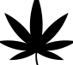
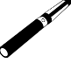
As a result (data from YRBS 2019 unless otherwise noted):
1 in 6 tobacco users reported getting tobacco from a store

1 in 3 used electronic vapor products (in past 30 days)

4 in 5 tobacco users used flavored products (in past 30 days) (YHS 2017)

1 in 5 used both tobacco and marijuana (in past 30 days)

Youth tobacco use remains a critical issue. Nicotine and other chemicals found in tobacco products are harmful to the developing brain and health of adolescents. Tobacco use is also a risk factor for other substance use (alcohol, marijuana, or other drugs) and poor academic achievement. Therefore, schools and communities should regularly monitor emerging trends in youth tobacco use and access.

Why Survey?
To monitor trends in both conventional tobacco use (cigarettes, cigars, and smokeless tobacco), and emerging products (electronic vapor products), this document includes suggestions for survey questions on the following topics:
- Access to tobacco products and perception of harm
- Cigars and smokeless tobacco use
- Electronic vapor product use
- Flavored tobacco product use
- Marijuana use
These data can be used:
- To capture trends over time in use of conventional and emerging tobacco products and compare local use rates with statewide use rates.
- To track use of marijuana in electronic vapor products, and concurrent use of tobacco and marijuana.
- To help tailor education efforts and inform decisions about school policies.
- To increase support for tobacco control policies which have the potential to decrease youth tobacco exposure, access, and use.

Emerging Tobacco Issues

Exposure and Access

How are youth exposed to and how do they access tobacco?
The retail environment is one of the primary ways the tobacco industry targets and advertises their products to youth. In a nationwide sample of tobacco retailers, almost all retailers (95%) displayed tobacco marketing. Furthermore, flavored tobacco products (including flavored electronic vapor products) are widely sold and promoted in stores which youth frequently visit, such as convenience stores. Youth also frequently report seeing tobacco advertisements in stores. In addition, youth report seeing advertisements through the internet, television, and newspapers/magazines (though less frequently than in stores).

In Massachusetts, 1 in 6 high school students who currently use tobacco reported obtaining their products from a store (including both convenience/gas station/mini-mart stores and vape stores) (YHS 2019). Following obtaining products from others, stores were the most frequently reported method by high school students of obtaining tobacco.

Inequities in exposure and access
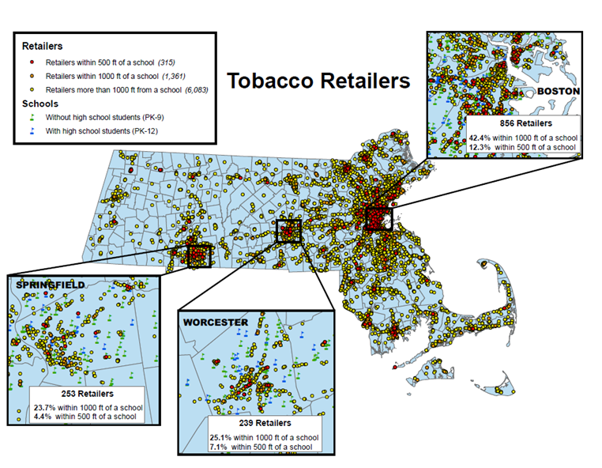
Retailers in neighborhoods with higher proportions of youth have also been found to display more tobacco marketing materials, compared to retailers located in neighborhoods with lower proportions of youth. Inequities also exist in the location of tobacco retailers, as a greater number of tobacco retailers have been found near schools with a greater proportion of Black, Hispanic, and low-income students. In Massachusetts, many areas, especially large urban cities, have retailers located near schools. In Boston, for example, close to half of all retailers are located within 1,000 feet of a school (see map below).

Impact on behavior
Many studies have found an association between higher density of tobacco retailers surrounding schools and higher youth smoking rates. In addition to the opportunity to obtain tobacco products, increased retail density may support normalization of tobacco use and increase environmental cues to smoke through constant exposure to tobacco products and advertising. For example, one experimental study found that hiding the tobacco “power wall” (display with all tobacco products and promotions) from view reduced the likelihood of youth reporting the desire to try a cigarette in the future.

Why collect data on exposure and access to tobacco?
Collecting data on how youth obtain tobacco products and perceptions of harm can help school administrators and teachers assess school-wide perceptions of tobacco, and the primary ways students are obtaining products, to better tailor health education efforts to their students. In addition, these data can inform decision makers on the importance of policies which restrict youth exposure and access to tobacco.

Flavored Tobacco Products

Rise in availability and use of flavored tobacco products
In 2009, the Family Smoking Prevention and Tobacco Control Act banned the sale of flavored cigarettes (FDA). However, this law did not extend to other tobacco products (cigars, cigarillos, e-cigarettes, blunts, smokeless tobacco). Since this time, the production and sale of flavored tobacco products has been on the rise, in flavors such as fruits, candy, alcohol, and mint. The tobacco industry intentionally targets flavored tobacco products towards younger users, and youth use of flavored products well exceeds that of adults. In 2017, the majority of Massachusetts high school students who reported using a form of tobacco (cigarettes, cigars, smokeless tobacco, or electronic vapor products) in the past 30 days reported using flavors (80%) (YHS 2017). Additionally, flavored tobacco products may attract youth who otherwise may not have tried tobacco. Research has found that the vast majority of youth tobacco ever-users report initiating with a flavored product and that these users are more likely to be current tobacco users compared to tobacco ever-users who did not initiate on flavor.

Retail environment
Flavored tobacco products are widely available in stores which youth frequent, such as convenient stores. The picture below is an example of the colorful and attractive display of flavored tobacco products in a Massachusetts convenient store in 2017.
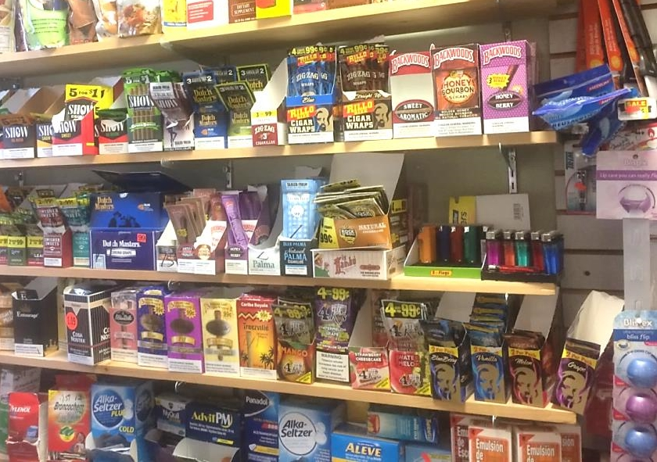

Flavored tobacco restrictions in Massachusetts
Due to the rise in flavored tobacco availability, since 2014, many Massachusetts towns passed regulations restricting the sale of flavored tobacco products to adult-only stores (such as tobacconists and vape shops). In 2019, Massachusetts passed a first-in-the-nation statewide law which restricts sales of all flavored tobacco products (including menthol) to adult-only smoking bars (for on-site consumption only). This law has the potential to decrease youth exposure, access, and use of flavored tobacco products.

Why collect data on flavored tobacco use?
Collecting data on flavored tobacco use can help school administrators and teachers assess use rates within their school, and better tailor health education efforts to their students. In addition, collecting these data will also help to assess the impact of the statewide flavored and menthol tobacco law on youth behavior.

Electronic Vapor Products

Rise in availability and use
Electronic vapor products (e.g., e-cigarettes, e-hookah, or vape pens) have risen in popularity, and schools report student use of these products, including brands such as JUUL, with frequency. These reported trends in use have coincided with a rise in product availability in retail stores. Advertising for electronic vapor products is also widespread, and in 2014, almost 70% of youth in the US reported viewing advertisements for electronic vapor products in retail stores or in the media. In addition to retail availability and exposure to advertising, the wide range of available flavors may attract new users, and youth are more likely to report viewing candy, fruit, or menthol flavored products as less harmful than tobacco or alcohol flavored products. Youth are also more likely to view electronic vapor products overall as less harmful than traditional combustible cigarettes. However, electronic vapor products still contain nicotine, which is harmful to the developing adolescent brain.

Electronic vapor products
Massachusetts high school students use electronic vapor products at a higher rate than any other tobacco product (see graph below). In 2019, MA YHS data suggest that half of all high school students (51.2%) reported ever trying an electronic vapor product, and almost one-third reported current use (use in the past 30 days). However, as the brands and types of electronic vapor products available in the retail environment continue to change over time, data collected in 2019 may not accurately represent current use rates.

Health outcomes
A growing body of literature suggests that electronic vapor use may lead to use of traditional combustible cigarette products, and that youth may use electronic vapor products as a delivery system for marijuana and other drugs. Electronic vapor product use alone exposes users to nicotine and other chemicals known to harm the developing adolescent brain. For example, nicotine can increase risk of other drug use and addiction, lead to impairments in cognition and attention, and increase risk of anxiety disorders and depression.

Why collect data on electronic vapor product use?
Due to changing types of electronic vapor products available in stores, collecting local data on use is important to accurately capture the magnitude of the issue. In addition, as these products can be used to vape a variety of substances, it is important to monitor the types of substances students are using with these devices. It is also important to assess norms around these emerging products, as perceived normalcy and overestimation of peer use may increase the likelihood that youth will use these products. These data can help school administrators and teachers better tailor health education efforts to their students.

Marijuana

Rise in use and concurrent tobacco use
Nationwide, adolescent marijuana use is on the rise. One national study found that marijuana use among 8th, 10th, and 12th grade students increased significantly in 2017 for the first time in seven years. In Massachusetts, high school students use marijuana at a higher rate than most tobacco products, and at a similar rate to electronic vapor products. In 2019, 44.4% of students reported ever trying marijuana, and 30.2% reported using marijuana in the past 30 days (YHS).
As electronic vapor products rise in popularity, many students also use these devices with substances containing marijuana. In Massachusetts, almost 1 in 10 students reported vaping as their usual method of using marijuana (YHS 2019)

Health effects of marijuana
While perceived harm of marijuana is decreasing among adolescents, research continues to find that earlier onset of marijuana use is associated with more severe cognitive deficits. Regular use of marijuana before age 18 is associated with attention difficulties, reduced IQ, and reduced executive functioning. In addition, frequent marijuana use in adolescence is associated with lower educational attainment and greater unemployment later in life.

Why collect data on marijuana use?
As youth are currently using electronic vapor products (which can be used to vape marijuana) at high rates, it is important to monitor trends and potential changes in marijuana use rates. These data can help school administrators and teachers better tailor health education efforts to their students.

Survey Questions for School Consideration

Exposure and Access
- If you tried to buy a tobacco product (including electronic vapor products) in your town, do you think you would be asked for ID?
  - Yes
  - No
  - Not sure

- In the past 3 MONTHS, how did you get your tobacco products (including electronic vapor products)? (Choose ALL that apply)
  - I did not get tobacco in the past 30 days
  - I got them from a convenience, corner, or gas station/mini-mart store
  - I got them from a vape store
  - I got them from a family member
  - I gave someone money to buy them for me
  - I got them from friend(s)/ I used a friend's
  - I got them online
  - Other: ___________________________

- How much do you think people risk harming themselves if they use tobacco regularly (not including electronic vapor products)?
  - No risk
  - Slight risk
  - Moderate risk
  - Great risk

Tobacco Use/Flavored Use

Use
- Have you EVER SMOKED cigars, cigarillos, or little cigars (e.g., Garcia y Vega Game, BluntVille, Backwoods, Rock N’Roll)?
  - Yes
  - No

- In the past 30 DAYS, have you smoked cigars, cigarillos, or little cigars (e.g., Garcia y Vega Game, BluntVille, Backwoods, Rock N’Roll)?
  - Yes
  - No

- Have you EVER USED smokeless tobacco that is chewed, sniffed, or held in the mouth (e.g., Skoal, Grizzly, Timber Wolf)?
  - Yes
  - No

- In the past 30 DAYS, have you used smokeless tobacco that is chewed, sniffed, or held in the mouth (e.g., Skoal, Grizzly, Timber Wolf)?
  - Yes
  - No

- Have you EVER USED an electronic vapor product (including JUUL, e-cigarettes, e-cigars, e-pipes, mods, personal vaporizers, vape pipes, vaping pipes, e-hookahs, and hookah pens)?*
  - Yes
  - No

- In the past 30 DAYS, have you used an electronic vapor product (including JUUL, e-cigarettes, e-cigars, e-pipes, mods, personal vaporizers, vape pipes, vaping pipes, e-hookahs, and hookah pens)?*
  - Yes
  - No
*Note: Questions differ from national and state YRBS questions on electronic vapor product questions (different examples of products listed) so national and state estimates may be an undercount.

Flavors (To be included after questions about ever and 30-day use of chewing tobacco, cigars, and electronic vapor products)
- During the past 30 DAYS, did the chewing tobacco, snuff, dip, snus, or dissolvable tobacco products you used contain a flavor such as cherry, citrus, peach, sweet scotch, etc.? NOTE: Do not include regular tobacco or menthol, mint, or wintergreen.
  - I have not used these products in the past 30 days
  - Yes
  - No
  - I don’t know

- During the past 30 DAYS, did the cigar, cigarillo or little cigars you smoked contain a flavor such as cherry, vanilla, pina colada, chocolate, tropical fusion, etc.? NOTE: Do not include regular tobacco or menthol, mint, or wintergreen.
  - I have not used these products in the past 30 days
  - Yes
  - No
  - I don’t know

- During the past 30 DAYS, did the electronic vapor product you used (such as e-cigarettes, e-cigars, e-pipes, vape pipes, vaping pens, JUUL, e-hookahs, and hookah pens) contain a flavor such as cherry, vanilla, pina colada, bubble gum, blue mist, fizzy pop, etc.? NOTE: Do not include regular tobacco or menthol, mint, or wintergreen.
  - I have not used these products in the past 30 days
  - Yes
  - No
  - I don’t know

- Which of these best describe the FIRST tobacco product (including electronic vapor products) you tried (please select ONE)?
  - Flavored (grape, cherry, tropical crush, etc.)
  - Menthol or mint
  - Plain or Tobacco
  - Don't know/Not sure

- If tobacco products (including electronic vapor products) were NOT available in flavors, would you still use them?
  - Yes
  - No
  - Not sure

Menthol
- In the past 30 DAYS, have you used any tobacco products (including electronic vapor products such as e-cigarettes, e-cigars, e-pipes, vape pipes, vaping pens, JUUL, e-hookahs, and hookah pens) that were flavored to taste like menthol, mint, or wintergreen?
  - I have not used any tobacco products in the past 30 days
  - Yes
  - No
  - Don’t know

Electronic Vapor Products
- During the past 30 DAYS, what substance(s) did you use in an electronic vapor product (including JUUL, e-cigarettes, e-cigars, e-pipes, mods, personal vaporizers, vape pipes, vaping pipes, e-hookahs, and hookah pens)? Choose ALL that apply.
  - I did not use an electronic cigarette
  - Nicotine
  - Marijuana (also called grass, pot, or weed)
  - Other: _________________________
  - Don't know

- How much do you think people risk harming themselves if they use an electronic vapor product (including JUUL, e-cigarettes, e-cigars, e-pipes, mods, personal vaporizers, vape pipes, vaping pipes, e-hookahs, and hookah pens) regularly?
  - No risk
  - Slight risk
  - Moderate risk
  - Great risk

- Out of every 10 students in your grade at school, how many do you think have used an electronic vapor product in the past 30 days (including JUUL, e-cigarettes, e-cigars, e-pipes, mods, personal vaporizers, vape pipes, vaping pipes, e-hookahs, and hookah pens)?
a. 0
b. 1
c. 2
d. 3
e. 4
f. 5
g. 6
h. 7
i. 8
j. 9
k.10

Marijuana
- Have you EVER USED marijuana (also called grass, pot, or weed)?
  - Yes
  - No

- In the past 30 DAYS have you used marijuana?
  - Yes
  - No

- If you have used marijuana in the past 30 DAYS, how have you usually used it?
  - I have not used marijuana in the past 30 days
  - I smoked it in a joint, bong, or pipe
  - I smoked it in a cigar or blunt wrap
  - I ate it in a food such as brownies, cakes, cookies, or candy (e.g., edibles)
  - I drank it in a tea, cola, alcohol, or other drinks
  - I vaped it (e.g., e-cigarette, vape pen, vaporizer)
  - Other: __________________________________

Endnotes

U.S. Federal Trade Commission. Cigarette Report for 2016. 2018. Retrieved from: https://www.ftc.gov/system/files/documents/reports/federal-trade-commission-cigarette-report-2016-federal-trade-commission-smokeless-tobacco-report/ftc_cigarette_report_for_2016_0.pdf; U.S. Federal Trade Commission. Smokeless Tobacco Report for 2016. 2018. Retrieved from: https://www.ftc.gov/system/files/documents/reports/federal-trade-commission-cigarette-report-2016-federal-trade-commission-smokeless-tobacco-report/ftc_smokeless_tobacco_report_for_2016_0.pdf.
Ribsil KM, D’Angelo H, Schleicher NC, et al. Disparities in tobacco marketing and product availability at the point of sale: results of national study. Preventive Medicine. 2017; 105: 381-388.
Ribsil et al., 2017; Sanders-Jackson A, Parikh NM, Schleicher NC, et al. Convenience store visits by US adolescents: rationale for healthier retail environments. Health Place. 2015; 34: 63-66.
Dube SR, Arrazola RA, Lee J, et al. Pro-Tobacco Influences and Susceptibility to Smoking Cigarettes Among Middle and High School Students—United States, 2011. Journal of Adolescent Health. 2013; 52: S45-S51; Marynak K, Gentzke A, Wang TW, et al. Exposure to Electronic Cigarette Advertising Among Middle and High School Students- United States, 2014-2016. Morbidity and Mortality Weekly Report. 2018; 67(10): 294-299.
Dube et al., 2013; Marynak et al., 2018
Ribsil et al., 2017
D’Angelo H, Ammerman A, Gordon-Larsen P, et al. Sociodemographic disparities in proximity of schools to tobacco outlets and fast-food restaurants. American Journal of Public Health. 2016; 106(9): 1556-1562. Rodriguez D, Carlos HA, Adachi-Mejia AM, et al. Predictors of tobacco outlet density nationwide. Tobacco Control. 2013; 22: 349-355.
Henriksen, L., Feighery, E. C., Schleicher, N. C., Cowling, D. W., Kline, R. S., & Fortmann, S. P. (2008). Is adolescent smoking related to the density and proximity of tobacco outlets and retail cigarette advertising near schools? Preventive medicine, 47(2), 210-214.
Henriksen et al., 2008
Shadel WG, Martino SC, Setodji CM, et al. Hiding the tobacco power wall reduces cigarette smoking risk in adolescents: using an experimental convenience store to assess tobacco regulatory options at retail point-of-sale. Tobacco Control. 2016; 25: 679-684; Lipperman-Kreda S, Grube J W, Friend KB. Local tobacco policy and tobacco outlet density: associations with youth smoking. Journal of Adolescent Health. 2012; 50(6): 547-552; Loomis BR, Kim AE, Busey AH, Farrelly MC, Willett JG, & Juster HR. The density of tobacco retailers and its association with attitudes toward smoking, exposure to point-of-sale tobacco advertising, cigarette purchasing, and smoking among New York youth. Preventive Medicine. 2012; 55(5): 468-474; McCarthy WJ, Mistry R, Lu Y, Patel M, Zheng H, and Dietsch B. Density of tobacco retailers near schools: effects on tobacco use among students. American Journal of Public Health. 2009; 99(11): 2006-2013; Novak SP, Reardon SF, Raudenbush SW, Buka SL. Retail tobacco outlet density and youth cigarette smoking: a propensity-modeling approach. American Journal of Public Health. 2006; 96(4): 670-676.
Harrell MB, Loukas A, Jackson CD, Marti CN, Perry CL. Flavored Tobacco Product Use among Youth and Young Adults: What if Flavors Didn't Exist? Tobacco Regulatory Science. 2017; 3(2): 168-173.; Corey CG, Ambrose BK, Apelberg BJ, King, BA. Flavored Tobacco Product Use Among Middle and High School Students—United States, 2014. Morbidity and Mortality Weekly Report. 2015; 64(38): 1066-1070. Retrieved from: http://www.cdc.gov/mmwr/preview/mmwrhtml/mm6438a2.htm
Villanti AC, Johnson AL, Ambrose BK, et al. Flavored Tobacco Product Use in Youth and Adults: Findings from the First Wave of the PATH Study (2013-2014). American Journal of Preventive Medicine. Published Online First: 2017.
Villanti et al., 2017; Kostygina G, Glantz SA, Ling PM. Tobacco industry use of flavours to recruit new users of little cigars and cigarillos. Tobacco Control. Published Online First: 29 October 2014.
Ribsil et al., 2017; Sanders-Jackson et al., 2015
Farley SM, Johns M. New York City flavoured tobacco product sales ban evaluation. Tobacco Control. Published Online First: 12 February 2016.
Centers for Disease Control and Prevention. E-cigarette Ads and Youth. 2017. Retreived from: https://www.cdc.gov/vitalsigns/ecigarette-ads/index.html.
Pepper JK, Ribisl KM, and Brewer NT. Adolescents’ interest in trying flavoured e-cigarettes. Tobacco Control. 2016; 25(2): ii62-ii66.
Amrock SM, Lee L, and Weitzman M. Perceptions of e-cigarettes and noncigarette tobacco Products among US youth. 2016; Pediatrics. 2016; 138(5): e20154306.
U.S. Department of Health and Human Services. E-Cigarette Use Among Youth and Young Adults. A Report of the Surgeon General. 2016. Atlanta, GA: U.S. Department of Health and Human Services, Centers for Disease Control and Prevention, National Center for Chronic Disease Prevention and Health Promotion, Office on Smoking and Health.; Morean ME, Kong G, Camenga DR, et al. High school students’ use of electronic cigarettes to vaporize cannabis. Pediatrics. 2015; 136(4): 611-616.
U.S. Department of Health and Human Services; 2016
U.S. Department of Health and Human Services; 2016
U.S. Department of Health and Human Services; 2016
Agaku IT, Odani S, Homa D et al. Discordance between perceived and actual tobacco product use prevalence among US youth: a comparative analysis of electronic and regular cigarettes. Tobacco Control. Published Online First: 18 April 2018. doi: 10.1136/tobaccocontrol-2017-054113.
Johnston, L. D., Miech, R. A., O’Malley, P. M., Bachman, J. G., Schulenberg, J. E., & Patrick, M. E. Monitoring the Future national survey results on drug use: 1975-2017: Overview, key findings on adolescent drug use. 2018; Ann Arbor: Institute for Social Research, The University of Michigan.
Johnston et al., 2018
Lisdahl KM, Gilbart ER, Wright NE, Shollenbarger S. Dare to Delay? The impacts of adolescent alcohol and marijuana use on cognition, brain structure, and function. Frontiers in Psychiatry. 2013; 4(53):1-19.

